Year 9 Systems Engineering - Text Adventure Game Planning Worksheet

Part 1: Game Overview
Game title and theme (fantasy, sci-fi, mystery, etc):

Game description (goal | setting | high level plot) (2-3 sentences):

Part 2: Story Planning
Draw your story flowchart below. Use arrows to show different paths from decisions.
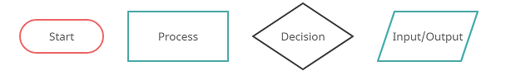

Part 3: Variables
What character information will you need to collect from the player & what stats will you track?

Variables to track:
Variable | Start Value | Purpose

Inventory Items:
Item Name | Purpose / Stats / Buffs / Debuffs

Part 4: Win and Lose Conditions
How to WIN & what happens when you win:

How to LOSE & what happens when you lose:

