# Components required

A list of the components for the system is given in the table below. You will also need some 4-core cable to connect the sensors to the box.

List of the components used to build the refraction system. Similar components could be substituted as required.

|  |  |  |  |
| --- | --- | --- | --- |
|  | **Price (€)** | **Quantity** | **Total (€)** |
| Funduino Mega | 11 | 1 | 11 |
| Adafruit LLC 1947 touch shield | 40 | 1 | 40 |
| Sparkfun SEN-13944 | 13 | 2 | 26 |
| 4 pole 3.5 mm jack plug | 2.50 | 2 | 5 |
| 4 pole 3.5 mm jack socket | 2 | 2 | 4 |
| 4 x AA battery holder | 2 | 1 | 2 |
| Power switch | 1 | 1 | 1 |
| Pegs | 2 | 2 | 4 |
| Box | 3 | 1 | 3 |
| TOTAL |  |  | 96 |

# Sensors

Each of the sensors should be attached to a peg and the jack plug connected to the end of the wire as shown below.

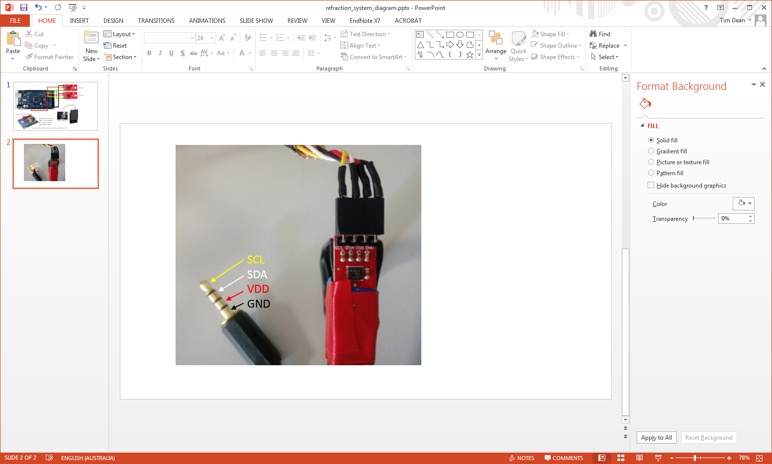

**Jack Plug Sockets**

The jack plug sockets are attached to the box by drilling holes into the bottom two corners as shown below. The following connections are then made between the sockets and the Arduino.

|  |  |
| --- | --- |
| **Socket** | **Arduino** |
| SCL | SCL – pin 21 |
| SCA | SCA – pin 20 |
| GND | GND – pin 55 |
| VCC | Power 3.3 V |

Note that the 3.3V power connection needs to be soldered to the base of the board to avoid interfering with the screen.

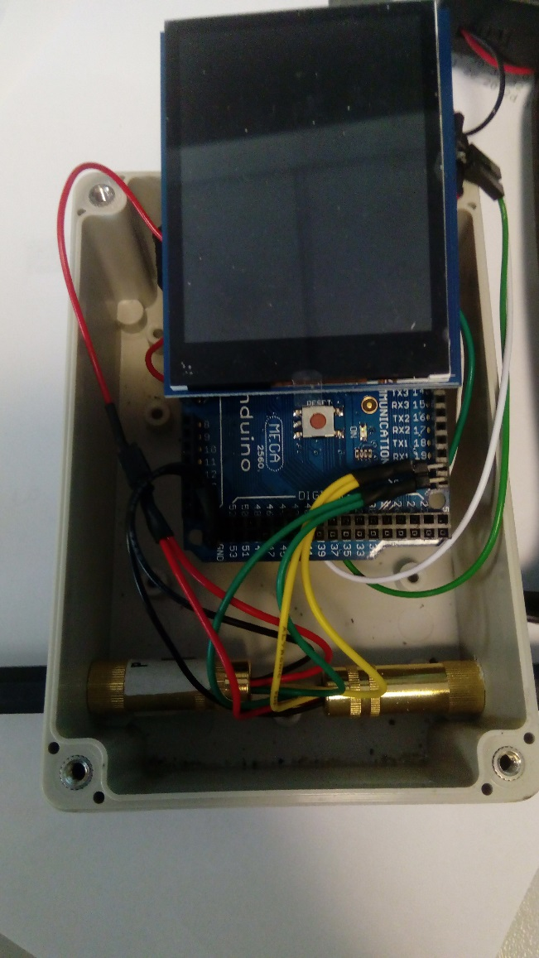

# Battery Pack

The positive wire from the battery pack is connected via the switch to the bottom of the Arduino (soldered on). The negative wire goes directly to the base of the Arduino.

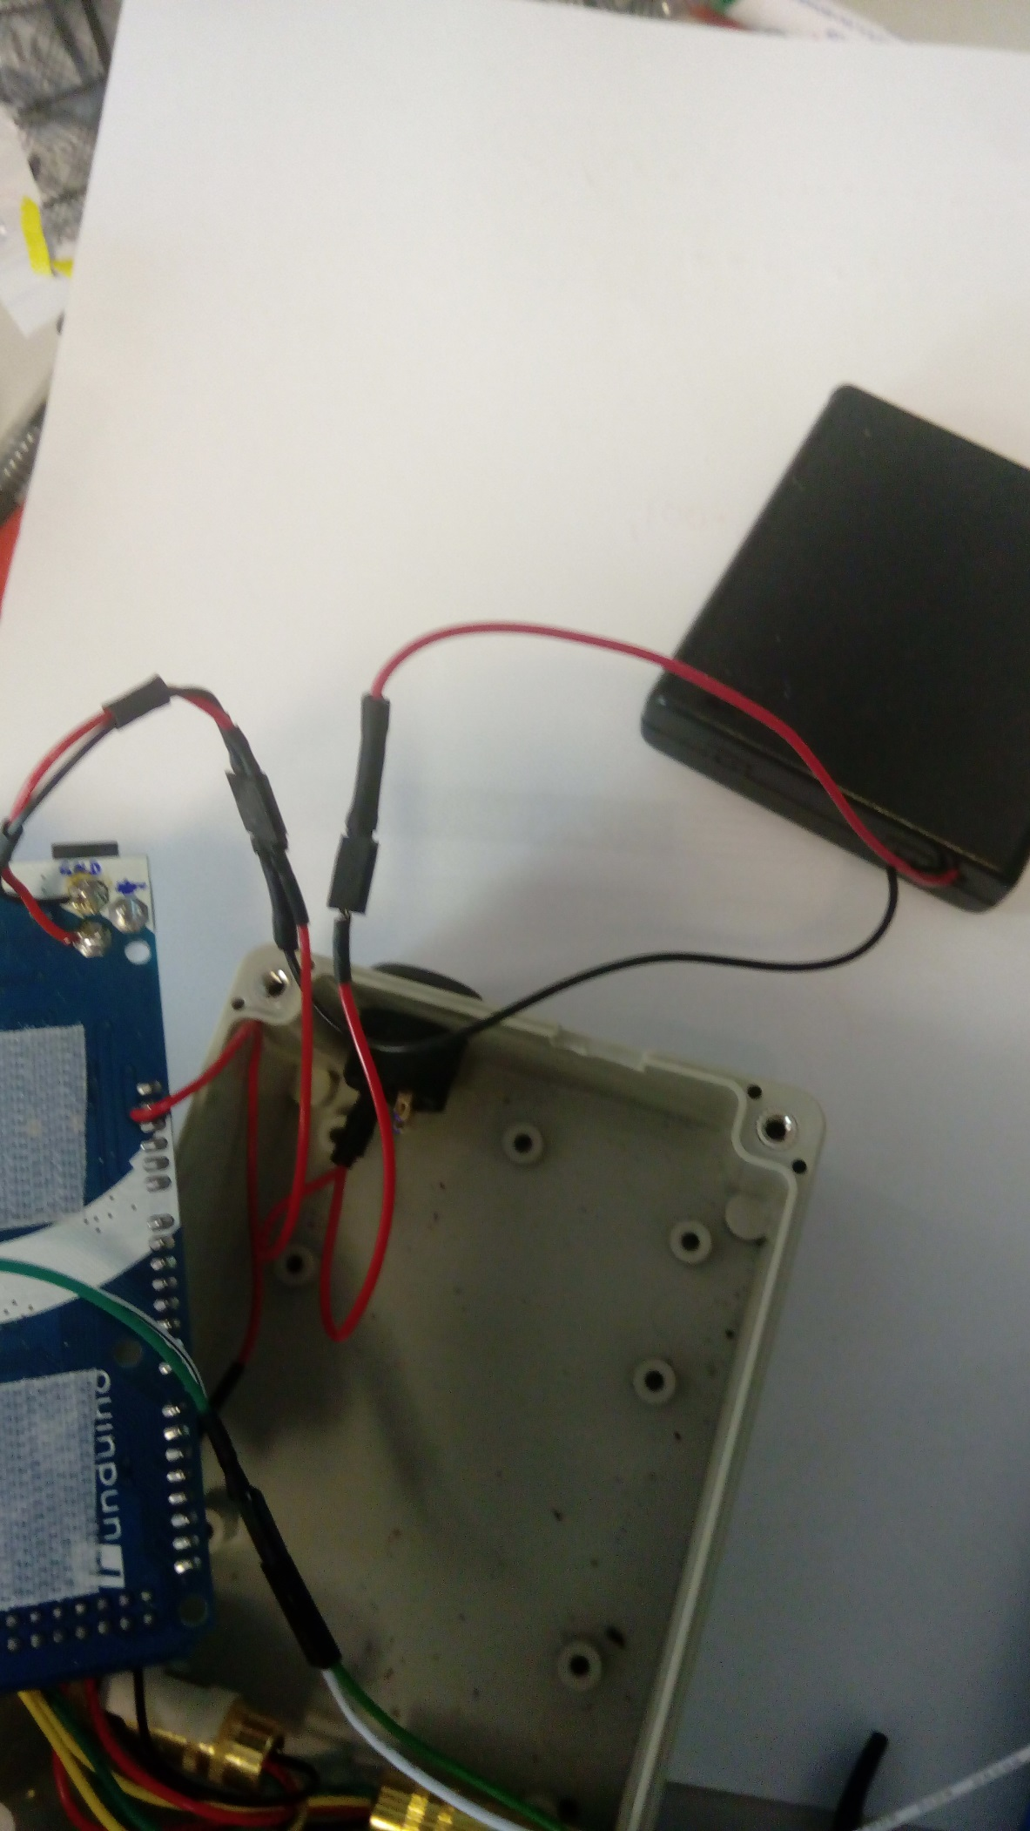

Connection to sensors

# Screen

The tracks 11, 12 and 13 need to be cut, and the ‘ICSP’ pads soldered as shown below.

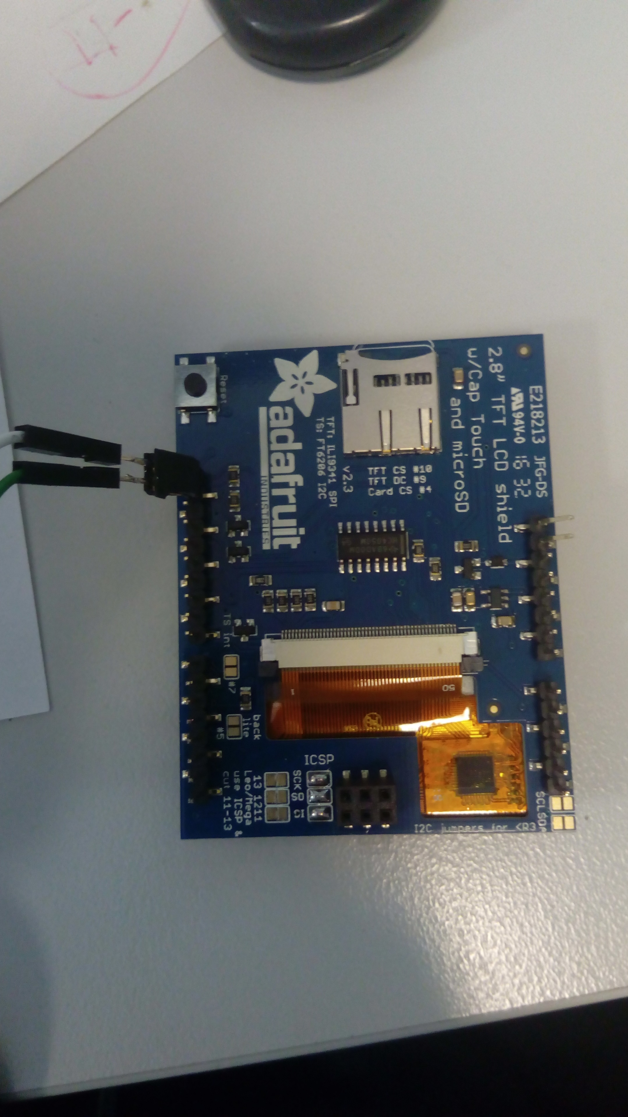

For the screen to fit onto the arudino you first have to bend the pins out as shown below.

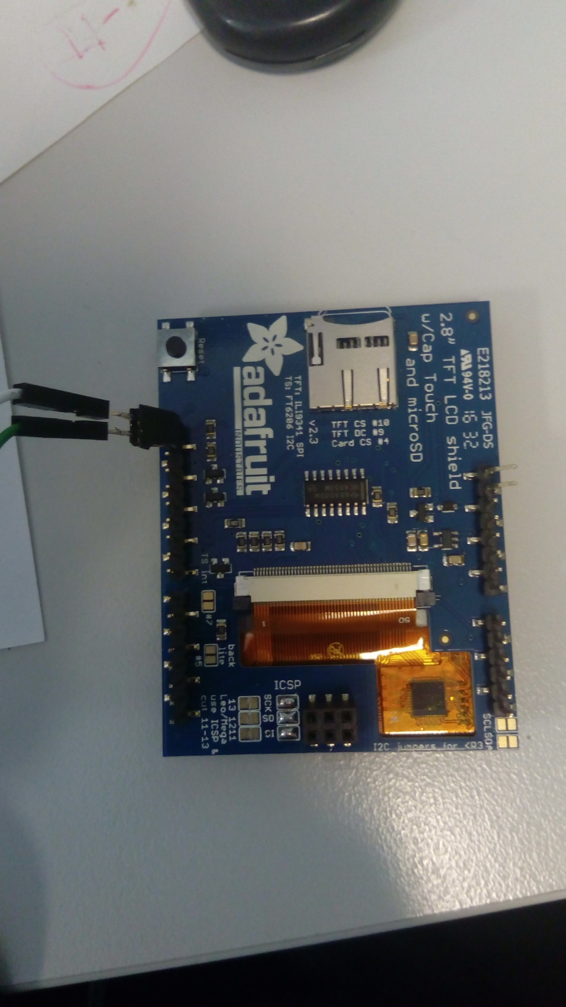

The two pins in the top left then need to be connected to the base of the Arduino (pins 20 and 21).

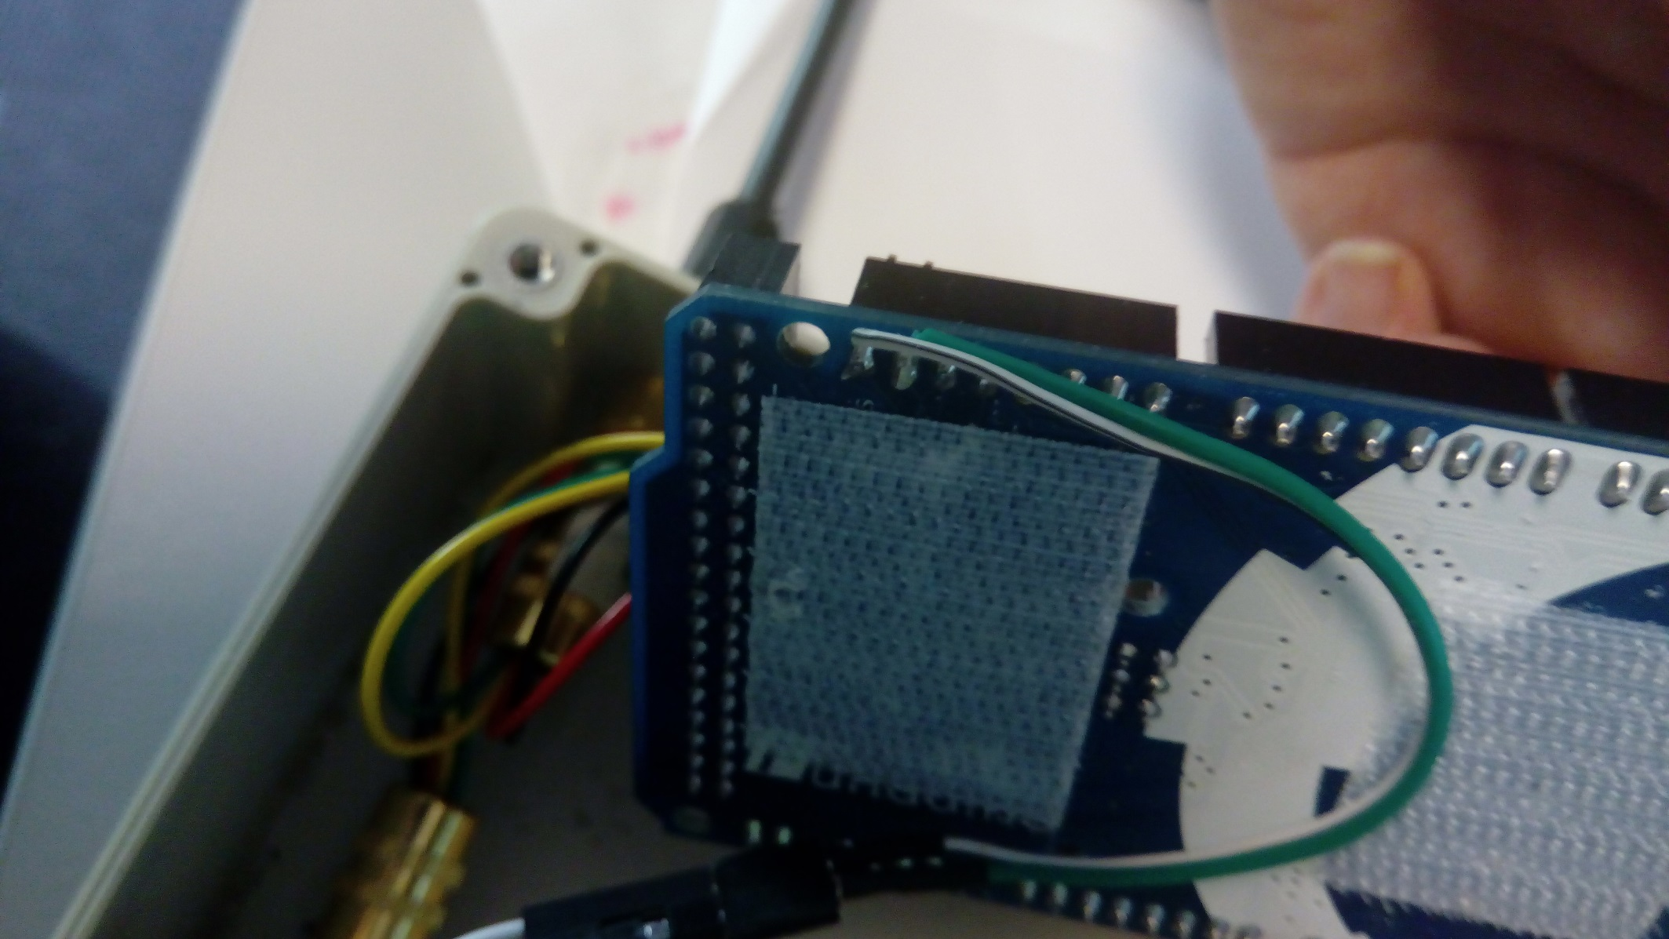

The screen can then be plugged in directly to the top of the Arduino.

# Final assembly

Finally, you need to cut a rectangle in the lid of the box for the screen to protrude out of and a hole for the Arduino USB connector.

