# Queries

## Total Number of Applications - Metric

Add Metric Element then go to Data change Data Source and execute the following SQL query:

SELECT count(distinct

context.tags.application) as cnt FROM "apm-*"

## Total Number of Applications in Poor Health - Metric

Add Metric Element then go to Data change Data Source and execute the following SQL query:

SELECT err from(select (a*100/b) as err from(select count(context.tags.application) as b, count(context.tags.error_code) as a from "apm-*" where context.tags.application is not null group by context.tags.application)) where err > 60

## Total Number of Applications in Medium Health – Metric

Add Metric Element then go to Data change Data Source and execute the following SQL query:

SELECT err from(select (a*100/b) as err from(select count(context.tags.application) as b, count(context.tags.error_code) as a from "apm-*" where context.tags.application is not null group by context.tags.application)) where err > 40 and err < 60

## Total Number of Applications in Poor Health – Bar Chart

Add Vertical Bar Chart Element then go to Data change Data Source and execute the following SQL query:

SELECT err , plat from(select (a*100/b) as err , plat from(select count(context.tags.application) as b, count(context.tags.error_code) as a , context.tags.platform as plat from "apm-*" where context.tags.application is not null group by context.tags.application , context.tags.platform)) where err > 60

## Total Number of Applications in Medium Health – Bar Chart

Add Vertical Bar Chart Element then go to Data change Data Source and execute the following SQL query:

SELECT err , plat from(select (a*100/b) as err , plat from(select count(context.tags.application) as b, count(context.tags.error_code) as a , context.tags.platform as plat from "apm-*" where context.tags.application is not null group by context.tags.application , context.tags.platform)) where err > 40 and err < 60

## Total Number of Applications in Poor Health – Table

Add Data Table Element then go to Data change Data Source and execute the following SQL query:

select "Application Name","Health Score %","No. of Requests" , "No. of Errors" from (select context.tags.application as "Application Name" , (100 - ((count(context.tags.error_code) * 100)/(count(context.tags.correlation_id)))) as "Health Score %" , count(context.tags.correlation_id) as "No. of Requests" , count(context.tags.error_code) as "No. of Errors" from "apm-*" where context.tags.correlation_id is not null group by context.tags.application) where "Health Score %" < 40

## Total Number of Applications in Medium Health – Table

Add Data Table Element then go to Data change Data Source and execute the following SQL query:

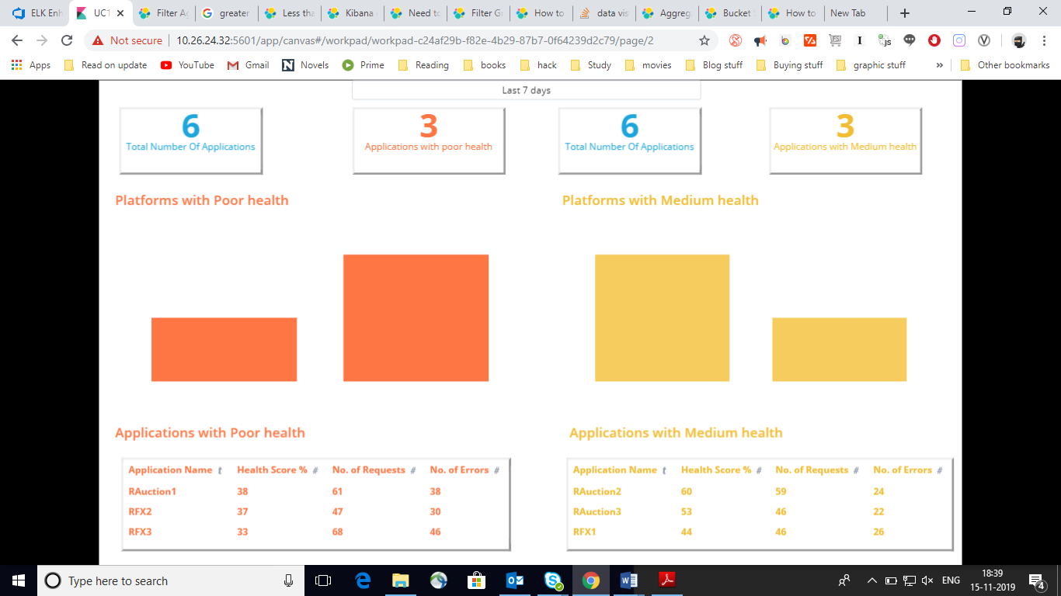select "Application Name","Health Score %","No. of Requests" , "No. of Errors" from (select context.tags.application as "Application Name" , (100 - ((count(context.tags.error_code) * 100)/(count(context.tags.correlation_id)))) as "Health Score %" , count(context.tags.correlation_id) as "No. of Requests" , count(context.tags.error_code) as "No. of Errors" from "apm-*" where context.tags.correlation_id is not null group by context.tags.application) where "Health Score %" < 60 and "Health Score %" > 40

# Json Used

tags: {

# All fields marked with * are mandatory.

*log_type : #Possible values :DEBUG < INFO < WARN < ERROR < FATAL

* platform:

* application:

* component_name: #Possible values : API Name, Batch Job name

* component_type: #possible values : API,NonAPI

* correlation_id:

sub_application :

* response_time : #Need to populate at the end of transaction.

* is_error: #Identify if error occurred in the transaction. If no error set to false,otherwise set to true.

#Placeholder for business events e.g. screen views/clicks logged through a single API(e.g. getDataForCharts)

event_id :

event_name :

* user_id :

#for Non-API, the interface_details field is mandatory.

* caller_system : # Interface execution initiated by

* interface_name : #External System to connect to

* interface_component : #API name,Batch/Integration Name

* intermediate_system : #Tibco,WSO2 ,any middleware

# Populate Error /Exception details in below fields.

*severity: HIGH, #defined severity of error. HIGH,LOW,MEDUIM

*error_code : #defined error_code. e.g. Business Exception, Technical Exception

*error_message:

}