  - EXERCISES
12/2025

Accessible content creation workshop

Table of Contents
Introduction 2
Pre-requisites 2
Exercise 1: Media Management 3
Exercise 2: Rich text editing 4
Exercise 3: PDF authoring 6

Introduction
Ideally, we will complete the webmastering exercises directly in the relevant CMS, but in general, the exercises at the workshop page can also be used.

Pre-requisites
- Access to CMS environment
  - Media library
  - WYSIWYG / Rich text feature
- Microsoft Word license
- Adobe Acrobat Pro license

Exercise 1: Media Management
Let’s put the theoretical principles of accessible media management into practice. We have selected three images that you may upload and add to the workshop page.

Pre-requisite: Install and open the Silktide Toolbar extension within your browser.

- Select Exercise 1 > Image 1.jpeg and fill in the upload form correctly
- Select Exercise 1 > Image 2.jpeg and fill in the upload form correctly
- Select Exercise 1 > Image 3.jpeg and consider the Link Destination URL field
  - Fill in the https://www.iodigital.com/en URL

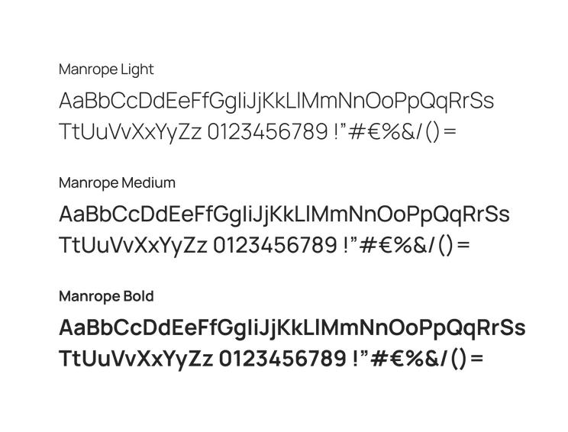



Exercise 2: Rich text editing
The goal of this exercise is to learn how to add WYSIWYG content that corresponds with the latest accessibility regulations.

- Add a heading “Heading sequences”
  - Use the right heading index (h2, h3, h4, …)
- Add a paragraph of text below the heading
  - “Headings should follow a logical sequence (H1 for main title, H2 for major sections, H3 for subsections, etc.) without skipping levels. Screen reader users often navigate content by jumping between headings to understand page structure and find relevant information quickly. When heading levels are skipped—like jumping from H2 directly to H4—it creates confusion about content relationships and can make users think they've missed important sections. Research shows that 67% of screen reader users rely primarily on heading navigation, making proper heading sequence one of the most impactful accessibility practices for content creators.”
- Add a link to the Axe Rule 4.8 Heading Order (https://dequeuniversity.com/rules/axe/4.8/heading-order) page
  - This page explains the “heading-order” rule that is used to automatically validate accessible heading structure. Use the right link text and make sure the link configuration (open in a new tab, downloadable) is applied correctly.
- Add a table with following cells, make sure the semantic table structure matches the visual representation:
  - Row 1, column 1: Feature
  - Row 2, column 1: Table headers
  - Row 3, column 1: Clear content
  - Row 1, column 2: Accessibility benefit
  - Row 2, column 2: Screen readers can identify column/row relationships
  - Row 3, column 2: Easier navigation for all users
- Add these items as ordered list below the table:
  - Follow logical heading sequence - Use H1 for main title, H2 for major sections, H3 for subsections, and continue hierarchically without skipping levels
  - Screen readers depend on heading structure - Users with assistive technology jump between headings to quickly understand page organization and locate relevant information
  - Skipping levels creates confusion - Jumping from H2 directly to H4 disrupts content relationships and may make users think they've missed important sections
  - 67% of screen reader users rely on heading navigation - Making proper heading sequence one of the most impactful accessibility practices for content creators

Exercise 3: PDF authoring
We will discuss both proactive and retroactive ways to create accessible PDF documents. In any case, even if your Word document is optimized for accessibility, it still needs to be evaluated in Acrobat Pro. Only through Acrobat Pro you can create a Tagged PDF, what constitutes an accessible PDF document.

A PDF evaluation involves an automated PDF Accessibility Check on the one hand, but also manual verification of the 23 PDF techniques on the other.

Pre-requisite: This exercise requires a Microsoft Word and Adobe Acrobat Pro license.

This exercise highlights 1 or 2 techniques per group:
- Image techniques
  - PDF 1: Alt text -> Image 1.jpg
  - PDF 4: Decorative images -> Image 2.jpg
- Structure techniques
  - PDF 9: Heading tags
  - PDF 2: Bookmarks
- Language techniques
  - PDF19: Language of Parts -> French quote
  - PDF 8: Abbreviations -> “AI”
- Links, tables and list techniques
  - PDF11: Links -> “https://www.example.com/insights/digital-transformation”
  - PDF13: Alt for links -> https://www.example.com/services/artificial-intelligence
  - PDF6: Table elements
    - Or fix with PDF20: Acrobat Pro’s Table Editor
- (optional) Form techniques
  - PDF12: Name, role and value of form fields
  - PDF23: Interactive form controls



Tim Dujardin
Head of Accessibility

tim.dujardin@iodigital.com

Campus Ghent

iodigital.com

