Business Analyst Project Portfolio Report
Late Delivery Risk Prediction & SLA Protection Engine (Proposed Architecture)
Dataset: Olist Brazilian E-Commerce | Validation: 3-Way Chronological Holdout

1. Problem Statement & Baseline Audit
Delivery delays on the Olist marketplace represent ~8.1% of all delivered orders (~7,800 out of ~96,500 orders), but they are strongly associated with negative customer sentiment. When orders arrive late, average customer review scores drop from 4.29 / 5.0 to 2.57 / 5.0. Furthermore, 45.2% of late orders receive a 1-star review (compared to just 6.6% for on-time deliveries), and late shipments account for 37.8% of all 1-star reviews on the platform.
To address this, a machine learning classification pipeline was built to predict late deliveries using only data available at the time of purchase. A proposed operational framework would flag high-risk orders at checkout, enabling proactive buffer days and priority dispatch workflows.

2. Out-of-Time Model Performance & Operational Metrics
- Validation Scheme: Strict 3-way temporal split. Train: Sep 2016 – Apr 2018 (70%, 67,517 orders). Validation: Apr 2018 – Jun 2018 (15%, 14,468 orders), used to select the ensemble size (300 trees, peak validation ROC-AUC 0.7328). Test Holdout: Jun 2018 – Aug 2018 (15%, 14,469 orders), used to score the final model after ensemble size was selected on validation.
- Out-of-Time ROC-AUC: 0.7351 (untouched holdout test period)
- PR-AUC (Average Precision): 0.1404 (vs. 0.0661 baseline late rate in the test period; 2.12x lift)
- Top 10% Flagged Volume: 1,446 orders flagged out of 14,469 test orders
- Late Orders Captured in Top 10%: 235 orders out of 957 actual delays
- Top Decile Capture Rate: 24.56% of all delays captured by reviewing only the 10% riskiest orders
- Delay Risk Concentration: 16.25% delay rate inside the flagged top decile (2.5x the baseline rate)

3. Out-of-Time Feature Drivers (SHAP) & Analytical Limitations
1. Promised Delivery Windows (estimated_delivery_days): Strongest driver (mean |SHAP| 0.64). Tight promised delivery windows are associated with higher late-delivery risk, as aggressive promises leave little margin for natural transit variance.
2. Purchase Month: Nearly tied with the top driver (0.63). Captures seasonal delay patterns, but the test window covers only June–August, so it acts largely as a seasonal baseline for that period. The signal rests on only ~2 years of history and warrants continuous monitoring as more data accumulates.
3. Geographic Association (customer_state, total_freight, seller_state, is_interstate): Interstate origin-destination pairs, higher freight values, and certain destination states are associated with increased delay risk.
4. Physical & Order Complexity: Product weight, package volume, item count, and seller count each have comparatively small effects (mean |SHAP| below 0.07).
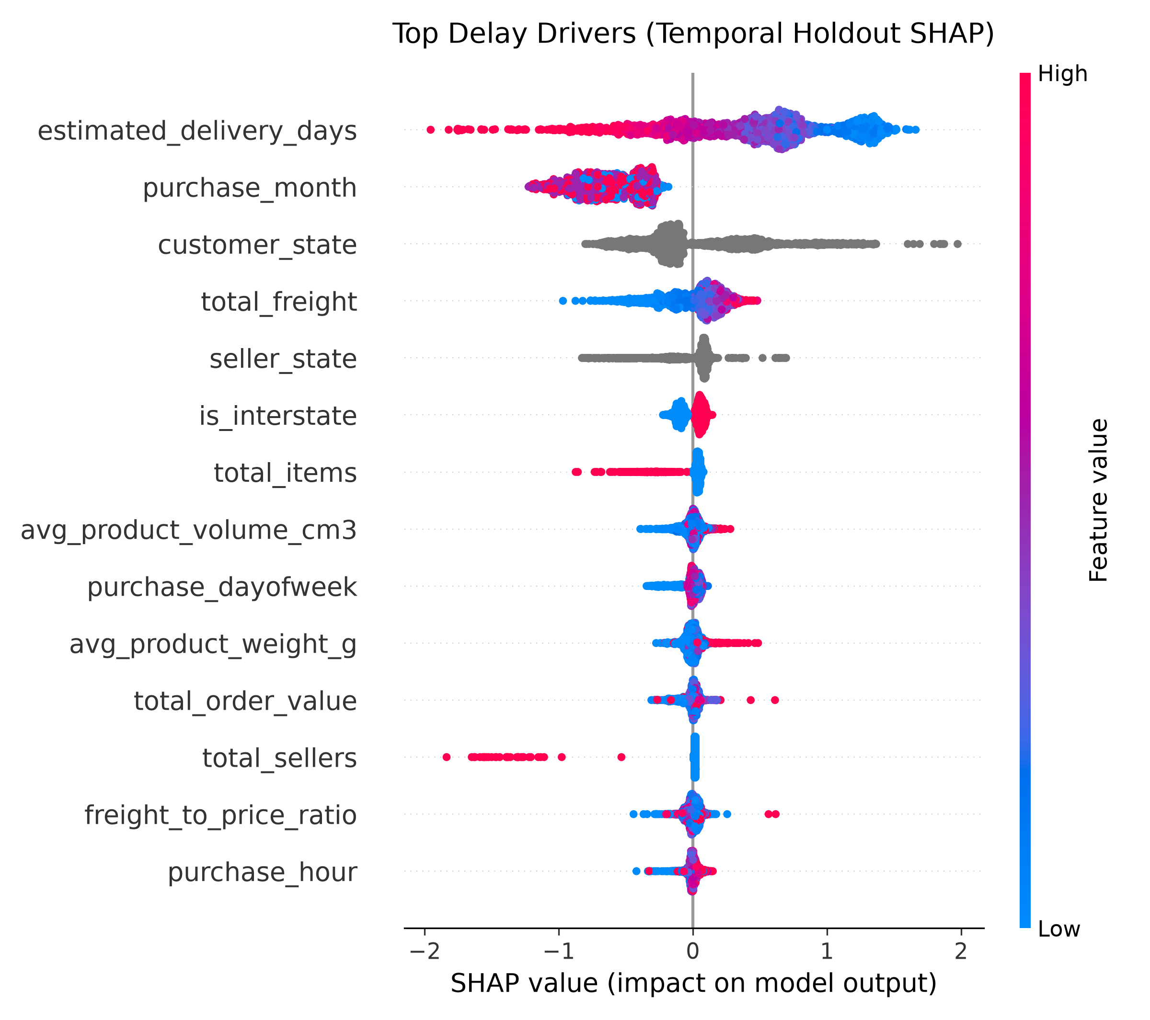
Figure 1: SHAP Summary Plot — Out-of-Time Feature Associations

4. Cost-Benefit Analysis (Illustrative Scenario with Assumptions)
Note: The following financial scenario is an illustrative projection based on assumptions (annual order volume of 50,000, $15 concession voucher per delay, and an assumed 35% delay resolution rate via dynamic buffering and warehouse prioritization). It is not a measured result.
Component | Baseline | With Proposed SLA Engine | Projected Net Delta
Annual Order Volume (Assumed) | 50,000 | 50,000 | —
Baseline Delay Rate (Holdout Period) | 6.61% (3,305 delays) | 6.61% (3,305 delays) | —
High-Risk Orders Flagged (Top 10%) | 0 | 5,000 | +5,000 flagged
Expected Delays in Flagged Group (16.25% hit rate) | 0 | 813 | +813 intercepted
Avoided Delays via Buffer/Routing (Assumed 35% resolution) | 0 | 284 | -284 delayed orders
Voucher Concession Savings (@ $15/delay avoided) | $49,575 | $45,315 | +$4,260 savings
Estimated GMV Retained (Assumed 50 retained accounts) | Baseline | +$17,500 | +$17,500 ARR
Cloud Infrastructure & Inference Costs (Assumed $300/mo) | $0 | -$3,600 | -$3,600 cost
Net First-Year Projected Business Impact | Baseline | — | +$18,160

5. Proposed Agile Specifications (Target Architecture)

User Story 1: Real-Time Risk Scoring Ingestion (Proposed)
As an Operations Product Manager, I want checkout order attributes scored by the delay prediction service, so that high-risk shipments can be identified before carrier manifests are generated.
Acceptance Criteria:
1. Return delay probability within 250ms of order placement.
2. If risk score exceeds the top-decile threshold, set sla_risk_tier = 'HIGH'.
3. System timeout (>500ms) gracefully falls back to 'STANDARD' without blocking customer checkout.

User Story 2: Merchant Portal Priority Tagging (Proposed)
As a Marketplace Merchant, I want high-risk shipments highlighted on daily picking lists, so that time-sensitive orders can be packed and transferred to carriers promptly.
Acceptance Criteria:
1. Orders flagged as 'HIGH' render with a visible red 'Priority Carrier Pickup' badge.
2. Shipping label manifests prepend 'EXP-' to carrier tracking payloads.

