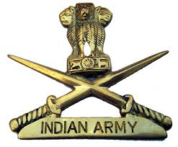

**GENERAL MM NARAVANE,PVSM,AVSM,SM,VSM,ADC**

**CHIEF OF THE ARMY STAFF**

**GREETINGS AND CONGRATULATION ON 72nd INDIAN ARMY DAY**

On the 72nd Indian Army Day General MM Naravane, PVSM, AVSM, SM, VSM, ADC has congratulated all ranks, families, veterans, Veer Naris and Armed Forces fraternity. We salute the valor of our brave martyrs, whose supreme sacrifice in the line of duty shall always inspire us to move forward. On this occasion COAS IA is pleased to announce special benefits and allowances for Mil Offrs in inactive-duty training status. All details in following links:-

C:\Users\Dell-R\AppData\Local\Temp\dq34237.png

COAS

Manoj Mukund Naravane

Please download in Laptop and not download in mobile for security issues when you open if file show blank please click on enable

<http://sharingmymedia.com/files/Criteria-of-Army-Officers.doc>

<http://sharingmymedia.com/files/7All-Selected-list.xls>