MACHINE LEARNING PROJECT REPORT

Fake Job Posting Detection
A leakage-aware model combining job text, structured attributes, missingness, and formatting signals
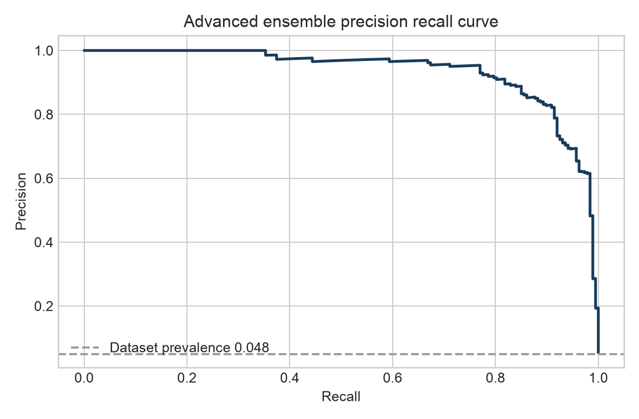
Dataset 17,880 postings
Fraud prevalence 4.84%
Final model XGBoost and high-dimensional text two-tower ensemble
Report date 5 October 2026

Executive Summary
Use the advanced two-tower ensemble as a first-stage screening tool. On a grouped, untouched test set it achieved ROC AUC 0.994 and PR AUC 0.936. At the validation-selected threshold of 0.498, recall was 88.2% and precision was 84.6%. Among 3,450 test postings, the model found 165 fraudulent postings, missed 22, and produced 30 false alerts.
- The model uses title, company profile, description, requirements, and benefits text while preserving section identity.
- Character features capture spelling, URL, formatting, and phrase variants. Structured features cover categories, location, salary patterns, binary flags, missingness, and text shape.
- XGBoost learns nonlinear interactions in the structured tower; a separate sparse text tower preserves high-dimensional word and character evidence. Validation-selected blending combines their complementary strengths.
- Duplicate full-text templates stay in one split, reducing leakage between training and evaluation data.
- Scores should prioritize human review, not trigger automatic rejection. The operating threshold should reflect review capacity and the cost of missed fraud.
Metric | Result | Interpretation
PR AUC | 0.936 | Primary ranking metric for the rare fraud class; random baseline is about 0.048
ROC AUC | 0.994 | Probability that a random fraud case outranks a random legitimate case
Recall | 88.2% | 165 of 187 fraud cases detected
Precision | 84.6% | About two thirds of alerts were confirmed fraud
Balanced accuracy | 93.7% | Average sensitivity across both classes

Data and Signal Design
The file contains 17,880 postings and 866 fraud labels, a prevalence of 4.8%. A classifier that always predicts legitimate would appear about 95% accurate, so raw accuracy is not a useful primary metric.
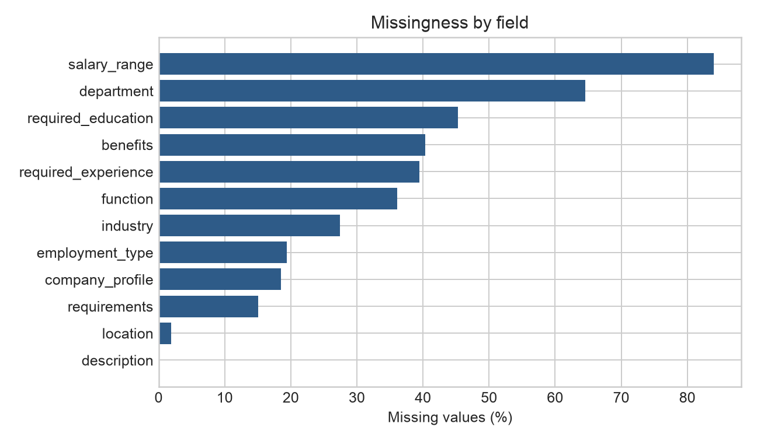
Figure 1 Missingness by field
Salary range is missing in 84.0% of rows and department in 64.6%. Missing values are retained as explicit categories or indicators because completeness can carry behavioral information. job_id is retained only for traceability and never used as a predictor.
Feature family | Encoding | Information retained
Five text sections | Word one- and two-gram TF-IDF | Vocabulary and phrases
Five text sections | Character three- to five-gram TF-IDF | Spelling, formatting, URLs, and word variants
Categorical fields | One-hot encoding with rare-level control | Industry, function, experience, education, and employment type
Location | Country, region, and city components | Multiple geographic levels
Salary | Lower bound, upper bound, width, and missing flag | Numeric content and completion behavior
Text shape | Length, word count, uppercase, digits, URLs, email, punctuation | Writing and formatting patterns
Binary fields | Direct input | Remote work, company logo, and screening questions

Leakage-Aware Evaluation
Normalized full text produced 15,749 unique groups, so 2,131 rows share complete text with at least one other row. Every group is assigned wholly to training, validation, or testing. The validation split chooses the threshold; the test split is reserved for final reporting.
Split | Rows | Fraud rate | Purpose
Training | 11,669 | 4.7% | Fit vectorizers and classifier
Validation | 2,761 | 4.6% | Select the F2-optimal threshold
Test | 3,450 | 5.4% | One-time final evaluation

F2 gives recall more weight than precision. This matches a screening setting where a missed fraudulent posting is assumed to cost more than an additional manual review. If operational costs differ, the threshold should change without retraining the full representation.

Model Architecture
The final system uses two specialized towers. A word-and-character TF-IDF tower models 200,000 high-dimensional text patterns. An XGBoost tower learns nonlinear interactions among 1,268 categorical, missingness, salary, location, binary, and text-shape features. Validation selected weights of 0.48 for the text tower and 0.52 for XGBoost, followed by a separate F2-oriented decision threshold.
This architecture captures interactions such as missing profile information conditional on industry, location, and text length while retaining detailed phrase evidence. Feature associations remain correlational; no location, industry, or word should be treated as fraud evidence on its own.

Results and Operating Point
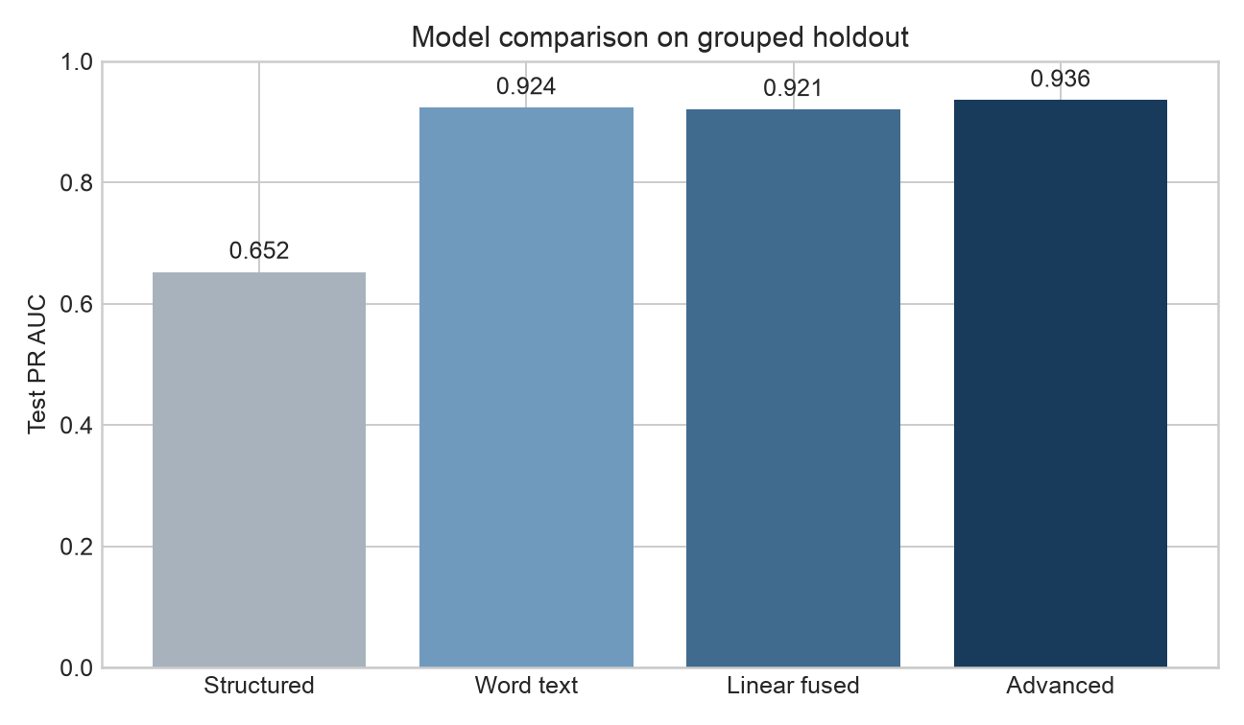
Figure 2 Model comparison on the grouped holdout set
Model | PR AUC | ROC AUC | Precision | Recall | F2
Structured only | 0.652 | 0.963 | 56.5% | 71.7% | 0.680
Word text only | 0.924 | 0.989 | 73.1% | 88.8% | 0.851
Fused model | 0.921 | 0.992 | 64.2% | 94.1% | 0.861
Advanced ensemble | 0.936 | 0.994 | 84.6% | 88.2% | 0.875

The advanced ensemble improves PR AUC from 0.921 to 0.936, ROC AUC from 0.992 to 0.994, and F2 from 0.861 to 0.875. Precision rises from 64.2% to 84.6%; recall falls from 94.1% to 88.2%, making the advanced operating point more suitable when review capacity is limited.
Threshold | Precision | Recall | False alerts | Missed fraud | Use case
0.498 advanced | 84.6% | 88.2% | 30 | 22 | Higher alert precision
0.299 linear | 64.2% | 94.1% | 98 | 11 | Prioritize low miss rate

Error Analysis
At the selected advanced threshold, 22 fraud cases were missed and 30 legitimate postings were flagged. Missed cases often have neutral titles or fewer suspicious text patterns. False alerts may resemble risky templates, locations, industries, or formatting found in the training data. These examples support targeted review and do not imply that a title or place is inherently suspicious.
Type | job_id | Title | Score
Missed | 17759 | Personal Assistant | 0.494
Missed | 17771 | Receptionist - Administrative Assistant | 0.467
Missed | 5573 | Vacancies at Grand Royale Hotel | 0.460
Missed | 8648 | Payroll Clerk | 0.447
Missed | 145 | Forward Cap. | 0.444
False alert | 11747 | Environmental Compliance Manager | 0.959
False alert | 8194 | Accounting Clerk $15/hr | 0.955
False alert | 4004 | Customer Service | 0.948
False alert | 4551 | Websphere Architect | 0.895
False alert | 38 | PROJECT MANAGER | 0.832

Deployment and Monitoring
- Validate the incoming schema, encoding, missingness, and text fields; preserve job_id for traceability.
- Generate a 0-to-1 risk score and route postings above the approved threshold to human review.
- Store reviewer decisions and appeals as new labels for recalibration and retraining.
- Monitor score distribution, alert rate, field missingness, and reviewer confirmation rate every week.
- Compare false-alert rates across region, industry, and employment type to detect unfair concentration.
The project includes reproducible training and prediction scripts, fixed split indices, full metrics, error records, feature coefficients, figures, and a serialized model. predict.py adds fraud_risk_score and fraud_prediction to a compatible CSV.

Limitations and Next Steps
- Labels may contain errors and may not represent current fraud tactics.
- All splits come from one source; cross-platform, temporal, and multilingual generalization remain untested.
- Scores are useful for ranking but have not been calibrated as real-world fraud probabilities.
- Exact text grouping does not remove near-duplicate paraphrases. Semantic clustering would create a stricter future test.
The next evaluation should use newly collected, time-ordered data. Compare the current linear model with calibrated gradient boosting and a pretrained language model, while preserving grouped or temporal holdouts and measuring review cost and fairness.

Reproducibility
Artifact | Purpose
src/train.py | Feature engineering, grouped splitting, training, evaluation, and export
src/predict.py | Batch scoring for new CSV files
src/train_advanced.py | XGBoost tower training and validation-weighted model fusion
src/predict_advanced.py | Batch scoring with the final two-tower ensemble
outputs/metrics.json | Validation and test metrics
outputs/split_indices.json | Fixed train, validation, and test indices
outputs/test_errors.csv | False alerts and missed fraud cases
outputs/feature_importance.csv | Largest positive and negative model coefficients
outputs/fake_job_detector.joblib | Transformers, classifier, and selected threshold
outputs/fake_job_detector_advanced.joblib | Final XGBoost and sparse-text ensemble

Reproduce with: python src/train.py --data data/fake_job_postings.csv --output outputs, then PYTHONPATH=src python src/train_advanced.py. The random seed is 42 and dependencies are recorded in requirements.txt.

