# F150 USB Memory Stick – User Guide

Starting Access Standard 2

Login 3

Logout 5

Change Password 6

Opening and Saving Files 9

## Starting Access Standard

1. Connect the USB Memory Stick to your computer.
2. Open “My Computer”.
3. Double- click the drive named “Application”. This will open the application partition on the USB memory stick.
4. Double-click Start .exe file (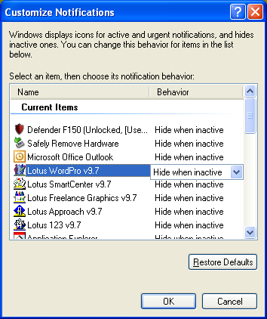Start) from the root directory on the application partition.
5. The  icon will appear on the notification area at the far right of the taskbar.

## 

## Login

**Method 1**

1. From the notification area, at the right of the taskbar, right-click the  icon and click **Login.**

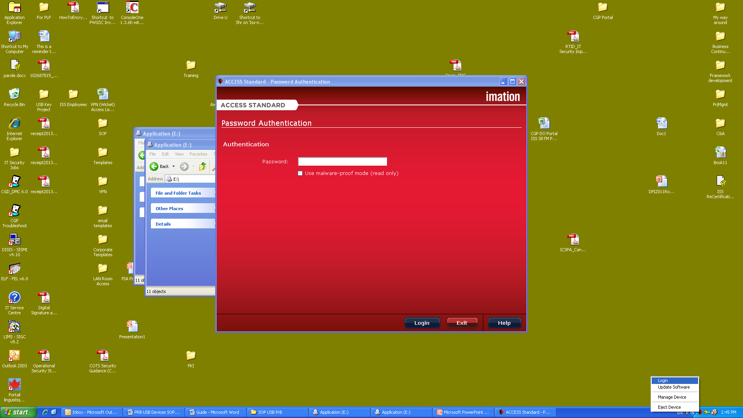

1. Enter the password and press the “Login” button.

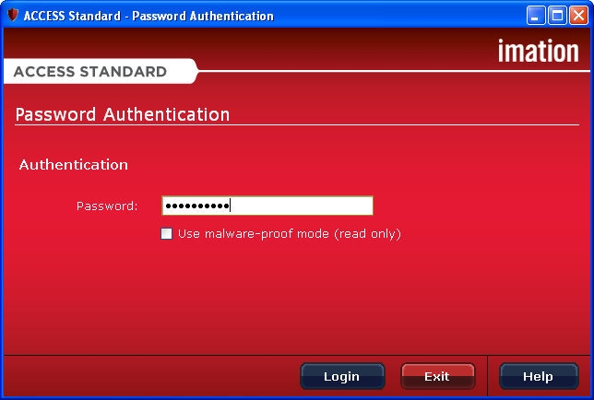

**Method 2**

1. From the notification area, at the right of the taskbar, right-click the  icon and then click **Manage Device.**

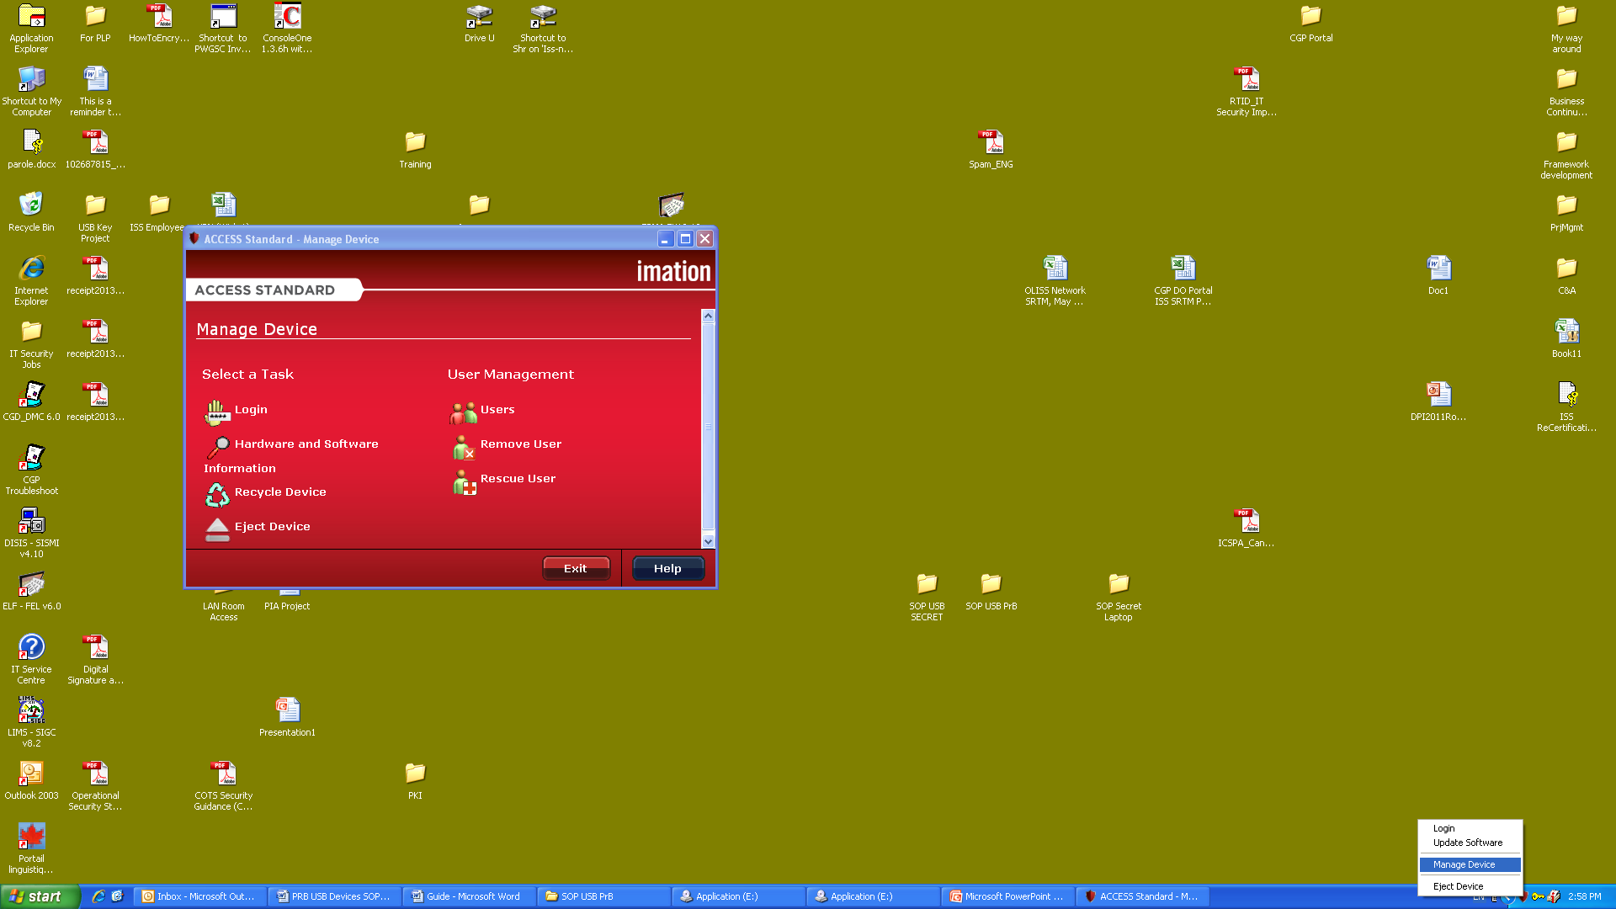

1. Select the **Login** button.
2. Enter password and click the “Login button”.



## Logout

**Method 1**

From the notification area, at the right of the taskbar, right-click the  icon and then click **Logout.**

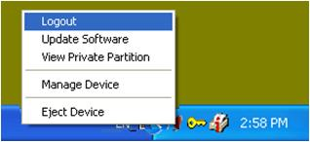

**Method 2**

From the Manage Device window select **Logout** or **Eject Device.**

## Change Password

Upon the first utilization of the device, you need to change the temporary password assigned to you by the Administrator.

1. Connect the device to a USB port and launch the Access Standard interface application (see Starting Access Standard Application - page 2).
2. From the notification area, at the right of the taskbar, right-click the  icon and click **Login.**



1. Enter the current (temporary) password and press the **Login** button.



1. From the notification area, at the right of the taskbar, right-click the  icon and then click “Manage Device”. This will open the Manage Device window.



1. On the “Manage Device” window, select the **Change Your Password** button. This will open the user authentication window.
2. Insert the current (temporary) password in the Password Verification pop-up window and then press **Verify** button. This will open the **Change Password** window.

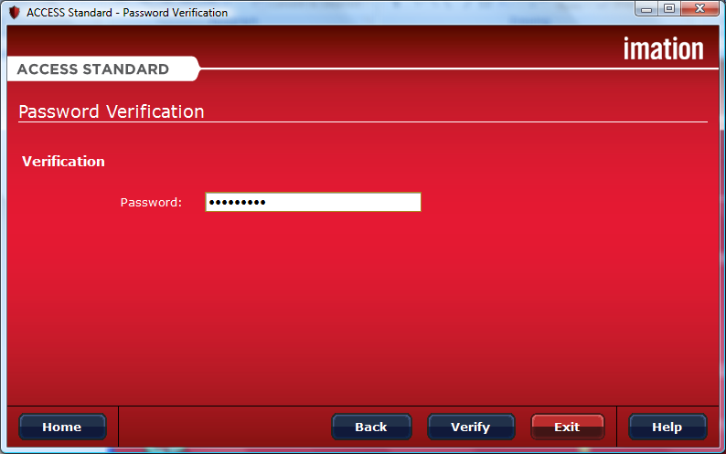

1. In the **Change Password** window enter a new password and then click **Next.**

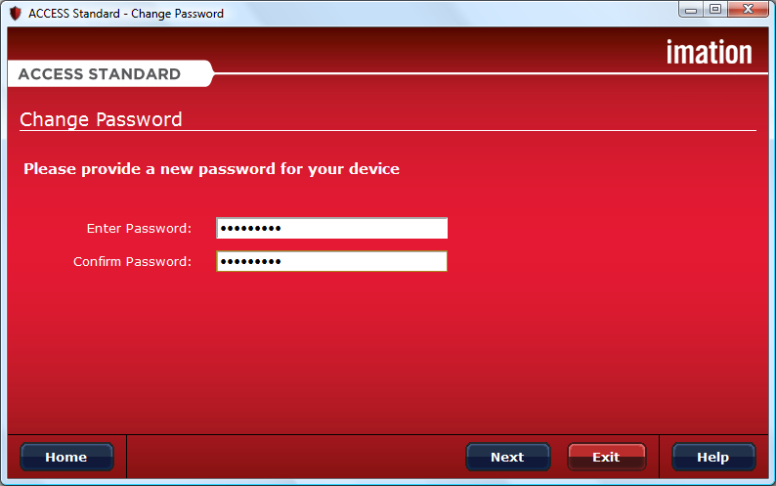

1. When the change password operation is complete press the **OK** button to return to the **Manage Device** window.

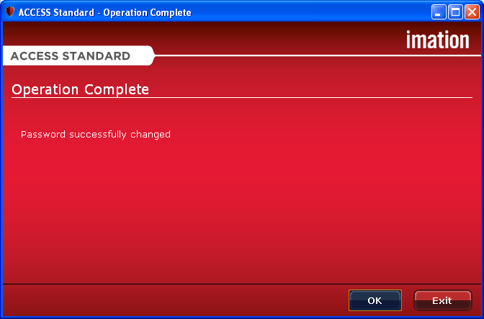

## Opening and Saving Files

The device contains two partitions, the Application partition and the Private partition. Your computer recognizes each partition as a separate drive.

The Application partition contains preinstalled applications such as Access Standard. You cannot save data or delete data from the Application partition.

The Private partition stores your data and **can be accessed only after you log into the device**.

**Opening Files**

Once you log into the device, you can open files on the Private partition using the appropriate program or a file manager program (such as Windows® Explorer). Alternatively, you can access the Private partition by right-click the  icon on the notification area of the taskbar and then select **View Private Partition**.



**Saving Files**

After you log into device, you can save data in the Private partition. When you save data to the private partition the device encrypts the data. Data is automatically decrypted when you open the file.