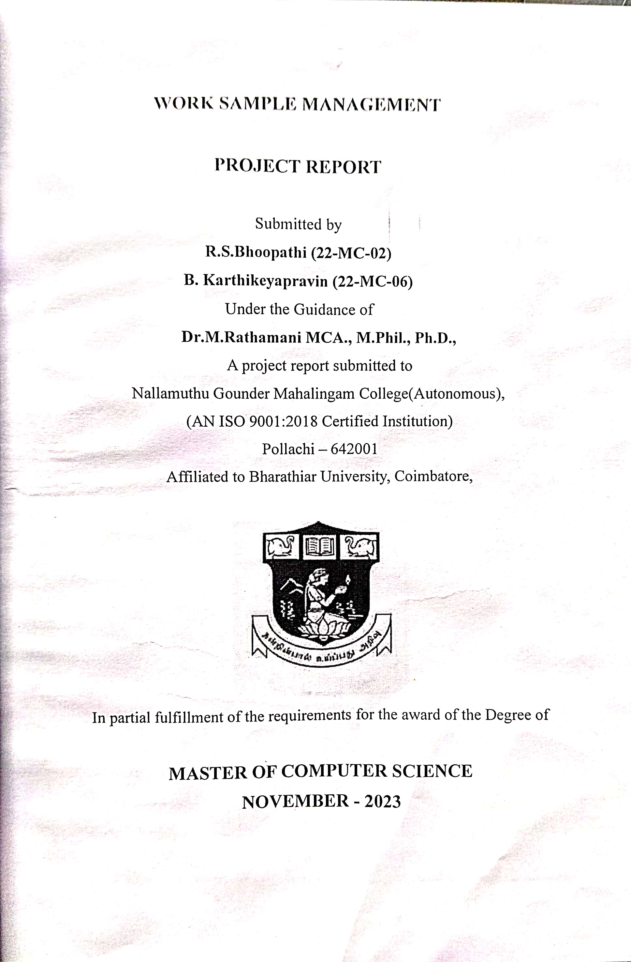

**CERTIFICATE**

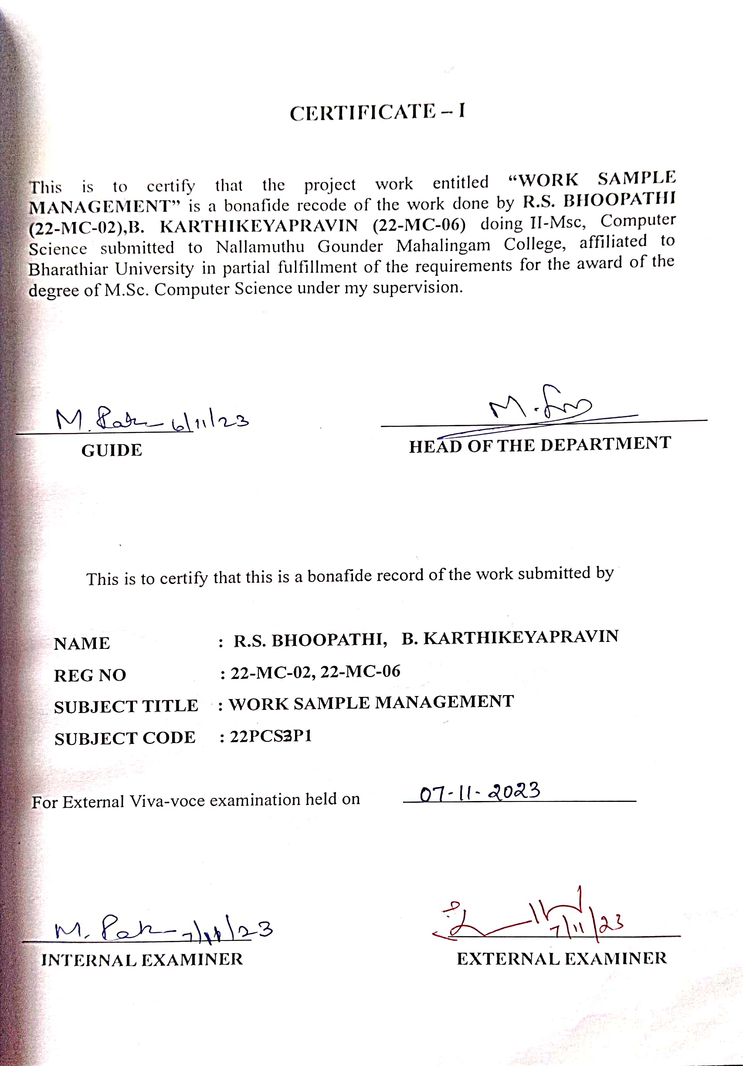

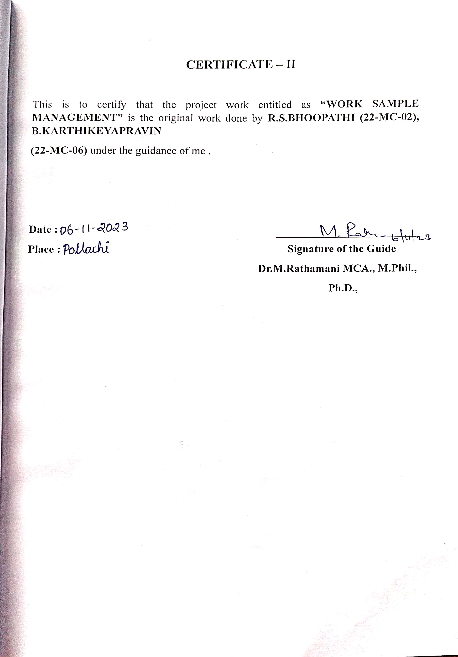

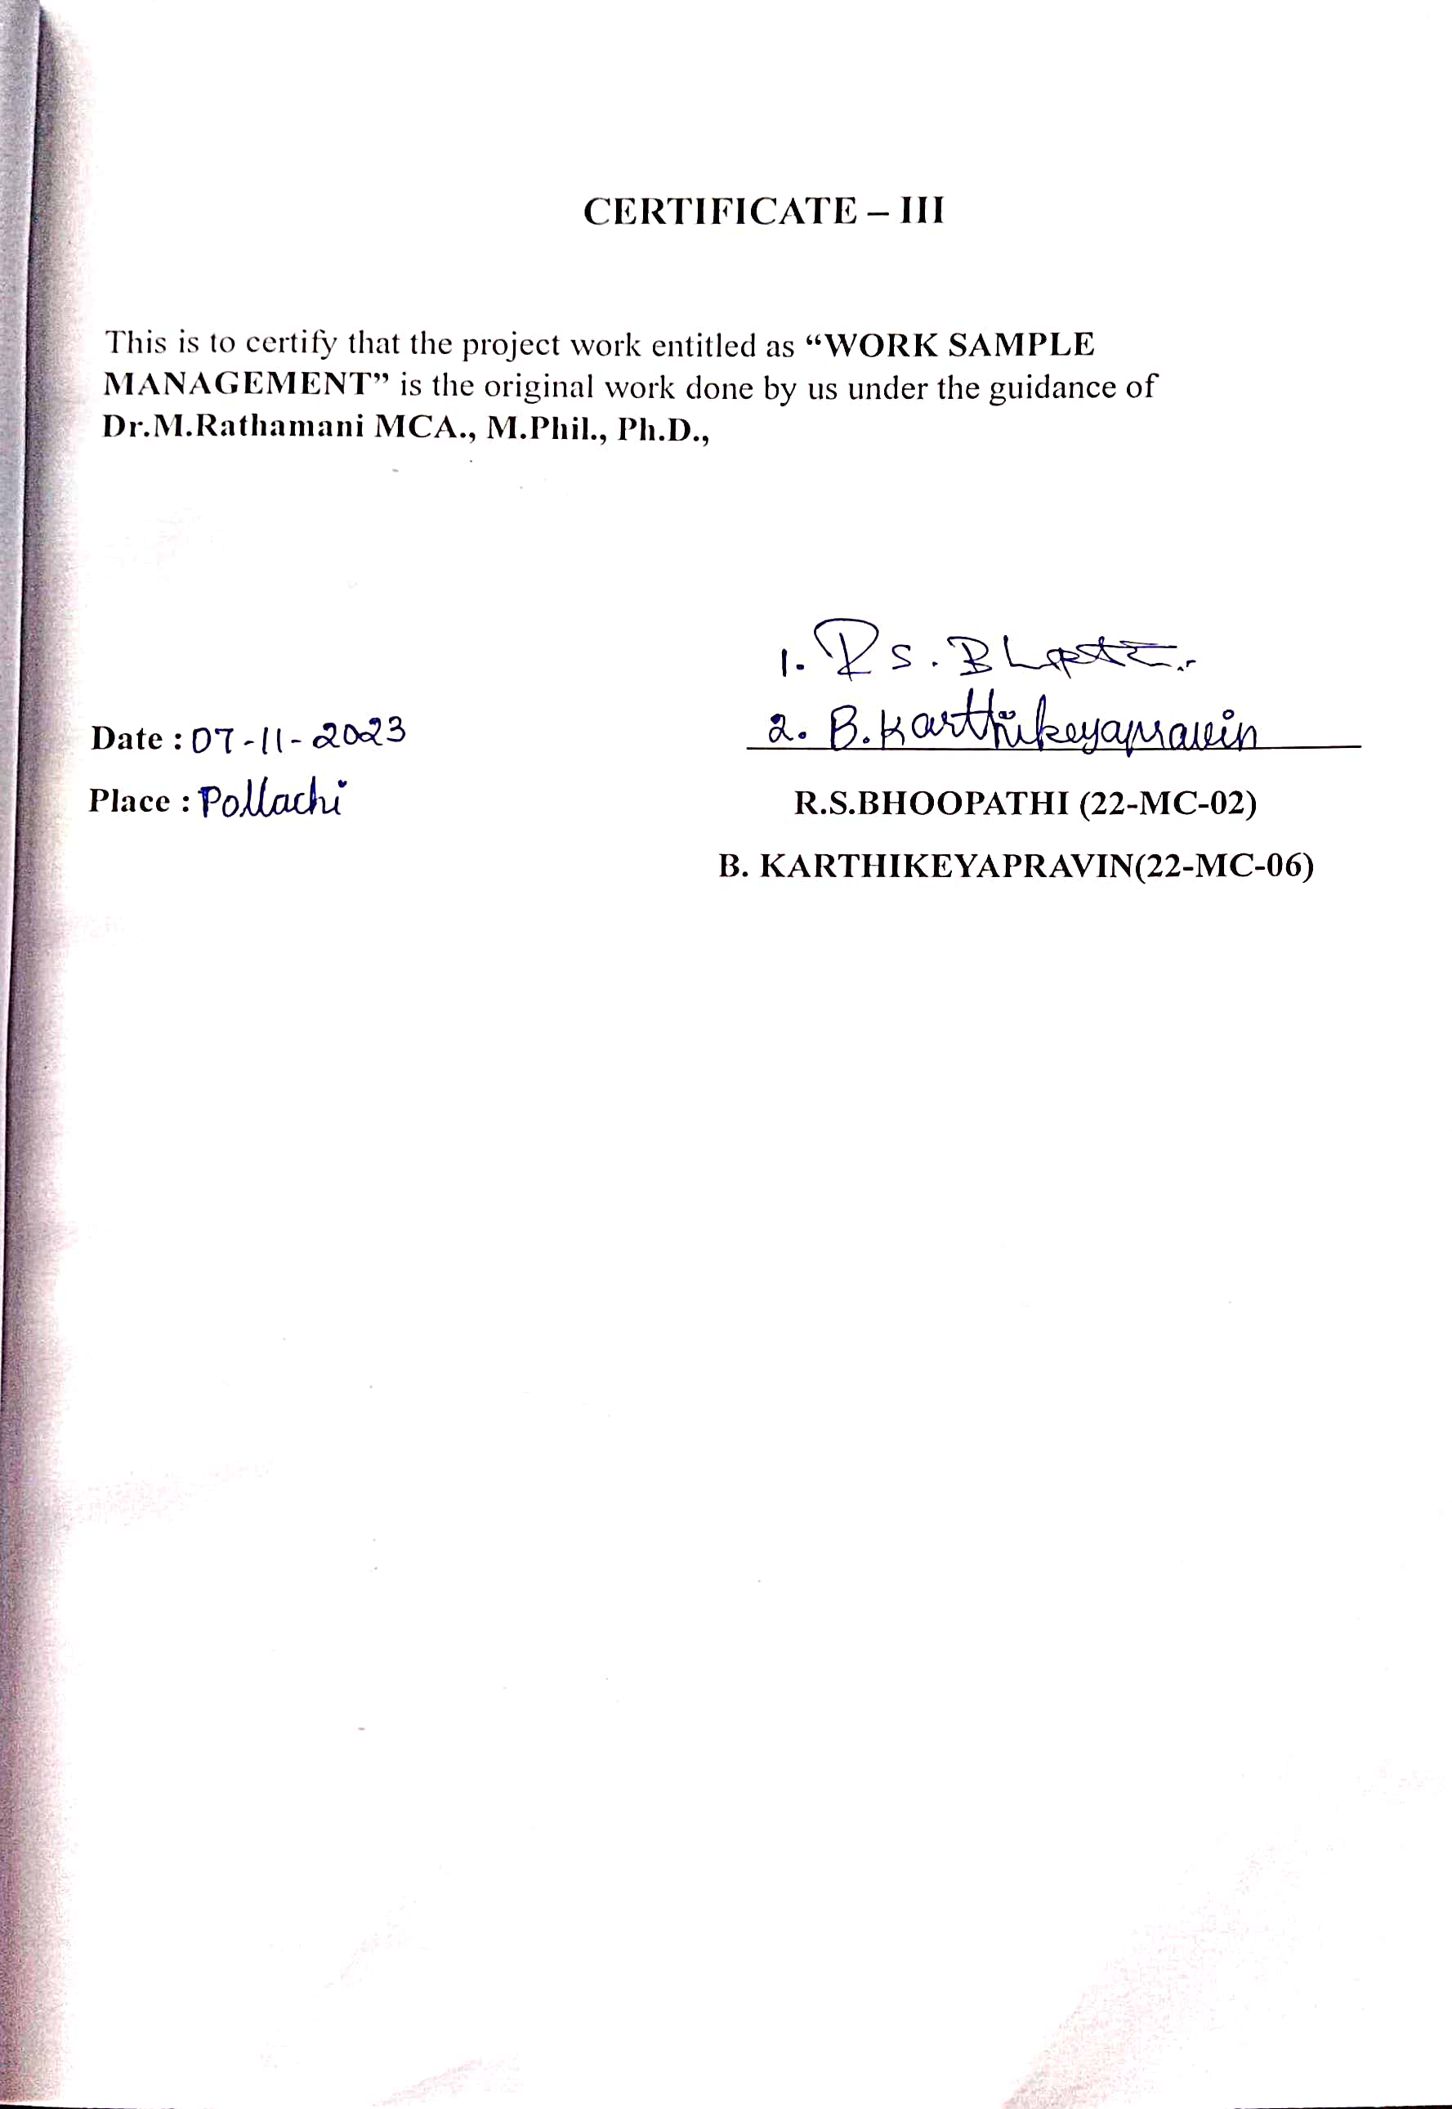

**DECLARATION**

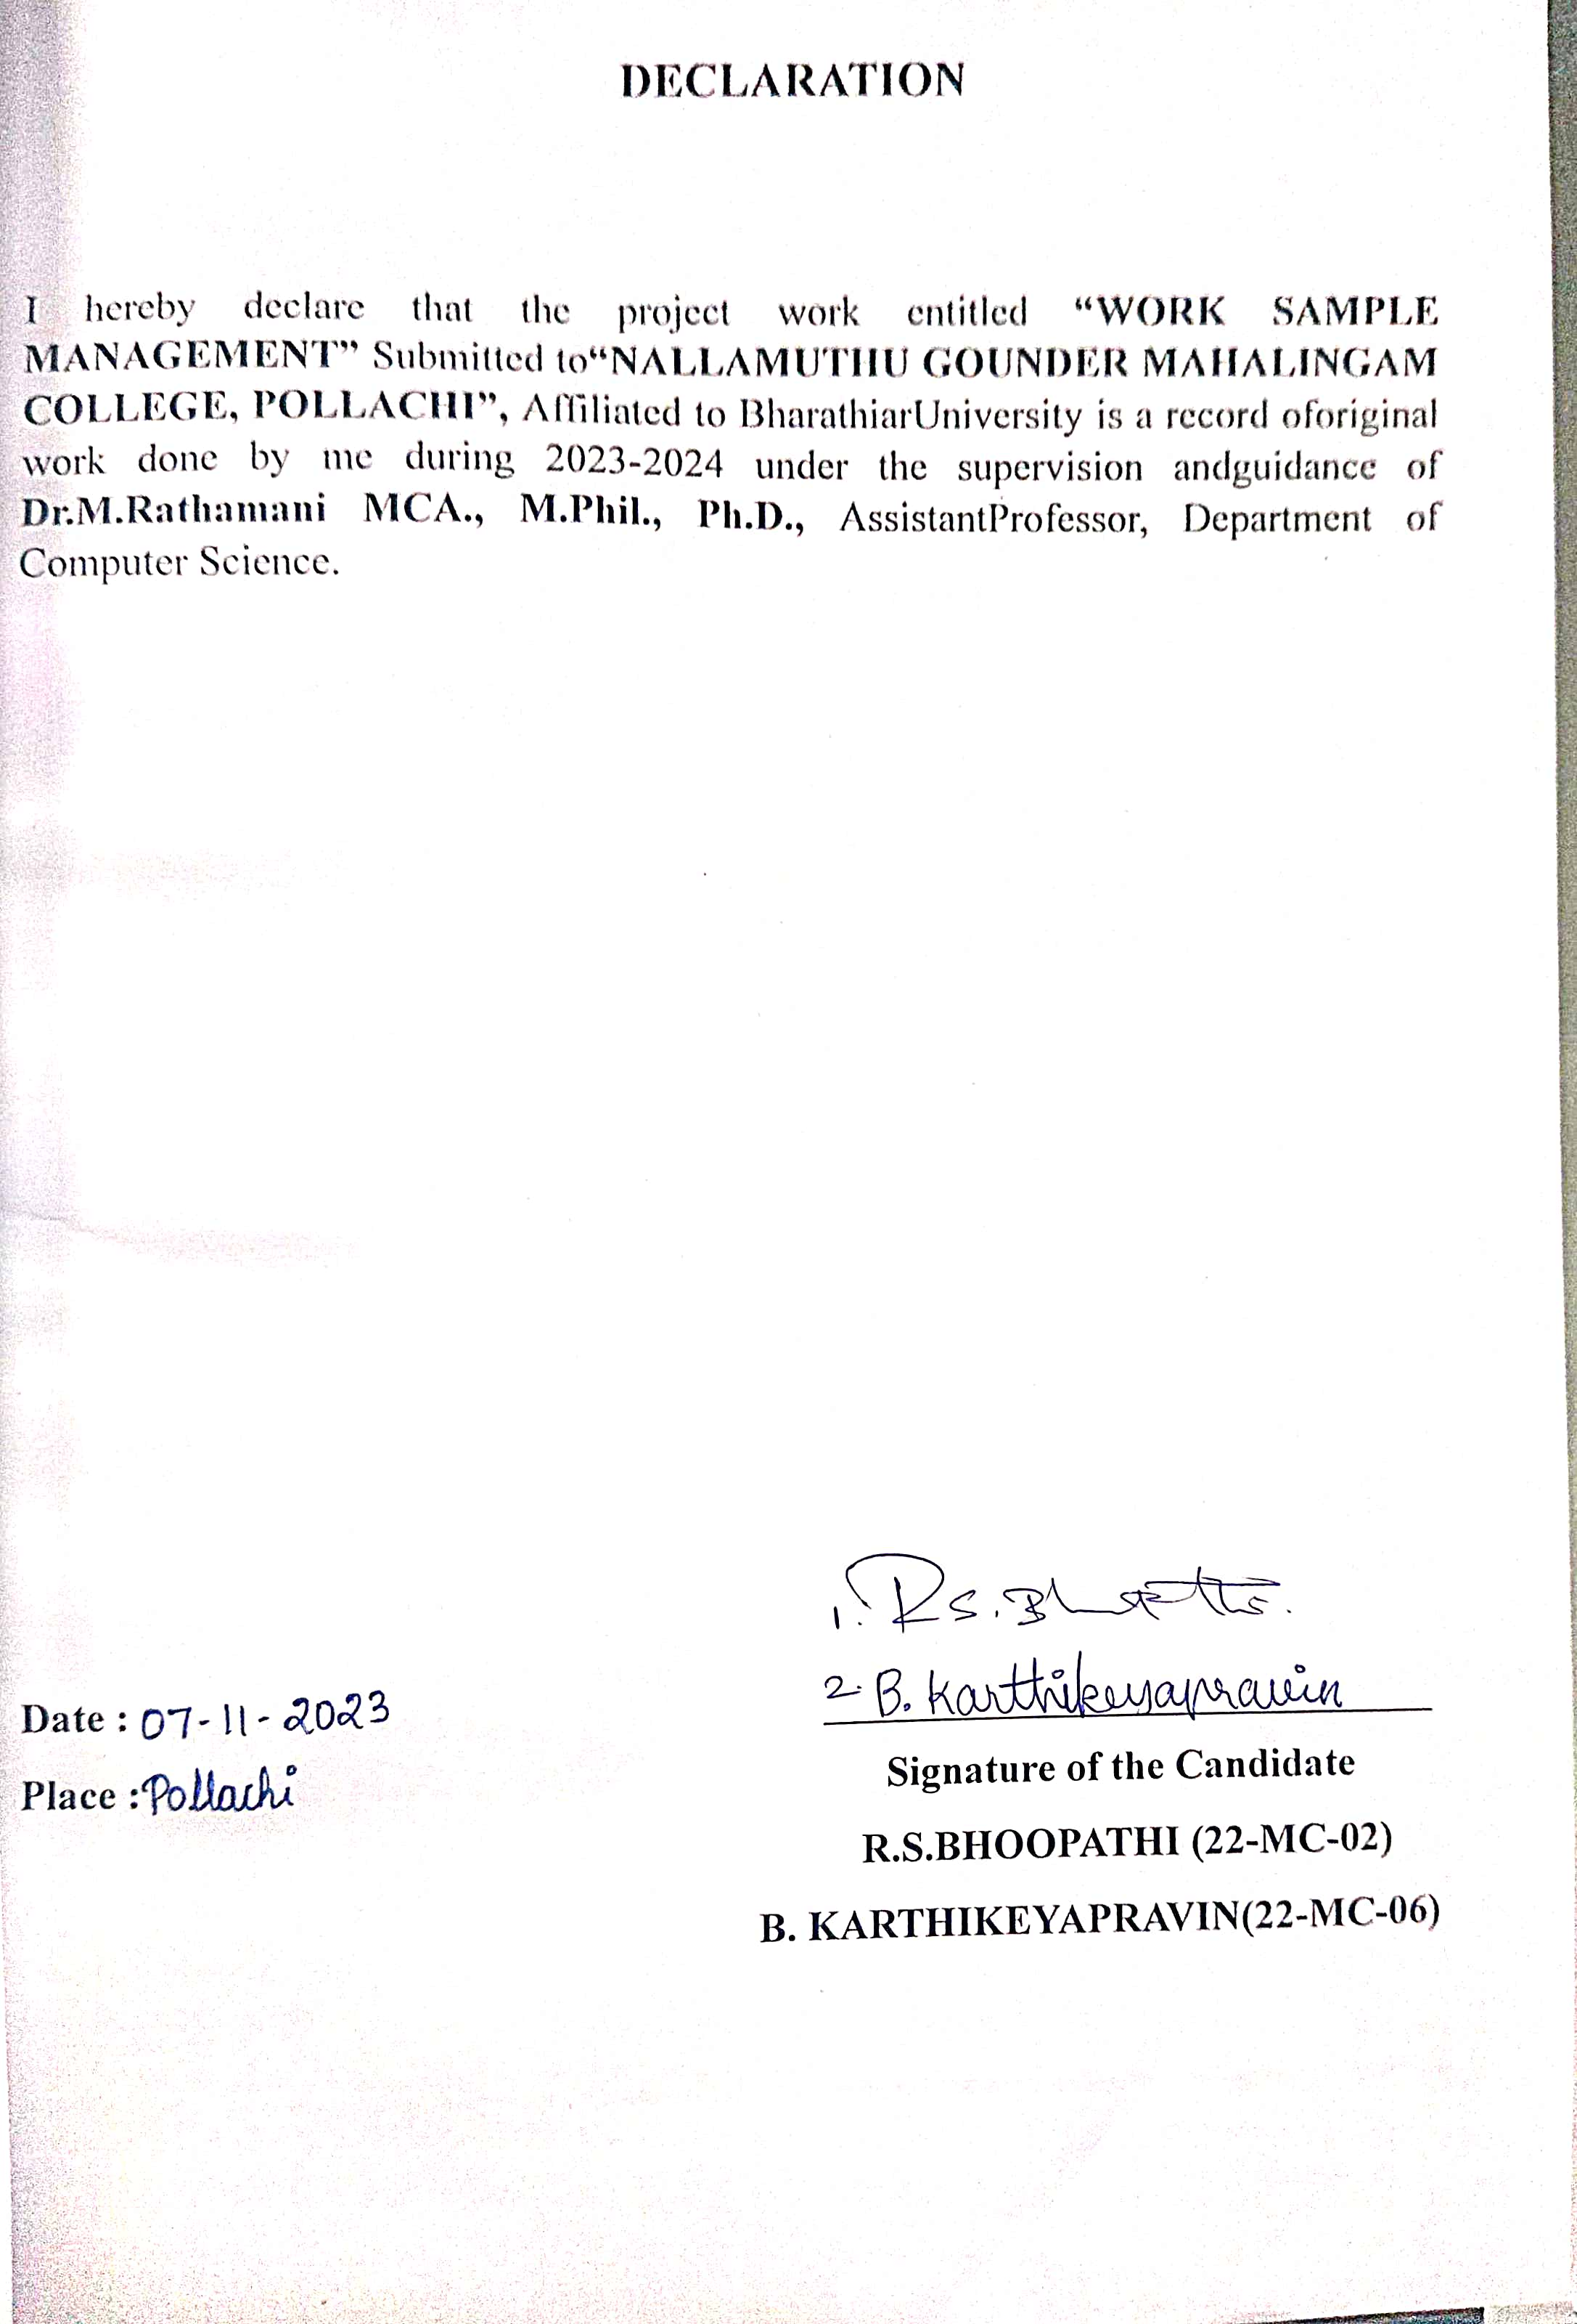

**CONTENTS**

**S.NO PARTICULARS PAGE NO**

**SYNOPSIS 2**

**INTRODUCTION 4**

**OBJECTIVE OF THE PROJECT 6**

**1 SYSTEM SPECIFICATION 7**

1.1 HARDWARE SPECIFICATION 8

1.2 SYSTEM SPECIFICATION 8

**2 SYSTEM STUDY 9**

2.1 EXISTING SYSTEM 10

2.2 DRAWBACKS 11

2.3 PROPOSED SYSTEM 12

2.4 PLANNING AND SCHEDULING 14

**3 SYSTEM DESIGN 15**

3.1 OVERVIEW OF THE PROJECT 16

3.2 MODULES OF THE PROJECT 16

3.3 OUTPUT DESIGN 17

3.4 TABLE DESIGN 19

3.5 SUPPORTING DIAGRAMS 20

**4 IMPLIMENTATION AND TESTING 21**

4.1 CODING METHODS 22

4.2 TESTING APPROACH 23

4.3 IMPLEMENTATION AND MAINTENANCE 25

**5 PROJECT EVALUATION 28**

5.1 PROJECT OVERVIEW 29

5.2 LIMITATION OF THE PROJECT 30

5.3 FUTURE SCOPE OF THE PROJECT 31

**6 CONCLUSION AND SCREENSHOTS 33**

6.1 CONCLUSION 34

6.2 SOURCE CODE 35

6.3 SCREENSHOTS AND REPORTS 46

**SYNOPSIS**

**SYNOPSIS**

The "React WORK SAMPLER" project is a dynamic and visually appealing web application designed to showcase the skills, work, and personality of an individual or a team. Leveraging the power of React, this project aims to create a stunning and responsive portfolio website that serves as a powerful tool for personal branding, job hunting, or networking. In a React portfolio, the user interface is divided into reusable components. Each component represents a specific section or feature of the portfolio, such as an about me section, projects section, contact information, skills, and more. This component-based approach makes it easy to manage and maintain the portfolio, as changes or updates can be made to individual components without affecting the entire application.

React portfolios often display dynamic data that can be updated easily. For example, a projects section may pull data from an external source or database, making it simple to add new projects or update existing ones without modifying the codebase. React enables the use of state and props to handle dynamic data, ensuring that the portfolio remains up-to-date and relevant. React portfolios often use React Router or a similar routing library to create a multi-page experience. This allows users to navigate between different sections of the portfolio without having to reload the entire page. For example, clicking on a "Projects" link might take the user to a dedicated projects page where they can view a list of projects. Reacts ability to create interactive and responsive user interfaces is one of its strengths. Portfolios can include animations, transitions, and interactive elements that engage visitors and make the portfolio more visually appealing. For instance, hovering over project images could trigger animations or display additional project details.

**INTRODUCTION**

**INTRODUCTION**

This Project is entitled as “WORK SAMPLE MANAGEMENT”. In an era where digital identity and personal branding have taken center stage, the need for a captivating, dynamic, and personalized online portfolio is more critical than ever. As the digital world evolves at a breakneck pace, a portfolio should not merely serve as a static repository of accomplishments, but rather, it should be a living embodiment of the creative journey, technical expertise, and unique identity. Enter the React Portfolio – a cutting-edge, highly extensible, and visually striking solution that empowers individuals and professionals to transcend the limitations of traditional portfolio websites. This project documentation is a passport to an immersive exploration of the React Portfolio, a tool that enables users to breathe life into their digital presence like never before.

The documentation takes users on a profound journey, unveiling the inner workings, intricacies, and boundless potential of a React portfolio. It's more than just a collection of code and design elements; it's a gateway to transforming an online identity into a captivating experience. Throughout this documentation, we'll guide users through each step of the portfolio creation process, from setting up the development environment and designing a portfolio's layout to incorporating advanced features and best practices. The aim is to empower users to showcase their work, whether they're an artist, a developer, a designer, a writer, or a professional in any field, in a manner that is both engaging and immersive.

**OBJECTIVE OF THE PROJECT**

**OBJECTIVE OF THE PROJECT**

The objective of a WORK SAMPLE MANAGEMENT is to showcase creative work in an immersive and interactive way that goes beyond traditional static presentations. By utilizing 3D technology and virtual environments, a WORK SAMPLE MANAGEMENT aims to achieve several key goals:

**Enhance Engagement:** The primary objective is to captivate and engage viewers by offering a dynamic and interactive experience. By allowing users to explore work from different angles and interact with the content, a more memorable and impactful presentation is created.

**Showcase Depth and Detail:** A WORK SAMPLE MANAGEMENT enables showcasing intricate details of work that may not be fully appreciated in 2D images. It allows viewers to zoom in, rotate, and analyze the finer aspects of creations.

**Provide Context and Insight:** WORK SAMPLE MANAGEMENTs often include accompanying narratives or descriptions that provide context, inspiration, and insights into the creative process. This helps viewers understand the story behind each piece and connects them more deeply to the work.

**Create an Immersive Experience**: The objective is to transport viewers into a virtual world where they can feel immersed in artistry. This immersive experience creates a stronger emotional connection and resonates with viewers on a deeper level.

**Differentiate Presentation:** In a competitive creative landscape, a WORK SAMPLE MANAGEMENT sets apart by showcasing the willingness to embrace innovative technology and present work in a unique and cutting-edge manner.

**Demonstrate Technical Skills:** If in a field related to technology, design, or 3D modeling, a WORK SAMPLE MANAGEMENT allows demonstrating technical skills directly through the portfolio presentation.

**SYSTEM SPECIFICATION**

1. **System Specification**

**1.1 Hardware Specification**

* Intel i5 11-Generation is used as a processor and it is sufficient enough for running a front-end API’s and a basic react server for a long period of time
* Maximum of 8 GB RAM and 256 ROM storage is being used to store and run the application

**1.2 Software Specification**

**Software IDE**

• Visual Studio code

**Database**

• Sql, Rdbms

**Operating System**

• Windows 11 Home is the operating system is being used

**Frontend Languages**

• Html

• Css

• JavaScript

• React Backend Languages

• Node js

• Express js

**SYSTEM STUDY**

1. **System Study**

**2.1 Existing System**

An existing system for a React Portfolio is a sophisticated platform designed to empower individuals and professionals to showcase their work and talents in an engaging and interactive manner. Here, we provide a comprehensive explanation of the key features that characterize the existing system of a React Portfolio:

**Customizable Design:**

The existing system offers a high degree of design customization. Users can select from a diverse range of templates, color palettes, and layout options. This level of customization ensures that each portfolio reflects the unique style and identity of the individual or professional. It enables users to create portfolios that are not only visually appealing but also aligned with their personal brand.

**Responsive and Dynamic Layout:**

One of the most impressive features of the existing system is its responsive and dynamic layout. Regardless of the device being used, whether it's a desktop computer, tablet, or smartphone, the portfolio's layout automatically adapts to provide an optimal viewing experience. The dynamic layout simplifies the organization and presentation of work, ensuring that it looks flawless on any screen.

**Project Showcases:**

Within the existing system, users have the ability to create detailed and visually appealing project showcases. Each project showcase can include images, comprehensive descriptions, videos, and links to the live demos or source code. This feature allows users to provide viewers with a comprehensive and immersive understanding of their projects.

**Contact and Social Links:**

The existing system includes sections for contact information and links to various social media profiles. This simplifies the process for visitors to get in touch with the portfolio owner or connect with them on social platforms. These features encourage networking and collaboration opportunities.

**Skills and Expertise Showcase:**

A dedicated section of the portfolio allows users to showcase their skills, expertise, and professional background. This section not only serves to demonstrate qualifications but also provides valuable context for the work presented in the portfolio.

**2.2 Drawbacks**

While React Portfolios offer a multitude of benefits for showcasing one's work in an engaging and interactive manner, they are not without their drawbacks. Here, we provide a comprehensive explanation of some of the limitations and potential drawbacks of using a React Portfolio:

**Technical Expertise Required:**

Creating and maintaining a React Portfolio typically requires a good understanding of web development technologies and React.js in particular. Users who are not familiar with these technologies may find it challenging to set up and customize their portfolio effectively.

**Complexity in Setup:**

Setting up a React Portfolio can be more complex than using simpler website builders or traditional HTML/CSS-based portfolios. Users may need to handle dependencies, server configurations, and development tools, which can be overwhelming for those with limited technical experience.

**Development Time:**

Building a custom React Portfolio can be time-consuming, especially if you wish to create a highly personalized and feature-rich portfolio. This drawback may deter users who are looking for a quick and simple solution to showcase their work.

**Costs and Hosting:**

While there are free hosting options for React Portfolios, advanced features or custom domains may incur additional costs. Users should be aware of potential hosting expenses when setting up their portfolios.

**Learning Curve:**

React Portfolios, being part of the larger field of web development, come with a learning curve. Users who are new to React.js or web development in general may need to invest time in learning these technologies before they can effectively build and maintain their portfolios.

**2.3 Proposed System**

**Interactive 3D Content:**

For those seeking a truly immersive experience, the existing system supports the integration of interactive 3D content. This enables visitors to explore projects in a three-dimensional environment. They can interact with 3D models, rotate them, zoom in for detailed examination, and gain a deeper understanding of the work. It takes the presentation of projects to a new level of engagement.

**Blog Integration:**

To cater to users who wish to share their insights and experiences, the existing system seamlessly integrates a blog feature. Users can create and publish articles related to their field, creative process, or personal journey. This blog feature adds depth and personalization to the portfolio, allowing users to connect with their audience on a more profound level.

**Contact and Social Links:**

The existing system includes sections for contact information and links to various social media profiles. This simplifies the process for visitors to get in touch with the portfolio owner or connect with them on social platforms. These features encourage networking and collaboration opportunities.

**Performance Optimization:**

The system places a strong emphasis on performance optimization. By employing various techniques such as image compression, lazy loading, and efficient code structuring, the portfolio ensures fast loading times and a seamless user experience. This is particularly crucial when presenting media-rich content.

**SEO-Friendly:**

The existing system is designed with search engine optimization (SEO) in mind. This means that the portfolio is structured and optimized to rank well in search engine results, expanding its reach to a broader audience.

**Analytics and Tracking:**

Some portfolios within the existing system come equipped with built-in analytics and tracking tools. These features allow users to monitor visitor behavior, track engagement, and gain valuable insights into which projects or pages are the most popular. This data-driven approach can help users tailor their portfolios for better user engagement.

**2.4 Planning and Scheduling**

Home page

Services

About

Contact

Projects

**SYSTEM DESIGN**

1. **System Design**

**3.1 Overview of the project**

In this section, we will design and structure a React WORK SAMPLE MANAGEMENT. A React Portfolio is a digital representation of a body of work, skills, and experiences. It typically includes a collection of projects, artworks, writings, or any form of creative or professional output that one wants to display. Unlike traditional static portfolios, React Portfolios offer a dynamic and interactive experience, allowing viewers to explore the work in depth. Viewers can often interact with 3D models, view detailed project showcases, read blog posts, and contact the portfolio owner directly, among other features. A React Portfolio is a powerful tool for personal branding. It allows one to create a distinct and memorable online presence that showcases skills and personality. It's particularly valuable for freelancers, creatives, and professionals who want to stand out in a competitive job market.

A React Portfolio is a modern and versatile tool that addresses the changing landscape of personal and professional branding in the digital age. It offers an engaging and interactive platform for showcasing work and making a lasting impression on potential clients, employers, and collaborators. Whether one is a designer, developer, artist, or professional in any field, a React Portfolio is an essential asset for building a strong online presence and advancing a career.

**3.2 Modules of the Project**

**Services:**

In this module the website will express the values of the services that the user is providing. This module is related with the skills fo the user and can express the kinds of service the user is providing.

**Portfolio:**

A dedicated section of the portfolio can be managed through this module, where users can showcase their skills, professional background, certifications, and achievements. It's a valuable part of the portfolio, providing context for the work and demonstrating qualifications.

**Contact:**

This module allows users to input their contact information, such as email addresses or phone numbers, and include links to various social media profiles. It simplifies the process for visitors to get in touch with the portfolio owner or connect with them on social platforms.

**About:**

In this module the Visters query, question, needed service will be collected by using a form that will send e-mail to the users G-mail. and will showcase the email, phonenumber, name of the user.

**3D and Interactive Content Module:**

This module, when implemented, allows users to incorporate 3D and interactive content into their portfolio. It provides tools to create and manage interactive 3D models, animations, or other immersive elements that enhance the user experience.

**Responsive Design and Compatibility Module:**

This module ensures that the portfolio's layout is responsive and compatible with various devices and web browsers. It adapts to different screen sizes, ensuring a consistent and appealing user experience.

**3.3 Input Design Format**

Designing the input form for a React Portfolio is a crucial aspect of creating a user-friendly and interactive web application. Here's an elaborate explanation of an input design format for a React Portfolio:

**Contact Information Form:**

* Name: Include a text input field for users to enter their full name.
* Email: Provide an email input field for users to enter their email address.
* Message: Use a textarea input for users to type and send messages or inquiries.

Submit Button: Place a prominent and visually appealing button that users can click to submit the form.

**Social Media Links:**

* Social Media Icons: Use recognizable icons for popular platforms like LinkedIn, GitHub, Twitter, or others.
* Input Fields: Include text input fields where users can enter their profile links or usernames for each platform.

**Project Showcase Form:**

* Project Title: Add a text input field for users to input the title of a project.
* Project Description: Provide a textarea for users to describe the project in detail.
* Images/Videos: Allow users to upload project images or link to project videos.
* Source Code Link: Include a text input for users to provide a link to the project's source code (e.g., GitHub repository).
* Live Demo Link: Offer an input field for users to insert a link to the live demo of the project.
* Add Another Project Button: Enable users to add multiple projects to their portfolio.
* Save/Update Button: Give users the option to save or update their project showcases.

**3.4 Output Design**

Home Page

Services

Portfolio

Contact

About

**3.5 Supporting diagrams**

**ER Diagram**

Services

Portfolio

Contact_me

**IMPLEMENTATION AND TESTING**

1. **Implementation and Testing**

**4.1 Coding Methods:**

React Portfolio project involves various coding methods and practices to build a dynamic and interactive website. Here's an elaborate explanation of the key coding methods and techniques commonly used in a React Portfolio project:

**React Components:**

React Portfolios are built using components. Each section of the portfolio, such as the header, project showcase, or contact form, is represented as a reusable React component. This modular approach simplifies development and maintenance, allowing for the creation of complex user interfaces.

**State and Props:**

React components use state and props to manage and pass data. State represents the internal data specific to a component, while props are used to pass data from parent to child components. This allows for dynamic content and interactivity within the portfolio.

**Router:**

React Router is often used to implement client-side routing. It allows for the creation of multiple pages or views within the portfolio, making it easy to navigate between sections or projects. Each route corresponds to a different component, enabling a seamless user experience.

**Conditional Rendering:**

Conditional rendering is employed to display different content based on user interactions or the state of the application. For example, a "show more" button can conditionally render additional project details when clicked, offering an interactive experience.

**Styling with CSS or CSS-in-JS:**

Styles are applied to React components using either traditional CSS or CSS-in-JS solutions like styled-components. These methods allow for the customization of the portfolio's design, layout, and visual appeal.

**Responsive Design:**

Media queries and responsive design principles are used to ensure that the portfolio looks and functions well on various devices and screen sizes. This involves adapting the layout and content to provide an optimal user experience on both desktop and mobile devices.

**API Integration:**

To fetch and display dynamic data, React Portfolios often integrate with various APIs. For instance, a GitHub API integration can automatically fetch project repositories and display them in the portfolio, keeping it up to date.

**On-Scroll:**

In the event listener function, calculate the scroll position, either by checking window.scrollY or other methods, and determine when a specific scroll point or range is reached. When the scroll point is reached, use JavaScript to add CSS styles or classes to the elements. These styles or classes can trigger animations or style changes that create on-scroll effects.

**4.2 Testing Approach**

**Unit Testing**

Unit testing is a software testing technique that focuses on testing individual units or components of a software application in isolation. A unit, in this context, typically refers to the smallest testable part of the software, often a single function, method, or class. The primary goal of unit testing is to verify that each unit of code functions as designed and produces the expected output for various inputs.

**Description**: Unit testing focuses on testing individual components, functions, or modules in isolation. In the context of a React Portfolio, this would involve testing React components to verify that they behave as expected.

**Tools**: Libraries like Jest and React Testing Library are commonly used for unit testing React components.

**End-to-End (E2E) Testing**

End-to-End (E2E) testing is a software testing methodology that evaluates the behavior of an entire application from start to finish, simulating real user scenarios and interactions. The goal of E2E testing is to ensure that all the integrated components of an application work together as expected and that the application functions correctly from the user's perspective.

**Description**: E2E testing evaluates the application as a whole by simulating real user interactions and scenarios. This type of testing ensures that the entire portfolio functions correctly from a user's perspective.

**Tools**: Tools like Cypress or Puppeteer can be used for E2E testing in React applications.

**Snapshot Testing:**

Snapshot testing is a software testing technique commonly used in the context of front-end development, particularly in libraries like React and Vue.js. The primary purpose of snapshot testing is to capture and compare "snapshots" of the rendered output of a component, such as a user interface (UI) component, to identify any unintended changes.

**Description**: Snapshot testing captures a "snapshot" of a component's output and compares it to a previously saved snapshot. It's particularly useful for tracking changes in component rendering.

**Tools**: Jest is commonly used for snapshot testing in React.

**4.3 Implementation & Maintenance**

**Implementation:**

**Set Up Development Environment:**

Install Node.js and npm (Node Package Manager) if Node.js and npm aren't installed yet.

Create a new React project using create-react-app or set up the development environment manually.

**Designing the Portfolio:**

* Plan the structure and layout of the portfolio. Decide on the sections to include, such as projects, skills, experience, and contact information.
* Create components to break down the portfolio into reusable React components. Each section or UI element should have its component.
* Apply CSS styles to components for a visually appealing design. You can use CSS-in-JS libraries, CSS preprocessors, or plain CSS.

**Content:**

Populate the portfolio with content, such as project details, skills, experience, and contact information.

**Routing:**

Implement client-side routing using React Router to handle navigation between different sections of the portfolio.

**State Management:**

Manage application state, especially if forms, user authentication, or dynamic content need to be handled. Use React's built-in state management or a state management library like Redux.

**Data Fetching:**

If the portfolio fetches data from an API or a backend, write code to make API calls and handle the data retrieval.

**Testing:**

Write tests for components to ensure they render correctly and function as expected. Use testing libraries like Jest and React Testing Library.

**Optimization:**

Optimize the portfolio for performance, accessibility, and SEO. Minify and bundle the code, add alt text to images, and use semantic HTML.

**Deployment:**

Deploy the React portfolio to a hosting service. Popular choices include Netlify, Vercel, GitHub Pages, or custom hosting.

**Domain and SSL:**

If using a custom domain, configure it to point to the deployed portfolio. Enable SSL for secure access.

**Maintenance:**

**Regular Updates:**

Regularly update the portfolio with new projects, skills, and experience. Keep the content fresh to reflect the latest work.

**Bug Fixes:**

Monitor the portfolio for any issues and fix bugs promptly. This includes addressing broken links, layout problems, and functionality errors.

**Performance Tuning:**

Periodically check the portfolio's performance and make optimizations as needed. Compress images, lazy-load assets, and improve load times.

**Security:**

Ensure the portfolio is secure by keeping dependencies up to date and addressing security vulnerabilities.

**SEO:**

Optimize the portfolio for search engines. Use proper meta tags, headings, and structured data to enhance visibility.

**Backup:**

Regularly back up the portfolio's source code and content. Use version control (e.g., Git) and store backups in a secure location.

**Monitoring:**

Set up monitoring and analytics to track visitor engagement and user interactions. Use tools like Google Analytics or similar services.

**User Feedback:**

Encourage and gather feedback from visitors to identify areas for improvement.

**Version Control:**

Continue using version control to track changes and collaborate with others.

**Documentation:**

Maintain documentation for the portfolio codebase, including comments and README files.

**PROJECT EVOLUTION**

1. **Project Evolution**

**5.1 Project outcome**

**Professional Online Presence:**

A React portfolio establishes a professional online presence, allowing one to showcase skills, work, and achievements to a global audience.

**Attractive Design:**

The portfolio is designed to be visually appealing, reflecting design skills and attention to detail.

**Easy Navigation:**

It provides a user-friendly experience with easy navigation, making it simple for visitors to find the information they're looking for.

**Responsive Layout:**

The portfolio is responsive, adapting to various screen sizes and devices, ensuring that it looks good and functions correctly on desktops, tablets, and mobile phones.

**Portfolio Sections:**

It includes dedicated sections for projects, skills, work experience, and contact information. Each section effectively communicates expertise and accomplishments.

**Project Showcase:**

The project section allows for showcasing work, including project descriptions, images, links to live projects, and GitHub repositories.

**Skills Highlight:**

It highlights skills and proficiencies, often accompanied by visual representations like skill badges or progress bars.

**Experience Details:**

The experience section provides details about education and work experience, demonstrating qualifications and background.

**Contact Information:**

There is a means for visitors to get in touch, usually through a contact form or by displaying an email address and social media profiles.

**5.2 Limitations of Project**

**Complex Learning Curve:**

Explanation: React is a powerful JavaScript library, but it has a steeper learning curve, especially for beginners. Understanding concepts like JSX, component-based architecture, state management, and routing can be challenging for newcomers.

Impact: The complexity of React may deter some individuals from building portfolios using this framework. It could require more time and effort to become proficient.

**SEO Challenges:**

Explanation: React applications are primarily single-page applications (SPAs), which can present challenges for search engine optimization (SEO). SPAs often rely on client-side rendering, making it harder for search engines to crawl and index content effectively.

Impact: Portfolio content might not rank as well on search engines, potentially limiting its discoverability to potential employers or clients.

**Performance Concerns:**

Explanation: React portfolios can be feature-rich and include numerous components. However, if not optimized properly, this can lead to performance issues, such as slow page load times or high resource consumption.

Impact: Poor performance can result in a subpar user experience and deter visitors from exploring the portfolio fully.

**Initial Load Time:**

Explanation: React applications, when not optimized, may exhibit slower initial load times because they need to download and execute JavaScript bundles. This can be exacerbated when using client-side routing and large dependencies.

Impact: Visitors might abandon the portfolio if it takes too long to load, impacting user engagement.

**5.3 Future Scope of Project**

**Blog Section:**

Incorporate a blog section to regularly publish articles related to the field of expertise or areas of interest. This feature serves as a platform for showcasing in-depth knowledge and strong writing skills. Blog posts can cover various topics, including industry trends, technical tutorials, or personal experiences, adding depth and authority to the portfolio.

**Testimonials:**

Integrate a section dedicated to displaying testimonials or endorsements from past clients, employers, or colleagues. Testimonials build trust and credibility by providing social proof of skills and professionalism. They serve as valuable references and can influence potential employers or clients positively.

**Interactive Charts and Infographics:**

Implement interactive charts and infographics to visually represent data, statistics, or notable achievements. This feature makes complex information more engaging and easier to comprehend. Visualizations can include graphs, charts, and infographics that illustrate accomplishments, expertise, or project outcomes.

**Video Integration:**

Embed videos within the portfolio to enhance the user experience. Videos can showcase project demos, technical tutorials, or personal introductions, offering a dynamic element that engages visitors. Whether it's a walkthrough of projects or a brief introduction about oneself, videos provide a more immersive way to present content.

**Client Projects:**

Create a dedicated section that highlights projects undertaken for clients or employers. Include comprehensive project details, challenges faced, and specific roles in the work. This section gives visitors a deeper understanding of practical experience and the ability to deliver results in a professional context.

**Case Studies:**

Offer in-depth case studies for selected projects to provide a detailed narrative of the problem, solution, and achieved results. Case studies allow the showcasing of problem-solving skills, project management, and the impact of the work. They demonstrate the ability to tackle real-world challenges effectively.

**Client Logo Wall:**

Showcase logos of companies or clients collaborated with in a dedicated section. This provides social proof of professional experience and partnerships. The client logo wall can instill confidence in potential employers or clients by demonstrating a history of successful collaborations and contributions.

**CONCLUSION AND SCREENSHOTS**

1. **Conclusion and Screenshots**

**6.1 Conclusion**

In conclusion, the development of this React portfolio project has been a journey of creativity, innovation, and self-expression. Closing the chapters of this documentation leads to a reflection on the significance of creating a digital identity in today's dynamic and competitive landscape.This React portfolio is not merely a collection of code and design elements; it represents personal and professional growth. It stands as a canvas where a unique story has been painted, a platform for showcasing skills, experiences, and aspirations.Through this project, the venture into the realm of modern web development, embracing the power of React to craft a digital space that not only represents but also engages and informs the audience. The feature-rich components, interactive elements, and immersive experiences have brought the portfolio to life in ways that a traditional static website could not.

The journey encompassed setting up the development environment, designing, coding, and optimizing, resulting in the honing of technical skills and the art of storytelling through code. The portfolio speaks volumes about dedication, attention to detail, and commitment to excellence.Exploration led to an understanding of the importance of regular updates, maintenance, and engagement. The portfolio is not a static entity but a living document that evolves with experiences and expertise. The added features, from blogs to case studies, testimonials to video integration, represent diverse dimensions of a professional journey.

This React portfolio project is more than a technical endeavor; it's a testament to a passion for the craft. It serves as a platform for sharing knowledge, showcasing capabilities, and connecting with a global audience. As the portfolio continues to be updated, enhanced, and expanded, it remains a reflection of growth, a story, and a commitment to excellence.

**6.2 Source code**

import React from 'react'

import ReactDOM from 'react-dom/client'

import App from './App.jsx'

ReactDOM.createRoot(document.getElementById('root')).render(

<React.StrictMode>

<App />

</React.StrictMode>,

)

import Test from "./Test";

import "./app.scss";

import Contact from "./components/contact/Contact";

import Cursor from "./components/cursor/Cursor";

import Hero from "./components/hero/Hero";

import Navbar from "./components/navbar/Navbar";

import Parallax from "./components/parallax/Parallax";

import Portfolio from "./components/portfolio/Portfolio";

import Services from "./components/services/Services";

const App = () => {

return (

<div>

<Cursor />

<section id="Homepage">

<Navbar />

<Hero />

</section>

<section id="Services">

<Parallax type="services" />

</section>

<section>

<Services />

</section>

<section id="Portfolio">

<Parallax type="portfolio" />

</section>

<Portfolio />

<section id="Contact">

<Contact />

</section>

{/* Framer Motion Crash Course */}

{/* <Test/>

<Test/> */}

</div>

);

};

export default App;

html {

scroll-snap-type: y mandatory;

scroll-behavior: smooth;

}

* {

padding: 0;

margin: 0;

box-sizing: border-box;

font-family: "DM Sans", sans-serif;

}

body {

background-color: #0c0c1d;

color: lightgray;

}

a {

text-decoration: none;

color: inherit;

}

section {

height: 100vh;

width: 100vw;

scroll-snap-align: center;

overflow: hidden;

}

@mixin mobile {

@media (max-width: 738px) {

@content;

}

}

@mixin tablet {

@media (max-width: 1024px) {

@content;

}

}

@mixin desktop {

@media (max-width: 1366px) {

@content;

}

}

import { motion } from "framer-motion";

import { useState } from "react";

const Test = () => {

const [open, setOpen] = useState(false);

const variants = {

visible: (i)=>( {

opacity: 1,

x: 100,

transition: { delay:i * 0.3 },

}),

hidden: { opacity: 0 },

};

const items = ["item1", "item2", "item3", "item4"];

return (

<div className="course">

<motion.ul initial="hidden" animate="visible" variants={variants}>

{items.map((item,i) => (

<motion.li variants={variants} key={item} custom={i}>

{item}

</motion.li>

))}

</motion.ul>

</div>

);

};

export default Test;

import { useState } from "react";

import { motion } from "framer-motion";

import Links from "./links/Links";

import "./sidebar.scss";

import ToggleButton from "./toggleButton/ToggleButton";

const variants = {

open: {

clipPath: "circle(1200px at 50px 50px)",

transition: {

type: "spring",

stiffness: 20,

},

},

closed: {

clipPath: "circle(30px at 50px 50px)",

transition: {

delay: 0.5,

type: "spring",

stiffness: 400,

damping: 40,

},

},

};

const Sidebar = () => {

const [open, setOpen] = useState(false);

return (

<motion.div className="sidebar" animate={open ? "open" : "closed"}>

<motion.div className="bg" variants={variants}>

<Links />

</motion.div>

<ToggleButton setOpen={setOpen} />

</motion.div>

);

};

export default Sidebar;

import { useRef } from "react";

import "./portfolio.scss";

import { motion, useScroll, useSpring, useTransform } from "framer-motion";

const items = [

{

id: 1,

title: "React Commerce",

img: "https://images.pexels.com/photos/18073372/pexels-photo-18073372/free-photo-of-young-man-sitting-in-a-car-on-a-night-street.jpeg?auto=compress&cs=tinysrgb&w=1600&lazy=load",

desc: "Lorem ipsum dolor sit amet consectetur adipisicing elit. Dolores ab id ad nesciunt quo aut corporis modi? Voluptate, quos sunt dolorum facilis, id eum sequi placeat accusantium saepe eos laborum.",

},

{

id: 2,

title: "Next.js Blog",

img: "https://images.pexels.com/photos/18023772/pexels-photo-18023772/free-photo-of-close-up-of-a-person-holding-a-wristwatch.jpeg?auto=compress&cs=tinysrgb&w=1600&lazy=load",

desc: "Lorem ipsum dolor sit amet consectetur adipisicing elit. Dolores ab id ad nesciunt quo aut corporis modi? Voluptate, quos sunt dolorum facilis, id eum sequi placeat accusantium saepe eos laborum.",

},

{

id: 3,

title: "Vanilla JS App",

img: "https://images.pexels.com/photos/6894528/pexels-photo-6894528.jpeg?auto=compress&cs=tinysrgb&w=1600&lazy=load",

desc: "Lorem ipsum dolor sit amet consectetur adipisicing elit. Dolores ab id ad nesciunt quo aut corporis modi? Voluptate, quos sunt dolorum facilis, id eum sequi placeat accusantium saepe eos laborum.",

},

{

id: 4,

title: "Music App",

img: "https://images.pexels.com/photos/18540208/pexels-photo-18540208/free-photo-of-wood-landscape-water-hill.jpeg?auto=compress&cs=tinysrgb&w=1260&h=750&dpr=2",

desc: "Lorem ipsum dolor sit amet consectetur adipisicing elit. Dolores ab id ad nesciunt quo aut corporis modi? Voluptate, quos sunt dolorum facilis, id eum sequi placeat accusantium saepe eos laborum.",

},

];

const Single = ({ item }) => {

const ref = useRef();

const { scrollYProgress } = useScroll({

target: ref,

});

const y = useTransform(scrollYProgress, [0, 1], [-300, 300]);

return (

<section >

<div className="container">

<div className="wrapper">

<div className="imageContainer" ref={ref}>

<img src={item.img} alt="" />

</div>

<motion.div className="textContainer" style={{y}}>

<h2>{item.title}</h2>

<p>{item.desc}</p>

<button>See Demo</button>

</motion.div>

</div>

</div>

</section>

);

};

const Portfolio = () => {

const ref = useRef();

const { scrollYProgress } = useScroll({

target: ref,

offset: ["end end", "start start"],

});

const scaleX = useSpring(scrollYProgress, {

stiffness: 100,

damping: 30,

});

return (

<div className="portfolio" ref={ref}>

<div className="progress">

<h1>Featured Works</h1>

<motion.div style={{ scaleX }} className="progressBar"></motion.div>

</div>

{items.map((item) => (

<Single item={item} key={item.id} />

))}

</div>

);

};

export default Portfolio;

import { useRef } from "react";

import "./parallax.scss";

import { motion, useScroll, useTransform } from "framer-motion";

const Parallax = ({ type }) => {

const ref = useRef();

const { scrollYProgress } = useScroll({

target: ref,

offset: ["start start", "end start"],

});

const yText = useTransform(scrollYProgress, [0, 1], ["0%", "500%"]);

const yBg = useTransform(scrollYProgress, [0, 1], ["0%", "100%"]);

return (

<div

className="parallax"

ref={ref}

style={{

background:

type === "services"

? "linear-gradient(180deg, #111132, #0c0c1d)"

: "linear-gradient(180deg, #111132, #505064)",

}}

>

<motion.h1 style={{ y: yText }}>

{type === "services" ? "What We Do?" : "What We Did?"}

</motion.h1>

<motion.div className="mountains"></motion.div>

<motion.div

className="planets"

style={{

y: yBg,

backgroundImage: `url(${

type === "services" ? "/planets.png" : "/sun.png"

})`,

}}

></motion.div>

<motion.div style={{ x: yBg }} className="stars"></motion.div>

</div>

);

};

export default Parallax;

import Sidebar from "../sidebar/Sidebar";

import "./navbar.scss";

import { motion } from "framer-motion";

const Navbar = () => {

return (

<div className="navbar">

{/* Sidebar */}

<Sidebar/>

<div className="wrapper">

<motion.span

initial={{ opacity: 0, scale: 0.5 }}

animate={{ opacity: 1, scale: 1 }}

transition={{ duration: 0.5 }}

>

Lama Dev

</motion.span>

<div className="social">

<a href="#">

<img src="/facebook.png" alt="" />

</a>

<a href="#">

<img src="/instagram.png" alt="" />

</a>

<a href="#">

<img src="/youtube.png" alt="" />

</a>

<a href="#">

<img src="/dribbble.png" alt="" />

</a>

</div>

</div>

</div>

);

};

export default Navbar;

**6.3 Screenshoots & Reports**

