2019054957 컴퓨터소프트웨어학부 이용우

1. Which requirements I implemented
2. ClassAssignment1의 코드와 동일하게 카메라 조절하기
3. Single mesh rendering mode

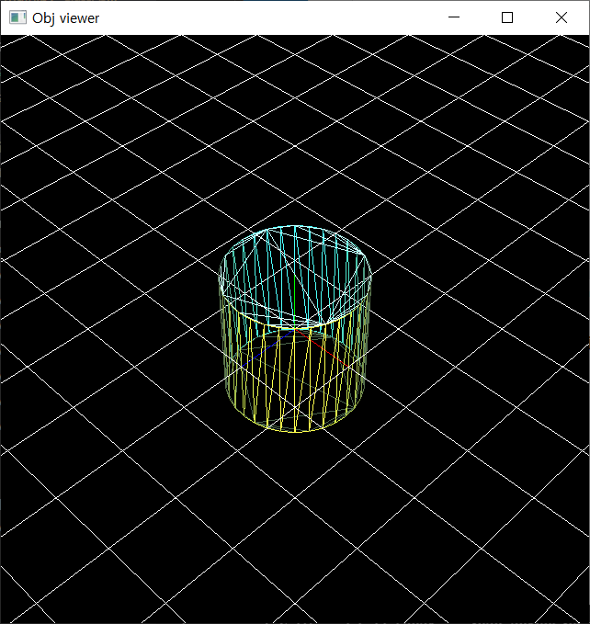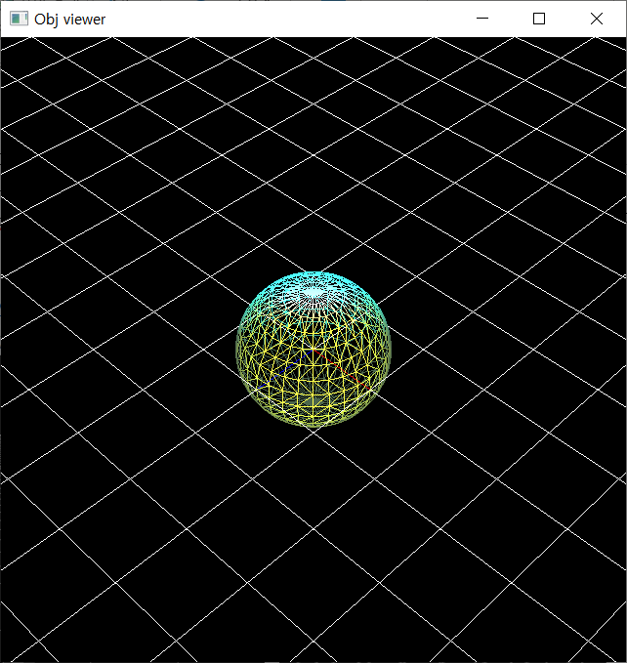



1. Animating hierarchical model rendering mode

Rotating Plate – Spinning teacups – Spinning spoons (hierarchy of 3 levels)

1. Lighting & Etc

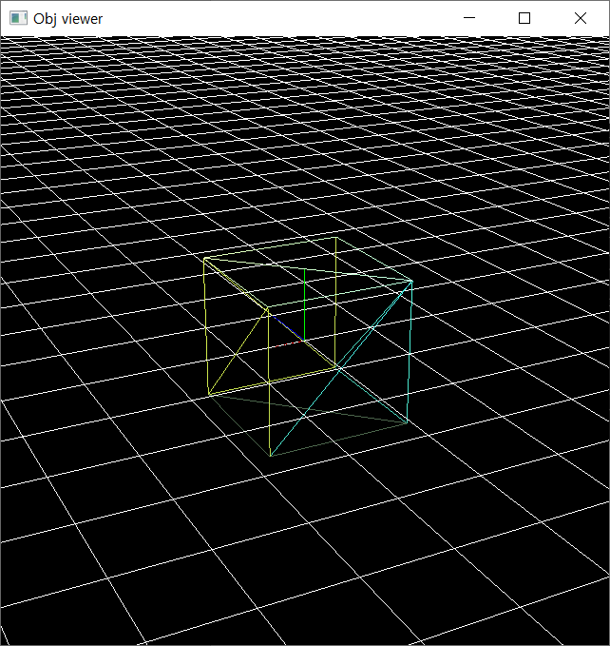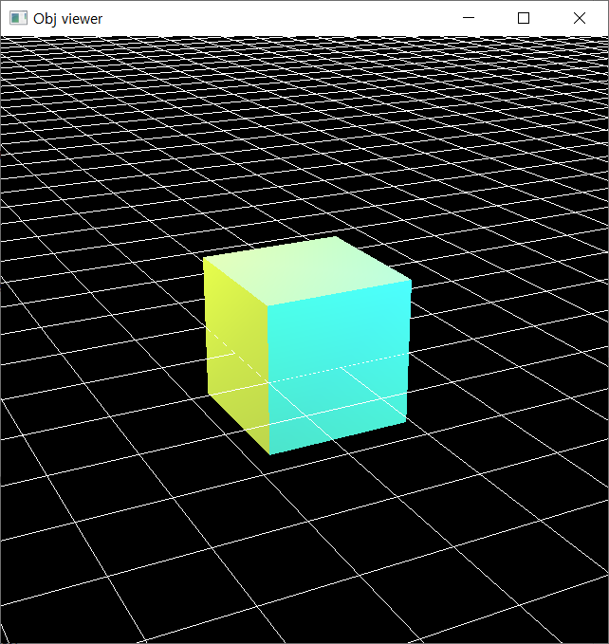

1. Extra credits

Toggle [shading using normal data in obj file] / [forced smooth shading]

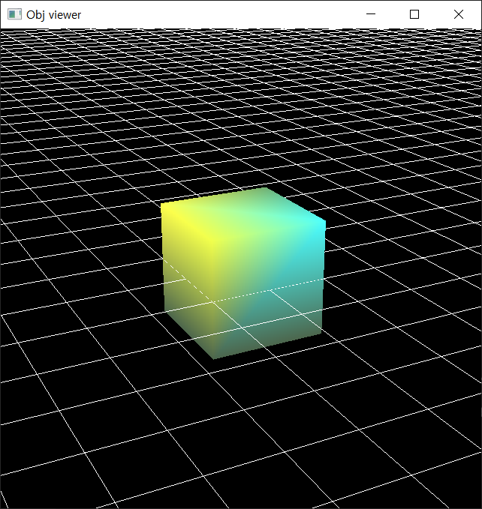

Load & render a mesh that does not have the same number of vertices of all polygons

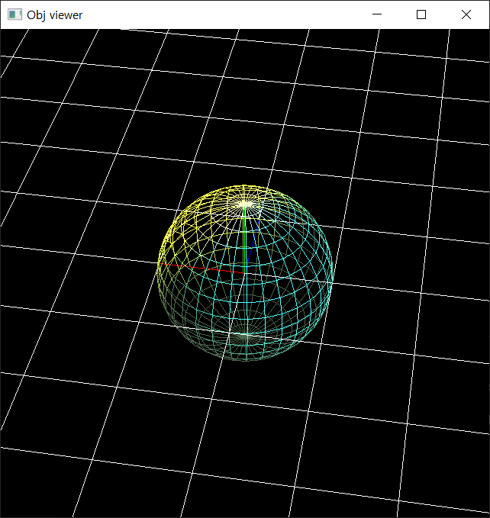

1. A hyperlink to the video uploaded to Internet video streaming services

<https://youtu.be/6z54sFBObC8>

1. Lighting configuration
2. Light0, Light1의 두 개의 light sources를 사용했다.
3. Light0 position: (5, 5, 5), Light1 position: (-5, 5, -5)
4. Light0: point light, Light1: point light