A BEGINNER'S GUIDEBOOK FOR THE
TIMESPACE
MATTER
MINDMACHINE
... EMBRACE PEACE AS A PROCESS ...
... ERECT A GLOBAL PEACE SYSTEM ...
... MAXIMIZE COLLECTIVE INNER PEACE ...
... NAVIGATE TO BETTER FUTURES ...
... SATISFY THE HUMAN IMPERATIVE ...
... INVENT A NEW KIND OF TIME MACHINE ...
... DEFEAT HUMANITY'S GREATEST ADVERSARY ...
.
.
.
... ONE WORLD PIECE COMPUTER AT A TIME ...
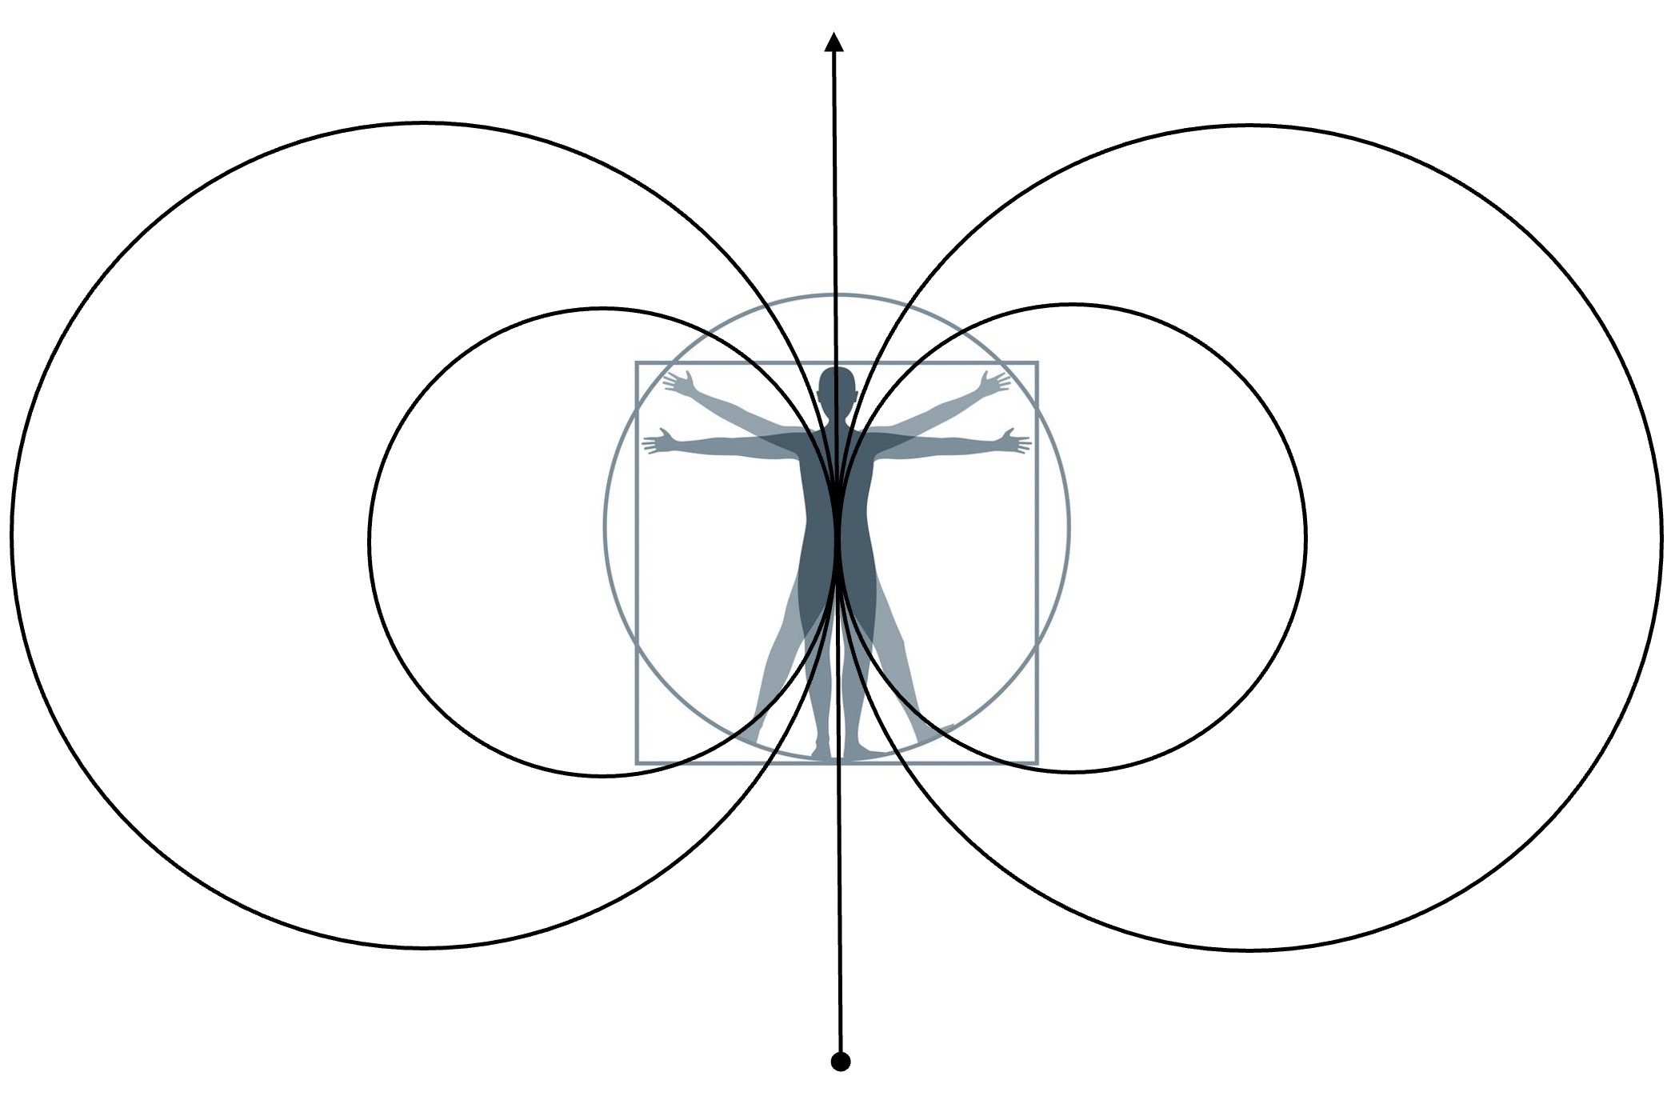
~ produced by the time machine for peace social invention program ~
~ toward installing the universal piece computer, a global peace system ~

