Origin Piece (( ! )) Advent.

0 PCE, Piece Computer Era

Deep frustration.
Fuck.
A pause in thought, deliberating. This was crazy.
Well, fuck it.
I'm just gunna have to invent a special computer to tackle this problem. Creating a new theory of Blob is just too much otherwise.
In that moment The Individual passed from the differentiation phase of growth into the maturation phase. The Individual had reached the state of being, a birthing moment. There was too much to do, not enough time, not enough energy, and not enough of the right people. The Individual needed a tool to help, to make it all work.
It would be another long and painful process. Painful beyond anything The Individual had known in the differentiation phase of growth that led to this new birthing moment. Pain in the war beyond anything The Individual could have imagined. Even the night terrors paled to some comparisons.
Time was to tell, if The Individual would even make it past the maturation phase. Most individuals that had preceded The Individual never made it past the maturation phase. For some individuals, it was even their demise. Things got real from then on. Those other individuals couldn't wiggle out of the maze of this or that life, fit the pieces of their puzzle together just right, and well it killed them.
Not enough time. Never enough time. My world has too many pieces. A multitude. My quest to create a new theory and physics of Blob has too many pieces. How do they all fit together? Too many pieces in my head. Too many fragments. How do I integrate them into a constellation like Stefolia said? Computer. How exactly would a computer help?
Indeed, how would a computer help?
I literally need something like an computer that can take all these little pieces in my world, like bits, and put them together in just the right way, in a reliable and timely manner. It's because I cannot do it reliably and timely myself. Its because I am not consistently alright.
A flash of humor,
Hah ...it would technically be my world piece computer. Doesn't that sound absurd. Well, the name is actually fitting in this case, ironically. If my world's pieces don't fit together, I experience inner war until I can't bear it any longer and take action to fix the malignant piece arrangement.
Huh. Well I have no idea how to invent a computer, never done that before, but I know other people have in the past, so it must be possible. I'll mindmap it. But all I have are small stickynotes plus my steering wheel and dashboard. Whatever.
The Individual spent the next 30 minutes frantically laying ideas down on the stickynotes, pasting them here and there on the truck steering wheel. It was like The Individual was following an algorithm, a computational approach to doing some thing.
Then it dawned:
A world piece computer could be non-electronic.
In fact,
Instead of wasting effort converting between media, we can just treat the pieces as the bits, and leave them where they lay. We can spread the computer out so that we don't have to move the pieces, OR, we can steal references or pointers from the world of modern computers, and apply them where we can't spread the world piece computer out.
In fact, we can even use pointers to refer to pieces in the imagination, or pieces that once existed or will exist but do not exist in the present.
The computer that optimizes the arrangement of all a world's pieces would literally be distributed through the ambient environment of all stuff in a world.
Like, a general stuff computer would be that dry name you found in a textbook hah.
It's also fascinating that for every piece, there is a corresponding mental representation. Like, in principle, it should be possible to use only one's Human brain as the processor (plus of course the knowledge of a piece and it's qualitative status in a given moment—where it is, what it is doing, what its properties are, etc).
How would it scale?
—No, no, let's not get ahead of ourselves. We need to prototype first.
Hmm. You know, I could in principle simulate an entire electronic computer just with stickynotes. Like, the bit operations, the logic gates, the processor registers, even the OS and software—all of it.
Yeah. I'll start small and try prototyping the world piece computer first with stickynotes. Yeah.
~~~~~~~~~~~~~~~~~~~~~~~~~~~~~~~~~~~~~~~~~~~~

The cafe was The Individual's favorite at the time. Dimly lit with hipster vibes. A wall of windows set the cold backdrop safely behind the warmth of that space where The Individual was standing at the coffee bar. Stickynotes were pasted everywhere. For whatever reason, The Individual was wearing reading glasses upside down. Intent. Deliberate.
"I don't mean to interrupt, but, what are you working on here?"
The Individual looked up. The upside down glasses didn't seem to disturb this Brave Soul. It was safe to talk.
"Oh...uh...thanks for asking! I'm inventing a new kind of computer..one that takes all the pieces in a world and arranges them in better and better ways. I don't entirely know how it works yet, so that's what I'm trying to figure out here."
"Oh. ! Well, I certainly have never invented a computer before, so I imagine it could indeed look something like this..."
"Yeah! Me neither! I'm just tinkering with the stickynote piece computer at the moment. But the computer could take on many shapes and forms."
"Well, I'll leave you to it, but I wish you the best of luck!' It sounds like a cool project!"
"Thanks! Yeah I always love the chance to chat about it with people. Thanks again for asking!"
"Absolutely, see you around!"
He left. Life was good. The Individual switched back to work-context. The people sitting around were glancing, some slightly disturbed. Whatever.
~~~~~~~~~~~~~~~~~~~~~~~~~~~~~~~~~~~~~~~~~~~~

"Oh hey! Nice to bump into you!"
The Individual looked up from the stickynotes, this time at a different cafe, one more like a cafeteria, and there was a bookstore beyond, totally different vibes. A homeless guy sleeping hunched over a back corner table, these were Midtown vibes, and The Individual was definitely contributing to them. Things were tense now tense. Things were't going so well. The Individual looked up,
"Oh...? oh!"
The Individual finally recognized the Brave Soul. A classmate at university. The Individual followed up,
"Yeah nice bumping into you! Are you book hunting?"
"Yeah, just checking out some titles, but... ...soooo, I gotta ask, what are you working on??"
Oh. Oh! That's right...there were stickynotes plastered everywhere on the cafe table. It was pure madness. But it made sense, didn't it?
"I uh, I'm, uh, I'm working on my sticknote computer. I'm inventing a new kind of computer and this is my first prototype. It's made out of office supplies. It's a distributed computer. It makes pieces fit together better."
The Brave Soul revealed a flash that showed he we disturbed, but pulled it together.
"You know you're one of the smart ones, and you and I roll hand in hand that way, but I'll be frank, this is totally beyond me!"
"Yeah, I get that a lot, sorta. I don't think it is beyond you actually, I just think I do a shitty job of explaining the grand idea. I think I just have to build the thing first, and just show people instead of trying to explain everything. You know what I mean? I gotta show people. I gotta show them what I mean."
"Yeah, that makes sense. It sounds cool for what its worth, whatever it is you're doing, and I hope I get the change to see this computer in action!"
"Yeah! I look forward to sharing! And yeah, anyway, I hope you found some good books.."
"Nope! Just got here. But yes we shall."
"See you in class."
"Yeah, see you Tuesday."
"Peace."
~~~~~~~~~~~~~~~~~~~~~~~~~~~~~~~~~~~~~~~~~~~~

"You need to get help. You are sick."
"But there's nothing wrong with me. I'm onto something bigger, better is all! Like I really don't need a fallback with this. I don't need to finish my education or get a fancy job, this is it."
"But that's your sickness talking! Your brain is wired wrong, its misfiring, You aren't yourself!"
"No. I am me. I am who I am. You can't tell me that I'm wrong, because I know I'm right. I'm not sick, I'm just being myself for the first time in front of you. I'm tired of hiding who I am from everybody! I'm tired of living in fear! Like really, fuck you people!"
"You're sick. ! You're sick! You aren't the child I raised, the loving child we used to know, you're all...messed up... it's not you, your sickness has taken over, you aren't the man I used to know. I don't even recognize you anymo—"
"—You know what? FUCK YOU. FUCK your FUCKING NOTION OF WHO I AM. YOU DON'T FUCKING KNOW ME. YOU'VE NEVER GIVEN ME A CHANCE. YOU'VE NEVER TAKEN THE FUCKING TIME TO KNOW WHO I AM, TO TALK TO ME ABOUT WHAT MATTERS TO ME. YOU JUST WRITE ME OFF AS MENTAL ILLNESS. I'M JUST AN ICON TO YOU, AN ICON. ALL THE REAL ME IS TO YOU IS FUCKING SICKNE'—"

* !

The Individual froze, heart pounding, lowering voice, hands shaking. Calming. This was too much, complete loss of control, rage. Shame, setting in hard, like it should. Self-loathing.
"—I'm sorry. Fuck. I'm sorry. I fucking hate myself right now. You aren't the problem, I am the problem. I am the fucking problem here. You call it mental illness, I call it me. Mental illness isn't the problem. I am the problem. I honestly don't know what much I can do about this. I just gotta get it out. I gotta make it stop. I gotta get the world piece computer out of my head. I gotta make it stop. My only hope is to show you."
The Individual couldn't take the shame any longer, lurching away,
Just gotta get away, just gotta make it stop, need to make it stop, make it stop. I don't know how much more I can take...I gotta get it out. Fuck this world piece computer bullshit. I need real peace. Fuck you Blair you stupid piece of reprehensible shit. Compute that worthless fucker.
~~~~~~~~~~~~~~~~~~~~~~~~~~~~~~~~~~~~~~~~~~~~

"Let's take a break from talking about the world piece computer, ok? So you know.. I need to ask if you have any plans in place to hurt yourself or others?"
The Individual knew this question. It was a trap, but it was important to answer honestly.
"I have many plans."
The therapist sat up.
"—Plans that you intend to follow out?"
That was the gotcha. Answering that question wrong would likely mean a trip to the hospital. A trip to the hospital would tear The Individual into a mindstate where it would be much harder to resist submitting to those plans if discharged without being fixed properly. This was an existential moment, if the question were answered incorrectly, it could mean The Individual's life. The Individual ultimately wished to live.
"No. I do not intend to carry out any of my plans. They are just options I have. They are the wrong options."
That did the trick for the time being, but everybody was skeptical, worried sick. The world piece computer was so important to The Individual; it was entirely overwhelming and all consuming; it was making this unexpected onset of mental illness worse. The Individual really did need to go to the hospital. The Individual really was very sick. Judgement was badly impaired. It was too much.
"You know, it doesn't have to be like this. You can still have your world piece computer without all the pain."
A pause, shifting,
"Oh? I honestly don't see how that could be possible. At least not with the way you people have been treating me."
"We have medicine that is proven to help for people experiencing the distress you're experiencing. It works. It won't change who you are. Please just give it a try, if it doesn't seem like it's working, we can try something different, ok?"
The Individual was desperate. Things were emphatically not ok; things were very very wrong. He was on the brink of homelessness and worse. Relenting,
"Ok. Whatever. Give me something. I don't care. I just need it to fucking stop. I gotta make it stop. It won't stop..."
The room seemed to sigh, The Observer seemed to sigh. Was it relief?
~~~~~~~~~~~~~~~~~~~~~~~~~~~~~~~~~~~~~~~~~~~~

The advent of the piece computer was dark, sickness. The next five years were dark. The first dark age followed the advent of the Piece Computer Era, and The Individual hit two more existential lows afterward—totaling three dark ages in the world piece computer invention effort. These tests, these darkages, made The Individual stronger, less fragile, but at great cost. This was the phase of maturation where one discovers that they have the power to make choices, especially the wrong ones. This was the state of individual free will.
To choose to do good means that doing good is not reflexive. Being good is an effort. Being and doing good is the act of restraint. Realizing this marks the point of individual free will—that is the knowledge of the ability to choose and what that entails. Just the knowledge alone does not mean one has the ability to choose however. To choose, The Individual needed to learn the power of individual free won't.
That is, without restraint, free will is an illusion. Without restraint, the most an individual can do is re-act to an external action applied to an individual. With restraint, an individual has time to make sense of the situation, and instead of react, form a response to the external action. So an individual needs the ability to not react, to deny the urge to act.
To respond, to submit one's will to something one otherwise wouldn't do (to not react), this is the basis of respondability, or cleanly, responsibility. Real individuals are responsible for their actions, their responses to the world around them.
The Individual needed time to learn this lesson. What to do?
The Individual spent over one hundred hours to derive an intricate equation according to formalisms from linear algebra and vector calculus to represent the learnings from that lesson. He could not risk losing the thought, the concept. The Individual tattooed the equation onto his lower right forearm and wrist, clearly visible, an indelible reminder of the lesson he needed so dearly to learn. I looked something like this:
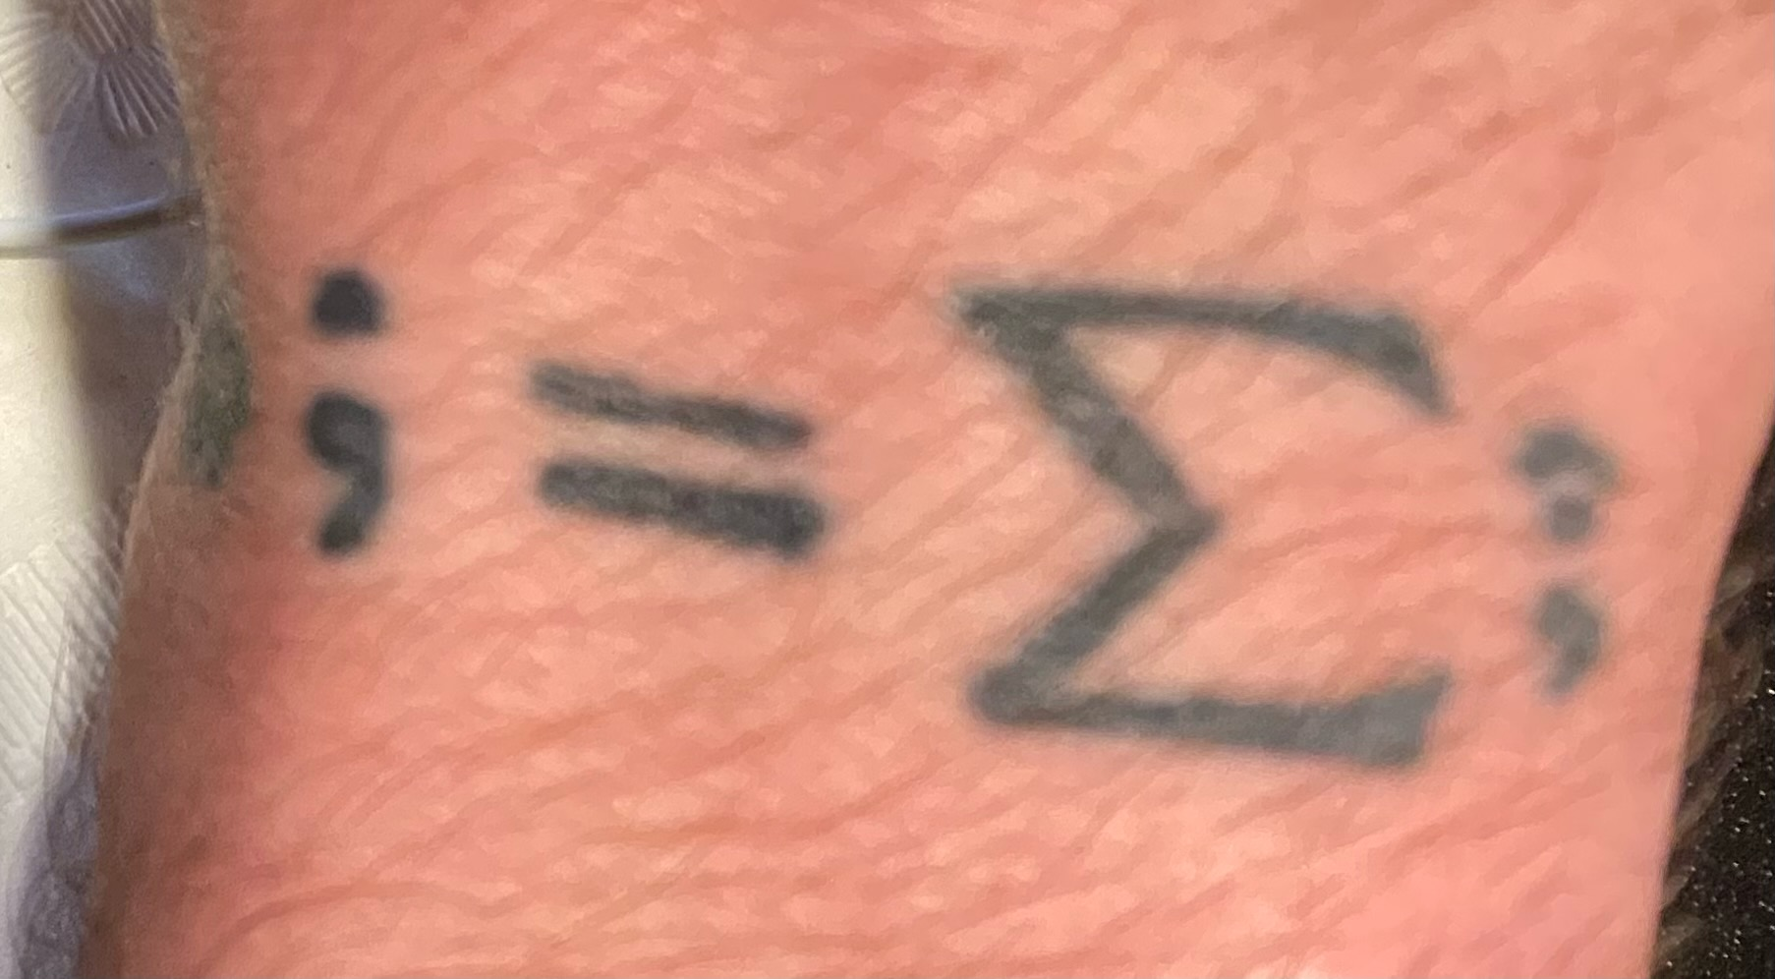

And something like this on the forearm:

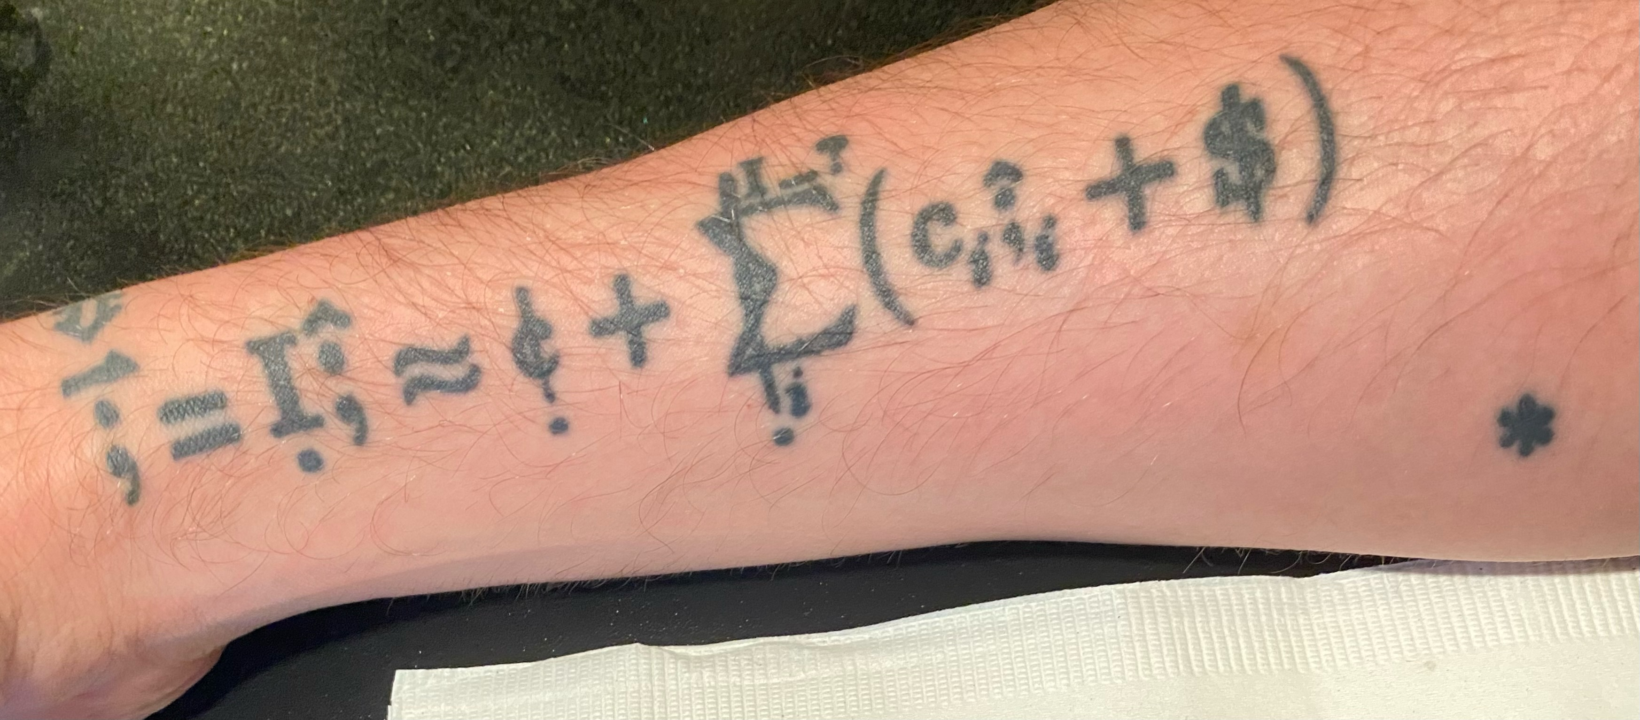

Every time somebody asked The Individual about the tattoo, he would be forced to engage with that learning process, refining and internalizing the learning with each new explanation. This was the first physical component in The Individual's personal world piece computer operating system.
Eventually the tattoo would take hold. It just needed time, perspective, and help.

