OPERATOR'S MANUAL FOR THE
TIMESPACE
MATTER
MINDMACHINE
~ LEARN TO EMBRACE PEACE AS A PROCESS ~
~ HELP ERECT A GLOBAL PEACE SYSTEM ~
~ MAXIMIZE COLLECTIVE INNER PEACE ~
~ NAVIGATE TO BETTER AND BETTER FUTURES ~
~ CONSTRUCT THE TIME MACHINE FOR PEACE ~
~ CRUSH HUMANITY'S GREATEST ADVERSARY ~
~ SATISFY THE HUMAN IMPERATIVE ~
.
... ONE WORLD PIECE COMPUTER AT A TIME !

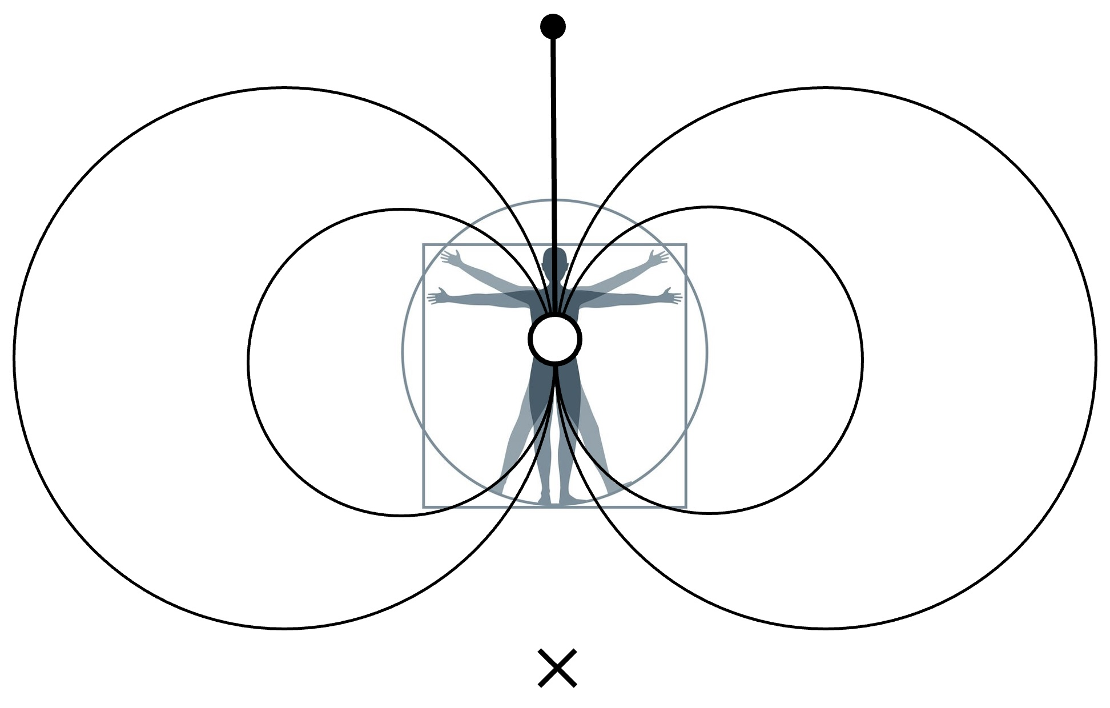

. produced by the time machine for peace social invention program .
. toward installing the universal piece computer, a global peace system .

