A Study In Peace.
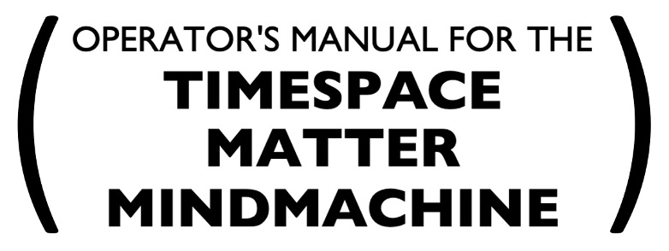
~ EMBRACE PEACE AS A PROCESS ~
~ ERECT A GLOBAL PEACE SYSTEM ~
~ MAXIMIZE COLLECTIVE INNER PEACE ~
~ CONSTRUCT THE TIME MACHINE FOR PEACE ~
~ NAVIGATE TO ITERATIVELY BETTER FUTURES ~
~ CRUSH HUMANITY'S GREATEST ADVERSARY ~
~ SATISFY THE HUMAN IMPERATIVE ~
.
~ ONE WORLD PIECE COMPUTER AT A TIME ~

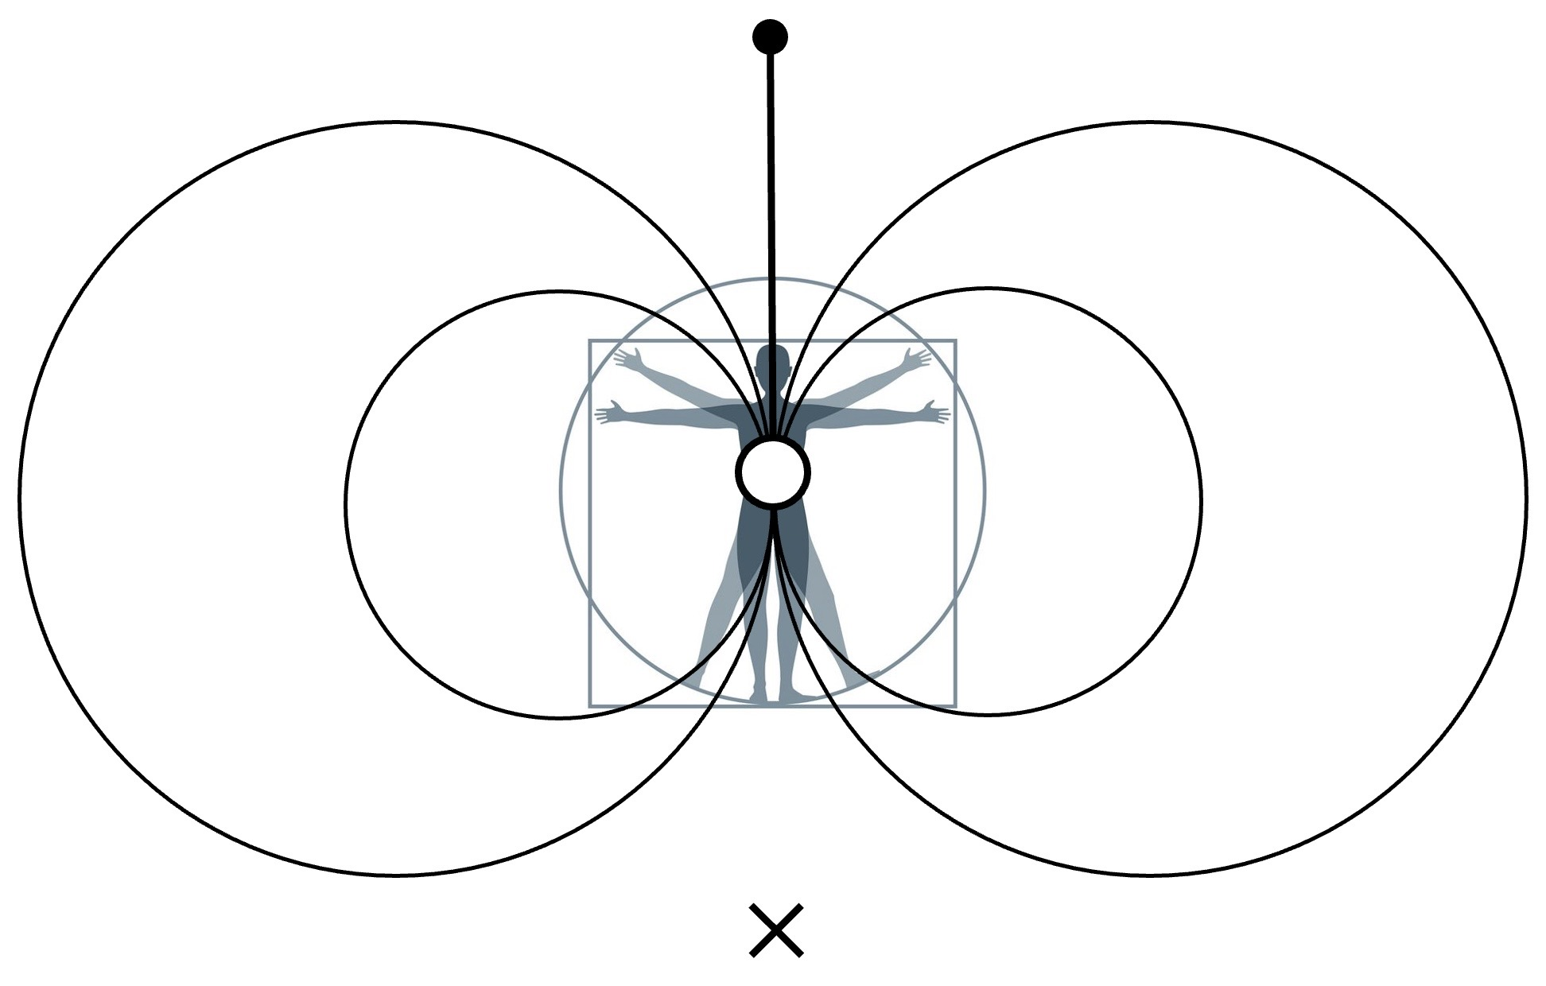

. produced by the time machine for peace social invention program .
. toward installing the universal piece computer, a global peace system .

