The Relationship of Risk Levels between Insurance Company Risk-Based Capital Ratios and Stock Value at Risks in Taiwan
Pei-Lin Liao, Jen-Shein Su, EnDer Su*

Abstract
Capital Adequacy Ratio (Risk-Based Capital, RBC) and Net Worth Ratio are important indicators for measuring the financial soundness of an insurance company. This study has two main objectives: first, to explore the correlation between the Capital Adequacy Ratio levels of life insurance companies and four risk areas of financial holding companies, including stock price risk, liquidity risk, operational risk, and other risks; second, to predict the relationship between the RBC rating and the Value at Risk (VaR) of stock price returns. This study focuses on nine financial holding companies in Taiwan's listed financial insurance industry that have significant life insurance subsidiaries. After categorizing the Capital Adequacy Ratios of life insurance companies into different levels using ordered logit model, box plots are generated for each level against the risk areas of the nine financial holding parent companies to examine the distribution of risk factors for the parent companies under different Capital Adequacy Ratio levels. Correlation tests are also conducted to determine if there is a significant correlation between the Capital Adequacy Ratio levels of life insurance companies and the four risk areas of financial holding companies.
Keywords: financial holding companies, risk-based capital, ordered logit model, value at risk.

1. Introduction
The first life insurance company to collapse in Taiwan's history was Kuo-Kuang Life in 1970. From 2005 to the present, four life insurance companies (Kuo-Kuang Life, Kuo-Pao Life, Hsing-Fu Life, and Chao-Yang Life) and two property insurance companies (Hua-Shan Property Insurance and Kuo-Kuang Property Insurance) have been ordered to cease operations in Taiwan. Fortunately, these companies found willing acquirers, so policyholder rights were not affected. However, if a successor company cannot be found, the Insurance Stabilization Fund will provide compensation, which may impact policyholder rights. For the public wishing to purchase insurance, the most convenient way to assess the financial health of an insurance company is to use the Financial Supervisory Commission's (FSC) Insurance Industry Public Information Observation Station website to search for company profiles, financial status, and business overview of each insurance company. Among these, the Capital Adequacy Ratio (Risk-Based Capital, RBC) and Net Worth Ratio are crucial indicators for evaluating an insurance company's financial soundness. When an insurance company's Capital Adequacy Ratio or Net Worth Ratio falls below the standards stipulated in the Regulations Governing the Capital Adequacy of Insurance Enterprises, the company may be taken over by the FSC in accordance with Article 149 of the Insurance Act.
In addition to affecting policyholder rights, the failure of an insurance company also impacts investors holding its stock. Therefore, this study aims to provide a more easily understandable method for the public to assess whether a company's stock price aligns with their personal reasonable target price risk value when considering investments in financial insurance-related sectors, thereby fulfilling the study's purpose.

2. Literature Review
2.Risk Assessment of Insurance Companies
Kozmenko & Oliynyk (2015) describe how to use probability methods to establish a model for assessing the operational risks of insurance companies. They suggest that insurance companies' risk management departments should use probability methods for preliminary analysis of different risk categories, classifying the analysis results into five levels: 'minimal risk,' 'low risk,' 'acceptable risk,' 'severe risk,' and 'catastrophic risk.' This allows for the identification of the most critical risk factors, enabling the implementation of measures to mitigate negative impacts on the company.
BarNiv & Hershberger (1990) authored the first study on life insurance company insolvency. The model proposed in their research aims to identify variables related to the financial solvency of life insurance companies. The objective of the study was to review the financial operations of life insurance companies to discover variables that could aid in monitoring their solvency and to examine the applicability and efficiency of multivariate models in monitoring life insurance company solvency. They employed three multivariate analyses: discriminant analysis, non-parametric analysis, and logistic regression. The research concluded that life insurance companies require absolute and relative returns (including investment yields) to maintain solvency. The IRIS test performed well in multivariate models combined with other financial indicators. Therefore, when reviewing companies listed for supervision, insurance regulators should consider these variables in addition to IRIS ratios.
Jhonpita et al. (2012) propose the use of ordinal classification to assess the financial stability of non-life insurance companies, categorizing them as 'strong,' 'medium,' 'weak,' and 'bankrupt.' This study developed an effective classification model that regulators can use to evaluate financial soundness and prioritize further reviews as an early warning system. This benefits policymakers in formulating solvency regulations and government guidelines on protecting the public from bankruptcy's negative effects.
2.2 Literature Related to Capital Adequacy Ratio
The primary objectives of Cummins & Phillips (2009) were: 1. To conduct an empirical analysis of the bankruptcy experience, capitalization, and causes of bankruptcy in the U.S. insurance industry; 2. To perform a comparative analysis and evaluation of the U.S. Risk-Based Capital (RBC) system, the European Solvency II system, and the Swiss Solvency Test (SST). The research results indicated that the U.S. RBC system cannot accurately predict insurance company bankruptcies. The U.S. solvency supervision system needs revision to meet current international standards by introducing stochastic models and market-consistent valuations. The results of internal company models should be incorporated into regulatory solvency supervision, but regulators should also develop standard stochastic regulatory models to determine minimum capital standards. U.S. regulations should also formally incorporate qualitative assessments, such as the Own Risk and Solvency Assessment (ORSA) process.
The financial stability of insurance companies is typically measured by solvency indicators, as insurance companies may need to pay claims at any time. The premiums received are reserves for future policyholder payments, essentially representing liabilities. Due to Taiwan's high insurance penetration and high policy ownership rates, any issues with an insurance company's ability to pay its debts could cause public anxiety and social instability, severely impacting the financial industry. Consequently, the insurance industry is highly regulated by the state. The FSC uses the Capital Adequacy Ratio and Net Worth Ratio to measure the stability of an insurance company's solvency. If a company's capital adequacy falls into the 'severely deficient' category, according to Article 149 of the Insurance Act, the insurance company must increase capital, implement a financial or business improvement plan, or merge within a period specified by the competent authority. If these requirements are not met by the deadline, the FSC will issue measures such as takeover, suspension of business for liquidation, or dissolution orders within 90 days after the deadline. Therefore, maintaining capital adequacy is crucial for insurance companies.
2.3 Research Related to Value at Risk
Erola et al. (2022) proposed a system for calculating Cyber Value at Risk (CVaR) for organizations. CVaR is the probability density function of losses from cyber events, applicable to any given threat and risk control practice. It can account for changes in control utility, the consequences of risk propagation through infrastructure, and the resulting cyber damage. The study demonstrated the system's practicality through a case study of organizations that experienced significant cyber events, with results showing the system can generate predictions representing actual financial losses. Insurance companies offering cyber products can use the proposed system to better inform the calculation of insurance premiums, and organizations can use it to infer the impact of specific risk control settings on reducing their cyber risk exposure.
Favre & Galeano (2002) studied the development of a new Value at Risk (VaR) measure, called Modified Value at Risk (MVaR), based on the standard VaR. This modified VaR has the characteristic of adjusting risk based solely on the skewness and kurtosis of the return distribution, as well as volatility. MVaR allows for the measurement of risk for portfolios with assets that do not follow a normal distribution (such as hedge funds or tech stocks) and can be used to determine optimal portfolios by minimizing MVaR at a given confidence level.
In summary, Value at Risk is the current mainstream method for measuring risk. Its calculation has evolved from a simple normal distribution to more complex methods through the research of various scholars. For the convenience of readers, this study will adopt the normal distribution method for calculating Value at Risk.

3. Research Methodology
This section first lists the research subjects. The second step explains the Capital Adequacy Ratio used by insurance companies, relevant regulations and measures, and the method used in this study to categorize the Capital Adequacy Ratio. The third step describes the ordinal logistic model and the risk areas of financial holding parent companies used for model prediction. Finally, the calculation method for stock price Value at Risk is introduced.
3.1 Research Subjects
The data for this study was obtained from the Taiwan Economic Journal (TEJ) database. This research focuses on nine financial holding companies in Taiwan's listed financial insurance industry that have significant life insurance subsidiaries. The observation period covers three years, from 2019 to 2021. The financial holding companies in Taiwan with life insurance subsidiaries are Fubon Financial Holding, Cathay Financial Holding, CDIB Capital, Yuanta Financial Holding, Taishin Financial Holding, Shin Kong Financial Holding, CTBC Financial Holding, First Financial Holding, and Taiwan Cooperative Financial Holding Co.Ltd. The reason for selecting life insurance companies is that this study uses the Value at Risk of financial holding companies' stock prices and compares it with the Capital Adequacy Ratio of insurance companies. Since the calculation methods for the Capital Adequacy Ratio of life insurance companies and property insurance companies differ, we have uniformly selected financial holding companies with life insurance subsidiaries for this study. Table 1 lists the stock codes of Taiwanese financial holding companies and their respective life insurance companies.
3.2 Capital Adequacy Ratio of Insurance Enterprises
The draft Regulations Governing the Capital Adequacy of Insurance Enterprises, issued by the Ministry of Finance, stipulated that the Capital Adequacy Ratio of insurance enterprises must not be lower than 200%, with a two-year grace period. The new regulations took effect on July 9, 2003. Those not meeting the standards were required to increase capital or reduce risky assets such as investments (Liu Ching-chun, 2002).
The Regulations Governing the Capital Adequacy of Insurance Enterprises (hereinafter referred to as 'these Regulations') are established in accordance with the fourth paragraph of Article 143-4 and the third paragraph of Article 148-2 of the Insurance Act. The 'equity capital' mentioned in the Insurance Act refers to the total capital recognized by the competent authority in accordance with these Regulations; its scope includes:
- Recognized owner's equity.
- Other adjustment items as stipulated by the competent authority.

Table 1 Life Insurance Subsidiaries of Taiwanese Financial Holding Companies
Financial holding Company Name | Abbreviation | Stock Code | Life Insurance Company Under Financial Holding Company
Fubon Financial Holding Co., Ltd. | FBND | 2881 | Fubon Life Insurance Co., Ltd.
Cathay Financial Holding Co., Ltd. | CFHS | 2882 | Cathay Life Insurance Co., Ltd.
China Development Financial Holding Corporation | CDFH | 2883 | China Life Insurance Co., Ltd.
Yuanta Financial Holding Co., Ltd. | YFH | 2885 | Yuanta Life Insurance Co., Ltd.
Taishin Financial Holding Co., Ltd. | TSFH | 2887 | Taishin Life Insurance Co., Ltd.
Shin Kong Financial Holding Co., Ltd. | SKFH | 2888 | Shin Kong Life Insurance Co., Ltd.
CTBC Financial Holding Co., Ltd. | CTBC | 2891 | Taiwan Life Insurance Co., Ltd.
First Financial Holding Co., Ltd. | FFHC | 2892 | First Life Insurance Co., Ltd.
Taiwan Cooperative Financial Holding Co.Ltd | TCFHC | 5880 | BNP Paribas Cardif TCB Life Insurance Co., Ltd.

The 'risk capital' mentioned in the Insurance Act refers to the total capital calculated based on the degree of risk undertaken by an insurance enterprise in its actual operations; its scope includes the following risk items:
- Life insurance enterprises:
1. Asset Risk  2. Insurance Risk | 3. Interest Rate Risk  4. Other Risks
- Property insurance enterprises:
1. Asset Risk  2. Credit Risk  3. Underwriting Risk | - Asset-Liability Management Risk  - Other Risks

3.3 Research Model

(1) Ordered Logit Model
Peter McCullagh (1980) proposed ordinal regression. In statistics and machine learning research, ordinal regression is a variant of regression models typically used when data involves ordinal variables. Ordinal regression is generally divided into the following two types:
- Ordered Logit Model
Applicable to ordinal dependent variables and pure regression models. For example, in a survey asking about product satisfaction with responses like 'bad,' 'good,' 'very good,' and 'excellent,' analyzing the predictive effect of these responses on the next product. This model can be used if the questions are quantitative. It can be viewed as an extension of logistic regression, allowing for more than two categories to be arranged in an ordered manner.
- Ordered Probit Model
This model can be considered a variant of the probability model, featuring an ordinal dependent variable and capable of yielding more than two outcomes. The ordinal dependent variable can be defined by values that have a natural order, such as 'very dangerous,' 'dangerous,' 'normal,' 'safe,' 'very safe.'
In many fields such as marketing, healthcare, and finance, ordinal regression may be found. In short, whenever data with categorical values are obtained in an ordered format, ordinal data can be used to identify factors that influence the ordered categorical values.
Financial holding parent company risk areas of life insurance companies
This study selects four risk areas of financial holding parent companies of life insurance companies: stock price risk, liquidity risk, operational risk, and other risks, which are explained below.
- Stock Price Risk
(1) Stock Price Return on Investment
Stock Price Return on Investment (ROI) is the ratio of investment returns to invested capital. The stock price return on investment in this study is referred to as Stk, and the calculation formula is as follows:
$$Stk=[(1+{ROI}_{t}\%)×(1+{ROI}_{t+1}\%)×(1+{ROI}_{t+2}\%)×…×(1+{ROI}_{t+n}\%)-1]×100\%$$ | ( 5 )
(2) Stock Price Risk Coefficient
The measurement of the stock price risk coefficient uses the Beta value from the Capital Asset Pricing Model (CAPM). The basic theory of this model is based on the portfolio theory proposed by Markowitz in 1952. Its purpose is to construct an optimal portfolio among a large number of risky assets. However, in the early stages of the model's proposal, due to the immaturity of computer technology, calculating using this model still required a lot of time and effort, making it difficult to use in investment practice. Subsequently, in the 1960s, American financial scholars gradually developed the Capital Asset Pricing Model, which is most commonly used today, from an empirical perspective. The model's formula is as follows:
$${ROI}_{i,t}=R_{f,t}+β_{1}\left({ROI}_{m,t}-R_{f,t}\right)+ε_{t}$$ | ( 6 )
$R_{f,t}$is the risk-free rate at time t, is the ${ROI}_{i,t}$return rate of individual stock (i) at time t, is the return${ROI}_{m,t}$ rate of the overall market (m) at time t, and is the error $ε_{t}$term. The calculation formula for the Beta value in the above equation is as follows:
$${\hat{β}}_{1}=\sum{({ROI}_{i,t}-\overline{{ROI}_{i}}})\left[\left( {ROI}_{m,t}-R_{f,t}\right)-\overline{{ROI}_{m}-R_{f}}\right]÷\sum{{\left[\left( {ROI}_{m,t}-R_{f,t}\right)-\overline{{ROI}_{m}-R_{f}}\right]}^{2}}$$ | ( 7 )
- Price-Book Ratio (PB)
The purpose of this ratio is to calculate the multiple of the company's stock price to its book value, which is to measure the stock price using the company's value, and to understand investors' preferences for the company's stock price. Usually, PB<1 means the stock price is currently below the company's book value, so it can be considered for purchase. Conversely, PB>1 means the stock price is currently above the company's book value, and it can be considered for sale, but it is not recommended to enter at this time because the potential return rate is lower. The calculation formula for the Price-Book Ratio is as follows:
$$PB=收盤價÷每股淨值$$ | (8)
- Liquidity Risk
- Interest Expense Ratio
The Interest Expense Ratio (INT) reflects the proportion of a company's interest expenses to its revenue. Generally, a lower interest expense ratio indicates that the company is more capable of making interest payments on time. The calculation formula is as follows:
$$INT=(利息支出+資本化之利息支出)/營業收入$$ | (9)
- Operational Risk
- Return on Assets (ROA)
The Return on Assets is adopted from the ratio that contributes to the components of insurance companies' financial performance in the paper by Morara & Sibindi (2021). It is the overall return rate of the entire company and is usually used to examine whether the company can effectively utilize its assets. Generally, a higher ROA indicates better utilization of assets for returns. The calculation method for ROA is: (Net Profit After Tax / Average Total Assets) * 100%. However, some argue that using net profit after tax does not fully reflect a company's profitability because net profit after tax has already deducted interest on debt, which may lead to an underestimate of net profit after tax, thereby leading to an underestimate of ROA. Therefore, the calculation formula used in this study is as follows:
$$ROA=\left[稅後淨利＋財務成本×(1-所得稅率)\right]÷平均資產總額×100\%$$ | (10)
- Return on Equity (ROE)
The Return on Equity is adopted from the paper by Morara & Sibindi (2021) and is an indicator for evaluating the return on equity investment of a company. A higher ROE indicates that the company can generate greater profits with its net assets. The calculation formula is as follows:
$$ROE=稅後淨利÷股東權益總額$$ | (11)
- Revenue Growth Rate
The Revenue Growth Rate divides time periods into annual, quarterly, or monthly, reflecting the company's revenue situation in different periods. This study uses the Year-Over-Year (YoY) revenue growth rate to measure the growth rate of a company's revenue in a specific period of the current year compared to the same period last year. The calculation formula is as follows:
$$YOY=[this year revenue÷last year revenue-1]×100\%$$ | (12)
- Other Risks
(1) Debt Ratio
The Debt Ratio is referenced from the paper by Morara & Sibindi (2021). It is the proportion of liabilities in a company's total assets, in other words, the company's debt situation. Generally, the debt ratio is positively correlated with the company's long-term debt-paying ability. Therefore, it is used as a ratio to assess the company's long-term debt-paying ability in financial ratio analysis. The formula for the debt ratio is as follows:
$$Debt ratio=\left(total debt ÷total asset\right)×100\%$$ | (13)
- Company Size
The larger the company size, the greater its position and influence within the entire industry. Therefore, this study uses the measurement method proposed by Bettis (1981) to measure enterprise size. The formula is as follows:
$$Size=log⁡(total asset)$$ | (14)
Value at Risk (3-5)
This study uses the standard normal distribution method to estimate Value at Risk (Gaussian VaR). This risk measurement method is used to quantify the potential loss risk of a company's investment, but it can only be estimated more accurately if the stock price return on investment follows a normal distribution; otherwise, this method may underestimate extreme risks (fat-tail risks). To improve this drawback, this paper also uses Modified Value at Risk (MVaR), which is modified or extended to correct for skewness and fat tails in the distribution of portfolio returns. In other words, MVaR adjusts the normal measurement of value at risk to account for the non-normal distribution of returns for specific asset classes.
To this end, MVaR accounts for higher moments of the return distribution by extending the quantiles of the standard normal distribution (using the Cornish-Fisher expansion). Portfolios can be optimized by minimizing MVaR at a given confidence level. Unlike Gaussian VaR, MVaR will be larger for financial assets with negative skewness or positive kurtosis. Furthermore, VaR using only volatility will be lower than VaR using skewness, volatility, and kurtosis.

Section 4. Empirical Analysis
4.1 Descriptive Statistical Analysis
4.1.1 Stock Price Risk
This study uses box plots to examine the distribution of independent variables for each financial holding company across different life insurance solvency ratio grades. A higher stock investment return (Stk) indicates greater investment returns with less capital input. Figure 1 shows the distribution of stock investment returns for nine financial holding companies across different life insurance solvency ratio grades. The graph indicates that only CTBC Financial and Yuanta Financial reached solvency ratio grade A as defined in this study. Although CTBC Financial's box plot falls entirely within the life insurance solvency ratio grade A range, based on the position of the box plot, CTBC Financial's stock investment return is not the highest among the companies. While Cathay Financial's stock investment return is at the highest position, its box plot for life insurance solvency ratio grade B is compressed, and most of the graph falls within solvency ratio grade C, indicating fewer data points for Cathay Financial's stock investment return at solvency ratio grade B. For life insurance solvency ratio grade B, excluding Cathay Financial, Fubon Financial's box plot is in the highest position among the other eight financial holding companies, indicating that Fubon Financial's stock investment return is higher than the other eight financial holding companies when the life insurance solvency ratio is grade B. For life insurance solvency ratio grade C, Cathay Financial's box plot shows larger outliers, representing greater volatility in Cathay Financial's stock investment return.
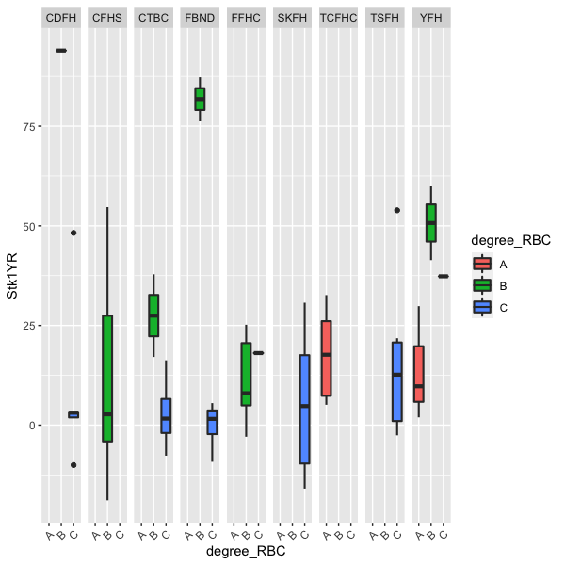
Figure 1 Box Plot of Stock Investment Returns
Note: CDFH for Cathay Financial, CFHS for Cathay Life, CTBC for CTBC Financial, FBND for Fubon Financial, FFHC for First Financial, SKFH for Shin Kong Financial, TCFHC for CTBC Financial, TSFH for Taishin Financial, YFH for Yuanta Financial.

4.2 Liquidity Risk
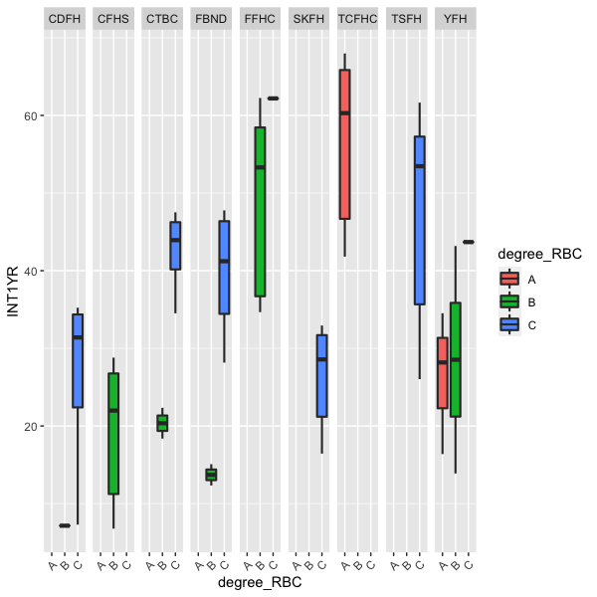
Interest Expense Ratio (INT) reflects the company's interest expense as a proportion of revenue. A lower interest expense ratio indicates that the company is better able to meet its interest payment obligations on time. From the box plot of Interest Expense Ratio in Figure 2, CTBC Financial's life insurance solvency ratio grade is A, but its median is higher than the other eight companies, indicating a greater risk of default on interest payments compared to other companies. At life insurance solvency ratio grade B, the overall box plots for the interest expense ratio of three companies, including Cathay Financial, CTBC Financial, and Fubon Financial, are lower than the other six companies, suggesting a lower risk of defaulting on interest payments for these three financial holding companies. For life insurance solvency ratio grade C, First Financial has the highest interest expense ratio, indicating a higher risk of defaulting on interest payments when the life insurance solvency ratio is lower.

Figure 2 Box Plot of Interest Expense Ratio
Note: CDFH for Cathay Financial, CFHS for Cathay Life, CTBC for CTBC Financial, FBND for Fubon Financial, FFHC for First Financial, SKFH for Shin Kong Financial, TCFHC for CTBC Financial, TSFH for Taishin Financial, YFH for Yuanta Financial.

4.3 Operational Risk
A higher Return on Assets (ROA) indicates that the company's assets are utilized more effectively. Figure 3 shows that although CTBC Financial's life insurance solvency ratio grade is A, its ROA box plot is nearly the lowest among the nine companies, suggesting poor asset utilization efficiency. Due to Cathay Financial's life insurance solvency ratio rarely reaching grade B, its box plot for solvency ratio grade B is compressed. At life insurance solvency ratio grade B, among the eight financial holding companies excluding Cathay Financial, Fubon Financial's ROA box plot is at
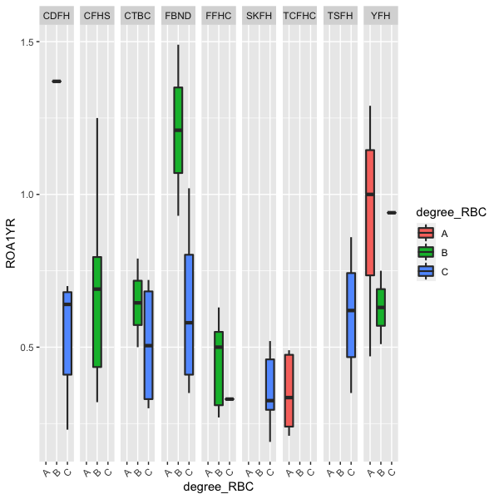
Figure 3 Box Plot of Return on Assets
Note: CDFH for Cathay Financial, CFHS for Cathay Life, CTBC for CTBC Financial, FBND for Fubon Financial, FFHC for First Financial, SKFH for Shin Kong Financial, TCFHC for CTBC Financial, TSFH for Taishin Financial, YFH for Yuanta Financial.
Year-over-Year (YOY) revenue growth rate reflects the growth rate of the company's revenue in a specific period of the current year compared to the same period last year. A higher revenue growth rate indicates better sales growth for the company. Figure 4 shows that Yuanta Financial's revenue growth rate box plot is more dispersed, indicating large fluctuations in the company's data and thus unstable revenue growth. CTBC Financial's life insurance solvency ratio grade is A, but the median of its box plot is below 0, indicating that over 50% of CTBC Financial's revenue growth rate data is negative. At life insurance solvency ratio grade B, CTBC Financial's box plot is below 0 and relatively flat, indicating negative revenue growth with small fluctuations. For life insurance solvency ratio grade C, Cathay Financial's box plot is relatively flat, indicating concentrated revenue growth data with small fluctuations. Conversely, CTBC financial's box plot at life insurance solvency ratio grade C is dispersed, indicating scattered revenue growth data with large fluctuations. FBND has the highest position, indicating better asset utilization efficiency for this financial holding company.

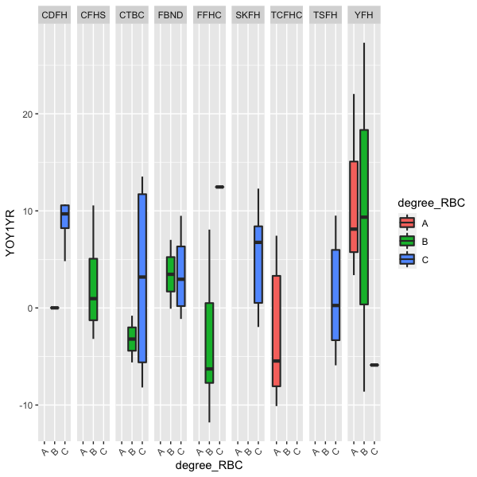
Figure 4 Box Plot of Revenue Growth Rate
Note: CDFH for Cathay Financial, CFHS for Cathay Life, CTBC for CTBC Financial, FBND for Fubon Financial, FFHC for First Financial, SKFH for Shin Kong Financial, TCFHC for CTBC Financial, TSFH for Taishin Financial, YFH for Yuanta Financial.
Other Risks
A higher Return on Equity (ROE) indicates that the company can generate greater profits from net assets. As shown in Figure 5, Fubon Financial's ROE box plot is the highest at life insurance solvency ratio grade B, indicating relatively good profitability for Fubon Financial. Although CTBC Financial's life insurance solvency ratio grade is A, its ROE box plot is not higher than the other eight financial holding companies, suggesting that a higher life insurance solvency ratio does not necessarily lead to a higher ROE.

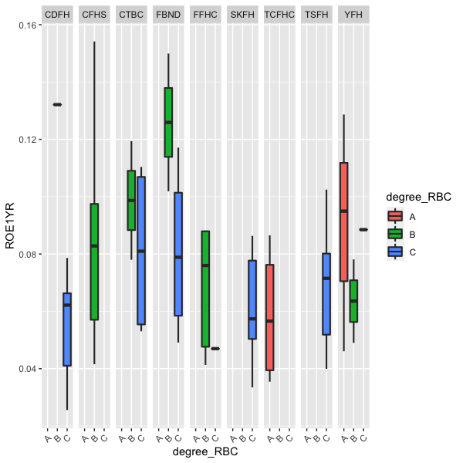
Figure 5 Box Plot of Return on Equity
Note: CDFH for Cathay Financial, CFHS for Cathay Life, CTBC for CTBC Financial, FBND for Fubon Financial, FFHC for First Financial, SKFH for Shin Kong Financial, TCFHC for CTBC Financial, TSFH for Taishin Financial, YFH for Yuanta Financial.
The Debt Ratio is generally positively correlated with a company's long-term solvency. Figure 6 shows that at life insurance solvency ratio grade A, CTBC Financial has better long-term solvency, while Yuanta Financial has the lowest. At life insurance solvency ratio grade B, First Financial has better long-term solvency. At life insurance solvency ratio grade C, Shin Kong Financial has better long-term solvency.
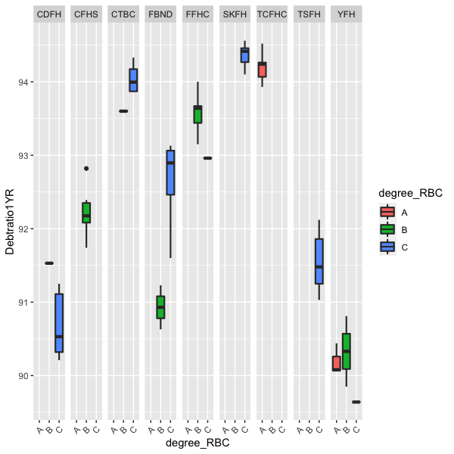
Figure 6 Box Plot of Debt Ratio
Note: CDFH for Cathay Financial, CFHS for Cathay Life, CTBC for CTBC Financial, FBND for Fubon Financial, FFHC for First Financial, SKFH for Shin Kong Financial, TCFHC for CTBC Financial, TSFH for Taishin Financial, YFH for Yuanta Financial.

4.4 Correlation Analysis
This study uses the Pearson Product-Moment Correlation Coefficient to explore the relationships between variables. In statistics, it is an indicator used to represent the degree of association between two variables, often denoted by the lowercase English letter 'r'. In terms of the magnitude of the correlation coefficient, it can be divided into two types: Type A correlation coefficients, with a range between 0 and 1; and Type B correlation coefficients, with a range between -1 and 1. The sign indicates whether the coefficient value is positive or negative; a positive value indicates a positive association between the two variables (e.g., as one variable increases, the other also increases; or as one variable decreases, the other also decreases), known as 'positive correlation'; a negative value indicates an inverse association between the two variables (e.g., as one variable increases, the other decreases; or as one variable decreases, the other increases), known as 'negative correlation' (Yu, 2000). The strength of the correlation, according to the Pearson Product-Moment Correlation Coefficient, is as follows: |r| = 1 indicates perfect correlation, |r| = 0.7-0.99 indicates high correlation, |r| = 0.40-0.69 indicates moderate correlation, |r| = 0.10-0.39 indicates low correlation, |r| < 0.10 indicates very weak or no correlation.
The following Figure 7 is a visualization of the correlation coefficients between the life insurance solvency ratio (RBC) and the nine risk factor independent variables of financial holding companies, showing the directional relationships and strength of change between variables. The closer to 1 or -1, the stronger the correlation, but it does not indicate whether the relationship between variables is significant.
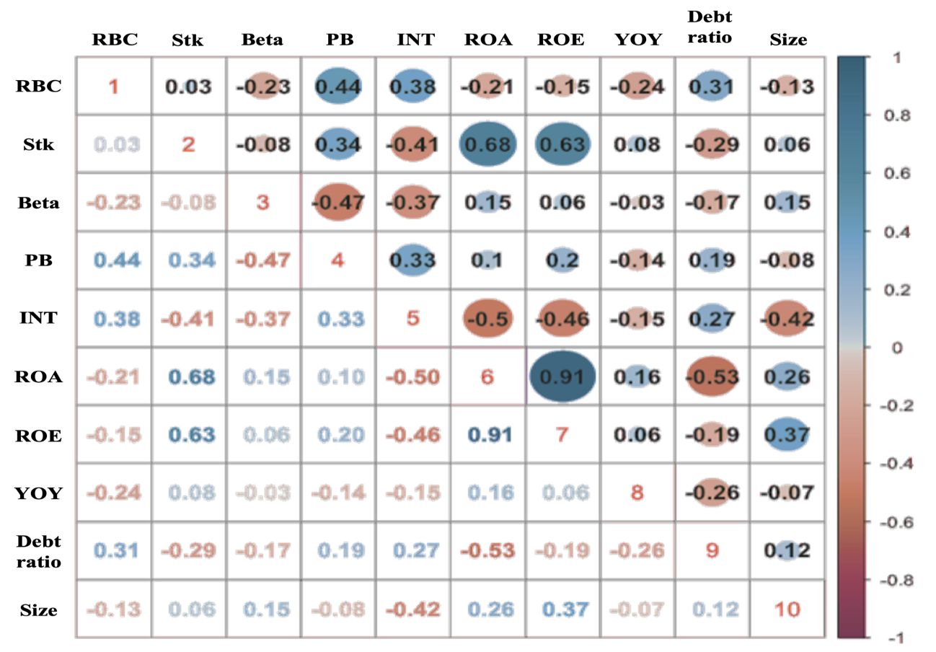
Figure 7 Correlation Plot of Various Variables
Table 2 adds significance testing to the correlation coefficients to show whether the relationships between variables are significant. It shows a significant positive correlation between the life insurance solvency ratio and the Price-to-Book ratio (PB) and Interest Expense Ratio (INT) of financial holding companies. This indicates that as the life insurance solvency ratio increases, investors are willing to pay a premium for the financial holding company's stock, but the financial holding company's interest expense as a percentage of revenue is higher.
The stock investment return (Stk) and the Interest Expense Ratio (INT) have a significant negative correlation, indicating that when the stock investment return is higher, the interest expense as a percentage of revenue is lower, and the financial holding company has a better ability to make timely interest payments.
The stock risk coefficient (Beta) and the Price-to-Book ratio (PB) and Interest Expense Ratio (INT) show a significant negative correlation. This implies that when the financial holding company's stock risk coefficient is larger and more affected by market volatility, investors are willing to purchase the stock at an amount below the financial holding company's book value, and the company's interest expense ratio is also at a lower level during this time, with a higher probability of making timely interest payments.
The Interest Expense Ratio (INT) shows a significant negative correlation with Return on Assets (ROA), Return on Equity (ROE), and Company Size (Size). This indicates that when the financial holding company's interest expense as a percentage of revenue is higher, the company's operational efficiency is poorer, and its size is smaller.
Return on Assets (ROA) and Debt Ratio show a significant negative correlation, meaning that when a financial holding company is more effective at utilizing assets for profit, its long-term solvency is not necessarily better. This is because the financial and insurance industry is a high financial leverage industry. Its primary profit model involves collecting deposits or premiums from bank depositors or insurance policyholders and then making reinvestments. Therefore, a portion of its assets comes from liabilities. If the financial and insurance industry has excessive liabilities, it could affect its long-term solvency.
Table 2 Correlation Test Table of Life Insurance Solvency Ratio and Financial Holding Company Risk Factors
 | RBC | Stk | Beta | PB | INT | ROA | ROE | YOY | Debt  ratio | Size
RBC | 1.00
Stk | 0.03 | 1.00
Beta | -0.23* | -0.08 | 1.00
PB | 0.44*** | 0.34** | -0.47*** | 1.00
INT | 0.38*** | -0.41*** | -0.37*** | 0.33** | 1.00
ROA | -0.21 | 0.68*** | 0.15 | 0.10 | -0.50*** | 1.00
ROE | -0.15 | 0.63*** | 0.06 | 0.20 | -0.46*** | 0.91*** | 1.00
YOY | -0.24* | 0.08 | -0.03 | -0.14 | -0.15 | 0.16 | 0.06 | 1.00
Debt  ratio | 0.31** | -0.29** | -0.17 | 0.19 | 0.27* | -0.53*** | -0.19 | -0.26* | 1.00
Size | -0.13 | 0.06 | 0.15 | -0.08 | -0.42*** | 0.26* | 0.37*** | -0.07 | 0.12 | 1.00
Notes 1. P value<0.1 represents *; <0.05**; <0.01***, 2. Stock Investment Return (Stk), Stock Risk Coefficient (Beta), Price-to-Book Ratio (PB), Interest Expense Ratio (INT), Return on Assets (ROA), Return on Equity (ROE), Revenue Growth Rate (YOY), Debt Ratio, Company Size (Size).

4.5 Empirical Results Analysis
4.5.1 Model Evaluation and Probability Prediction
To predict the probability of life insurance companies falling into each of the three solvency ratio grades in the future, this study uses the proportional odds model to calculate the risk factors of financial holding companies. The prediction results are shown in Table 3 below.
Regarding the predicted results, only the life insurance companies of Fubon Financial and Cooperative Financial Holdings may reach a solvency ratio rating of A in the future. Fubon Financial's better earnings capacity can be seen from the box plots of stock risk and operational risk items, making it reasonable to infer that the company's life insurance company is financially sound. In contrast, for Cooperative Financial Holdings, although its life insurance company's solvency ratio rating has always been A, its earnings capacity in terms of stock risk, liquidity risk, and operational risk is poorer compared to other financial holdings companies. This indicates that Cooperative Financial's earnings capacity and asset utilization are ineffective. From a long-term perspective, this situation is unfavorable for high financial leverage industries such as finance and insurance.

Table 3 Prediction Results of Life Insurance Solvency Ratio Grades for Financial Holding Companies
Company Name | Life Insurance Company Solvency Ratio Rating A | Life Insurance Company Solvency Ratio Rating B | Life Insurance Company Solvency Ratio Rating C | Life Insurance Company Solvency Ratio Rating Predicted Result
Fubon Financial | 0.503 | 0.402 | 0.095 | A
Cathay Financial | 0.195 | 0.501 | 0.304 | B
Development Financial | 0.374 | 0.476 | 0.151 | B
Yuanta Financial | 0.260 | 0.509 | 0.231 | B
Taishin Financial | 0.074 | 0.356 | 0.570 | C
Shin Kong Financial | 0.000 | 0.003 | 0.996 | C
CTBC Financial | 0.144 | 0.470 | 0.387 | B
First Financial | 0.331 | 0.493 | 0.176 | B
Cooperative Financial | 0.469 | 0.424 | 0.107 | A

4.6 Value at Risk and Solvency Ratio Rating Analysis
This study used two methods, Gaussian VaR and MVaR, to calculate the Value at Risk. The Value at Risk was calculated as the difference between the lower tail value and the average of the stock price investment returns of the financial holding parent companies.
Table 4 below shows the average comparison of the calculated Value at Risk and the life insurance company solvency ratio ratings while Table 5 shows the comparison of the predicted results for both.
Among the nine financial holding companies, only Yuanta Financial, First Financial, and Cooperative Financial have an MVaR smaller than Gaussian VaR for their stock value at risk. This indicates that MVaR generally has a smaller average loss risk than Gaussian VaR at a 95% confidence level. Overall, there is a certain correlation between the magnitude of stock value at risk and the average solvency ratio rating of life insurance companies. When the stock value at risk of the financial holding parent company is lower, the solvency ratio rating of its life insurance subsidiary will be higher.

Table 4 Summary of Average Results for Financial Holding Company Value at Risk and Life Insurance Company Solvency Ratio Ratings
Company Name | Average Value of Gaussian VaR Estimate | Average Value of MvaR Estimate | Average Result of Life Insurance Company Solvency Ratio Rating
Fubon Financial | -0.3701 | -0.3022 | C
Cathay Financial | -0.2968 | -0.2586 | B
Development Financial | -0.3660 | -0.2545 | C
Yuanta Financial | -0.0203 | -0.0270 | B
Taishin Financial | -0.1516 | -0.0950 | C
Shin Kong Financial | -0.2297 | -0.2279 | C
CTBC Financial | -0.1322 | -0.1100 | C
First Financial | -0.0375 | -0.0457 | B
Cooperative Financial | -0.0018 | -0.0029 | A
Note: Confidence level is 95%

To predict companies’ future value at risks, this study uses two models, EWMA (Zangari, 1994) and GARCH (Engle, 2000), to predict the future Value at Risk for financial holding companies. In Table 5, it can be seen that there is no absolute relationship between the magnitude of stock value at risk and the predicted solvency ratio rating of life insurance companies. However, according to the new Basel Accord III regulations, the proportion of common equity in the capital adequacy components must be higher. Therefore, to meet this new requirement, the market stock performance cannot have too high a Value at Risk, otherwise, in the event of a financial crisis, the solvency ratio will decrease. Regarding the recent predicted solvency ratio rating of As, Fubon Financial has a low stock value at risk, so its solvency ratio A should not be affected by financial risks leading to stock price declines. In contrast, Cooperative Financial's solvency ratio A may be affected by financial risks and consequently downgraded. Similarly, Yuanta Financial, with a solvency ratio B, would also be downgraded due to financial risks. Taishin Financial and Shin Kong Financial, with solvency ratio C, currently also have the same solvency ratios of C because they do not have particularly high risk values, thus their solvency ratios seems more stable.

Table 5 Summary of Predicted Results for Financial Holding Company Value at Risk and Life Insurance Company Solvency Ratio Ratings
Company Name | EWMA Predicted Value at Risk | GARCH Predicted Value at Risk | Predicted Result of Life Insurance Company Solvency Ratio Rating
Fubon Financial | 0.06638 | 0.08265 | A
Cathay Financial | 0.14478 | 0.17887 | B
Development Financial | 0.06355 | 0.08709 | B
Yuanta Financial | -0.04368 | -0.03947 | B
Taishin Financial | 0.02177 | 0.02441 | C
Shin Kong Financial | 0.13823 | 0.15445 | C
CTBC Financial | 0.05696 | 0.06239 | B
First Financial | 0.00943 | 0.00952 | B
Cooperative Financial | -0.05204 | -0.05751 | A
Note: Confidence level is 95%

5. Conclusion
This study focuses on nine financial holding companies in Taiwan's listed financial and insurance industry that have significant life insurance subsidiaries. Data for financial holding companies and life insurance companies from 2019 to 2021, a total of three years, were collected from TEJ and the Insurance Industry Public Information Observation Center. This data was used to explore the relationship between the solvency ratio of life insurance companies and the risk domains of their financial holding parent companies. Empirical results show that the solvency ratio rating of life insurance companies is significantly correlated with the stock risk, operational risk, and other risks of their financial holding parent companies; the significance with liquidity risk is less clear.

References
BarNiv, R., & Hershbarger, R. A. (1990). Classifying Financial Distress in the Life Insurance Industry. The Journal of Risk and Insurance, 57(1), 110-136. https://doi.org/10.2307/252927
Cummins, J. D. P., Richard D. (2009). Capital Adequacy and Insurance Risk-Based Capital Systems. Journal of Insurance Regulation.
Erola, A., Agrafiotis, I., Nurse, J. R. C., Axon, L., Goldsmith, M., & Creese, S. (2022). A system to calculate Cyber Value-at-Risk. Computers & Security, 113, 102545. https://doi.org/https://doi.org/10.1016/j.cose.2021.102545
Favre, L., & Galeano, J.-A. (2002). Mean-modified value-at-risk optimization with hedge funds. The journal of alternative investments, 5(2), 21-25.
Jhonpita, P., Sinthupinyo, S., & Chaiyawat, T. (2012). Ordinal classification method for the evaluation of Thai non-life insurance companies. arXiv preprint arXiv:1203.6424.
Kozmenko, O., & Oliynyk, V. (2015). Statistical model of risk assessment of insurance companys functioning. Investment Management and Financial Innovations(12, Iss. 2 (contin.)), 189-194.

