Project in software engineering - ECCO KeFaX (ECCO Linux Kernel FeAture eXtraction)

List of contents
1 Introduction 2
2 Getting started 2
2.1 How-To use 2
2.2 How-To develop 5
3 Linux kernel configuration/build 6
3.1 Kconfig 7
3.2 Generating a .config file: 7
3.3 Kbuild system 8
4 Required code structure for ECCO 9
5 KeFaX requirements / KeFaX tasks 10
6 KeFaX Development / Implementation 11
6.1 Evaluation of existing tools 11
6.1.1 Using existing compilers / compiler-generators 11
6.1.2 EMF 11
6.1.3 Xtext 11
6.2 Parsing .config 12
6.3 Obtaining compilation options 12
6.4 Collecting necessary source files 12
6.5 Parsing source code 12

Introduction
This project has been developed as part of my project in software engineering for the master course computer science. The Extraction and Composition for Clone-and-Own (ECCO, http://www.jku.at/isse/content/e139529/e126342/e216409) tool is developed at the Institute of Software Systems Engineering (ISSE, http://www.jku.at/isse/content) at Johannes Kepler University (JKU) in Linz, Austria. More information about ECCO can be found in the paper Fischer, Stefan, et al. "Enhancing clone-and-own with systematic reuse for developing software variants." Software Maintenance and Evolution (ICSME), 2014 IEEE International Conference on. IEEE, 2014
The Linux kernel should be used as a real-life case study for ECCO (as the Linux kernel is a pretty well-known example / case study and a project with huge impacts in industry and research). The KeFaX project should provide an importer for the Linux kernel to the ECCO tool. Therefore, this project should parse the Linux .config file, set-up the minimal infrastructure of source code for the modules and parse the source code. At the end, this project should create an “input tree” data
structure.

Getting started
This project is provided as a set of Eclipse plug-ins. Depending on if you would like to use the project or just want to explore the source code there are different requirements. Both development and runtime execution have been tested under Eclipse Modeling Luna SR2 and Eclipse Modeling Mars.2 Release (4.5.2) on AMD64 architecture with a Linux operating system and at least 8 GB RAM.
Warning: This is a prototype / proof-of-concept and is not intended to be used in production environments!!! It may contain some serious bugs, security issues or design flaws which might lead to data loss or data corruption. You have been warned ;-).

How-To use
- Ensure that you have Git installed and that the git executable is in your current $PATH variable.
- Download Eclipse Modeling from
  - either https://eclipse.org/downloads/
  - or https://eclipse.org/downloads/packages/release/luna/sr2
- Unzip and open the Eclipse IDE
- Install Eclipse Modisco (Help→Install new software, select the predefined software site Modeling package updates for Eclipse Mars or Modeling package updates for Eclipse Luna and install either Modisco/Modisco SDK (incubation) 0.13.2.201601200708 or Modeling/Modisco SDK (Incubation) 0.12.2.201501021045 (depending on your Eclipse version).
- Install NeoEMF by opening the install new software dialog again and add https://timeraider4u.github.io/NeoEMF/ as NeoEMF update site. Install
  - Base/NeoEMF Persistence framework
  - Backends/NeoEMF Blueprints adapter
  - and Backends/NeoEMF Blueprints implementation
each with version 0.0.1.201604020242
- Install org.xtext.antlr.generator by adding https://timeraider4u.github.io/org.xtext.antlr.generator/ as an update site and selecting the feature org.xtext.antlr.generator/org.xtext.antlr.generator.feature with version 3.2.1.201604141818
- Install xtext-modified by adding https://timeraider4u.github.io/xtext/ as an update site and select Xtext/Xtext Complete SDK 2.9.0.v201604150031
- Install KeFax by adding https://timeraider4u.github.io/kefax/ as an update site and select at.jku.weiner.kefax/at.jku.weiner.kefax with version 0.1.0.201605080110
- Your installed software (Help→About Eclipse → Installation Details) should now look similiar to the following screenshot:
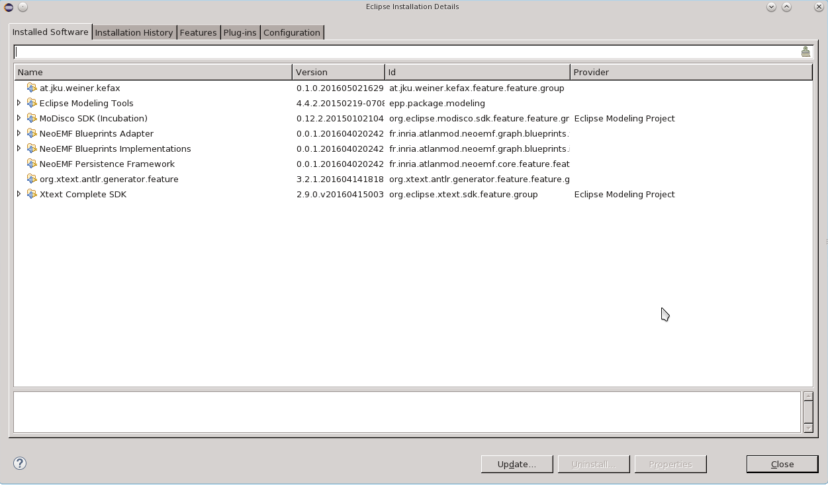
- Edit the eclipse.ini file. It should contain the following configuration:
--launcher.XXMaxPermSize
512m
--launcher.defaultAction
openFile
--launcher.appendVmargs
-vmargs
-Dosgi.requiredJavaVersion=1.7
-XX:MaxPermSize=512m
-Xms512m
-Xmx2800m
- Restart Eclipse
- Run by selecting menu items from KeFaX menu either
  - KeFax→ Run KeFax demonstration mode A
  - or KeFax → KeFax demonstration mode B
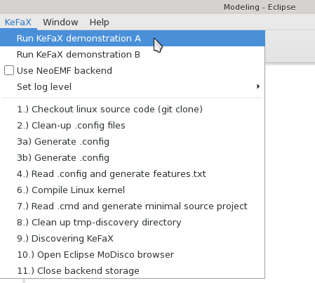
This will now download the Linux source code with git, generating a minimal working configuration file, execute a kernel compilation to obtain the compile options for all source files, generate a features.txt file in the destination project kefax-linux-working, copy the minimal required source and header files to the kefax-linux-working project and start discovering the kefax-linux-working project. Once pre-processing and parsing is done, KeFax will open the MoDisco EMF browser which shows the reverse-engineered Linux kernel C source model.

Demonstration mode A and demonstration mode B just differ by one feature: B has CONFIG_UNIX98_PTYS set to yes will it is not set for A at all. This is either done in step 3a) or in step 3b).

The resulting EMF model file(s) can than be found in the folder tmp-discover of the kefax-linux-working project.

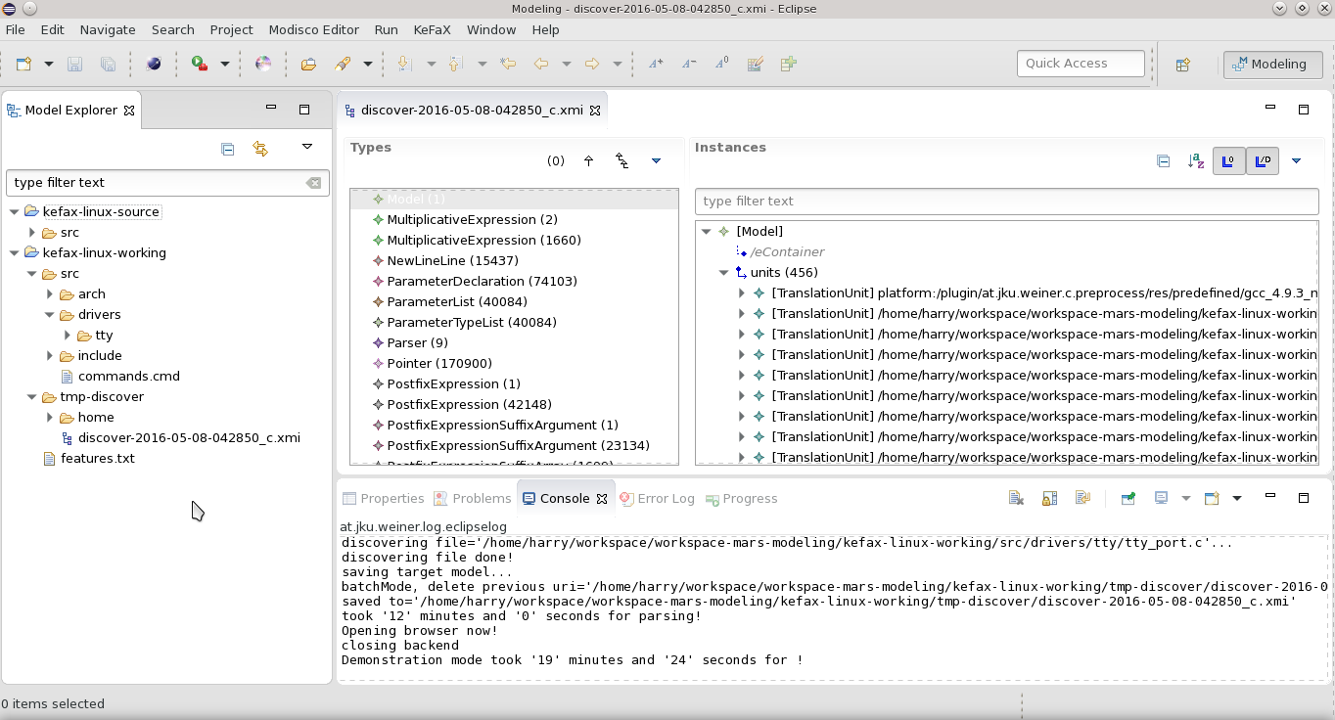
You might also adjust the log-level or run the individual commands step-wise to see what they are doing in detail.

Warning: Do not run with log-level set to trace. Log-level trace is only meant to be used for debugging very nasty bugs (e.g., preprocessor macro expansion). It will take almost forever to execute the preprocessor due to printing the detailed log to the console. Use at your own risk… You have been warned ;-).

How-To develop
The whole project is distributed under Eclipse Public License - v 1.0 (see http://www.eclipse.org/legal/epl-v10.html) unless otherwise stated. The source code can be obtained with git from https://github.com/timeraider4u/kefax:
- git clone https://github.com/timeraider4u/kefax
- Execute steps 2-7 from How-To use.
- Add https://timeraider4u.github.io/kefax/ as an update site, just like in step 8 of How-To use, but instead of installing kefax select at.jku.weiner.xtexttest/at.jku.weiner.xtexttest version 0.1.0.201605080110
- Restart Eclipse
- Import project into workspace (File→Import → General → Existing projects into workspace) and select the workspace folder inside the local kefax git repository as the root directory. Select all projects and start the import process.
- If there are any errors/failures shown after importing you may try to execute Project→ Clean → Clean all projects. This will remove temporary Xtext/Xtend files and enforce a global rebuild.
- The code structuring will be explained later in this paper.
- KeFaX uses Maven (and Github Travis) for continuous integration: A local Maven 3.0 build can be started by navigating to the local kefax git repository root and executing
mvn clean install. This will also execute all JUnit tests.
- Feel free to start a pull request or report an issue on Github.
  - The master branch is used for development
  - The branch gh-pages is used to store the Eclipse update site.
- Also take a look at the README.md file and execute git pull from time to time to keep in touch with the latest changes.

Linux kernel configuration/build
The Linux kernel is developed by programmers from all around the world and can be obtained at https://www.kernel.org/. A mirrored version of the Linux kernel can be found at https://github.com/torvalds/linux. The kernel is developed, compiled and installed by using Unix-like tools. The main documentation is provided as plain text files while the kernel itself is programmed in the C programming language. Although the kernel itself is developed in C and Assembler, some of the included helper tools are written in C++, in Bash shell scripts, or even in Python (e.g., see tools/perf/python/) or in Perl (e.g., see tools/perf/perl). The Linux kernel also uses its own ecosystem of „programming languages“ for configuration and building of the binary objects which are somehow „domain-specific languages“, which have historically grown over time.

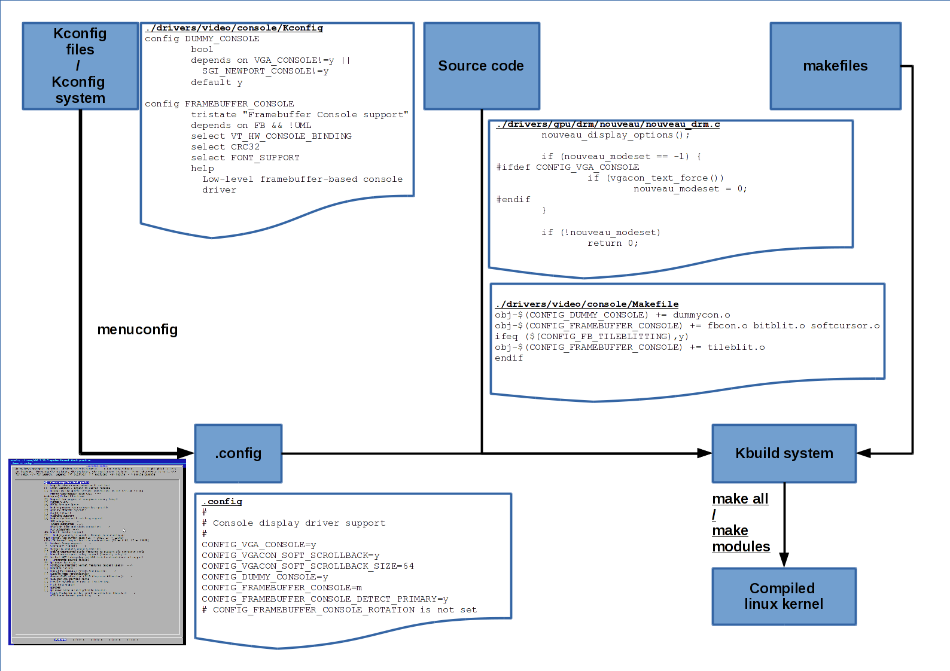
The picture above shows an overview of the dependencies between the different „DSLs“.

An overview of the kernel compilation and building can also be found at http://www.linuxjournal.com/article/6568

Kconfig
First, the Kconfig system specifies which features depend on each other or can not be combined together. Therefore, kconfig serves as some kind of non-formalized feature model. Here is an example:
./drivers/video/console/Kconfig
config DUMMY_CONSOLE
bool
depends on VGA_CONSOLE!=y ||
SGI_NEWPORT_CONSOLE!=y
default y

config FRAMEBUFFER_CONSOLE
tristate "Framebuffer Console support"
depends on FB && !UML
select VT_HW_CONSOLE_BINDING
select CRC32
select FONT_SUPPORT
help
Low-level framebuffer-based console driver

A detailed description of the kconfig system can be found at https://www.kernel.org/doc/Documentation/kbuild/kconfig-language.txt

The variability model of the Linux kernel is, e.g., described in She, Steven, et al. "The Variability Model of The Linux Kernel." VaMoS 10 (2010): 45-51, in Sincero, Julio, and Wolfgang Schröder-Preikschat. "The Linux Kernel Configurator as a Feature Modeling Tool." SPLC (2). 2008
and in Tartler, Reinhard, et al. "Dead or alive: finding zombie features in the linux kernel." Proceedings of the First International Workshop on Feature-Oriented Software Development. ACM, 2009. for older kernel versions but the main conclusions are still valid.

Generating a .config file:
The users can then use one of the configuration tools which get delivered with the Linux kernel,
e.g. make oldconfig when you already have a running kernel and you want to only update to a new kernel version or make menuconfig, etc. These applications use the kconfig files as input to determine which additional features must be selected or hide options which are not available due to conflicts. The configuration is then saved into a .config file at the root directory of the Linux kernel source code.

The following text listing is an example for such a generated configuration file:
#
# Console display driver support
#
CONFIG_VGA_CONSOLE=y
CONFIG_VGACON_SOFT_SCROLLBACK=y
CONFIG_VGACON_SOFT_SCROLLBACK_SIZE=64
CONFIG_DUMMY_CONSOLE=y
CONFIG_FRAMEBUFFER_CONSOLE=m
CONFIG_FRAMEBUFFER_CONSOLE_DETECT_PRIMARY=y
# CONFIG_FRAMEBUFFER_CONSOLE_ROTATION is not set

The following screenshot shows the menuconfig program, a graphical configuration tool which can be used on the terminal:

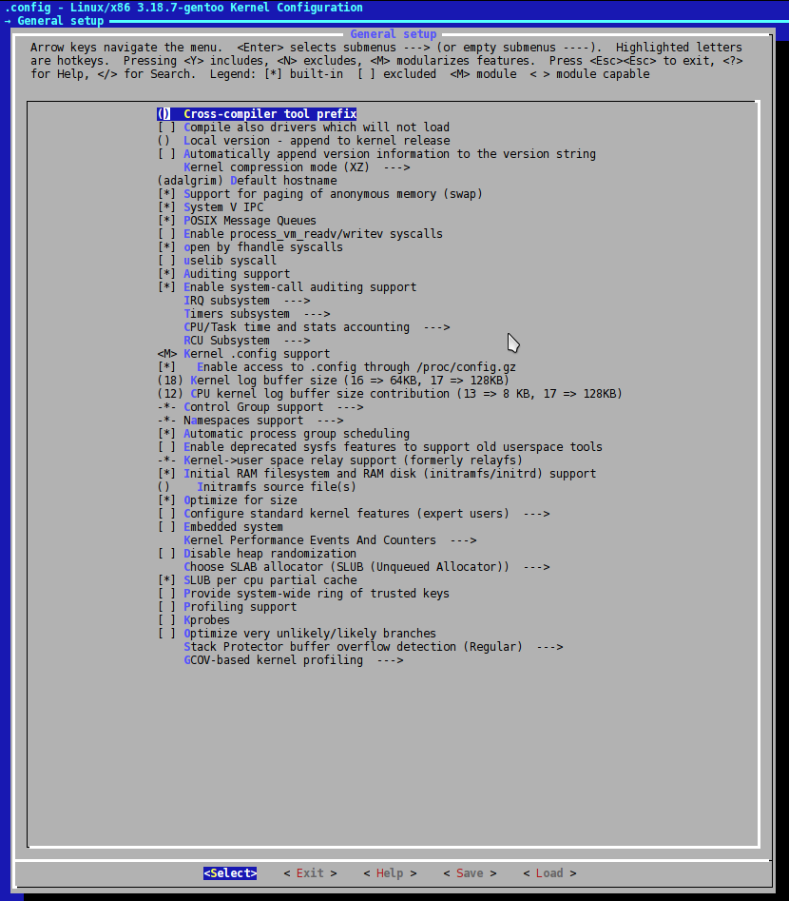

Kbuild system
Whenever the kernel, its modules or any initramfs should be built the kbuild system is invoked.
Some valid targets for building are
- make all
- make kernel
- make modules
- make vmlinux
- make initramfs

The makefile in the root directory of the linux source code then invokes the kbuild which generates / collects all necessary makefiles and processes them step-wise. Most of them just contain plain GNU make instructions but some contain additional bash script magic.

An example kbuild makefile is the following:
./drivers/video/console/Makefile
obj-$(CONFIG_DUMMY_CONSOLE) += dummycon.o
obj-$(CONFIG_FRAMEBUFFER_CONSOLE) += fbcon.o bitblit.o softcursor.o
ifeq ($(CONFIG_FB_TILEBLITTING),y)
obj-$(CONFIG_FRAMEBUFFER_CONSOLE) += tileblit.o
endif

The commands in the makefile then instruct the C compiler which source files to compile and which command line options to use. The selected features of the .config file are provided as pre-processor macro definitions. But also include directories are enlisted.

The following source snippet shows how the macro definitions are used in the C source code:
./drivers/gpu/drm/nouveau/nouveau_drm.c
nouveau_display_options();
if (nouveau_modeset == -1) {
#ifdef CONFIG_VGA_CONSOLE
if (vgacon_text_force())
nouveau_modeset = 0;
#endif
}
if (!nouveau_modeset)
return 0;

The results of the compilation are binary object files which can be installed to /boot and/or /lib/modules/<linux-version> with make install.

More information about kbuild itself can be found at
https://www.kernel.org/doc/Documentation/kbuild/makefiles.txt and
http://www.linuxjournal.com/content/kbuild-linux-kernel-build-system?page=0,2

The relationship between kconfig and kbuild is described in more detail at:
http://hemaprathaban.blogspot.co.at/2013/06/makefile-and-kconfig.html

$ find /usr/src/linux/ -name 'Makefile' | wc -l
1906 Makefiles in total!

Required code structure for ECCO

Ecco requires a structure similiar to the following file tree to be able to parse the product:
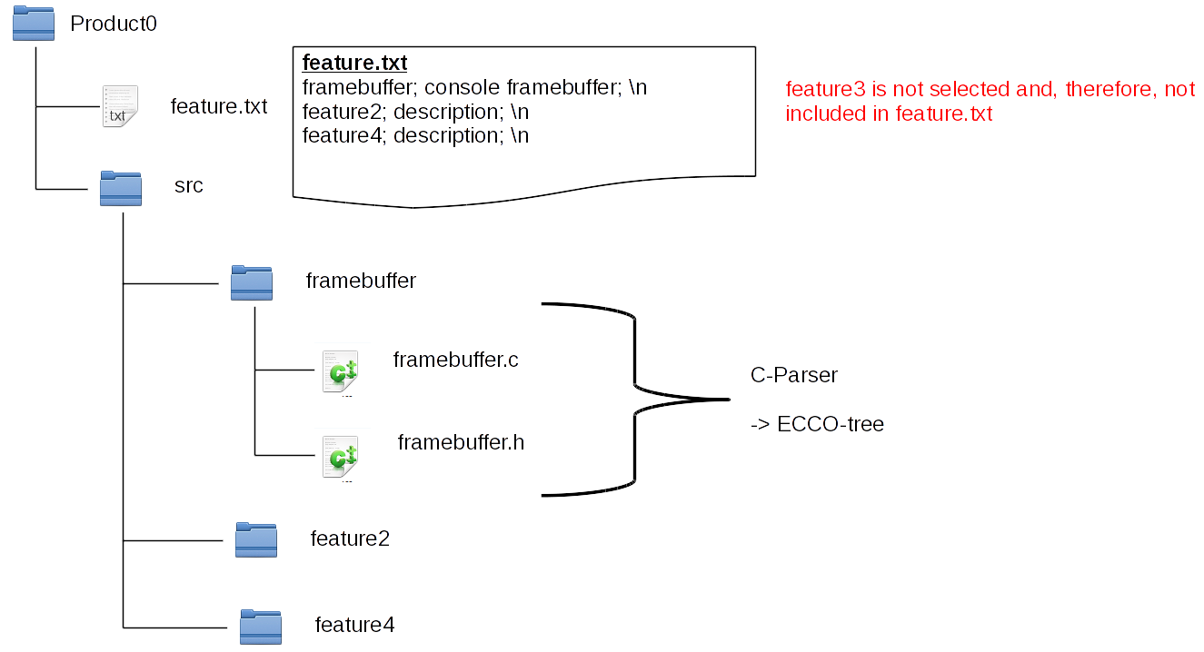
The feature.txt should list all enabled features, one per line starting with a unique name separated with a semicolon from the feature's description and a new-line character at the end.
The file structure should only contain the pruned source code (so no folders / source files for disabled features).
The source files should be parsed by some parser and be presented to ECCO as a tree data structure.

KeFaX requirements / KeFaX tasks

As a result of the required input structure of ECCO, the following coarse tasks can be identified for this project:
- Parsing .config file
- Obtaining compilation options (which source files are required to be parsed, which include directories are used)
- Pre-processing source code and removing un-taken pre-processor conditionals
- Parsing source code (.c / .h files)
- „Glue code“ + (Complete data model)
- Providing the data structure somehow to ECCO

These steps can be re-defined as:
- manually create .config by selecting features (e.g., in menuconfig)
- parse .config
- create features.txt (.config -> features.txt)
- obtain compilation options from kbuild makefiles
- prune source code files (code files for features that are not selected should be deleted) (.config+makefiles -> code structure)
- Step 6: run pre-processor on files and do fine-grain (#ifdef code which is not selected should be thrown away) (.config -> source code files)
- run C/C++ parser on source code
- generate ECCO data structure

KeFaX Development / Implementation
This chapter will clarify the development history, discovered bugs and design decisions taken.

Evaluation of existing tools
Let us first take a look on programs which already existed when this project started and why they have or have not been used for KeFaX:

Using existing compilers / compiler-generators
C/C++ are very complex programming languages with a lot of disambiguties, lots of different revisions (e.g. Std89, C++11) and a huge amount of compiler specific extensions (GNU GCC extensions, etc.). The Linux kernel makes use of some of the GNU C extensions. Therefore, it is not possible to compile the vanilla sources of the Linux kernel with Clang LLVM yet - the Clang front-end would provide a nice abstract syntax tree (AST), e.g., as a XML file. For compiler generators like CocoR, GNU's implementation of Yacc called Bison, etc. there is no unique and/or clear EBNF available for C/C++ which would also include most of the GNU C extensions. A little out-dated grammar for GNU GCC can be found at http://slebok.github.io/zoo/c/gnu/cordy-malton-dahn/extracted/index.html. GNU gcc itself provides its internal data structures to external programs. Applications might use this information and provide AST as XML, e.g. Antoniol, Giuliano, et al. "XOgastan: XML-oriented gcc AST analysis and transformations." Source Code Analysis and Manipulation, 2003. Proceedings. Third IEEE International Workshop on. IEEE, 2003.
The problem with these tools is that they are either not available anymore or are out-dated or buggy. But even if they would work, the next question is how to build-up the AST, which tools and which data structures to use and how much effort would be required to do so...

EMF
A tutorial for Eclipse EMF can be found under http://eclipsesource.com/blogs/tutorials/getting-started-with-the-emf-client-platform/

Xtext
Xtext can be used to develop domain-specific languages and graphical text editors for these languages. It can be obtained from
Xtext takes a language description file (.xtext) as input and generates Eclipse plug-ins (parser/lexer, graphical editor) and an Ecore metamodel as its output. This generated plug-in takes as input a text file and generates an EMF model as its output (if the file is an element of the language).

Parsing .config
The following hyperlink provides a Xtext DSL for the .config language http://linuxwochenende2011.luga.at/5/lwe2011rw.pdf
This description has been updated to be synchronized with the latest changes to the .config language. The following screenshot shows how the IDE looks-like when a .config file is opened with the generated UI text editor:
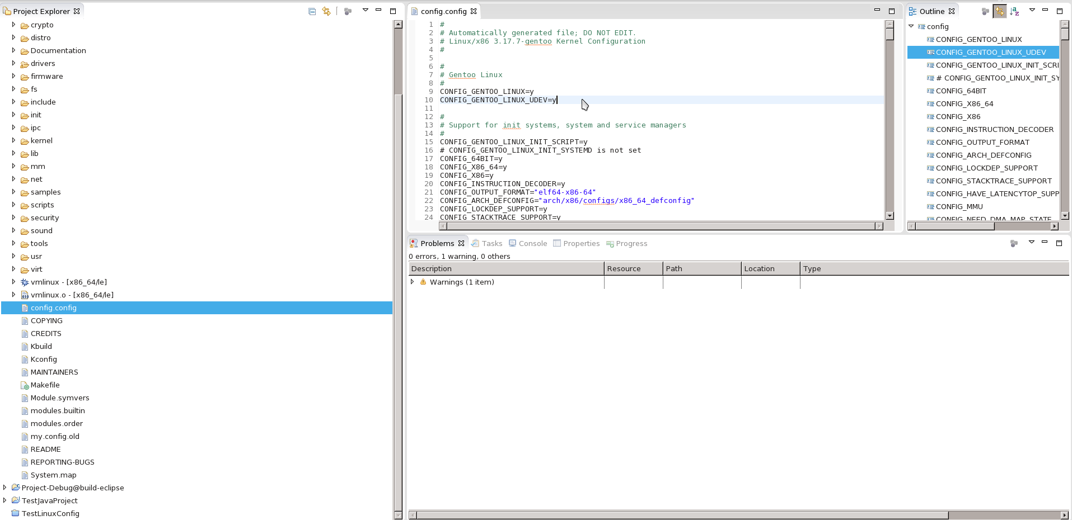

Obtaining compilation options

Collecting necessary source files

Parsing source code

