Accommodation is located at [Dong Hwa University Guest House](http://www.lio168.com/about.html" \t "_blank) [(MAP)](http://www.lio168.com/location.html) in the beautiful Dong Hua University campus. Rooms can be booked by contacting with the Guest House directly ([Online Booking](https://www.ezhotel.com.tw/donghwa/)).

|  |  |  |
| --- | --- | --- |
| **Room Type** | **Price** | **Photo** |
| Single Occupancy | 1200 | [view](http://www.lio168.com/double_room.html#images/r1-2.jpg) |
| Double Occupancy | 1600 | [view](http://www.lio168.com/4person_room.html#images/r2-2.jpg) |
| Triple Occupancy | 2000 | [view](http://www.lio168.com/6person_room.html#images/r3-2.jpg) |



Buffet style breakfast is included in the room charge

Please Note:

Advanced payment of 30% total room charge is required for reservation.

If traveler cannot arrive at the Guest House on the scheduled date, part of the advanced payment will be deducted according to governmental regulations in Taiwan. The amount is as follows:

All advanced payment is refundable if cancellation is received prior to 14 days of the scheduled arrival date.

70% advanced payment is refundable if cancellation is received 10-13 days prior to the scheduled arrival date.

50% advanced payment is refundable if cancellation is received 7-9 days prior to the scheduled arrival date.

40% advanced payment is refundable if cancellation is received 4-6 days prior to the scheduled arrival date.

30% advanced payment is refundable if cancellation is received 2-3 days prior to the scheduled arrival date.

20% advanced payment is refundable if cancellation is received 1 day prior to the scheduled arrival date.

All advanced payment is non-refundable if cancellation is made on the day of arrival.

In situations of natural disasters beyond human control, if cancellation is received before 12:00 the scheduled arrival date, advanced payment is returned via bank transfer after deducting the bank processing fee.

If there is any modification in the number or type of room reserved, if must be confirmed by the Guest House.

Conference Venues

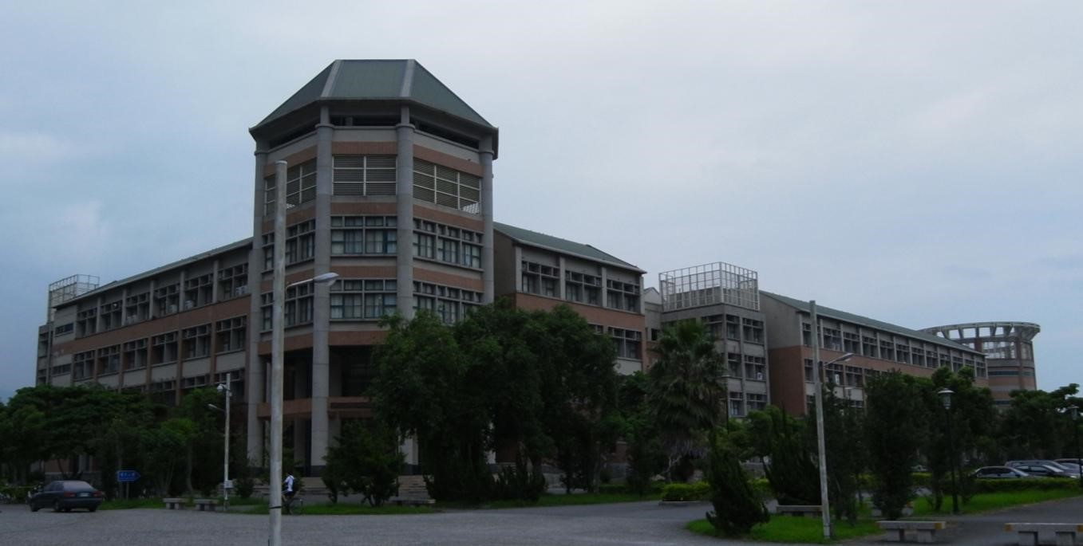

國立東華大學 電機工程學系（理工二館）

97401 花蓮縣壽豐鄉大學路二段一號

National Dong Hwa University Department of Electrical Engineering (Science and Engineering Building II)

No. 1, Sec. 2, Da Hsueh Rd. Shoufeng, Hualien 97401, Taiwan, R.O.C.

**Map to the Department of Electrical Engineering (Click the map directly to have a magnified image)**

