**Transportation**

For international participants who enter Taiwan through the Taoyuan Airport, you are suggested to follow the three steps below to reach the workshop venue:

* 1. **From Taoyuan Airport to Taipei Railway Station.(Bus, THSR, Taxi)**
  2. **From Taipei Railway Station to Hualien Railway Station.(Railway)**
  3. **From Hualien Railway Station to Dung Hwa University.(Shuttle)**

1. **From Taoyuan Airport to Taipei Railway Station**You are able to reach Taipei Railway Station from Taoyuan Airport by taking (i) a bus (ii) Taiwan High Speed Railway (THSR) (iii) a taxi. The maps below indicate the places to take the THSR (RED boxes), bus (YELLOW boxes), or taxi (GREEN boxes) at Terminal I and Terminal II. Taking a bus is more recommended because the bus goes directly from the TaoYuan Airport to the Taipei Station directly.
   * + 1. **Arrival at Terminal I**

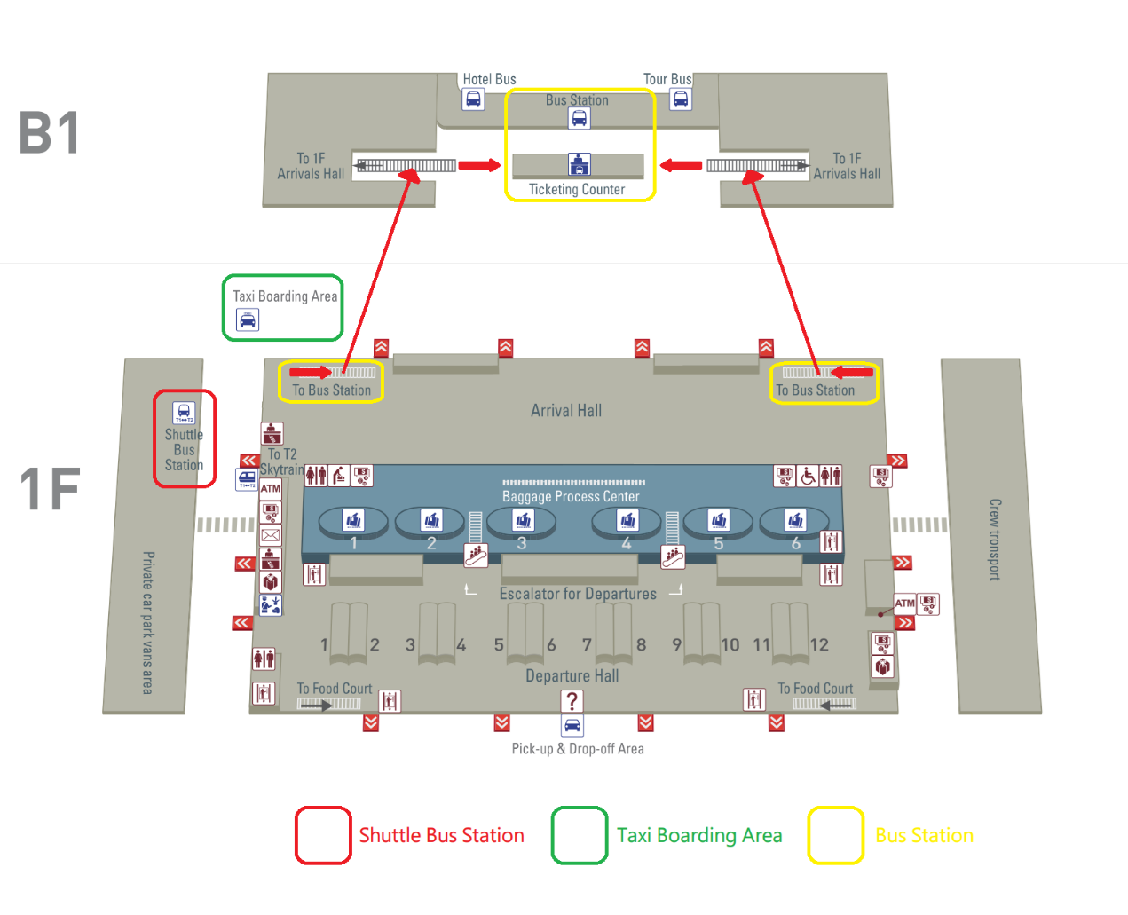

* + - 1. **Arrival at Terminal II**

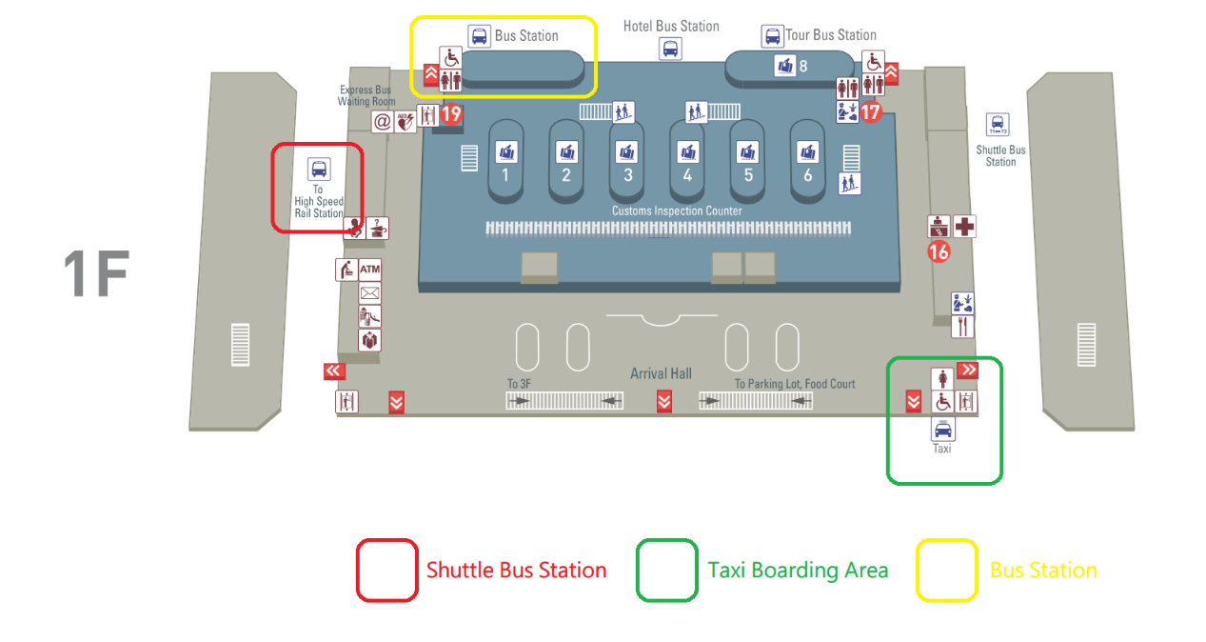

1. **Bus:**

The Bus tickets can be purchased at the Ticket Counter of the Arrival Halls directly. The ticket price ranges between 90-140 TWDs, depending on the service provider. The pickup points for all buses are highlighted by the YELLOW boxes in the maps above.   
Terminal 1 bus pickup point: B1.

Terminal 2 bus pickup point: The northeast arcade of the 1st floor.  
You could take the “1819 Bus” to Taipei Main Station and “1961 West Bus” to Taipei Railway Station.

1. **Taiwan High Speed Railway:**The UBUS shuttle service at the Arrival Halls takes passengers from the airport to the THSR TaoYuan station. One-way ticket costs 30 TWD, and the travelling time is about 25 minutes. The THSR ticket can be purchased at the station right before you get on the train, or you can book a seat online in advance. The on-line booking service is provided by the websites listed below, and the reservation can be made no more than 28days before your departure.

[**https://irs.thsrc.com.tw/IMINT/**](https://irs.thsrc.com.tw/IMINT/) **(中文訂票網站)**[**https://irs.thsrc.com.tw/IMINT?locale=en**](https://irs.thsrc.com.tw/IMINT?locale=en) **(Englishbooking website)**[**https://irs.thsrc.com.tw/IMINT?locale=ja**](https://irs.thsrc.com.tw/IMINT?locale=ja) **(日本語チケット予約)**

1. **Taxi:** Taxis Boarding Areas are highlighted by the GREEN boxes in the maps above. All taxis drivers must obtain a license from the Aviation Police Office to serve airport passengers. The Taxi fare is calculated by a certified meter automatically in the taxi. Do not take any unlicensed taxi or private car which does not use a meter to calculate the taxi fair. The taxi fair is estimated to be 1000~1200 TWDs, depending on the traffic conditions and the no. of red-light stops. If you do not speak Chinese, you can show the Chinese sentence below to the driver to go to the Taipei Railway Station:

“請把這位貴賓送到台北火車站，謝謝。”

1. **From Taipei Railway Station to Hualien Railway Station**

The timetable of the train and the ticket-booking service are provided by the websites below. Individual passengers can book and pay his tickets **two weeks** before his travelling date. Booked but unpaid tickets are only reserved till the midnight of the next day (counted from the date when the booking is made). Paid tickets can be reserved till the travelling date, and the tickets must be collected **30 minutes** before the train departure at the ticket counter of any railway station. Your ID or Passport needs to be shown to the ticket counter for ticket collection.

[**http://railway.hinet.net/**](http://railway.hinet.net/) **(中文訂票網頁)**

[**http://twtraffic.tra.gov.tw/twrail/**](http://twtraffic.tra.gov.tw/twrail/)**(中文時刻表)**

[**https://ticket.chinatrust.com.tw/railway/index.php**](https://ticket.chinatrust.com.tw/railway/index.php) **(訂票付款網站)**

[**http://railway.hinet.net/net_eng.htm**](http://railway.hinet.net/net_eng.htm) **(English booking website)**

[**http://twtraffic.tra.gov.tw/twrail/English/e_index.aspx**](http://twtraffic.tra.gov.tw/twrail/English/e_index.aspx) **(English Timetable)**

[**https://ticket.chinatrust.com.tw/railway/index.php**](https://ticket.chinatrust.com.tw/railway/index.php) **(Payment website)**

[**http://railway.hinet.net/ja_JP/net_eng.htm**](http://railway.hinet.net/ja_JP/net_eng.htm)**(日本語チケット予約)**

To makes BioPro participants’ travel easier, the BioPro2015 organizer provides the **extra service of booking train tickets from Taipei to Hualien on Aug. 24th and from Hualien to Taipei on Aug. 31st.** By the group-ticket booking service, we are eligible to book train tickets **two months** before the travelling dates. The tables below summarize the selected trains and ticket prices we plan to book in advance. Participants interested in using our service need to **select the train in the registration questionnaire,** and **pay the train ticket together with the registration fee** in advance. We will try to book 30 seats for each train on Aug.24th and 60 seats for each train on Aug.31st two months before the travelling dates. But **the organizing committee can not guarantee the booking will be successful**, as we need to compete with all travel agents in Taiwan. If the ticket is not successfully booked for your request, the ticket charge will be **fully refund** to you. For domestic faculties or international participants who will travel with family members, it is possible to book more than one ticket by sending your special request to [biopro2015.favs@gmail.com](mailto:biopro2015.favs@gmail.com) .

From Taipei to Hualien on Aug. 24th, five different trains are selected for our booking service 表格格式請用與General Information相同

|  |  |  |  |  |  |
| --- | --- | --- | --- | --- | --- |
| Number | Type | Train I.D | Departure Time from Taipei | Arrival Time to Hualien | Price |
| 1 | Taroko | 280 | 09:40 | 11:50 | $ 440 |
| 2 | Puyoma | 222 | 11:30 | 13:45 | $ 440 |
| 3 | Taroko | 232 | 14:30 | 16:38 | $ 440 |
| 4 | Puyoma | 238 | 16:30 | 18:35 | $ 440 |
| 5 | Puyoma | 248 | 19:30 | 21:35 | $ 440 |

From Taipei to Hualien on Aug. 31st, two different trains are selected for our booking service. 表格格式請用與General Information相同

|  |  |  |  |  |  |
| --- | --- | --- | --- | --- | --- |
| Number | Type | Train I.D | Departure Time from Taipei | Arrival Time to Hualien | Price |
| 1 | Puyoma | 229 | 16:35 | 19:00 | $ 440 |
| 2 | Taroko | 283 | 18:00 | 20:12 | $ 440 |

1. **From Hualien Railway Station to Dung Hwa University**

At Hualien Railway Station, you can take the 301 line shuttle to Dong Hwa University. As you walk out the Hualien Railway FRONT Station, you will see the shuttle station on your left-hand side. The Dong Hwa University Library is the final stop of the 301 shuttle. The timetable of the shuttle service is shown below, but it is subject to changes after June. 30th, 2015. The BioPro organizing committee may arrange our own shuttle service on Aug. 24th and 31st. The information will be announced on the iLMS system once it is set.

