Dong Hua University

The summer school will be held at National Dong Hua University (NDHU), located at the middle-east coast of Taiwan. According to [NDHU official website](http://www.ndhu.edu.tw/),

*University campus is located 16 km south from Hualien city in Shoufeng township. In all, the University campus and surrounding grounds total to more than 251 hectares (650 acres). Nestled between the Coastal Mountain Range and the Central Mountain Range in the verdant and pristine Papaya Creek Delta, the University is situated in a spectacularly beautiful natural environment. The air is pure and clean, and the campus possesses a tranquil and peaceful quality.*

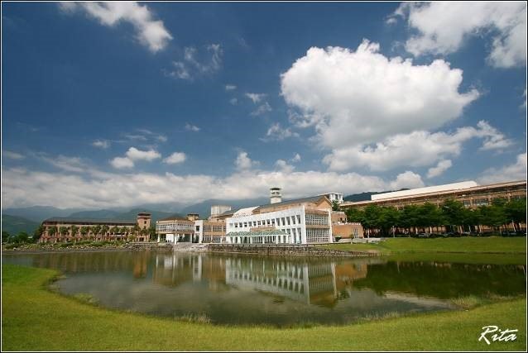

The following two videos gives a tour of the beautiful scenery on campus: （請內嵌）

<https://www.youtube.com/watch?v=Zz72fcRShfc>

<https://www.youtube.com/watch?v=7tlrFArSoJI>

The Science and Engineering Building II

The venue will take place at the science and engineer building II on Dong Hua University campus, where the electrical engineering department is located.

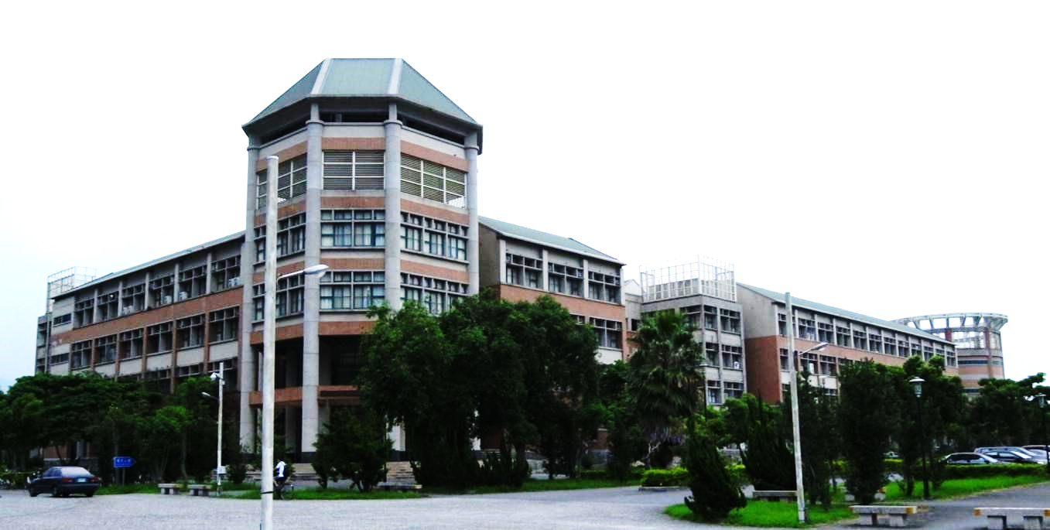

Lecture and discussion sessions will take place at the International Conference Halls located at the south-east corner of the building, as shown on the floor map below. Two electronic teaching labs will hold the hands-on project sessions.

|  |  |
| --- | --- |
|  |  |
| Conference Hall for Lectures and Tutorial | Conference Hall for Discussion Sessions |
|  |  |
| Entrance to Electronic Teaching Lab | Electronic Teaching Lab |



Campus Map （請留綠色那一張就好）

Below is the map of Dong Hua University campus. Participants are accommodated at the Guest House, while the Science and Engineering Building II (denoted “ENG. School”) will hold the summer school sessions. All are within walking distance.