SQL DAMP









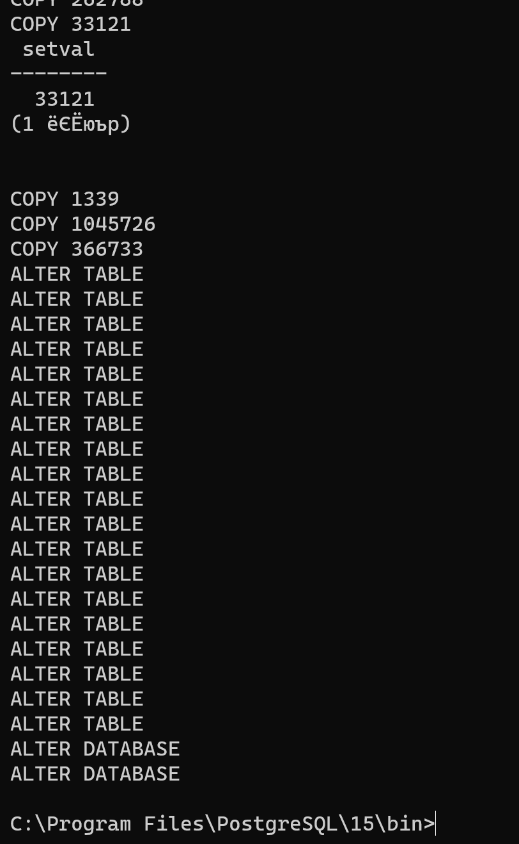

First SQL query

Select passenger_name,contact_data from tickets  
UNION ALL  
SELECT timezone, city from airports_data  
ORDER BY passenger_name DESC

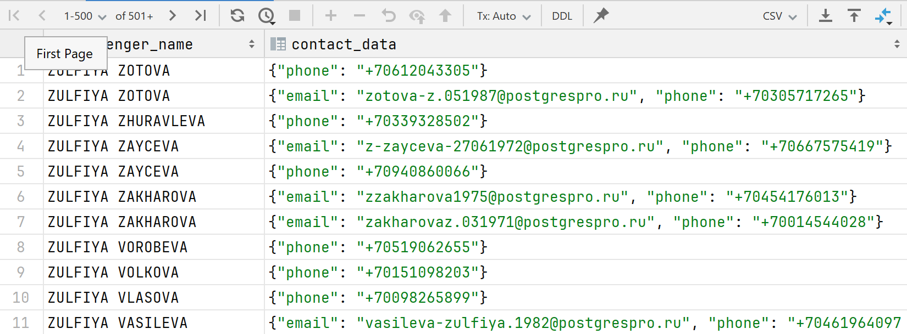

Second SQL query

Select passenger_name, passenger_id from tickets where passenger_name = 'ZULFIYA ZOTOVA'  
limit 1

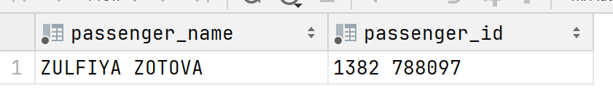

Third SQL query

Select flight_id, fare_conditions, *sum*(amount)  
from ticket_flights  
where *exists*(select 1 FROM flights where departure_airport = 'KZN')  
group by flight_id,fare_conditions

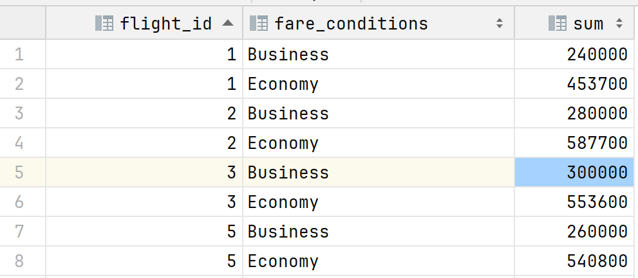

Fourth SQL query

Select departure_airport,arrival_airport FROM flights as fl1  
WHERE *EXISTS*(select 1 FROM flights as fl2 where fl1.**departure_airport** = fl2.departure_airport and fl1.**arrival_airport** = fl2.arrival_airport and fl1.**departure_airport** < fl1.**arrival_airport**)  
GROUP BY departure_airport, arrival_airport

