SQL запросы

A

Select airport_code, coordinates  
from airports_data  
where city ->> 'ru' = 'Казань'  
 or city ->> 'ru' = 'Москва'  
ORDER BY airport_code DESC;

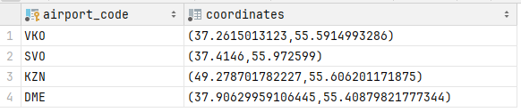

B

Select airports_data.airport_code || airports_data.city || airports_data.coordinates || airports_data.timezone ||  
 airports_data.airport_code as "полная информация"  
from airports_data  
ORDER BY "полная информация";

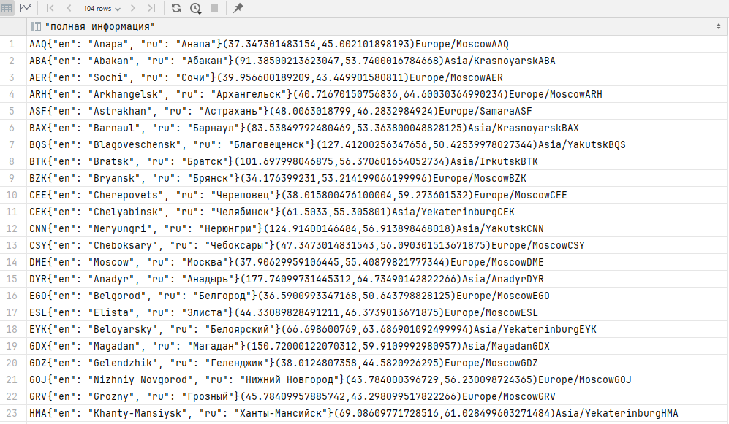

C

select airports_data.airport_name ->> 'ru', *count*(*\**)  
from flights  
 join airports_data on airport_code = departure_airport  
where flights.departure_airport in ('KZN', 'DME', 'OVB', 'IKT', 'LED', 'SVO')  
group by airports_data.airport_name  
ORDER BY *count*(*\**) Desc;

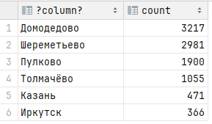

D

select airports_data.airport_name ->> 'ru', *count*(*\**)  
from flights  
 join airports_data on airport_code = departure_airport  
where flights.departure_airport not in ('KZN', 'DME', 'OVB', 'IKT', 'LED', 'SVO')  
group by airports_data.airport_name  
ORDER BY *count*(*\**);

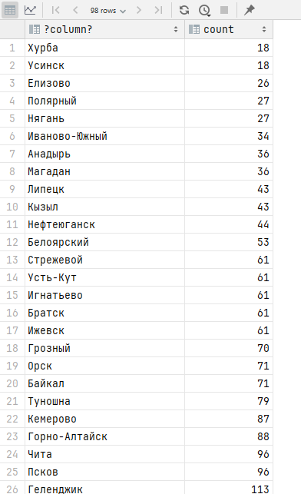

E

select flights.flight_no, flights.scheduled_departure, *count*(ticket_flights)  
from flights  
 JOIN ticket_flights on flights.flight_id = ticket_flights.flight_id  
group by flights.flight_no, scheduled_departure  
HAVING *count*(ticket_flights) between 27 and 90  
ORDER BY flight_no DESC, scheduled_departure DESC, *count*(ticket_flights) DESC;

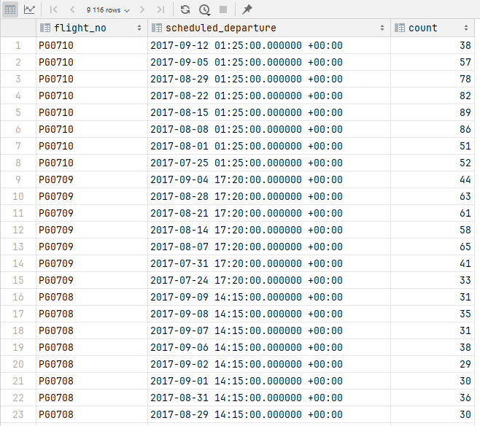

F

select tickets.passenger_name as element  
from tickets  
UNION ALL  
select airports_data.airport_name ->> 'ru'  
from airports_data  
ORDER BY element DESC;

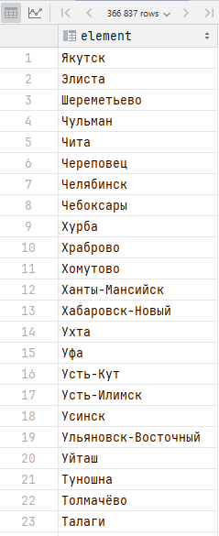

G

select tickets.passenger_name as element, 'Пассажир' type  
from tickets  
UNION ALL  
select airports_data.airport_name ->> 'ru', 'Аэропорт'  
from airports_data  
ORDER BY type DESC, element DESC;

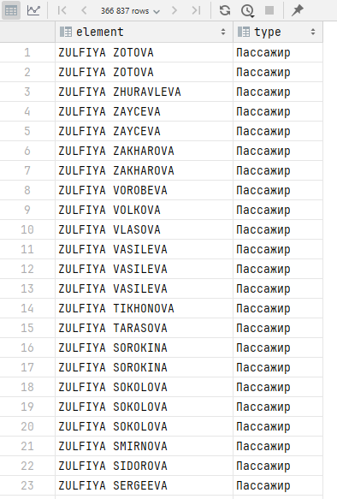

H

select *count*(*\**)  
from flights  
 LEFT JOIN ticket_flights on flights.flight_id = ticket_flights.flight_id  
where ticket_flights.flight_id is null;

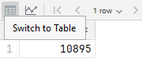

I

select airport_name ->> 'ru' as airport_name,  
 (  
 Select *AVG*(param)  
 FROM (  
 select *count*(seats) as param from seats  
 join aircrafts_data on seats.aircraft_code = aircrafts_data.aircraft_code  
 join flights on aircrafts_data.aircraft_code = flights.aircraft_code  
 join airports_data as air on flights.departure_airport = air.airport_code  
 where air.airport_code = airports_data.**airport_code** and (select *extract*(MONTH FROM scheduled_departure)) = 9  
 group by flight_id  
 ) as alias  
 ) as average_seats,  
 (  
 Select *AVG*(param)  
 FROM (  
 select *count*(ticket_flights) as param from ticket_flights  
 join flights on ticket_flights.flight_id = flights.flight_id  
 join airports_data as air on flights.departure_airport = air.airport_code  
 where air.airport_code = airports_data.**airport_code** and (select *extract*(MONTH FROM scheduled_departure)) = 9  
 group by flights.flight_id  
 ) as alias  
 ) as average_tickets  
 from airports_data  
 *-- where (select extract(MONTH FROM scheduled_departure)) = 9* group by airport_name ->> 'ru', airport_code  
 order by average_seats desc, average_tickets desc;

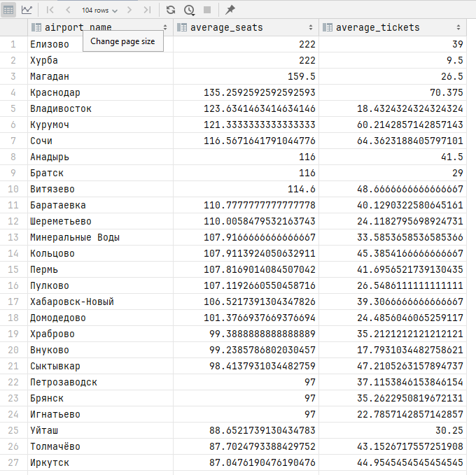

J

Select flight_id, *min*(amount) as min_price, *max*(amount) as max_price from ticket_flights  
group by flight_id  
order by flight_id;

