*-- 1*select airports_data.airport_name ->> 'ru' as name from airports_data  
EXCEPT  
SELECT airports_data.city ->> 'ru' from airports_data  
order by name;

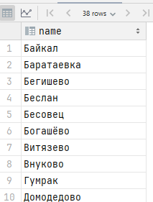

*-- 2*select airports_data.airport_name ->> 'ru' as name from airports_data  
INTERSECT  
SELECT airports_data.city ->> 'ru' from airports_data  
order by name;

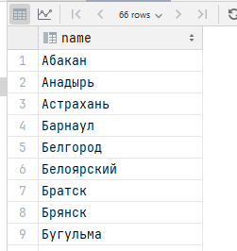  
  
*-- 3*select flights.aircraft_code, *count*(*\**) from flights  
join aircrafts_data on flights.aircraft_code = aircrafts_data.aircraft_code  
where departure_airport = 'KZN' and (select *extract*(YEAR from scheduled_departure)) = 2017 and (select *extract*(Month from scheduled_departure)) = 8  
group by flights.aircraft_code  
having *count*(*\**) > 50  
order by *count*(*\**) desc, flights.aircraft_code;

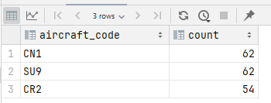

*-- 4*select *\** from bookings  
join tickets on bookings.book_ref = tickets.book_ref  
join ticket_flights on tickets.ticket_no = ticket_flights.ticket_no  
join boarding_passes on ticket_flights.ticket_no = boarding_passes.ticket_no and ticket_flights.flight_id = boarding_passes.flight_id  
join flights on ticket_flights.flight_id = flights.flight_id  
join airports_data on flights.departure_airport = airports_data.airport_code  
join aircrafts_data on flights.aircraft_code = aircrafts_data.aircraft_code  
join seats on aircrafts_data.aircraft_code = seats.aircraft_code

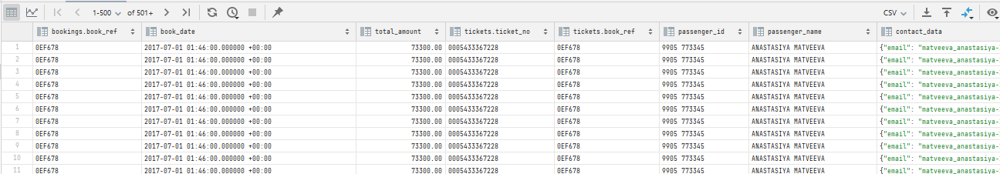

*-- 5*select flights.flight_id  
from ticket_flights  
 RIGHT JOIN flights on flights.flight_id = ticket_flights.flight_id  
where ticket_flights.flight_id is null;

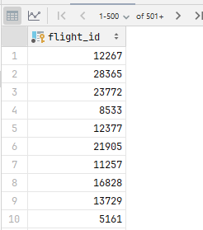  
  
*-- 6*select flight_no, *sum*(ticket_flights.amount) as sum from ticket_flights  
join flights on ticket_flights.flight_id = flights.flight_id  
group by flight_no, scheduled_departure  
having (select *extract*(YEAR from scheduled_departure)) = 2017 and (select *extract*(Month from scheduled_departure)) = 8  
order by sum desc;

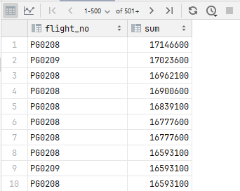  
  
*-- 7*select flight_no,  
 (select *sum*(amount) from ticket_flights where ((select *extract*(YEAR from scheduled_departure)) = 2017 and (select *extract*(Month from scheduled_departure)) = 8 and flights.**flight_id** = ticket_flights.flight_id)) as august,  
 (select *sum*(amount) from ticket_flights where ((select *extract*(YEAR from scheduled_departure)) = 2017 and (select *extract*(Month from scheduled_departure)) = 9 and flights.**flight_id** = ticket_flights.flight_id)) as september from ticket_flights  
join flights on ticket_flights.flight_id = flights.flight_id  
group by flight_no, scheduled_departure  
order by flight_no, september desc , august desc;

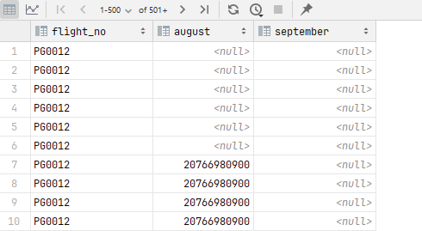

*-- 8*select tickets.passenger_name from tickets  
where passenger_name ilike '%iRiNa%'  
group by tickets.passenger_name

