Corvus installation instructions

Requirements:
- FEFF10: https://times-software.github.io/feff10/
- Python:
Two alternatives:
  - Miniconda (preferred for windows): https://www.anaconda.com/download
This version of python will allow you to continue without administrative privileges, even on Windows.
Note: anaconda (miniconda) sometimes has problems if it is installed in a directory that contains spaces, so if your home directory has spaces, you might choose a different directory to install in.
  - https://www.python.org/downloads/
IMPORTANT: Make sure python is in your path before attempting to install corvus! In order to do that with the above python installer and Windows, make sur the “Add python.exe to PATH” button is selected on the first screen after starting the installer.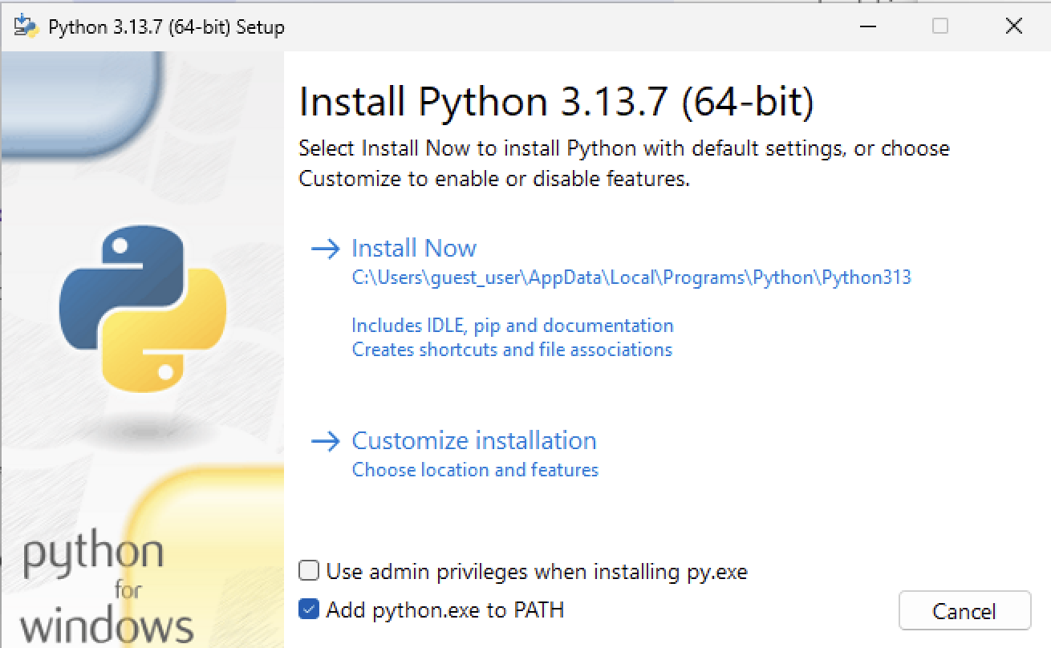
    - The above python requires Microsoft visual C++ build tools 14.0: https://visualstudio.microsoft.com/visual-cpp-build-tools/
You cannot install Microsoft visual C++ unless you have administrative privileges.
When you install, select the following packages for installation:
- Desktop development with C++ workload:
- MSVC v14x build tools (latest):
- Windows SDK:

Installation of Corvus
Warning: This installation is fairly large due to the use of pymatgen. It can take a while to download and install everything. Expect 10 to 20 minutes for the installation process to complete.
Note: The following download instructions will make a venv python environment in your home directory, i.e.,
your_home/.venv/Corvus
and install corvus in that directory. If you do not want to use a venv environment (for example if you use anaconda) you should perform a manual install as detailed below.

Windows:
- Download the latest release version of corvus:
https://github.com/times-software/corvus/releases/latest
- Unzip the archive.
- Open a terminal
  - Miniconda: open an anaconda powershell terminal
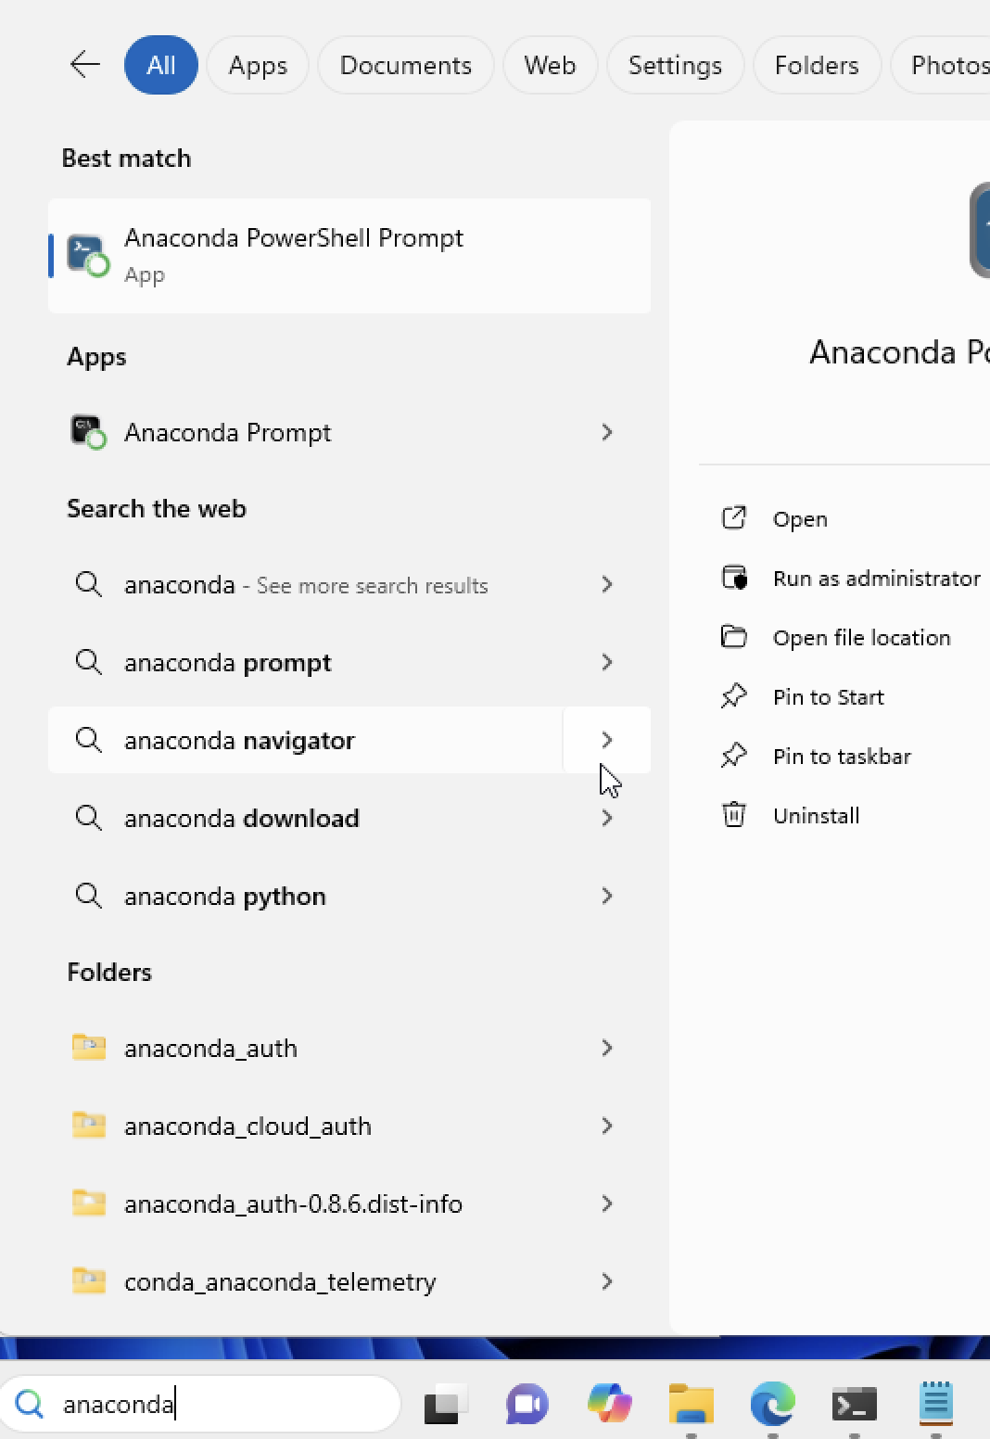
  - Standard python: open a powershell script
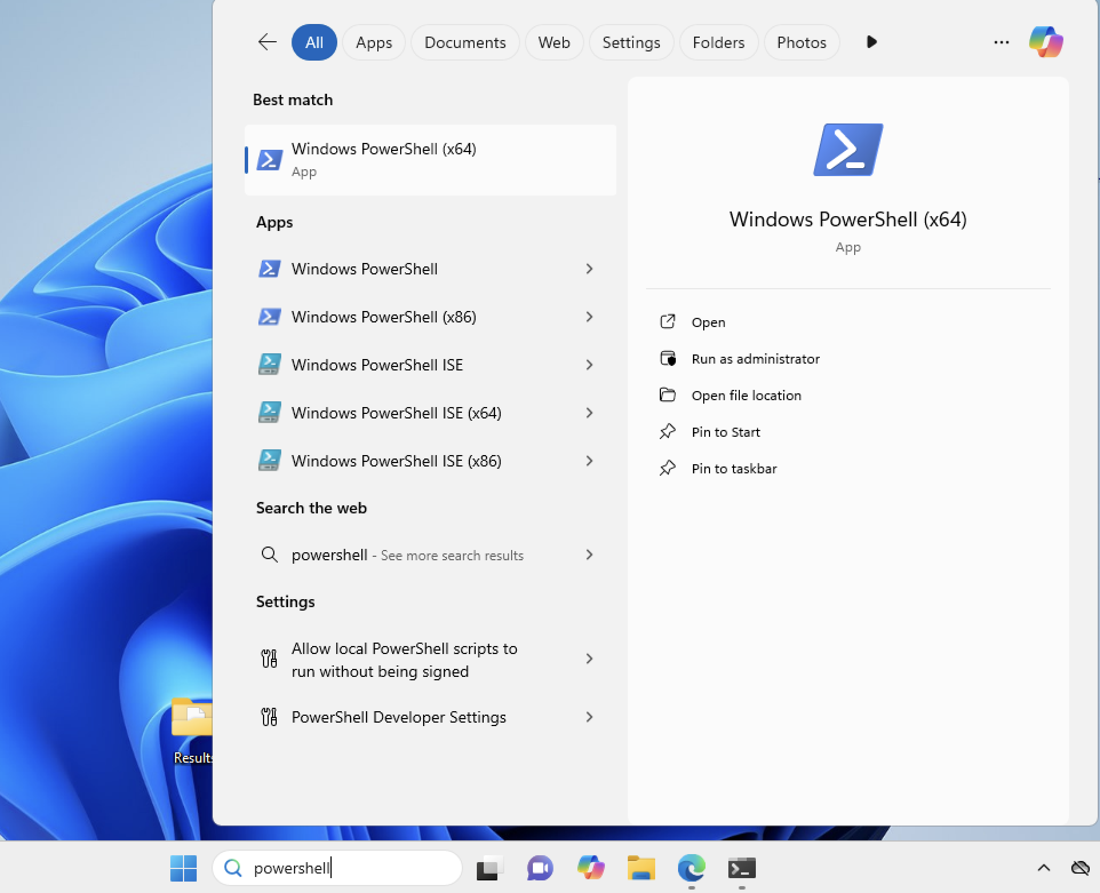
- Type
cd ~\Downloads
cd Corvus-[latest version]\Corvus-[latest version]
where [latest version] signifies the version that you downloaded. Note that this is TWO folders named Corvus-[latest version]
- Run the appropriate install script
  - Miniconda python:
.\install_w_miniconda.ps1
  - Standard python
Set your execution policy so that you can run the powershell script.
Set-ExecutionPolicy -Scope CurrentUser -ExecutionPolicy Bypass -Force
.\install_w_venv.ps1
- Activate the corvus environment:
  - Miniconda:
open an anaconda powershell terminal and type:
conda activate Corvus
  - Standard python
~\.venv\Corvus\Scripts\Activate.ps1
- Run Corvus
You should then be able to run corvus from the command line with
run-corvus [options]
You can test this by typing:
run-corvus –version
You can run the corvus GUI by typing
corvus
Mac OS:
- Download the latest release version of corvus:
https://github.com/times-software/corvus/releases/latest
- Unzip the archive.
- Open a terminal: “Applications -> Utilities -> Terminal
- Type the following command in the terminal to change directory to the downloaded corvus directory:
cd ~/Downloads/Corvus-[latest version]/
where [latest version] signifies the version that you downloaded, e.g., Corvus-1.5.0
- Type:
source install_w_venv.sh
and follow the instructions.
- There will now be several executable scripts on your desktop. Double click to start corvus:
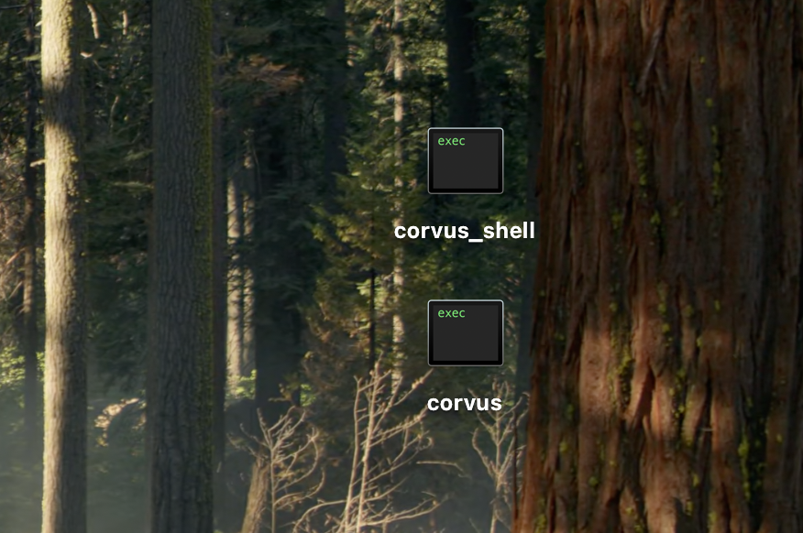
- corvus_shell – open a shell to run corvus in the terminal
To test the installation, you can type:
run-corvus --version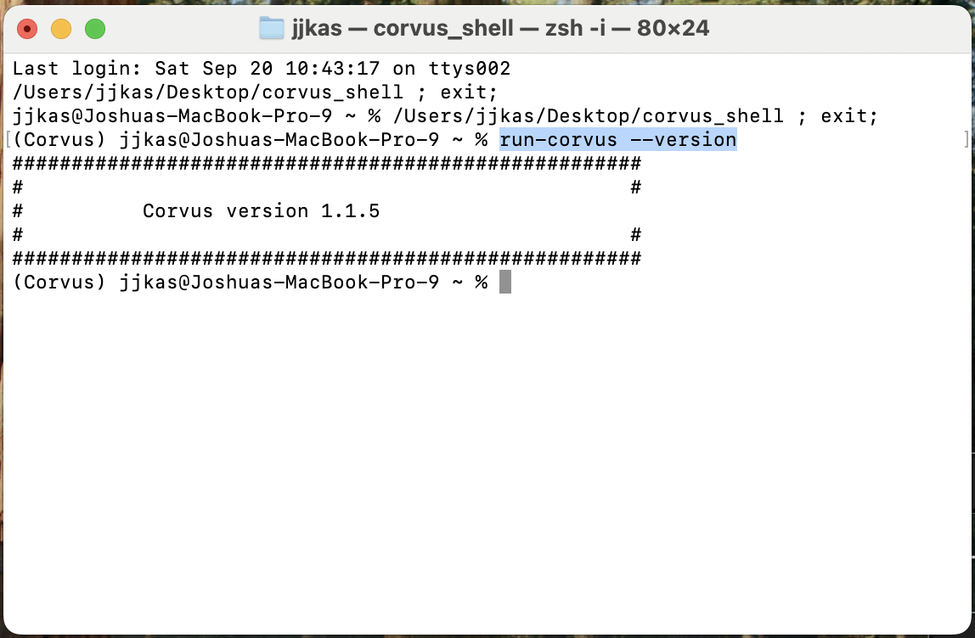
- corvus – open the corvus graphical user interface.
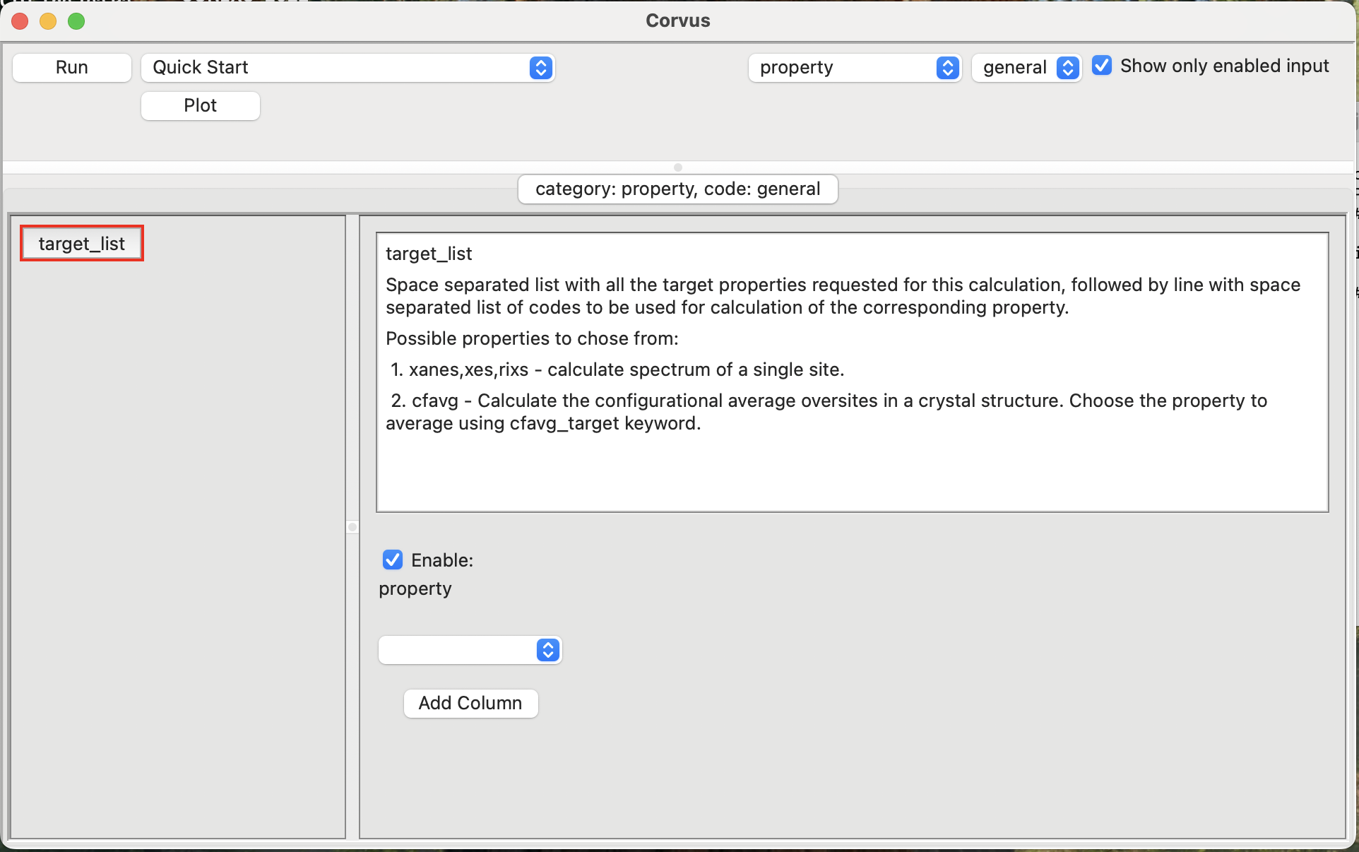
Note: Sometimes the above window does not come to the front on MacOS. If you don’t see it look behind other windows or for the python icon in your toolbar.
Manual installation:
If you do not want to use venv environments, or the above installations don’t work for your system, use the manual installation instructions below.
- Download the latest release version of corvus:
https://github.com/times-software/corvus/releases/latest
- Unzip the archive.
- Go into the expanded archive directory. Inside it you should see a setup.py file.
- Optional: create a python environment and activate it to isolate this installation from your other python projects.
- Install with pip.
pip3 install .
- If you want the corvus graphical user interface, download it at: https://github.com/times-software/SciGUI/archive/refs/heads/main.zip
- Unzip the downloaded file SciGUI-main.zip.
- Use the terminal to install it. If you created a python environment, make sure it is activated before using pip to install.
cd ~/Downloads/SciGUI-main
Activate your environment if you made one
pip3 install .
- Now in the future, to start corvus:
  - Open a terminal
  - Activate your environment if you chose to make one
  - Test corvus
run-corvus –version
  - Open the corvus GUI
corvus

