**Concert Calendar**

Project Deliverable

**Project Description**

Concert Calendar is an Android 4.2.2 application that displays a searchable list of upcoming concerts in Philadelphia area. This application allows users to track artists by name as well as see a list all upcoming concerts for the next 5 days. Searches can be saved and accessed at a later time.

Concert information used is loaded from <http://www.xpn.org/events/concert-calendar>. Project utilizes <https://cloudmine.me> object storage to store concert information. Running application for the first time parses and stores concert data into Cloudmine. Subsequent runs will load data from Cloudmine, thereby skipping the parsing step and speeding up the application. Before loading concert data from Cloudmine, Concert Tracker will check if it is less than 24 hours old. Running application more than 24 hours after previous run will once again download, parse and store fresh data from www.xpn.org into Cloudmine.

**Project Features**

* Search for upcoming concerts in Philadelphia area by artist name.
* Search artist names by using multiple search strings.
* Save searches to Cloudmine to access quickly in the future.
* List all artists performing in Philadelphia area for the next 5 days.
* Easy to use interface.

**Usage**

***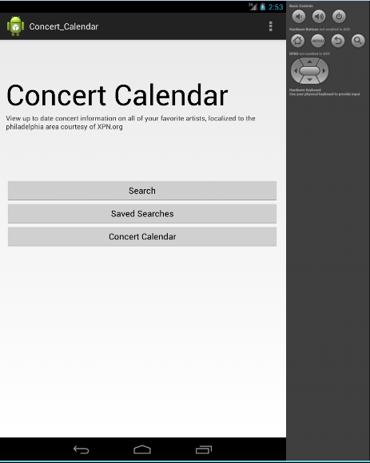****Initial Screen* contains 3 buttons, Search, Saved Searches, and Concert Calendar. To exit application press android back button.

* Search Button - Search concerts by artist
* Saved Searches - Loads previously saved searches
* Concert Calendar Button - View all artists performing in the next 5 days

*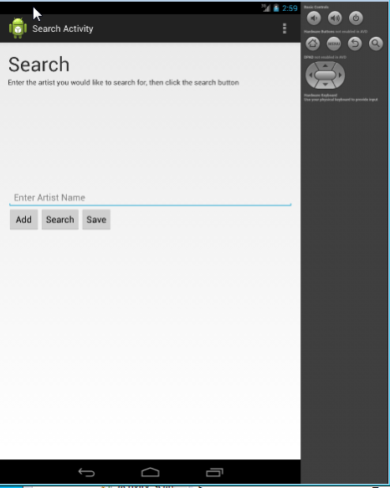Search Screen* contains 3 buttons, Add, Search and Save. Artist name should be typed in provided space.

* Add Button - adds artist name to list of artists to search. Names of artists will appear at the bottom.
* Search Button - runs search, takes to search result screen.
* Save Button - saves current search.

Note that searching for artists without first adding search string will produce no results. To go to previous screen press android back button.

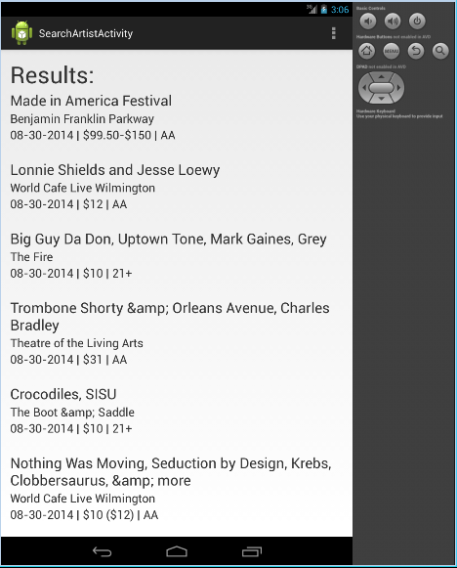This is an example of search *Results Screen*. Results can be scrolled up and down. Each concert is visibly separated by space.

* On top of each concert appears artist and band . For long names this may appear as two lines.
* Next line shows venue, location.
* Last line shows concert date, price, and age restrictions.

Press android back button to go back to search screen.

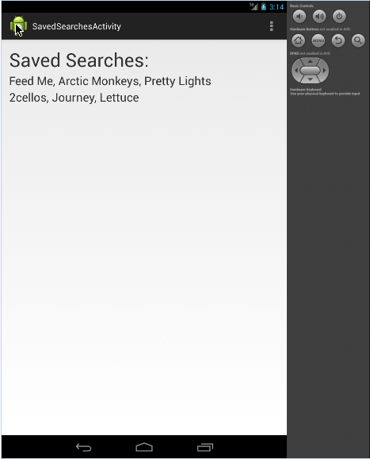Pressing Saved Searches from *Initial Screen* will list all artists whose searches have been saved. Press android back button to go back to Initial Screen.

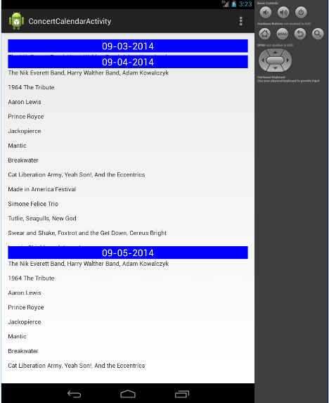Concert Calendar screen shows all artists performing in the next 5 days. It is accessed by pressing Concert Calendar button in Initial Screen.

Note that days when no artists are performing are hidden. Each day is separate and is scrollable up and down. To go back to Initial Screen press android back button.

**Design and Implementation Details**

Project Source Code: **https://github.com/times05/Concert_Calendar.git**

Note that this was only for submission purposes. Github has not actually been used for version control.

Software Tools:

* Java SE 1.8
* Development Environment Eclipse Java EE IDE for Web Developers. Luna Release 4.4.0. (Other versions of Eclipse as well).
* Android Development Tools from adt-bundle-windows-x86_64-20140702
* Device Target: Android 4.4.2 - API level 17
* Requires appcompat_v7 to run.

Libraries Used:

* jsoup-1.7.3.jar - from <http://jsoup.org> . This library does Java HTML parsing.
* cloudmine-android-v0.6.3.jar
* ConcertCalendar.jar - this is a library written by our project members. It does basic parsing of xpn.org concert calendar using jsoup. It stores concert calendar variables in memory as MAP <Int, String>. Library started out as a pure java project that would download, parse and print out all of the concert calendar data from xpn.org. Source code for original will be included in Github folder as a standalone parseURL.java for grading purposes. Note that it isn't required to run our project, its code is already included in ConcertCalendar.jar library.

Android Emulator Configuration (as seen in Eclipse)

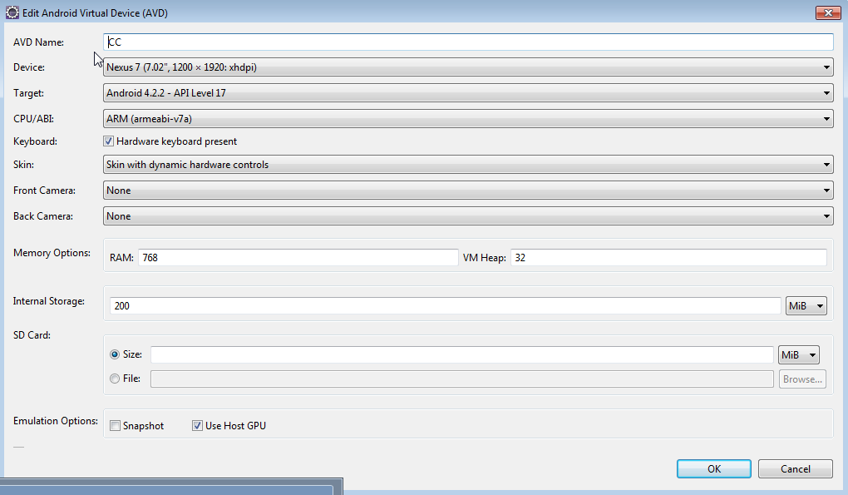

Version Control and Collaboration Mechanism Used:

We did not use a version control tool. Instead we had a remote server computer with development environment setup. RealVNC was used to access this machine remotely by several project members at once. In conjunction with Skype, it gave us the ability to collaborate from our homes and do side by side programming. This is similar to editing google doc, except all 3 project members were able to contribute to the same development environment one at a time while others can watch, make suggestions, and interact with the screen at any moment as needed.

This setup gave us some advantages as well as disadvantages. On a small project, where many modules depend on each other it is difficult to spread out workload for individuals to work independently. Also Eclipse is very uncooperative with importing projects, there are numerous adjustments that had to be made each time. This setup was advantageous in that using same environment we saved a lot of setup and configuration time which would have been spent had we each used separate environments. It allowed us to focus on writing code.

On the other hand we did not really use a version control mechanism, so when a mistake was made, going back to previous state was not always trivial. We could easily delete or place malfunctioning code in comments as needed. That part did not present a problem. Once there was an issue where bad code had overwritten our Cloudmine database. At that version, deleting and writing code back to Cloudmine was not possible, although it was possible in a much earlier version. This caused us to scramble and attempt to find a very specific older version. That task would have been trivial had we used version control system like Git for example.

In retrospect we could have combined both methods. Using remote machine, while still backing up code via Github's version control. This would have given us advantages from both methods.

**Program Structure and Overview:**

Layouts Used (located in Concert_Calendar/res/layout/ folder):

activity_concert_calendar.xml - displays 5 day list of upcoming concerts

activity_main.xml - first screen that appears when launching application.

activity_saved_searches.xml - displays saved searches, artist names.

activity_search_artist.xml - displays search results, scrollable up/down list of concerts.

activity_search.xml - search screen itself where user types in artist name and adds to search.

Development Log:

7/15/2014 - First version of Concert Calendar java only is made. This version uses jsoup to parse url, namely xpn.org and separates artist/venue/price and other fields which will later be used.

7/21/2014 - Problem porting code to android, attempted to just copy paste, into sample android Hello World app, does not work. Had to use it as library. Made ConcertCalendar.jar .