## **Option1: Create an API for leaderboard application**

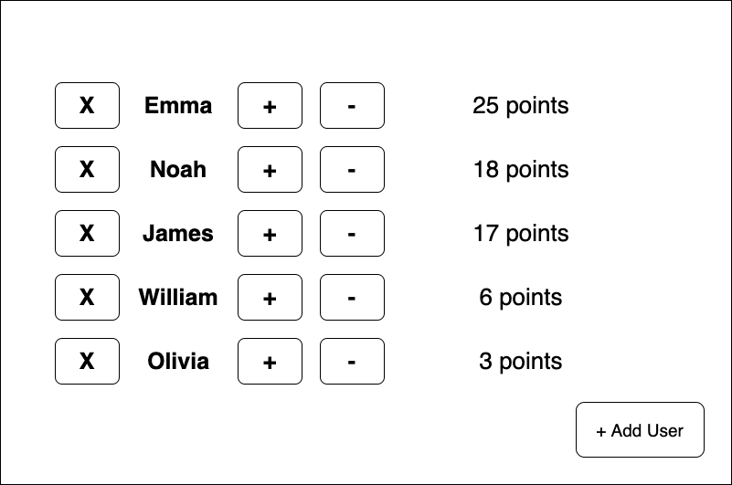

**Requirements:**

* IMPORTANT: There is no need to implement the UI
* Write an API that would power the leaderboard Screen above (REST/GraphQL or)
* All users start with 0 points
* As you click +/-, the leaderboard updates and users are re-ordered based on score
* You are able to add users (+) and delete users (x)
* When the name is clicked on, UI would show details of this user
  + Name
  + Age
  + Points
  + Address

**Guideline:**

* Please include a readme file with instructions to run the application
* We are open to your choice of language (preference would be php/python)
* Unit test for areas you see fit
* Brief documentation on the endpoints
* Provide us with link to repository, and link to the API (if you are able to host)