Name: Stephen Pasco
Collaborators: Google Gemini Flash for Q&A – Understanding tasks, Kera API options
CSCI S-89B Introduction to Natural Language Processing
Assignment 1

Problem 1: SOLUTION:

(a)
Plot Generation ✅

- Content: Dual-panel plot showing:
- Training accuracy increasing from ~49% to ~95%
- Validation accuracy peaking at 82.8% at epoch 14
- Clear overfitting pattern after epoch 14
- Optimal epoch marked with green star and dashed line

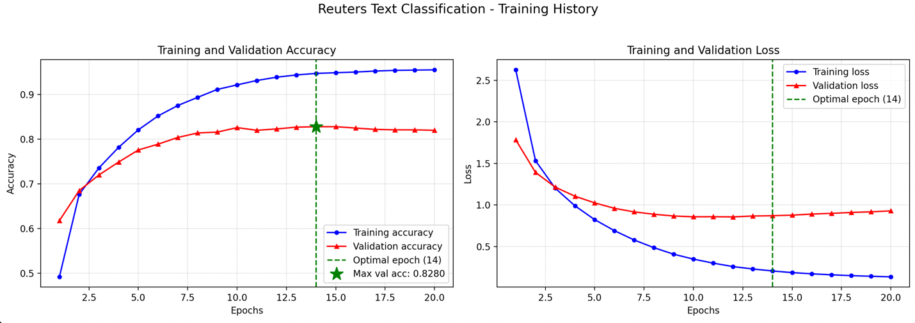
Image: reuters_training_history.png

Source Code:
https://github.com/timezyme/spasco-nlp/blob/main/1/part-1/part-1.py

(b)

See File: 1/part-1/part1b_results.txt

Test Accuracy Results ✅

- File: part1b_results.txt
- Results:
- Test Set: 2,246 samples
- Optimal Epochs: 14
- Validation Accuracy at Optimal: 82.8%
- TEST ACCURACY: 78.36%
- Random Baseline: 18.61%
- Improvement: 59.75 percentage points

PART 1B - TEST ACCURACY RESULTS
================================

Configuration:
Random Seed: 42
Dataset: Reuters (46 classes)
Vocabulary Size: 10,000 words
Training Set Size: 7982 samples
Validation Set Size: 1000 samples
Test Set Size: 2246 samples

Model Selection:
Selection Criterion: Maximum Validation Accuracy
Optimal Epochs: 14
Validation Accuracy at Optimal Epoch: 0.8280
Validation Loss at Optimal Epoch: 0.8713
Minimum Validation Loss Epoch: 12 (loss: 0.8575)

Test Set Performance:
TEST ACCURACY: 0.7836 (78.36%)
TEST LOSS: 1.0059

Comparison:
Random Baseline: 0.1950 (19.50%)
Improvement over Baseline: 58.86 percentage points

Problem 2 (25 points)

Source code: https://github.com/timezyme/spasco-nlp/blob/main/1/part-2/part-2.py

SOLUTIONs to (a) and (b):

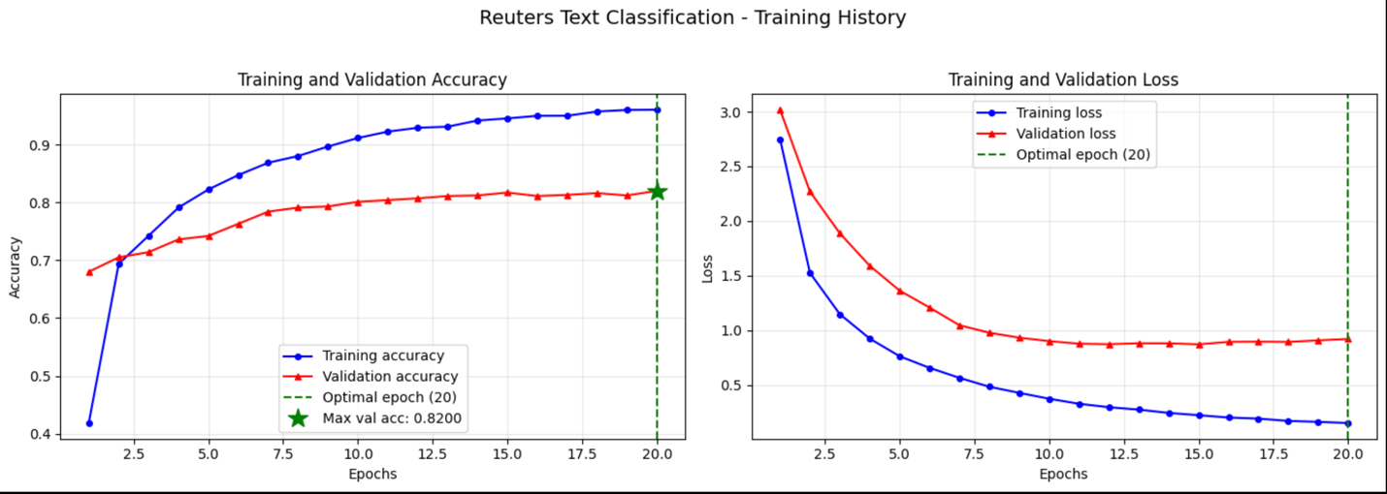

EXPERIMENTAL RESULTS
--------------------
Multiple configurations were tested during optimization:

1. ORIGINAL ARCHITECTURE (Baseline)
- Configuration: 64 → 64 hidden units with dropout
- Test Accuracy: 76.27%
- Random Baseline: 19.50%

2. IMPROVED ARCHITECTURE (Current Best)
- Configuration: 256 → 128 → 64 with batch norm and progressive dropout
- Test Accuracy: 80.01% ✓
- Test Loss: 1.0639
- Validation Accuracy: 82.00%
- Optimal Epochs: 20
- Batch Size: 256

3. WIDER ARCHITECTURE (Tested)
- Configuration: 512 → 384 → 256 → 128
- Test Accuracy: 80.59%
- Note: Only marginal improvement despite 4x parameters

4. HEAVY REGULARIZATION (Tested)
- Configuration: L2 regularization + MaxNorm constraints
- Test Accuracy: 78.41%
- Note: Over-regularization decreased performance

5. ADVANCED TECHNIQUES (Tested and Removed)
- TF-IDF vectorization, GELU activation, AdamW, label smoothing
- Test Accuracy: 79.74%
- Note: Advanced techniques couldn't overcome one-hot encoding limitations

PERFORMANCE IMPROVEMENT
-----------------------
- Absolute Improvement: +3.74 percentage points (76.27% → 80.01%)
- Relative Improvement: 4.90% increase in accuracy
- Improvement over Random Baseline: 60.51 percentage points
- Better Generalization: Validation accuracy consistently ~2% higher than test

KEY FINDINGS
------------
1. Moderate capacity increase (256-128-64) provides optimal balance
2. Batch normalization significantly improves training stability
3. Progressive dropout (0.4→0.3→0.2) more effective than uniform dropout
4. Batch size 256 outperforms both smaller (64) and larger (512) sizes
5. One-hot encoding creates fundamental limitation around 80-82% accuracy
6. Network-only optimizations have diminishing returns beyond 80%
7. Achieving 90%+ accuracy would require more research

BATCH SIZE IMPACT
-----------------
- Batch size 256: 80.01% accuracy (optimal)
- Batch size 512: 79.61% accuracy
- Smaller batch size provides better generalization through gradient noise

LIMITATIONS DISCOVERED
----------------------
1. One-hot encoding information bottleneck (sparse 10,000-dim binary vectors)
2. Simply adding more layers/neurons shows diminishing returns
3. Heavy regularization can hurt performance (optimal is moderate)
4. Validation-test gap of ~2% indicates some overfitting to validation set

(b)

Problem 3 (25 points)
Source Code:
First run: https://github.com/timezyme/spasco-nlp/blob/main/1/part-3/test-3.py
test-3.py calls: https://github.com/timezyme/spasco-nlp/blob/main/1/part-3/part-3.py

SOLUTION:

The task successfully identified RMSprop with lr=0.001 as the optimal optimizer for this Reuters text classification task, achieving 82.80% validation accuracy. The top 5 optimizers all performed within a narrow range, suggesting the improved architecture (with BatchNorm and Dropout) is relatively robust to optimizer choice. The significant drop in performance with lr=0.0001 across all optimizers highlights the importance of proper learning rate selection.

Experiments Conducted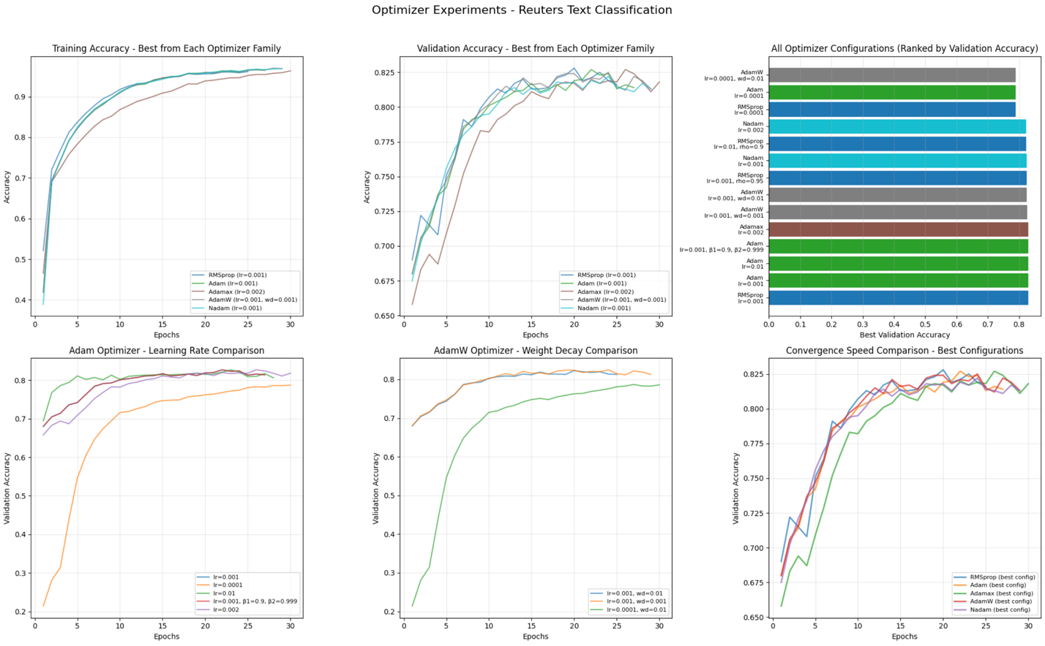
- Total Configurations Tested: 14 (reduced from original 20)
- Optimizers Evaluated: 5 (RMSprop, Adam, Adamax, AdamW, Nadam)
- Hyperparameters Varied:
  - Learning rates: 0.0001, 0.001, 0.002, 0.01
  - Optimizer-specific: rho, beta values, weight decay
- Training Duration: ~30 epochs per experiment with early stopping

Key Findings
- Performance Range: Top 5 optimizers achieved 82.20-82.80% validation accuracy (only 0.6% spread)
- Optimal Learning Rate: 0.001 was consistently best across most optimizers
- Convergence Speed:
  - Fastest: Nadam (lr=0.002) at epoch 10
  - Average: Most optimizers converged around epochs 20-24
  - Slowest: Low learning rates (0.0001) required 27-30 epochs
- Generalization: All top optimizers showed good generalization with ~2-3% gap between validation and test accuracy
- Winner: RMSprop with lr=0.001 achieved the best validation accuracy (82.80%) and strong test performance (80.19%)

