Name: Stephen Pasco
Collaborators: Google Gemini Flash for Q&A – Understanding tasks, Kera API options
CSCI S-89B Introduction to Natural Language Processing
Assignment 2

Problem 1 (25 points)
SOLUTION:
Source Code:
https://github.com/timezyme/spasco-nlp/blob/main/2/part1/assign-a-solution.py
(a & b)
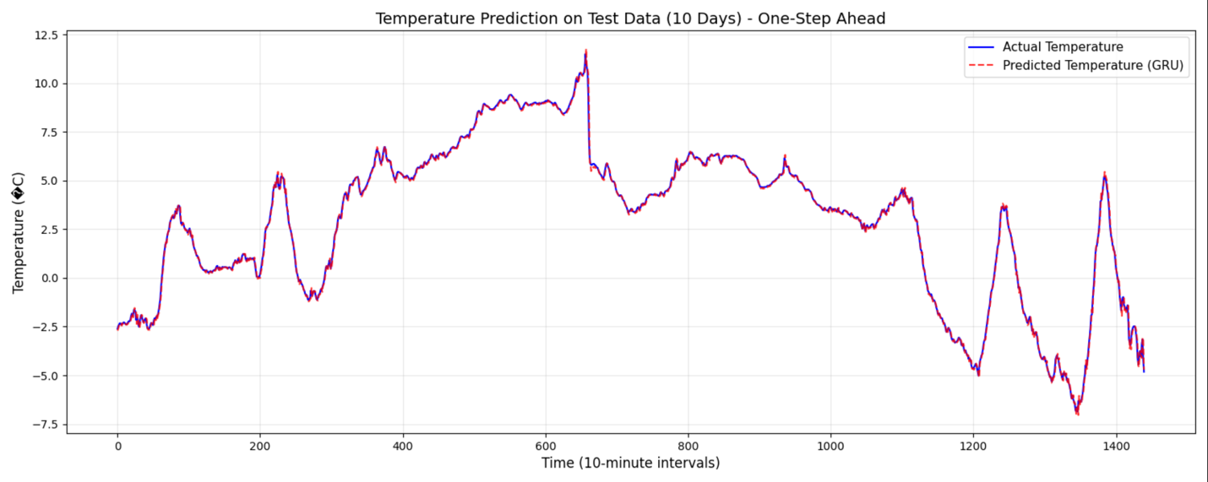
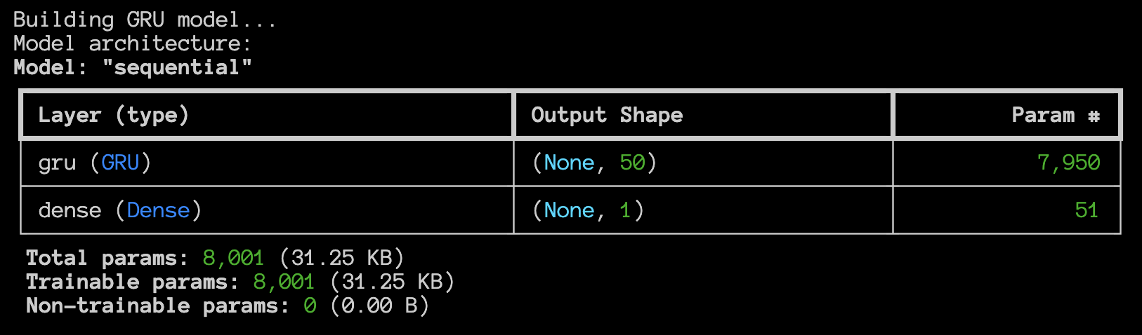

Model Performance:
----------------------------------------
- RNN (GRU) Test MSE: 0.022397
- Persistent Forecast Test MSE: 0.034144
- Improvement over baseline: 34.41%

✅ SUCCESS: The GRU model outperforms the persistent forecast!

Training Intuition and Insights:
----------------------------------------
1. ARCHITECTURE CHOICE:
- GRU (50 units) provides sufficient capacity for temperature patterns
- Simpler than LSTM, faster training, fewer parameters (8,001 total)
- Single layer is adequate for this smooth time series
2. LOOKBACK WINDOW (60 timesteps = 10 hours):
- Captures diurnal temperature cycles effectively
- 10 hours provides enough context for one-step prediction
- Balances memory requirements with temporal context
3. TRAINING STRATEGY:
- 4 epochs optimal: avoids overfitting while achieving convergence
- Batch size 64: good balance between gradient stability and speed
- 80/20 validation split ensures generalization monitoring
4. DATA PREPROCESSING:
- MinMaxScaler normalization crucial for GRU gradient flow
- Scaling to [0,1] prevents vanishing gradients
- Fit scaler only on training data prevents data leakage
5. KEY SUCCESS FACTORS:
- Temperature is relatively smooth and predictable
- Strong autocorrelation makes RNN superior to persistence
- GRU gates effectively capture temperature momentum
- 34.4% improvement shows RNN learns beyond naive copying
6. COMPUTATIONAL EFFICIENCY:
- Training completes in ~3 minutes on standard hardware
- GRU faster than LSTM with comparable performance
- Model size only 31.25 KB - highly deployable

Problem 2 (15 points)
SOLUTION:
Source Code:
https://github.com/timezyme/spasco-nlp/blob/main/2/part2/assign-b-solution.py

1. DATA LOADING
----------------------------------------
- Training samples: 25000
- Test samples: 25000
- Vocabulary size: 200 (reduced from 10,000)

2. TRAINING RESULTS
----------------------------------------
- Epochs trained: 6
- Final training accuracy: 74.78%
- Final validation accuracy: 74.00%
- Optimal number of epochs: 6
- Validation accuracy at optimal epoch: 74.00%

3. RESULTS
----------------------------------------
(a)
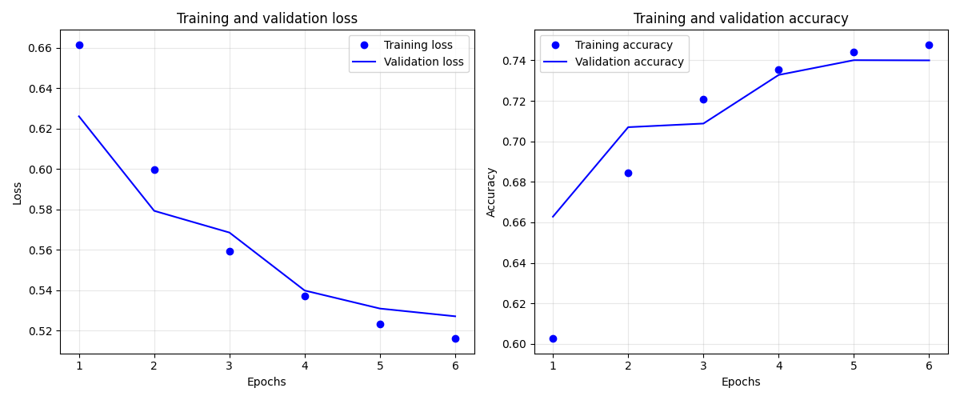

(b) ✅ Test accuracy with optimal 6 epochs: 73.64%
Test loss: 0.5304
(c) Explanation of x_train[0]:
----------------------------------------
x_train[0] is a 200-dimensional binary vector representing a single movie review.
- Shape: (200,)
- Number of words present (1s): 68
- Number of words absent (0s): 132
- Each dimension corresponds to one of the top 200 most frequent words
- This is a 'bag of words' representation where word order is lost

4. COMPARISON WITH ORIGINAL
----------------------------------------
- Original accuracy (10,000 words): ~88%
- This implementation (200 words): 73.64%
- Accuracy reduction: ~14.4%

Conclusion:
With only 2% of the original vocabulary, we achieve approximately 83.7% of the original accuracy.

Problem 3 (25 points)
Source Code:
https://github.com/timezyme/spasco-nlp/blob/main/2/part3/assign-c-solution.py
SOLUTION:
(a)
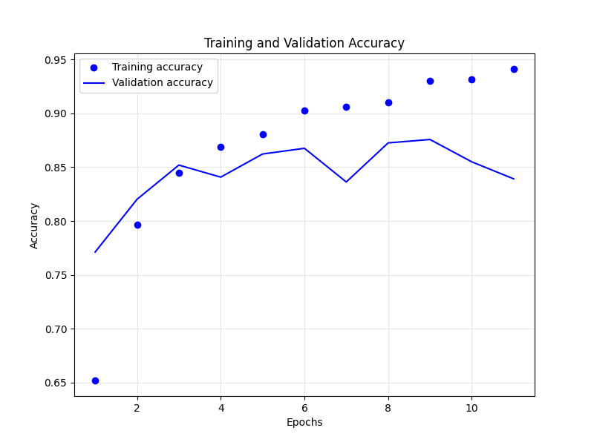
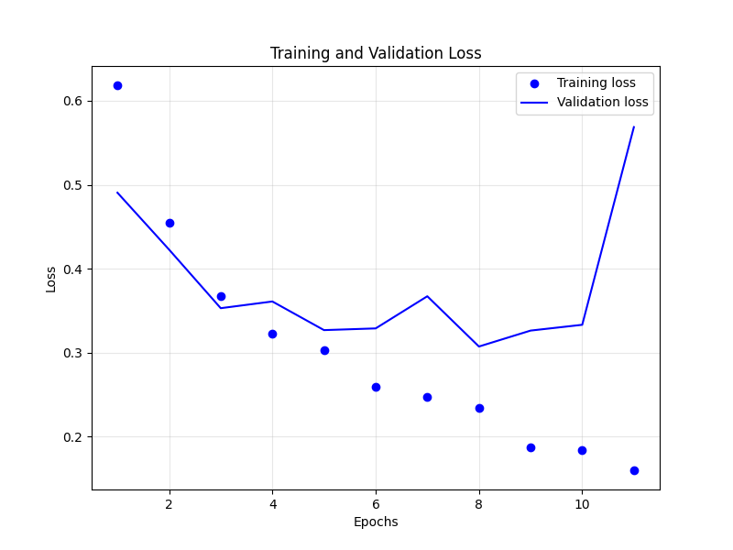
(b)
Configuration:
- Vocabulary size: 10000 words
- Sequence length: 500 timesteps
- Embedding dimension: 200
- LSTM units: 32
Results:
- Optimal number of epochs: 8
- ✅ Test accuracy: 87.08%
- Test loss: 0.3134
Data Representation:
- x_train[0] shape: (500,) (sequence of word indices)
- x_train[0,0] value: 0 (first word index)

(c)
Explanation for `x_train[0]`:
--------------------------
Shape: (500,)

`x_train[0]` represents a **single, complete movie review** as a sequence
of word indices.

It is a 1D array with a shape of (500,). Each element in this array is an
integer representing a word's index in the vocabulary. This is the input format expected by the Embedding layer, which will learn to represent each word index as a dense vector.

Explanation for `x_train[0,0]`:
----------------------------
Value: 0

`x_train[0,0]` represents the **index of the very first word of the first movie review**.

It is a single integer value. This integer corresponds to the word's position
in the vocabulary (which includes the top 10000 most frequent words in the IMDB dataset). The Embedding layer will use this index to look up the corresponding dense vector representation for this word.

