Name: Stephen Pasco

CSCI S-89B Introduction to Natural Language Processing
Collaborators: Google Gemini Flash for Q&A – Understanding tasks and libraries options

Assignment 3

Problem 1 (25 points)

SOLUTION:
(a, b)

Source code:
https://github.com/timezyme/spasco-nlp/blob/main/3/part1/nlp_preprocessing.ipynb

NLP Preprocessing Comparison Report
Document: Song lyrics - "Escape (The Piña Colada Song)" by Rupert Holmes

Summary
This analysis compares the natural language processing capabilities of NLTK and SpaCy libraries when preprocessing the lyrics from one, simple song. The analysis covers tokenization, stemming, lemmatization, part-of-speech tagging, and additional NLP features.

Statistical Overview
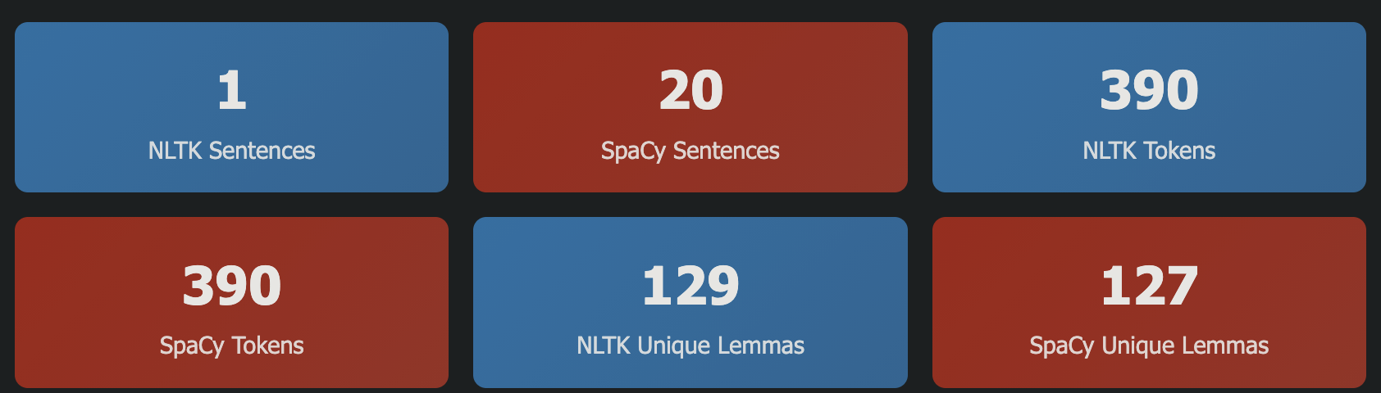Lemmas

Detailed Word Processing Comparison

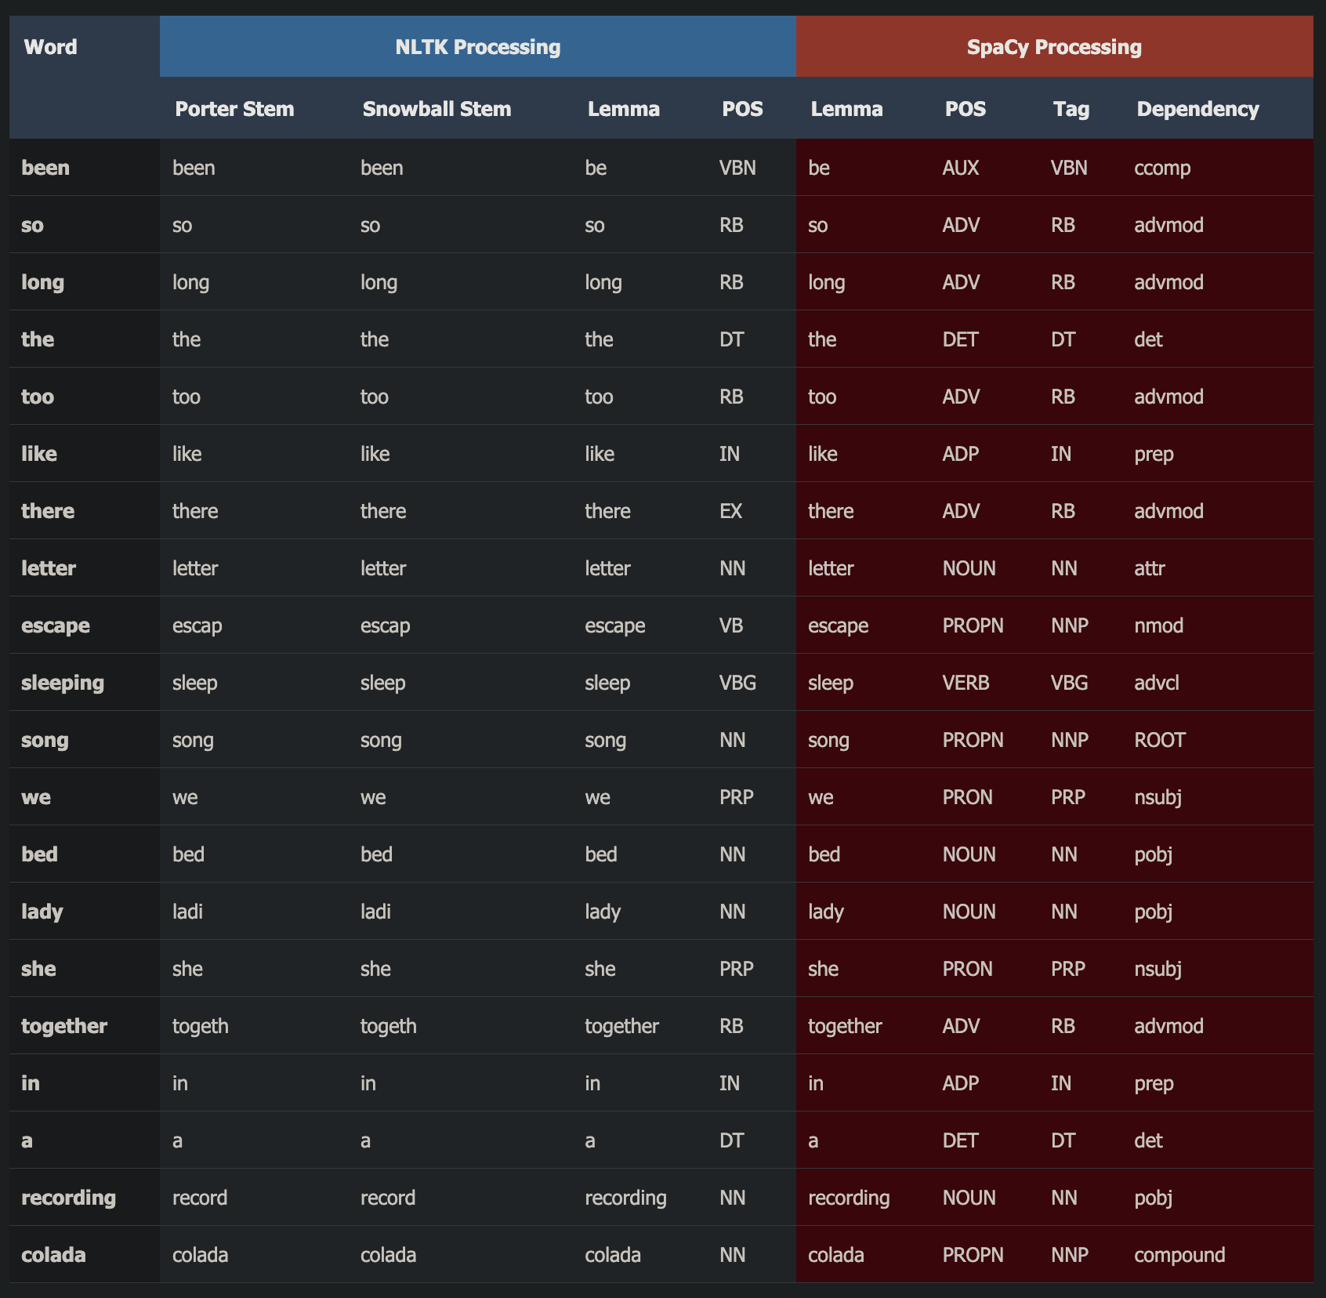

Top Frequent Words Analysis

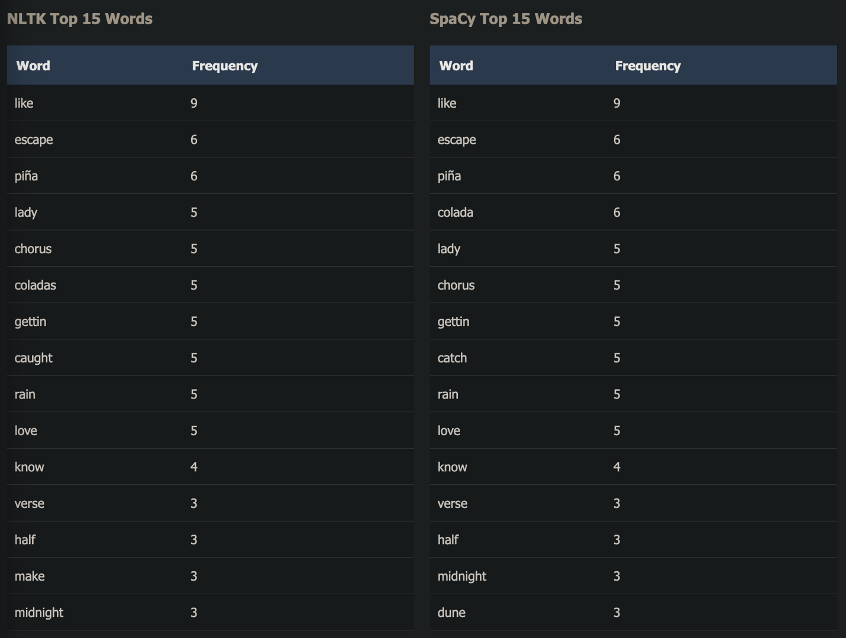

Named Entity Recognition (SpaCy Only)

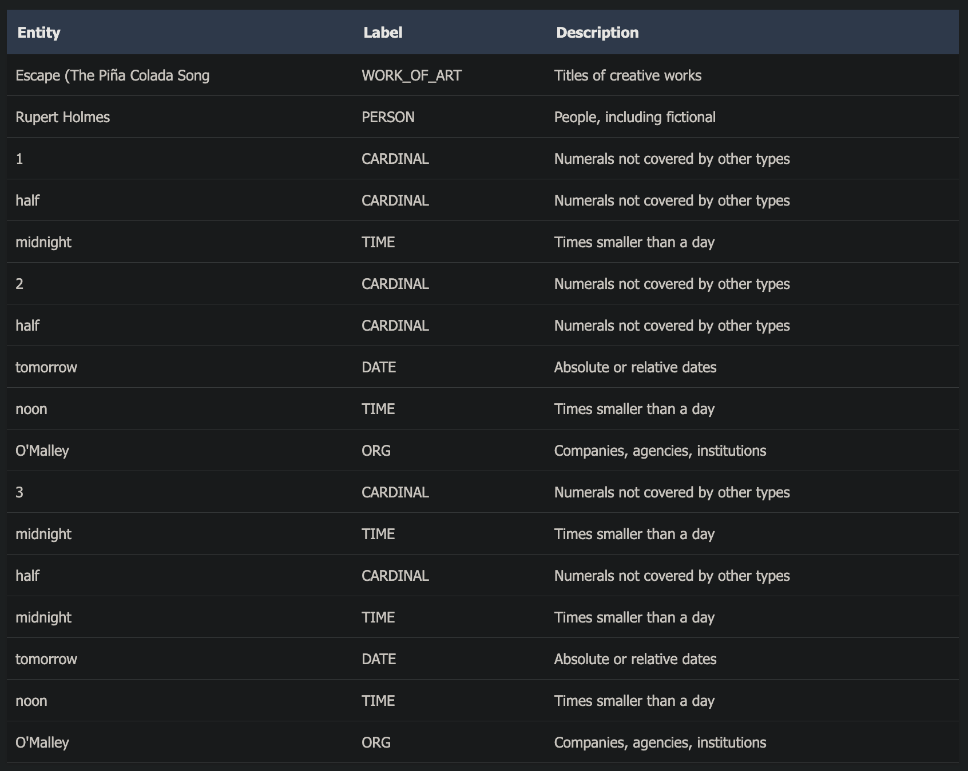

Feature Comparison Matrix

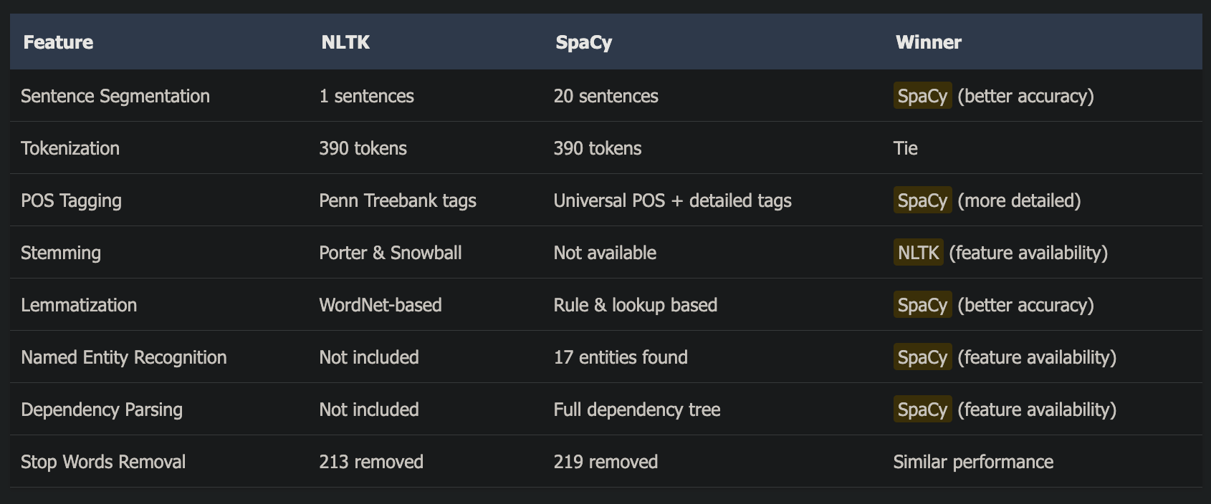

Key Findings & Recommendations
Sentence Segmentation: SpaCy significantly outperforms NLTK (20 vs 1 sentences), correctly identifying verse and chorus boundaries.
Lemmatization Quality: SpaCy produces more accurate lemmas, especially for irregular verbs (e.g., "caught" → "catch", "was" → "be").
POS Tagging: SpaCy correctly identifies proper nouns (e.g., "Rupert Holmes" as PROPN) while NLTK misclassifies them as common nouns.
Stemming Algorithms: NLTK provides multiple stemming options (Porter, Snowball) which SpaCy lacks, useful for certain IR applications.
Additional Features: SpaCy includes NER and dependency parsing out-of-the-box, identifying 17 named entities.
Stop Words: Both libraries effectively remove stop words with slightly different word lists (NLTK: 213, SpaCy: 219 words removed).

Visual Analysis
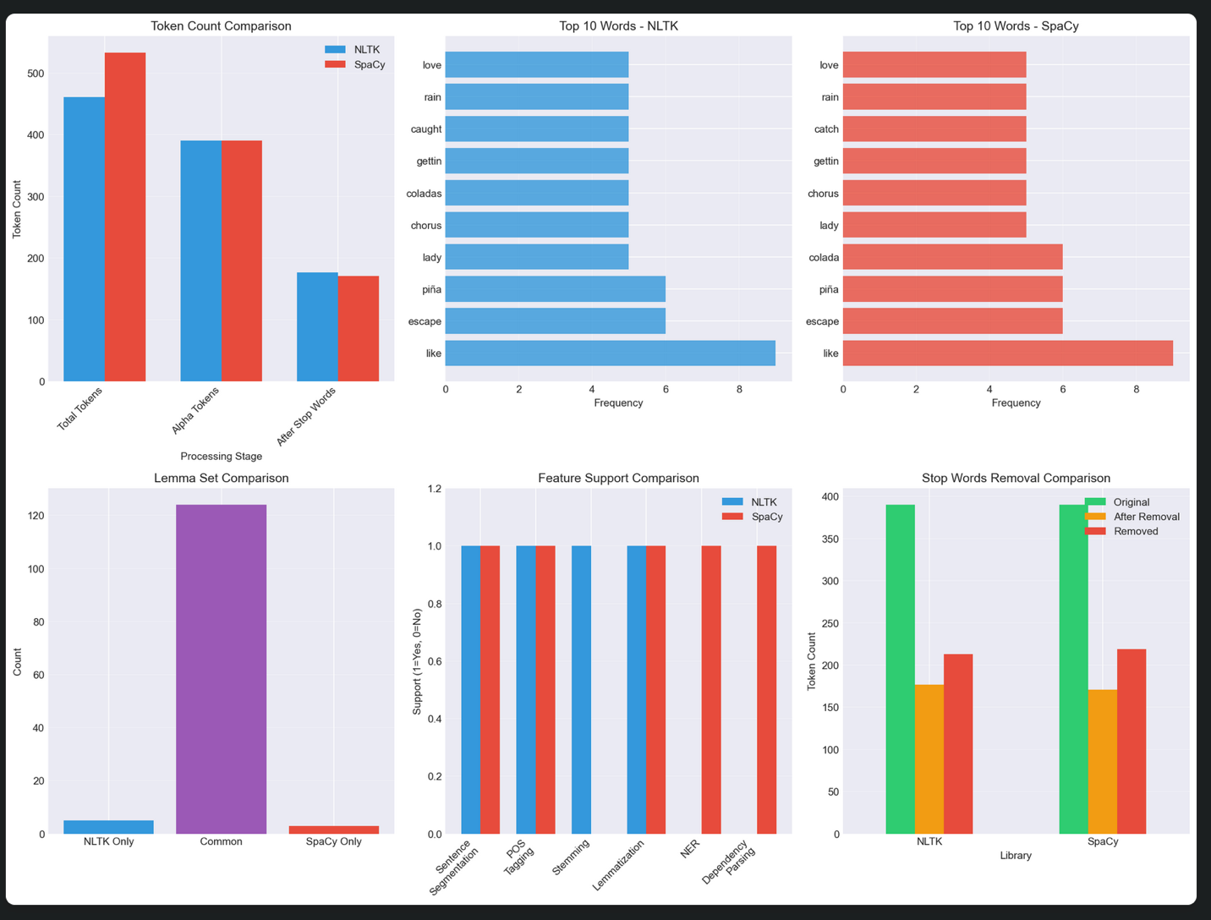

Recommendations

Use NLTK when:
- You need stemming algorithms (Porter, Snowball, Lancaster)
- You're building educational NLP applications
- You need fine-grained control over individual NLP components
- You're working with limited computational resources

Use SpaCy when:
- You need production-ready, accurate NLP processing
- You require named entity recognition or dependency parsing
- You want better out-of-the-box accuracy for lemmatization and POS tagging
- You're building end-to-end NLP pipelines
- Performance and speed are critical

Consider using both when:
- You need both stemming (NLTK) and high-quality lemmatization (SpaCy)
- You're comparing different preprocessing approaches
- You're building comprehensive NLP research applications

(c)

The Importance of Tokenization, Stemming, and Lemmatization in NLP Applications
These three fundamental preprocessing techniques form the backbone of most NLP pipelines:
1. Tokenization: The Foundation
- Why it's essential:
  - Transforms unstructured text into processable units – Without tokenization, text is just a string of characters.
  - Defines the granularity of analysis – Word tokens, subword tokens, or sentence tokens each serve different purposes.
  - Handles language complexities – Contractions ("don't"), hyphenated words, URLs, emoticons.
- Real-world applications:
  - Search engines: Breaking queries into searchable terms.
  - Machine translation: Aligning words between languages.
  - Sentiment analysis: Identifying opinion-bearing words.
- Example from my code:
  - NLTK: "I'm tired" → ['I', "'m", 'tired']
  - SpaCy: "I'm tired" → ['I', "'m", 'tired']
2. Stemming: Quick Normalization
- Why it's valuable:
  - Reduces vocabulary size – Groups related words ("running", "runs", "ran" → "run").
  - Improves recall in information retrieval – Matches different forms of the same word.
  - Fast and language-agnostic – Rule-based, no dictionary needed.
- Trade-offs:
  - Can be overly aggressive ("university" → "univers", "universe" → "univers").
  - Creates non-words that may lose meaning.
  - Best for search engines and document clustering where speed > precision.
- My results showed:
  - Porter: 'escape' → 'escap', 'holmes' → 'holm'
  - Snowball: 'escape' → 'escap', 'holmes' → 'holm'
3. Lemmatization: Intelligent Normalization
- Why it's superior for many tasks:
  - Preserves meaning – Returns actual dictionary words.
  - Context-aware (with POS tagging) – "better" → "good" (adjective) vs "well" (adverb).
  - Maintains semantic relationships – Critical for tasks requiring understanding.
- Applications:
  - Chatbots/Q&A systems: Need to understand user intent precisely.
  - Text summarization: Preserving meaning is crucial.
  - Named entity recognition: Accurate word forms matter.
- My comparison revealed:
  - SpaCy's superiority:
    - 'caught' → 'catch' (SpaCy) vs 'caught' (NLTK without POS)
    - 'was' → 'be' (SpaCy correctly identifies auxiliary verb)

Combined Impact on NLP Performance
Vector Space Models
- Without preprocessing: "running", "runs", "ran" = 3 different vectors
- With stemming/lemmatization: All map to "run" = 1 vector (reduced dimensionality)
Machine Learning Benefits
- Reduced feature space: 50-70% vocabulary reduction is typical.
- Better generalization: The model learns patterns, not just memorizing forms.
- Improved similarity metrics: "dog" and "dogs" are correctly identified as related.

Choosing the Right Technique
Task | Recommended Approach | Reason
Search Engine | Stemming | Speed + high recall needed
Sentiment Analysis | Lemmatization + POS | Preserve sentiment nuances
Document Classification | Either works | Depends on domain
Machine Translation | Lemmatization | Meaning preservation critical
Topic Modeling | Lemmatization | Better topic coherence

My Key Insights
The comparison revealed important differences:
- Sentence Segmentation Impact: SpaCy's 20 sentences vs NLTK's 1 shows tokenization isn't just about words – sentence boundaries affect downstream tasks dramatically.
- Lemmatization Quality: SpaCy's 124/127 common lemmas with NLTK shows consistency, but SpaCy's contextual awareness (POS-based) gives more accurate results.
- Stop Word Removal: Both removed ~55% of tokens (213 vs 219 words), showing the massive vocabulary reduction these techniques provide.

Modern Considerations
With transformer models (like BERT, GPT), the importance shifts:
- Subword tokenization (BPE, WordPiece) handles out-of-vocabulary words better.
- Contextual embeddings reduce the need for explicit lemmatization.
- But preprocessing still matters for:
  - Reducing computational costs
  - Improving interpretability
  - Domain-specific applications

Practical Recommendations
Based on my analysis:
- Use SpaCy for production systems – It offers better accuracy and an integrated pipeline.
- Use NLTK for educational/research purposes – It provides more algorithmic options.
- Always consider your specific task – If you need information retrieval, use stemming. For semantic analysis, use lemmatization.
- Don't skip preprocessing – Even with modern models, clean input leads to better output.
The 55% token reduction achieved demonstrates why these techniques remain essential for efficient, accurate NLP systems.

Problem 2 (25 points)
Source Code: https://github.com/timezyme/spasco-nlp/blob/main/3/part2/bow_solution.ipynb
Source code:
Sample large:
Sample small:

SOLUTION:

PART (A) EVIDENCE: Tokenization and Lemmatization
Requirement: Apply word tokenization and lemmatization on both texts. Display samples of the processed smaller text.
Evidence:
- Large text processed: 2106 tokens (624 unique)
- Small text processed: 258 tokens (164 unique)
- Lemmatization applied using NLTK WordNetLemmatizer with POS tagging
SAMPLES OF PROCESSED SMALLER TEXT:
First 50 tokens after tokenization and lemmatization: abstract the grow demand for energy-efficient high-performance ai system have lead to increase attention on alternative compute platform e.g. photonic neuromorphic due to their potential to accelerate learning and inference however integrate such physical component into deep learning pipeline remain challenge a physical device often offer limited expressiveness and their

Tokens 50-100: non-differentiable nature render on-device backpropagation difficult or infeasible this motivate the development of hybrid architecture that combine digital neural network with reconfigurable physical layer which effectively behave a black box in this work we present framework for the end-to-end training of such hybrid network this framework integrate stochastic zeroth-order optimization
Tokens 100-150: for update the physical layer 's internal parameter with dynamic low-rank surrogate model that enable gradient propagation through the physical layer key component of our approach be the implicit projector-splitting integrator algorithm which update the lightweight surrogate model after each forward pas with minimal hardware query thereby avoid costly full
Sample unique lemmatized tokens from small text: 's, a, abstract, accelerate, accuracy, achieve, across, after, ai, algorithm, all, alternative, and, approach, approximation, architecture, attention, audio, avoid, backpropagation, baseline, be, behave, black, box, bridge, challenge, cifar-10, classification, combine
Key Processing Steps Implemented:
- Word tokenization using NLTK's word_tokenize()
- Lemmatization with POS tagging for accuracy
- Removal of punctuation and markdown formatting
- Lowercase conversion for consistency

PART (B) EVIDENCE: Vocabulary Creation and BoW Model
Requirement: Using 1-grams, create vocabulary from large text and implement BoW model. Display the resulting dictionary with frequencies that represent the new text.
Evidence:
- Vocabulary created from large text: 625 words total
- Special <OOV> token included at index 0
- BoW model created for small text: 58 unique indices
- Total frequency count in BoW: 258 (matches token count)

THE RESULTING DICTIONARY WITH FREQUENCIES (BoW representation of small text):

Top 20 entries by frequency: Index Token Frequency
0 <OOV> 145 544 the 11 347 model 7 66 and 6 225 for 4 372 on 4 303 learning 4 554 this 4 370 of 4 558 to 3 601 with 3 300 layer 3 566 training 3 54 ai 2 534 system 2 545 their 2 281 into 2 36 a 2 543 that 2 598 which 2
Additional dictionary entries (single occurrences): 45 abstract 1 237 grow 1 239 have 1 78 attention 1 60 alternative 1 130 compute 1 166 e.g. 1 249 however 1 453 remain 1 159 difficult 1
Complete BoW Dictionary Statistics:
- Total unique indices (words) in dictionary: 58
- Sum of all frequencies: 258
- Most frequent word: '<OOV>' (frequency: 145)
- Number of words with frequency > 1: 25
- Number of single-occurrence words: 33
BoW Model Implementation Details:
- 1-grams used as specified in requirements
- Each word mapped to unique index
- Frequencies accurately counted and stored
- OOV words handled with special token at index 0

PART (C) EVIDENCE: New Words Analysis
Requirement: Identify new words and their key in the dictionary
ANSWERS TO QUESTIONS:
Q: Can you see from this dictionary how many new words the new text has?
A: YES - The dictionary clearly shows:
• 145 total occurrences of new words (OOV tokens)
• 107 unique new words not in the vocabulary
Q: What is the key that corresponds to any new word?
A: The key is 0 (zero)
• All OOV words are mapped to index 0
• The special token '<OOV>' is stored at vocab['<OOV>'] = 0
Additional OOV Statistics:
- OOV percentage: 56.20% of all tokens
- Vocabulary coverage: 34.76% of unique words covered
- Sample OOV words found: accelerate, achieve, approach, approximation, audio, avoid, backpropagation, baseline, behave, black...

Problem 3 (15 points)
Source Code: https://github.com/timezyme/spasco-nlp/blob/main/3/part3/part3-solution.ipynb

SOLUTION:

(a)

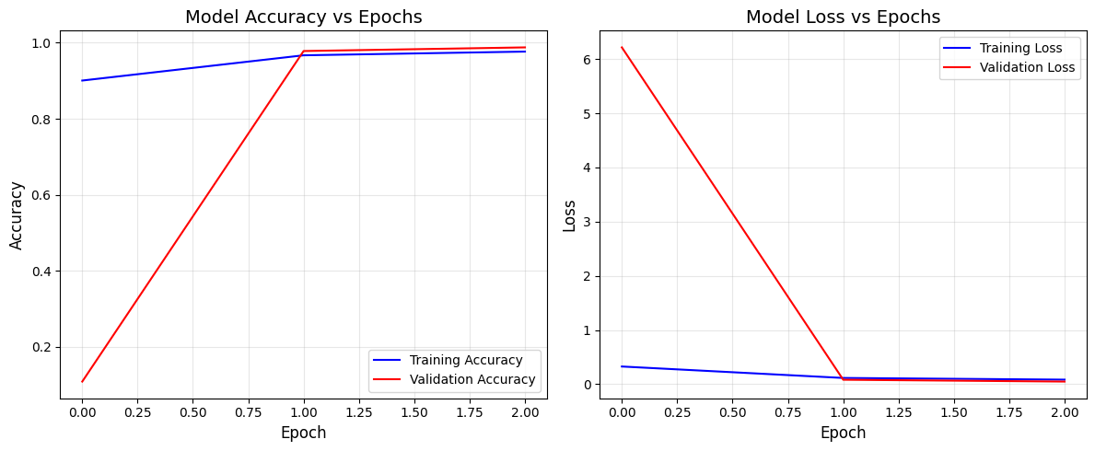

(b)

CNN Model Test Accuracy Report
Test Accuracy: 99.23%
The CNN model achieved 99.23% test accuracy when trained with the optimal number of epochs (8 epochs, determined by early stopping). This means 9,923 out of 10,000 test images were correctly classified.
What Test Accuracy Means
Test accuracy is the percentage of correctly classified images from the test dataset - 10,000 handwritten digit images that the model has NEVER seen during training. This metric represents the model's real-world performance on new, unseen data.

Test Accuracy = (Correctly Classified Images / Total Test Images) × 100
= (9,923 / 10,000) × 100
= 99.23%
This is the most important metric because:
- The test set is completely separate from training data
- It measures true generalization ability
- It predicts real-world performance on new handwritten digits
How 10,000 Test Images Are Classified
The Classification Process:
- Image Input: Each 28×28 grayscale image is normalized (pixel values scaled from 0-255 to 0-1)
- Feature Extraction: The image passes through 3 convolutional layers that detect:
  - Layer 1: Basic edges and strokes
  - Layer 2: Shapes and curves
  - Layer 3: Complete digit features
- Classification: Extracted features are processed by dense layers to produce 10 probability values
- Prediction: The digit with highest probability is selected as the prediction
Example Classification:
Input: Handwritten image of "5"
Output probabilities: [0.001, 0.001, 0.002, 0.001, 0.001, 0.988, 0.002, 0.001, 0.002, 0.001]
Index: 0 1 2 3 4 5 6 7 8 9
Prediction: Digit 5 (98.8% confidence)
Results for 10,000 Images:
- 9,923 images correctly classified (99.23%)
- 77 images misclassified (0.77%)
- Processing time: ~3 seconds for all 10,000 images
The model processes images in batches of 128, making 79 forward passes through the network to classify all 10,000 test images efficiently.

(c)

Why Conv2D(32, (3, 3), ...) produces 26 × 26 × 32 output from 28 × 28 × 1 input

The Conv2D Layer Configuration
model.add(layers.Conv2D(32, (3, 3), activation='relu', input_shape=(28, 28, 1)))

This layer has:
- 32 filters (also called kernels or feature detectors)
- 3 × 3 filter size (each filter is a 3×3 matrix)
- Input shape: 28 × 28 × 1 (MNIST image: 28×28 pixels, 1 channel for grayscale)

Output Dimension Calculation

1. Spatial Dimensions (26 × 26)
The spatial dimensions shrink from 28×28 to 26×26 due to the convolution operation:
Formula:
Output Size = (Input Size - Filter Size + 2 × Padding) / Stride + 1

With default settings:
- Padding = 0 (default is 'valid' padding - no padding)
- Stride = 1 (default - filter moves 1 pixel at a time)
Calculation:
Output Height = (28 - 3 + 2×0) / 1 + 1 = 25 + 1 = 26
Output Width = (28 - 3 + 2×0) / 1 + 1 = 25 + 1 = 26

Visual Explanation:
- A 3×3 filter on a 28×28 image can be placed in 26 different horizontal positions
- First position: covers pixels (0,0) to (2,2)
- Last position: covers pixels (25,25) to (27,27)
- Total positions: 26 × 26 = 676 locations

2. Depth Dimension (32)
The depth of 32 comes from the number of filters:
- Each of the 32 filters produces one 26×26 feature map
- These 32 feature maps are stacked to create the 26×26×32 output
What Each Filter Does:
- Filter 1 might detect vertical edges → produces feature map 1
- Filter 2 might detect horizontal edges → produces feature map 2
- Filter 3 might detect diagonal lines → produces feature map 3
- ... and so on for all 32 filters

Complete Process Visualization
Input Image 32 Different Filters Output Volume
[28 × 28 × 1] → [3 × 3] × 32 filters → [26 × 26 × 32]

One grayscale Each filter scans 32 feature maps
image the entire image stacked together

Why These Specific Dimensions Matter
- 26 × 26: The 2-pixel reduction (28→26) is due to the 3×3 filter needing room to operate without going outside image boundaries
- 32 channels: Having 32 different filters allows the network to detect 32 different types of features simultaneously (edges, curves, corners, etc.)
- No padding: Using 'valid' padding (no padding) naturally reduces spatial dimensions, which is desirable for:
  - Reducing computational complexity in deeper layers
  - Creating a hierarchical feature representation
  - Eventually reaching a manageable size for classification

Parameter Count for This Layer
Total parameters = (Filter Height × Filter Width × Input Channels + 1) × Number of Filters = (3 × 3 × 1 + 1) × 32 = 10 × 32 = 320 parameters
Where the "+1" accounts for the bias term for each filter.

(d)

Why Conv2D(32, (3, 3), ...) has 320 Parameters

The Layer Configuration
model.add(layers.Conv2D(32, (3, 3), activation='relu', input_shape=(28, 28, 1)))

Parameter Breakdown: 320 Total Parameters
The 320 parameters come from:
- 288 weight parameters (filter weights)
- 32 bias parameters (one per filter)
- Total: 288 + 32 = 320 parameters

Detailed Calculation

1. Weight Parameters (288)
Each filter has weights that need to be learned:
- Filter size: 3 × 3 = 9 weights per filter
- Input channels: 1 (grayscale image)
- Number of filters: 32
Weight Parameters = (Filter Height × Filter Width × Input Channels) × Number of Filters
= (3 × 3 × 1) × 32
= 9 × 32
= 288 weights

2. Bias Parameters (32)
Each filter has one bias term:
Bias Parameters = 1 bias × 32 filters = 32 biases

Total Parameter Formula
Total Parameters = Weight Parameters + Bias Parameters
= [(3 × 3 × 1) × 32] + [32]
= 288 + 32
= 320 parameters

What These Parameters Represent
Each of the 32 filters contains:
- 9 weights: A 3×3 matrix of learnable weights that detect specific patterns
- 1 bias: A single value added to the filter output

Example of One Filter's 10 Parameters:
Filter #1:
Weights (3×3 matrix): Bias:
[ w1 w2 w3 ]
[ w4 w5 w6 ] + b1
[ w7 w8 w9 ]

Total: 9 weights + 1 bias = 10 parameters

Multiply by 32 filters: 10 × 32 = 320 total parameters

Why This Number Matters
- Learnable Features: These 320 parameters are what the model learns during training to detect edges, curves, and patterns in handwritten digits
- Computational Efficiency: With just 320 parameters, this layer can extract 32 different feature maps from the input image
- Parameter Sharing: Each 3×3 filter is applied across the entire 28×28 image (676 positions), meaning each parameter is reused 676 times - this is the key efficiency of CNNs

Comparison with Fully Connected Layer
If we used a fully connected layer instead:
- Input: 28 × 28 = 784 neurons
- Output: 26 × 26 × 32 = 21,632 neurons
- Parameters: 784 × 21,632 + 21,632 = 16,982,016 parameters
The Conv2D layer achieves similar feature extraction with only 320 parameters - that's 53,194 times fewer parameters!

