Name: Stephen Pasco
CSCI S-89B Introduction to Natural Language Processing
Collaborators: Google Gemini Flash for Q&A – Understanding tasks and libraries
Assignment 7

Problem 1
SOLUTION:
(a)
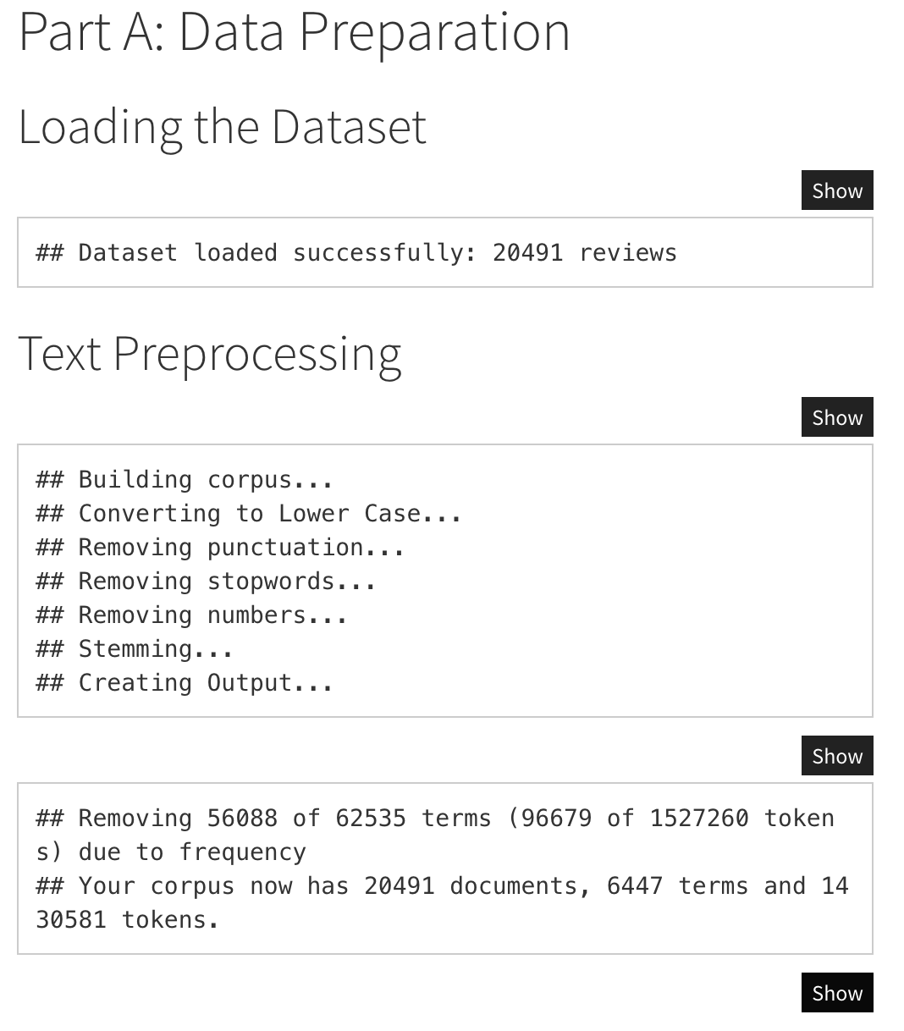

(b)
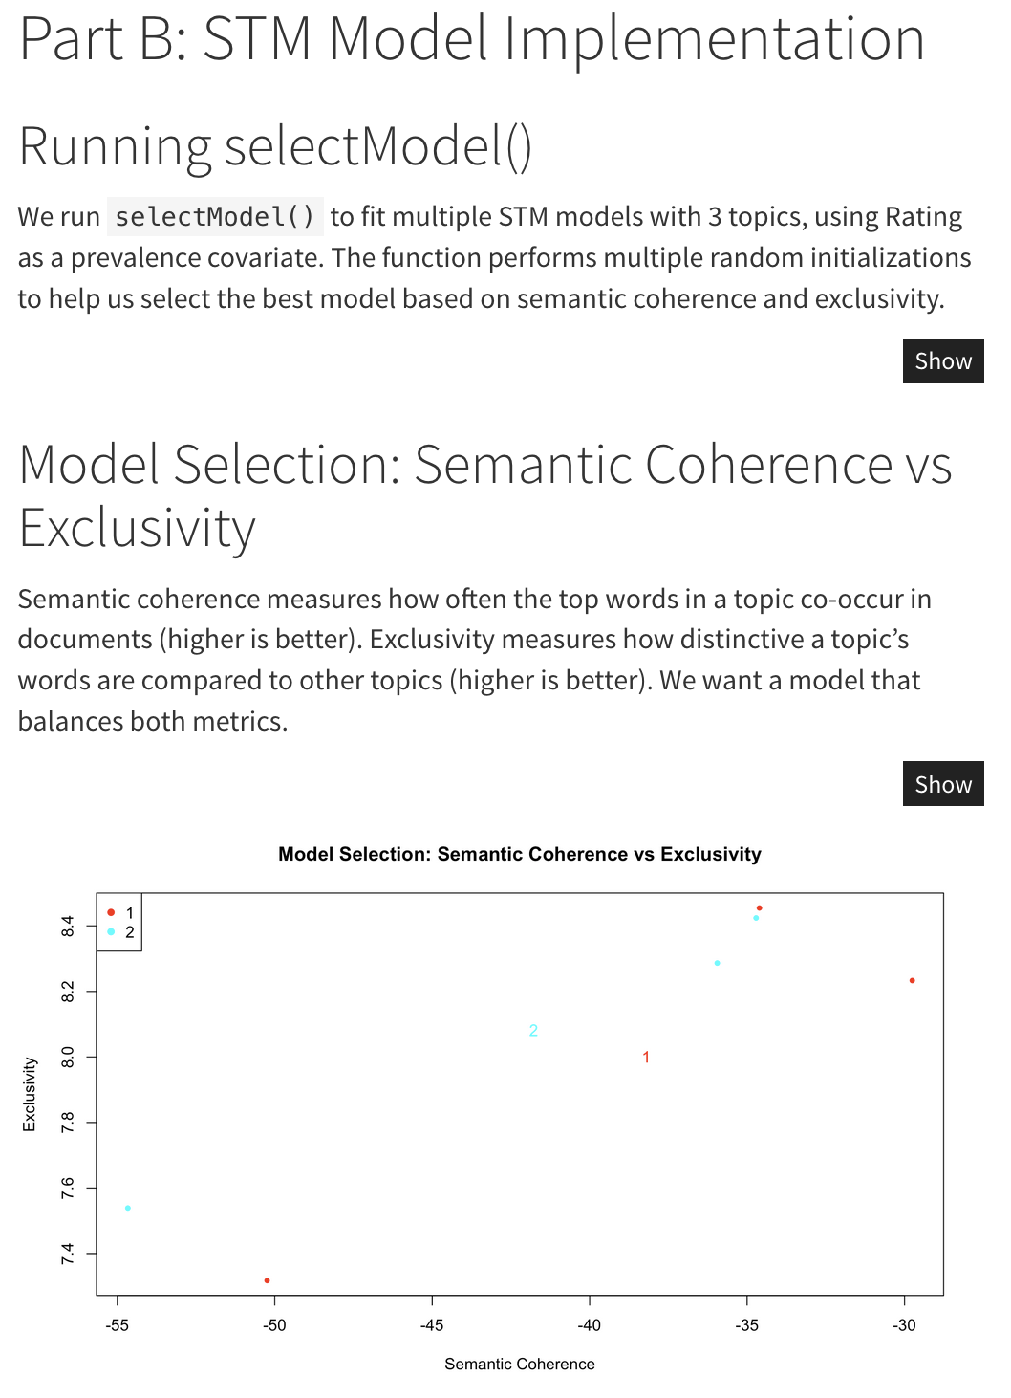

(C)
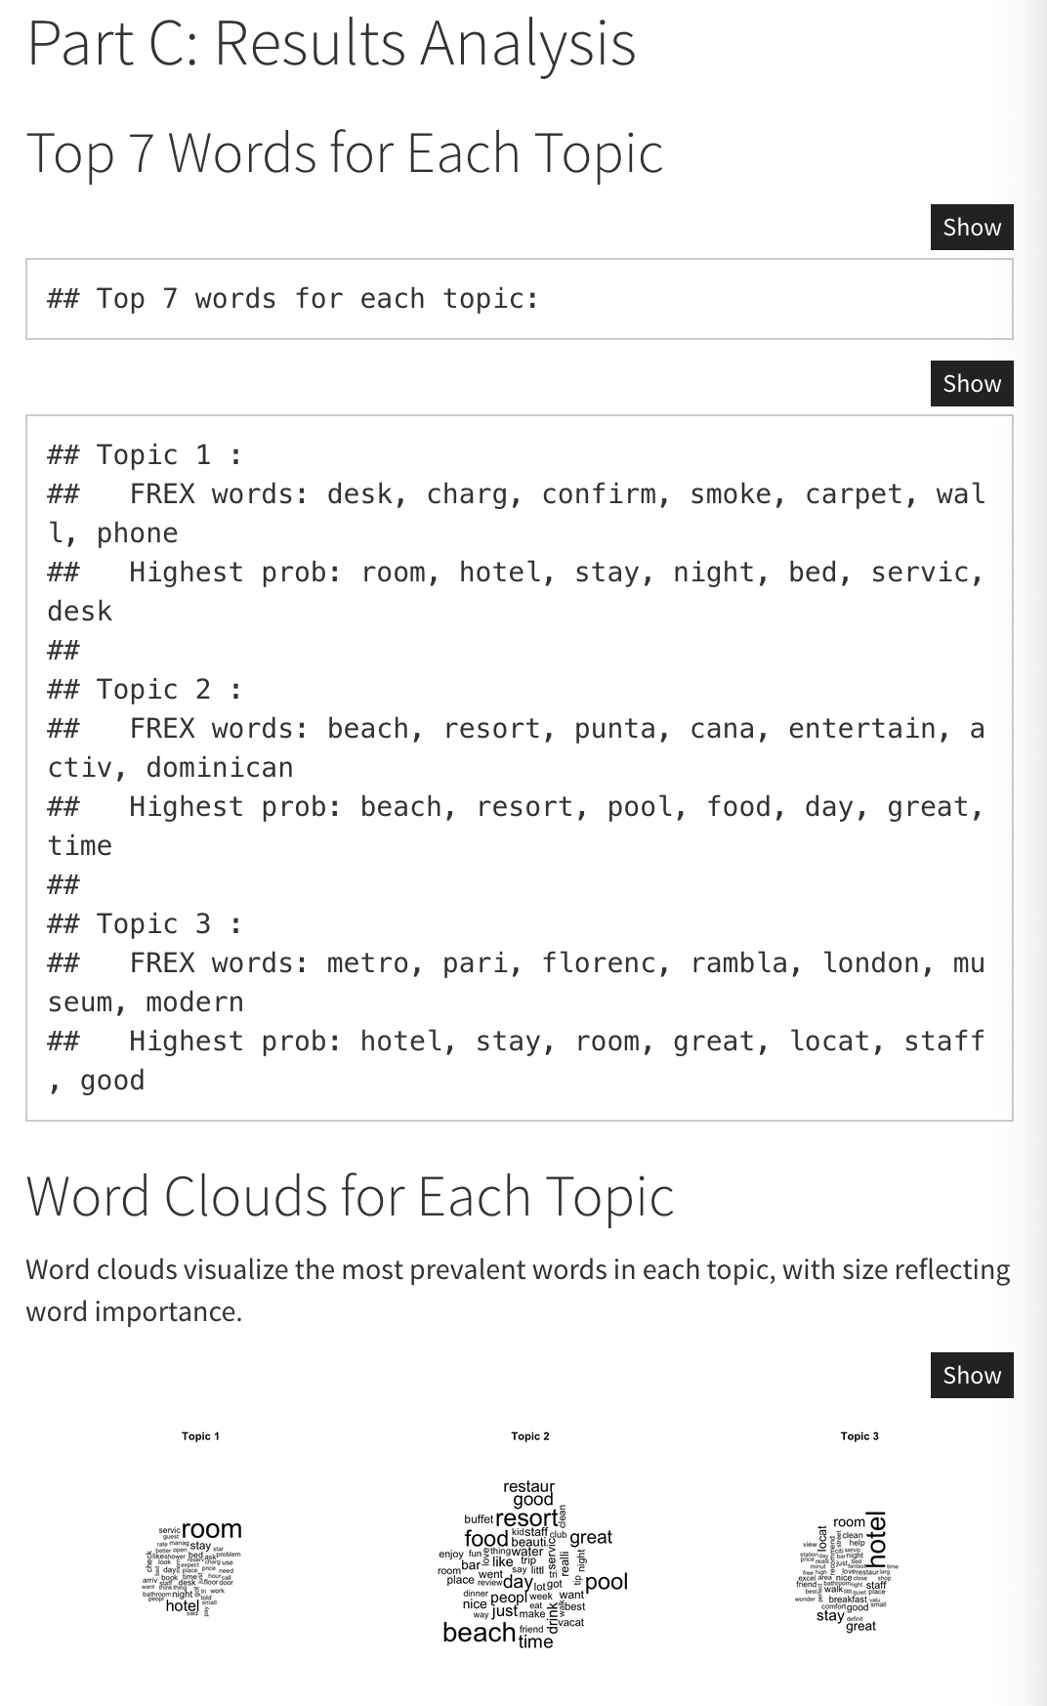

## Topic 1 - Top 5 Reviews:
=============================================================================
##
## Review 1 (Rating: 1 ):
## horrible customer service worst hilton possibly worst hotel, trying review guidelines feel important people know kinds business practices ran into.we stayed hilton nights second night having wedding reception hilton.all booking went smoothly room decent exectutive sweet not overpriced got discount having reception there.the problems arrived later reception short summary things happened.-elevators ...
##
## Review 2 (Rating: 1 ):
## worst place stayed started just fine, greeted nice receptionist gave early check, not told renovations taking place floors noise level horrendous, did not sign warning hazardous chemicals harmful health cause birth defects pregnancy checked, inquired desk receptionist told knew nothing, area nasty unsafe, sink clogged plumber called, water turned freezing cold husband taking hot shower, did n't ex ...
##
## Review 3 (Rating: 1 ):
## horrible experience customer service live 20 minutes hotel reservations birthday stay close proximity clubs/bars frequent, weekend birthday torrential rainstorm overnight stay just did n't like good idea, called toll free reservation hotline happen canceled reservation, center n't reservation transferred desk n't reservation, explicitly asked charges penalties canceling reservation told no far con ...
##
## Review 4 (Rating: 1 ):
## save money hostel, booked night stay january standard room starting thursday, checking unfriendly receptionist went small dirty room, scuffed walls clearly hairs sheets make-up pillowcases holes towels, speaking receptionist requesting new room current room cleaned told no option wait monday manager came, unable leave hotel charge nights stay regardless stayed not, night using sleeping bags went r ...
##
## Review 5 (Rating: 1 ):
## worst experience hotel, hotel claim online service kicker, reservations hotels.com not honored whim rude night manager edwin moore, refused contact hotels.com resolve issue demanded guest self pay extra stay, verifying reservations day actual hotel desk staff, resigned check paying addition price hotels.com charged resolve general manger morning kicked no refund place stay, say service unacceptabl ...
##
## =============================================================================
## Topic 2 - Top 5 Reviews:
=============================================================================
##
## Review 1 (Rating: 5 ):
## ca n't wait till year, 2nd 16th 2008we stayed lofts week 3 adults allow 2 adults suite rs.the second willis maribell fantastic, tipped simply deserved it.the grounds beautiful fact groundsthrough entire resort magnificent.picture perfect beach pool lobby just everywhere.the second wk.we stayed rs, super.what better salvator worked 3 days rs.the rooms service attention just unbeliveable.the sports ...
##
## Review 2 (Rating: 5 ):
## secrets excellence truly excellente, husband just returned 5 amazing days secrets, loved minute fabulous vacation, read reviews went admit nervous, decided make opinion glad did, thought food excellent, went honeymoon mexico iberostar playa del carmen thought food 100 better, loved bite, highly recommend restaurant called quisqueya, lobster bisque chateaubriand amazing, tip seafood restaurant shri ...
##
## Review 3 (Rating: 5 ):
## incredible place husband went night day stay punta cana booked adventure tours, tour guide lisa england punta cana years, helpful friendly, iberostar bavaro truly star inclusive premium alcohol, yes plenty ages games bingo ping pong pool tables painting ceramics excellent massages beach learning dances endless activities, buffets great large buffet lobby snack buffet pool swim bar ice cream sweets ...
##
## Review 4 (Rating: 4 ):
## relaxing vacation husband went melia caribe tropical 1st anniversary, did not royal service not regret, pros cons vacation start cons really did not like food, best meal day breakfast, went buffet caribe pool, pancakes waffles best loved fresh squeezed oj, really dissapointed food, ate specialty restaurants, ones did n't international french, liked mexican dominican places best not did eat 1/2 mea ...
##
## Review 5 (Rating: 5 ):
## absolutely terrific, let tell prior leaveing vacation little concerned negative reviews read, like stayed, great time resort terrific, got hot cloudy windy, went 7 nights day weather got better better, hot single day, days wind cloudy hot, rained twice, early morning 6:30a time got 9am know rained not puddle, second time 10:30pm day absoultely hot.food good, buffet little, breakfast pancakes eggs ...
##
##
=============================================================================
## Topic 3 - Top 5 Reviews:
=============================================================================
##
## Review 1 (Rating: 5 ):
## perfect city centre madrid hotel perfect place city break madrid, group 2 mothers 4 teenagers twin bedded rooms comfy beds 6th floor perfect, hotel brilliantly located city break metro 10 steps hotel entrance, shops restaurants close madrid vision tourist bus stop minute walk away, not recommend hotel highly want place stay madrid city break, hotel staff friendly efficient breakfast buffet include ...
##
## Review 2 (Rating: 5 ):
## little gem enjoyed stay excellent hotel 21 year old daughter recently, impressed friendliness efficiency proprietors, arrival presented map florence major tourist attractions location good restaurants pointed, bedroom en-suite bathroom spacious clean nicely decorated, nice buffet breakfast provided, hotel colomba located heart florence walking distance train station important sights shops san lore ...
##
## Review 3 (Rating: 5 ):
## loved casa fuster hotel thrilled stay casa fuster hotel, accompanied husband business trip hotel arrangements, hotel location great easy walking city sights nice quiet safe area, room faced inside courtyard extremely quiet comfortable, staff helpful spoke english, favorite restaurant nearby la pomarada great food reasonable prices excellent attentive service, restaurant 5-minute walk street, hotel ...
##
## Review 4 (Rating: 5 ):
## classy comfortable best paris, just returrned european trip stay paris highlight memorable excellence hotel grand hommes exceeded expectations respects apart room size, hotel ideally positioned latin quarter opposite teh pantheon walking distance countless restaurants river public transport.the rooms small spotlessly clean quality bedding classy decor staff exceptionally courteous accommodating.i ...
##
## Review 5 (Rating: 5 ):
## great hotel friend stayed hotel fusion sept 26 2 nights, great location close union square cable car turnaround near visitor centre bart, rooms clean bit small nicely decorated, staff friendly helpful, free breakfast 7am 930am muffins bread toast crossants juice coffee tea, great experince hotel fusion highly recommend,

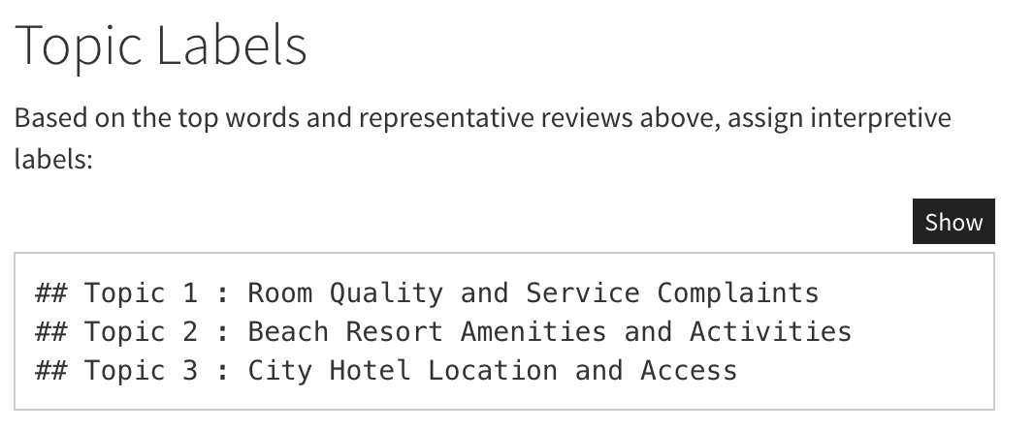

(d)
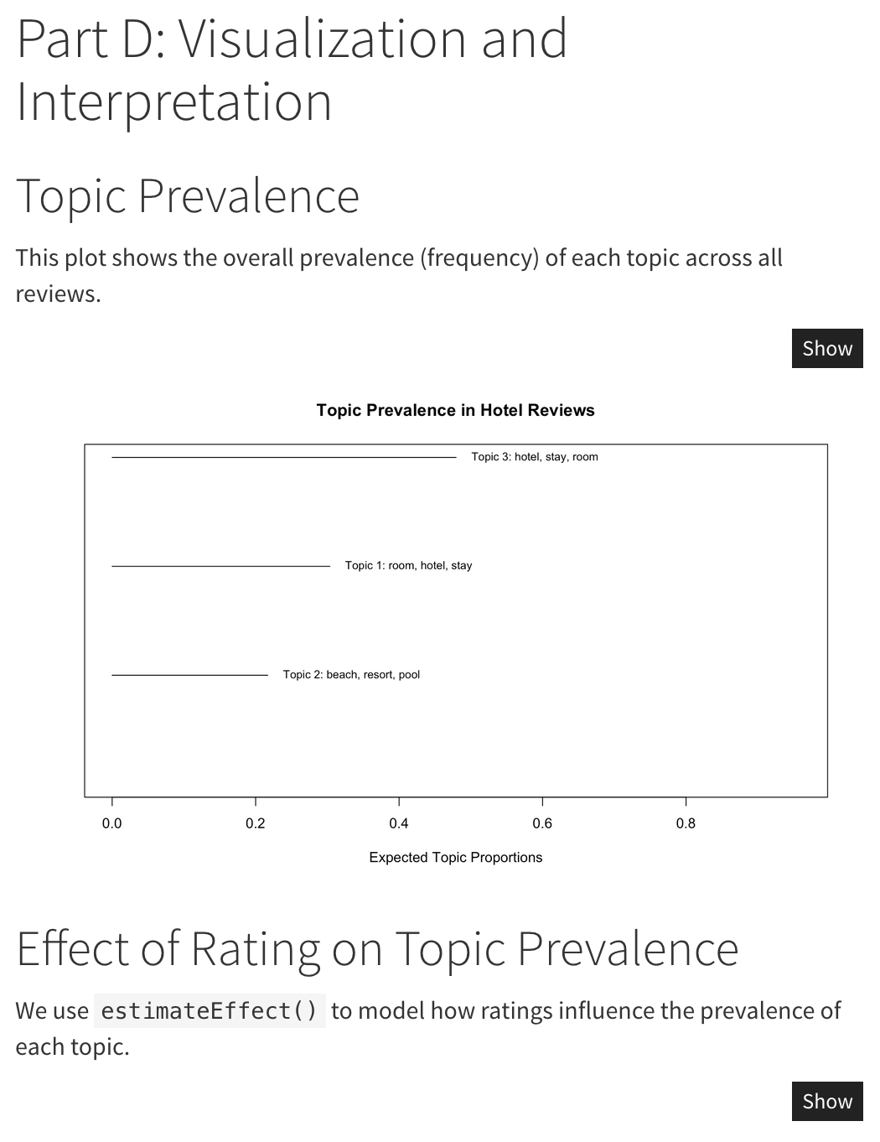
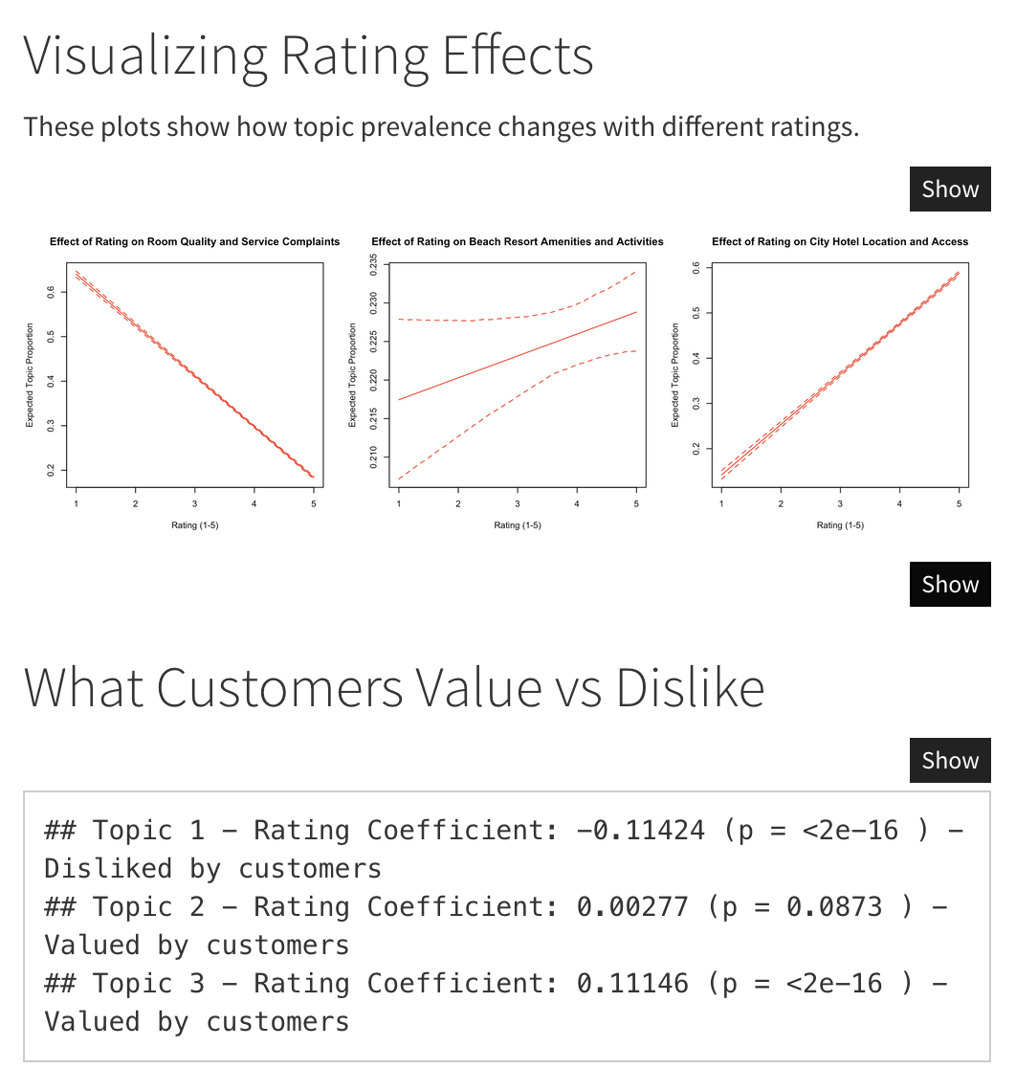

Problem 2
SOLUTION:
(a)
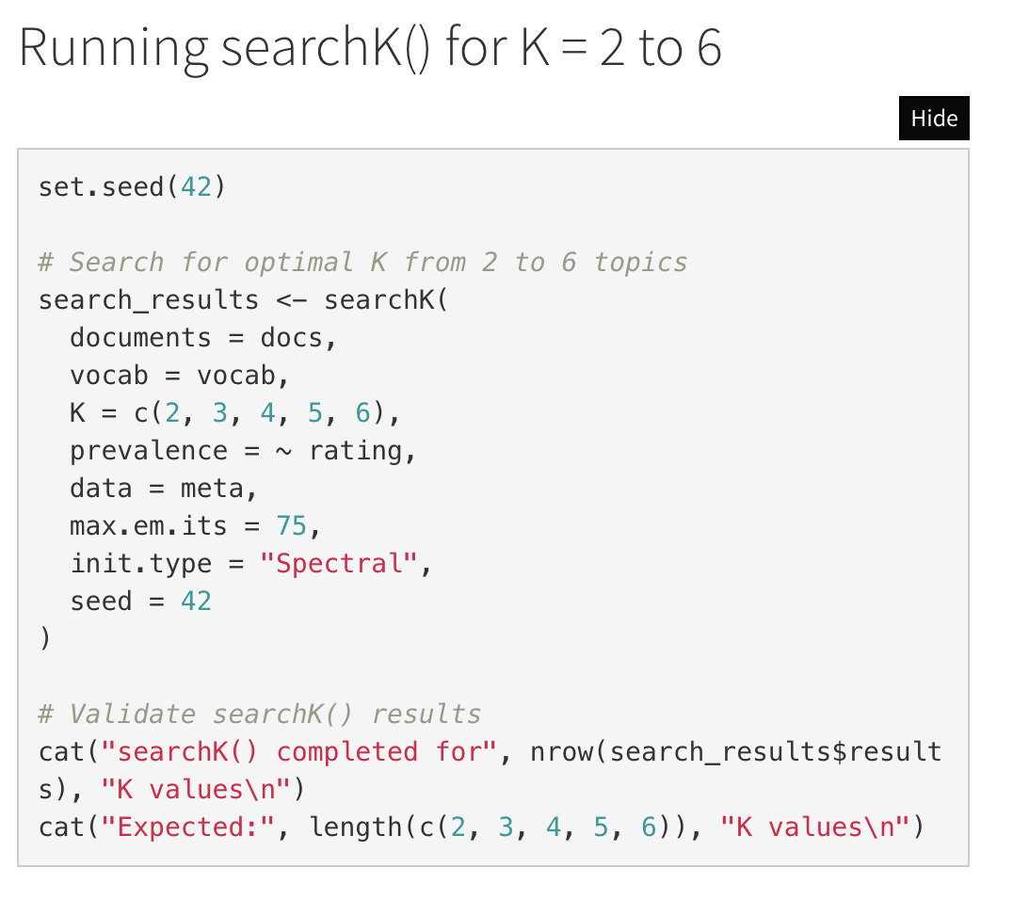

(b)
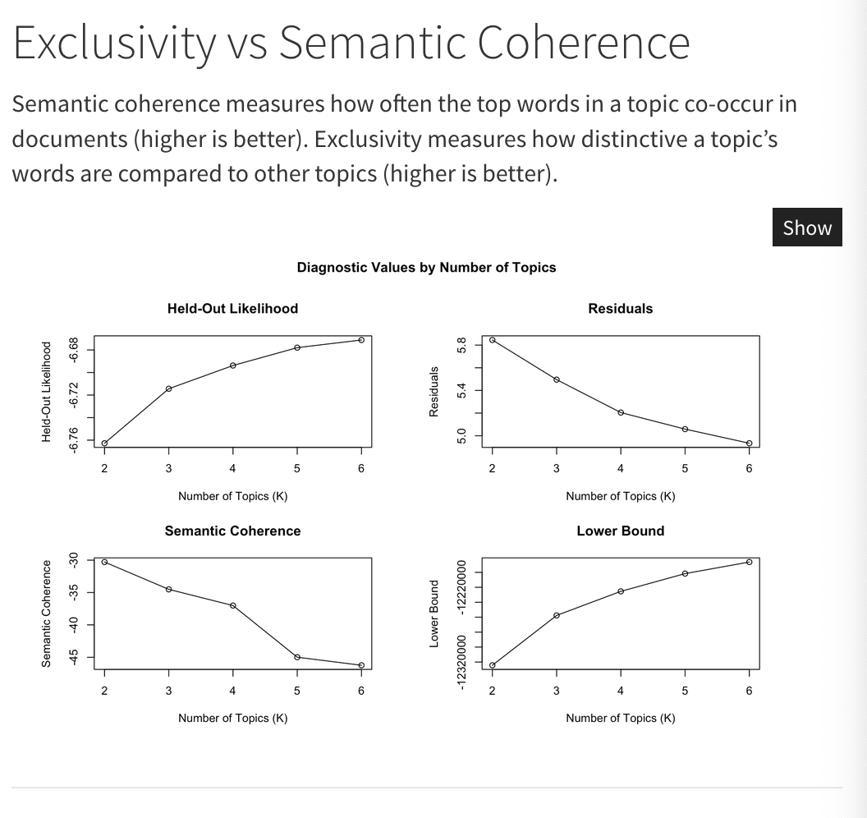

(c)
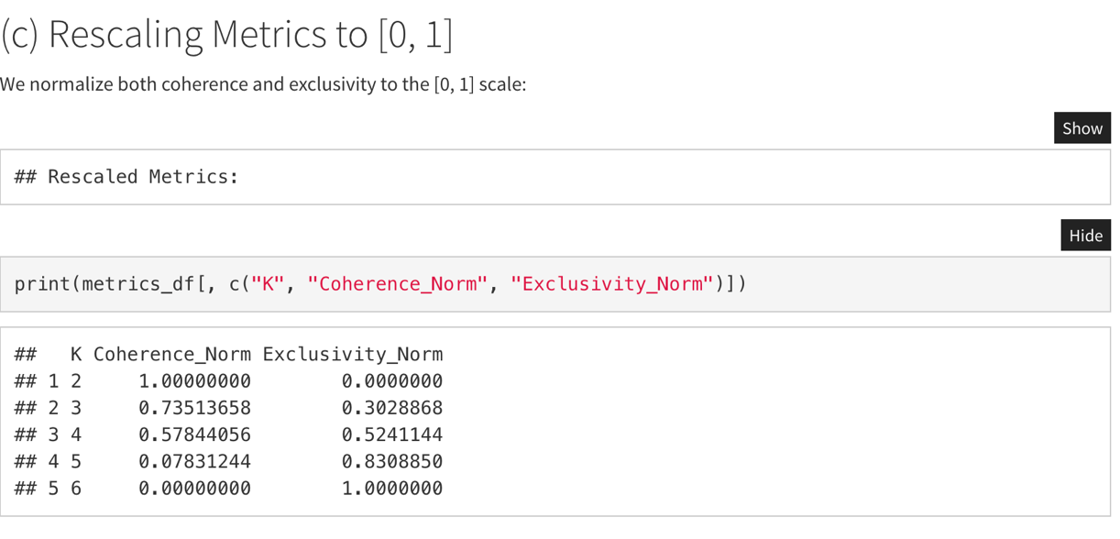
(d)
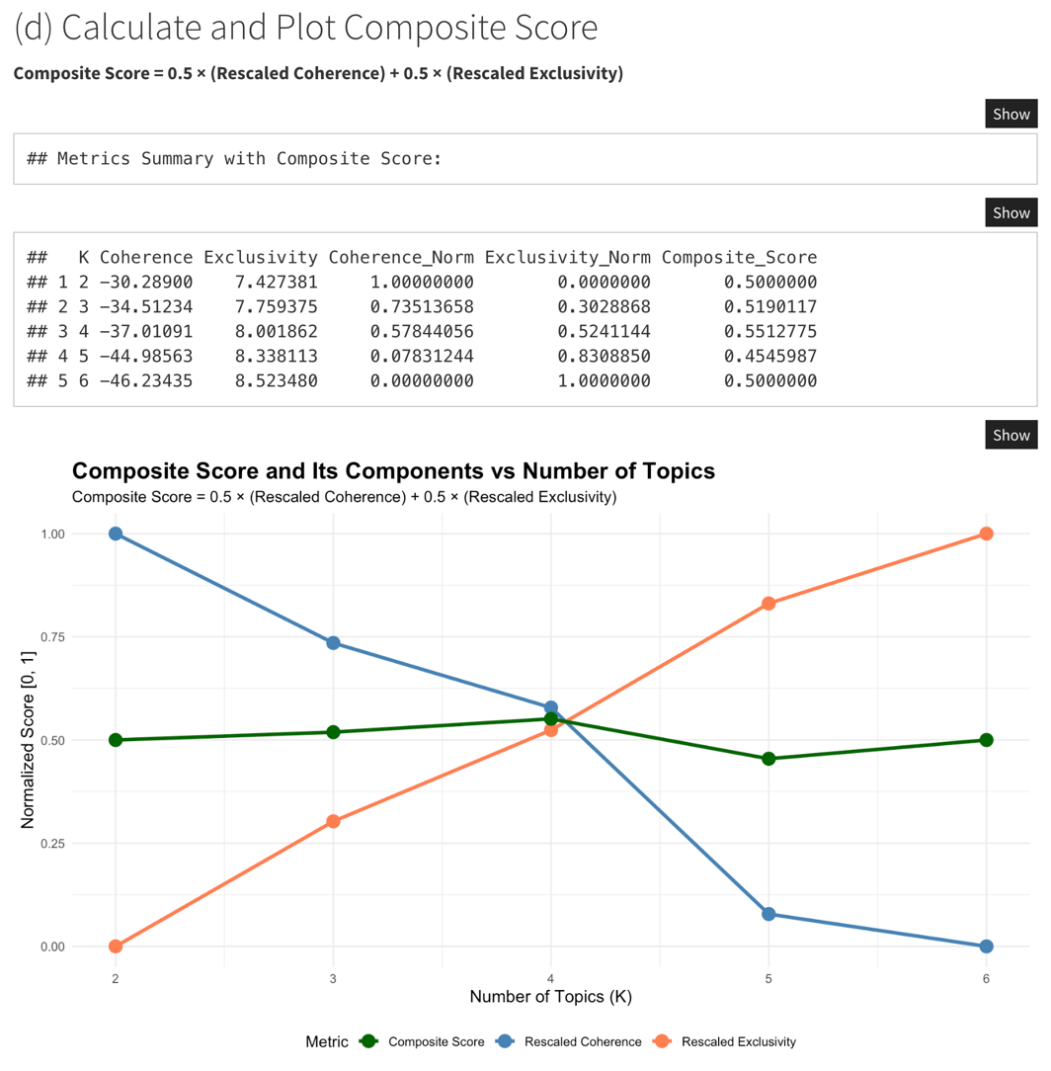

(e)

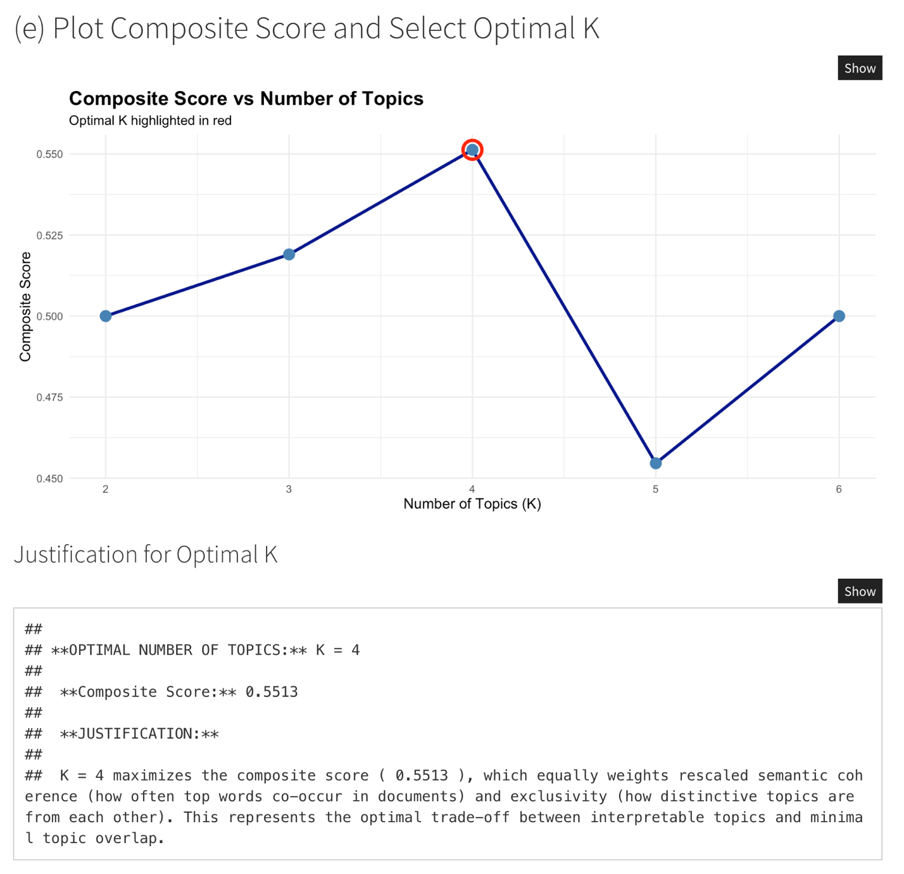

(f)
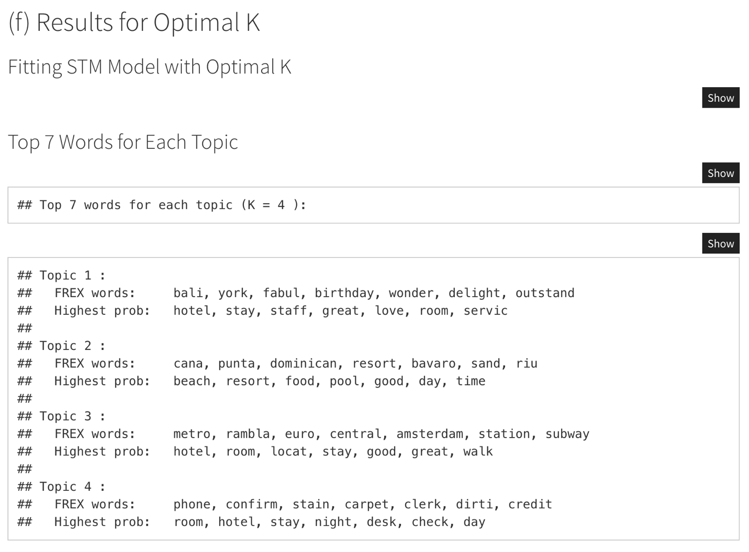
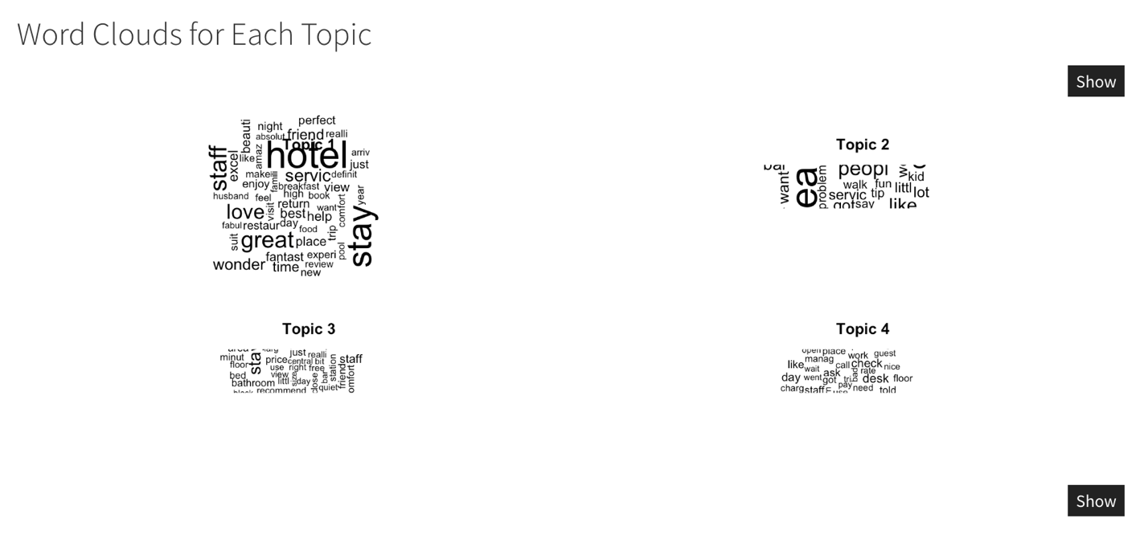

## ==========================================================================
## Topic 1 - Top Review:
## ==========================================================================
##
## Rating: 5
##
## Review:
## total elegance plus week experience elegant welcoming environment totally positive, staff friendly supportive professional times making extra effort ensure stay pleasant possible, suite perfect added touches make feel special, breakfast feast time attentive staff ensure dietary needs catered, ca n't fault beautiful hotel wonderful staff, thank relaxing enjoyable stay fantastic, kate carol new zealand,
##
##
## ================================================================================
## Topic 2 - Top Review:
## ================================================================================
##
## Rating: 5
##
## Review:
## n't listen reviews, husband couple just returned punta cana march 26th, left started read reviews thought maybe not place go.. wonderful time going, no problems airport, customs pretty easy, just make sure plane blue paper airport save time line, faster coming goingwhen got resort beautiful workers greeted arrived helped rooms, rooms clean, yes bring little gifts house maids, does make difference far house maids nice, left dollar little, make sure leave note gifts not geting trouble, clean towels drinks filled mini bar room, room safe did use did not feel not safe forgot, pools nice clean, swim bar great, did tip bartenders usually drinks alittle stronger did, dollar means alot them.we went safari tour, interesting, tour visit village lunch mountains boogy boarding, beautiful water, went tiki boat adventure, went snorkling day partying boat, lots fun, specially like dancing, went 4-wheeler adventure village rode road, lots fun, bring gifts kids, candy great colors, love mm gum, not money tell not, did notas far food really ate breakfast morings did, lunch pretty normal, supper situation, make dinner reservations arrive, book early, reservations supper canceled, thought ok. pretty fancy, just alley carts, supper time.you bring money, like purchase, brings lots 1.00 smaller bills, ca n't break big bills, 20.00 great.they speak alot english husband did not speak words spanish, n't worry ca n't no problems, work make understand just shaking head no understand, try speak english, apple vacations reps lobby helpful, questions problems help, make reservations activities tours, far reading reviews people n't worry great time, did,
##
## ==========================================================================
## Topic 3 - Top Review:
## ==========================================================================
##
## Rating: 4
##
## Review:
## great location adequate well-priced rooms central florence stayed triple room beacci tornabuoni 2 nights friends, biggest plus excellent location historical district, 5 min, walk duomo piazza di signoria uffizi gallery ponte vecchio 10 min, main train station taxi 9 euros, tornabuoni major upmarket shopping street good local restaurants easy reach, great price 135e large-sized triple room off-season, room 2 no view fine, not expecting luxury rarely room sleep, room clean plenty space store luggage small fridge/minibar small tv mainly italian channels adequate bathroom shower/tub combo bidet, breakfast fine hard-boiled eggs breads cheese ham yogurt fresh fruits no custom-made items, short perfect hotel main decent clean place central location, want luxury look,
##
## ==========================================================================
## Topic 4 - Top Review:
## ==========================================================================
##
## Rating: 1
##
## Review:
## horrible customer service worst hilton possibly worst hotel, trying review guidelines feel important people know kinds business practices ran into.we stayed hilton nights second night having wedding reception hilton.all booking went smoothly room decent exectutive sweet not overpriced got discount having reception there.the problems arrived later reception short summary things happened.-elevators having issues night.-myself reception stuck lobby n't reception elevators not working key card given not working up-the dj closing party early party no staff locking room not allowing entrance gather belongs use reception room additional hour half booked contract-a hilton staff member challenging fist fight telling hit got aggravated insisted let up.-having head security apologize actions said staff member.-finally getting executive suite stay rest night.-having police wife assaulted hilton staff member tried fight putting hand getting security apologized us.-after police left hearing story hour later long elevators broken night manager security officer showed kick mentioned assault glad arrest n't made.-after threatening lawyers involved breach contract told stay.-getting 15 minutes later night manager apologize told work sort discount trouble.-waking morning finding double charged room parking vehicles not ours.-dealing people nice saying work getting charges reversed right back.-finding hilton additional charges not outlined contract consent-being told willing reverse small portion charges staff says story false.so end breached contract refused credit, not sure action burned abuse received,
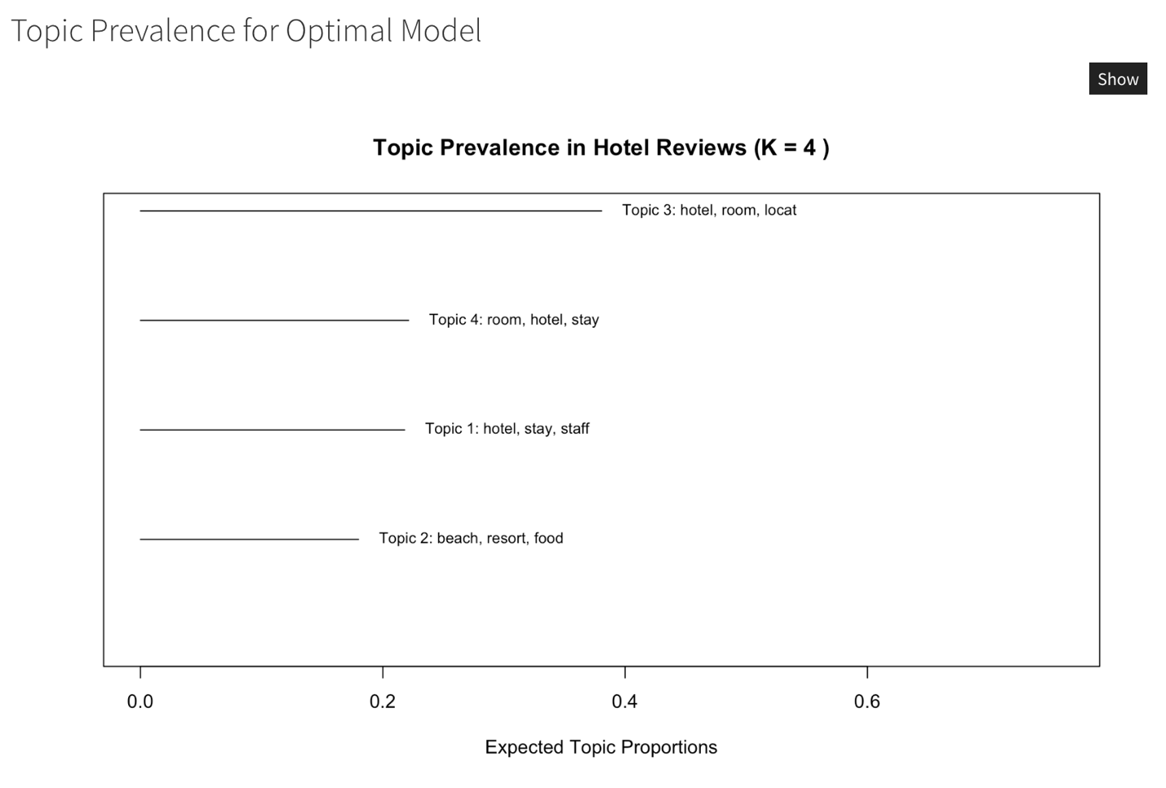

(h)
