|  |
| --- |
| 数字信号处理课程期末项目 |
| MATLAB实现拨号声音的去噪与拨号结果识别 |

|  |
| --- |
| 刘奕夫  2014-1-14 |

## 项目概述：

手机拨号数字键盘上的每个按键所发出的的声音是由两个特定频率的声音合成，具体由下表确定：  
 1209 Hz 1336 Hz 1477 Hz

_ _ _ _ _ _ _ _ _ _ _ _ _ _ _

| | |

| | ABC | DEF |

697 Hz | 1 | 2 | 3 |

|_ _ _ _ __ _ _ _ __ _ _ _ _

| | |

| GHI | JKL | MNO |

770 Hz | 4 | 5 | 6 |

|_ _ _ _ __ _ _ _ __ _ _ _ _

| | |

| PRS | TUV | WXY |

852 Hz | 7 | 8 | 9 |

|_ _ _ _ __ _ _ _ __ _ _ _ _

| | |

| | | |

941 Hz | * | 0 | # |

|_ _ _ _ __ _ _ _ __ _ _ _ _

在matlab上对一段对手机拨号键盘声音采集而成的音频信号（wav格式）进行分析和去噪，在对其进行频域分析，将录制时所输入的号码提取出来。

~~另外，这个项目还有一些其他开发潜力，之后会尝试将代码封装成一个可以实时处理音频的程序，~~所以给出项目工作室的地址如下，包含所有下方源代码的最新版，以及这个项目中用到的声音文件。



## 方法：

主函数代码：

% DSP course final project. Liu Yifu, San yat-sen university.

% this is the matlab .m file that calls the noise reduction function

% (noiseReduction.m) and dial recognition function (dialRecognition.m) to

% recognize any dialing sound from a .wav file and display the number.

% NOTE THAT:

% this program is designed for audio files that only contain the most

% common phone dialing sound

%% import data

clear all;clc;close all;

[hard,fs]=audioread('C:\Users\feirg\Google Drive\DSP projects\hard environment.mp3');

sound(hard,fs)

%% frequency domain overview

% hardSnippet=hard(2.918e5:3.198e5);

figure(1)

subplot(211)

plot_fftshift(hard,fs);

subplot(212)

plot_fft(hard,fs);

%% noise reduction

% the sound of phone dial are basically a series of Dual-tone

% Multi-Frequency signals, the way i reduce the noise of these signals are

% basically attenuating all frequencies except those that compose DTMF

% signals.

% generating filter

Fs = 44100; % Sampling Frequency

Fstop = 400; % Stopband Frequency

Fpass = 650; % Passband Frequency

Astop = 80; % Stopband Attenuation (dB)

Apass = 1; % Passband Ripple (dB)

match = 'stopband'; % Band to match exactly

% Construct an FDESIGN object and call its BUTTER method.

h = fdesign.highpass(Fstop, Fpass, Astop, Apass, Fs);

Hd = design(h, 'butter', 'MatchExactly', match);

% finish generating filter

hardSilenced=filter(Hd,hard);

figure(2)

subplot(211)

plot(hardSilenced)

title('{\bf After high-pass filtering}')

subplot(212)

plot_fft(hardSilenced,fs);

% sound(hard,fs)

%% dialing tone recognition

% [peaks,peaks_indice]=findpeaks(hard_fft);

% plot(peaks_indice,peaks);

plot_fft函数代码

function [signal_fft,frequencyRange]=plot_fft(signal,frequency)

% this function plots the FFT with corresponding frequency of the input

% signal, and at the same time return the FFT and frequency bins.

transformLength=pow2(nextpow2(length(signal)));

signal_fft=abs(fft(signal,transformLength));

frequencyRange=(0:transformLength-1)*(frequency/transformLength);

plot(frequencyRange,signal_fft);

xlabel('Frequency (Hz)')

ylabel('Magnitude')

title('{\bf Spectrum}')

plot_fftshift函数代码

function [signal_fft,frequency_bins]=plot_fftshift(signal,frequency)

% see plot_fft.m

signal_fft=abs(fftshift(fft(signal)));

frequency_bins=-frequency/2:frequency/(length(signal)-1):frequency/2;

plot(frequency_bins,signal_fft);

xlabel('Frequency (Hz)')

ylabel('Magnitude')

title('{\bf 0-Centered Spectrum}')

## 结果：

原始音频时域表现：

可以看出分析价值不大，转而在频域上分析。

原始音频的频域表现：

对照项目概述中的拨号键声音频率合成表，放大650-1500Hz的部分：

可见低频处有较高能量的噪声。用Butterworth滤波器处理。

低频计滤波器如下：

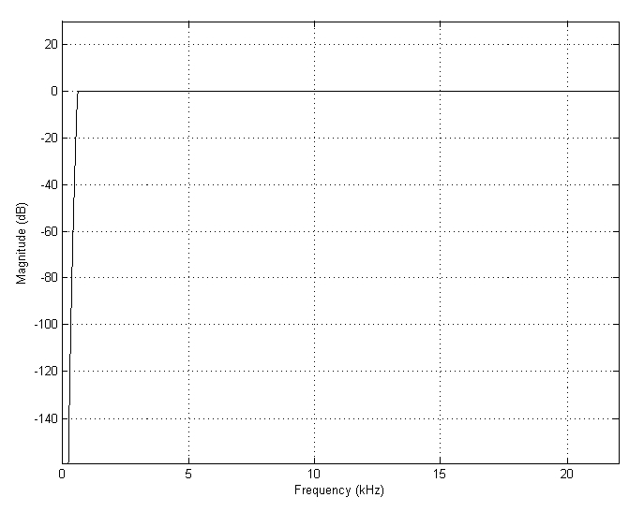

处理后频谱图如下：

可以看见低频噪声已经被消除。

再观察拨号键盘声音的频域合成表格，放大680-1500Hz的部分：



注意到所有的能量峰值都落在我们感兴趣的7个特定频率上，非常令人满意。

为了分析每一次按键声音所代表的的号码，还需要在时域上对声音进行剪切，再依照频率合成表对声音信号进行对比分析，（该过程比较简单且不涉及信号处理核心知识点，报告中不给出详细步骤）。最终发现录音中录入的数字是15920353036，我的电话号码。