Random Forrest classification – Mixed model: Hierarchical/Nested ANOVA with random effects + Modified Linear Mixed Model (LMM) with REML estimation
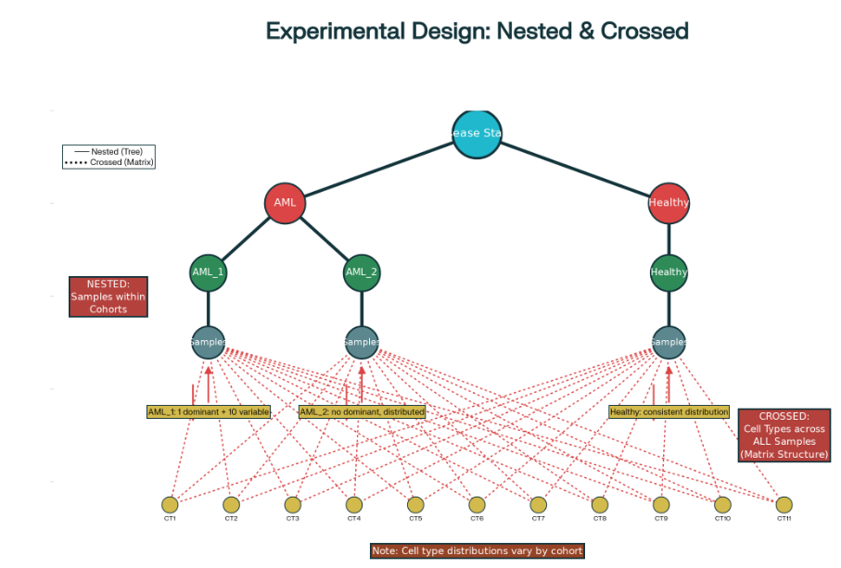
Approach: Hierarchical/Nested ANOVA with Random Effects enhanced with compositional cell-type weighting

