**Limits Service**

Optum

Student Exercise Manual

**Contents**

Limits Service 2

# Limits Service

**Overview**

**Time: X Minutes**

In this exercise, you will:

* Develop limits service to read configuration from a properties file.

**Step 1: Bootstrap Simple Rest Service**

Open URL <https://start.spring.io/>

Pick latest boot version and add dependencies as shown below.

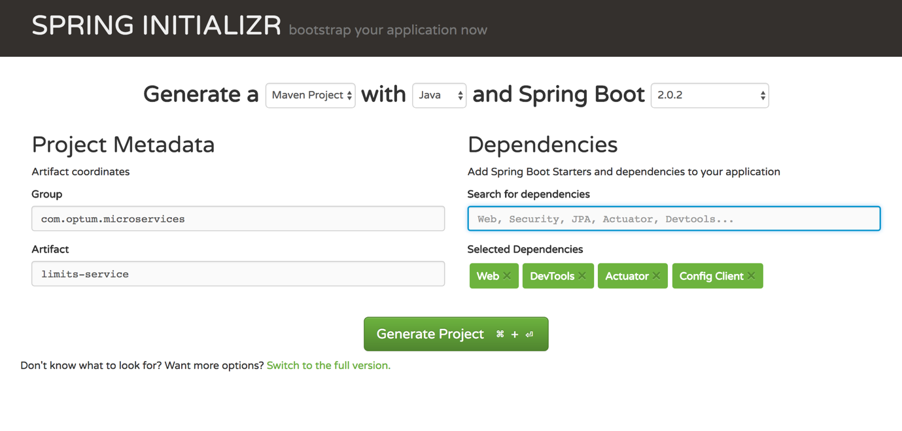

**After** clicking generate, a zip file will be downloaded, unzip the file and keep it in a folder of your choosing.

Open this project in your favorite IDE. **The f**irst time setup takes time for Spring Boot.

Run com.optum.microservices.limitsservice.LimitsServiceApplication to assure service is working fine. Should show below on run

Started LimitsServiceApplication in 8.917 seconds (JVM running for 10.546)

**Step 2: Create a Bean to Serve Data through Rest**

Create a bean to return a value from thecontroller**.** com.optum.microservices.bean.LimitConfiguration

public class LimitConfiguration {

private int maximum;

private int minimum;

protected LimitConfiguration() {

}

public LimitConfiguration(int maximum, int minimum) {

this.maximum = maximum;

this.minimum = minimum;

}

public int getMaximum() {

return maximum;

}

public int getMinimum() {

return minimum;

}

}

**Step 3: Adding Configuration to Properties**

spring.application.name=limits-service

limits-service.minimum=1

limits-service.maximum=999

**Step 4: Create Property Configuration Reader**

Add com.optum.microservices.limitsservice.Configuration class**.**

Add thefields maximumand minimum, the same as wasadded in application.properties and generate getters/setters.

Also**,** add theprefix we have used in the properties "limits-service" to the annotation ConfigurationProperties**.**

@org.springframework.context.annotation.Configuration

@ConfigurationProperties("limits-service")

public class Configuration {

private int maximum;

private int minimum;

public int getMaximum() {

return maximum;

}

public void setMaximum(int maximum) {

this.maximum = maximum;

}

public int getMinimum() {

return minimum;

}

public void setMinimum(int minimum) {

this.minimum = minimum;

}

}

**Step 5: Create Rest Controller to Handle Incoming Requests**

Create a class com.optum.microservices.limitsservice.LimitsConfigurationController.

Create a public method retrieveLimitsFromConfiguration and annotate this method for GetMapping as /limits.

Annotate **the** class with the annotation RestController.

@RestController

public class LimitsConfigurationController {

@GetMapping("/limits")

public LimitConfiguration retrieveLimitsFromConfiguration() {

}

}

Autowire this class with **an** instance of configuration reader to read **the** value from **the** properties file**.**

@RestController

public class LimitsConfigurationController {

@Autowired

private Configuration configuration;

@GetMapping("/limits")

public LimitConfiguration retrieveLimitsFromConfiguration() {

return new LimitConfiguration(configuration.getMaximum(), configuration.getMinimum());

}

}

Restart your application and hit URL <http://localhost:8080/limits>

{"maximum":999,"minimum":1}