**Cloud 300**

Optum

Student Exercise Manual

# # Openshift Lab 1.3:

## Installing Openshift Command Line Interface

### Prerequisites

* A computer system with internet connectivity.
* A Github account.
* Openshift Online account set up.
* Git software installed.
* Complete Openshift Labs 1.1 and 1.2 before this step.
* Keep an open browser window logged in to your Github account.

### Topics to cover

* Installing the Openshift Command Line Interface (CLI).
* Introduction to oc.exe command.

### Step 1 - Installing Openshift CLI

* Login to your Openshift online account and navigate to the web console.
* On the top right of your screen you will see a ? with a down arrow as pictured below.
* Click on the down arrow and then click on "Command Line Tools."

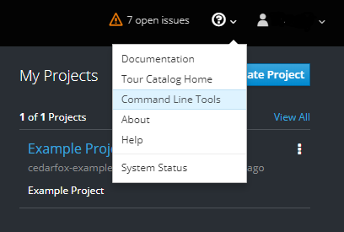

* This will bring you to a screen as pictured below.
* Under the line on the top left that says "Download", click on the download link based on the operating system you are using.

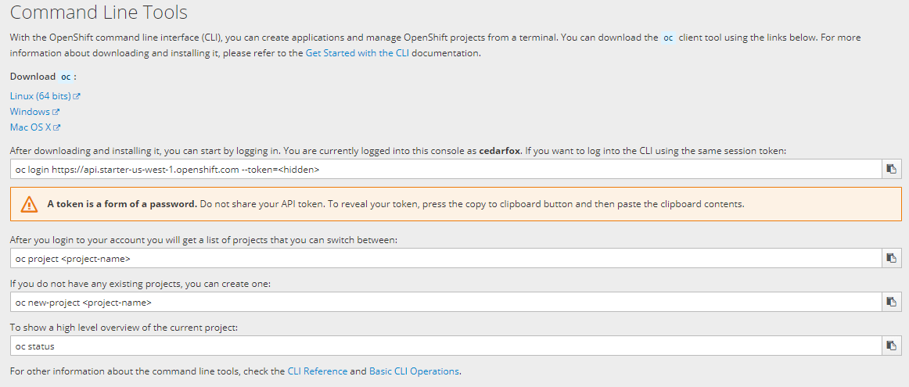

* Once the file is downloaded, open the download folder/directory containing the downloaded file. The name of the file should be oc.exe. This is how it looks if using Windows.



* Choose which PATH directory you want to copy the oc.exe file to.
  + Check existing path directories by opening a command prompt.
    - In Windows
      * Type cmd in the search bar and Click on "Command Prompt."
      * In the command prompt type: "path".
      * A list of current path directories will display in the command prompt
      * Choose one of the existing directories/folders in PATH for you to copy the oc.exe file or add a new directory as described below.

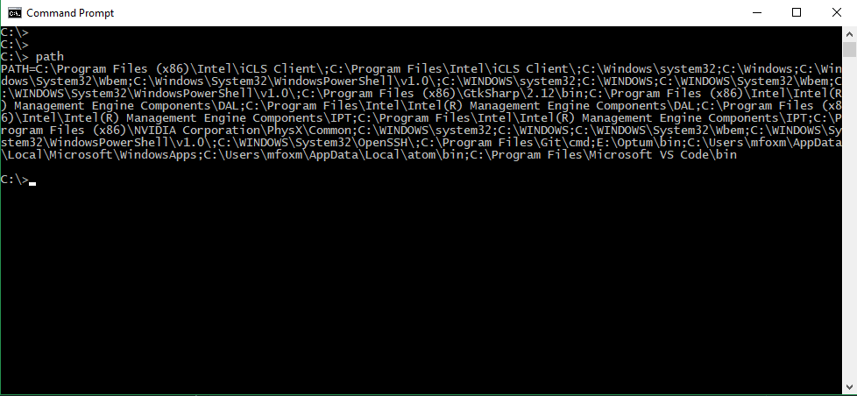

* In Linux/MAC:
  + Open the terminal and type this command to display the current PATH directories.
  + $ echo $PATH
* Add a new directory to the PATH (if needed).
  + In Windows:
    - Open the control panel, click "System."
    - Click "Advanced system settings" on the top right; a "System Properties" window will open.
    - Click on the box at the bottom of the "System Properties" window which says "Environment Variables."

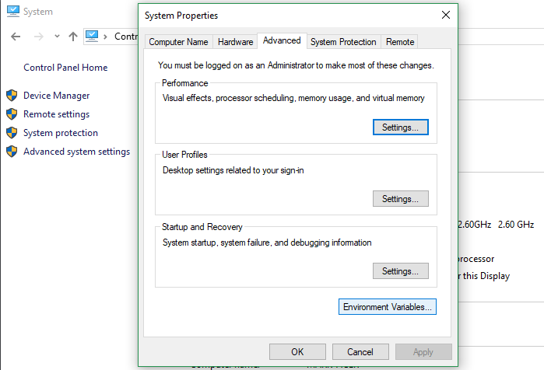

* A new box opens. Look under the lower box which says "System variables" and Click "Path." Then click the "Edit button" underneath.
* A box with lists of directories in PATH appears. Click "NEW" on the top right.
* This makes a new empty field; you should type the path to the directory where you want to copy the oc.exe file.

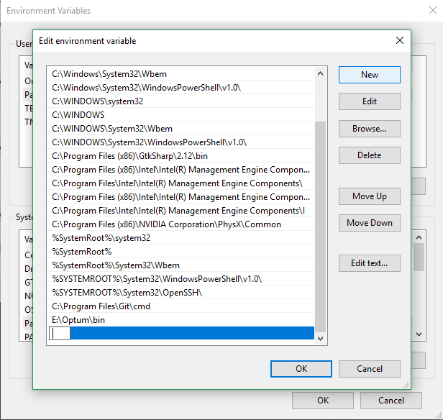

* Then close the 3 windows by clicking OK on each.
* Linux/MAC: To make a new directory in PATH, open the terminal and type the command below. Replace "/path/to/my/directory" with your actual path.

console export PATH=$PATH:/path/to/my/directory

* Unzip or extract the oc.exe file to a PATH location on the local computer.
  + Windows instructions:
    - Right click over the name of the application "oc" (oc.zip)
    - Select "Extract all..."
    - Enter or browse to a directory in the PATH destination for copying the oc file.
    - Click Extract
* Mac/Linux instructions * Extract the oc.exe file and copy the file to the chosen directory in PATH.

To run the oc command line interface: * In Windows, you need to open the command prompt "as an administrator."

* Type "cmd" in the search bar and right click on "Command Prompt" in the start menu.  
 * Left click on "Run as administrator."  
 * The command prompt will open.  
 * Type the following command to make sure it is working. It should display version detail.  
  
 oc version  
  
<p style="text-align:center;"><img src="../images/ocversion.png" height="300" class="center"/></p>

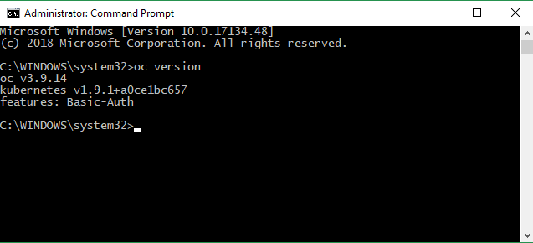

* In Linux/Mac you can use the "oc version" command from your terminal to ensure it is installed properly.
* An Introduction to using the Openshift CLI found in Openshift Lab 2.1.

Notes:

For more information on the command line interface check the following links:

Information obtained from https://docs.openshift.com/online/getting_started/beyond_the_basics.html#getting-started-beyond-the-basics https://blog.openshift.com/installing-oc-tools-windows/ https://docs.openshift.com/online/getting_started/beyond_the_basics.html#getting-started-beyond-the-basics

## Thanks for completing Openshift Lab 1.3!