**Cloud 300**

Optum

Student Exercise Manual

# # Openshift Lab 3.1:

## Working with Complex Deployments

### Prerequisites

* A computer system with internet connectivity.
* A Github account.
* Keep an open browser window logged in to your Github account.
* Openshift Online free account.
* Git software installed.
* Complete Openshift Labs 1.1, 1.2, 1.3, 2.1, 2.2, and 2.3 before this step.
* A text editor of your choice installed to your system.
* Note for Windows users: do not use notepad as the text editor. If you do not have another text editor installed, you should download and install a text editor.
* Some example text editors:
  + Notepad ++ - https://notepad-plus-plus.org/
  + Atom - https://atom.io/
  + Brackets - http://brackets.io/
  + Visual studio code - https://code.visualstudio.com/
  + Vim text editor - https://www.vim.org/

### Topics to Cover

* Scaling an application.
* Autoscaling an application.
* Practice creating pods with an affinity rule.
* Clustering an application.
* Creating a router in Openshift.

### Notes

* If the example commands show a $ command prompt, then do not actually type the $.

### Initial preparation

* Keep a browser window logged into your Github account.
* Open a browser window and log in to your Openshift Online account and enter the web console.
* Open a terminal (or in Windows a command prompt "as an administrator".)
* If you are not logged in to your Openshift Online account through the command prompt/terminal, then log in using the oc login command copied from your web console. (Lab 2.1 describes how to login).
* Type oc project into the command line. It will tell you the name of the project you are working on.
* If you have the free Openshift Online starter account, then you can only have one project. Delete the project by typing oc delete project username-example. Replace username-example with the name of your project.
* Make a new project with a unique name using the following command. Replace username-project with the name you want to give the project.
* oc new-project username-project --display-name="Test Java Application"

### Install an Example Application

* Step 1. Open the browser window to the following Github link: https://github.com/elephantscale/jee-start
* Step 2. Fork the application by clicking the "Fork" button on the upper right hand of the screen.



* Step 3. Open your Git Bash or terminal window.
* Step 4. You may optionally change directories to the directory where you want to clone the file.
* Step 5. In your Git Bash window or terminal window, clone the forked application from your repository. Instead of "username," type your actual Github username.
* $ git clone https://github.com/username/jee-start  
  $ cd jee-start
* Step 6. Install the jee-start application by typing this command in your command prompt/terminal. Replace the "username" in the Github URL with your actual Github username.
* oc new-app openshift/wildfly-101-centos7~https://github.com/username/jee-start.git --name=jee-start
* Step 7. Check the status of the new-app by typing oc status.
* Step 8. Give the application a route with the following command.
* oc expose svc/jee-start
* Step 9. Type oc get routes into the command line, then copy the URL under the HOST/PORT field to your clipboard.
* Step 10. Paste the URL into a new web browser window address bar.

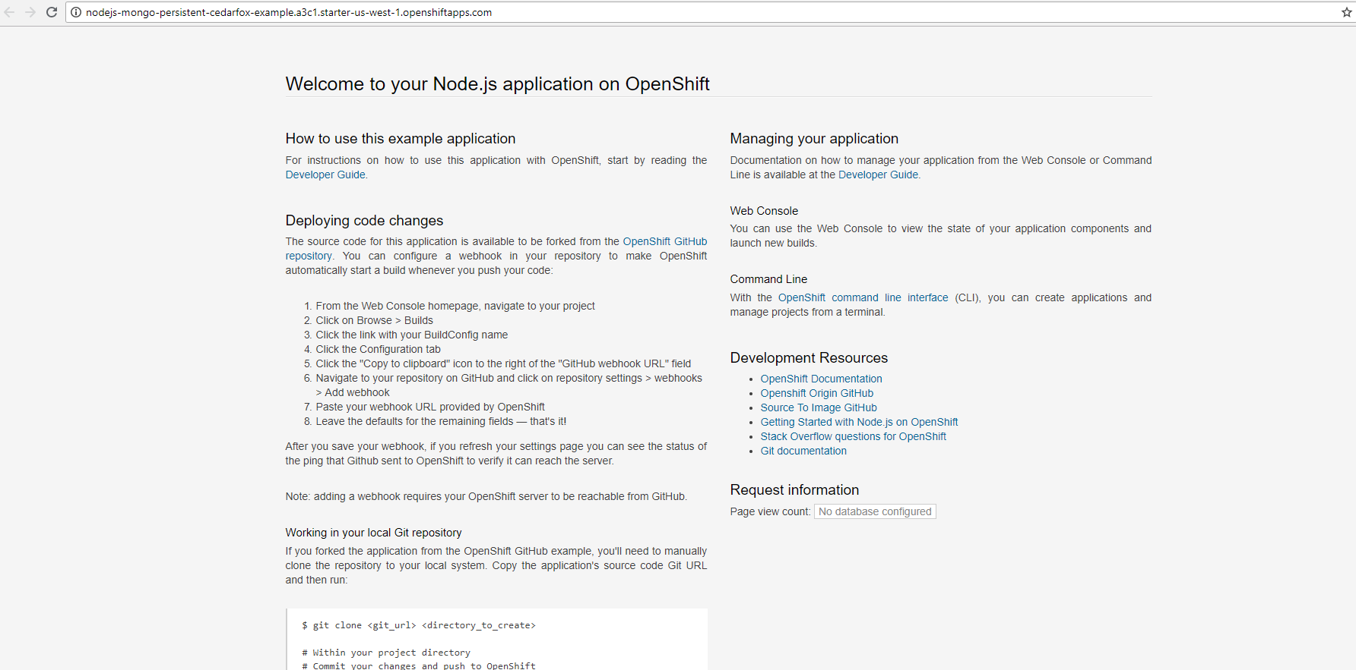

* Step 11. Note that this applciation has a hidden HelloWorld link. After the end of the existing URL in the web browser, add /HelloWorld and you should get a view of the HelloWorld screen.

### Scaling an Application

* Step 1. Check for information about replication controllers by typing oc get rc.
* Step 2. Check for information about pods by typing oc get pods.

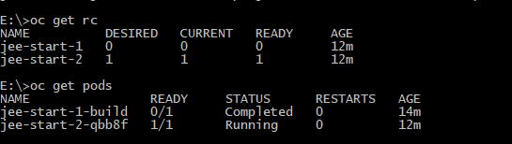

* Step 3. Manually scale the application using the oc scale command.
* oc scale dc jee-start --replicas=5
* Step 4. Check for information again about replication controllers by typing oc get rc, and about pods by typing oc get pods.

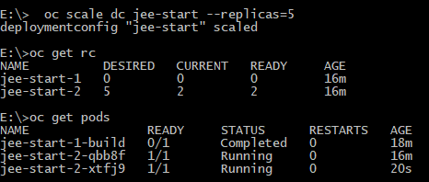

It should show that there is "5" under "DESIRED", and "2" or more under "CURRENT." Notice in this example that it increased the number of pods from 1 to 2.

* Step 5. Navigate to your project under the web console. Then click on the name of your application "jee-start" and the "Configuration" tab.

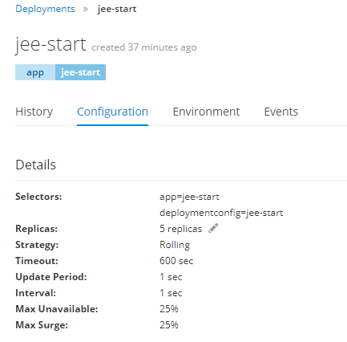

* Step 6. Click on the pencil next to the "5 replicas," and change it to 10 and click the checkmark.
* Step 7. Type oc get rc again in the command line, and it should show you 10 under the "DESIRED" field.

### Autoscaling an application

* Step 1. Go back to the web console window and look on the same page where you changed the replicas, and on the right, click the "Add autoscaler" link.
* Step 2. Fill in the details in the form as the following:
* Min pods: 1, Max pods: 8, CPU Request Target: 80%.
* Then click "Save."

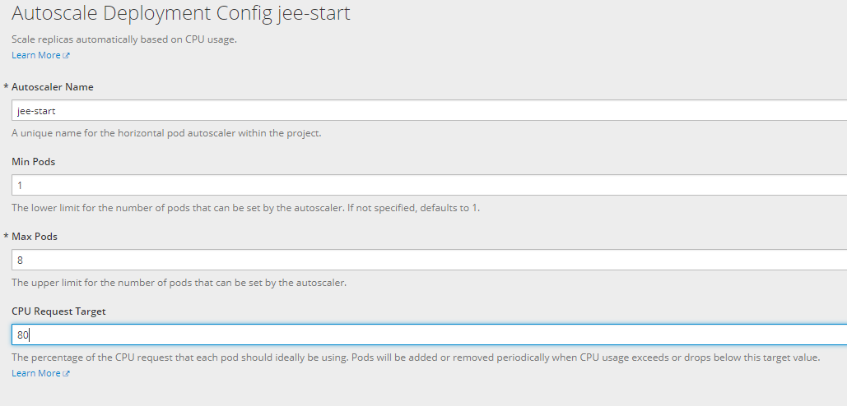

* Step 3. Go to your CLI and type oc get hpa to get information on the autoscaling. it will provide details regarding the numbers of pods and CPU usage.
* Step 4. Turn off autoscale by deleting the hpa: oc delete hpa --all.
* Step 5. Now autoscale using the oc autoscale command.
* oc autoscale dc/jee-start --min=1 --max=10 --cpu-percent=75
* Step 6. Type oc get hpa to check the status again.



* You have successfully scaled and autoscaled.

### Practice Creating Pods with an Affinity Rule

* In Lab 2.3, we walked through the process of how to create a pod and edit the pod object defintion file.
* A pod affinity rule is a form of advanced pod scheduling which tries to put that type of pod on the same node. An Anti-affinity rule tries to put the pods on different nodes.
* This is an example of a pod affinity configuration. (Note that on Openshift Online Starter, there is not enough resources to run both copies of the hello-pod images, so in the second file, we changed the name of the image file so it would install. )
* Step 1. Select the following text and copy it to the clipboard.

apiVersion: v1  
kind: Pod  
metadata:  
 name: team4  
 labels:  
 team: "4"  
spec:  
 containers:  
 - name: ocp  
 image: docker.io/ocpqe/hello-pod

* Step 2. Open up a new text file in your text editor and paste the text in. Save it in yaml format with the name team4.yaml .
* Step 3. Now select the following text and copy it to your clipboard.

apiVersion: v1  
kind: Pod  
metadata:  
 name: team4a  
spec:  
 affinity:  
 podAffinity:  
 requiredDuringSchedulingIgnoredDuringExecution:  
 - labelSelector:  
 matchExpressions:  
 - key: team  
 operator: In  
 values:  
 - "4"  
 topologyKey: kubernetes.io/hostname  
 containers:  
 - name: pod-affinity  
 image: openshift/origin-docker-registry:v0.6.2

Examples obtained from: https://docs.openshift.com/container-platform/3.9/admin_guide/scheduling/node_affinity.html

* Step 4. Open up another new text file and paste the above text in. Save it in yaml format with the name team4a.yaml .
* Step 5. Create the pods by typing oc create -f team4.yaml, enter, oc create -f team4a.yaml
* Step 6. Type oc get pods. You should see the team4 and team 4a pods listed.
  + This was just an example to show the process. You may have a CreateContainerError listed on team4a pod due to using the origin-docker-registry image.
* Step 7. Delete the pods by typing oc delete pod team4, enter, oc delete pod team4a.

### Creating a Router in Openshift

* Routers are a component of Openshift Container Platform, but in Openshift Online, the Routing is built-in. You can still create a router in Openshift Online, though there will be some errors.
* Step 1. Save a copy of default router settings before creating.
* oc adm router --dry-run -o yaml > router.yaml
* Ignore the error it gives you. In Openshift Container Platform, you can actually create the router using the "oc adm router" command.
* Step 2. Open the file router.yaml with a text editor and scroll down through the settings.
* Step 3. Change the number of replicas (on line 31) from 1 to 3. Then save the file.
* Step 4. Type the following command oc create -f router.yaml.
* Step 5. View the status by typing oc get all.
* You can view any of the router configuration files by using the oc edit command, like in this example.
* oc edit dc/router
* When you are done viewing the configuration files, close them in the editor without saving.

### References

* Duncan, J., Osborne, J. (2018). Openshift In Action. Pages 147-167. Manning Publications: Shelter Island, NY. www.allitebooks.com

https://docs.openshift.com/container-platform/3.6/install_config/router/index.html#install-config-router-overview

https://docs.openshift.com/container-platform/3.6/install_config/router/default_haproxy_router.html#install-config-router-default-haproxy

https://docs.openshift.com/container-platform/3.9/admin_guide/scheduling/scheduler.html

https://docs.openshift.com/online/architecture/core_concepts/pods_and_services.html

https://docs.openshift.com/container-platform/3.9/admin_guide/scheduling/node_affinity.html

## Thanks for completing Openshift Lab 3.1!