

**Keep Hope Alive Scholarship Report**

August 9, 2024

## Table of contents

Executive Summary 3

Introduction 4

Methods 4

Results 6

Conclusions 8

Appendix 9

# Executive Summary

### Background and Aim

1. A significant proportion (37%) of first-time, full-time students who enroll at Georgia State University (GSU) with the HOPE scholarship eventually lose it. In response, GSU introduced the Keep HOPE Alive (KHA) program to help these students improve their academic performance and regain eligibility for the HOPE scholarship.
2. The goal of this analysis was to determine the effect of receiving the KHA scholarship on the likelihood of regaining the HOPE scholarship and graduating.

### Methods

1. The analytic sample included 372 KHA recipients and 372 non-recipient students who also lost the HOPE scholarship. The two groups were matched for demographic, socioeconomic, and academic performance characteristics.
2. Logistic regression was used to estimate the effect of the KHA scholarship on (1) regaining the HOPE scholarship and (2) graduating within 6 years of first enrollment.

### Results

1. KHA recipients were nearly two times more likely to regain the HOPE scholarship than non-recipients. Additionally, the percentage point improvements in the HOPE regain rates for Black (+18 pp), Hispanic (+21 pp), first-generation (+19 pp), and Pell recipient (+17 pp) students were larger than the regain rate for all students combined (+16pp).
2. KHA recipients were two times more likely to graduate than non-recipients, with graduation rates that were 15 percentage points higher than non-recipients. The largest gains in graduation rates occurred for Black students (+19 pp) and Pell recipients (+17 pp).

### Conclusions

1. The KHA program increases the likelihood that a student will regain the HOPE scholarship and graduate. Moreover, the increases in regain rates and graduation rates for Black students and Pell recipients were larger than the increase for all students combined.
2. These findings provide compelling evidence that scholarship programs like Keep HOPE Alive benefit all students and are particularly impactful for students from underserved backgrounds.

# Introduction

The HOPE scholarship is awarded to Georgia residents who demonstrate academic excellence and offers financial support to students by covering part of their tuition at eligible higher education institutions. From 2012 to 2017, over 15,000 first-time, full-time students enrolled at GSU with the HOPE scholarship. However, almost 6,000 students lost the scholarship over the course of their enrollment (see Figure 1). To help students regain the scholarship, GSU introduced the Keep HOPE Alive (KHA) program. The program awards a $1,000 scholarship to students on the condition that they engage in a series of support interventions aimed at improving their academic performance. This paper evaluates the effect of receiving the KHA scholarship on regaining the HOPE scholarship and graduating.

# Methods

### Sample Selection

The analytic sample of KHA recipients and non-recipients was determined based on predefined inclusion criteria and a matching method (see Figure 1). The initial sample was composed of first-time, full-time freshman students who enrolled at GSU with the HOPE scholarship in the Fall 2012 through Fall 2017 terms. These specific years were chosen because they are the most recent cohorts with data available for 6-year graduation outcomes (graduation years of 2018-2023). The second inclusion criterion was the loss of the scholarship. This selection process led to a mid-point sample size of 372 KHA recipients and 5,469 non-recipients (see Table 1 for descriptive statistics). To reduce the loss of data points for KHA recipients due to missing information (31 students), missing values for socio-demographic variables were re-coded as ‘missing’, and academic performance variables were imputed with the group average. Due to the unbalanced sample sizes, a matching method (Nearest Neighbor; see the Appendix for more information) was used to improve the balance between KHA recipients and non-recipients. The final analytic sample included 372 KHA recipients and 372 non-recipient students matched for similar demographic, socioeconomic, and academic performance characteristics.

### Statistical Analysis

A logistic regression model was used to estimate the effect of the KHA scholarship as follows:

𝑌𝑖 =𝛽0 +𝛽1𝐾H𝐴𝑖 +𝑋𝑖𝛾+𝑒𝑖

where 𝑌𝑖 is the binary outcome variable, 𝐾H𝐴𝑖 is the predictor variable for a Keep Hope Alive scholarship, 𝑋𝑖 is a vector of student characteristics, 𝛾 is a vector of the coefficients associated with the student characteristics, and 𝜀𝑖 is the error term. The student characteristics included in the model were Black/non-black, Hispanic/non-Hispanic, Pell status, first-generation status, sex, high school GPA, and GSU GPA and credit hours at the time when the HOPE scholarship was lost. Two separate models were used: one with the outcome variable as regaining the HOPE scholarship and another with the outcome variable as graduating. Statistical significance was set at P < 0.10 (see the Appendix for an explanation of P-values).

### Figure 1: Sample Selection Flowchart

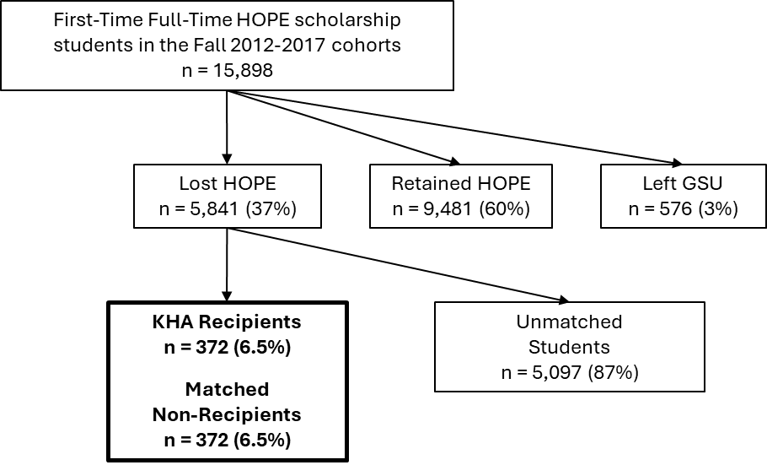

### Table 1: Descriptive Statistics

|  |  |  |  |
| --- | --- | --- | --- |
|  | Keep Hope Alive Recipients  (n = 372) | Matched non-Recipients  (n = 372) | All non-Recipients (n = 5,469) |
| High School GPA | 3.39 | 3.39 | 3.41 |
| GSU GPA at HOPE Loss | 2.87 | 2.85 | 2.73 |
| Credit Hours at HOPE Loss | 36 | 35 | 50 |
| Black | 64% | 64% | 47% |
| Hispanic | 10% | 10% | 11% |
| Female | 67% | 67% | 60% |
| First Generation | 22% | 22% | 22% |
| Pell Recipient | 71% | 71% | 61% |

# Results

### Impact on Regaining HOPE

The results of the logistic regression show that KHA recipients are 1.9 times more likely to regain HOPE than non-recipients (Figure 2; confidence interval: 1.50-2.51; p <0.001). 57% of KHA recipients regained HOPE, compared to only 41% of non-recipient students (Figure 3), an increase of 16 percentage points. The increase in regain rates was largest for Hispanic students (+21 pp), followed by First Generation (+19 pp), Black (+18 pp), and Pell students (+17 pp).

### Impact on 6-year Graduation

The results of the logistic regression show that KHA recipients are 2.1 times more likely to graduate than non-recipients (Figure 2; confidence interval: 1.60-2.73; p <0.001). Specifically, 78% of KHA recipients graduated within six years of enrolling, compared to only 63% of nonrecipients (Figure 4), an increase of 15 percentage points. The largest gains were for Black and Pell students, whose graduation rates increased by 19 and 17 percentage points, respectively (Figure 4).

### Figure 2: Odd Ratios for regaining HOPE and graduating

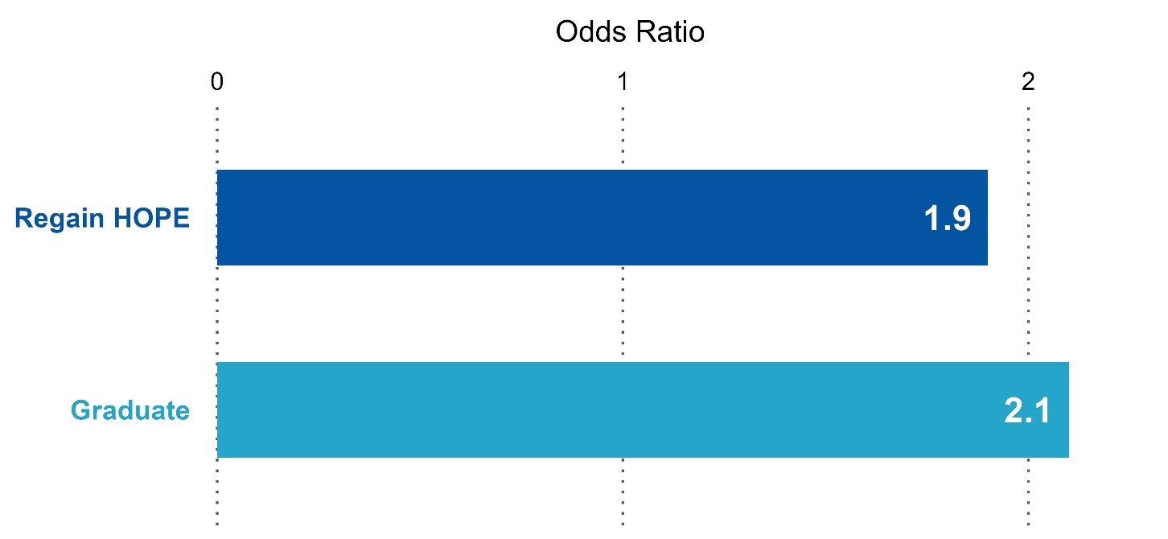

### Figure 3: Percentage of students who regain HOPE, displayed by student group

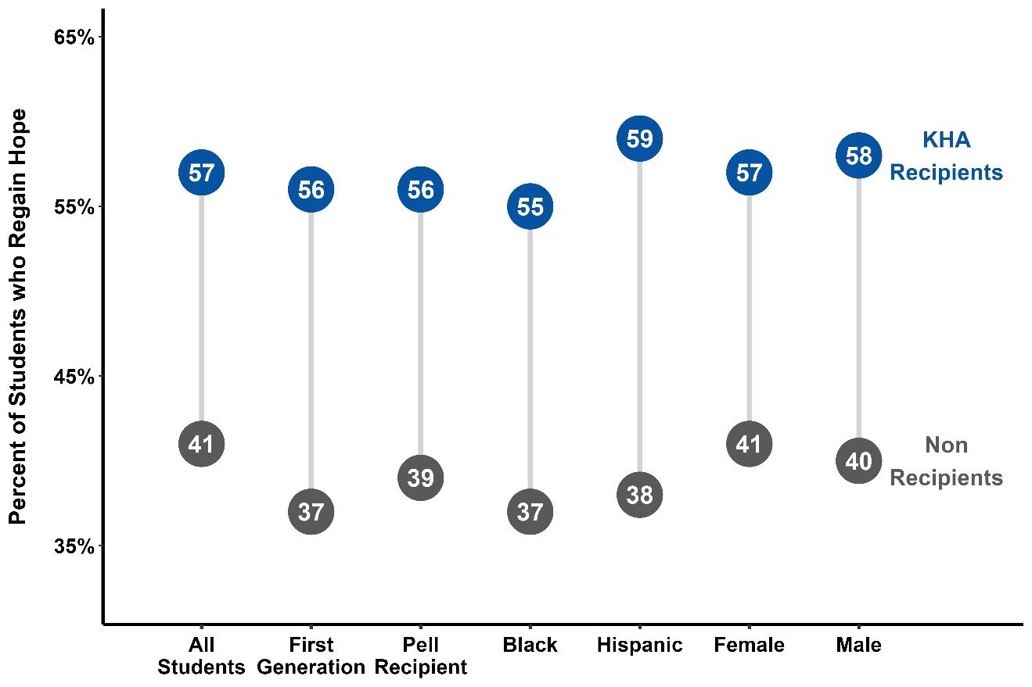

### Figure 4: 6-year graduation rates, displayed by student group

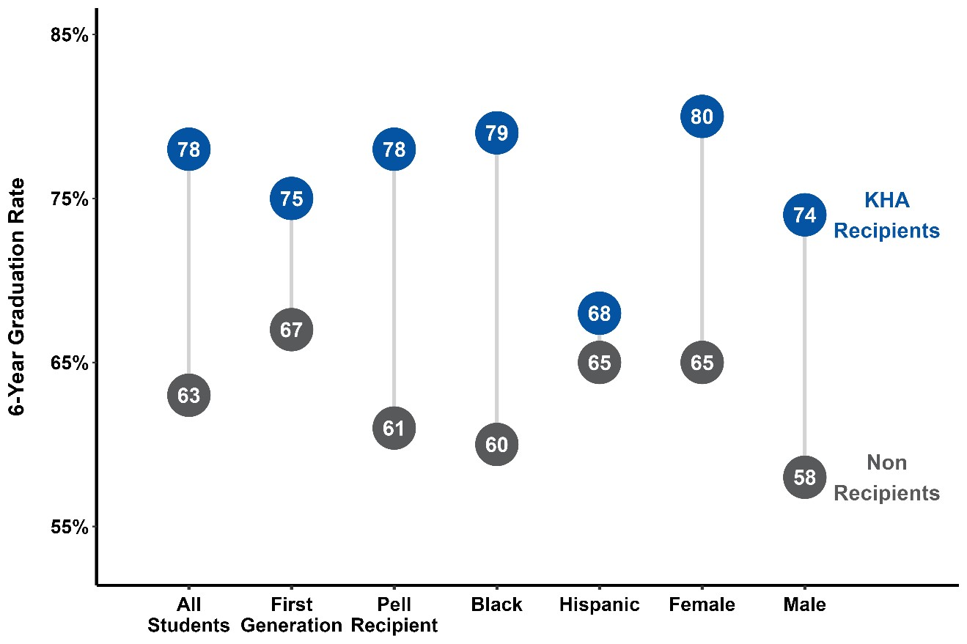

# Conclusions

This project aimed to assess the effect of receiving the KHA scholarship on regaining the HOPE scholarship and graduating. The findings demonstrate that the KHA program increases the number of students who regain HOPE and graduate compared to non-recipients with similar demographic, socioeconomic, and academic performance characteristics. Furthermore, the percentage point improvements in the HOPE regain rates for Black, Hispanic, first-generation, and Pell recipient students were larger than the regain rate for all students combined. Similarly, the largest gains in graduation rates were for Black students and Pell recipients. These findings provide compelling evidence that scholarship programs like KHA benefit all students and are particularly impactful for students from underserved backgrounds.

# Appendix

### Odds Ratio Explanation

An odds ratio is a number that can range from 0 to very large values and is a way to measure the likelihood of an event occurring in one group compared to another group.

* An odds ratio of 1 means the likelihood (or chance) of an event occurring is equal between the two groups.
* An odds ratio of greater than 1 suggests a greater likelihood of the event occurring in one group.
* An odds ratio of less than 1 suggests a lesser likelihood of the event occurring in one group.

For example, the odds ratio of 1.9 for regaining HOPE indicates how much more likely a KHA recipient is to regain HOPE compared to a non-recipient.

### P-value Explanation

A P-value, or probability value, is a number that can range from 0 to 1. A P-value close to 0 indicates that the true odds ratio is different than 1. Typical cutoff points to make the determination are 0.05 or 0.10. In other words, if the P-value is less than 0.10, there is strong evidence that the true odds ratio is different than 1.

### Nearest Neighbor Matching

The initial sample consisted of 372 Keep Hope Alive (KHA) recipients and 5,469 non-recipients. Given the substantial difference in group size and moderate disparities in demographic, socioeconomic, and academic performance characteristics, we employed nearest neighbor matching to enhance sample balance. This matching method pairs one KHA recipient with one non-recipient based on similar demographic, socioeconomic, and academic performance characteristics (i.e., covariates included in the regression model). Overall, the matching method improves the balance between the KHA recipients and the control students, allowing for a more robust comparison of the effects of the KHA scholarship.