TIM GEANEY

STUDENT NUMBER: D10120047

DATE: 06/11/2012

DT265 ENTEPRISE APPLICATION DEVELOPMENT CA1

Introduction
This is my implementation of the game Hunt the Wumpus. I decided to use python as I have been learning it myself recently and it’s a good functional language ideal for programs such as this one. Hunt the Wumpus is basically an exercise in keeping track of items as they are moved around a game board of 20 nr linked caves making it perfect for executing simple data structures. For reference lists in pythons are basically equivalent to arrays in most other languages.

Instructions for running
The game is run in the console or a python shell such as the one idle runs. There are two files one wumpus.py which has the game as its supposed to be played and one wumpus_test.py which can be run to easily test the game.

Design Of Game and Algorithms used

The data structure I decided to use for the game was a 2d array or in python lingo a lists of lists to hold the caves and their associated links. The items are stored in lists as in the player the wumpus, bats and pits. All the other functions basically revolve around either updating these lists adding or removing items to keep track and reflect moves made during game.

The deign of the game I have split up into three parts:

The cave structure

Place items into cave structure (as in wumpus, bats, pits and player)

The game logic

The cave structure:

There are twenty interlinked caves each cave is linked to 3 other caves. I have followed the traditional wumpus map which is a dodecahedron with 20 points each representing a cave.

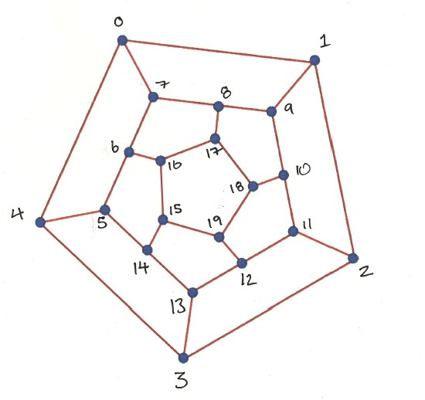

Fig 1: Cave Structure

To represent this structure in code I have use a list of lists in python. First I create a list of size 20 then I append another empty list into each of these lists (see setup_caves() fn). I now have a structure to hold the cave layout. For added complexity instead of just randomizing cave numbers at the start of each game I decided to stick with the dodecahedron structure but write an alogorithm that turns the outer pentagon clockwise and then turns the inner pentagon clockwise and then re-do all the links as illustrated in Fig 2. and Fig. 3.

Fig 2: Positions changed after turning outer pentagon

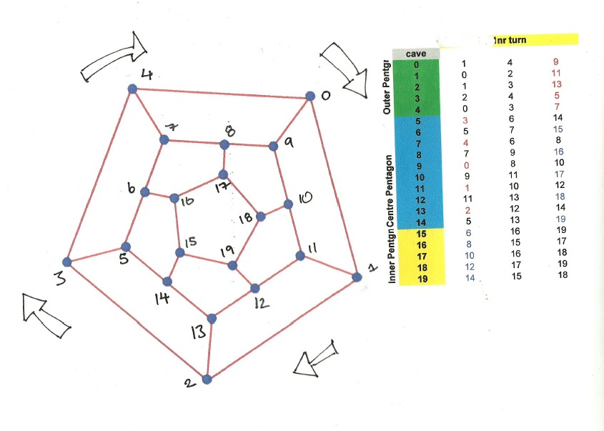

Fig. 3 Positions changed after turning inner pentagon.

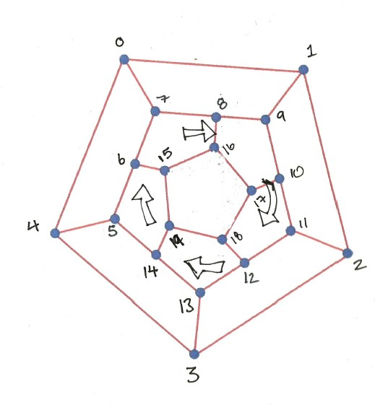

Pseudocode for rotate_pentagons() alogortithm:
Loop through 5 points of the outer pentagon:
For i in range(pentagon_points)
Swap each point with the next point of middle pentagon caves[] list
caves[i][j] = caves[i+1][j]
Then swap point on centre pentagon with outer pentagon to complete turn and all links redone:
caves[i][j] = caves[i-2][j]
Then return the new 2d array.

2. Place items into cave structure

I store all items information in seperate lists. The 2nd main problem was how to introduce items into game structure in an ordered manner. At the start of each game there are wumpus, bats, pits and a player positioned into caves within the cave structure. They are added randomly and because of this they could end up being placed into each others caves, as in a player could be placed into a cave that already has a wumpus resulting in a game being over before it even started.

To solve this I used another list data structure in python to hold the initial set up numbers. This was the list used to allocate cave positions to items and as positions were allocated they were then removed from this list. So when adding wumpus to the cave structure 3 random numbers are picked from this list. Those numbers are then removed from the setup list and this new list returned. The returned list, less wumpus positions, is then passed in to the setup_bats function that assigns three more random positions and removes these from setup_list and so on. In this way two items can ever be placed into the same cave.

Game logic

The game logic is relatively simple and can be outlined as follows:

Get players position

Take input from the player to either move or shoot

Carry out player input

Move input:

If player moves into caves linked to dangers he is warned first

If player moves into a cave with a pit or a wumpus its game over

If a player moves into a cave with a bat he is moved to another random cave

Shoot input:

If a player missed with his shot but fired into a cave that wumpus is linked to wumpus is moved to another random cave

If a player shoots into a cave where there is a wumpus then wumpus is killed.

If all wumpus are dead player wins.

If player runs outs of arrows its game over

Functions of note:

Warn of dangers

In order to give warnings a if player has entered a cave that is linked to other caves that contain dangers I had to compare two lists. One list contained the caves that the player was linked to and where he could enter and the other list contained the positions of dangers(pits, wumpus and bats). Python has a handy way of doing this by using the intersection method that compares two sets for items that are common to both. So I wrote a function check_for_intersection() that take in two lists as its parameters and returns true if there are any matches. So if the players linked caves positions matched any of the danger positions the appropriate warning could be given in the print_location() function.

The shoot() fn handles the following functionality. Every time its called it deducts an arrow. If the player misses but shoots into a cave linked to wumpus it changes wumpus position by removing current position form the list and appending in a new random position. If player shoots wumpus then it removes that position from wumpus list.
Levels
Levels are set by taking player input at the start of the game and then assigning that input into a global variable lev_num. This then dictates how many arrows wumpus, bat and pits there are as the setup functions for these itesm take in the lev_num as a parameter and make lists to that size.
Magic Arrow
A player can shoot into three different caves as long as they are linked. This is handles using the magic_arrow() functions. Which is basically similar to the shoot function but uses the check_for_intersection () to see if caves are linked if they are then it checks if any wumpus are in these caves.

Evaluations and testing
I have included two versions of the code. The code marked wumpus.test is used for testing purposes it contains all the print statements after each input to show how lists containing data have changed. It also print out complete cave structure at the start showing how the rotate_pentagons() fn changes positions and then redoes all the links making the game more challenging.
One of the hardest functions to test was the rotate_pentagons() function. I carried out basic unit testing on this to make sure it was working correctly. I called the function and then compared its outputs to known correct results. There were numerous errors highlighted initially, mainly due to for loops incorrect range parameters resulting in swapping values that should not have been swapped. The unit testing highlighted this.
Fig 4 shows correct results after 1, 2 and 3 turns.

 |  | Origional Cave Structure |  |  |  |  | 1nr turn |  |  |  | 2nr turn |  |  |  | 3nr turn
 | cave |  | links
Outer Pentgn | 0 | 1 | 4 | 7 |  | 1 | 4 | 9 |  | 1 | 4 | 11 |  | 1 | 4 | 13
Outer Pentgn | 1 | 0 | 2 | 9 |  | 0 | 2 | 11 |  | 0 | 2 | 13 |  | 0 | 2 | 5
Outer Pentgn | 2 | 1 | 3 | 11 |  | 1 | 3 | 13 |  | 1 | 3 | 5 |  | 1 | 3 | 7
Outer Pentgn | 3 | 2 | 4 | 13 |  | 2 | 4 | 5 |  | 2 | 4 | 7 |  | 2 | 4 | 9
Outer Pentgn | 4 | 0 | 3 | 5 |  | 0 | 3 | 7 |  | 0 | 3 | 9 |  | 0 | 3 | 11
Centre Pentagon | 5 | 4 | 6 | 14 |  | 3 | 6 | 14 |  | 2 | 6 | 14 |  | 1 | 6 | 14
Centre Pentagon | 6 | 5 | 7 | 16 |  | 5 | 7 | 15 |  | 5 | 7 | 19 |  | 5 | 7 | 18
Centre Pentagon | 7 | 0 | 6 | 8 |  | 4 | 6 | 8 |  | 3 | 6 | 8 |  | 2 | 6 | 8
Centre Pentagon | 8 | 7 | 9 | 17 |  | 7 | 9 | 16 |  | 7 | 9 | 15 |  | 7 | 9 | 19
Centre Pentagon | 9 | 1 | 8 | 10 |  | 0 | 8 | 10 |  | 4 | 8 | 10 |  | 3 | 8 | 10
Centre Pentagon | 10 | 9 | 11 | 18 |  | 9 | 11 | 17 |  | 9 | 11 | 16 |  | 9 | 11 | 15
Centre Pentagon | 11 | 2 | 10 | 12 |  | 1 | 10 | 12 |  | 0 | 10 | 12 |  | 4 | 10 | 12
Centre Pentagon | 12 | 11 | 13 | 19 |  | 11 | 13 | 18 |  | 11 | 13 | 17 |  | 11 | 13 | 16
Centre Pentagon | 13 | 3 | 12 | 14 |  | 2 | 12 | 14 |  | 1 | 12 | 14 |  | 0 | 12 | 14
Centre Pentagon | 14 | 5 | 13 | 15 |  | 5 | 13 | 19 |  | 5 | 13 | 18 |  | 5 | 13 | 17
Inner Pentgn | 15 | 14 | 16 | 19 |  | 6 | 16 | 19 |  | 8 | 16 | 19 |  | 10 | 16 | 19
Inner Pentgn | 16 | 6 | 15 | 17 |  | 8 | 15 | 17 |  | 10 | 15 | 17 |  | 12 | 15 | 17
Inner Pentgn | 17 | 8 | 16 | 18 |  | 10 | 16 | 18 |  | 12 | 16 | 18 |  | 14 | 16 | 18
Inner Pentgn | 18 | 10 | 17 | 19 |  | 12 | 17 | 19 |  | 14 | 17 | 19 |  | 6 | 17 | 19
Inner Pentgn | 19 | 12 | 15 | 18 |  | 14 | 15 | 18 |  | 6 | 15 | 18 |  | 8 | 15 | 18

Fig. 4

Lessons Learned
I learnt how to build simple data structures using python lists.

Challenges Encountered
The main challenge was deciding on the right data structure to hold the cave structure and when this was decided then keeping track of the flow data. For example all items locations are contained in lists but these lists are continually being changed depending on game.

Conclusion
It was an interesting and enjoyable project that I would like to develop further by refactoring the code and re-designing it in an object oriented manner.

