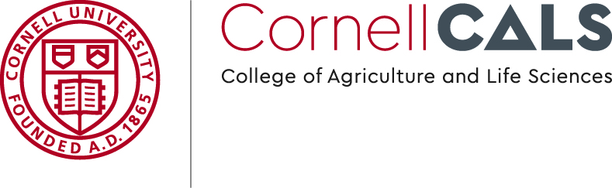

Office of Marketing and Communications

241 Roberts Hall | Ithaca, NY 14853