**Key Insights and How Might We Questions**

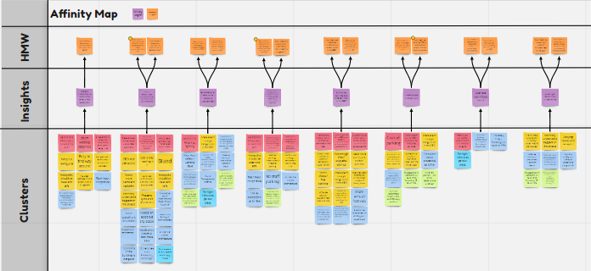

The group have gone through observations around the CBD, done secondary research on specified topics, done interviews with the Central Business Association people, general public, friends and relatives. We have got lot of points from them, which we have categorised based on their relevance and then we have clustered it on the basis of the important insights that we come across. Insights that we have gathered is listed below.

1. **Signage improvements are needed to better direct traffic flow**

***Clusters***

* Hard to find information to where to park
* Save time and effort if signs have been properly installed
* Easy to navigate if proper signage is installed
* Easy to find way around with appropriate signage
* Chances of get lost the way due to the lack of proper signage
* No clear signage to aid public where proper places are

Signage problem for the people around the CBD is a main problem that we come across when interviewed people. The general problem that we found is people find it very difficult to find parking spaces due to the lack of proper signage, it is easy to get lost if we don’t know the proper address of the place where we have parked out car, rush hour congestion which make it really difficult for parking as well as the visibility of the signage reduces due to this. If the signage is made proper people suggest it will be better to navigate and easy to find the way as well.

**HMW Questions**

* How might we improve signage of Hamilton in such a way to reduce effort and save time?
* How might we improve our media perception both physical and digital?

1. **Visual infrastructure improvements are needed to raise CBD perception**

***Clusters***

* Need of city to be more vibrant and pleasant
* City should include more architectural stuff which will make the city more attractive
* City should be more clean and safe
* More waterfront attractions and greenery
* More murals, paintings and sculptures

The main thing in this insight is that most of the people find CBD not that vibrant as some of the cities in New Zealand such as Auckland and Wellington. Some say that the city should include more infrastructural and architectural implementations, which will make the city more vibrant and beautiful. Others are too keen for lot of greenery within the city and want the city to be much more clean and pleasant. People want the architecture of the city to be updated and thereby make the city more aesthetically attractive.

**HMW Questions**

* How might we implement visual infrastructure that would improve the visual representation of the CBD?
* How might we implement regulations to keep front facing business clean?

1. **Extra security is added to the volatile areas**

***Clusters***

* After hour safety and lighting issue
* Violence centred around the Hamilton Depot
* CCTV camera should be implemented in important locations in Hamilton
* No night lighting at garden place

There is a need for extra safety in the CBD because it is a common issue of robbing cars, bicycle and other stuff around the CBD. People suggest to implement more lighting and security camera around the CBD, which will reduce the chances of burglary and other criminal activities also. No proper lighting in the garden place and violence centred around Hamilton depot is also an issue.

**HMW Questions**

* How might we implement different technology to improve the safety within the CBD?
* How would we implement added security in order to improve the public perception of safety within the CBD?

1. **Infrastructural improvements are required to either minimize vehicle traffic flow or increase parking availability**

***Clusters***

* Not enough parking spaces in the CBD
* Malls feel to be too crowded and congested
* Rush hour congestion is a main problem during these days
* No enough staff parking spaces

More parking slots should be made within the CBD, because in rush hours no spaces will be available at all and people hesitate to come to CBD at that time. People use to shop from their nearest places other than CBD due to this reason.

**HMW Questions**

* How might we improve parking infrastructure in order to reduce traffic build up and increase parking availability?
* How might we direct traffic around the CBD to reduce congestion?

1. **Enhancing activities and entertainment in the CBD**

***Clusters***

* Thera are not enough family oriented activities in the CBD
* Events happening in the CBD is not properly advertised
* Should include more musical events in the city, which attract people
* Not enough enjoyable activities
* Needs more events and outdoor activities
* More live bands in popular areas would be nice

People tell that there are not enough activities either for family or youth being done in the CBD and the activities that are being done is not properly advertised. People needs more festivals, entertainment and activities that are related to music etc. Since half the population in Hamilton is under 30 which is a population which is less earning, so more activities and events have to be conducted for them in subsidized manner.

**HMW Questions**

* How might we incentivize business to conduct events in the CBD?
* How might we create additional events or activities that would give people incentives to visit the CBD?

1. **Unaffordable/Expensive**

***Clusters***

* Cost of Parking
* CBD is expensive for shopping purposes
* Shops expensive from Kmart and Warehouse
* Age group between 20 to 30 around CBD is more than 50%

People are finding CBD to be expensive in case of parking, shopping, food etc. According to the survey have of the resident under Hamilton is under 30, so the people in this age group will be about to begin their actual earning. So, these age group might think CBD to be expensive as well as the low income earning group.

**HMW Questions**

* How might we alter the student perspective of the CBD in regards of cost?
* How might we alter the CBD to cater towards people of lower income brackets?

1. **Business Open/Close Hours**

***Clusters***

* Shops are closing around 5 or 6 and opening late
* Extend business opening and closing hours
* No night life other than week ends

Shops are opening late and closing earlier which prevents the people from shopping after their work hours. Most of them tell that Auckland is quite good because shops will be only closing at 10. People who are working have to wait until the weekend to shop something, but most of the shops will be close in the weekend, which we have to take into consideration.

**HMW Questions**

* How might we reduce and regulate the number of undesirables within the CBD?
* How might we alter business hours to improve the liveliness of the CBD?

1. **Loitering and Harassment**

***Clusters***

* Homeless and begging issues need to be solved
* Too many beggars on the street
* Annoying surveyors

There is lot of homeless people and beggars around the CBD which some people will affect the business.

**HMW Questions**

* How might we reduce the rate of homelessness in the CBD?
* How might we create ways for the people to move around the city more instead of loitering around?