

**Summary**

Ultimutt Walks is a dog walking business located in Fort Lauderdale, FL and has been operating since April of 2019. Currently Ultimutt Walks has no formal system in place to keep track of any data for the business. Their data is currently being kept on several planners, in staff phones, or not stored anywhere at all. We propose to implement a database for Ultimutt Walks so that they may track customers, scheduling, profits, and to identify any trends that may be useful to increase business. In Phase 1 we will be defining the business in terms of entities and relationships by determining business rules, providing a data glossary, identifying the questions we would like to answer as a result of this project, and demonstrating both a conceptual and logical model of the future database. After review and upon approval from the stakeholders involved, we will then be able to move to the next phase of implementing this database.

**Stakeholders**

The stakeholders included in this project are the owner, the employees, customers, their current investors, and their potential business partner Wag, who has discussed buyouts with Ultimutt Walks. We have proposed that the implementation of a database will increase the profitability of the Company and therefore will affect all stakeholders positively. Customers will be able to access their past and scheduled walks and make updates about their pets if needed. Employees will be able to view their walk schedule and log any information about each walk completed. Investors, owners, and potential business partners will be able to track profitability, number of walks each week, and have an overview of day-to-day business.

**Business Rules**

* A customer owns one or more pets.
* A customer places an order.
* A staff member completes an order.
* An order contains order details.
* An order status updates the order.
* A dog walk makes up an order detail.
* A pet is included in an order detail.
* A staff payment is paid to a staff.
* An order creates an invoice.
* An invoice payment completes the invoice.
* An invoice status updates the invoice.

**Glossary**

A **customer** is a person who schedules a service through Ultimutt Walks.

A **pet** is an animal owned by a person.

An **order** is placed by a customer and contains the time the order is placed, which staff member will complete it, the customer who placed the order, and the staff member assigned to the order.

An **order detail** includes the requested date for the service to take place, the amount charged for the order, the status of the order, and may contain details about the dog walk.

A **dog walk** is a service where a pet or pets is taken outside for a certain number of miles or minutes.

The **order status** can either be OPEN or CLOSED.

A **CLOSED order status** means that a staff member has completed the order.

An **OPEN order status** means that an order is scheduled and assigned to a staff member.

A **staff member** is a person employed by Ultimutt Walks.

A **staff payment** is earnings paid to one of the staff after the customer pays for the service.

An **invoice** is sent to the customer to be paid after their order is completed.

An **invoice status** is either PAID or UNPAID.

A **PAID invoice status** is when Ultimutt Walks has received payment for a completed order.

An **UNPAID invoice status** is when Ultimutt Walks has not received any payment.

**Data Questions**

* How many walks are requested for the same day versus being prescheduled?
* What are the most serviced zip codes?
* What are the profits of the company at any given moment?
* What is the average length of a dog walk? How many miles are walked a month?
* What is the average age for a pet and what is the most common breed?

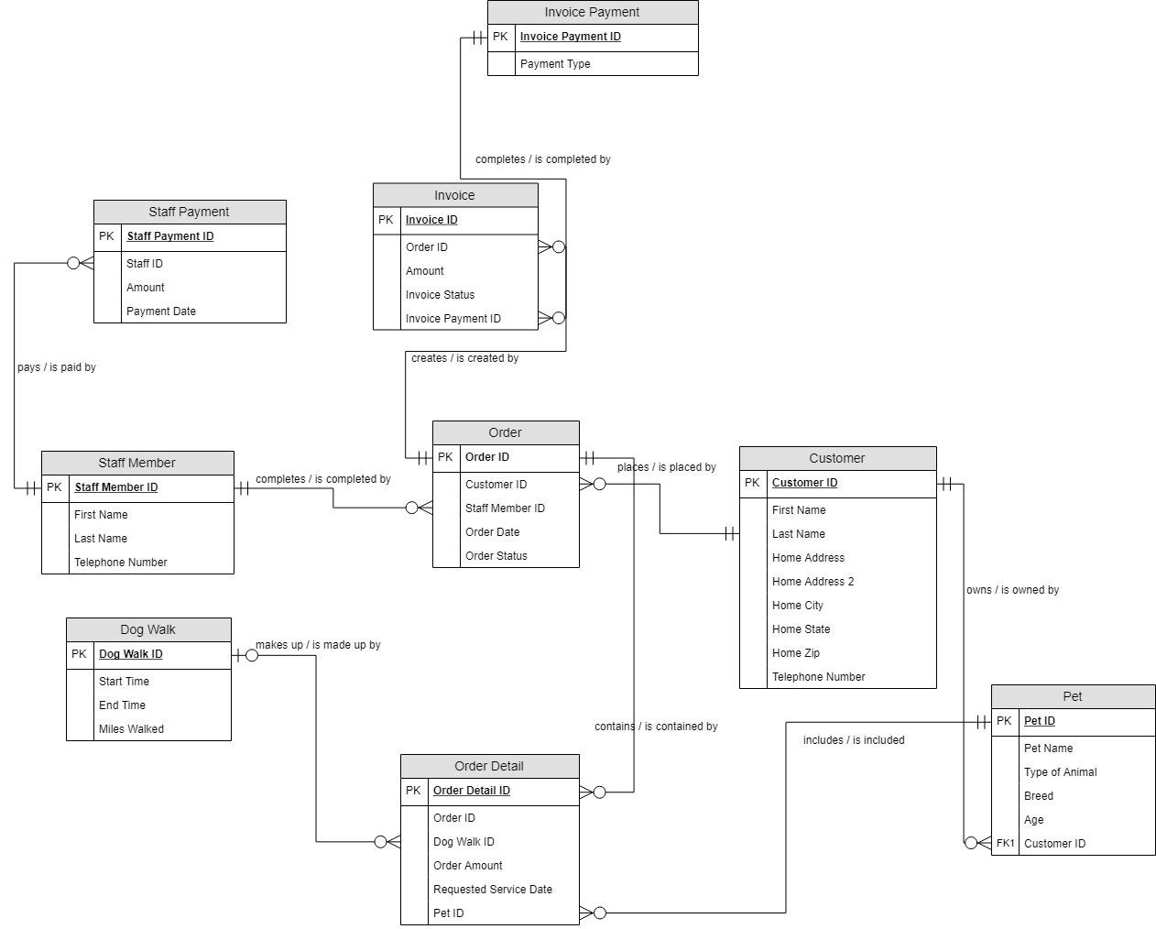**Conceptual Model**

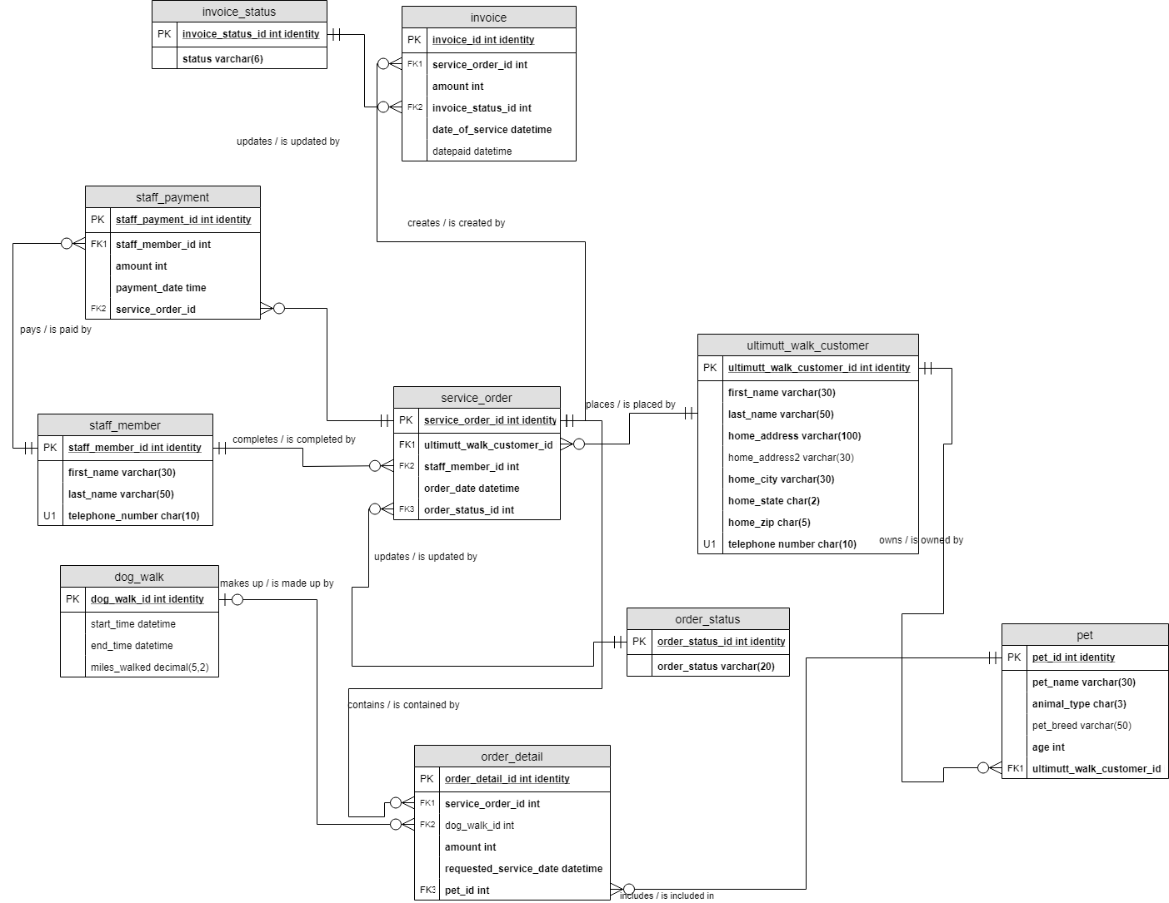**Logical Model**

**Raw Data Sample**: (Note from Chad: This is optional!)

As aforementioned, Ultimutt Walks previously was using notebooks, phones, and from memory to store data. Below is Customer and Pet information from one of the company’s notebooks.

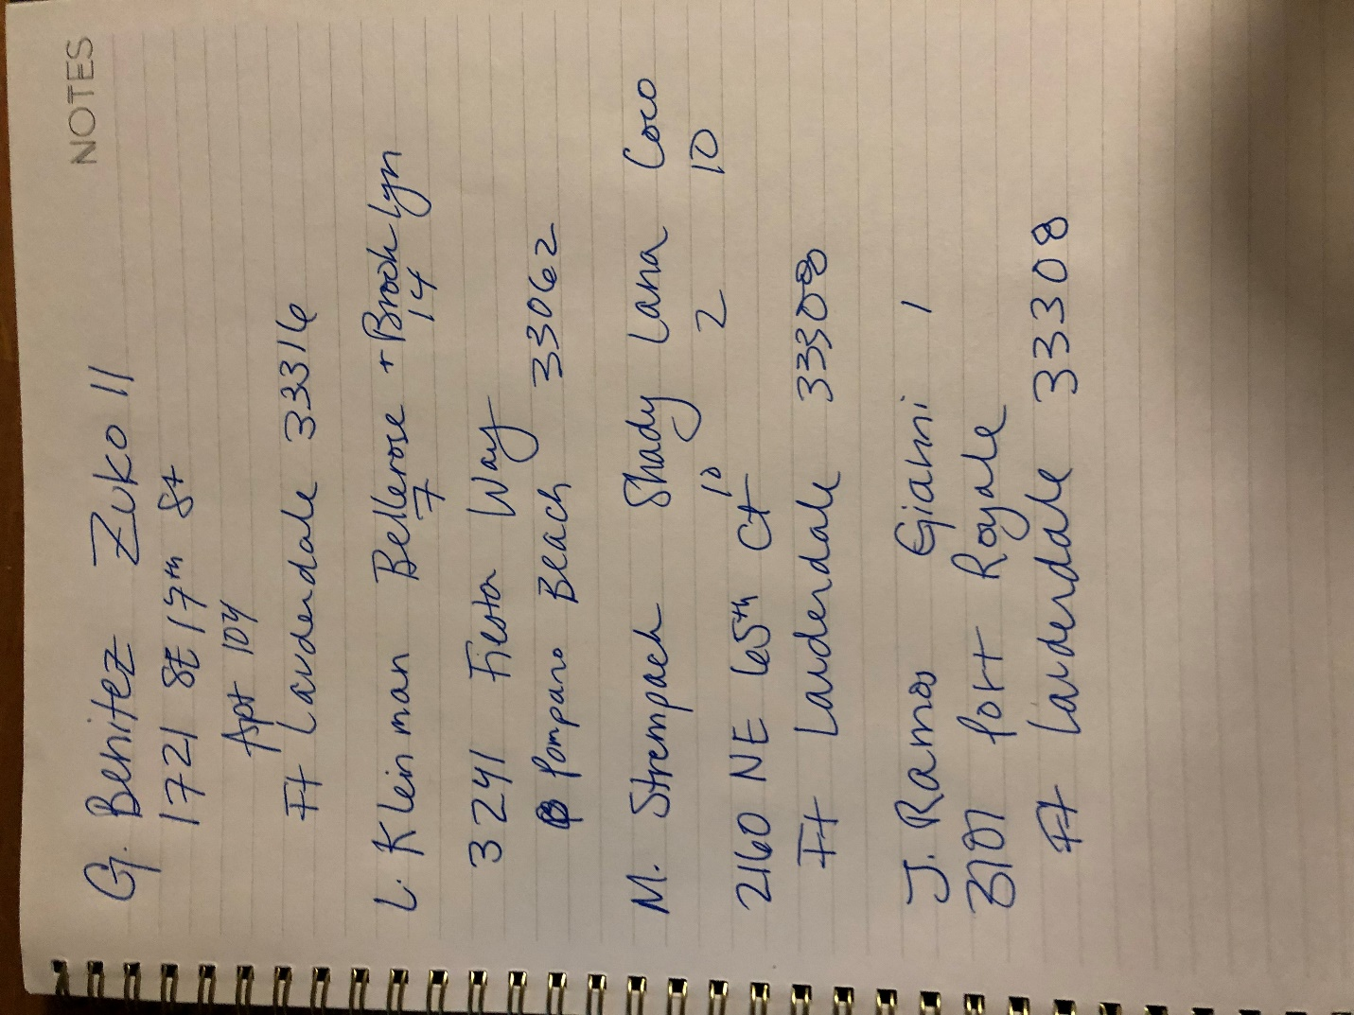

**From Chad: PART ONE STOP HERE. The rest is part 2.**

**Physical Database Design**

--create tables/views/procedures/functions in repeatable form

-- create drops

--drop procedures

IF OBJECT_ID('dbo.ViewMyPayments') IS NOT NULL

DROP PROCEDURE dbo.ViewMyPayments

IF OBJECT_ID('dbo.CloseOutOrder') IS NOT NULL

DROP PROCEDURE dbo.CloseOutOrder

--drop views

IF OBJECT_ID('dbo.ClosedOrders') IS NOT NULL

DROP VIEW dbo.ClosedOrders

IF OBJECT_ID('dbo.Invoices') IS NOT NULL

DROP VIEW dbo.Invoices

IF OBJECT_ID('dbo.OpenOrders') IS NOT NULL

DROP VIEW dbo.OpenOrders

IF OBJECT_ID('dbo.PetandOwners') IS NOT NULL

DROP VIEW PetandOwners

IF OBJECT_ID('dbo.totalprofit') IS NOT NULL

DROP VIEW dbo.totalprofit

IF OBJECT_ID('dbo.weekly_profit') IS NOT NULL

DROP VIEW dbo.weekly_profit

--drop tables

IF OBJECT_ID('dbo.staff_payment') IS NOT NULL

DROP TABLE dbo.staff_payment

IF OBJECT_ID('dbo.invoice') IS NOT NULL

DROP TABLE dbo.invoice

IF OBJECT_ID('invoice_status') IS NOT NULL

DROP TABLE dbo.invoice_status

IF OBJECT_ID('dbo.order_detail') IS NOT NULL

DROP TABLE dbo.order_detail

IF OBJECT_ID('dbo.service_order') IS NOT NULL

DROP TABLE dbo.service_order

IF OBJECT_ID('dbo.order_status') IS NOT NULL

DROP TABLE dbo.order_status

IF OBJECT_ID('dbo.staff_member') IS NOT NULL

DROP TABLE dbo.staff_member

IF OBJECT_ID('dbo.dog_walk') IS NOT NULL

DROP TABLE dbo.dog_walk

IF OBJECT_ID('dbo.pet') IS NOT NULL

DROP TABLE dbo.pet

IF OBJECT_ID('ultimutt_walk_customer') IS NOT NULL

DROP TABLE dbo.ultimutt_walk_customer

--create database tables

CREATE TABLE ultimutt_walk_customer(

--create columns

ultimutt_walk_customer_id int identity

, first_name varchar(50) NOT NULL

, last_name varchar(50) NOT NULL

, home_address varchar(200) NOT NULL

, home_address2 varchar(50)

, home_city varchar(30) NOT NULL

, home_state char(3) NOT NULL

, home_zip char(5) NOT NULL

, telephone_number char(10) NOT NULL

--place constraints

, CONSTRAINT PK_ultimutt_walk_customer PRIMARY KEY (ultimutt_walk_customer_id)

, CONSTRAINT U1_ultimutt_walk_customer UNIQUE(telephone_number)

)

CREATE TABLE pet(

--create columns

pet_id int identity

, pet_name varchar(30) NOT NULL

, animal_type char(3) NOT NULL

, pet_breed varchar(50) NOT NULL

, age int NOT NULL

, ultimutt_walk_customer_id int NOT NULL

--place constraints

, CONSTRAINT PK_pet PRIMARY KEY(pet_id)

, CONSTRAINT FK1_pet FOREIGN KEY(ultimutt_walk_customer_id) REFERENCES ultimutt_walk_customer(ultimutt_walk_customer_id)

)

CREATE TABLE dog_walk(

--create columns

dog_walk_id int identity

, start_time datetime

, end_time datetime

, miles_walked decimal(5,2)

-- place constraints

, CONSTRAINT PK_dog_walk PRIMARY KEY(dog_walk_id)

)

CREATE TABLE staff_member(

--create columns

staff_member_id int identity

, first_name varchar(30)NOT NULL

, last_name varchar(50) NOT NULL

, telephone_number char(10) NOT NULL

--place constraints

, CONSTRAINT PK_staff_member PRIMARY KEY (staff_member_id)

, CONSTRAINT U1_staff_member UNIQUE(telephone_number)

)

CREATE TABLE order_status(

--create columns

order_status_id int identity

, order_status varchar(20) NOT NULL

--place constraints

, CONSTRAINT PK_order_status PRIMARY KEY (order_status_id)

)

CREATE TABLE service_order(

--create columns

service_order_id int identity

, ultimutt_walk_customer_id int NOT NULL

, staff_member_id int NOT NULL

, order_date datetime NOT NULL

, order_status_id int NOT NULL

--place constraints

, CONSTRAINT PK_service_order PRIMARY KEY(service_order_id)

, CONSTRAINT FK1_service_order FOREIGN KEY(ultimutt_walk_customer_id) REFERENCES ultimutt_walk_customer(ultimutt_walk_customer_id)

, CONSTRAINT FK2_service_order FOREIGN KEY(staff_member_id) REFERENCES staff_member(staff_member_id)

, CONSTRAINT FK3_service_order FOREIGN KEY(order_status_id) REFERENCES order_status(order_status_id)

)

CREATE TABLE order_detail(

--create columns

order_detail_id int identity

, service_order_id int NOT NULL

, dog_walk_id int

, amount int NOT NULL

, requested_service_date datetime NOT NULL

, pet_id int NOT NULL

--place constraints

, CONSTRAINT PK_order_detail PRIMARY KEY(order_detail_id)

, CONSTRAINT FK1_order_detail FOREIGN KEY(service_order_id) REFERENCES service_order(service_order_id)

, CONSTRAINT FK2_order_detail FOREIGN KEY(dog_walk_id) REFERENCES dog_walk(dog_walk_id)

, CONSTRAINT FK3_order_detail FOREIGN KEY(pet_id) REFERENCES pet(pet_id)

)

CREATE TABLE invoice_status(

--create columns

invoice_status_id int identity

, invoice_status varchar(6) NOT NULL

--place constraints

, CONSTRAINT PK_invoice_status PRIMARY KEY(invoice_status_id)

)

CREATE TABLE invoice(

--create columns

invoice_id int identity

, service_order_id int NOT NULL

, amount int NOT NULL

, invoice_status_id int NOT NULL

, date_of_service datetime NOT NULL

, datepaid datetime

--place constraints

, CONSTRAINT PK_invoice PRIMARY KEY(invoice_id)

, CONSTRAINT FK1_invoice FOREIGN KEY(service_order_id) REFERENCES service_order(service_order_id)

, CONSTRAINT FK2_invoice FOREIGN KEY(invoice_status_id) REFERENCES invoice_status(invoice_status_id)

)

CREATE TABLE staff_payment(

-- create column

staff_payment_id int identity

, staff_member_id int

, amount int NOT NULL

, payment_date datetime NOT NULL

, service_order_id int NOT NULL

--place constraints

, CONSTRAINT PK_staff_payment PRIMARY KEY(staff_payment_id)

, CONSTRAINT FK1_staff_payment FOREIGN KEY(staff_member_id) REFERENCES staff_member(staff_member_id)

, CONSTRAINT FK2_staff_payment FOREIGN KEY(service_order_id) REFERENCES service_order(service_order_id)

)

--insert allcustomers into ultimutt_walk_customer table

--NOTE Barbara Fehrenbach is moving, will need updated address

INSERT INTO ultimutt_walk_customer(first_name, last_name, home_address, home_address2, home_city, home_state, home_zip, telephone_number)

VALUES ('Jose', 'Ramos', '3101 Port Royale Blvd', 'Apt 636', 'Fort Lauderdale', 'FL', '33308', '9542940388')

, ('Mimi', 'Strempack', '2160 NE 65th Ct', NULL, 'Fort Lauderdale', 'FL', '33308', '9542950685')

, ('Lily', 'Kleinman', '3241 Fiesta Way', NULL, 'Pompano Beach', 'FL', '33062', '5612134947')

, ('Brady', 'Bunch', '1371 NE 27th Way', NULL, 'Pompano Beach', 'FL', '33062', '7273658881')

, ('Cher', 'Brahmer', '611 SE 9th Ave', NULL, 'Pompano Beach', 'FL', '33060', '9544489222')

, ('Lady', 'Cooke', '918 NE 17th Terrace', 'Apt 1', 'Fort Lauderdale', 'FL', '33304', '8602480981')

, ('Michael', 'London', '611 SW 11th St', 'Apt 2', 'Fort Lauderdale', 'FL', '33315', '9546085634')

, ('Jack', 'Scott', '1626 SE 1st St', NULL, 'Fort Lauderdale', 'FL', '33301', '9548951400')

, ('Demi', 'Lovato', '2121 S Ocean Blvd', 'Unit 303', 'Pompano Beach', 'FL', '33062', '7046617161')

, ('Talula', 'Wright', '2137 N Cypress Bend Dr', 'Apt 404', 'Pompano Beach', 'FL', '33069', '9542708435')

, ('Scooby', 'Doo', '3101 Port Royale Blvd', 'Apt 534', 'Fort Lauderdale', 'FL', '33308', '5615421689')

, ('Pooh', 'Bear', '1620 SE 2nd CT', NULL, 'Fort Lauderdale', 'FL', '33301', '3152444296')

, ('Greg', 'Benitez','1721 SE 17th St' , '104', 'Fort Lauderdale', 'FL', '33316', '9547328587')

, ('Barbs', 'Fehrenback', 'John Knox Village', NULL, 'Pompano Beach', 'FL', '33062', '6317664449')

, ('Shania', 'Twain', 'Unknown', NULL, 'Oakland Park', 'FL', '33305', '4077566083')

, ('Ted', 'Rochester', '3101 Port Royale Blvd', NULL, 'Fort Lauderdale', 'FL', '33308', '9547893293')

--look at inserts to check for mistakes

SELECT * FROM ultimutt_walk_customer

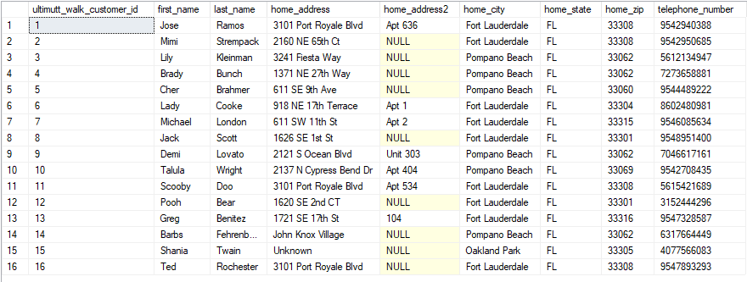

--16 solid customers so far! that's great

--insert pet info, identify customer ID through unique telephone number provided

INSERT INTO pet(pet_name, animal_type, pet_breed, age, ultimutt_walk_customer_id)

VALUES

('Gianni', 'dog', 'French Bulldog', 1, (SELECT ultimutt_walk_customer_id FROM ultimutt_walk_customer WHERE telephone_number = '9542940388'))

, ('Coco', 'dog', 'Dachshund', 8, (SELECT ultimutt_walk_customer_id FROM ultimutt_walk_customer WHERE telephone_number = '9542950685'))

, ('Shady', 'dog', 'Dachshund', 8, (SELECT ultimutt_walk_customer_id FROM ultimutt_walk_customer WHERE telephone_number = '9542950685'))

, ('Lana', 'dog', 'Shih Tzu', 8, (SELECT ultimutt_walk_customer_id FROM ultimutt_walk_customer WHERE telephone_number = '9542950685'))

, ('Bellerose', 'dog', 'Min Pin', 8, (SELECT ultimutt_walk_customer_id FROM ultimutt_walk_customer WHERE telephone_number = '5612134947'))

, ('Brooklyn', 'dog', 'Papillon', 14, (SELECT ultimutt_walk_customer_id FROM ultimutt_walk_customer WHERE telephone_number = '5612134947'))

, ('Charlie', 'cat', 'Orange Cat', 14, (SELECT ultimutt_walk_customer_id FROM ultimutt_walk_customer WHERE telephone_number ='7273658881'))

, ('Lil Bit', 'cat', 'White Cat', 3, (SELECT ultimutt_walk_customer_id FROM ultimutt_walk_customer WHERE telephone_number ='9544489222'))

, ('Tux', 'cat', 'Black & White Cat', 3, (SELECT ultimutt_walk_customer_id FROM ultimutt_walk_customer WHERE telephone_number ='9544489222'))

, ('Checko', 'dog', 'Mutt - Maybe Australian Shepherd', 5, (SELECT ultimutt_walk_customer_id FROM ultimutt_walk_customer WHERE telephone_number ='8602480981'))

, ('Barlo', 'dog', 'Pitbull & Black Mouth Curr', 1, (SELECT ultimutt_walk_customer_id FROM ultimutt_walk_customer WHERE telephone_number = '9546085634'))

, ('Opi', 'dog', 'Italian Greyhound', 4, (SELECT ultimutt_walk_customer_id FROM ultimutt_walk_customer WHERE telephone_number = '9548951400'))

, ('Boo', 'dog', 'Italian Greyhound', 3, (SELECT ultimutt_walk_customer_id FROM ultimutt_walk_customer WHERE telephone_number = '9548951400'))

, ('Barney', 'dog', 'King Charles Cavalier', 12, (SELECT ultimutt_walk_customer_id FROM ultimutt_walk_customer WHERE telephone_number = '7046617161'))

, ('Mocha', 'dog', 'Mini Schnauzer', 3, (SELECT ultimutt_walk_customer_id FROM ultimutt_walk_customer WHERE telephone_number = '9542708435'))

, ('Shadow', 'dog', 'Husky', 4, (SELECT ultimutt_walk_customer_id FROM ultimutt_walk_customer WHERE telephone_number = '5615421689'))

, ('Sunny', 'dog', 'Great Dane & Lab Mix', 7, (SELECT ultimutt_walk_customer_id FROM ultimutt_walk_customer WHERE telephone_number = '3152444296'))

, ('Ruby', 'dog', 'Pitbull & Lab Mix', 7, (SELECT ultimutt_walk_customer_id FROM ultimutt_walk_customer WHERE telephone_number = '3152444296'))

, ('Zuko', 'dog', 'English Bulldog', 8, (SELECT ultimutt_walk_customer_id FROM ultimutt_walk_customer WHERE telephone_number = '9547328587'))

, ('Evy', 'dog', 'Dachshund Mix', 4, (SELECT ultimutt_walk_customer_id FROM ultimutt_walk_customer WHERE telephone_number = '4077566083'))

, ('Kakao', 'dog', 'Great Dane & Lab Mix', 9, (SELECT ultimutt_walk_customer_id FROM ultimutt_walk_customer WHERE telephone_number = '4077566083'))

, ('Sylvie', 'dog', 'Mini Poodle', 3, (SELECT ultimutt_walk_customer_id FROM ultimutt_walk_customer WHERE telephone_number = '6317664449'))

, ('Jax', 'dog', 'Puggle', 4, (SELECT ultimutt_walk_customer_id FROM ultimutt_walk_customer WHERE telephone_number = '9547893293'))

, ('Gnocchi', 'dog', 'Terrier Mix', 1, (SELECT ultimutt_walk_customer_id FROM ultimutt_walk_customer WHERE telephone_number = '9547893293'))

--create view of pets and their owners

--NOTE: Later make a form to enter new customers with pets, will be much easier

GO

CREATE VIEW PetandOwners

AS

SELECT

pet.pet_name as PetName,

pet.pet_breed as Breed,

ultimutt_walk_customer.first_name + ' ' + ultimutt_walk_customer.last_name as Pet_Owner

FROM pet

INNER JOIN ultimutt_walk_customer ON pet.ultimutt_walk_customer_id = ultimutt_walk_customer.ultimutt_walk_customer_id

GO

SELECT*FROM PetandOwners

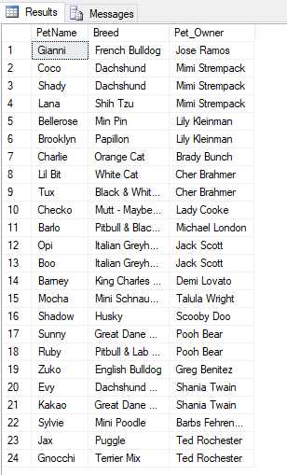

GO

--form made from Access to enter in new customer& their pets

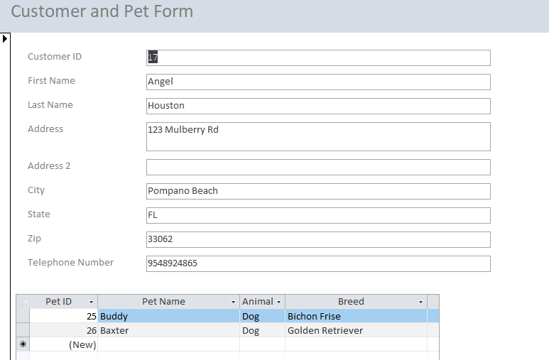

--time to employ staff members!

INSERT INTO staff_member(first_name, last_name, telephone_number)

VALUES ('Katie', 'Hanks', '7867792553')

, ('Gary', 'Guinta', '6035455470')

, ('Fran', 'Guinta', '6316262029')

--let's check out the newest members of Ultimutt Walks

SELECT * FROM staff_member

--Create order status options

--Keeping it to OPEN or CLOSED

--OPEN order means that the walk has not been completed

--CLOSED order means that the walk has been finished

--Order Status does NOT reflect invoice status

INSERT INTO order_status(order_status)

VALUES ('OPEN'), ('CLOSED')

--identify ID numbers for open and closed for future orders

SELECT * FROM order_status

--OPEN = 1

--CLOSED = 2

--create invoice status choices: UNPAID or PAID

INSERT INTO invoice_status(invoice_status)

VALUES ('UNPAID'), ('PAID')

--identify ID numbers for UNPAID and PAID

SELECT * FROM invoice_status

--UNPAID = 1

--PAID = 2

-- enter orders for the week of 9/2

--

INSERT INTO service_order(ultimutt_walk_customer_id, order_status_id, staff_member_id, order_date)

VALUES ((SELECT ultimutt_walk_customer_id FROM ultimutt_walk_customer WHERE telephone_number= '9542940388'), 1, (SELECT staff_member_id FROM staff_member WHERE first_name = 'Katie'), '9/4/2019')

, ((SELECT ultimutt_walk_customer_id FROM ultimutt_walk_customer WHERE telephone_number= '9542940388'), 1, (SELECT staff_member_id FROM staff_member WHERE first_name = 'Katie'), '9/4/2019')

, ((SELECT ultimutt_walk_customer_id FROM ultimutt_walk_customer WHERE telephone_number= '9547328587'), 1, (SELECT staff_member_id FROM staff_member WHERE first_name = 'Katie'), '9/4/2019')

, ((SELECT ultimutt_walk_customer_id FROM ultimutt_walk_customer WHERE telephone_number= '9547328587'), 1, (SELECT staff_member_id FROM staff_member WHERE first_name = 'Katie'), '9/4/2019')

, ((SELECT ultimutt_walk_customer_id FROM ultimutt_walk_customer WHERE telephone_number= '9547328587'), 1, (SELECT staff_member_id FROM staff_member WHERE first_name = 'Katie'), '9/4/2019')

, ((SELECT ultimutt_walk_customer_id FROM ultimutt_walk_customer WHERE telephone_number= '9547328587'), 1, (SELECT staff_member_id FROM staff_member WHERE first_name = 'Katie'), '9/4/2019')

, ((SELECT ultimutt_walk_customer_id FROM ultimutt_walk_customer WHERE telephone_number= '5612134947'), 1, (SELECT staff_member_id FROM staff_member WHERE first_name = 'Katie'), '9/4/2019')

, ((SELECT ultimutt_walk_customer_id FROM ultimutt_walk_customer WHERE telephone_number= '5612134947'), 1, (SELECT staff_member_id FROM staff_member WHERE first_name = 'Katie'), '9/4/2019')

, ((SELECT ultimutt_walk_customer_id FROM ultimutt_walk_customer WHERE telephone_number= '5612134947'), 1, (SELECT staff_member_id FROM staff_member WHERE first_name = 'Katie'), '9/4/2019')

, ((SELECT ultimutt_walk_customer_id FROM ultimutt_walk_customer WHERE telephone_number= '5612134947'), 1, (SELECT staff_member_id FROM staff_member WHERE first_name = 'Katie'), '9/4/2019')

, ((SELECT ultimutt_walk_customer_id FROM ultimutt_walk_customer WHERE telephone_number= '5612134947'), 1, (SELECT staff_member_id FROM staff_member WHERE first_name = 'Katie'), '9/4/2019')

, ((SELECT ultimutt_walk_customer_id FROM ultimutt_walk_customer WHERE telephone_number= '7046617161'), 1, (SELECT staff_member_id FROM staff_member WHERE first_name = 'Katie'), '9/4/2019')

, ((SELECT ultimutt_walk_customer_id FROM ultimutt_walk_customer WHERE telephone_number= '7046617161'), 1, (SELECT staff_member_id FROM staff_member WHERE first_name = 'Katie'), '9/4/2019')

, ((SELECT ultimutt_walk_customer_id FROM ultimutt_walk_customer WHERE telephone_number= '7046617161'), 1, (SELECT staff_member_id FROM staff_member WHERE first_name = 'Katie'), '9/4/2019')

, ((SELECT ultimutt_walk_customer_id FROM ultimutt_walk_customer WHERE telephone_number= '7046617161'), 1, (SELECT staff_member_id FROM staff_member WHERE first_name = 'Katie'), '9/4/2019')

, ((SELECT ultimutt_walk_customer_id FROM ultimutt_walk_customer WHERE telephone_number= '5612134947'), 1, (SELECT staff_member_id FROM staff_member WHERE first_name = 'Katie'), '9/4/2019')

, ((SELECT ultimutt_walk_customer_id FROM ultimutt_walk_customer WHERE telephone_number= '5612134947'), 1, (SELECT staff_member_id FROM staff_member WHERE first_name = 'Katie'), '9/4/2019')

, ((SELECT ultimutt_walk_customer_id FROM ultimutt_walk_customer WHERE telephone_number= '5612134947'), 1, (SELECT staff_member_id FROM staff_member WHERE first_name = 'Katie'), '9/4/2019')

, ((SELECT ultimutt_walk_customer_id FROM ultimutt_walk_customer WHERE telephone_number= '5612134947'), 1, (SELECT staff_member_id FROM staff_member WHERE first_name = 'Katie'), '9/4/2019')

, ((SELECT ultimutt_walk_customer_id FROM ultimutt_walk_customer WHERE telephone_number= '5612134947'), 1, (SELECT staff_member_id FROM staff_member WHERE first_name = 'Katie'), '9/4/2019')

--now let's get into the details of next week's orders

INSERT INTO order_detail(service_order_id, requested_service_date, pet_id, amount)

VALUES (1, '9/5/2019', (SELECT pet_id FROM pet WHERE pet_name = 'Gianni'), 15)

, (2, '9/6/2019', (SELECT pet_id FROM pet WHERE pet_name = 'Gianni'), 15)

, (3, '9/3/2019', (SELECT pet_id FROM pet WHERE pet_name = 'Zuko'), 15)

, (4, '9/4/2019', (SELECT pet_id FROM pet WHERE pet_name = 'Zuko'), 15)

, (5, '9/5/2019', (SELECT pet_id FROM pet WHERE pet_name = 'Zuko'), 15)

, (6, '9/6/2019', (SELECT pet_id FROM pet WHERE pet_name = 'Zuko'), 15)

, (7, '9/3/2019', (SELECT pet_id FROM pet WHERE pet_name = 'Bellerose'), 6)

, (8, '9/4/2019', (SELECT pet_id FROM pet WHERE pet_name = 'Bellerose'), 6)

, (9, '9/5/2019', (SELECT pet_id FROM pet WHERE pet_name = 'Bellerose'), 6)

, (10, '9/6/2019', (SELECT pet_id FROM pet WHERE pet_name = 'Bellerose'), 6)

, (11, '9/7/2019', (SELECT pet_id FROM pet WHERE pet_name = 'Bellerose'), 6)

, (12, '9/3/2019', (SELECT pet_id FROM pet WHERE pet_name = 'Barney'), 15)

, (13, '9/4/2019', (SELECT pet_id FROM pet WHERE pet_name = 'Barney'), 15)

, (14, '9/5/2019', (SELECT pet_id FROM pet WHERE pet_name = 'Barney'), 15)

, (15, '9/6/2019', (SELECT pet_id FROM pet WHERE pet_name = 'Barney'), 15)

, (16, '9/3/2019', (SELECT pet_id FROM pet WHERE pet_name = 'Brooklyn'), 6)

, (17, '9/4/2019 ', (SELECT pet_id FROM pet WHERE pet_name = 'Brooklyn'), 6)

, (18, '9/5/2019', (SELECT pet_id FROM pet WHERE pet_name = 'Brooklyn'), 6)

, (19, '9/6/2019', (SELECT pet_id FROM pet WHERE pet_name = 'Brooklyn'), 6)

, (20, '9/7/2019', (SELECT pet_id FROM pet WHERE pet_name = 'Brooklyn'), 6)

--create a view to see OpenOrders so that order_detail and service_order can be viewed in a meaningful way

GO

CREATE VIEW OpenOrders

AS

SELECT

order_detail.order_detail_id as OrderNumber

, service_order.order_date as OrderDate

, order_detail.requested_service_date as ServiceDate

, ultimutt_walk_customer.first_name + ' ' + ultimutt_walk_customer.last_name as CustomerName

, pet.pet_name as Pet

, staff_member.first_name + ' ' + staff_member.last_name as StaffMemberAssigned

, order_detail.amount as AmountCharged

, order_status.order_status as OrderStatus

FROM order_detail

INNER JOIN service_order on service_order.service_order_id = order_detail.service_order_id

INNER JOIN ultimutt_walk_customer on ultimutt_walk_customer.ultimutt_walk_customer_id = service_order.ultimutt_walk_customer_id

INNER JOIN staff_member ON staff_member.staff_member_id = service_order.staff_member_id

INNER JOIN pet ON pet.pet_id = order_detail.pet_id

INNER JOIN order_status ON order_status.order_status_id=service_order.order_status_id

WHERE order_status.order_status_id = 1

GO

--Now we can VIEW all open Orders. Will be helpful for my employees Fran and Gary.

SELECT * FROM OpenOrders

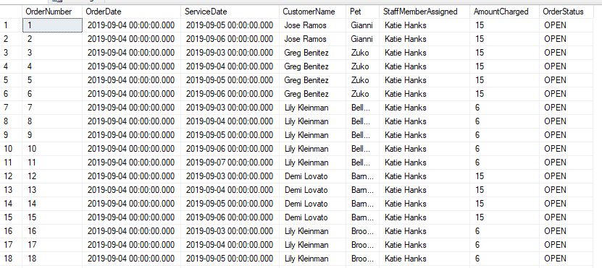

--View for all CLOSED orders as well - helpful for invoicing

GO

CREATE VIEW ClosedOrders

AS

SELECT

order_detail.order_detail_id as OrderNumber

, service_order.order_date as OrderDate

, order_detail.requested_service_date as ServiceDate

, ultimutt_walk_customer.first_name + ' ' + ultimutt_walk_customer.last_name as CustomerName

, pet.pet_name as Pet

, staff_member.first_name + ' ' + staff_member.last_name as StaffMemberAssigned

, order_detail.amount as AmountCharged

, order_status.order_status as OrderStatus

FROM order_detail

INNER JOIN service_order on service_order.service_order_id = order_detail.service_order_id

INNER JOIN ultimutt_walk_customer on ultimutt_walk_customer.ultimutt_walk_customer_id = service_order.ultimutt_walk_customer_id

INNER JOIN staff_member ON staff_member.staff_member_id = service_order.staff_member_id

INNER JOIN pet ON pet.pet_id = order_detail.pet_id

INNER JOIN order_status ON order_status.order_status_id=service_order.order_status_id

WHERE order_status.order_status_id = 2

GO

--double check there aren't any open orders when calling code

SELECT * FROM ClosedOrders

-- nothing appears, great!

-- now I will create some orders from last week so that I can see the whole process from order to invoice to staff payment

INSERT INTO service_order(ultimutt_walk_customer_id, order_status_id, staff_member_id, order_date)

VALUES ((SELECT ultimutt_walk_customer_id FROM ultimutt_walk_customer WHERE telephone_number= '9546085634'), 1, (SELECT staff_member_id FROM staff_member WHERE first_name = 'Gary'), '8/27/2019')

, ((SELECT ultimutt_walk_customer_id FROM ultimutt_walk_customer WHERE telephone_number= '9546085634'), 1, (SELECT staff_member_id FROM staff_member WHERE first_name = 'Katie'), '8/30/2019')

--find service_order_id number

SELECT * FROM

service_order

WHERE ultimutt_walk_customer_id =(SELECT ultimutt_walk_customer_id FROM ultimutt_walk_customer WHERE telephone_number= '9546085634')

--insert into the details

INSERT INTO order_detail(service_order_id, requested_service_date, amount, pet_id)

VALUES (21, '8/27/2019', 15, (SELECT pet_id FROM pet WHERE pet_name ='Barlo'))

, (22, '8/30/2019', 15, (SELECT pet_id FROM pet WHERE pet_name = 'Barlo'))

-- create procedure to close out an order

-- much easier

GO

CREATE PROCEDURE CloseOutOrder(@service_order_ID int)

AS

BEGIN

UPDATE service_order SET order_status_id = 2

WHERE service_order_id = @service_order_ID

END

GO

DECLARE @closedorder int

SET @closedorder = (SELECT service_order_id FROM service_order WHERE service_order_id=21)

EXEC CloseOutOrder @closedorder

-- check if it worked!

SELECT * FROM service_order WHERE service_order_id = 21

-- it did, close other order

DECLARE @secondclosedorder int

SET @secondclosedorder = (SELECT service_order_id FROM service_order WHERE service_order_id=22)

EXEC CloseOutOrder @secondclosedorder

SELECT * FROM ClosedOrders

--so both of Barlo's walks are officially closed



--let us move on to payment

--insert INVOICE info

INSERT INTO invoice(service_order_id, invoice_status_id, datepaid, amount, date_of_service)

VALUES (1,2,'9/8/2019',15, '9/5/2019'),(2,1,'9/8/2019',15,'9/6/2019'),(10,1,'9/6/2019',6,'9/6/2019'),(11,2,'9/6/2019', 6,'9/7/2019'),(12,2,'9/6/2019',15,'9/3/2019'),(13,2,'9/6/2019', 30,'9/4/2019'), (14,2, '9/6/2019',15, '9/5/2019'),

(15,2, '9/6/2019',15, '9/6/2019'), (16,2, '9/6/2019',6, '9/3/2019'), (17,2, '9/6/2019',6, '9/4/2019'), (18,2, '9/6/2019',6,'9/5/2019'), (19,2, '9/6/2019',6, '9/6/2019'), (20,2, '9/6/2019',6,'9/7/2019'), (21,2,'8/27/2019',15,'8/27/2019'), (22,2,'8/30/2019',15, '8/30/2019')

--create view to see invoices / paid and not paid

GO

CREATE VIEW Invoices as

SELECT

invoice.invoice_id as InvoiceNumber

, service_order.service_order_id as ServiceNumber

, order_detail.requested_service_date as DateofService

, ultimutt_walk_customer.first_name + ' ' + ultimutt_walk_customer.last_name as CustomerName

, invoice.amount as AmountCharged

, invoice_status.invoice_status as InvoiceStatus

FROM invoice

INNER JOIN service_order on service_order.service_order_id = invoice.service_order_id

INNER JOIN invoice_status on invoice_status.invoice_status_id = invoice.invoice_status_id

INNER JOIN ultimutt_walk_customer on ultimutt_walk_customer.ultimutt_walk_customer_id = service_order.ultimutt_walk_customer_id

INNER JOIN order_detail on order_detail.service_order_id = service_order.service_order_id

--take a look at our view

GO

SELECT * FROM Invoices

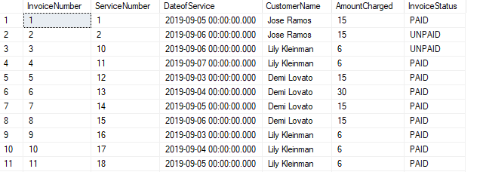

--now let's update our staff payments

INSERT INTO staff_payment(staff_member_id, amount, payment_date, service_order_id)

VALUES ((SELECT staff_member_id FROM staff_member WHERE first_name = 'GARY'), 15, '8/31/2019', (SELECT service_order_id FROM service_order WHERE service_order_id = 2))

--now let's update our staff payments

INSERT INTO staff_payment(staff_member_id, amount, payment_date, service_order_id)

VALUES ((SELECT staff_member_id FROM staff_member WHERE first_name = 'GARY'), 15, '8/31/2019', (SELECT service_order_id FROM service_order WHERE service_order_id = 2))

SELECT * FROM staff_payment

-- once again not useful so I am going to create a PROCEDURE for each employee to keep track of their payments

GO

CREATE PROCEDURE ViewMyPayments(@employeeID int)

AS

BEGIN

SELECT

staff_member.first_name + ' ' + staff_member.last_name as EmployeeName

,staff_payment.payment_date as DateofPayment

, staff_payment.amount as AmountPaid

, staff_member.first_name + ' ' + staff_member.last_name as EmployeeName

, service_order.service_order_id as OrderID

, order_detail.requested_service_date as DateofService

, pet.pet_name as PetWalked

FROM staff_payment

INNER JOIN staff_member ON staff_member.staff_member_id = staff_payment.staff_member_id

INNER JOIN service_order ON service_order.service_order_id = staff_payment.service_order_id

JOIN order_detail ON order_detail.service_order_id = service_order.service_order_id

JOIN pet ON pet.pet_id = order_detail.pet_id

END

--let's look at Gary Guinta's payments, staff ID = 2

GO

DECLARE @myID int

SET @myID = (SELECT staff_member_id FROM staff_member WHERE staff_member_id=2)

EXEC ViewMyPayments @myID

--view open orders

SELECT * FROM OpenOrders

-- need to close orders for gina due to hurricane, no invoice needed

--gina ID = 13

--close the rest of the orders out

SELECT * FROM service_order

WHERE ultimutt_walk_customer_id = 13

--service order 3-6 to be closed

DECLARE @closedorder int

SET @closedorder = (SELECT service_order_id FROM service_order WHERE service_order_id=3)

EXEC CloseOutOrder @closedorder

--next

DECLARE @secondclosedorder int

SET @secondclosedorder = (SELECT service_order_id FROM service_order WHERE service_order_id=4)

EXEC CloseOutOrder @secondclosedorder

--next

DECLARE @thirdclosedorder int

SET @thirdclosedorder = (SELECT service_order_id FROM service_order WHERE service_order_id=5)

EXEC CloseOutOrder @thirdclosedorder

-- next

DECLARE @fourthclosedorder int

SET @fourthclosedorder = (SELECT service_order_id FROM service_order WHERE service_order_id=6)

EXEC CloseOutOrder @fourthclosedorder

--Gianni/Joel First, order 1,2

--close Linda's 7 8 9 10 16 17 18 19

--close Kristie's 12 13 14 15

GO

DECLARE @closedorder int

SET @closedorder = 1

EXEC CloseOutOrder @closedorder

GO

DECLARE @closedorder int

SET @closedorder = 2

EXEC CloseOutOrder @closedorder

--Linda's

GO

DECLARE @closedorder int

SET @closedorder = 7

EXEC CloseOutOrder @closedorder

GO

DECLARE @closedorder int

SET @closedorder = 8

EXEC CloseOutOrder @closedorder

GO

DECLARE @closedorder int

SET @closedorder = 9

EXEC CloseOutOrder @closedorder

GO

DECLARE @closedorder int

SET @closedorder = 10

EXEC CloseOutOrder @closedorder

GO

DECLARE @closedorder int

SET @closedorder = 16

EXEC CloseOutOrder @closedorder

GO

DECLARE @closedorder int

SET @closedorder = 17

EXEC CloseOutOrder @closedorder

GO

DECLARE @closedorder int

SET @closedorder = 18

EXEC CloseOutOrder @closedorder

GO

DECLARE @closedorder int

SET @closedorder = 19

EXEC CloseOutOrder @closedorder

--Kristie's

GO

DECLARE @closedorder int

SET @closedorder = 12

EXEC CloseOutOrder @closedorder

GO

DECLARE @closedorder int

SET @closedorder = 13

EXEC CloseOutOrder @closedorder

GO

DECLARE @closedorder int

SET @closedorder = 14

EXEC CloseOutOrder @closedorder

GO

DECLARE @closedorder int

SET @closedorder = 15

EXEC CloseOutOrder @closedorder

--close out some more orders

GO

DECLARE @closedorder int

SET @closedorder = 11

EXEC CloseOutOrder @closedorder

GO

DECLARE @closedorder int

SET @closedorder = 15

EXEC CloseOutOrder @closedorder

GO

DECLARE @closedorder int

SET @closedorder = 20

EXEC CloseOutOrder @closedorder

--double check they closed out

SELECT * FROM ClosedOrders

--forgot an order of last week - Ted Rochester walks for his two dogs. Same Day Request

INSERT INTO service_order(ultimutt_walk_customer_id, order_status_id, staff_member_id, order_date)

VALUES ((SELECT ultimutt_walk_customer_id FROM ultimutt_walk_customer WHERE telephone_number= '9547893293'), 1, (SELECT staff_member_id FROM staff_member WHERE first_name = 'Katie'), '9/5/2019')

, ((SELECT ultimutt_walk_customer_id FROM ultimutt_walk_customer WHERE telephone_number= '9547893293'), 1, (SELECT staff_member_id FROM staff_member WHERE first_name = 'Katie'), '9/5/2019')

INSERT INTO dog_walk(start_time, end_time, miles_walked)

VALUES ('9/5/2019 8:00PM', '9/5/2019 9:00PM', 1), ('9/5/2019 8:00PM', '9/5/2019 9:00PM', 1)

SELECT * FROM dog_walk

INSERT INTO order_detail(requested_service_date, amount, dog_walk_id, pet_id, service_order_id)

VALUES ('9/5/2019', 10, 1, 23, 23), ('9/5/2019', 10,2 , 24, 24)

INSERT INTO invoice(amount,date_of_service,datepaid,invoice_status_id,service_order_id)

VALUES (10, '9/5/2019', '9/5/2019', 2, 23),(10, '9/5/2019', '9/5/2019', 2, 24)

--Data Question 1: How many walks are prescheduled vs. scheduled on same day

SELECT

(SELECT

COUNT(requested_service_date)

FROM order_detail OD

JOIN service_order SO

ON SO.service_order_id = OD.service_order_id

WHERE OD.requested_service_date = SO.order_date) as SameDayWalks,

(

SELECT

COUNT(requested_service_date)

FROM order_detail OD

JOIN service_order SO

ON SO.service_order_id = OD.service_order_id

WHERE OD.requested_service_date != SO.order_date) as PreScheduledWalks,

(

SELECT

COUNT(requested_service_date)) as TotalWalks

FROM order_detail

--total out of 24

--8/24 or 1/3 are scheduled same-day

--16/24 or 2/3 are pre-scheduled

--create Bar Chart in R

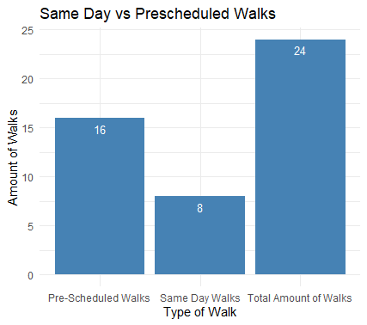

--Data Question 2: What are the most serviced zip codes?

--create choropleth map

--create Query for R to select zip codes

SELECT

home_zip

FROM ultimutt_walk_customer

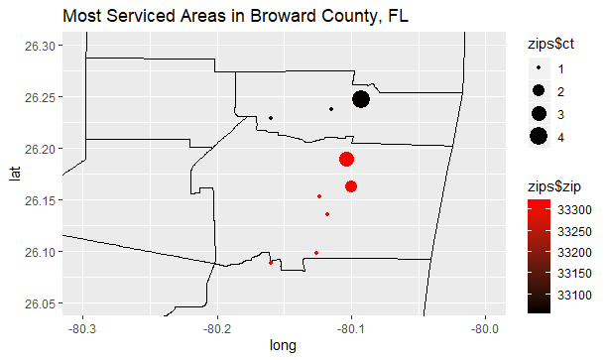

--Data Question 3: What are the profits of the company at any given moment?

--weekly profit function, business week starts on Monday

--create VIEW

GO

CREATE VIEW weekly_profit AS

SELECT

DATEADD(week, DATEDIFF(week, 0, date_of_service), 0) 'Week_Begin'

,SUM(amount) as weekly_profit

FROM

invoice

GROUP BY

DATEADD(week, DATEDIFF(week, 0, date_of_service), 0)

GO

SELECT * FROM weekly_profit

GO

CREATE VIEW totalprofit AS

SELECT

SUM(amount) as TotalProfit,

GETDATE() as ToDate

FROM invoice

WHERE invoice_status_id=2

GO

SELECT * FROM totalprofit

--create report from Access

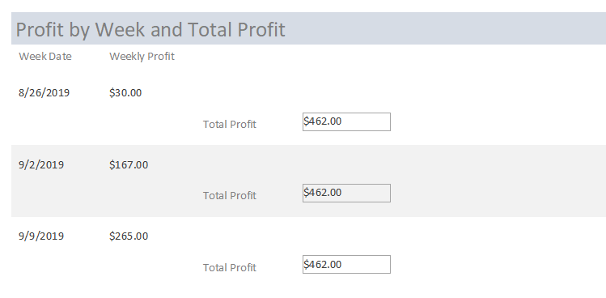

--Data Question 4: What is the average length of a dog walk? How many miles are walked a month?

--use Form to Enter Dog Walk Info

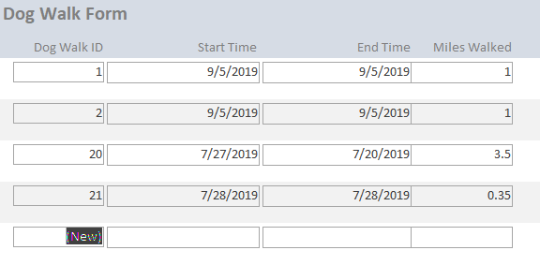

--info for dog_walk

SELECT

requested_service_date,

| **Total and Average Miles Walked Per Month** | | |
| --- | --- | --- |
| **Month** | **Total Miles Walked** | **Avg Miles Walked** |
| August 2019 | 5.9 | 0.98 |
| July 2019 | 6.23 | 0.89 |
| September 2019 | 8.2 | 1.03 |

pet.pet_name

FROM order_detail

INNER JOIN pet ON pet.pet_id = order_detail.pet_id

--what is average length of dog walks?

SELECT

AVG(miles_walked)

FROM dog_walk

--average length is .97 miles

-- report of miles walked per month

--Data Question 5: What is the average age of the pets and most common breed?

SELECT

animal_type,

AVG(age) as AverageAgeOfPets

FROM pet

GROUP BY animal_type

SELECT

TOP 3 pet_breed

,COUNT(pet_breed) as Count_of_Breed

FROM pet

WHERE animal_type = 'dog'

GROUP BY pet_breed

ORDER BY COUNT(*) DESC

SELECT

TOP 3 pet_breed

,COUNT(pet_breed) as Count_of_Breed

FROM pet

WHERE animal_type = 'cat'

GROUP BY pet_breed

ORDER BY COUNT(*) DESC

---TOP DOG breeds are Italian Greyhounds, Dachshunds, and Great Dane & Lab Mix

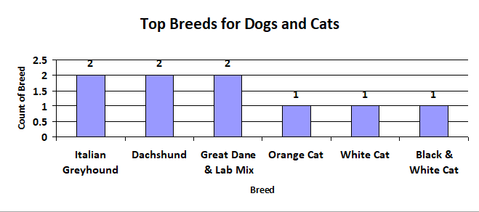--- Only 3 cat breeds so far - Orange, White, White Black

**Reflection**

My first and only assumption in this class was that the theory portion, including the conceptual and logical model, wasn’t useful. However, upon reflection I understand the importance of the conceptual and especially the logical model. I don’t think I would have been able to complete my project in a timely manner if I didn’t have the model to map everything out. If there is anything I could have done differently that would have been collected data more meticulously and for a longer period of time, I felt towards the end I ran out of time so I wasn’t able to insert all of the data I collected. If I had collected more data I believe my project would have been more insightful at identifying trends and more detailed profit information. Also, I would have separated the dates into separate columns as well to track trends more in depth, it was hard to do it by the ‘mm/dd/yyyy’ format. I believe this is a good lesson for me as a data science that the more data the better. Also, learning how to connect a database to R and Microsoft Access was extremely helpful and I will be able to use that in the future.

**Summary**

Developing the business rules and then the logical model were extremely crucial in the implementation of the database to create tables, the data types, and relationships between them. Also, the logical model was helpful for mapping the relationships in Microsoft Access. Most of my data questions were answered by a combination of SQL SELECT statements and creating a chart in either Access or R. Microsoft Access was the easiest to use for generating forms and made data entry very easy so that the answers to my data questions could be as insightful as possible. But, I believe R was much easier to use for generating plots and the choropleth map. I also believe the reports generated by R were much more aesthetically pleasing. It would have been much more helpful to have learned the connection to Access and R earlier on in the course and in a little more detail to utilize the tools to the ultimate potential.