**Project**

**Create two separate networks, Site1 and Site2. Site1 has the IP address 172.20.0.0/16, and within its virtual network, there are three subnets: I. Appserver (172.20.10.0/24) II. Work Subnet (172.20.20.0/24) III. DB subnet (172.20.30.0/24). Site2, on the other hand, has the IP address 172.16.0.0/16, and its virtual network contains four subnets: I. Account (172.16.10.0/24) II. HR (172.16.20.0/24) III. Development (172.16.30.0/24) IV. Administration (172.16.40.0/24). Establish a peering connection for communication between these two distinct networks (Site1 and Site2). Next, we need to launch VM2 with both a public and private IP address under the Administration subnet in Site2's virtual network. Similarly, launch VM1 with a private IP address under the Work Subnet subnet in Site1's virtual network. Additionally, attach network storage to VM1. Moving on, launch VM3 with both a public and private IP address under the DB subnet in Site1's virtual network and attach a Database server to it. Lastly, launch VM4 and VM5 in the Appserver subnet and establish connectivity via a LoadBalancer.**

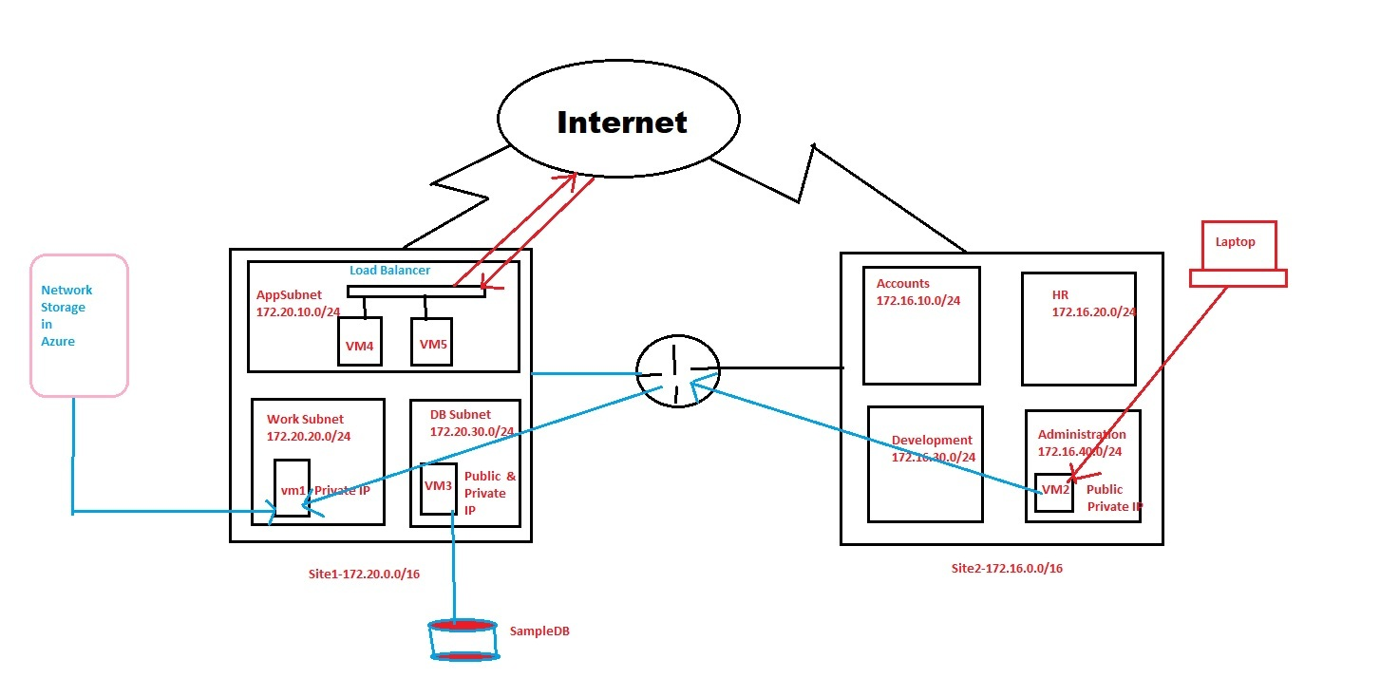

**Step: - 1**

Create a Resource group i.e Class.

**Step:-2**

We have to create 2 separate Virtual Network by following name :-

1. Site1 whose IP address is 172.20.0.0/16, with in virtual network there are 3 nos of Subnet. I.e. I. Appserver (172.20.10.0/24), II.Work Subnet (172.20.20.0/24), III. DB subnet (172.20.30.0/24).
2. Site2 whose IP address is 172.16.0.0/16, with in virtual network there are 4 nos of Subnet. I.e. I. Account (172.16.10.0/24), II.HR (172.16.20.0/24), III. Development (172.16.30.0/24), IV. Administration (172.16.40.0/24).

**Creation of Virtual network Site1**

Go to Virtual network dashboard

Create Virtual network

Resource group: class

Instance details Name:-Site1

Then IP Address Portion:- Put IP of Site1 i.e 172.20.0.0/16 in IPv4 address space then add Subnet Appserver , workSubnet, DBsubnet with the corresponding IP 172.20.10.0/24, 172.20.20.0/24 and 172.20.30.0/24.

Then hit review +create button, after validation Passed press create button. Now we have successfully created site1 virtual network.

**Creation of Virtual network Site2**

Go to Virtual network dashboard

Create Virtual network

Resource group: class

Instance details Name:-Site1

Then IP Address Portion:- Put IP of Site2 i.e 172.16.0.0/16 in IPv4 address space then add Subnet Account , HR , Development and Administration with corresponding IP 172.16.10.0/24, 172.16.20.0/24 ,172.16.30.0/24 and 172.16.40.0/24.

Then hit review +create button, after validation Passed press create button. Now we have successfully created site1 virtual network.

**Step:-2**

**As per requirement we have to establish peering connection for communication of two different networks (i.e site1, site2).**

**Open Site1 virtual network**

Under setting option go to peering option then add peering and follow the steps .

Virtual network Peering link name: site1-site2

Remote virtual network Peering link name : site2-site1

virtual network: Site2

Then hits add option now we can clearly show the peering status is connected to Site2. Similarly if we go to the site2 virtual network under peering option same status shown.

**Step:-3**

**As per requirement we have to launch VM2 with having public and private under Administration subnet in Site2 virtual network.**

**Steps are given below:-**

1. Go to virtual machine.
2. Create azure virtual machine.
3. resource group: class
4. image: Windows Server 2022 Datacenter
5. Select the size as per your requirement.
6. Enter user-id and password.
7. Then go to network option under network option go to network interface option select virtual network site2.
8. Subnet option: - Administration.
9. Public IP option: - (new) vm2-ip.

Then hit review +create button, after validation Passed press create button. Now we have successfully created VM2 with having public and private under Administration subnet in Site2 virtual network.

**Step:-4**

**As per requirement we have to launch VM1 with having only private IP under WorkSubnet subnet in Site1 virtual network.**

**Steps are given below:-**

1. Go to virtual machine.
2. Create azure virtual machine.
3. Resource group name: class.
4. Image: Windows Server 2022 Datacenter
5. Select size: as per your requirement.
6. Enter userid and password.
7. Then go to network option under network option go to network interface option select virtual network site1.
8. Subnet option:- WorkSubnet
9. Public IP option: - nope (Because of VM1 have only private IP).

Then hit review +create button, after validation Passed press create button. Now we have successfully created VM1 with having only private under WorkSubnet subnet in Site1 virtual network.

**Step:-5**

**As per task we have to attach a network storage in VM1.**

**For Network Storage we have to create a storage account. Go to Storage account dashboard and create.**

**Steps are given below:-**

1. resource group Name: class
2. Storage account name: timirlab
3. Redundancy: locally redundant storage
4. In Advance option enable Data Lake Storage Gen2 for big data.

Then hit review after validation Passed press create button. Now we have successfully created storage account with the name of timirlab.

In Storage account i.e timirlab under data storage option go to file share. Add file share with the name of officedata then create. After creation of officedata click on it and hit connect option.

**Step:-6**

As VM1 have only have private IP so that we can’t do RDP directly. VM2 have public IP so that we can RDP VM2 via any machine. Although VM1 and VM2 is in different network but with the help of peering connection we can easily access VM1 via VM2 .

**Steps are given below:-**

1. Open run and pass the mstsc command for RDP.
2. In RDP Popup window enter public IP of VM2 & hit enter.
3. Enter credentials i.e userid & password and hit ok buttom.
4. Now we are in VM2, for accessing VM1 Open run and pass the mstsc command for RDP.
5. In RDP Popup window enter private IP of VM1 & hit enter.
6. Enter credentials i.e userid & password of VM1 then hit ok buttom.
7. Now we are in VM1.
8. Open windows powershell.
9. Go to Azure portal Open storage account (timirlab) then go to fileshare . In fileshare menu we have already created officedata click on it and hit the connect option. Within connect option select drive, click on showscript and copy the script.
10. Paste the script into VM1 powershell and hit option.
11. Now we have successfully attached a network storage into VM1.

**Step:-7**

**As per requirement we have to launch VM3 with having public and private under DB subnet in Site1 virtual network and attached a Database server.**

For attaching a Database we have to create a SQL database and steps are given below:

1. Go to SQL database.
2. Create a SQL database.
3. Resource group name: class
4. Database name: SampleDB
5. Server: we have to create
6. Server name:-timirlabserver.
7. Authentication method: Use SQL authentication.
8. Enter server admin login & password then hit the ok buttom.
9. Workload environment : Development
10. Backup storage redundancy: Locally-redundant backup storage.
11. Go to network option & Connectivity method: Public.
12. Under Firewall rules Allow Azure services and resources to access this server: Yes
13. Go to Addl.settings under Data source Use existing data: Sample.

Then hit review +create button, after validation Passed press create button. Now we have successfully created database i.e SampleDB.

**Creation of VM3**

**Steps are given below:-**

1. Go to virtual machine.
2. Create azure virtual machine.
3. Resource group name: class.
4. Image: Windows Server 2022 Datacenter
5. Select size: as per your requirement.
6. Enter user-id and password.
7. Then go to network option under network option go to network interface option select virtual network site1.
8. Subnet option:- DBSubnet
9. Public IP option: - (new) vm3-ip.

Then hit review +create button, after validation Passed press create button. Now we have successfully created VM3 with having public and private IP under DBSubnet subnet in Site1 virtual network.

So that other server cannot access this database therefore we have to enable set server firewall rule now only VM3 can allow accessing the database and the steps are:-

1. Copy the Public IP VM3 .
2. Go to mysampleDB database dashboard.
3. Click on set server firewall rules.
4. Under public access go to firewall rules and add your public IPv4 Address.
5. Rule name:-Appserver , Start IPv4 Address & End IPv4 Address is Public IP of VM3
6. Save

**Now RDP VM3**

**For attaching database into VM3 steps are given below:-**

1. Open Microsoft edge browser.
2. Search & Download SQL Server Management Studio (SSMS)
3. Install SQL Server Management Studio (SSMS).
4. Open SQL Server Management Studio (SSMS).
5. Enter server name:- timirlabserver1.database.windows.net
6. Authentication mode: SQL server Authentication.
7. Enter SQL server login & password.
8. Under timirlabserver1.database.windows.net>Databases>mysample>table Now we can see our tables.

**Step:-7**

**As per requirement we have to launch VM4 & VM5 in Appserver subnet & connect through via Loadbalancer**

**Launching VM4**

Availability option: Select Availability set

Create Availability set: Set1

Then go to network option under network option go to network interface option select virtual network site1.

Subnet option: - Appserver

Create VM4

**Creating Loadbalancer**

Name: LB1

Type: Public

Go to frontend IP Configuration & Add it. Name:LBIP,

Public IP Address create, Name: pip & add

Go to Backend Pool.

Pool Name: Pool1, Virtual network: Site1, Backend Pool Configuration: IP Address

In IP Address section Add Private IP of VM4.

Review & create.

**Launching VM5**

Availability option: Select Availability set

Availability set: Set1

Then go to network option under network option go to network interface option select virtual network site1.

Subnet option:- Appserver

Create VM5

**Go to Loadbalaner for some setting**

To associate VM5 with loadbalancer go to loadbalancer backend pool option add VM5 private IP.

Create Heathprobes.

## Load balancing rules:

## Name: Inboundhttps rules

Select frontend IP Address & Backend Pool. Port-80, Backend port-80

Add it.