GitHub repo:

**https://github.com/timjar3/Pro_1Java_app_CI_CD.git**

**Jenkins Pipeline on Oracle VM Box running Linux Ubuntu,**

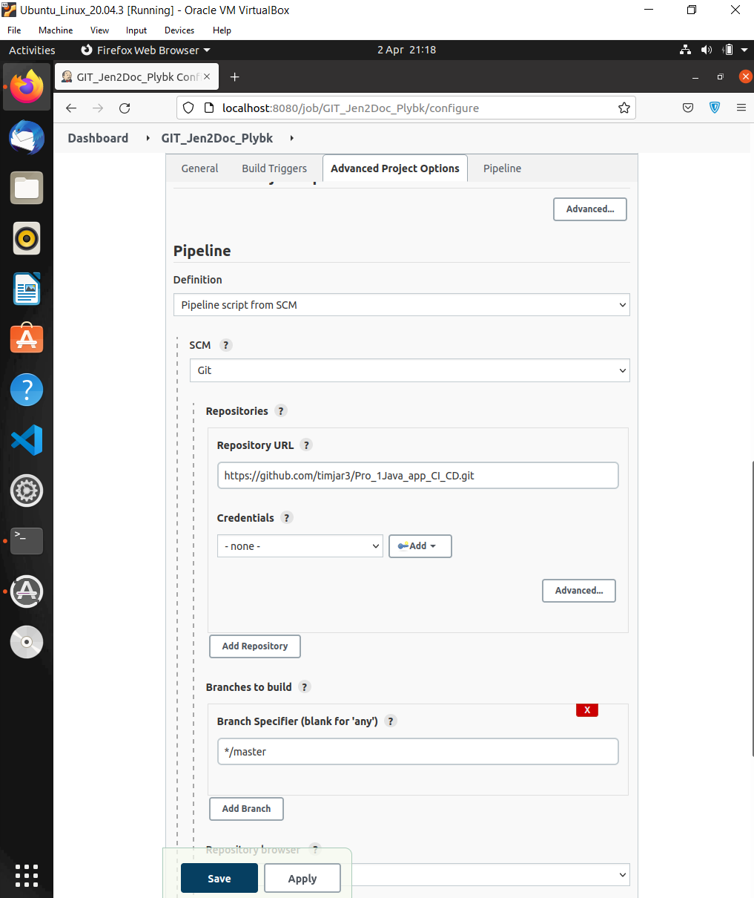

**Centi master instance is the Jenkins slave node running on AWS EC2 instance, where all the tasks will be executed and docker images will be created and pushed.**

**Note:**

*On Prem*

**Linux Ubuntu = Jenkins Master**

*On AWS*

**Centi master = Jenkins slave node**

**Node1_DevServer = is the server where we will deploy the docker container and other dependencies using Ansible.**

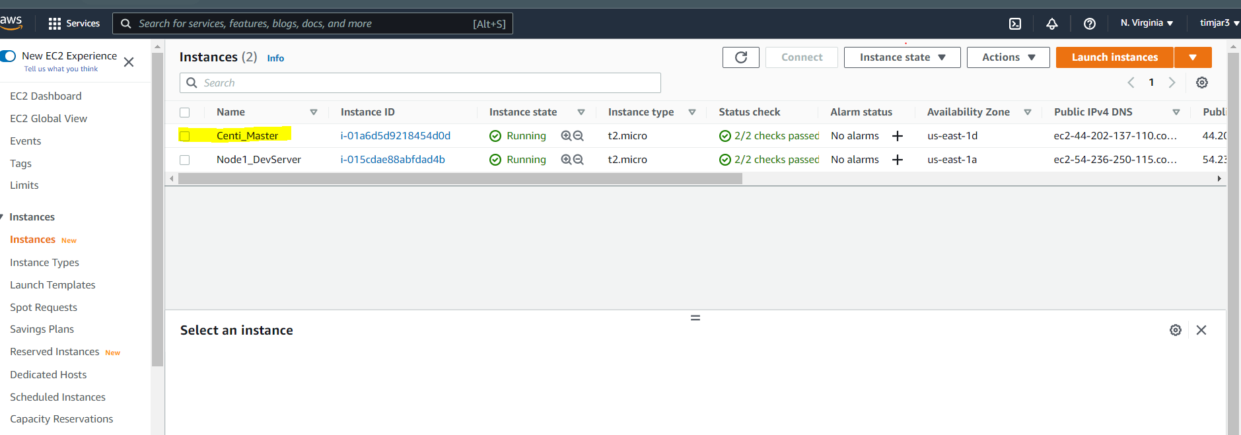

***Necessary pre-configuration for Jenkins with all the necessary plugins have been installed for the project to be executed successfully, like the Global configuration setting for Ansible, GIT, JAVA and Maven have been modified as necessary. ****

* **You can find all the necessary Jenkins file, playbook, and docker file in the SCM at GIT hub repo.**
* **We will add the clone URL of the GIT repo to the SCM pipeline to provide a source.**
* **This is a public repo so there are no credentials added.**

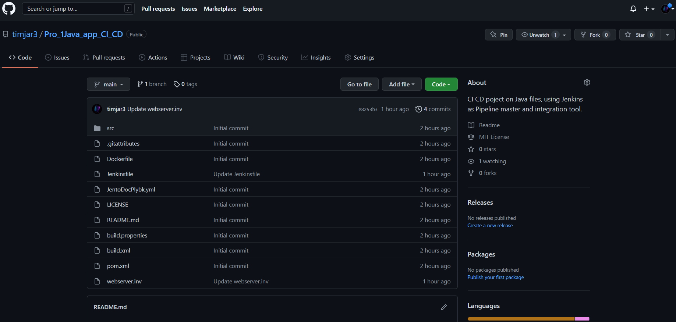

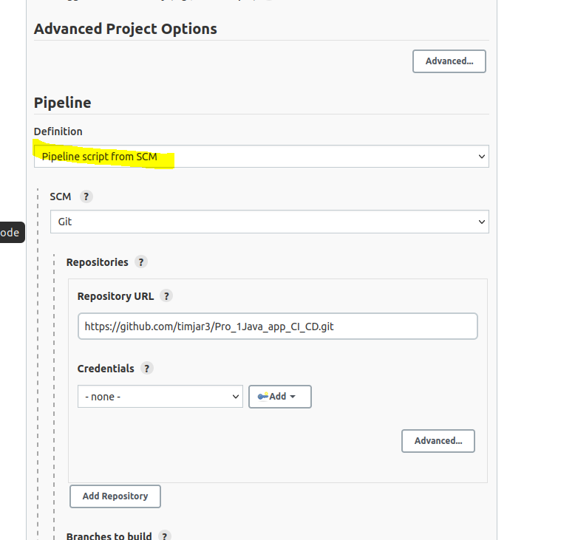

**The complete Jenkinsfile code can be previewed in git repo:**

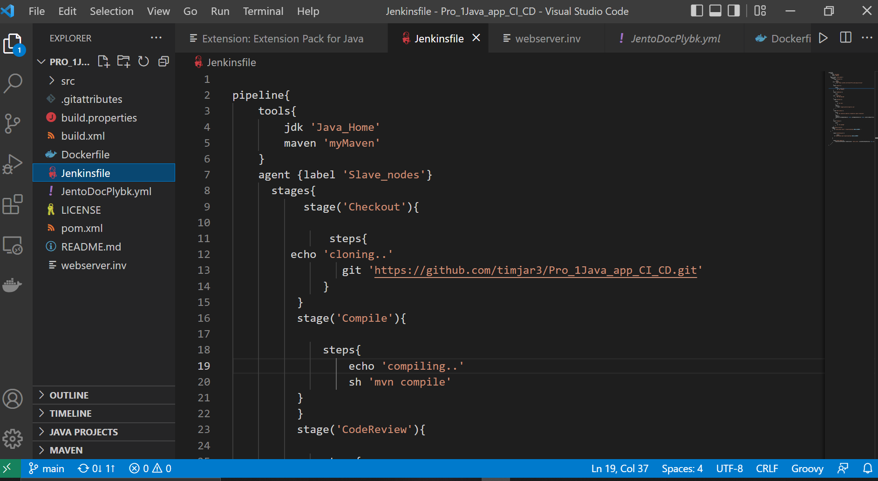

**DockerFile:**

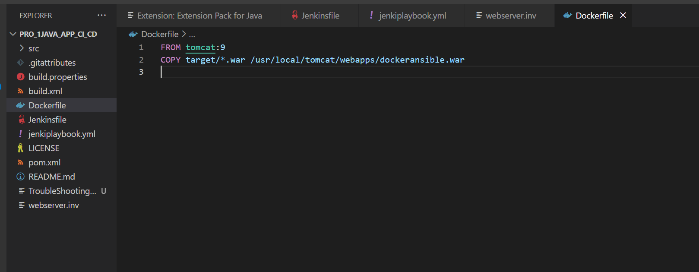

**Ansible Playbook yml file.**

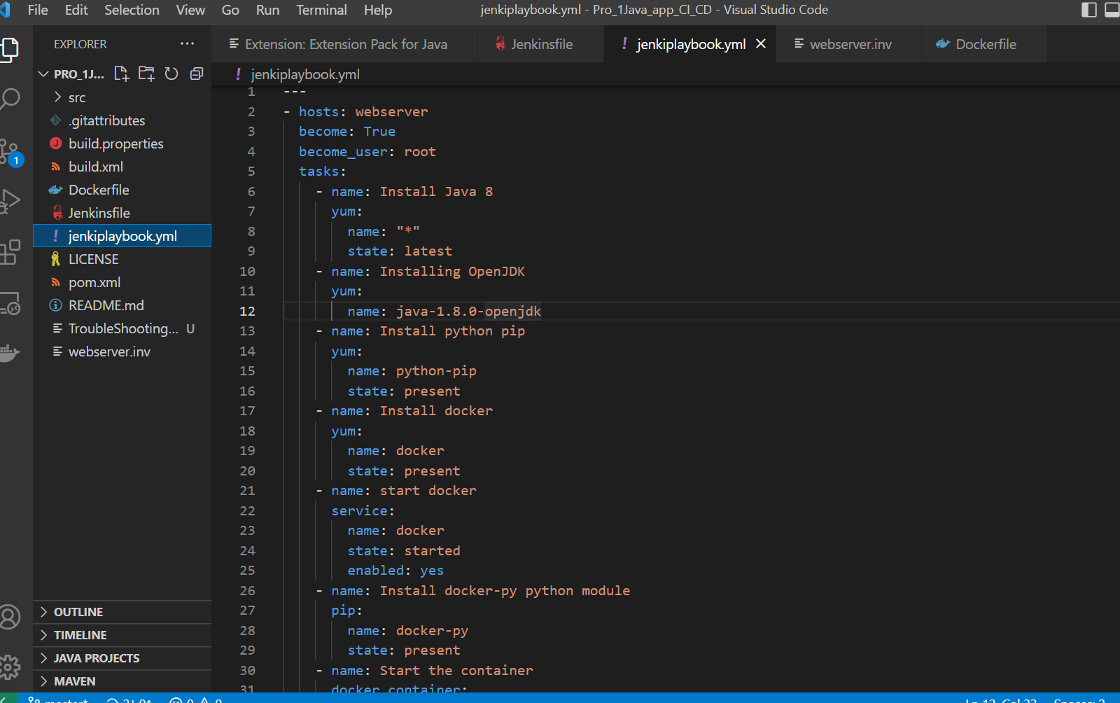

Test results and the Pipeline View:

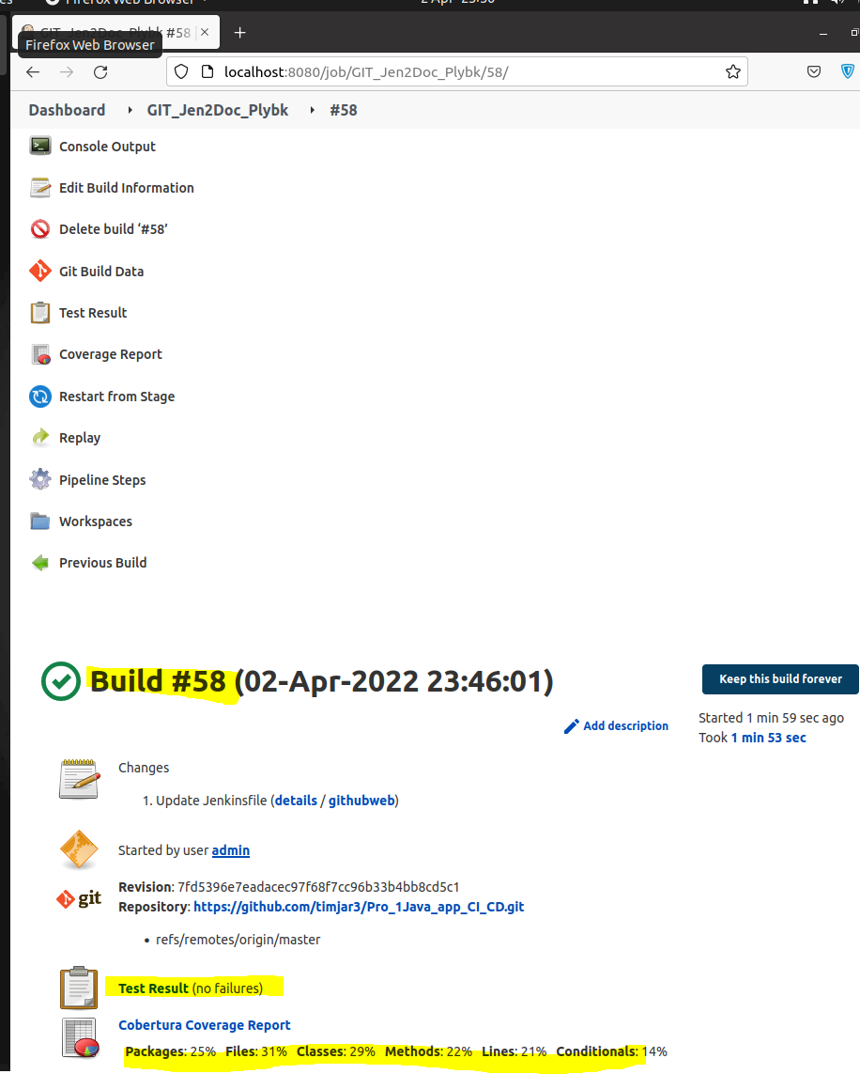

**Pipeline View:**

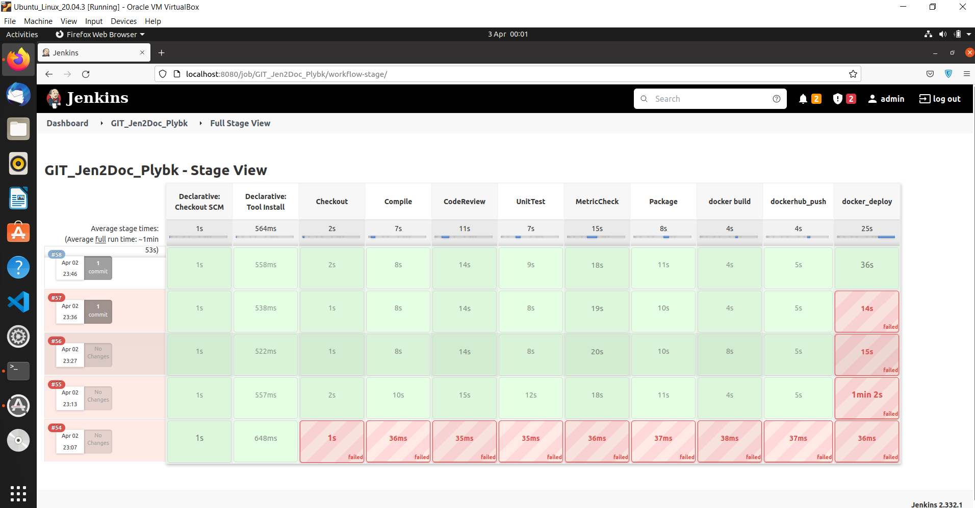

**Below we can see the docker image uploaded on the docker hub.**

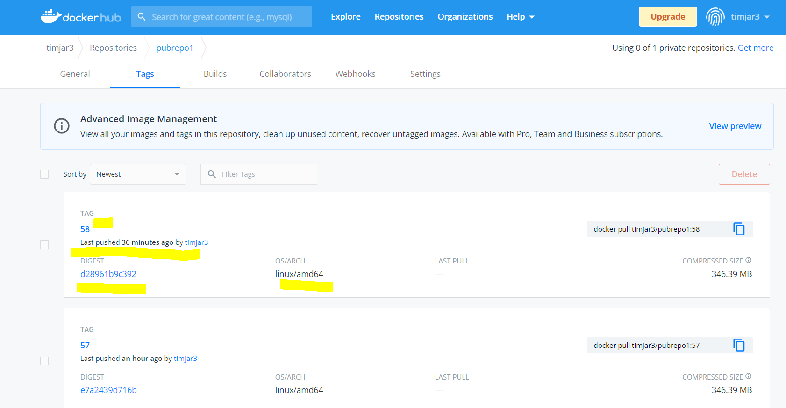

**Successfully deployed Docker and other dependencies using Ansible on Dev_server.**

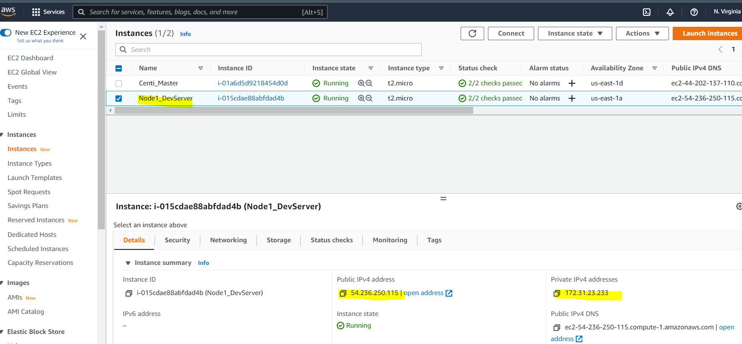

**And also requested the pull command for the Docker image with respective build number from the dockerhub.io, and successfully deployed the container as you can see below in the image. STATUS is Running and healthy.**

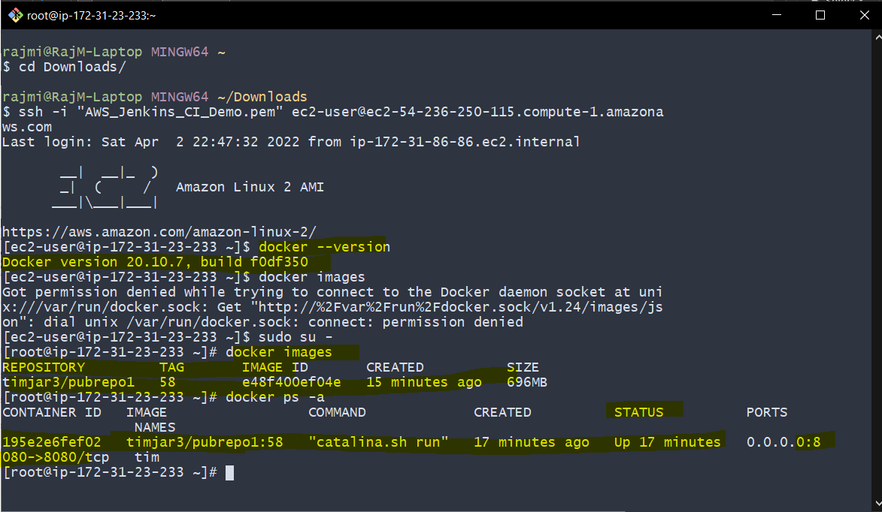

Now we can check Successful deployment of the App in the browser using the dev server public IP with the respective port map and the package name:

