Create N2 Glcoud instance

Debain

sudo su -

apt update

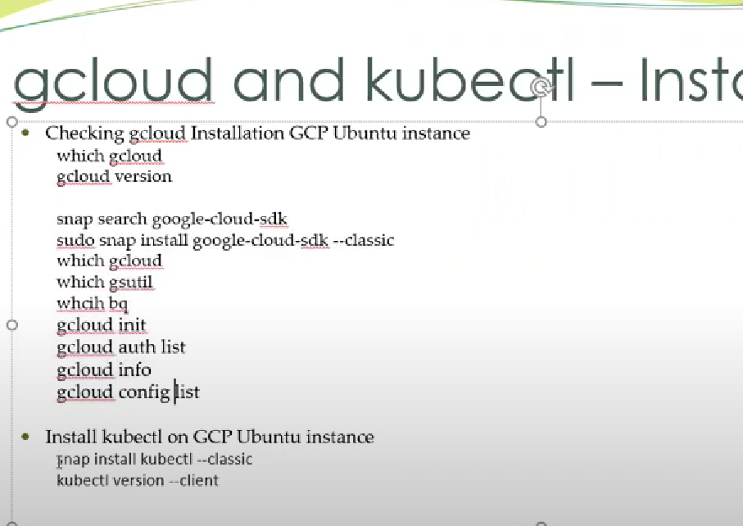

Apt install snap

Sudo apt-get install kubectl

CENTOS

https://www.liquidweb.com/kb/install-java-8-on-centos-7/

Yum -y update

yum install java-1.8.0-openjdk

update-alternatives --config java

**Set Java’s Home Environment**

**Step 1: Find Java’s Path**

Let’s set the**JAVA_HOME** variable, using the following command will give us a path so we can set the variable.

update-alternatives --config java

You’ll see a prompt to “Enter to keep the current selection[+], or type selection number:”, if you had multiple Java version you could set the default here, but all we need is the path of Java so we can exit pressing enter.  The highlighted area is the path we will need to copy/paste into our .bash_profile file.

Selection    Command  
-----------------------------------------------  
*+ 1           java-1.8.0-openjdk.x86_64 (/usr/lib/jvm/java-1.8.0-openjdk-1.8.0.191.b12-1.el7_6.x86_64/jre/bin/java)</code?

**Step 2: Setting Java’s Path in Your Environment**

After copying your Java’s path, open the .bash_profile with your text editor.

vim .bash_profile

Export your Java path into the .bash_profile by adding the following to the bottom of the file. (Your path may look different from mine, and it’s not important that they vary.)

export JAVA_HOME=/usr/lib/jvm/java-1.8.0-openjdk-1.8.0.191.b12-1.el7_6.x86_64/jre/bin/java

Refresh the File:

Source .bash_profile

When you use the**JAVA_HOME** variable you’ll now be able to see the path you set.

echo $JAVA_HOME

**Example Output:**

/usr/lib/jvm/java-1.8.0-openjdk-1.8.0.191.b12-1.el7_6.x86_64/jre/bin/java

**Instal Jenkins**

[**https://linuxize.com/post/how-to-install-jenkins-on-centos-7/**](https://linuxize.com/post/how-to-install-jenkins-on-centos-7/)

**https://www.jenkins.io/doc/book/installing/linux/#red-hat-centos**

## Installing Jenkins

To install Jenkins on your CentOS system, follow the steps below:

1. Jenkins is a Java application, so the first step is to install Java. Run the following command to install the OpenJDK 8 package:

sudo yum install java-1.8.0-openjdk-develCopy

The current version of Jenkins does not support Java 10 (and Java 11) yet. If you have multiple versions of Java installed on your machine [make sure Java 8 is the default Java version](https://linuxize.com/post/install-java-on-centos-7/#set-the-default-version) .

1. The next step is to enable the Jenkins repository. To do that, import the GPG key using the following [curl](https://linuxize.com/post/curl-command-examples/) command:

curl --silent --location http://pkg.jenkins-ci.org/redhat-stable/jenkins.repo | sudo tee /etc/yum.repos.d/jenkins.repoCopy

And add the repository to your system with:

sudo rpm --import https://jenkins-ci.org/redhat/jenkins-ci.org.keyCopy

1. Once the repository is enabled, install the latest stable version of Jenkins by typing:

sudo yum install jenkinsCopy

After the installation process is completed, start the Jenkins service with:

sudo systemctl start jenkinsCopy

To check whether it started successfully run:

systemctl status jenkinsCopy

You should see something similar to this:

● jenkins.service - LSB: Jenkins Automation Server

Loaded: loaded (/etc/rc.d/init.d/jenkins; bad; vendor preset: disabled)

Active: active (running) since Thu 2018-09-20 14:58:21 UTC; 15s ago

Docs: man:systemd-sysv-generator(8)

Process: 2367 ExecStart=/etc/rc.d/init.d/jenkins start (code=exited, status=0/SUCCESS)

CGroup: /system.slice/jenkins.serviceCopy

Finally enable the Jenkins service to start on system boot.

sudo systemctl enable jenkinsCopy

jenkins.service is not a native service, redirecting to /sbin/chkconfig.

Executing /sbin/chkconfig jenkins onCopy

## Adjust the Firewall

If you are installing Jenkins on a remote CentOS server that is [protected by a firewall](https://linuxize.com/post/how-to-setup-a-firewall-with-firewalld-on-centos-7/) you need to port 8080.

Use the following commands to open the necessary port:

sudo firewall-cmd --permanent --zone=public --add-port=8080/tcpsudo firewall-cmd --reloadCopyCopy

## Setting Up Jenkins

To set up your new Jenkins installation, open your browser and type your domain or IP address followed by port 8080:

http://your_ip_or_domain:8080

Copy

A screen similar to the following will appear, prompting you to enter the Administrator password that is created during the installation:

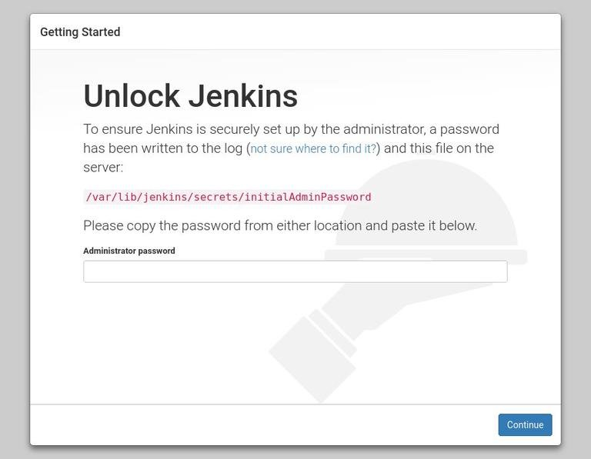

Use the following command to print the password on your terminal:

sudo cat /var/lib/jenkins/secrets/initialAdminPasswordCopy

You should see a 32-character long alphanumeric password as shown below:

2115173b548f4e99a203ee99a8732a32

Copy

Copy the password from your terminal, paste it into the Administrator password field and click Continue.

nano /etc/sudoers

Jenkins ALL=(ALL) NOPASSWD: ALL

Sudo yum install docker

sudo systemctl start docker

systemctl status docker

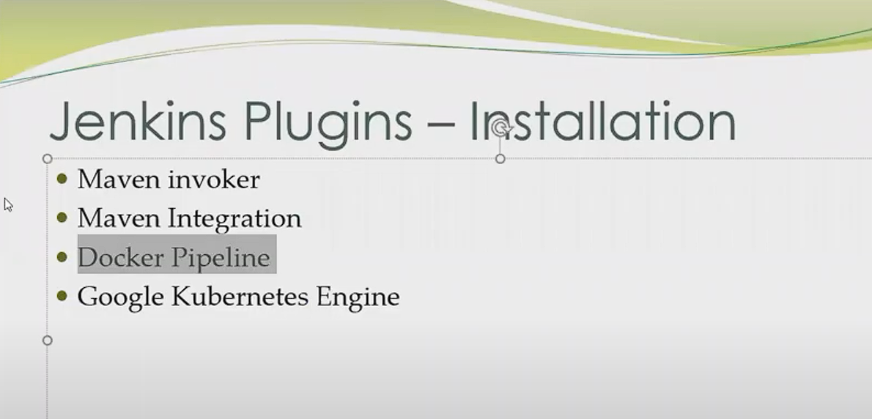 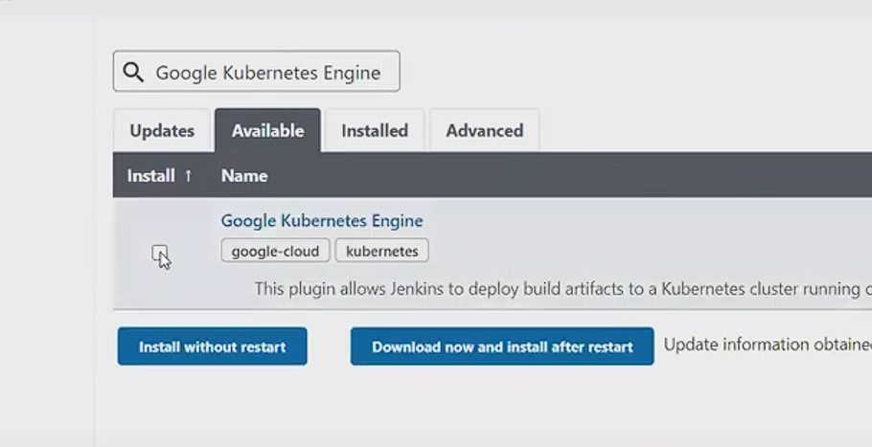 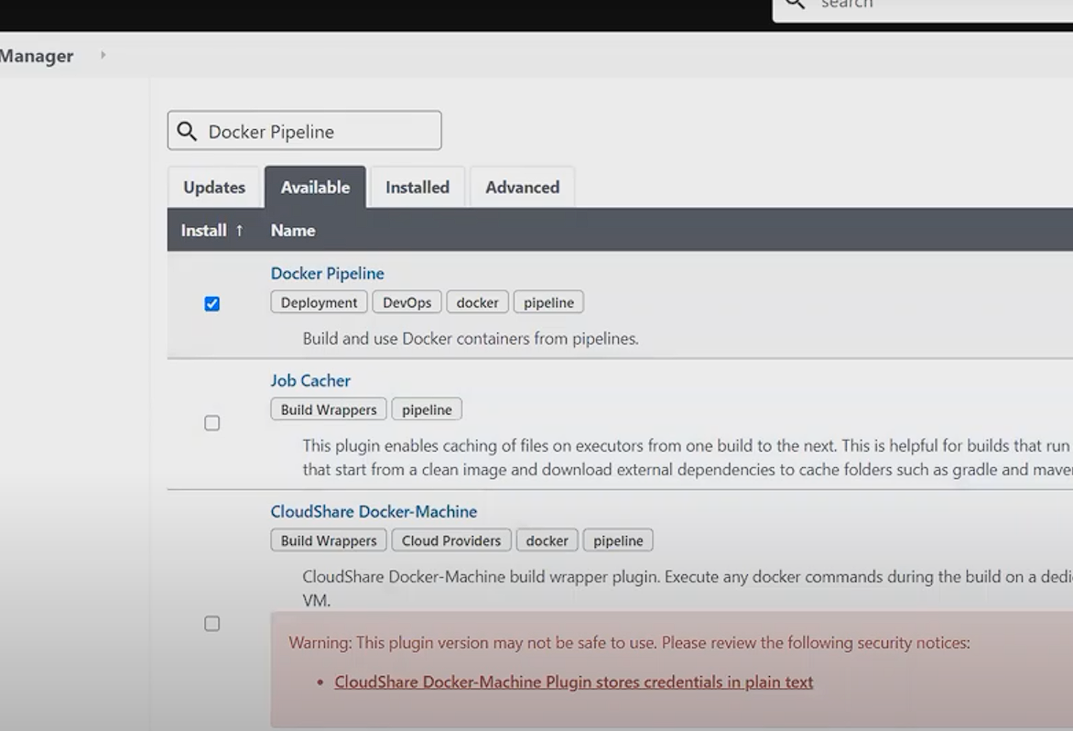

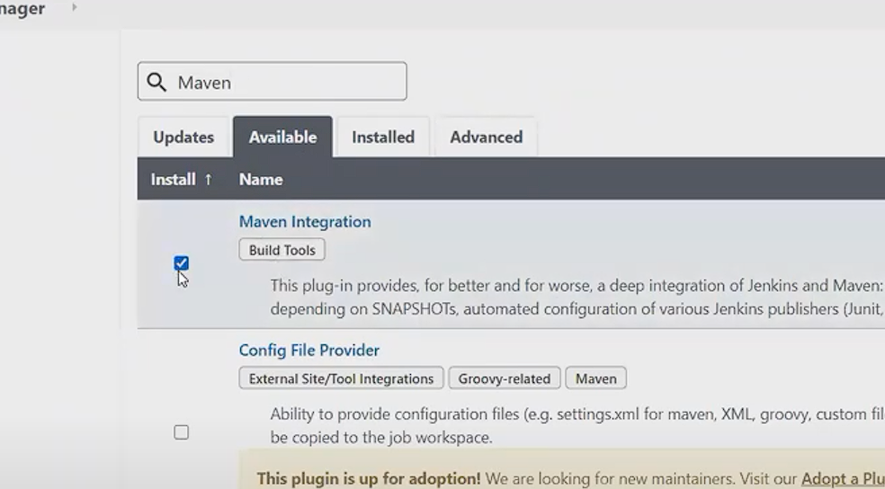

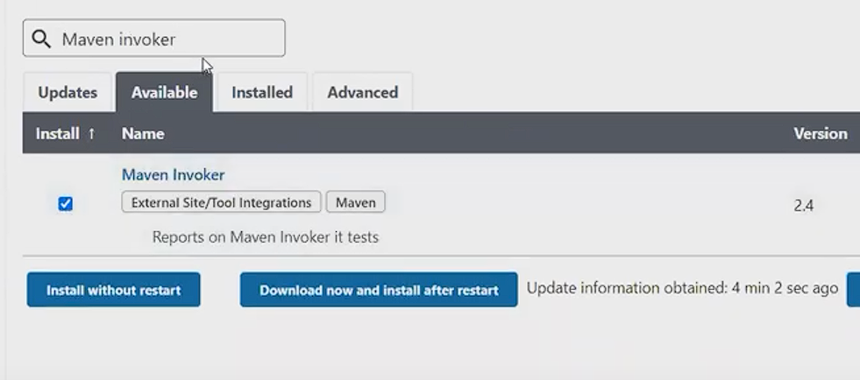

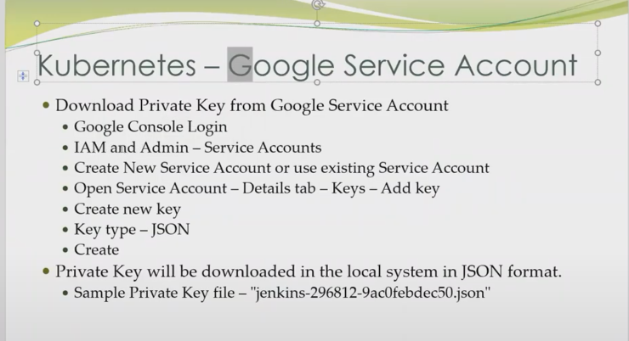

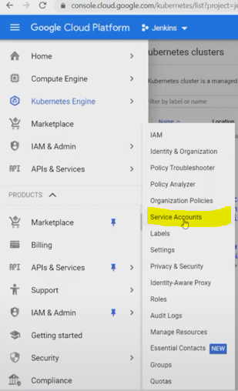

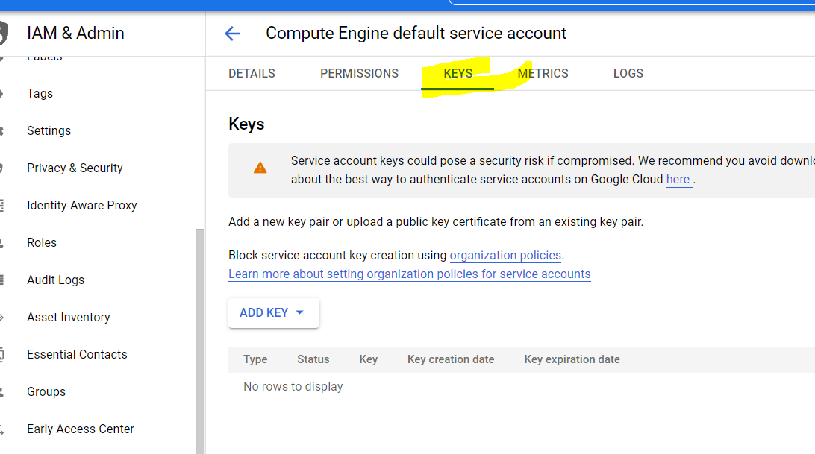

= to check java home

update-alternatives --display java