Our Modern Nativity


12 December 2025|Feature Articles|Volume 29 Issue 12
Jolene Latimer, Western Canada Correspondent

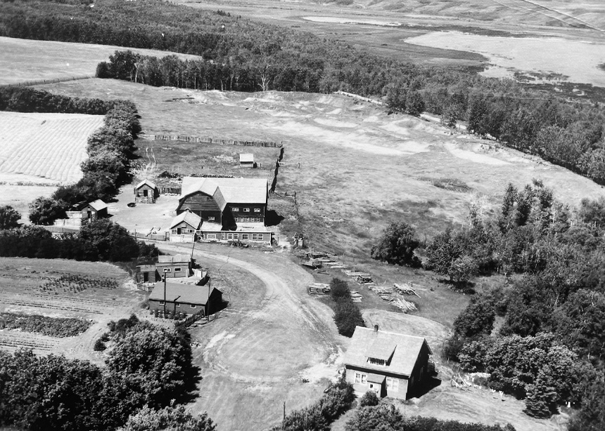Photo: Supplied
A Farmyard Fire, Big-City Hospitality and Unexpected Grace
Because there was nothing else he could do, he had no choice but to watch it burn.
The flames were undaunted by the midwinter snow. There was no hope of fire trucks, at least none that could readily reach the little farm so far down the country road it had been aptly named Trail’s End.
He, just 17 and the only brother at home with seven sisters, was outmanned before it began. Mom and Dad were away for the afternoon. No cavalry coming. So it was that the blaze tore through the modest garage on an even more modest dairy farm, greedily consuming the family car, a tractor, the work bench, all the tools and every bit and bob needed to keep the place alive.
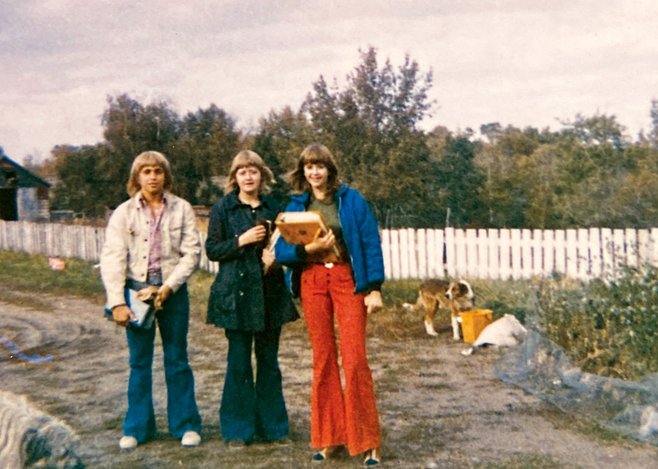Photo: Supplied
He managed to save the attached wooden granary, but the fire took the utility pole feeding electricity to the barn.
“It was a horrific feeling, just thinking about how disappointed my parents would be,” my dad recalled.
That winter, the aftermath was its own kind of work. Even if he tried not to look at the ruins, they refused to be ignored. They stubbornly smoldered for a month through the dead of winter, smelling of burned farm equipment and mistakes that couldn’t be undone. Through the ashes, the 1962 Pontiac Laurentian’s sooty taillights stared mockingly at him, burning themselves into his memory.
The disappointment wasn’t just about youthful carelessness, but because everything that burned was somewhat irreplaceable. You might think nothing was lost that money can’t buy, but that’s just the thing: there wasn’t any money. It was part of the reason he’d been welding alone in the garage in the first place.
As the only boy on the family farm in central Alberta, my dad worked before and after school helping his dad with the 65 cattle they corralled in and out of a barn that had withstood a half-century of prairie winters. The constant condensation on the wood had finally rendered it unsafe, and just months before the fire, they had decided to build a new barn.
A new barn—the first new thing they’d had. A bank loan provided just enough to hire help building the basic structure. The finer details would be a do-it-yourself undertaking. That included assembling the stanchions, which, according to my dad, were beautiful in their newness but arrived eight inches too short. Hence the welding.
They never did get another family car or rebuild the garage. But they did restore power to the barn that night; there was milking to be done.

That’s how my dad has always told the story.
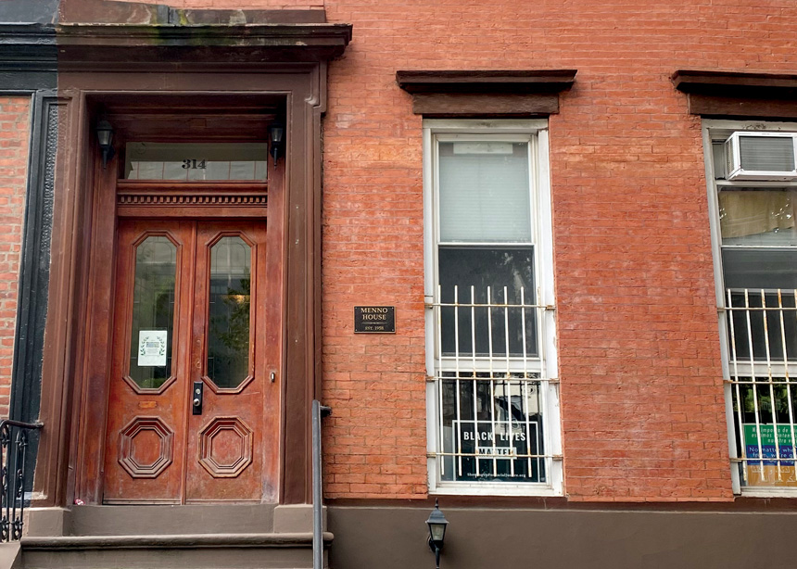Photo: Jolene Latimer
But the last time he told it, we weren’t talking about farming at all. We were talking about a place far from central Alberta—Manhattan. I was the one dominating the conversation. I was telling him about a discovery I had recently made on a trip there, one that would end up tying our stories together.
My childhood was much different from my dad’s; he made sure I never had to worry about being hemmed in by circumstances. I took that gift and used it to become a reporter. On this occasion, I’d gone to New York City for the weekend to meet with contacts in hopes of scoring a big assignment.
In this industry, you have to hustle and it often feels like no one’s in your corner, especially in a city like New York where so many people want the same thing.
Accommodations for my trip were an issue. Hotels were prohibitively expensive, but it also didn’t feel appropriate to stay with the people I knew.
I settled on staying in an old brownstone in Gramercy Park known as Menno House. Until recently, I hadn’t known much about Mennonites, so I was surprised to learn it had been purchased in 1957 to house conscientious objectors during the Vietnam War while they fulfilled their alternative service. Today, it’s a short-term guesthouse and affordable residence in the heart of Manhattan—three guest rooms, $125 a night, each with a bed, desk and sleeping loft. The best deal in the city.
Menno House is more than just a place to sleep. It offers the feeling of home: a kitchen, living room, backyard and, once a week, a shared dinner.
The night I joined, the house manager, Greg, made a New York Times chicken recipe with pumpkin spice ice cream for dessert. Around the table sat a woman who had played classical piano while Greg cooked, a young man obsessed with moths and a journalism student already disillusioned with the profession. Then there was me, a not-quite-as-jaded journalist recently hired by a Mennonite publication. This was a safe, soft place to land in a busy city. It felt, in some way, like a place practicing the ancient art of making room in the inn.
As I described the particularities of this experience, my dad asked questions. “Why? Why do they do all this? Why provide affordable stays for travellers? Why take on long-term tenants when that property is worth so much more?”
I hadn’t considered it. But my dad already had an answer forming. He revisited his own story of the burning garage, only this time it had an ending I hadn’t heard before.
Several weeks after the garage burned, while it was still smoldering in the barnyard, his family was surprised to see a line of trucks rolling down their driveway. There were about 10 trucks in all, each carrying two or three Mennonite men. They came with just a quiet instinct to help.
In another story, they might have been shepherds at a stable.
It turned out Mennonites weren’t strangers to my dad. We’d never talked about it before—he tends toward unbelief and avoids religious talk—but now he revealed his grandparents had been practicing Mennonites who fled persecution in Russia and settled near Saskatoon in the early 1900s, speaking Low German and farming the prairie soil. When his mother later moved to Alberta, she kept in touch with Mennonite families nearby, as did his sister. Somehow, word of the burned garage had reached these families.
What happened next stayed with my dad all his life. Understanding the strain his family was under, the men offered something simple: their labour. They trudged through nearly two feet of snow, crossing the little farm’s fields, to collect the square hay bales that had been sitting out since fall. One by one, they hauled them into the barnyard, stacking them in neat rows until the work was done. One less manual task, easing at least part of the burden the fire had left behind.
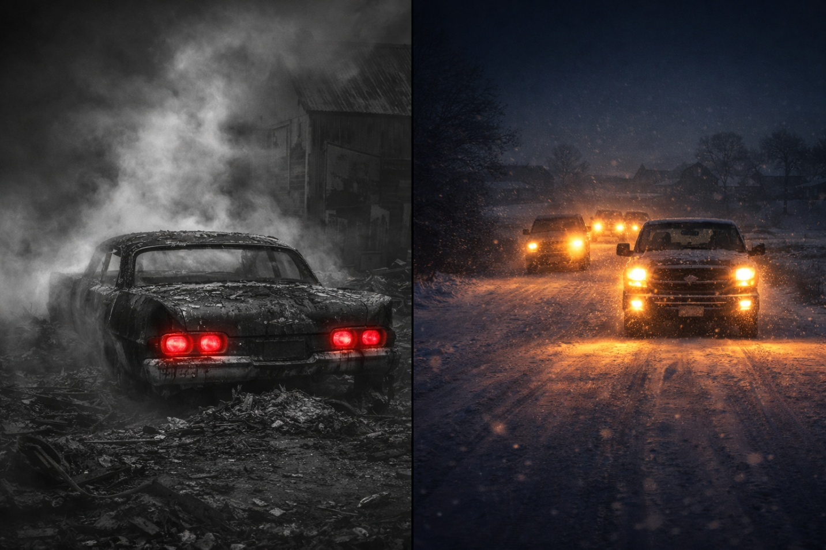
I realized we had both, in our own ways, experienced a kind of modern Nativity—not performed for recognition, but born of quiet grace. His: hay. Mine: shelter. Gestures without fanfare, yet more memorable than anything done to be seen.
And when he finally answered his own question of why, it felt like the Christmas story in a single line: “It was the first time I ever saw someone give without expecting anything in return.”

