Supplemental Material

Implementing two-dimensional autocorrelation in either survival or natural mortality improves a state-space assessment model for Southern New England-Mid Atlantic yellowtail flounder

Brian C. Stock*, Haikun Xu, Timothy J. Miller, James T. Thorson, and Janet A. Nye

*brian.stock@noaa.gov
Supplemental methods description: Simulation self- and cross-tests
We fit each model to the original data and then used the simulation feature of TMB to conduct self- and cross-tests. For each model, we generated 100 sets of new data and random effects, keeping the fixed effect parameters constant at values estimated in original fits. These were “unconditional” simulations because new random effects were generated (using the fixed effect parameter values controlling their variance and correlation) and then new data were simulated based on these values (i.e. the simulated data were not conditional on the original random effects). We then re-fit all models to datasets simulated under each as an operating model. We calculated the relative error in parameters constraining random effects (Table S1) and quantities of interest, such as spawning stock biomass (SSB), F, , , and recruitment. We calculated relative error as , where is the true value for simulated dataset i and is the value estimated from fitting the model to the simulated data. To estimate bias of each estimation model for a given operating model, we calculated 95% confidence intervals of the median relative error using the binomial distribution (Thompson 1936). To summarize the bias across simulations and years for each model, we calculated the median across years and took the mean of the medians across simulations.

Table S1. Model descriptions are summarized below for convenience, as in Tables 1 and 2. Parameters constraining numbers at age (NAA) and natural mortality (M) random effects are in Equations 5 and 6, respectively.
Model | Description | Estimated parameters
Numbers at age (NAA) / Survival
Base | Independent recruitment deviations | σ_{R}
NAA-1 | AR(1) recruitment deviations | σ_{R}, ρ_{year}
NAA-2 | Independent NAA/survival deviations (all ages) | σ_{R}, σ_{a}
NAA-5 | 2D AR(1) NAA/survival deviations (age x year) | σ_{R}, σ_{a}, ρ_{year}, ρ_{age}
Natural mortality (M)
Base | No M deviations | σ_{R}
M-1 | Independent M deviations | σ_{R}, σ_{M}
M-4 | 2D AR(1) M deviations (age x year) | σ_{R}, σ_{M}, φ_{year}, φ_{age}
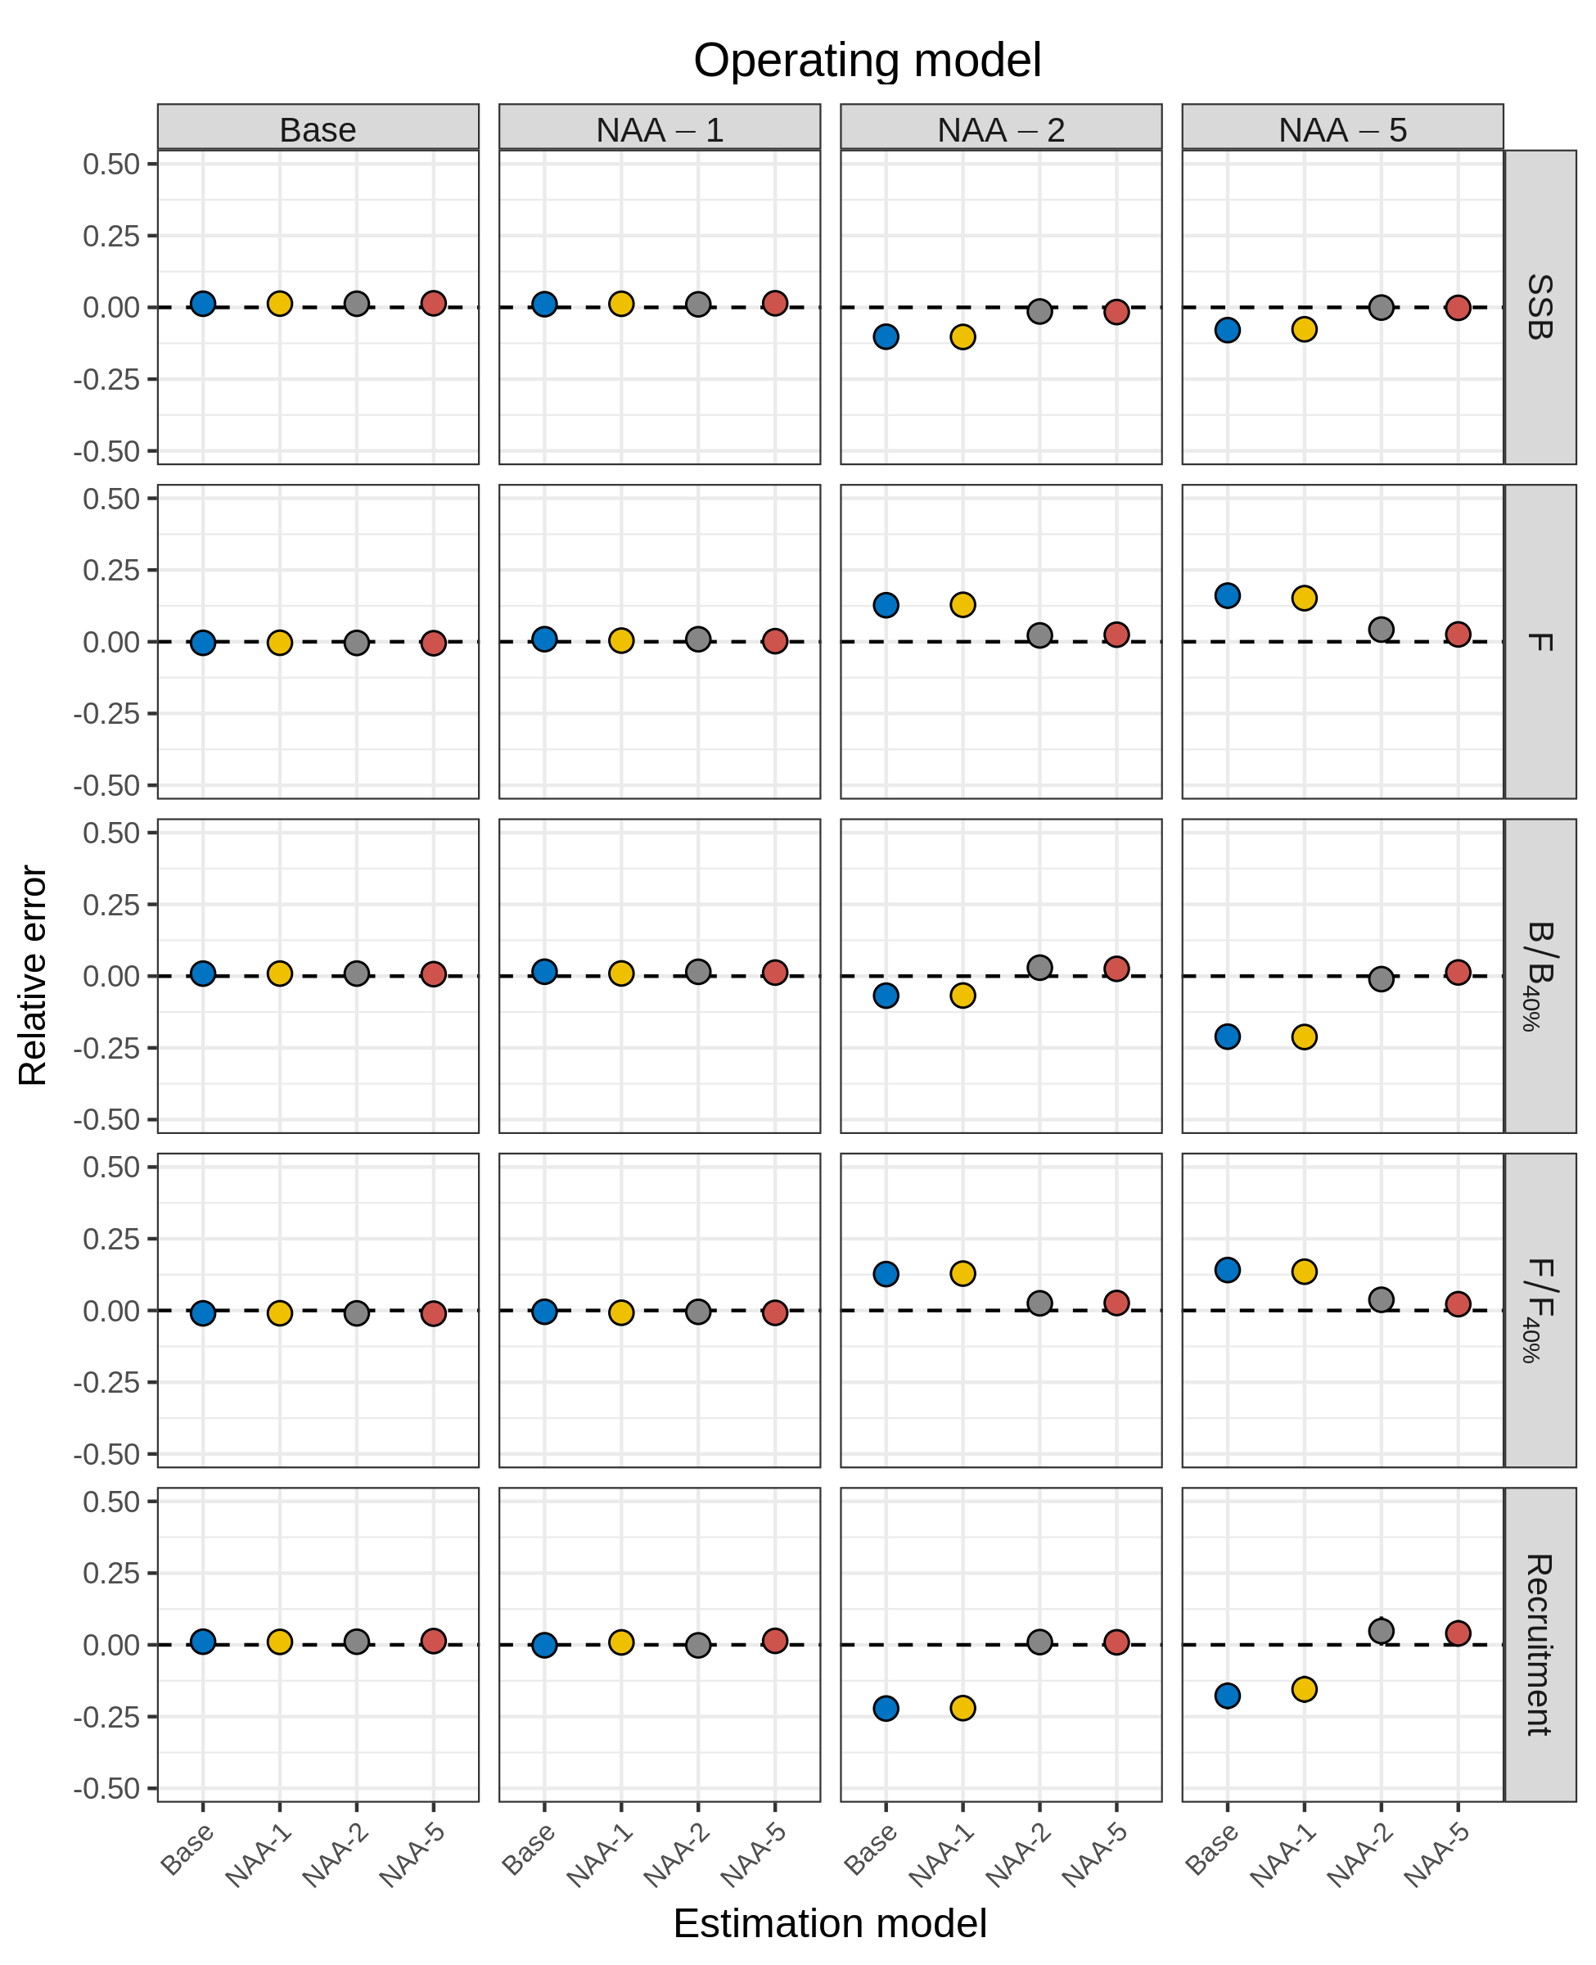
Figure S1. Relative error of key quantities in simulation self- and cross-tests for models with numbers-at-age (NAA) as random effects. Model descriptions are as in Tables 1 and S1. See supplemental methods for description of simulations and relative error calculation. Points without lines indicate that 95% confidence intervals for the mean relative error were smaller than points.
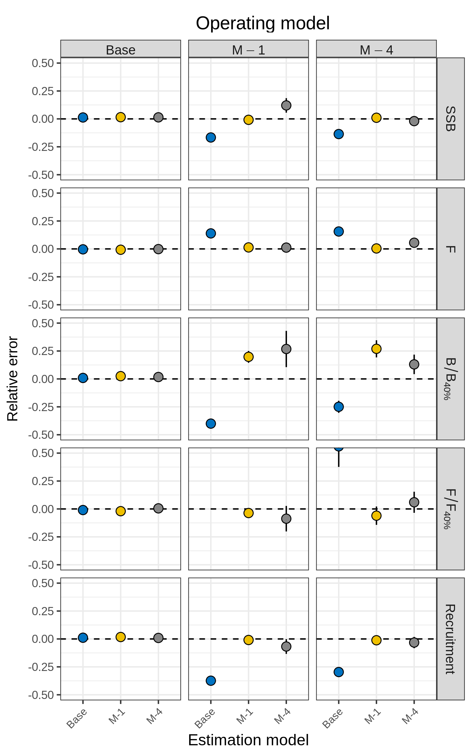
Figure S2. Relative error of key quantities in simulation self- and cross-tests for models with natural mortality (M) random effect deviations. Model descriptions are as in Tables 2 and S1. See supplemental methods for description of simulations. Points without lines indicate that 95% confidence intervals for the mean relative error were smaller than points.
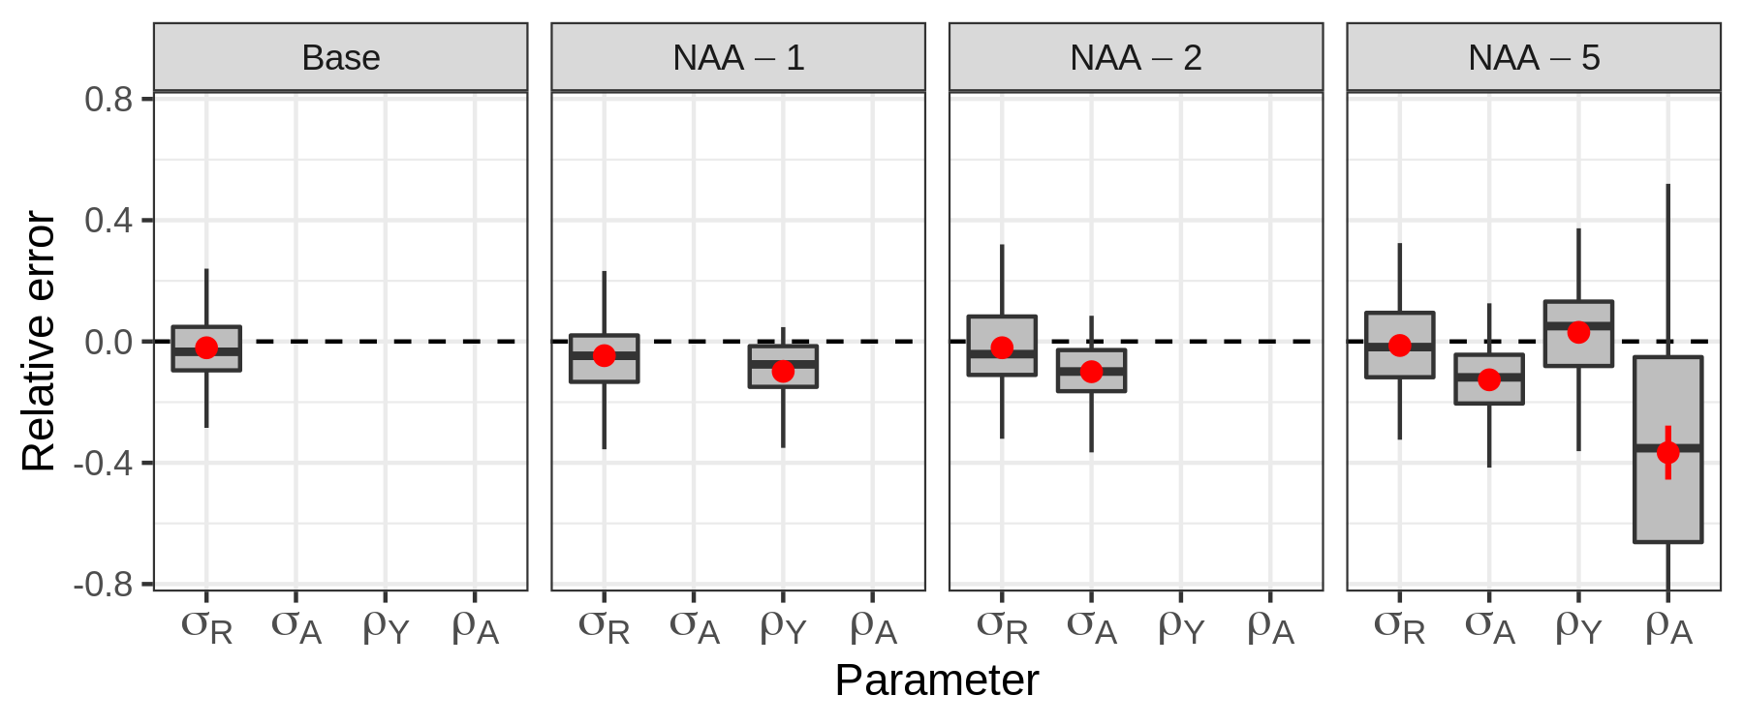
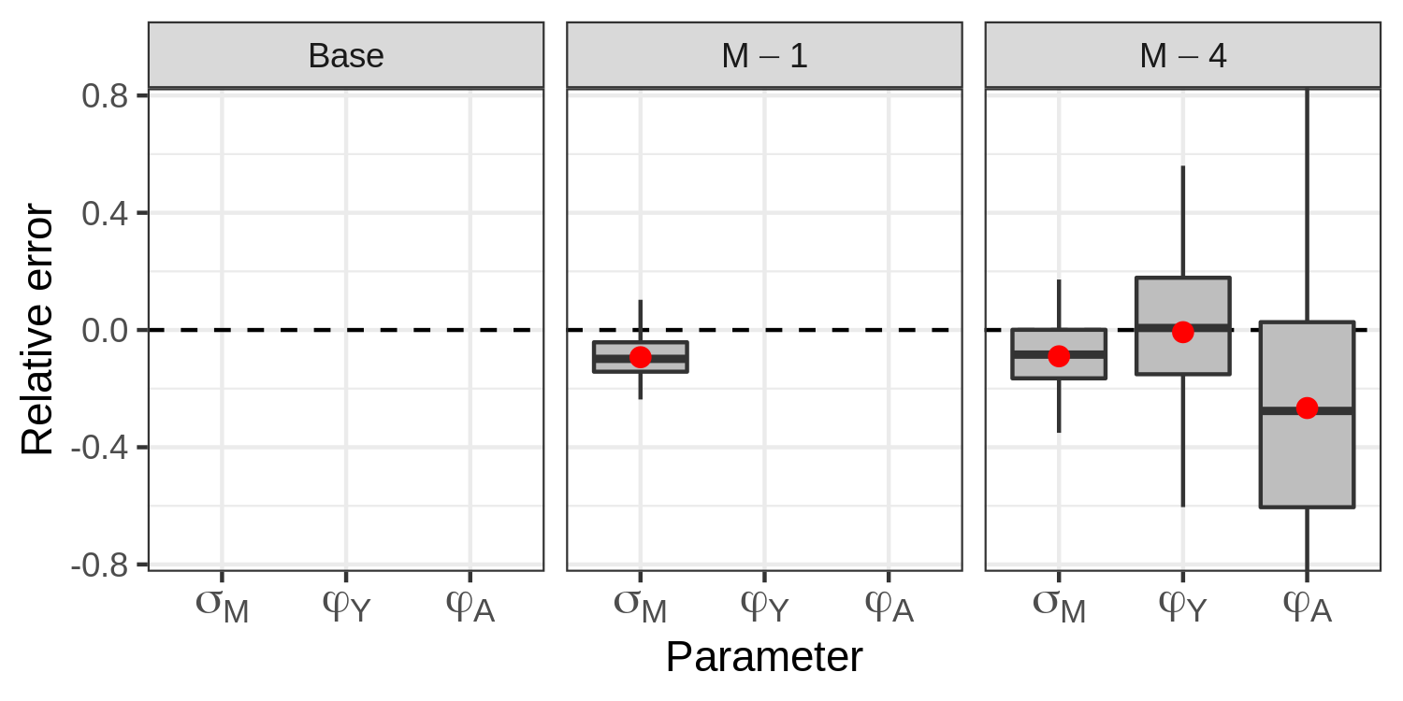
Figure S3. Relative error of parameters constraining numbers-at-age (NAA) and natural mortality (M) random effect deviations. Red points and lines show median relative error with 95% CI. See supplemental methods for description of simulations. Model descriptions are in Tables 1, 2, and S1. Parameter descriptions are in Equations 5 and 6.
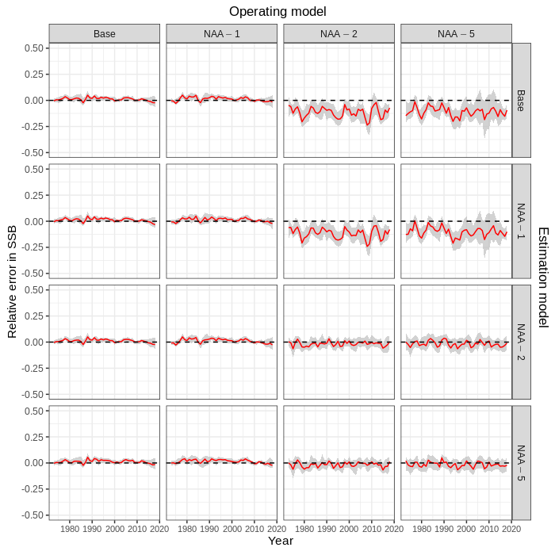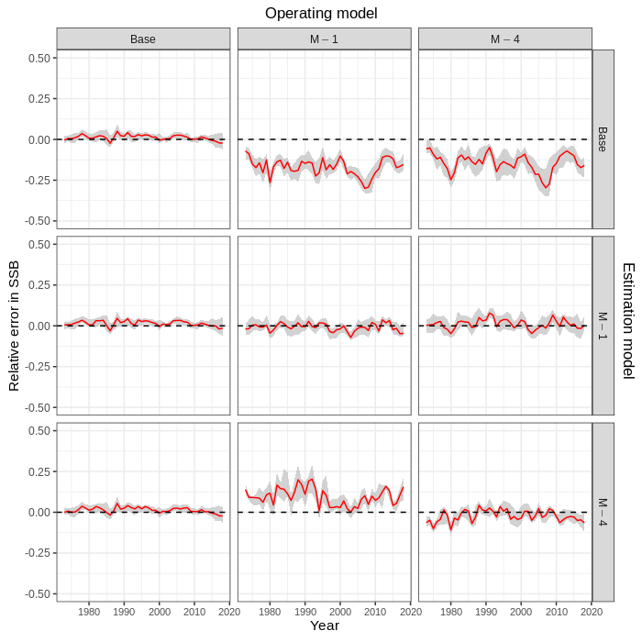
Figure S4. Relative error in spawning stock biomass (SSB) in simulation cross-tests for models with numbers-at-age (NAA, left) and natural mortality (M, right) random effect deviations. Solid red lines and grey shading show the median relative error with 95% CI, calculated within year and across simulations. See supplemental methods for description of simulations.
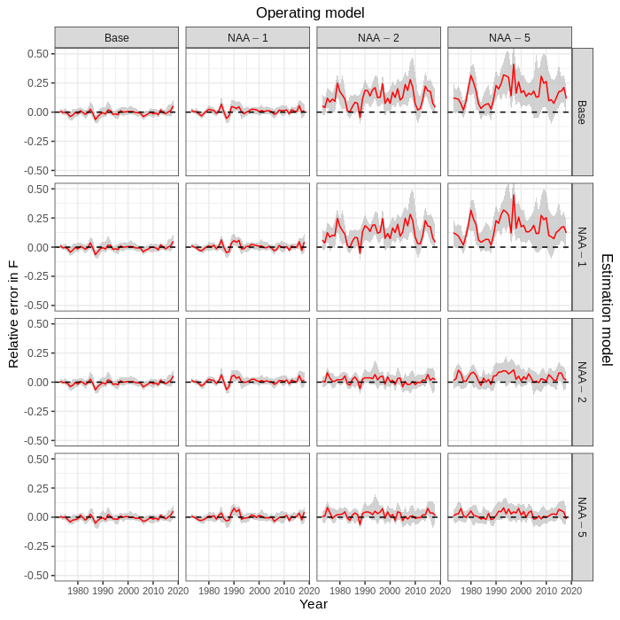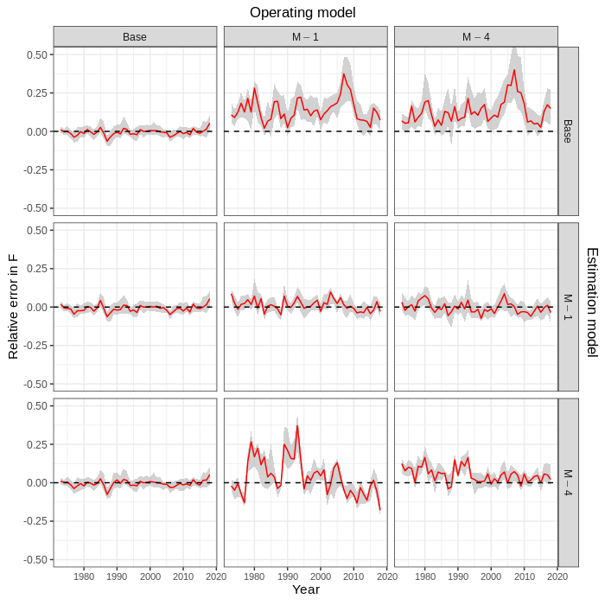
Figure S5. Relative error in fishing mortality (F) in simulation cross-tests for models with numbers-at-age (NAA, left) and natural mortality (M, right) random effect deviations. Solid red lines and grey shading show the median relative error with 95% CI, calculated within year and across simulations. See supplemental methods for description of simulations.

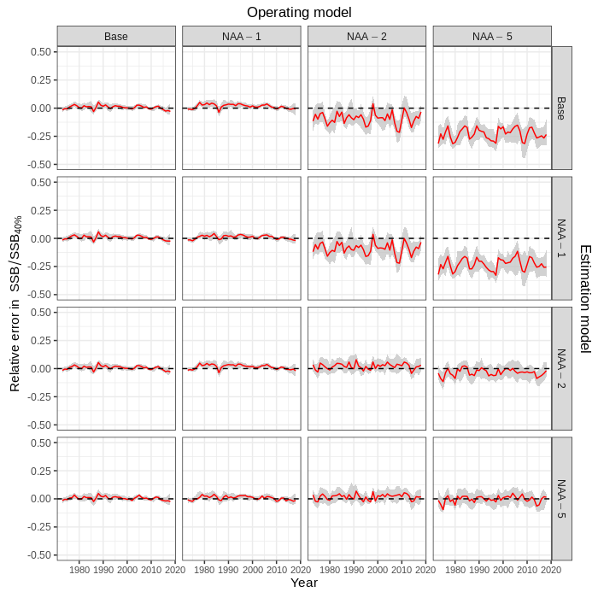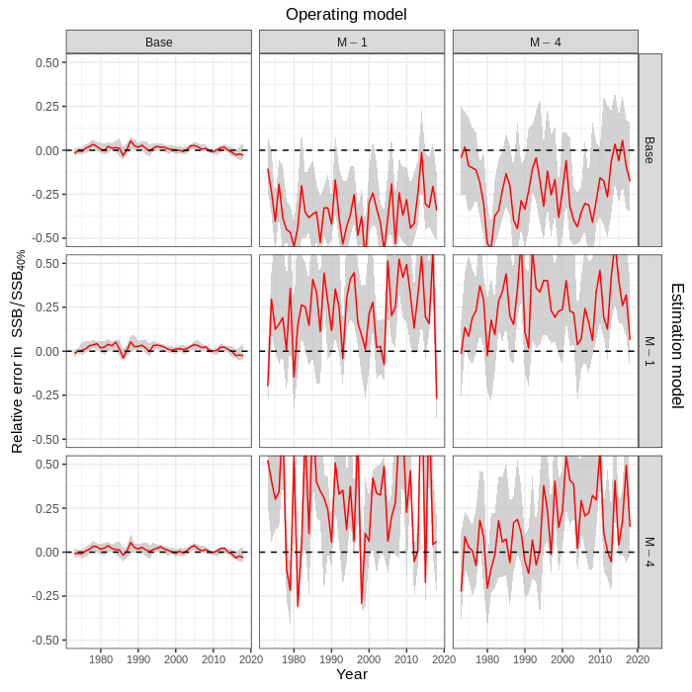
Figure S6. Relative error in relative spawning stock biomass () in simulation cross-tests for models with numbers-at-age (NAA, left) and natural mortality (M, right) random effect deviations. Solid red lines and grey shading show the median relative error with 95% CI, calculated within year and across simulations. See supplemental methods for description of simulations.
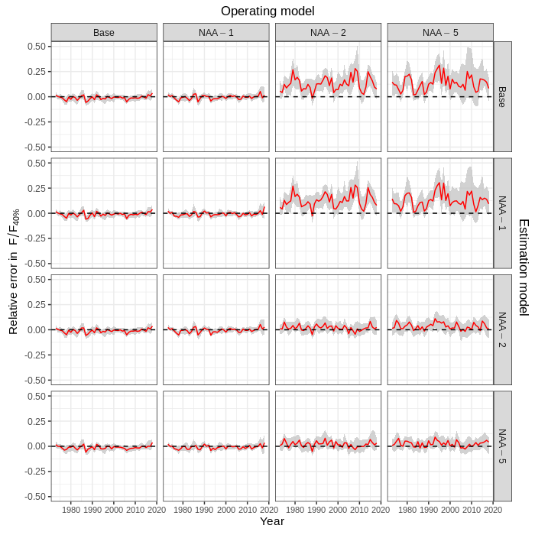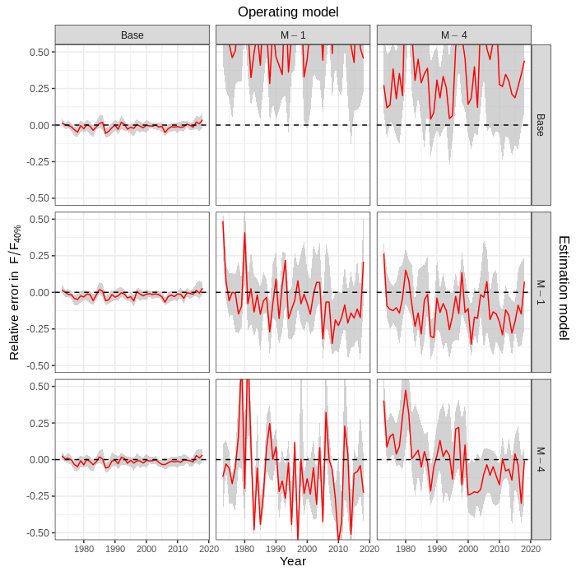
Figure S7. Relative error in relative fishing mortality () in simulation cross-tests for models with numbers-at-age (NAA, left) and natural mortality (M, right) random effect deviations. Solid red lines and grey shading show the median relative error with 95% CI, calculated within year and across simulations. See supplemental methods for description of simulations.
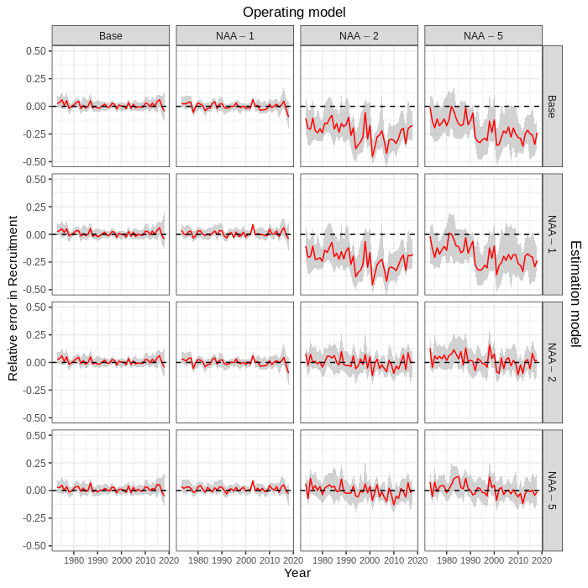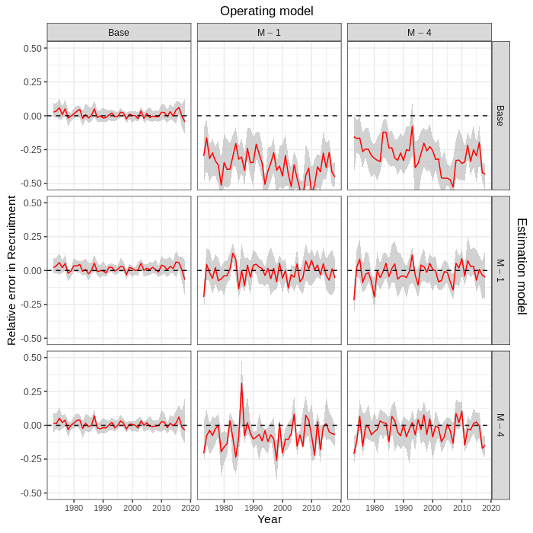
Figure S8. Relative error in recruitment in simulation cross-tests for models with numbers-at-age (NAA, left) and natural mortality (M, right) random effect deviations. Solid red lines and grey shading show the median relative error with 95% CI, calculated within year and across simulations. See supplemental methods for description of simulations.
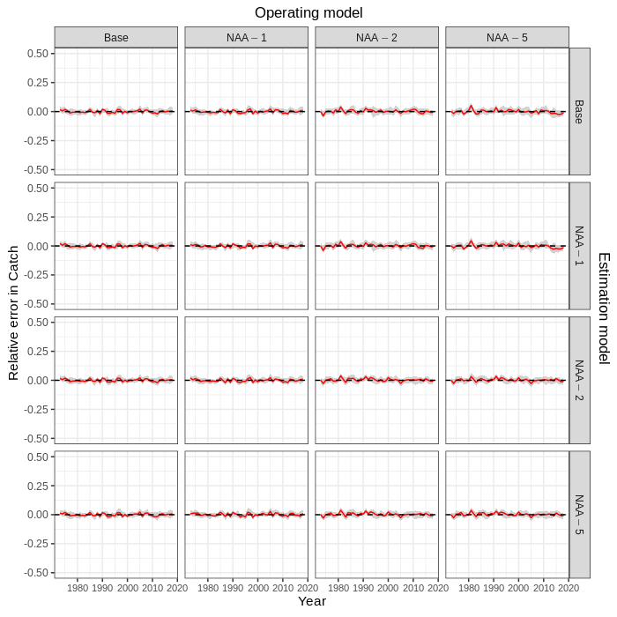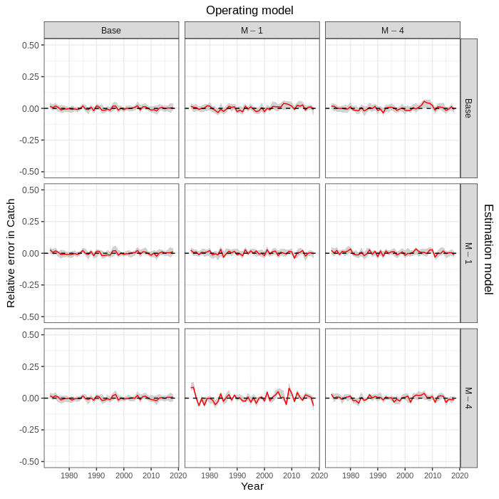
Figure S9. Relative error in predicted catch in simulation cross-tests for models with numbers-at-age (NAA, left) and natural mortality (M, right) random effect deviations. Solid red lines and grey shading show the median relative error with 95% CI, calculated within year and across simulations. See supplemental methods for description of simulations.

