Supplemental Information

The Woods Hole Assessment Model (WHAM): a general state-space assessment framework that incorporates time- and age-varying processes via random effects and links to environmental covariates

Brian C. Stock* and Timothy J. Miller

*brian.stock@noaa.gov
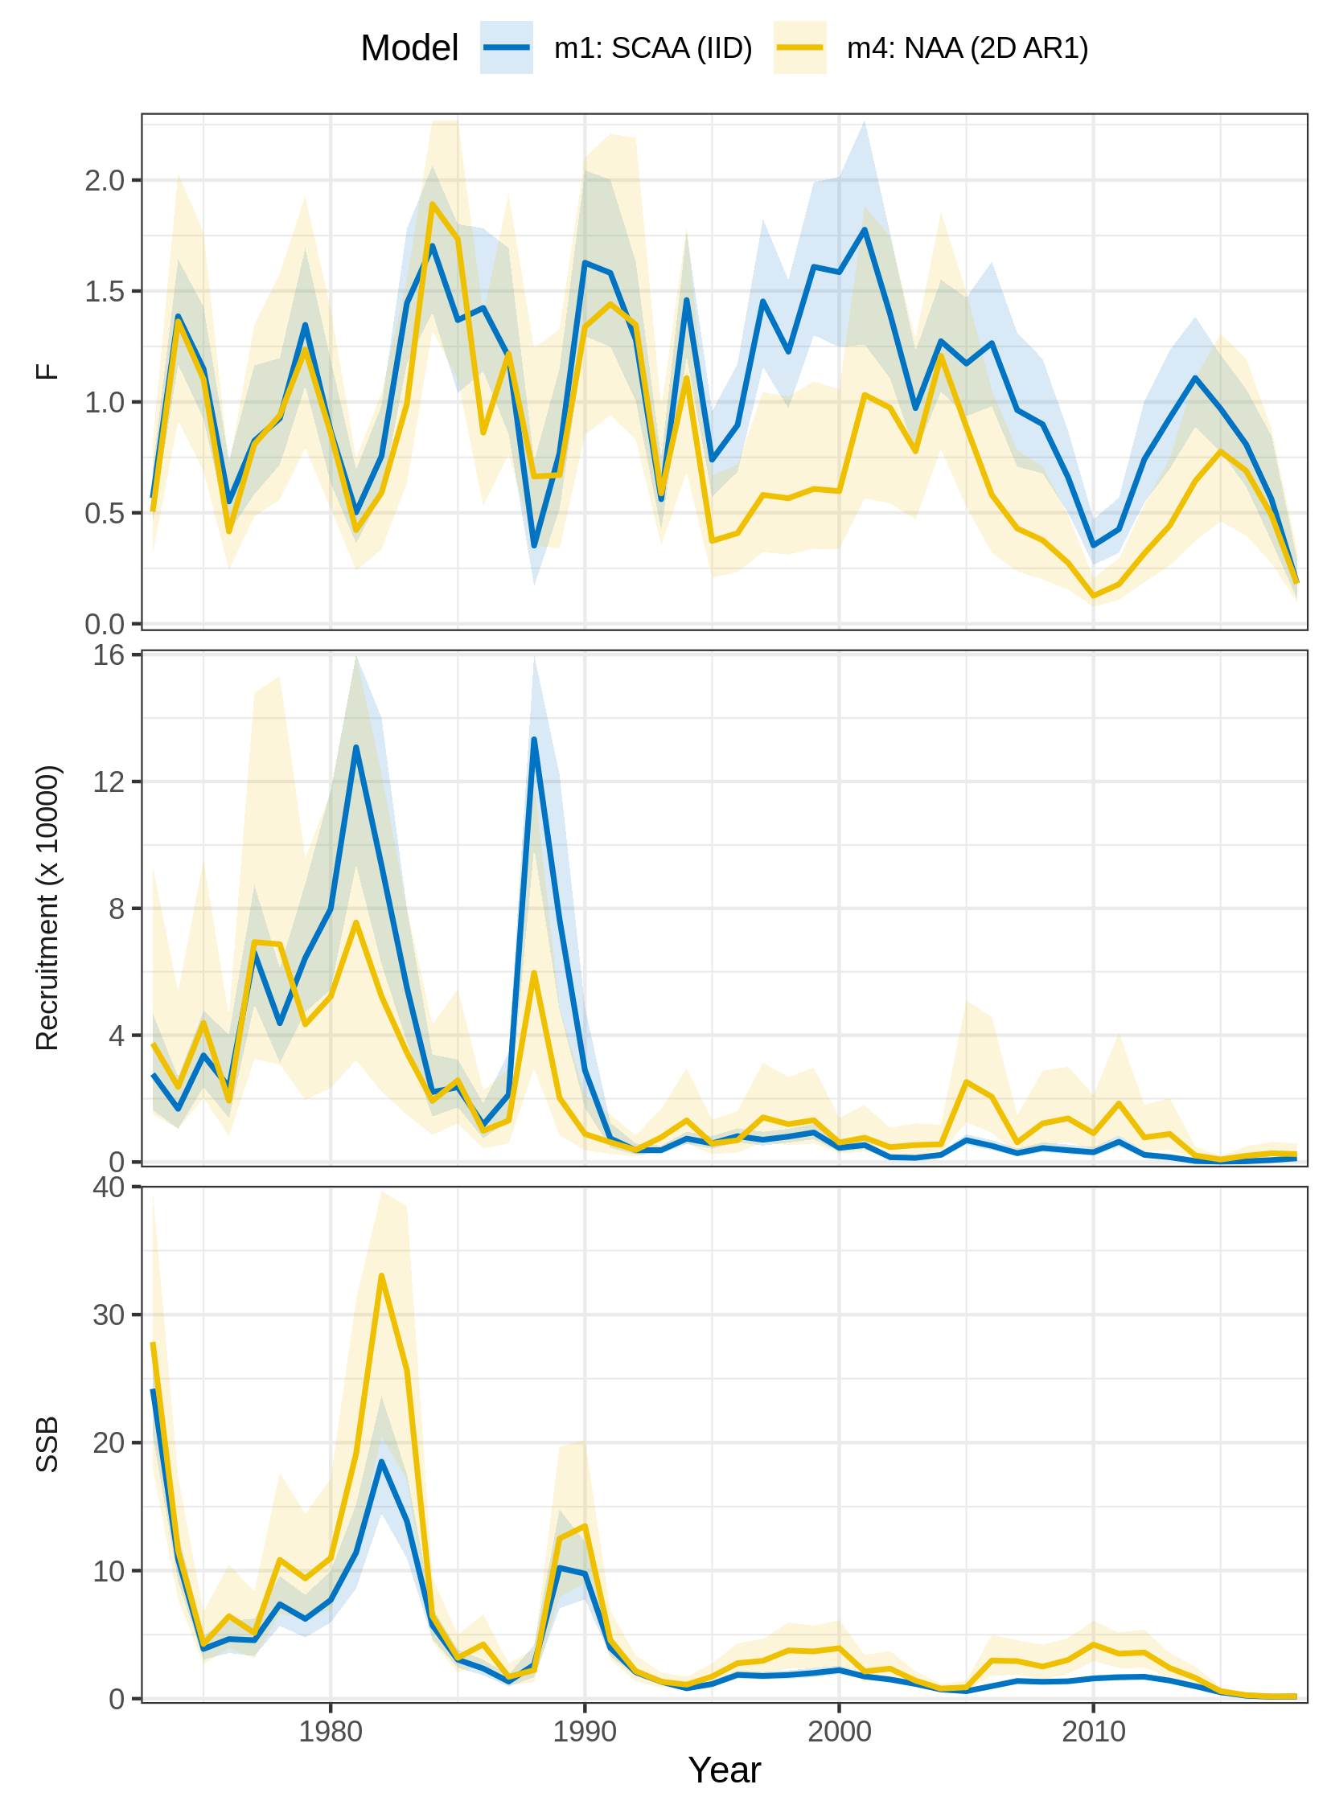
Figure S1. Trends in F, recruitment, and SSB estimated for SNEMA yellowtail flounder using two models of numbers-at-age (NAA) random effects. m1 = only recruitment deviations are random effects (most similar to traditional statistical catch-at-age, SCAA), and deviations are independent and identically distributed (IID). m4 = all NAA deviations are random effects correlated by age and year (2D AR1). Model m4 had the lowest AIC (Fig. 1 in main text).
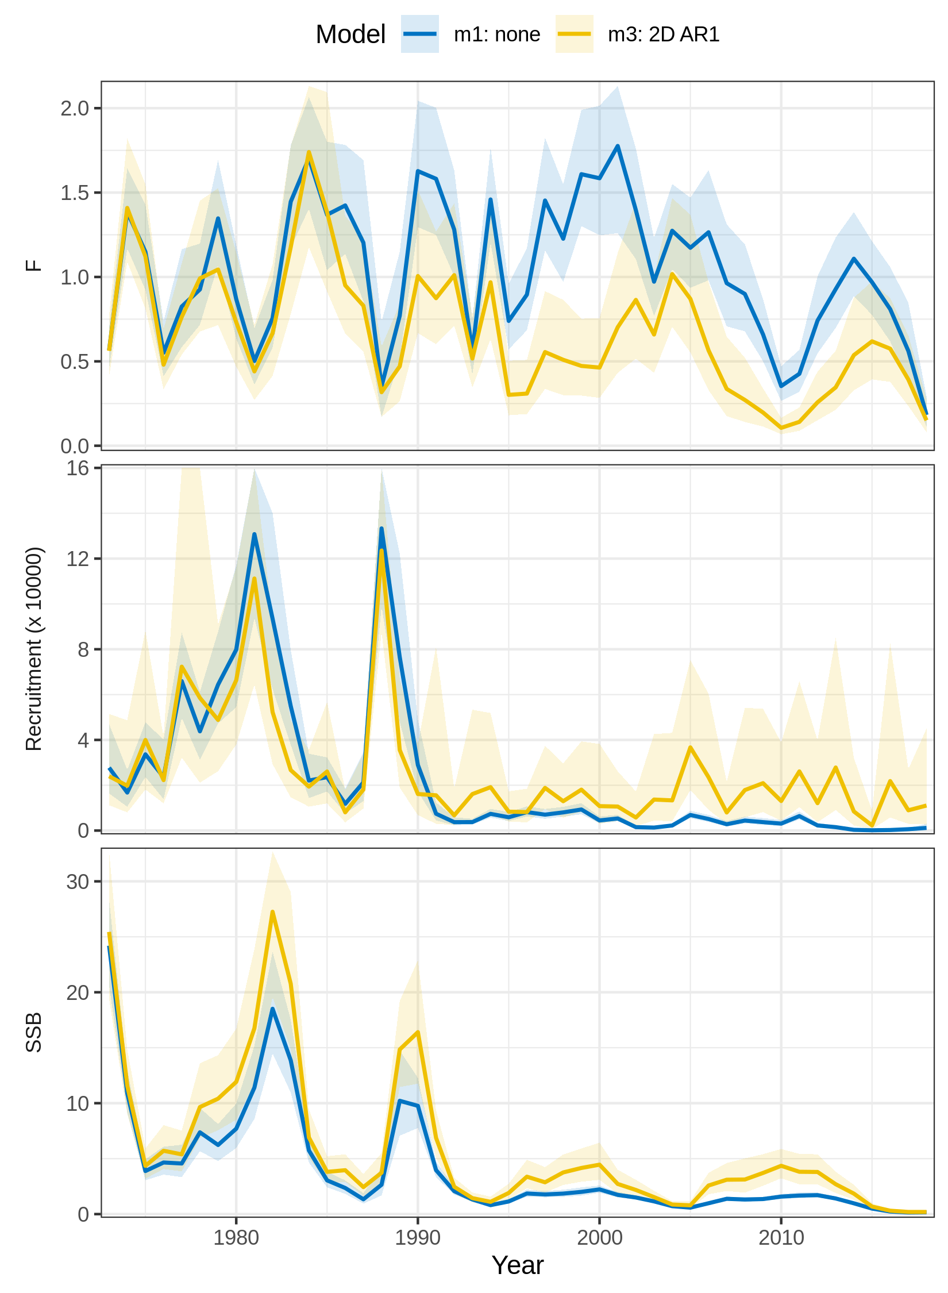
Figure S2. Trends in F, recruitment, and SSB estimated for SNEMA yellowtail flounder using two models of natural mortality (M) random effects. m1 = no random effects on M. m3 = M deviations are random effects correlated by age and year (2D AR1). Model m3 had the lowest AIC (Fig. 1 in main text).
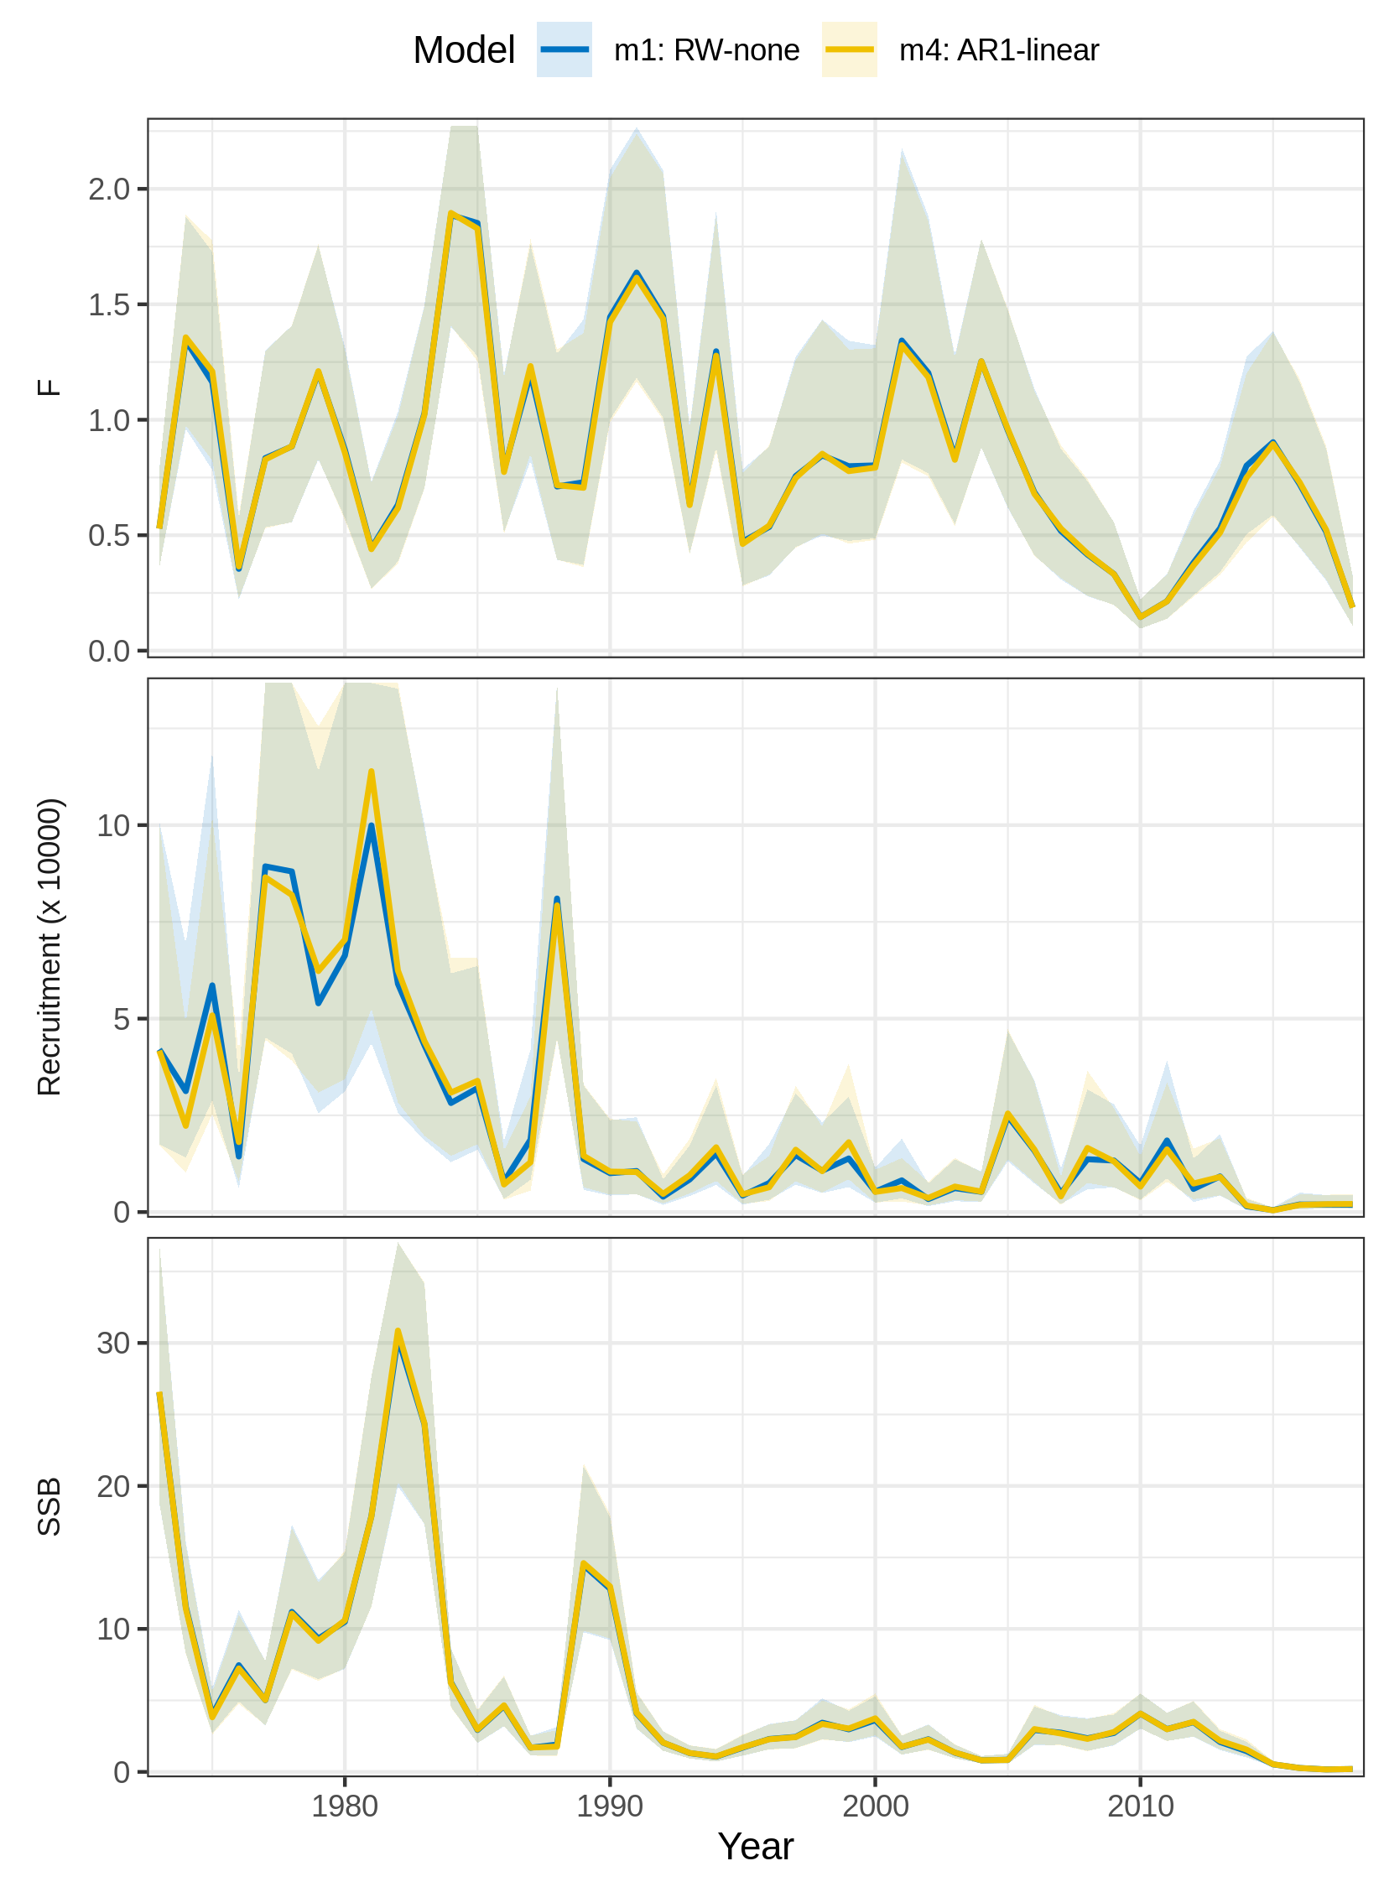
Figure S3. Trends in F, recruitment, and SSB estimated for SNEMA yellowtail flounder using models with and without effects of the Cold Pool Index (CPI) on recruitment. m1 = no CPI effect. m4 = CPI modeled as AR1 process with linear effect on the Beverton-Holt β parameter. Model m4 had the lowest AIC (Fig. 1 in main text).
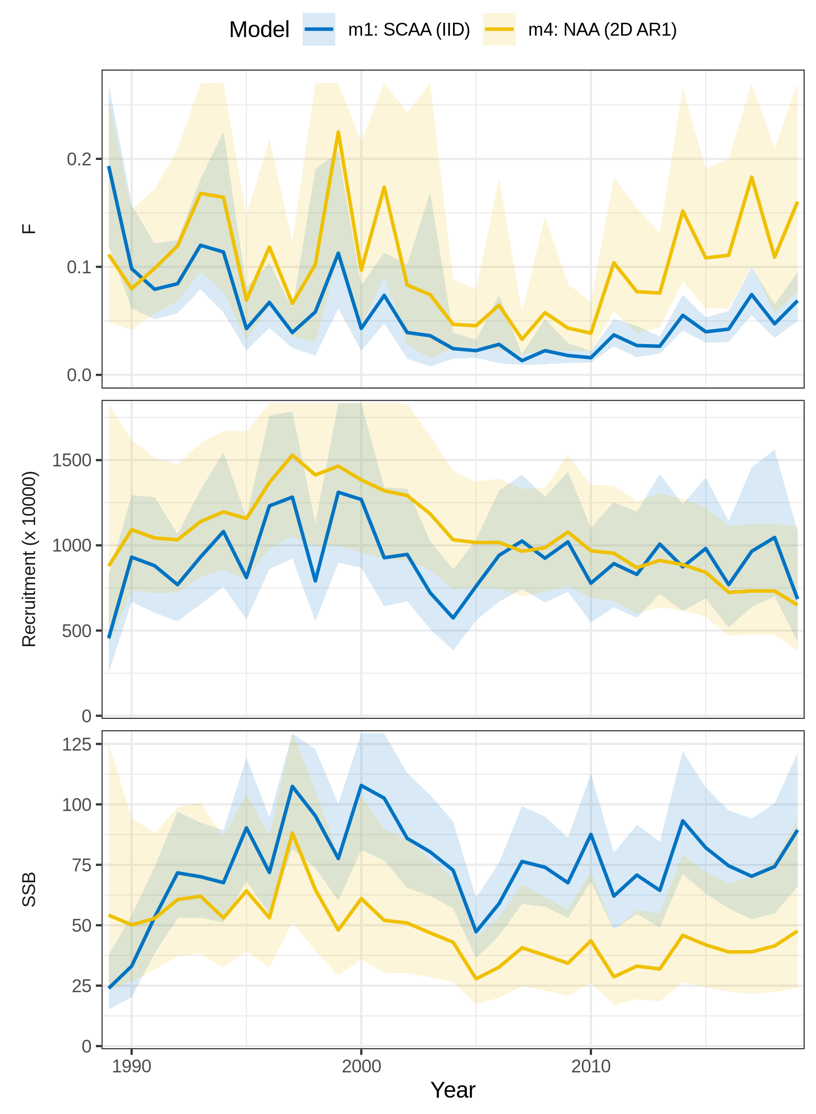
Figure S4. Trends in F, recruitment, and SSB estimated for butterfish using two models of numbers-at-age (NAA) random effects. m1 = only recruitment deviations are random effects (most similar to traditional statistical catch-at-age, SCAA), and deviations are independent and identically distributed (IID). m4 = all NAA deviations are random effects correlated by age and year (2D AR1). Model m4 had the lowest AIC (Fig. 1 in main text).
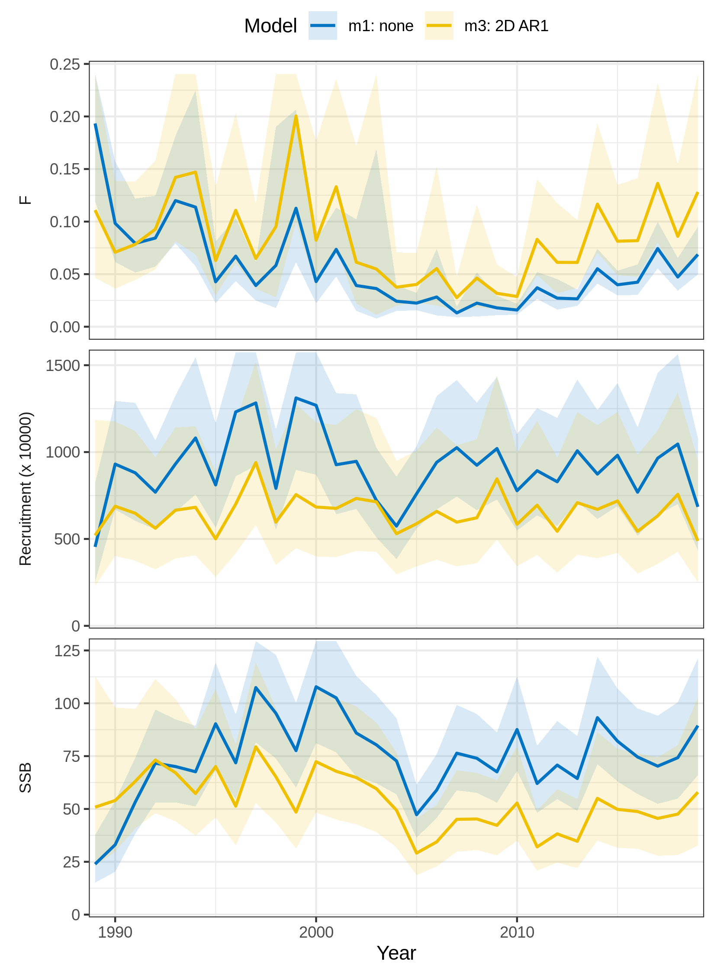
Figure S5. Trends in F, recruitment, and SSB estimated for butterfish using two models of natural mortality (M) random effects. m1 = no random effects on M. m3 = M deviations are random effects correlated by age and year (2D AR1). Model m3 had the lowest AIC (Fig. 1 in main text).
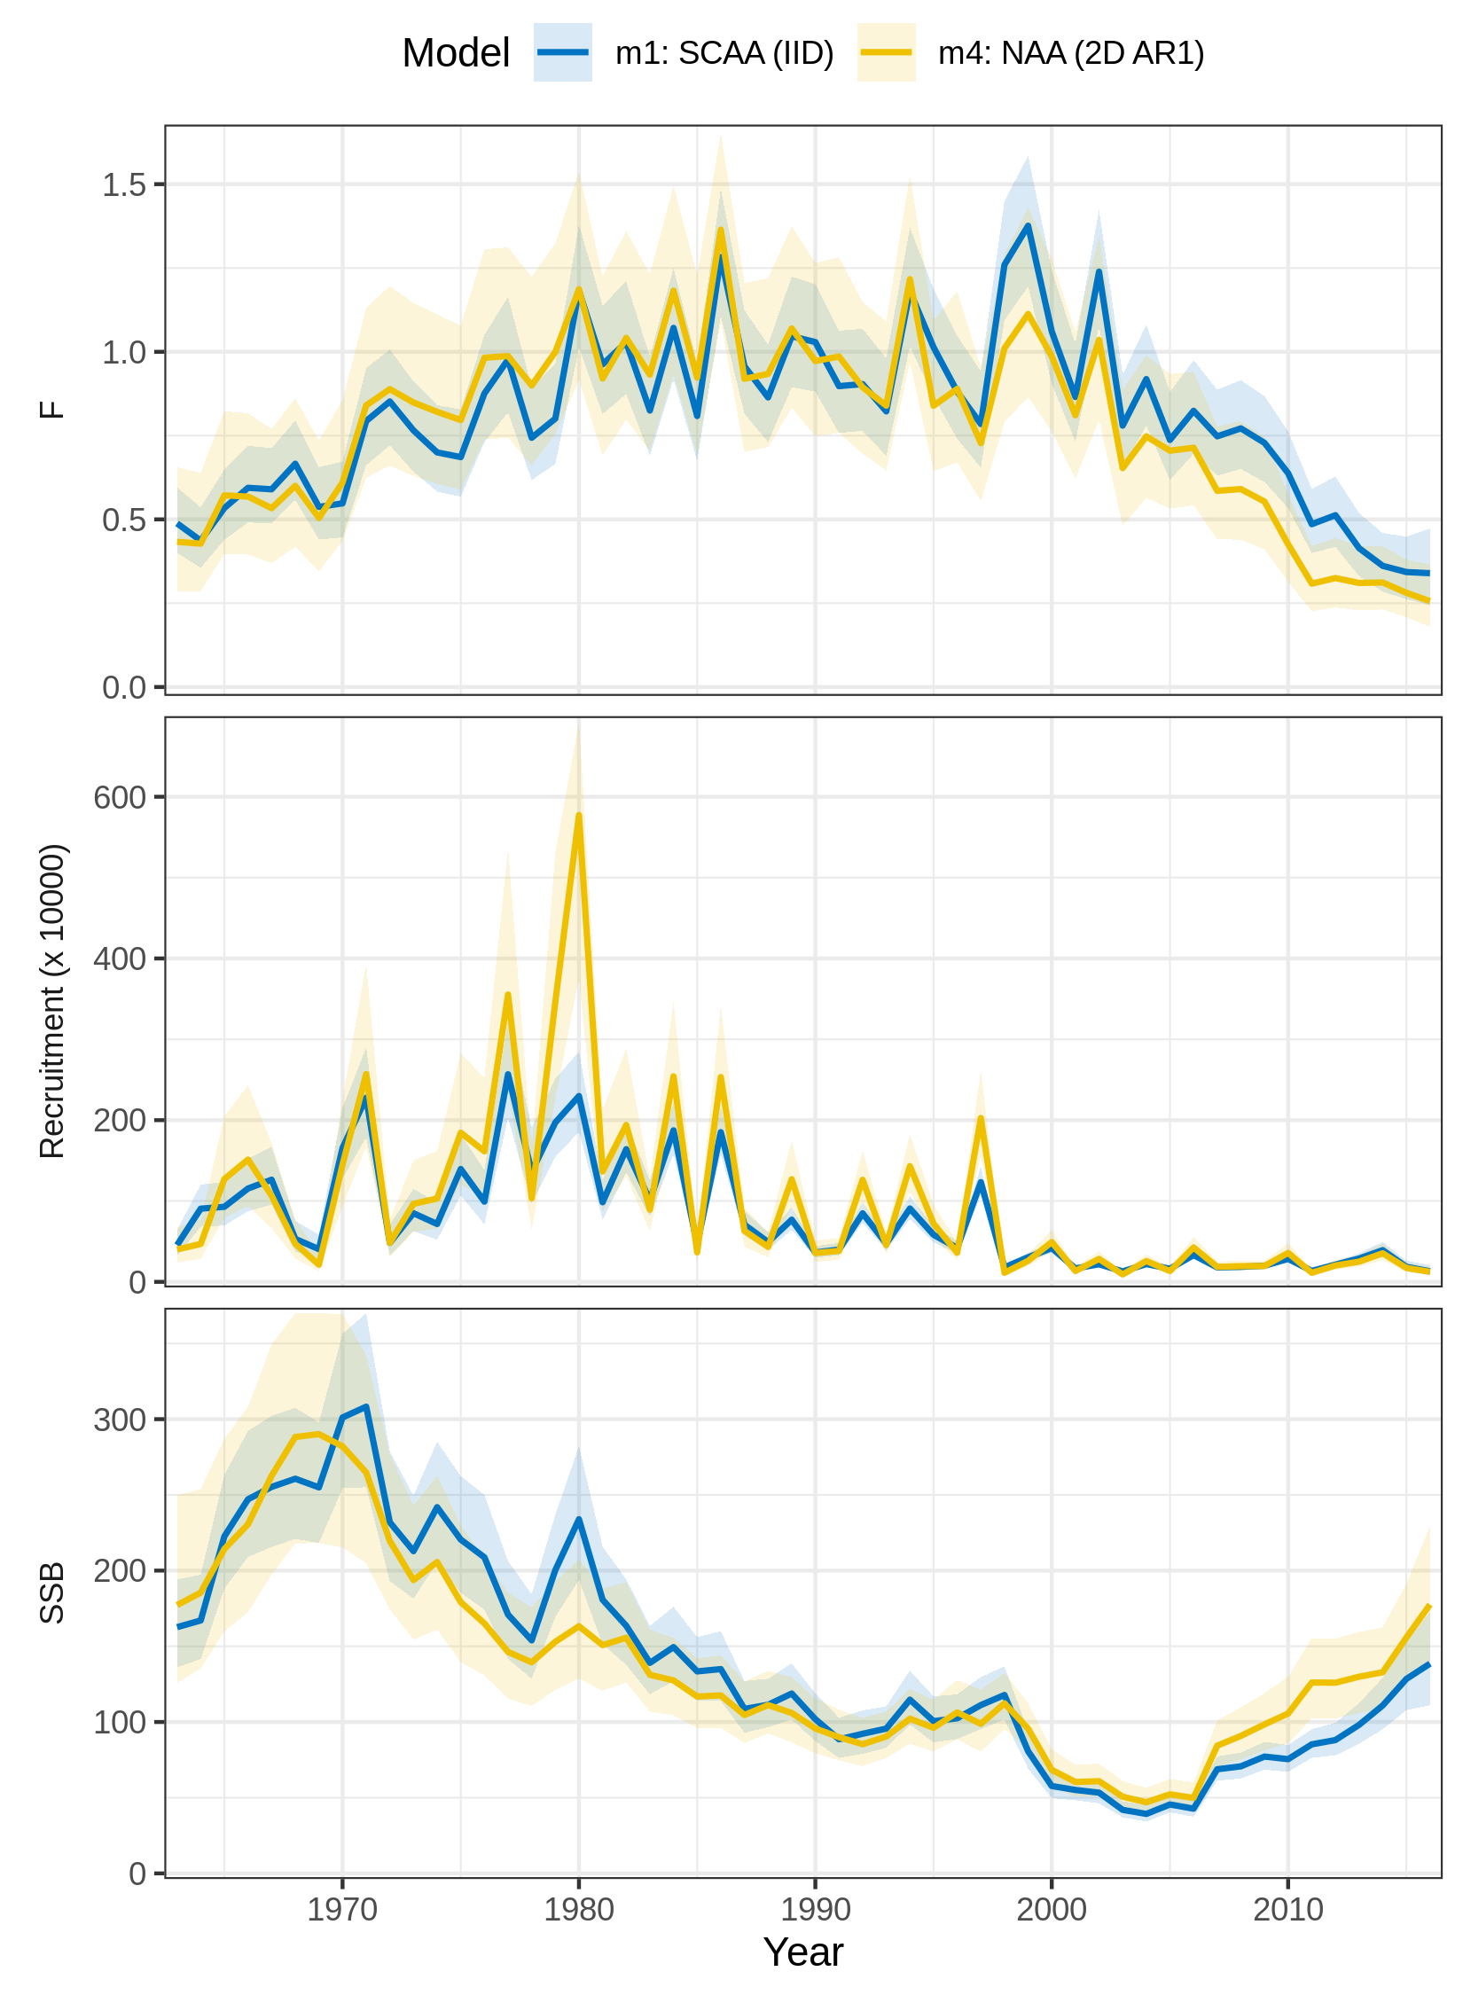
Figure S6. Trends in F, recruitment, and SSB estimated for North Sea cod using two models of numbers-at-age (NAA) random effects. m1 = only recruitment deviations are random effects (most similar to traditional statistical catch-at-age, SCAA), and deviations are independent and identically distributed (IID). m4 = all NAA deviations are random effects correlated by age and year (2D AR1). Model m4 had the lowest AIC (Fig. 1 in main text).
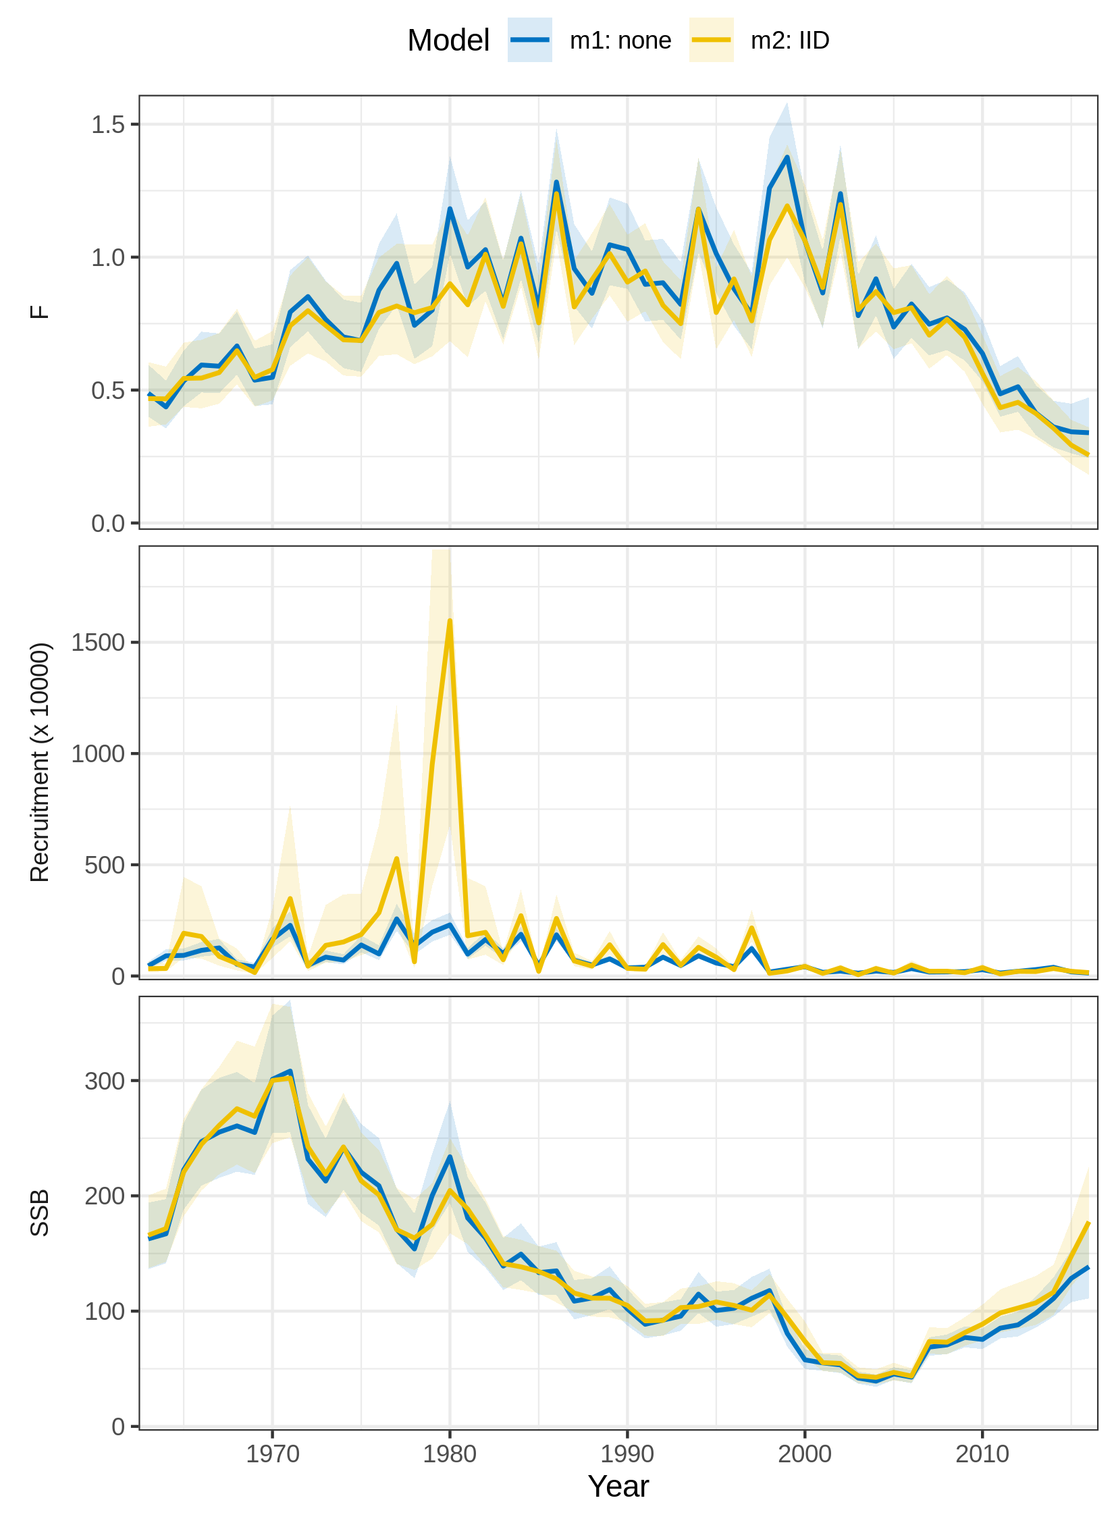
Figure S7. Trends in F, recruitment, and SSB estimated for North Sea cod using two models of natural mortality (M) random effects. m1 = no random effects on M. m2 = M deviations are independent random effects (IID). Model m2 had the lowest AIC (Fig. 1 in main text).
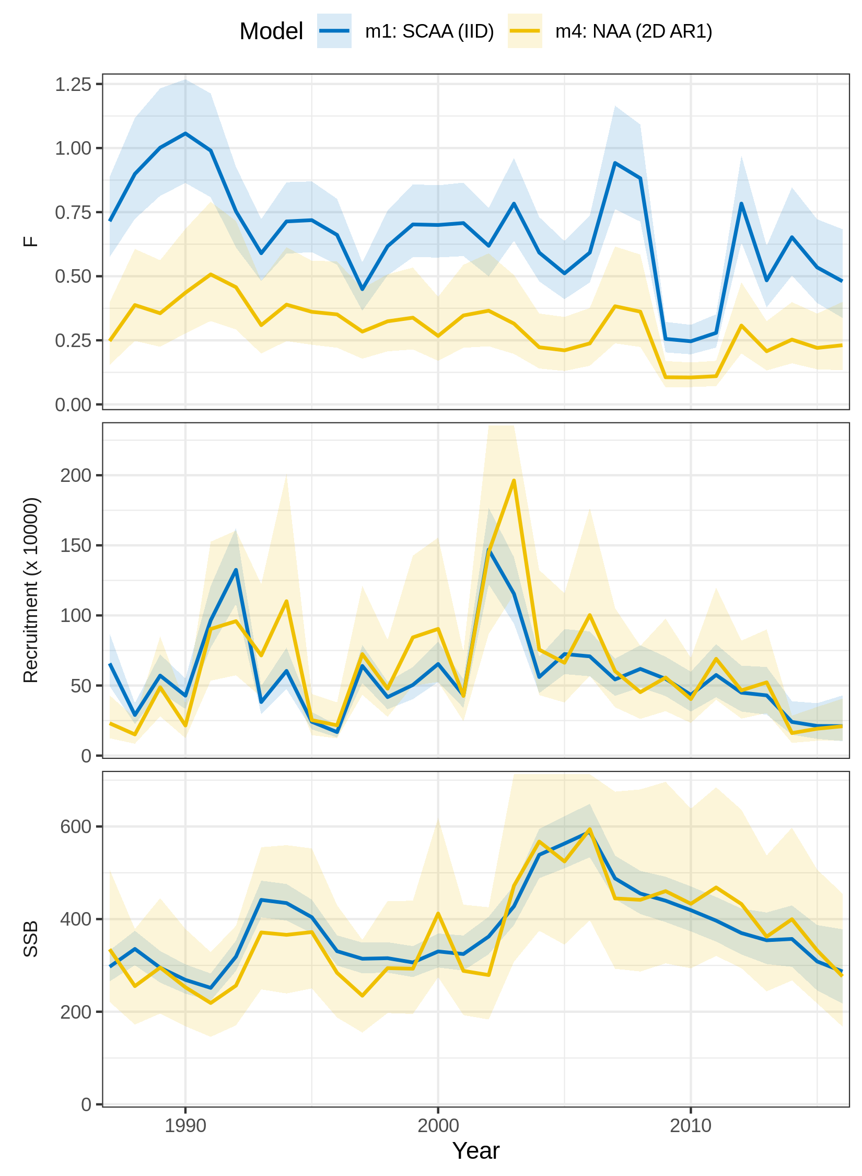
Figure S8. Trends in F, recruitment, and SSB estimated for Icelandic herring using two models of numbers-at-age (NAA) random effects. m1 = only recruitment deviations are random effects (most similar to traditional statistical catch-at-age, SCAA), and deviations are independent and identically distributed (IID). m4 = all NAA deviations are random effects correlated by age and year (2D AR1). Model m4 had the lowest AIC (Fig. 1 in main text).
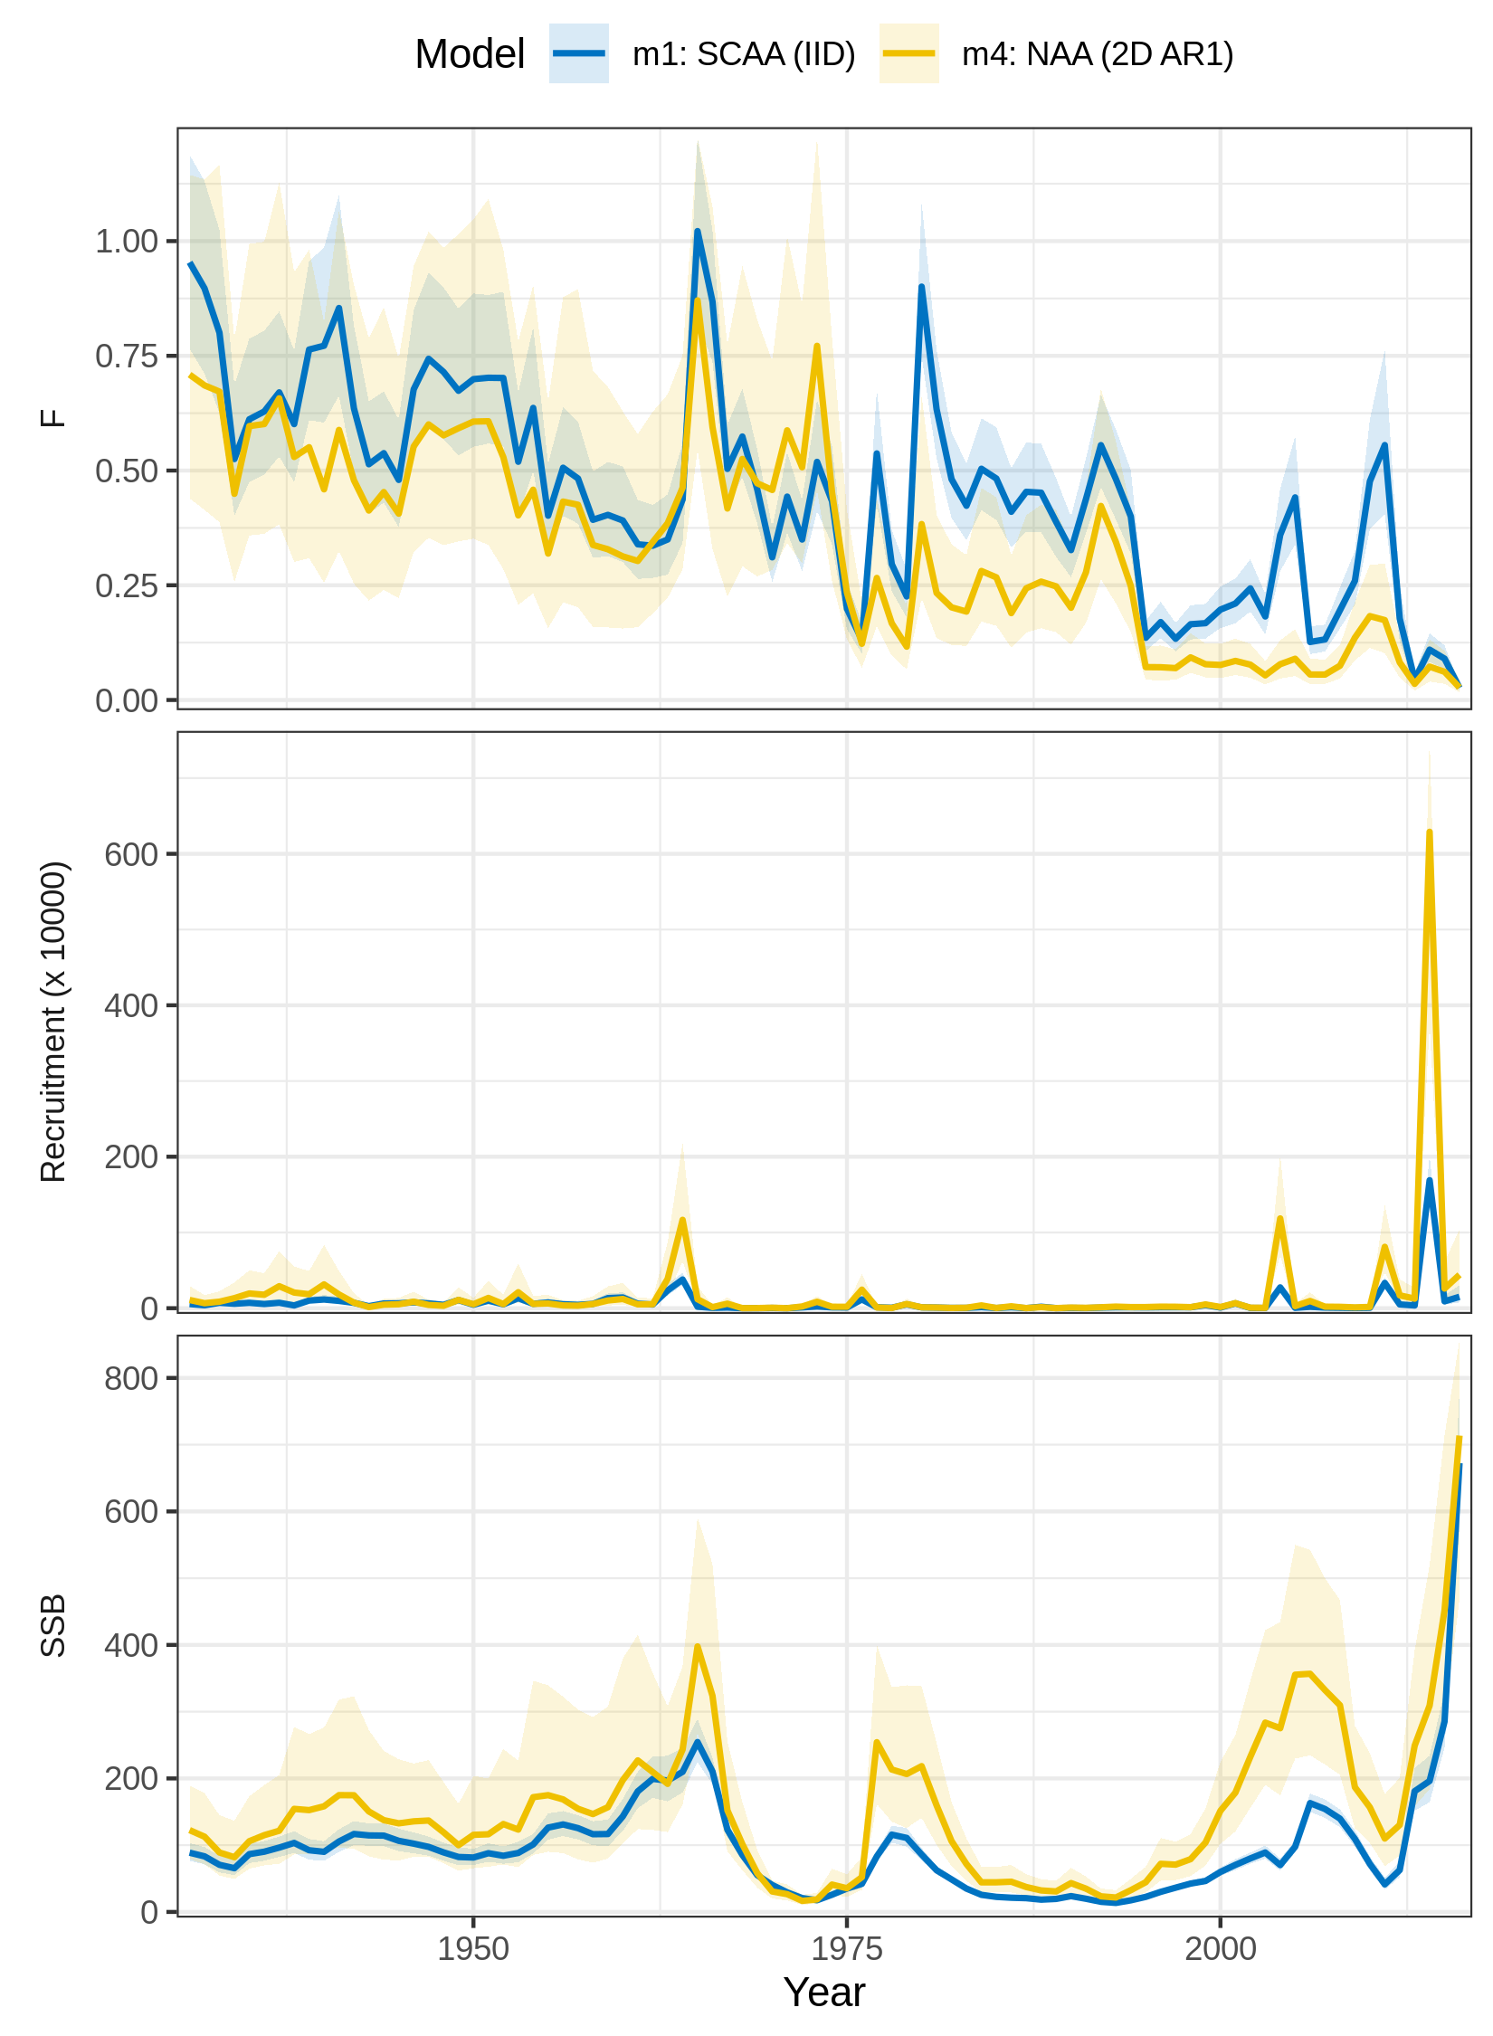
Figure S9. Trends in F, recruitment, and SSB estimated for Georges Bank haddock using two models of numbers-at-age (NAA) random effects. m1 = only recruitment deviations are random effects (most similar to traditional statistical catch-at-age, SCAA), and deviations are independent and identically distributed (IID). m4 = all NAA deviations are random effects correlated by age and year (2D AR1). Model m4 had the lowest AIC (Fig. 1 in main text).
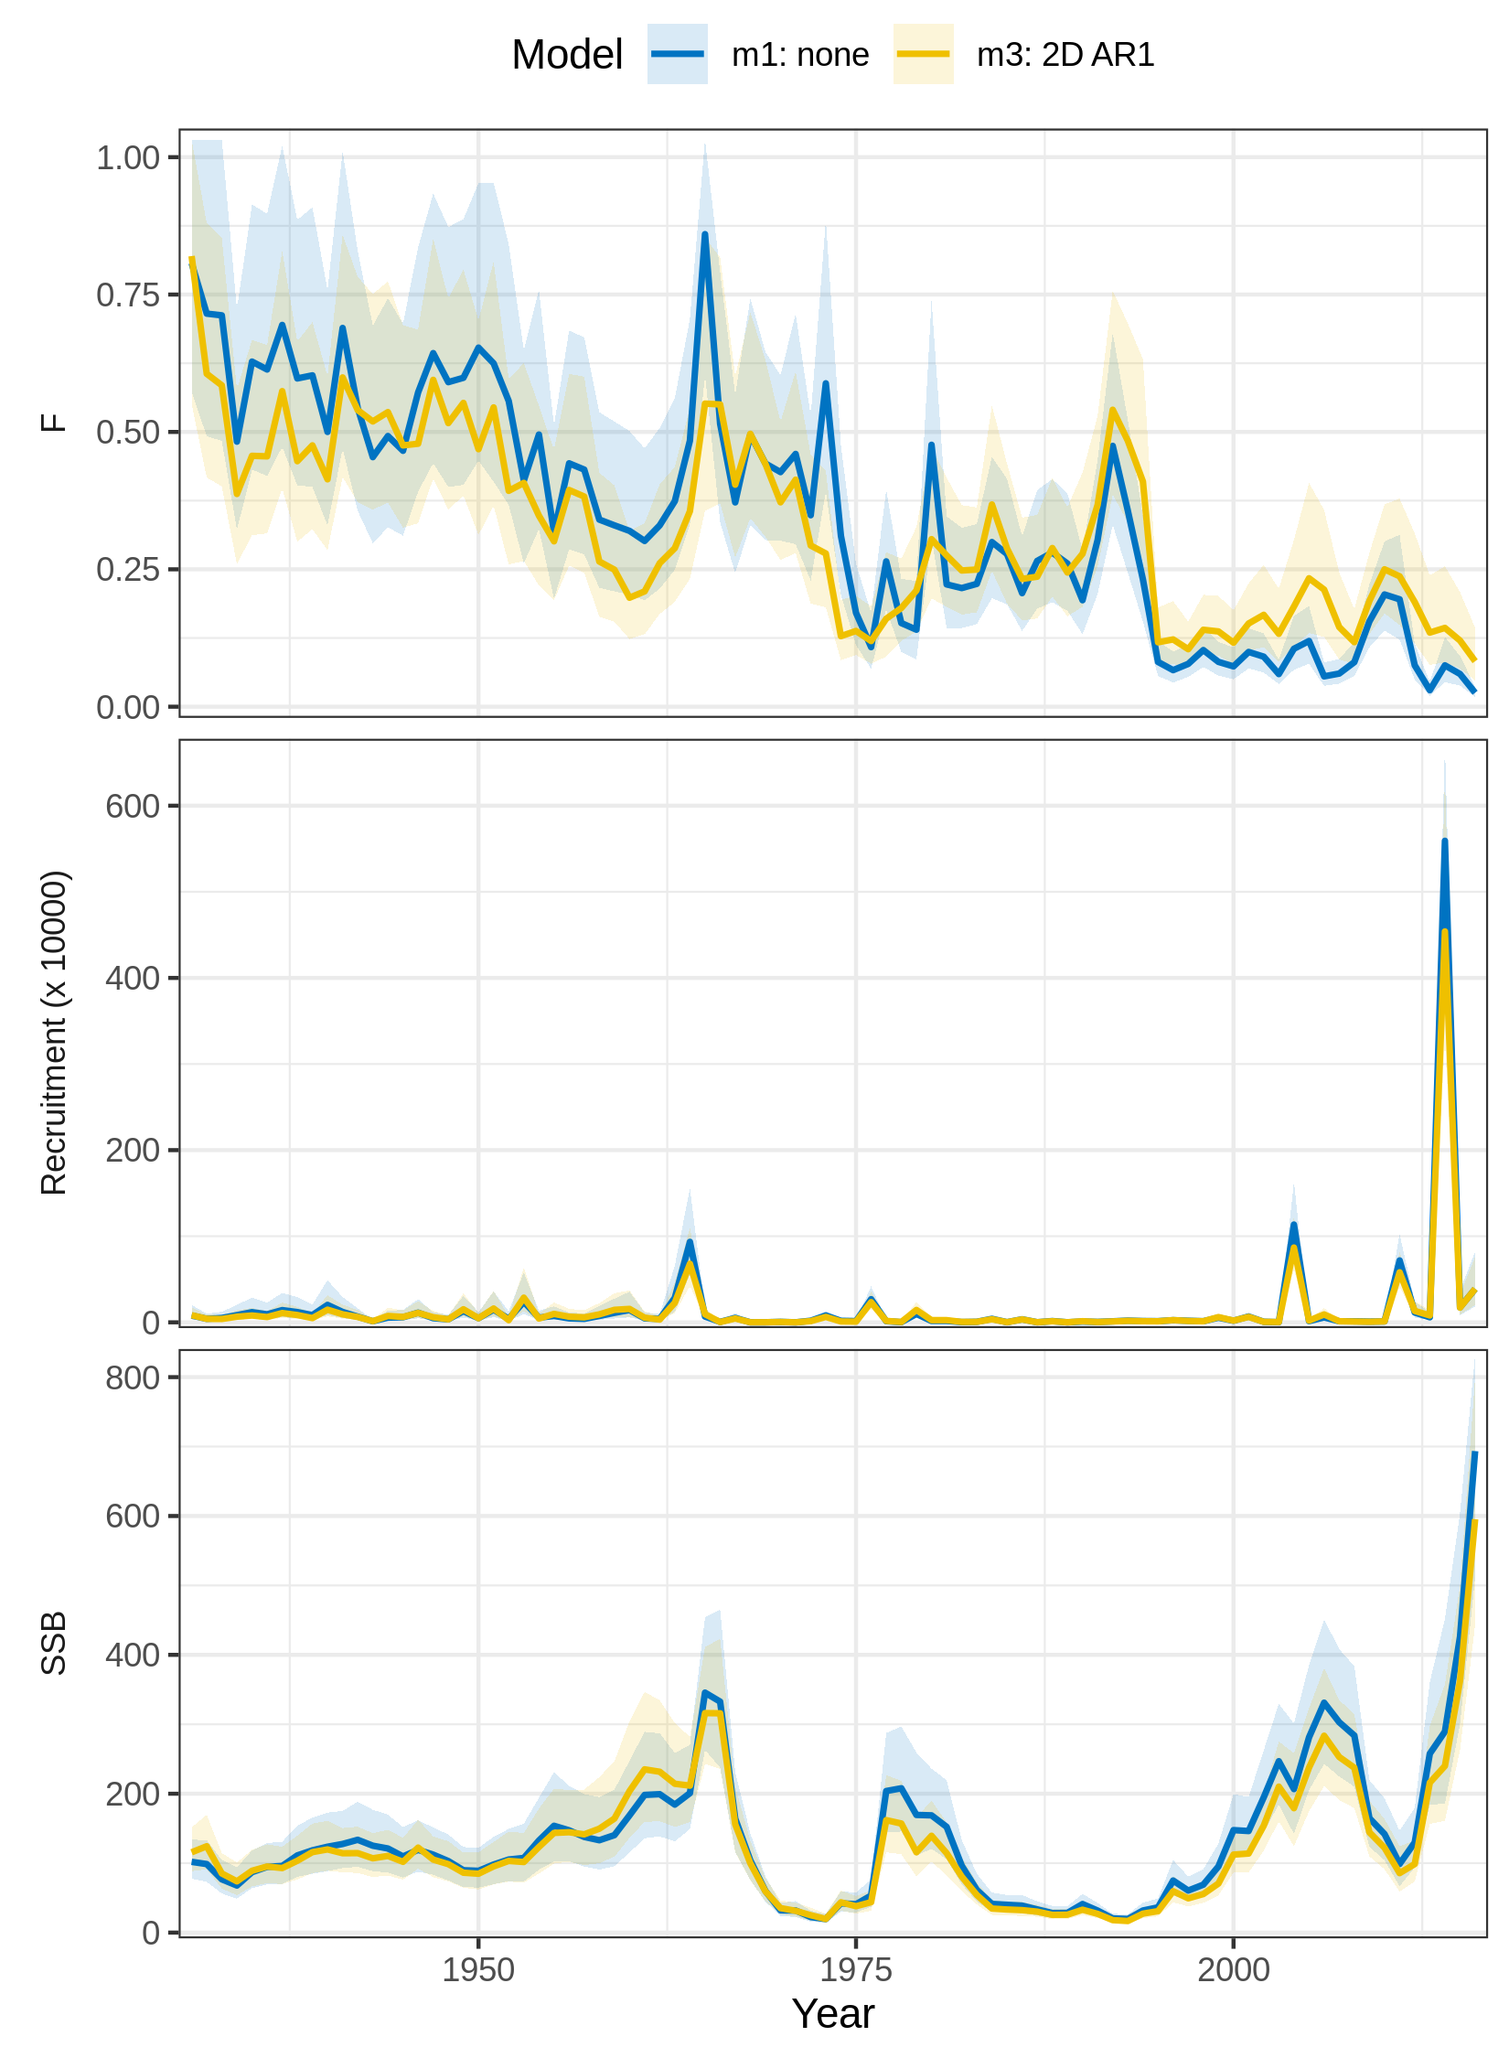
Figure S10. Trends in F, recruitment, and SSB estimated for Georges Bank haddock using two models of selectivity random effects. m1 = time-constant selectivity. m3 = random effect deviations in the logistic selectivity parameters correlated by parameter and year (2D AR1). Model m3 had the lowest AIC (Fig. 1 in main text).
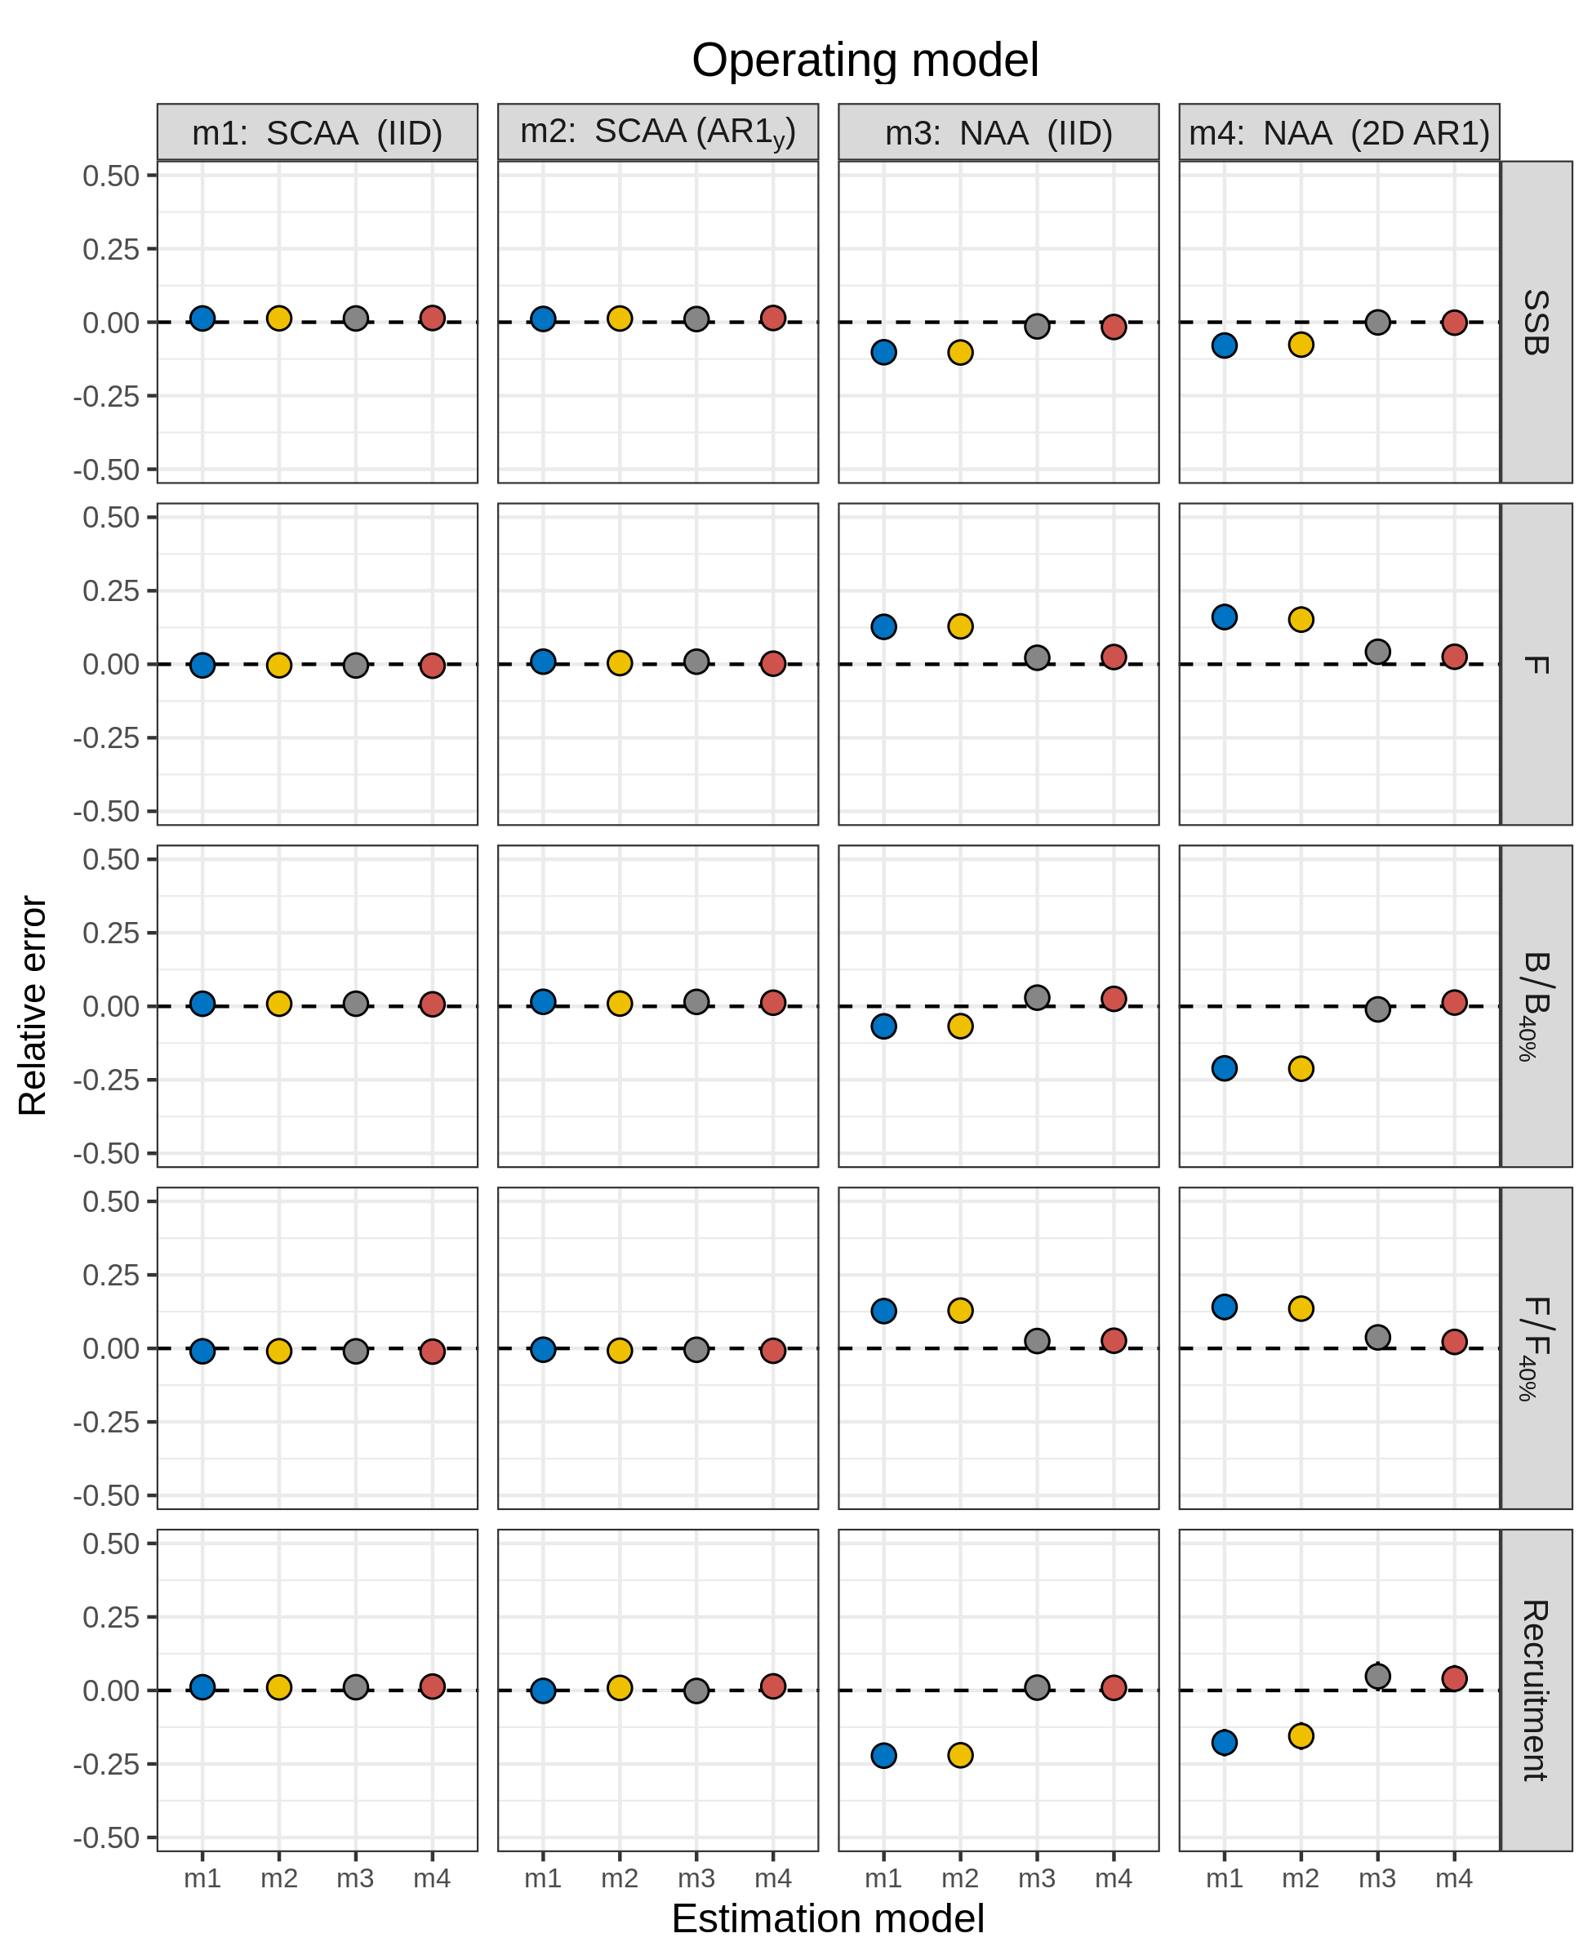
Figure S11. Relative error of key quantities estimated for SNEMA yellowtail flounder using four models of numbers-at-age (NAA) random effects. m1 = only recruitment deviations are random effects (most similar to traditional statistical catch-at-age, SCAA), and deviations are independent and identically distributed (IID). m2 = as m1, but with autocorrelated recruitment deviations (AR1). m3 = all NAA deviations are IID random effects. m4 = as m3, but deviations are correlated by age and year (2D AR1).
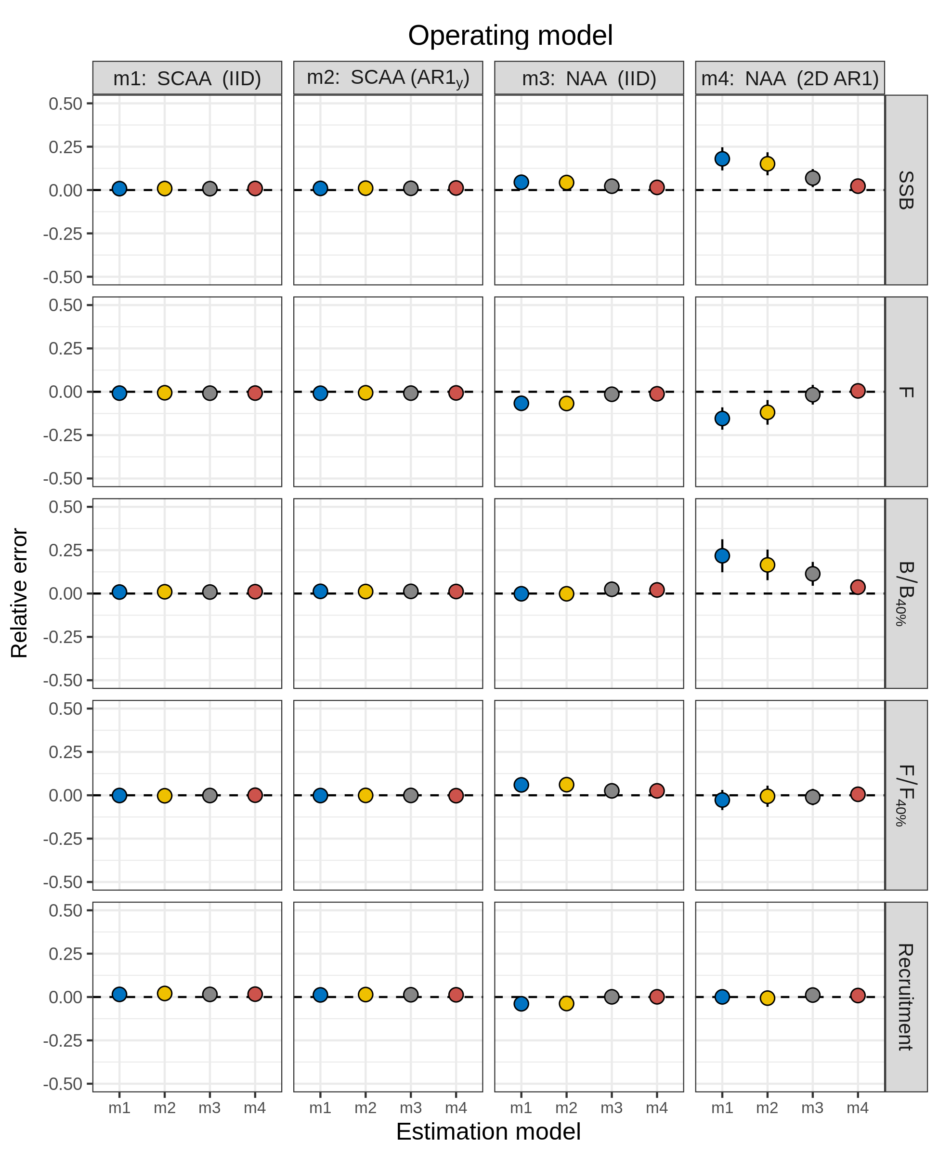
Figure S12. Relative error of key quantities estimated for butterfish using four models of numbers-at-age (NAA) random effects. m1 = only recruitment deviations are random effects (most similar to traditional statistical catch-at-age, SCAA), and deviations are independent and identically distributed (IID). m2 = as m1, but with autocorrelated recruitment deviations (AR1). m3 = all NAA deviations are IID random effects. m4 = as m3, but deviations are correlated by age and year (2D AR1).
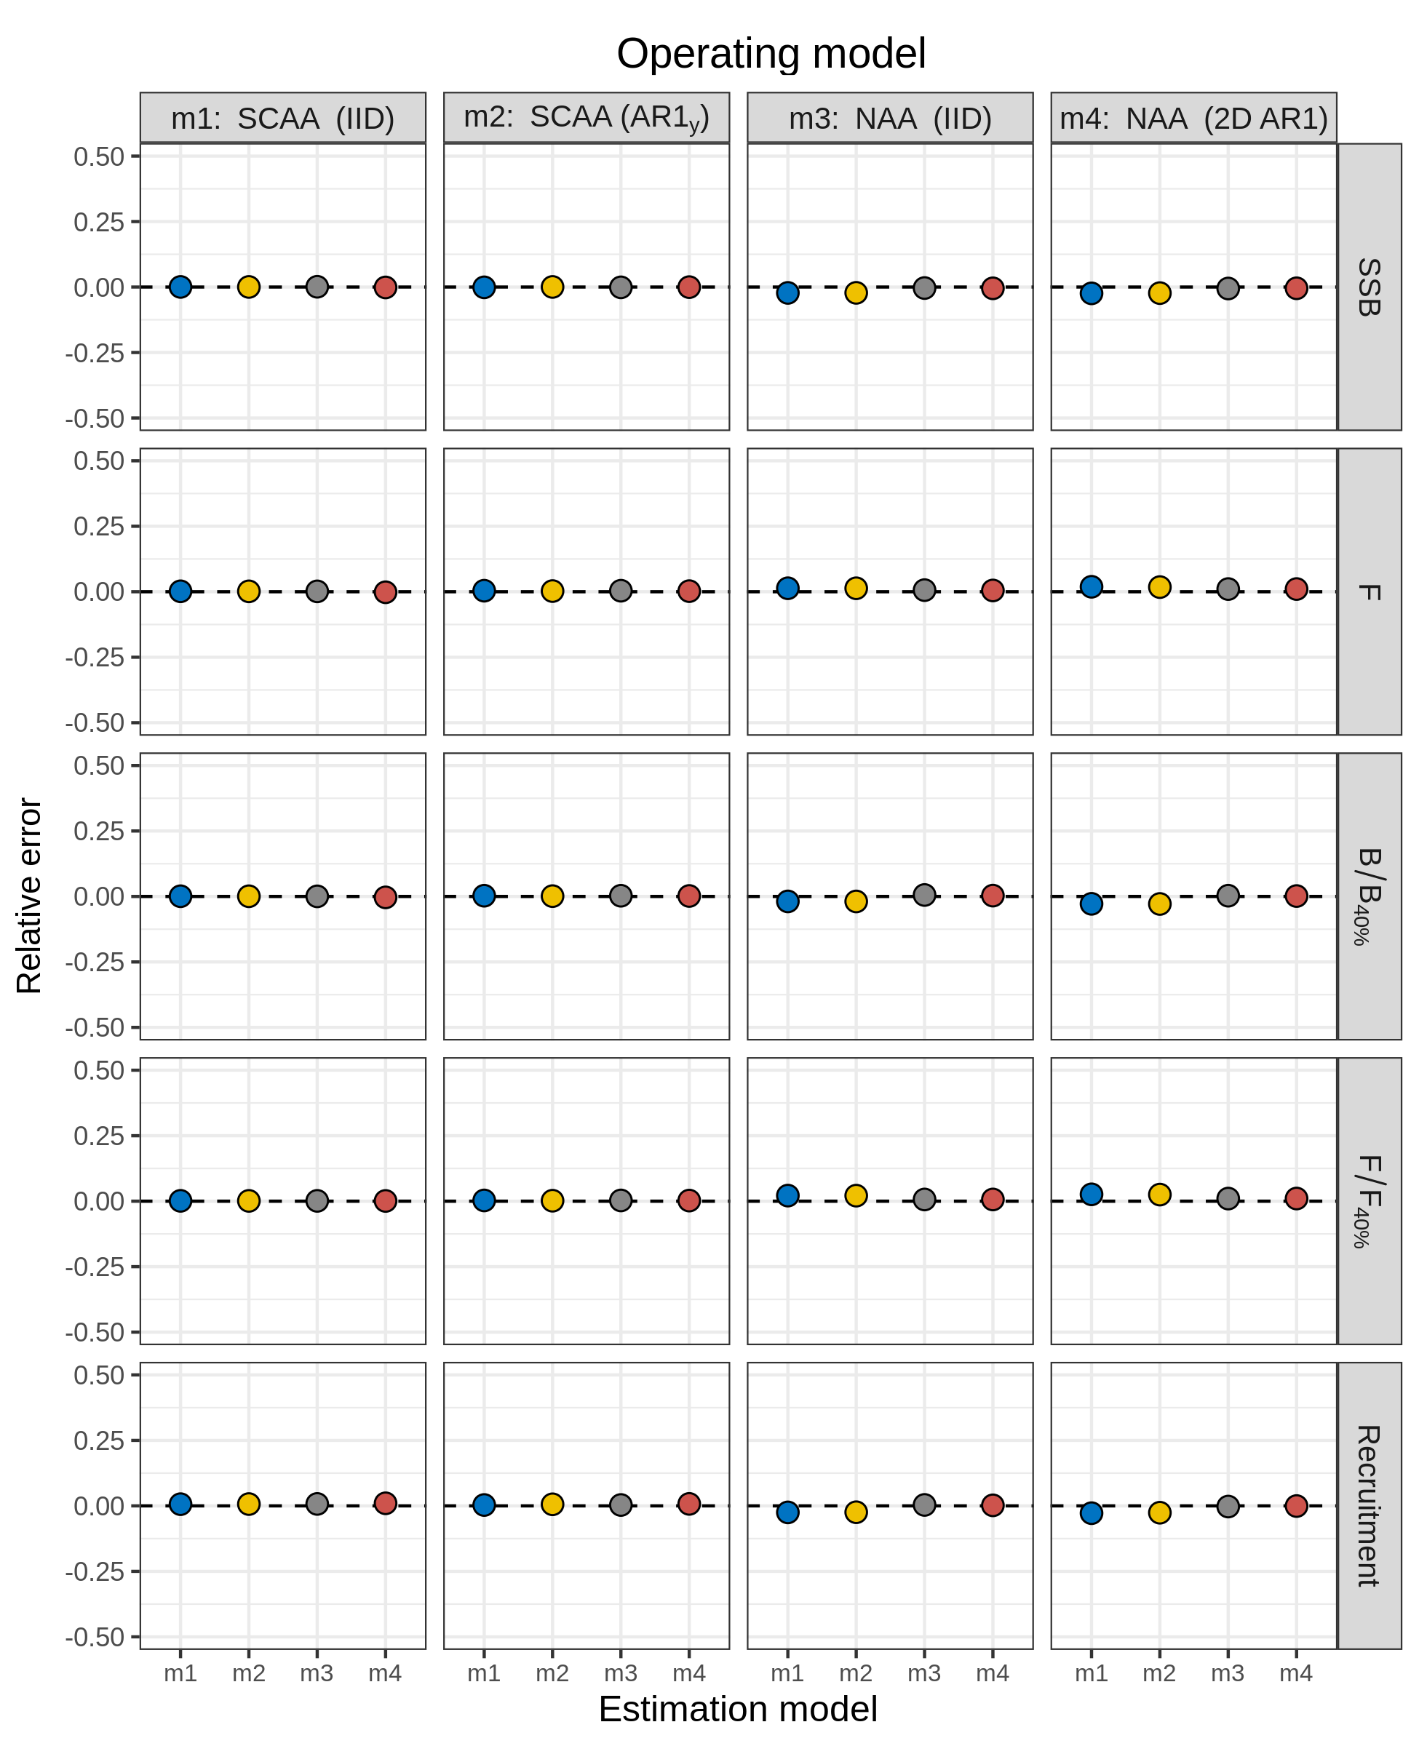
Figure S13. Relative error of key quantities estimated for North Sea cod using four models of numbers-at-age (NAA) random effects. m1 = only recruitment deviations are random effects (most similar to traditional statistical catch-at-age, SCAA), and deviations are independent and identically distributed (IID). m2 = as m1, but with autocorrelated recruitment deviations (AR1). m3 = all NAA deviations are IID random effects. m4 = as m3, but deviations are correlated by age and year (2D AR1).
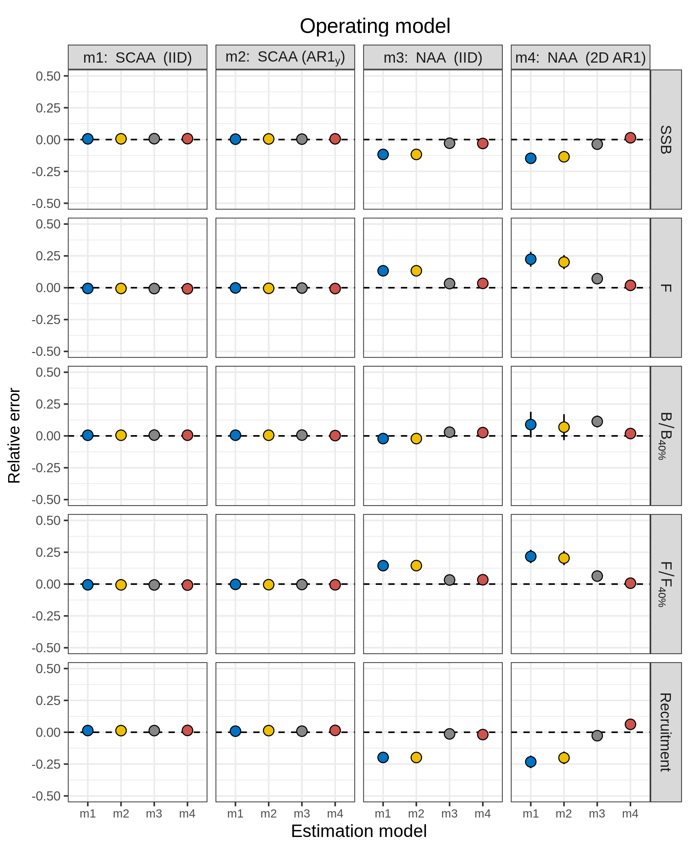
Figure S14. Relative error of key quantities estimated for Georges Bank haddock using four models of numbers-at-age (NAA) random effects. m1 = only recruitment deviations are random effects (most similar to traditional statistical catch-at-age, SCAA), and deviations are independent and identically distributed (IID). m2 = as m1, but with autocorrelated recruitment deviations (AR1). m3 = all NAA deviations are IID random effects. m4 = as m3, but deviations are correlated by age and year (2D AR1).
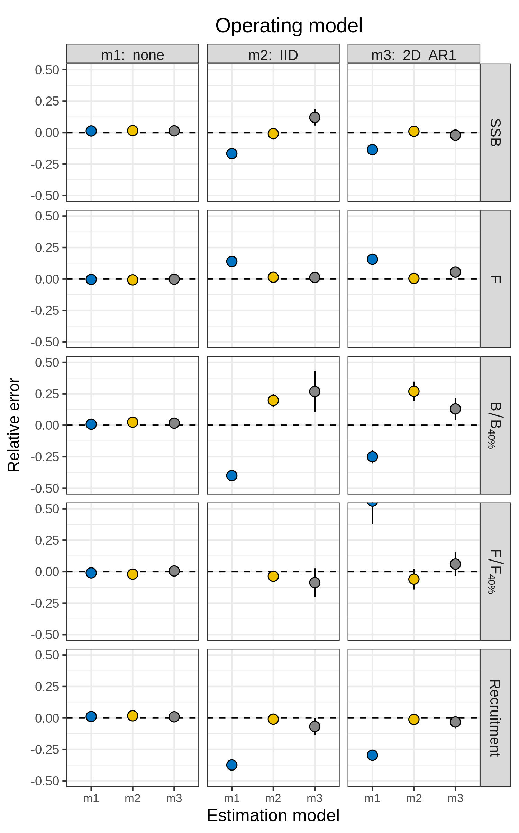
Figure S15. Relative error of key quantities estimated for SNEMA yellowtail flounder using three models of natural mortality (M) random effects. m1 = no random effects on M. m2 = M deviations are independent and identically distributed (IID). m3 = M deviations are correlated by age and year (2D AR1).
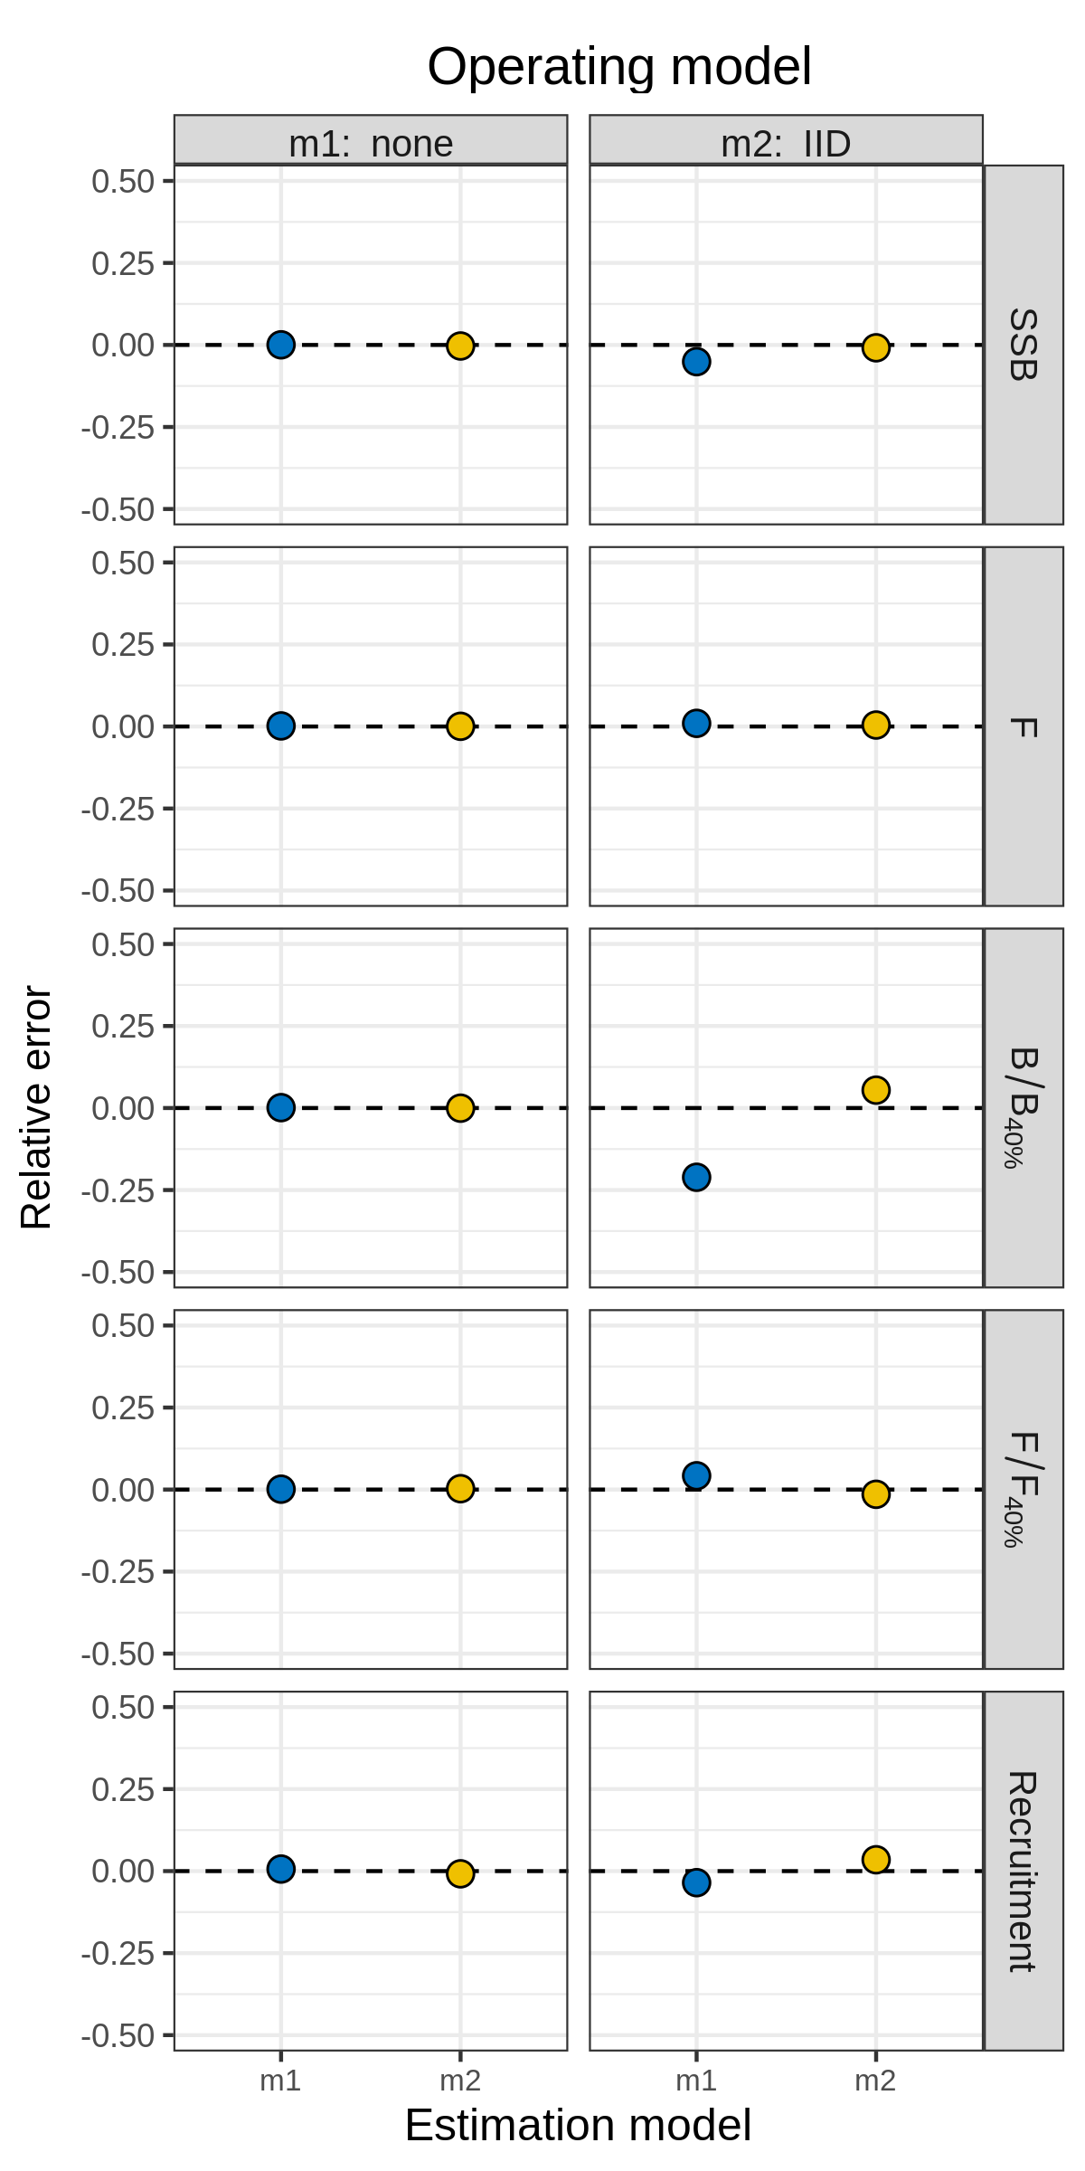
Figure S16. Relative error of key quantities estimated for North Sea cod using two models of natural mortality (M) random effects. m1 = no random effects on M. m2 = M deviations are independent and identically distributed (IID). The model with M deviations correlated by age and year (m3, 2D AR1) did not converge.
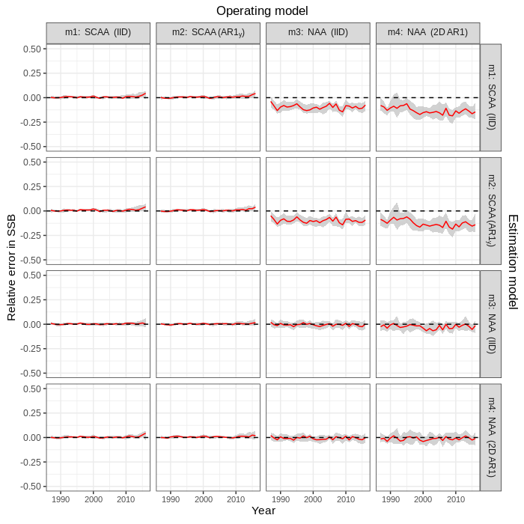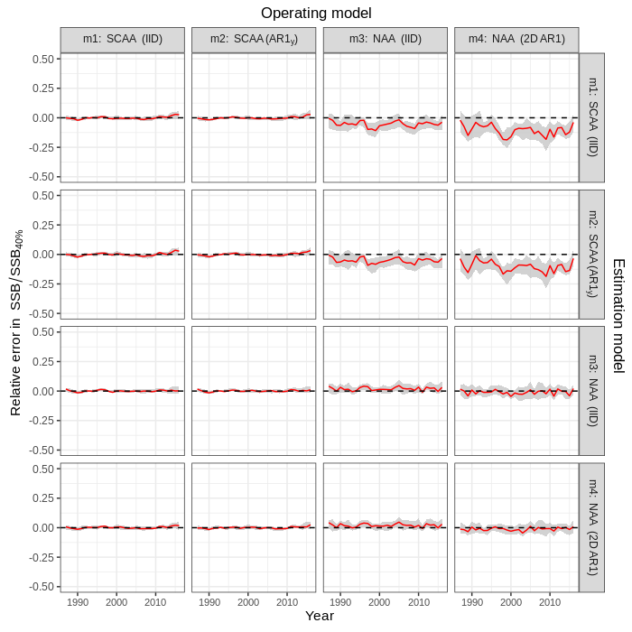
Figure S17. Relative error in SSB (left) and SSB / SSB_{40%} (right) in simulation cross-tests for the four numbers at age (NAA) models fit to Icelandic herring data. Relative error was calculated as , where was the estimate in simulation i for parameter θ, and was the true value (estimate from original dataset). Solid red lines and grey shading show the median relative error with 95% CI, calculated within year and across simulations.
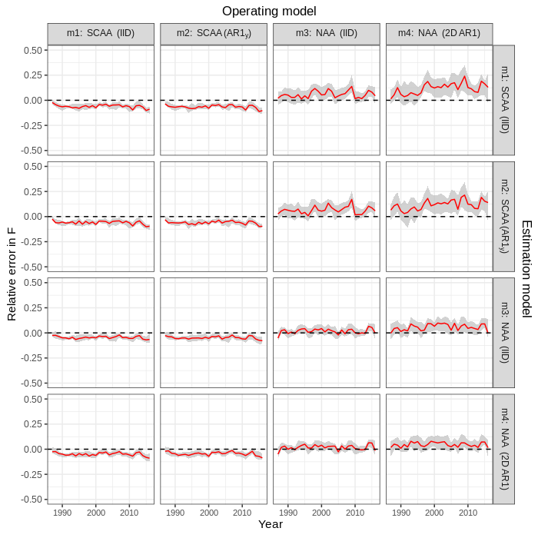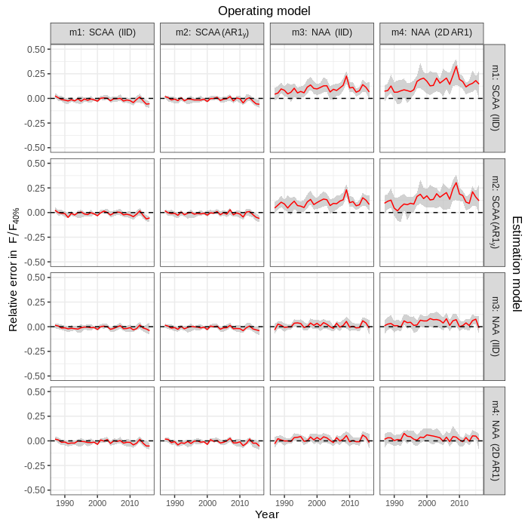
Figure S18. Relative error in F (left) and F / F_{40%} (right) in simulation cross-tests for the four numbers at age (NAA) models fit to Icelandic herring data. Relative error was calculated as , where was the estimate in simulation i for parameter θ, and was the true value (estimate from original dataset). Solid red lines and grey shading show the median relative error with 95% CI, calculated within year and across simulations.
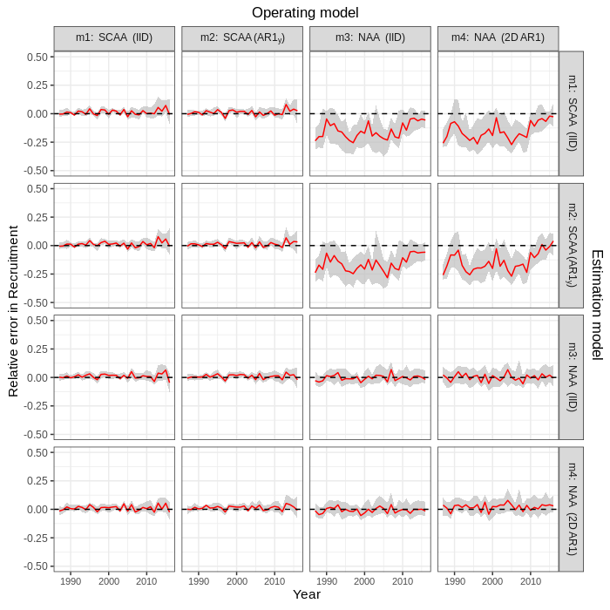
Figure S19. Relative error in recruitment in simulation cross-tests for the four numbers at age (NAA) models fit to Icelandic herring data. Relative error was calculated as , where was the estimate in simulation i for parameter θ, and was the true value (estimate from original dataset). Solid red lines and grey shading show the median relative error with 95% CI, calculated within year and across simulations.
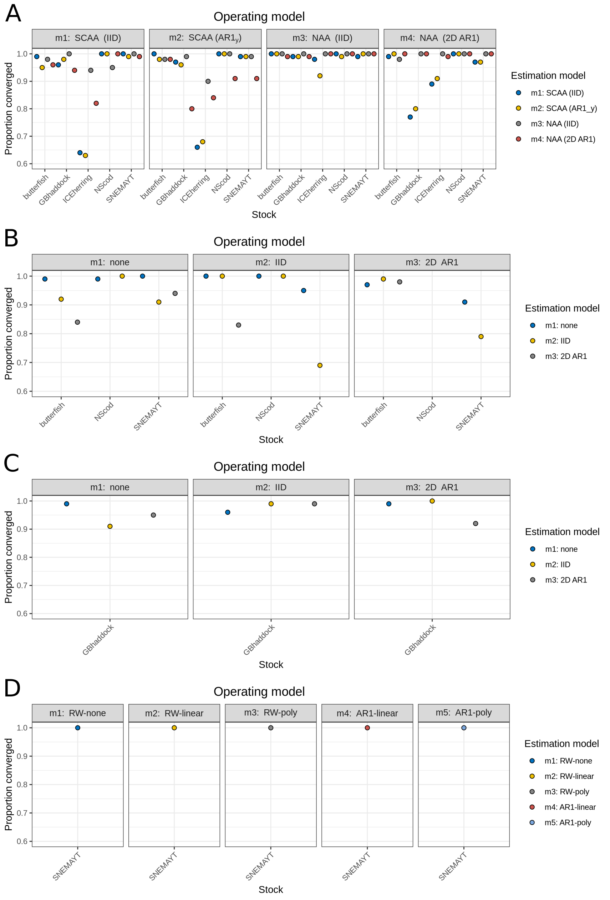

Figure S20. Proportion of cross-test simulations in which models converged for a) NAA, b) M, c) selectivity, and d) Ecov random effects. Models with positive definite Hessian matrix were considered to be converged.

