Supplemental Information

The Woods Hole Assessment Model (WHAM): a general state-space assessment framework that incorporates time- and age-varying processes via random effects and links to environmental covariates

Brian C. Stock* and Timothy J. Miller

*brian.stock@noaa.gov
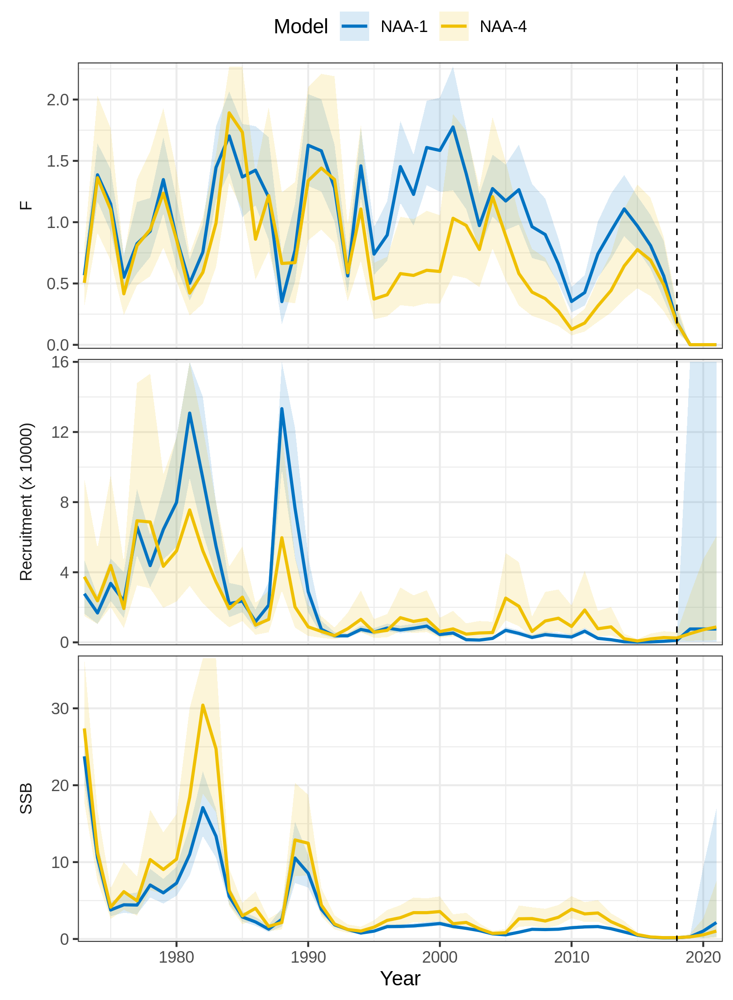
Figure S1. Trends in F, recruitment, and SSB estimated for SNEMA yellowtail flounder using two models of numbers-at-age (NAA) random effects. NAA-1 = only recruitment deviations are independent random effects (most similar to traditional statistical catch-at-age). NAA-4 = all NAA deviations are random effects correlated by age and year (2D AR1). NAA-4 had the lowest AIC (Fig. 1 in main text). The vertical dashed line indicates the terminal year in the assessment.
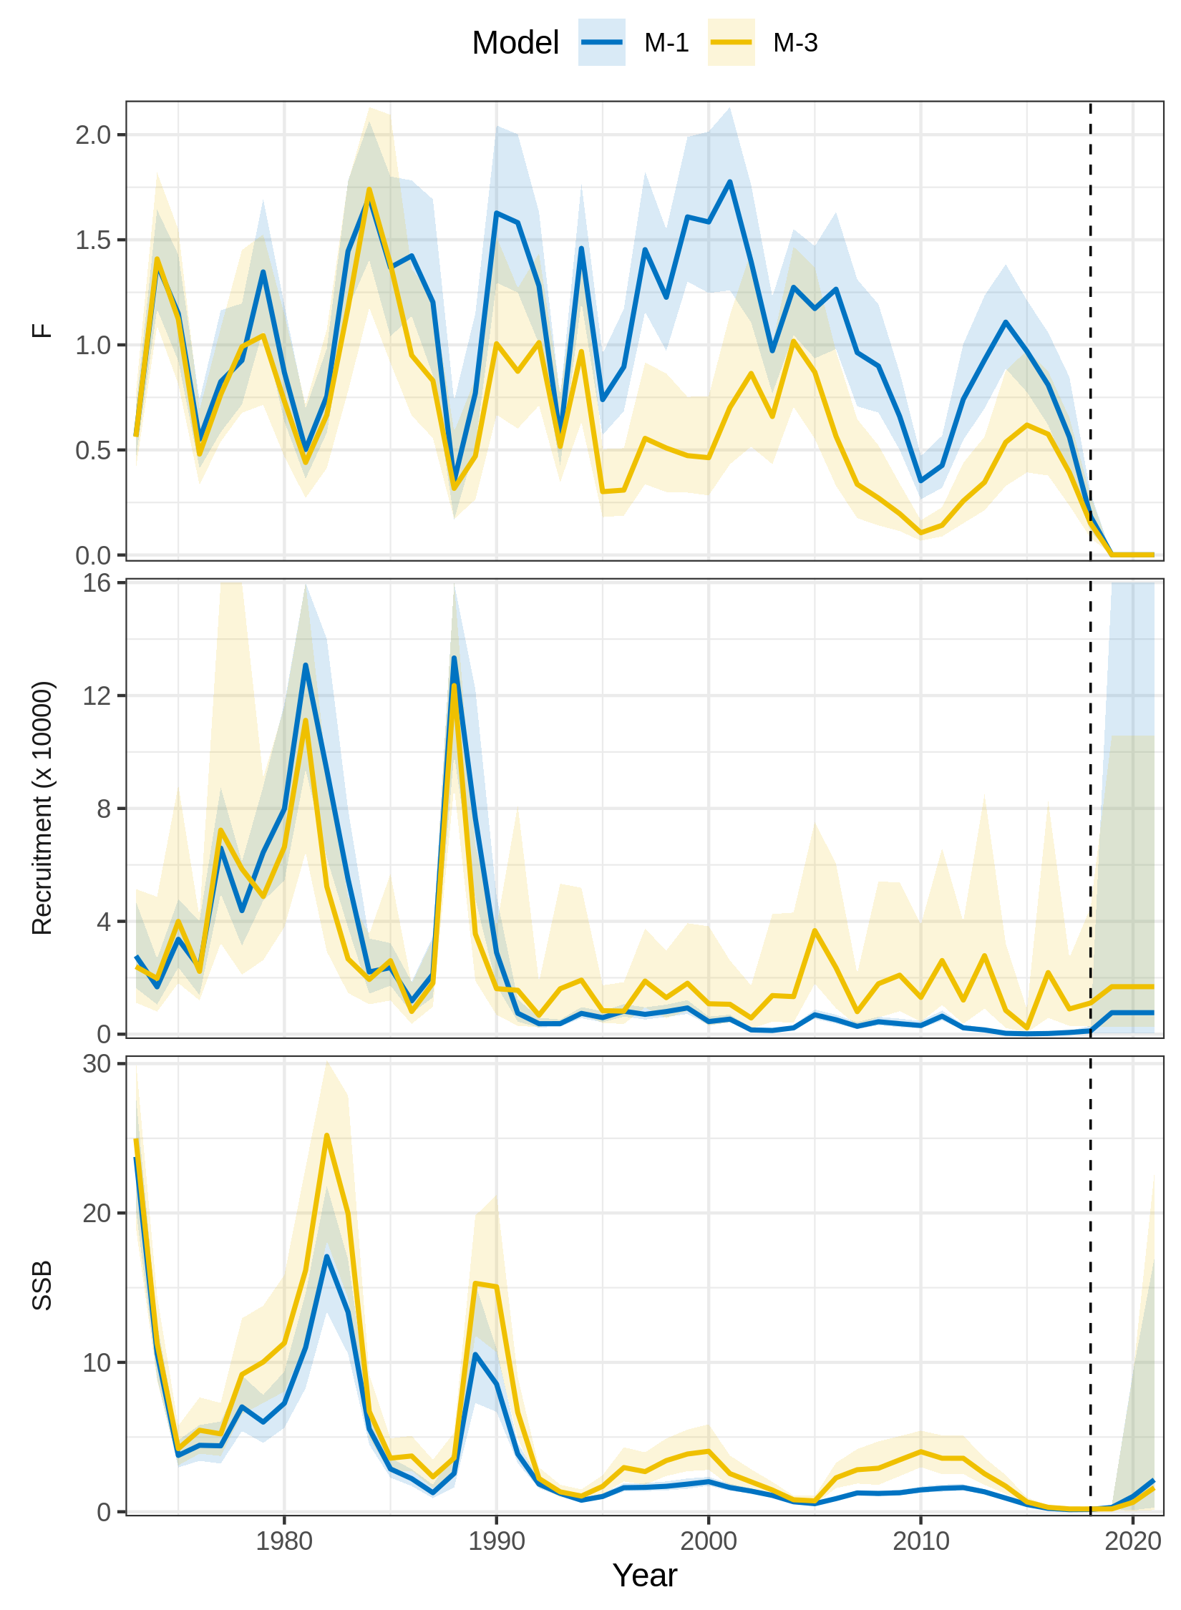
Figure S2. Trends in F, recruitment, and SSB estimated for SNEMA yellowtail flounder using two models of natural mortality (M) random effects. M-1 = no random effects on M. M-3 = M deviations are random effects correlated by age and year (2D AR1). M-3 had the lowest AIC (Fig. 1 in main text). The vertical dashed line indicates the terminal year in the assessment.
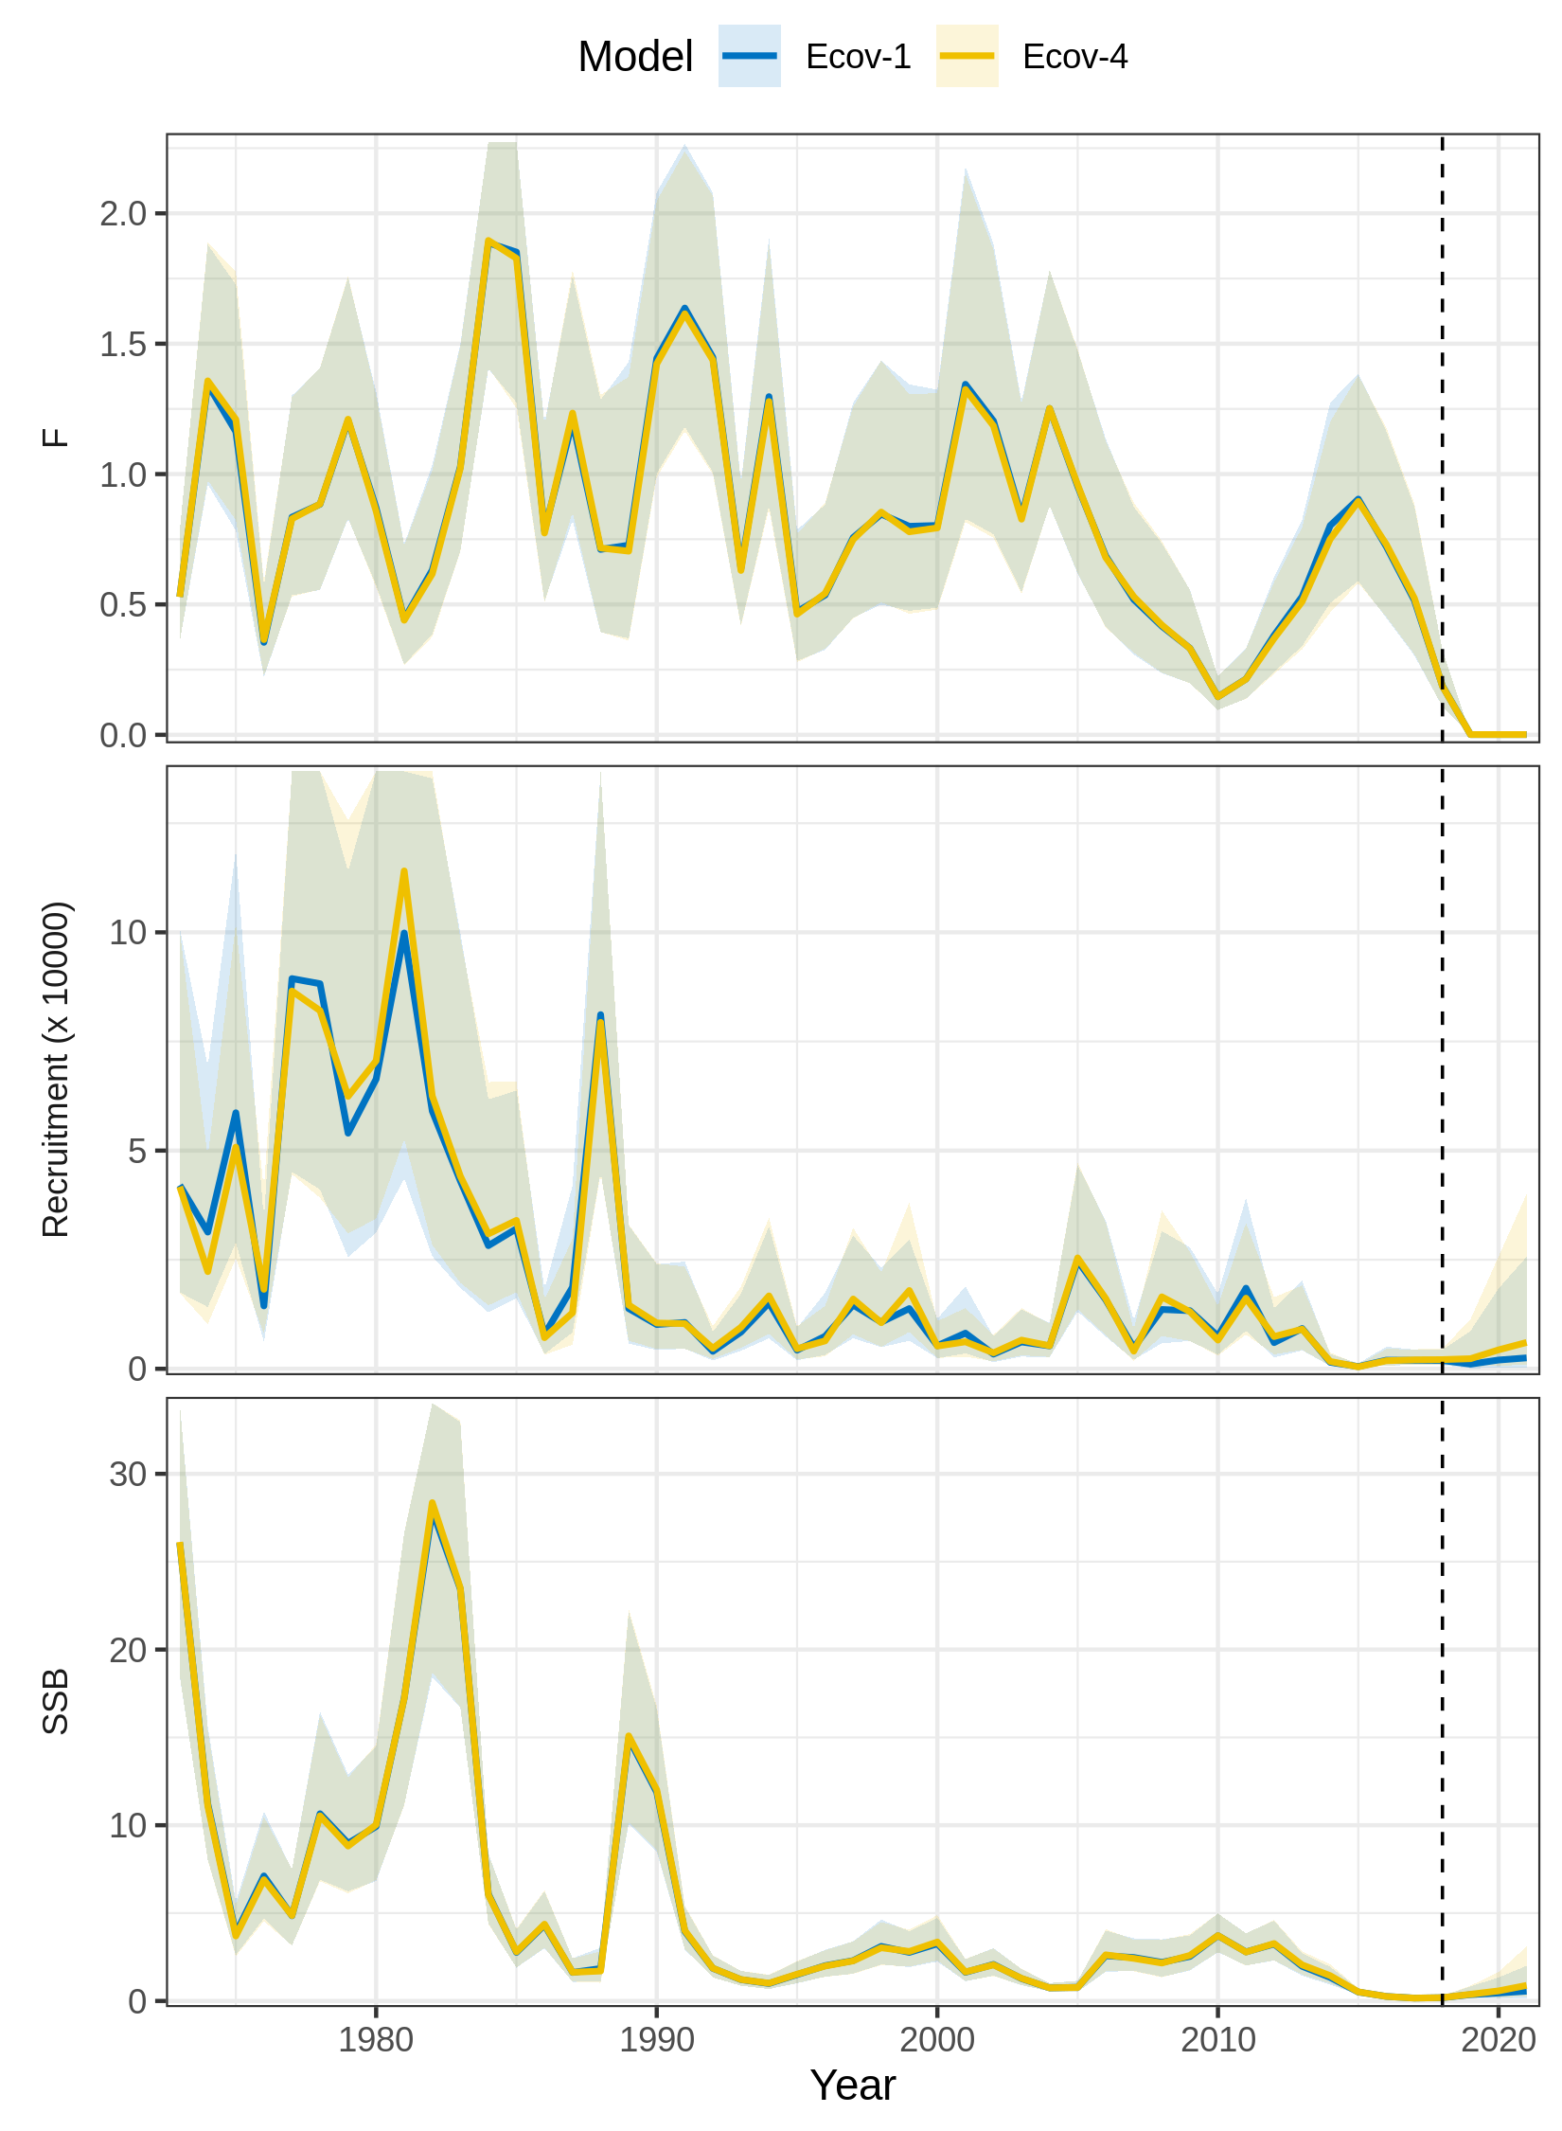
Figure S3. Trends in F, recruitment, and SSB estimated for SNEMA yellowtail flounder using models with and without effects of the Cold Pool Index (CPI) on recruitment. Ecov-1 = no CPI effect. Ecov-4 = CPI modeled as AR1 process with linear effect on the Beverton-Holt β parameter. Ecov-4 had the lowest AIC (Fig. 1 in main text). The vertical dashed line indicates the terminal year in the assessment.
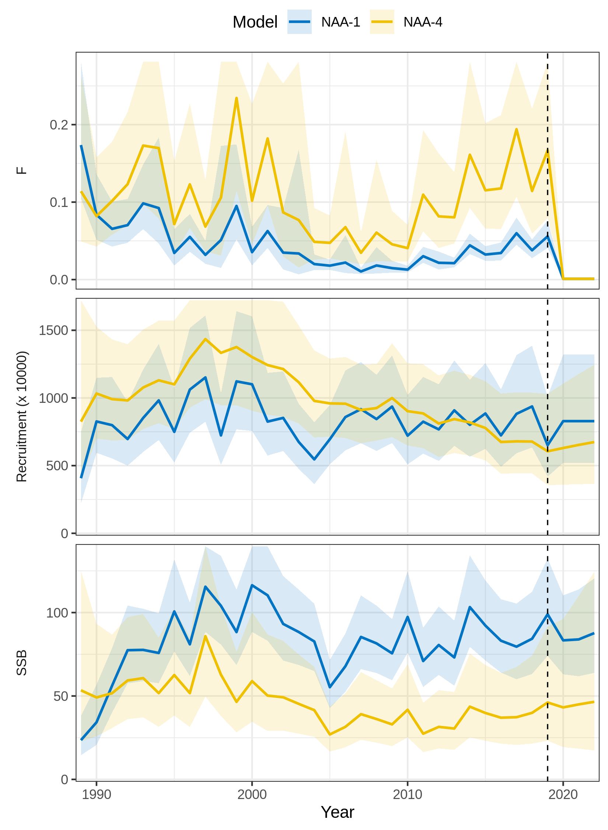
Figure S4. Trends in F, recruitment, and SSB estimated for butterfish using two models of numbers-at-age (NAA) random effects. NAA-1 = only recruitment deviations are independent random effects (most similar to traditional statistical catch-at-age). NAA-4 = all NAA deviations are random effects correlated by age and year (2D AR1). NAA-4 had the lowest AIC (Fig. 1 in main text). The vertical dashed line indicates the terminal year in the assessment.
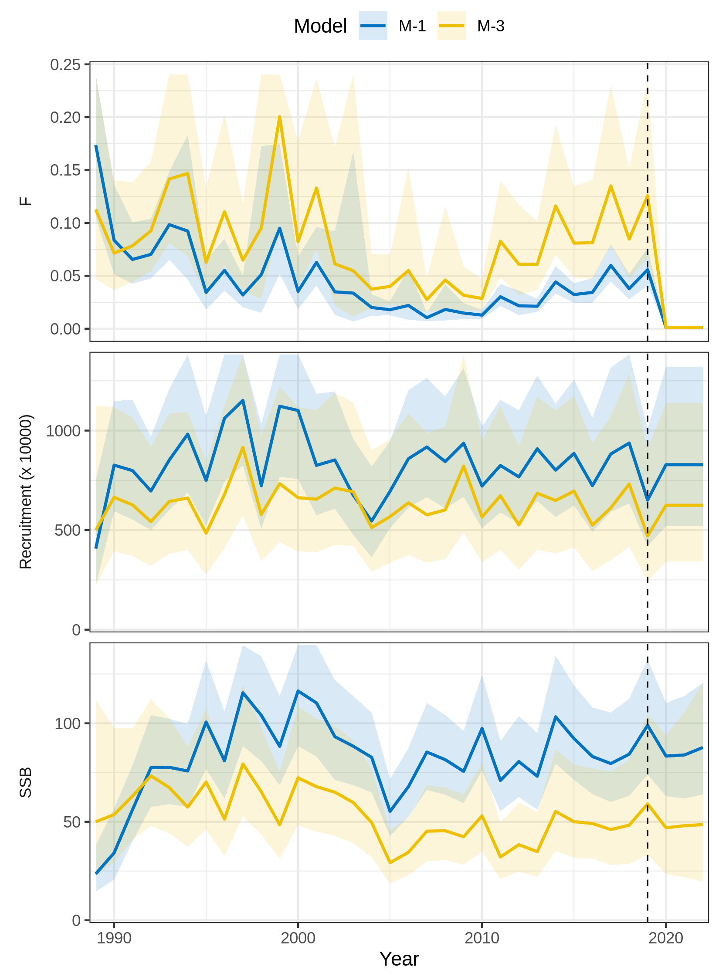
Figure S5. Trends in F, recruitment, and SSB estimated for butterfish using two models of natural mortality (M) random effects. M-1 = no random effects on M. M-3 = M deviations are random effects correlated by age and year (2D AR1). M-3 had the lowest AIC (Fig. 1 in main text). The vertical dashed line indicates the terminal year in the assessment.
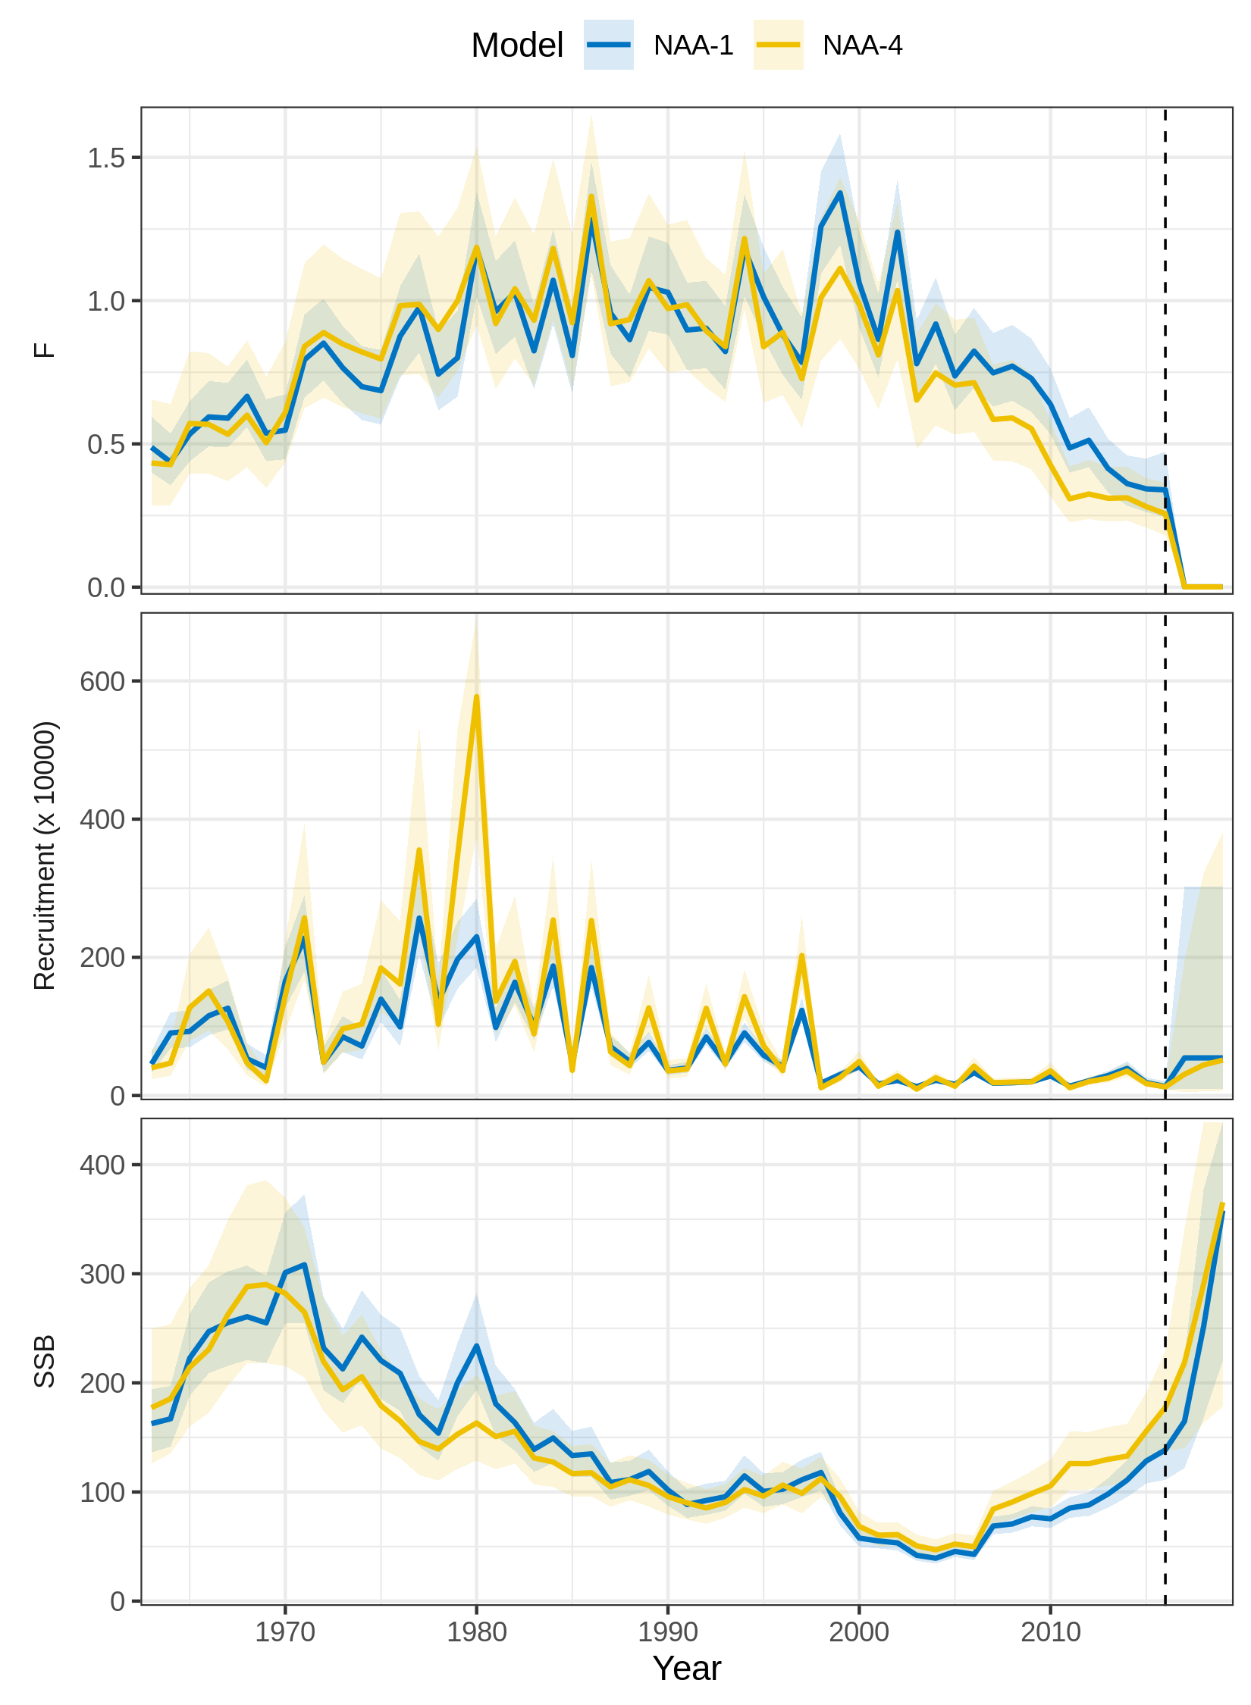
Figure S6. Trends in F, recruitment, and SSB estimated for North Sea cod using two models of numbers-at-age (NAA) random effects. NAA-1 = only recruitment deviations are independent random effects (most similar to traditional statistical catch-at-age). NAA-4 = all NAA deviations are random effects correlated by age and year (2D AR1). NAA-4 had the lowest AIC (Fig. 1 in main text). The vertical dashed line indicates the terminal year in the assessment.
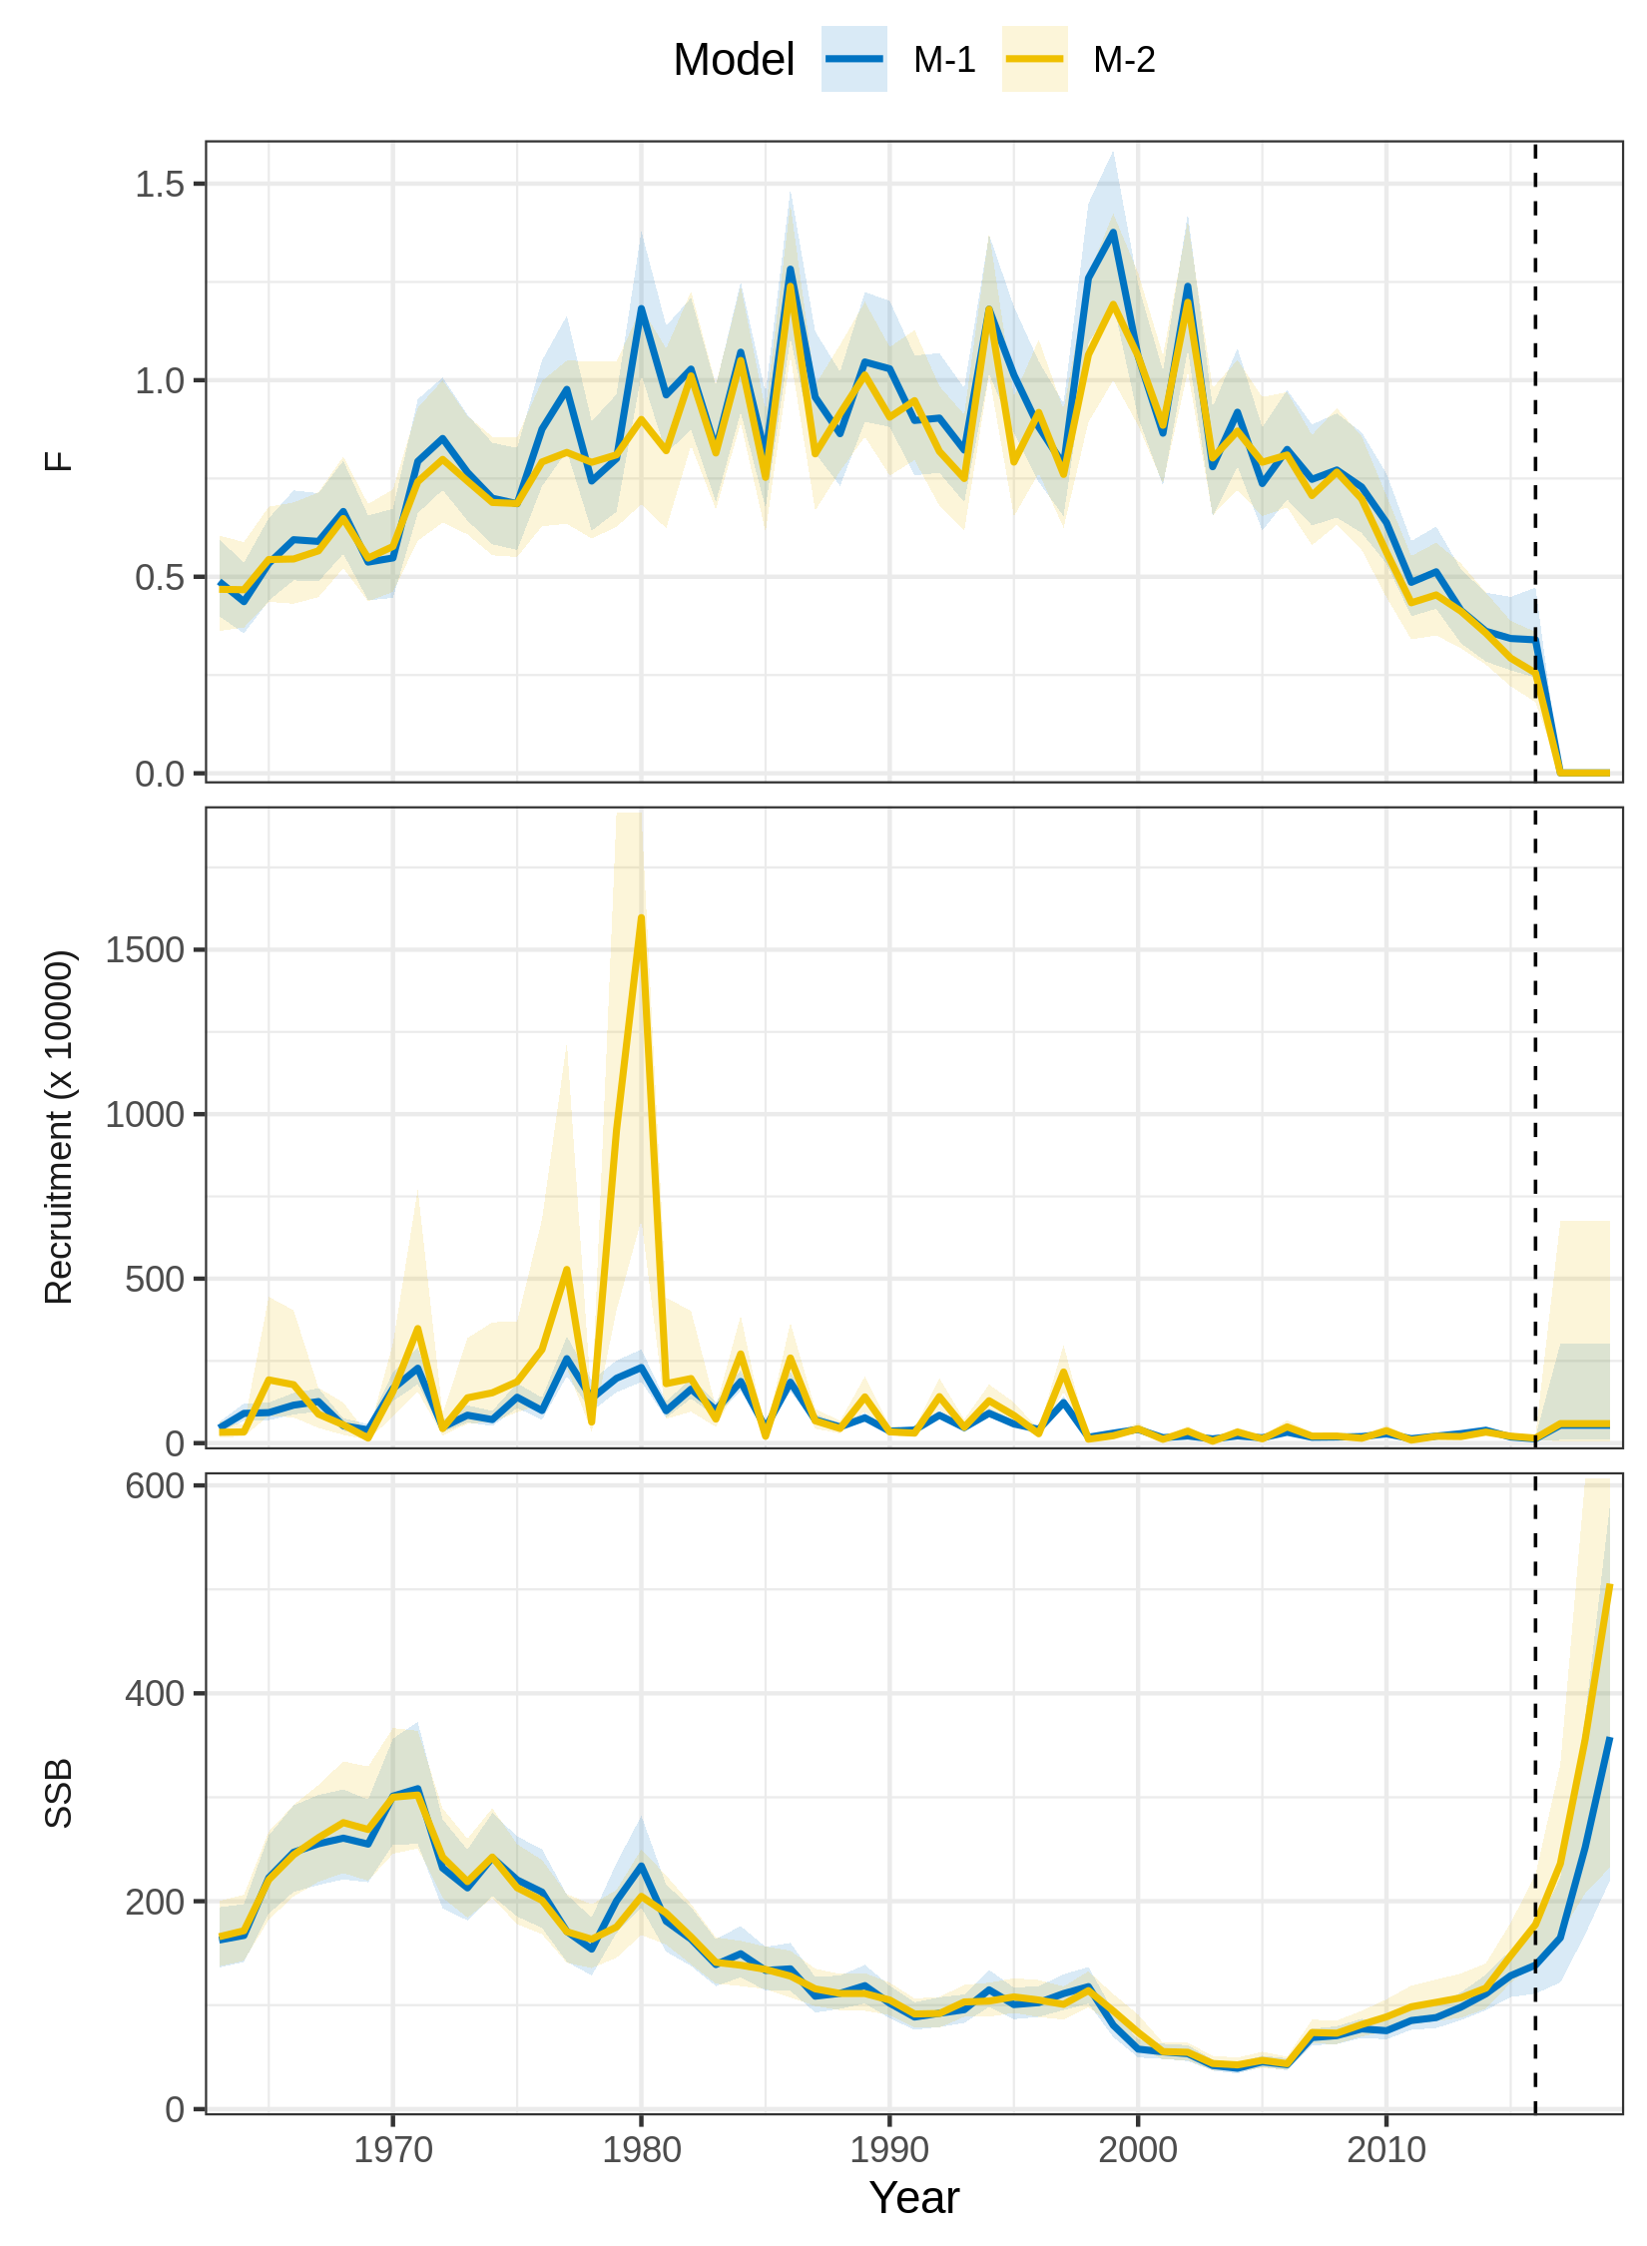
Figure S7. Trends in F, recruitment, and SSB estimated for North Sea cod using two models of natural mortality (M) random effects. M-1 = no random effects on M. M-2 = M deviations are independent random effects. M-2 had the lowest AIC (Fig. 1 in main text) and M-3 did not converge. The vertical dashed line indicates the terminal year in the assessment.
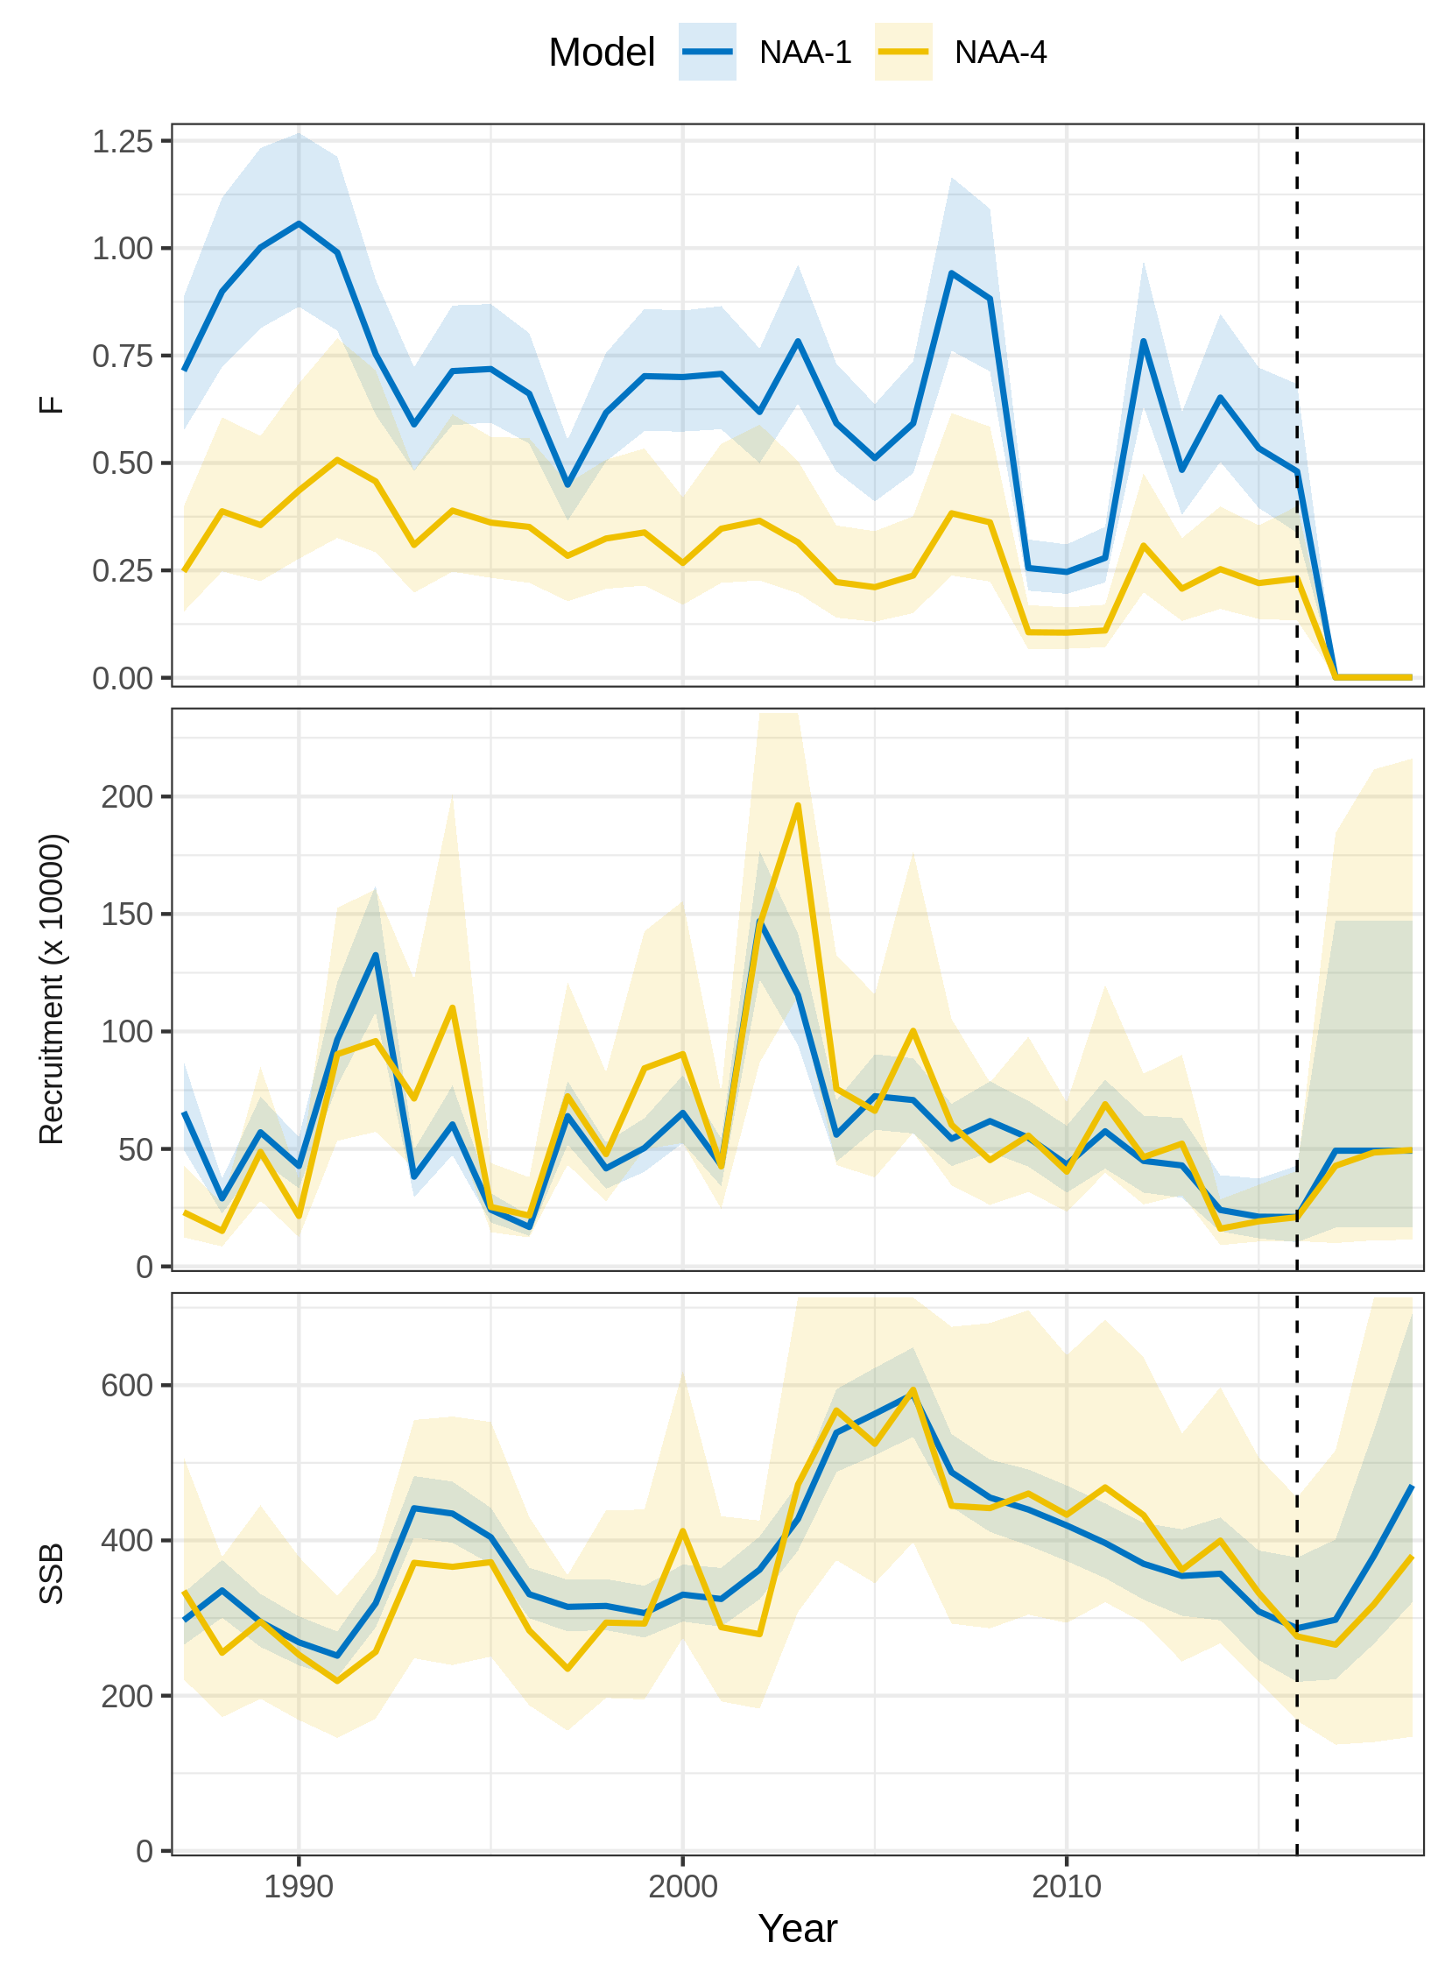
Figure S8. Trends in F, recruitment, and SSB estimated for Icelandic herring using two models of numbers-at-age (NAA) random effects. NAA-1 = only recruitment deviations are independent random effects (most similar to traditional statistical catch-at-age). NAA-4 = all NAA deviations are random effects correlated by age and year (2D AR1). NAA-4 had the lowest AIC (Fig. 1 in main text). The vertical dashed line indicates the terminal year in the assessment.
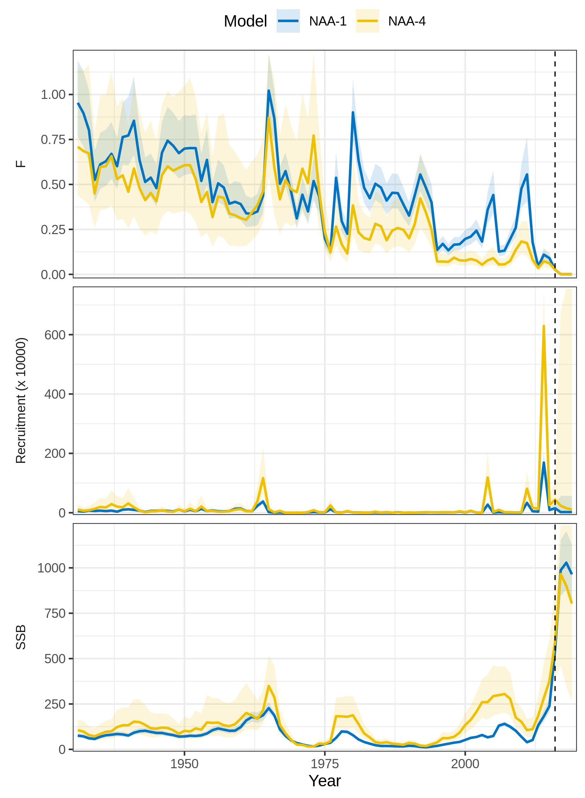
Figure S9. Trends in F, recruitment, and SSB estimated for Georges Bank haddock using two models of numbers-at-age (NAA) random effects. NAA-1 = only recruitment deviations are independent random effects (most similar to traditional statistical catch-at-age). NAA-4 = all NAA deviations are random effects correlated by age and year (2D AR1). NAA-4 had the lowest AIC (Fig. 1 in main text). The vertical dashed line indicates the terminal year in the assessment.
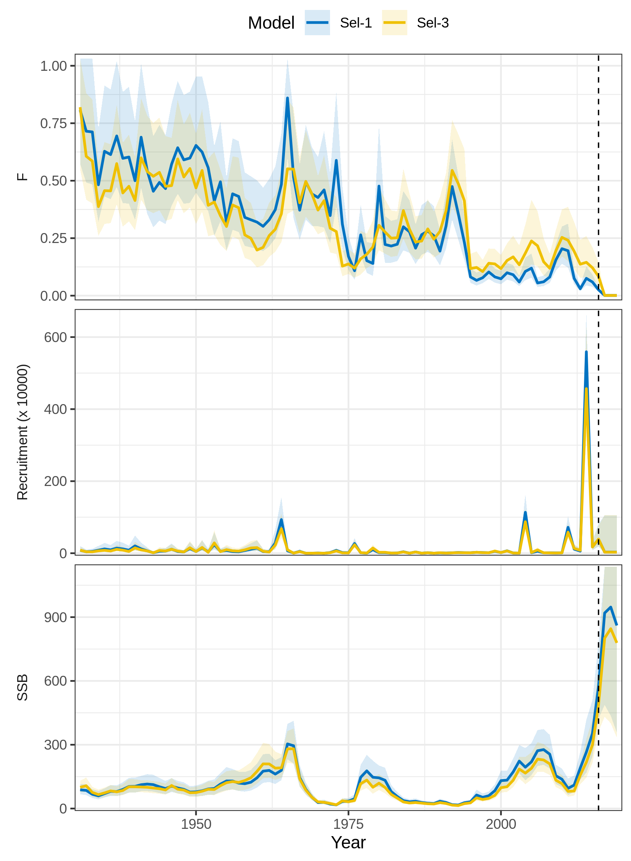
Figure S10. Trends in F, recruitment, and SSB estimated for Georges Bank haddock using two models of selectivity random effects. Sel-1 = time-constant selectivity. Sel-3 = random effect deviations in the logistic selectivity parameters correlated by parameter and year (2D AR1). Sel-3 had the lowest AIC (Fig. 1 in main text). The vertical dashed line indicates the terminal year in the assessment.
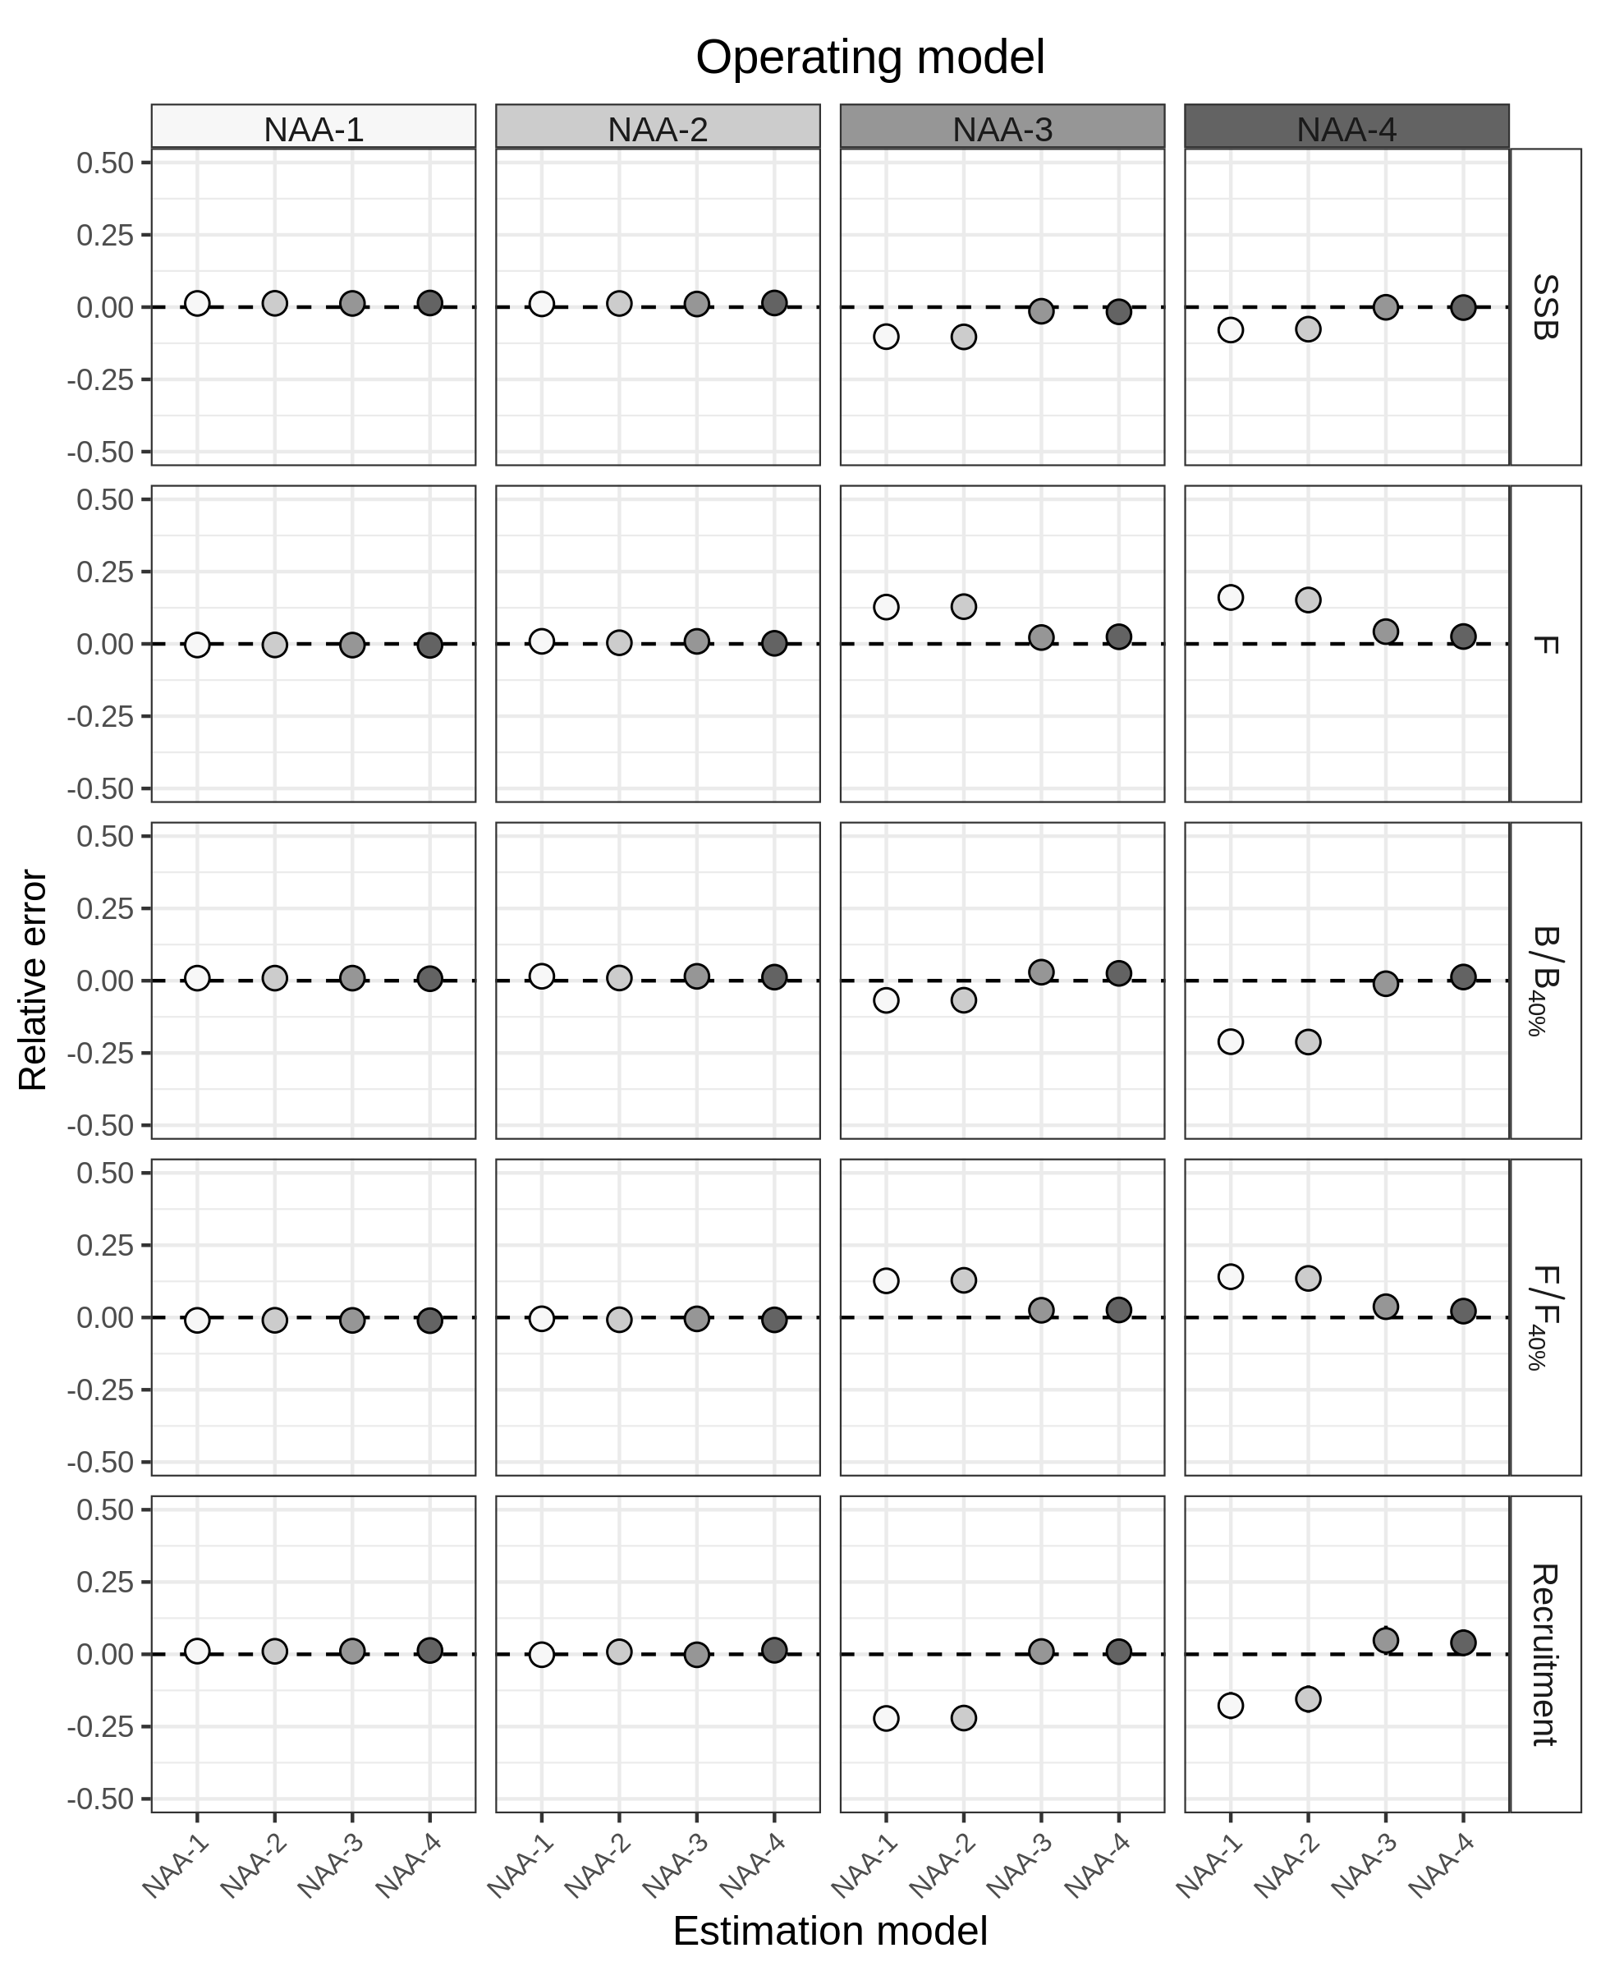
Figure S11. Relative error of key quantities estimated for SNEMA yellowtail flounder using four models of numbers-at-age (NAA) random effects. NAA-1 = only recruitment deviations are independent random effects (most similar to Base). NAA-2 = as NAA-1, but with autocorrelated recruitment deviations (AR1). NAA-3 = all NAA deviations are independent random effects. NAA-4 = as NAA-3, but deviations are correlated by age and year (2D AR1). Points without lines indicate that 95% CI are smaller than the points.
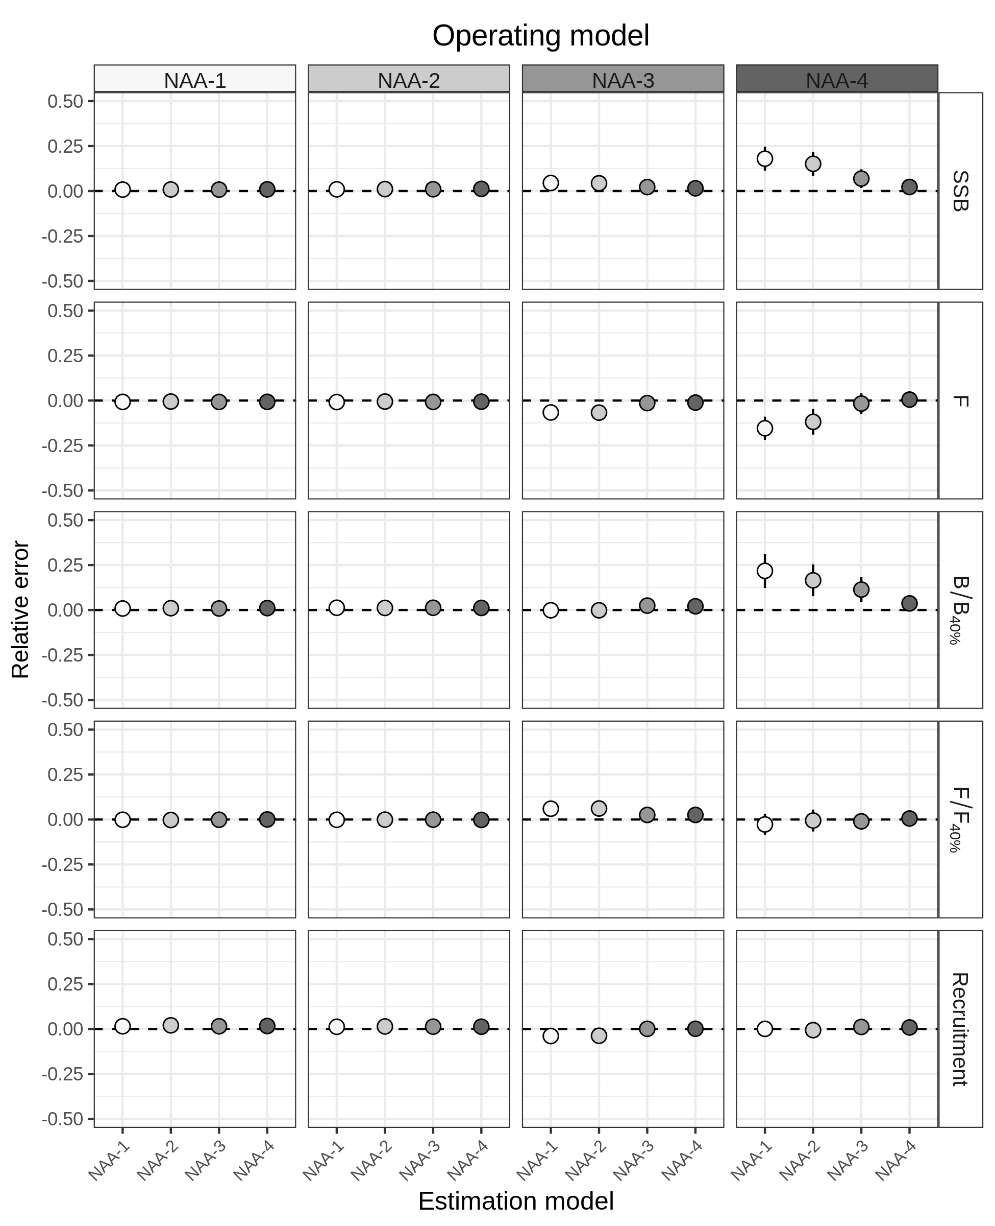
Figure S12. Relative error of key quantities estimated for butterfish using four models of numbers-at-age (NAA) random effects. NAA-1 = only recruitment deviations are independent random effects (most similar to Base). NAA-2 = as NAA-1, but with autocorrelated recruitment deviations (AR1). NAA-3 = all NAA deviations are independent random effects. NAA-4 = as NAA-3, but deviations are correlated by age and year (2D AR1). Points without lines indicate that 95% CI are smaller than the points.
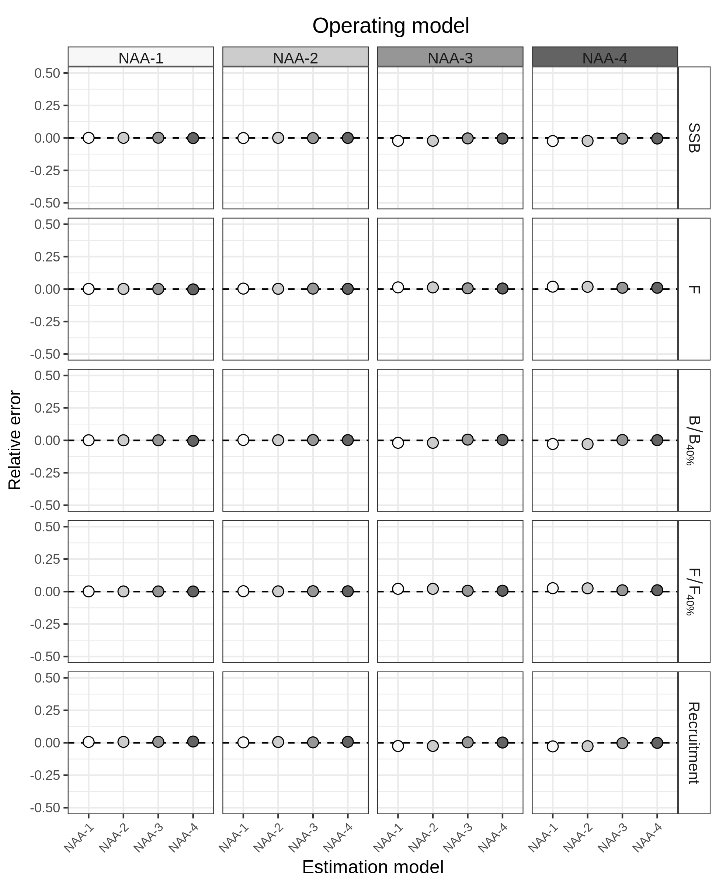
Figure S13. Relative error of key quantities estimated for North Sea cod using four models of numbers-at-age (NAA) random effects. NAA-1 = only recruitment deviations are independent random effects (most similar to Base). NAA-2 = as NAA-1, but with autocorrelated recruitment deviations (AR1). NAA-3 = all NAA deviations are independent random effects. NAA-4 = as NAA-3, but deviations are correlated by age and year (2D AR1). Points without lines indicate that 95% CI are smaller than the points.
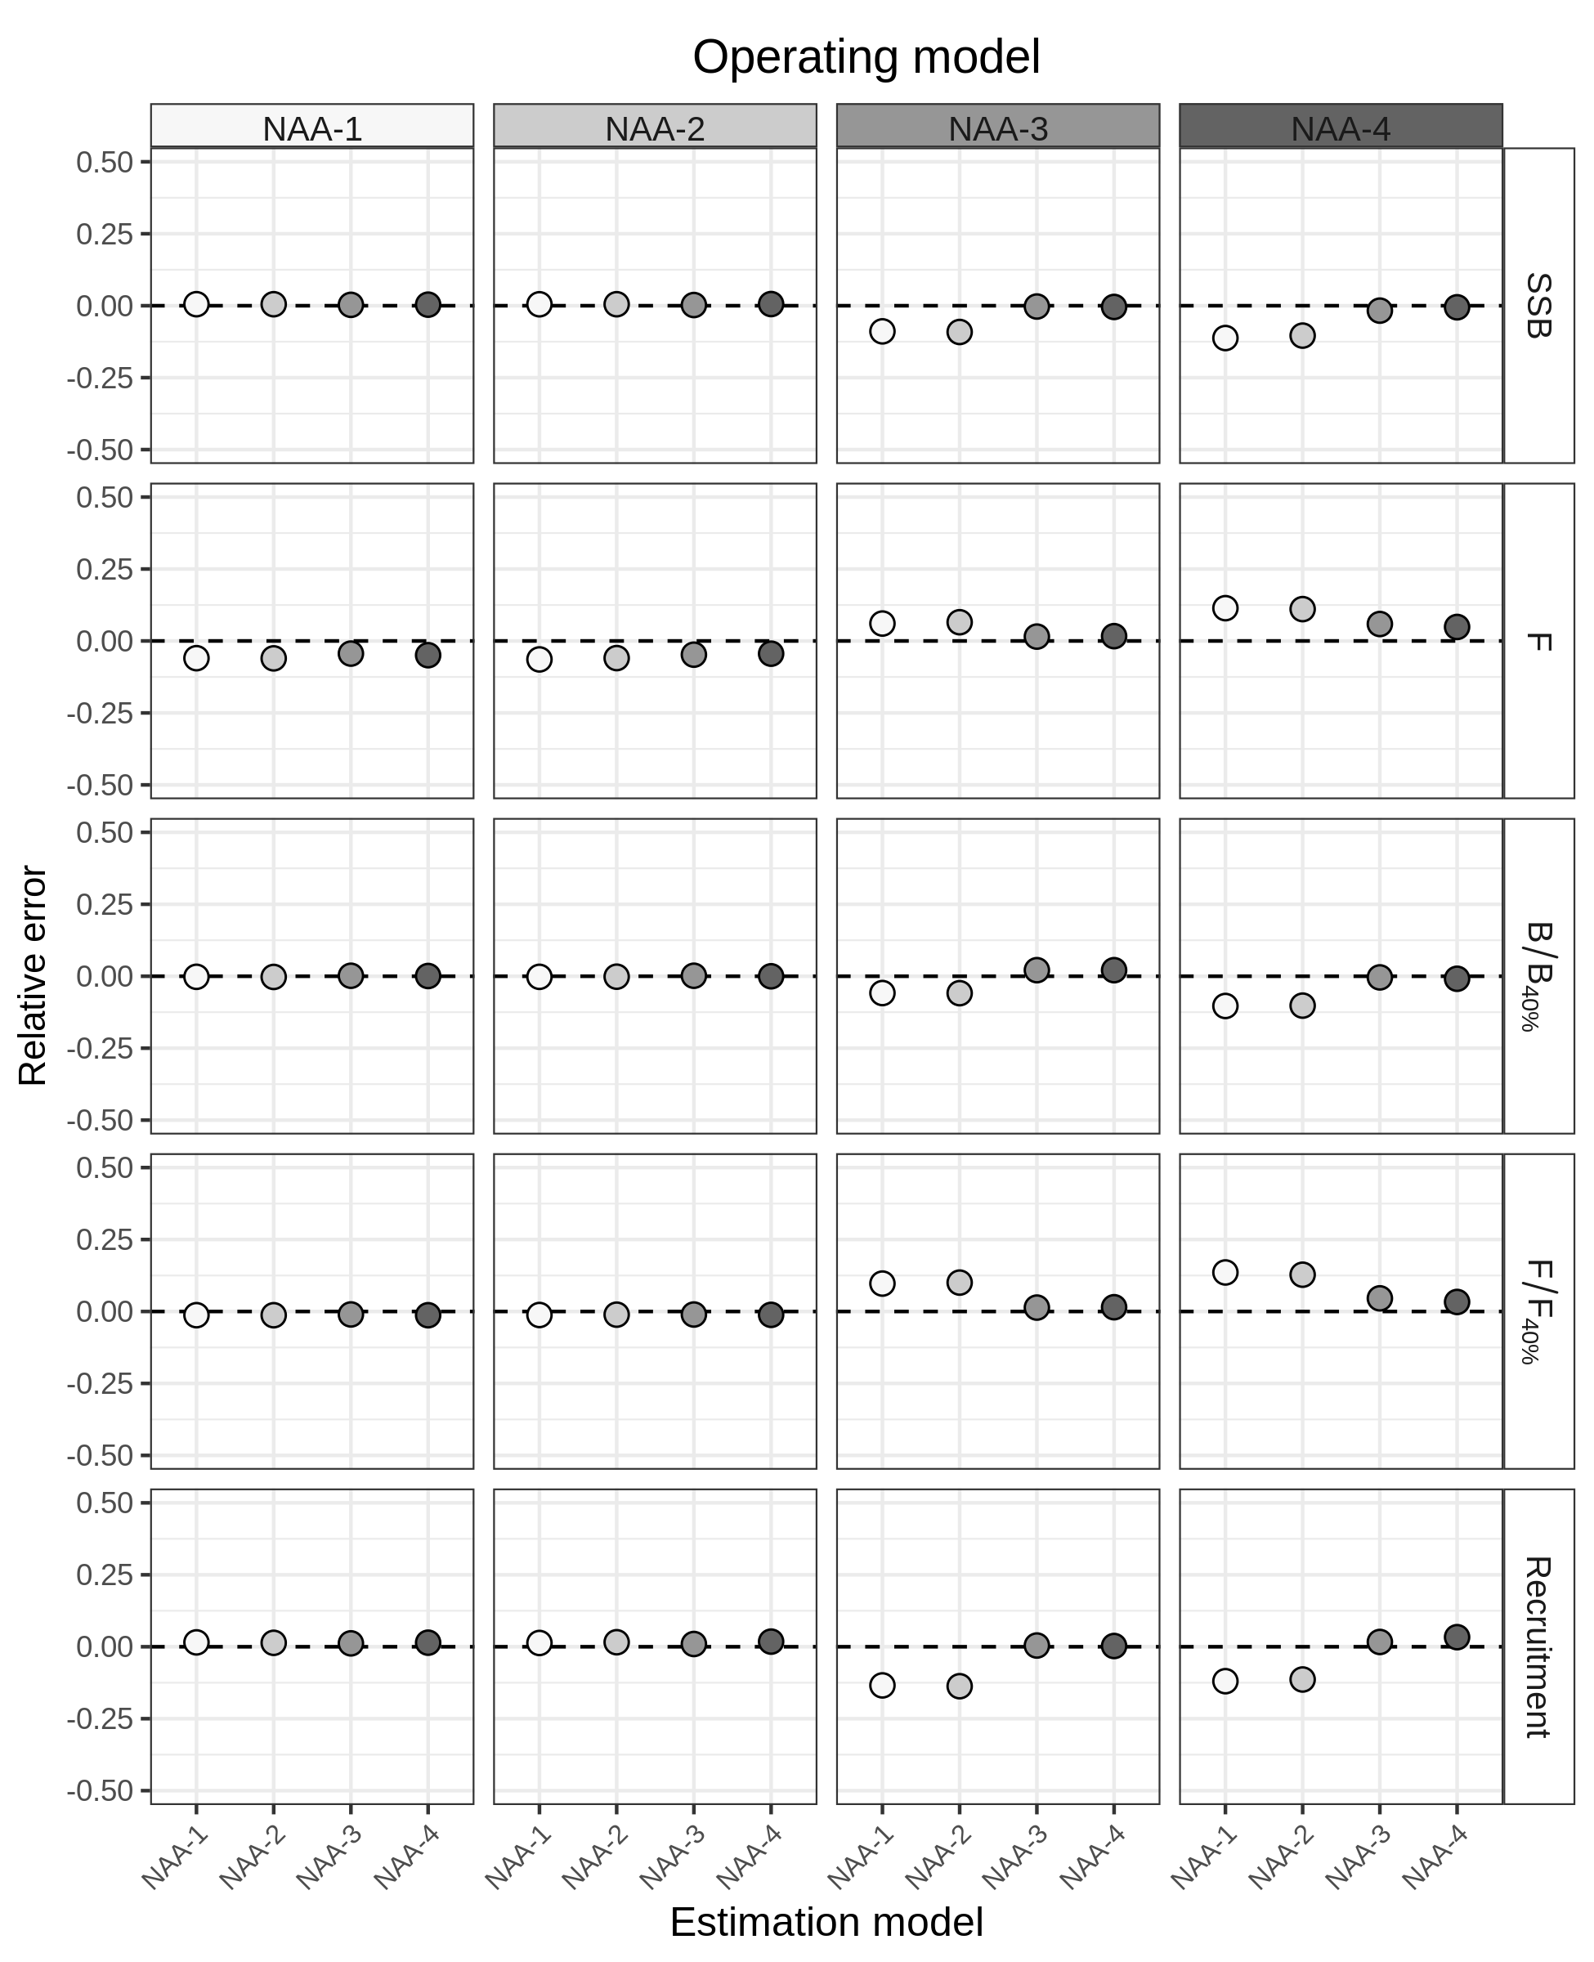
Figure S14. Relative error of key quantities estimated for Icelandic herring using four models of numbers-at-age (NAA) random effects. NAA-1 = only recruitment deviations are independent random effects (most similar to Base). NAA-2 = as NAA-1, but with autocorrelated recruitment deviations (AR1). NAA-3 = all NAA deviations are independent random effects. NAA-4 = as NAA-3, but deviations are correlated by age and year (2D AR1). Points without lines indicate that 95% CI are smaller than the points.
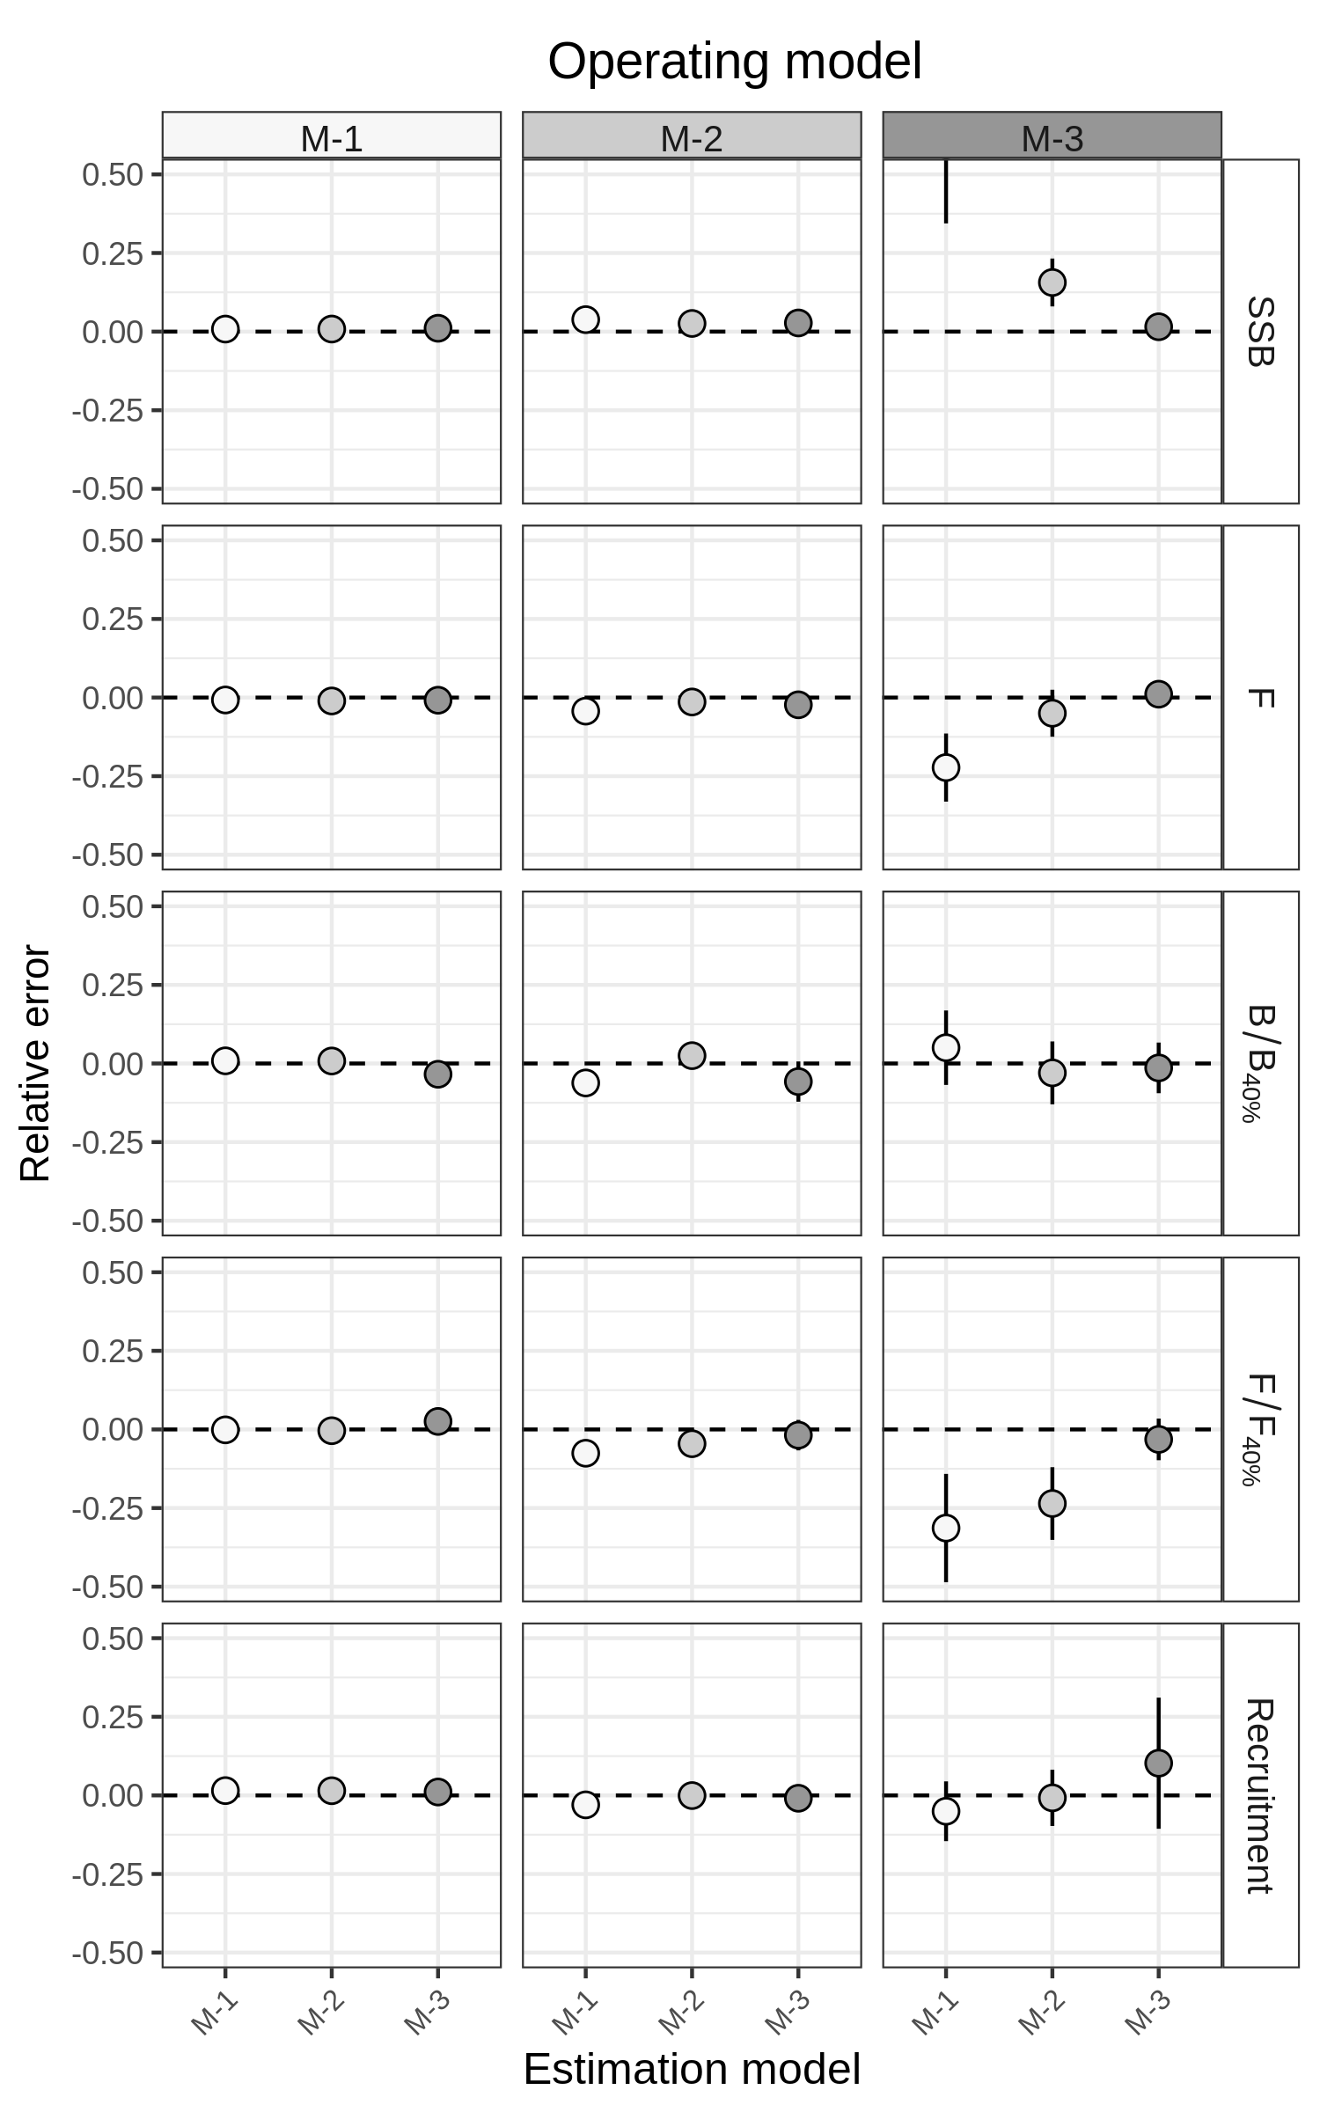
Figure S15. Relative error of key quantities estimated for butterfish using three models of natural mortality (M) random effects. M-1 = no random effects on M. M-2 = independent M deviations. M-3
= M deviations are correlated by age and year (2D AR1). Points without lines indicate that 95% CI are smaller than the points.
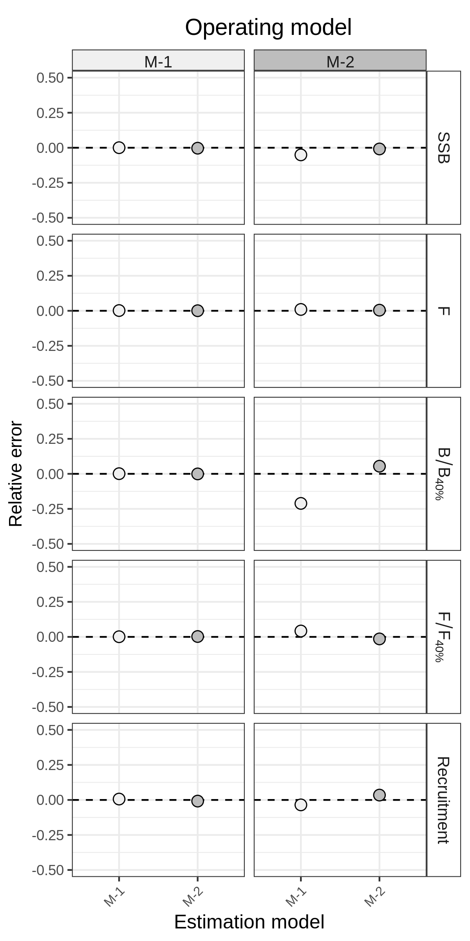
Figure S16. Relative error of key quantities estimated for North Sea cod using two models of natural mortality (M) random effects. M-1 = no random effects on M. M-2 = independent M deviations. M-3, with M deviations correlated by age and year (2D AR1), did not converge. Points without lines indicate that 95% CI are smaller than the points.
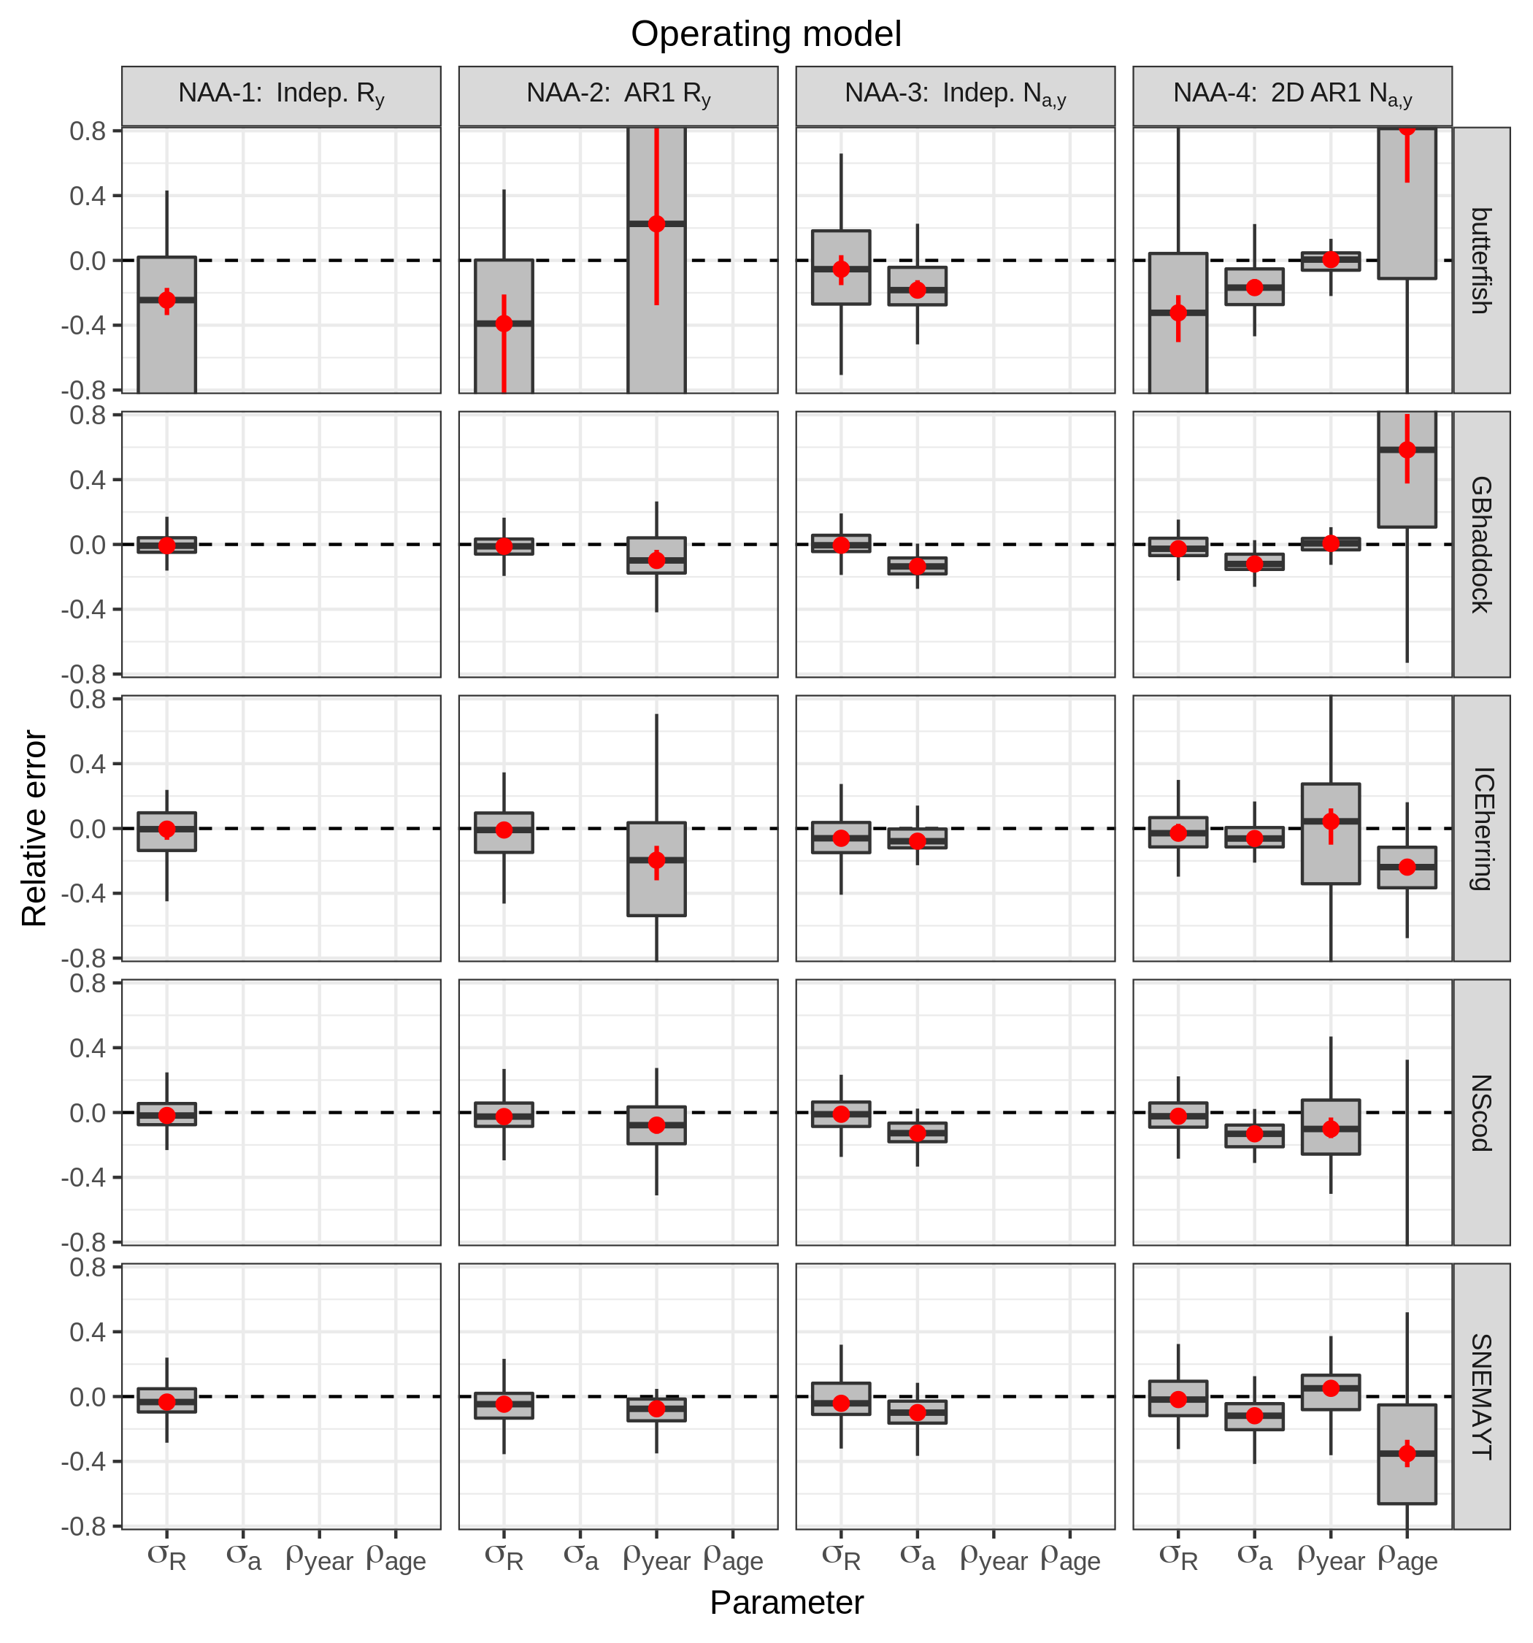
Figure S17. Relative error of parameters constraining numbers-at-age (NAA) random effects. Four models were used to simulate 100 datasets keeping fixed effect parameters constant, and then re-fit to each simulated dataset. NAA-1 = only recruitment deviations are independent random effects. NAA-2 = as NAA-1, but with autocorrelated (AR1) recruitment deviations. NAA-3 = all NAA deviations are independent random effects. NAA-4 = as NAA-3, but deviations are correlated by age and year (2D AR1). Relative error was calculated as , where was the estimate in simulation i for parameter θ, and was the true value (estimate from original dataset). Red points and lines show median relative error with 95% CI.
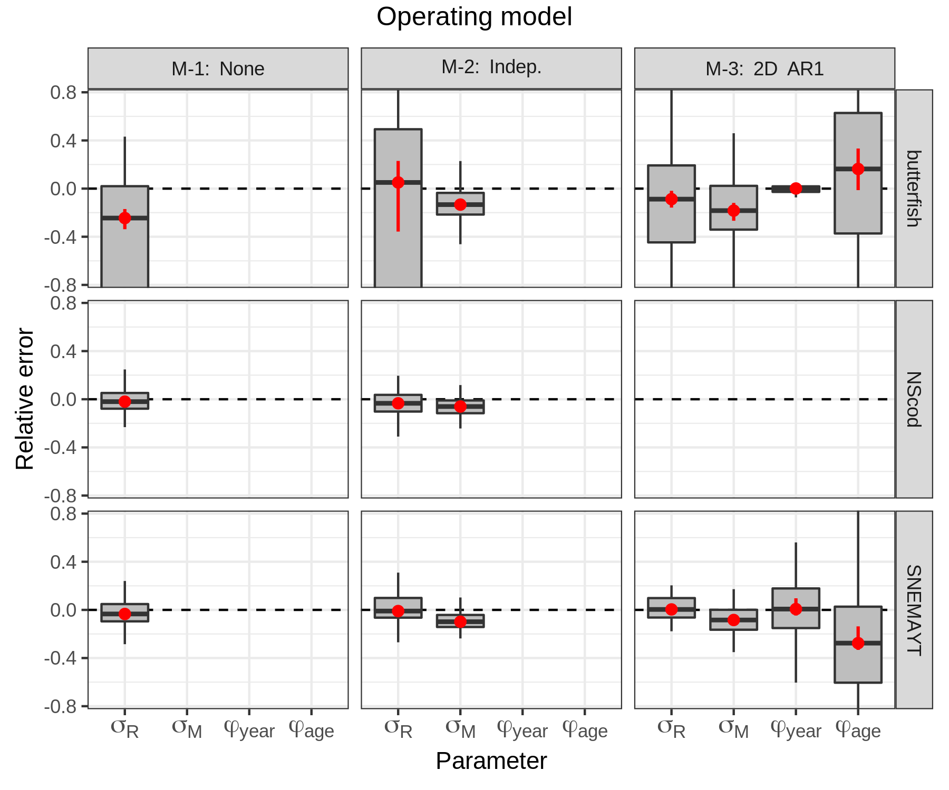
Figure S18. Relative error of parameters constraining natural mortality (M) random effects. Three models were used to simulate 100 datasets keeping fixed effect parameters constant, and then re-fit to each simulated dataset. M-1 = no random effects on M. M-2 = independent M deviations. M-3 = M deviations are correlated by age and year (2D AR1). Relative error was calculated as , where was the estimate in simulation i for parameter θ, and was the true value (estimate from original dataset). Red points and lines show median relative error with 95% CI. Stock abbreviations: SNEMA yellowtail flounder (SNEMAYT) and North Sea cod (NScod, M-3 did not converge).
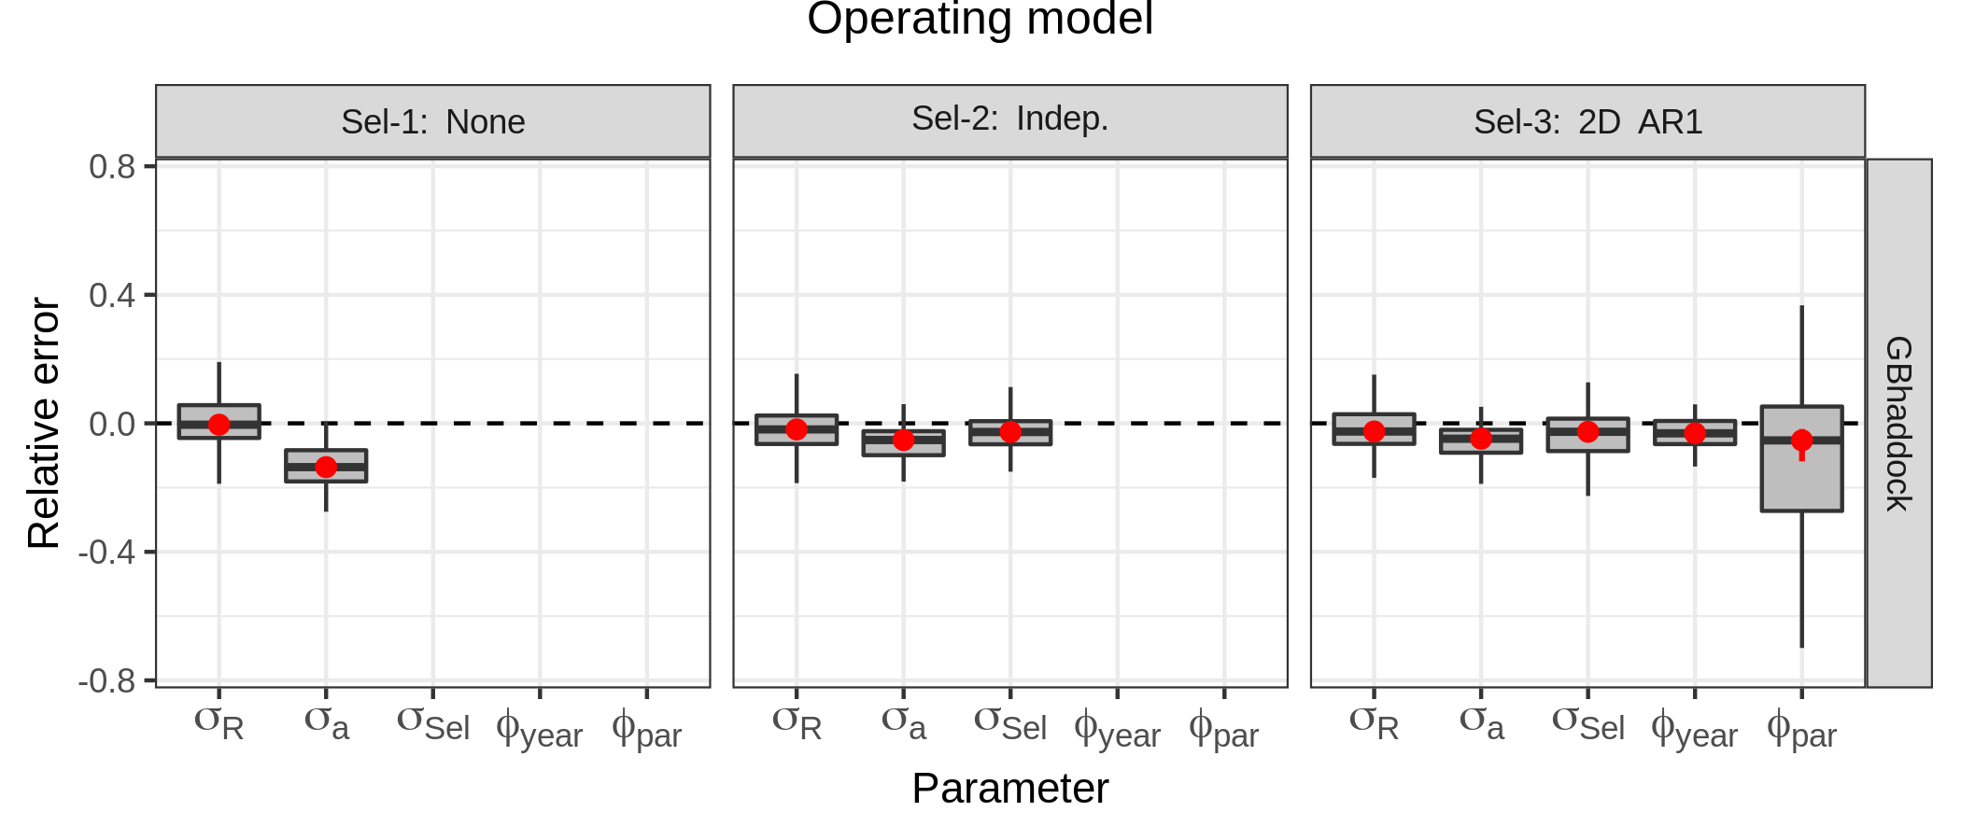
Figure S19. Relative error of parameters constraining selectivity random effects for Georges Bank haddock (GBhaddock). Three models were used to simulate 100 datasets keeping fixed effect parameters constant, and then re-fit to each simulated dataset. Sel-1 = no random effects (constant logistic selectivity). Sel-2 = independent selectivity deviations. Sel-3 = selectivity deviations are correlated by parameter and year (2D AR1). Relative error was calculated as , where was the estimate in simulation i for parameter θ, and was the true value (estimate from original dataset). Red points and lines show median relative error with 95% CI.
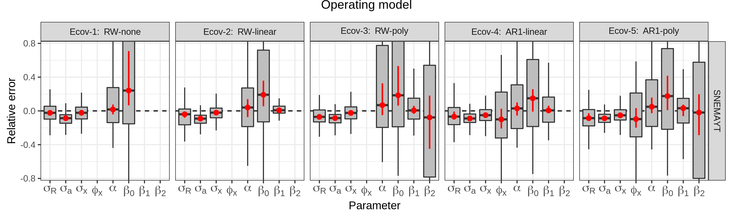
Figure S20. Relative error of parameters constraining variation in recruitment for Southern New England-Mid Atlantic yellowtail flounder (SNEMAYT). Five models were used to simulate 100 datasets keeping fixed effect parameters constant, and then re-fit to each simulated dataset. All models estimated recruitment using the Beverton-Holt function, with effect of the Cold Pool Index (CPI) as β terms: . Ecov-1 = CPI modeled as a random walk (RW) with no effect on recruitment (). Ecov-2 = CPI as RW, linear effect on β. Ecov-3 = CPI as RW, 2nd order polynomial effect on β. Ecov-4 = CPI as AR1, linear effect. Ecov-5 = CPI as AR1, polynomial effect. Relative error was calculated as , where was the estimate in simulation i for parameter θ, and was the true value (estimate from original dataset). Red points and lines show median relative error with 95% CI.
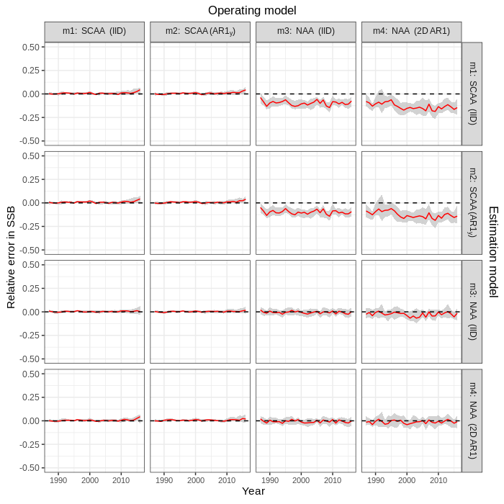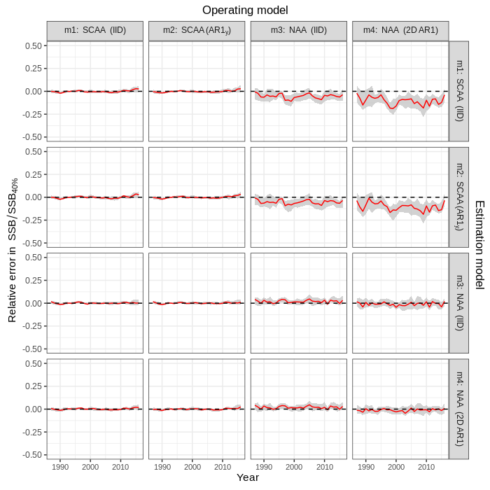
Figure S21. Relative error in SSB (left) and SSB / SSB_{40%} (right) in simulation cross-tests for the four numbers at age (NAA) models fit to Icelandic herring data. Relative error was calculated as , where was the estimate in simulation i for parameter θ, and was the true value (estimate from original dataset). Solid red lines and grey shading show the median relative error with 95% CI, calculated within year and across simulations.
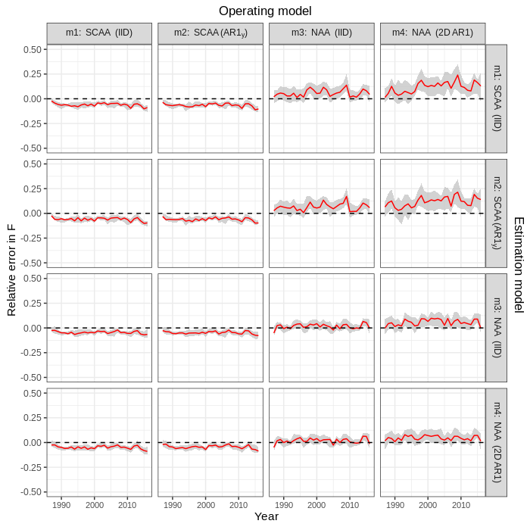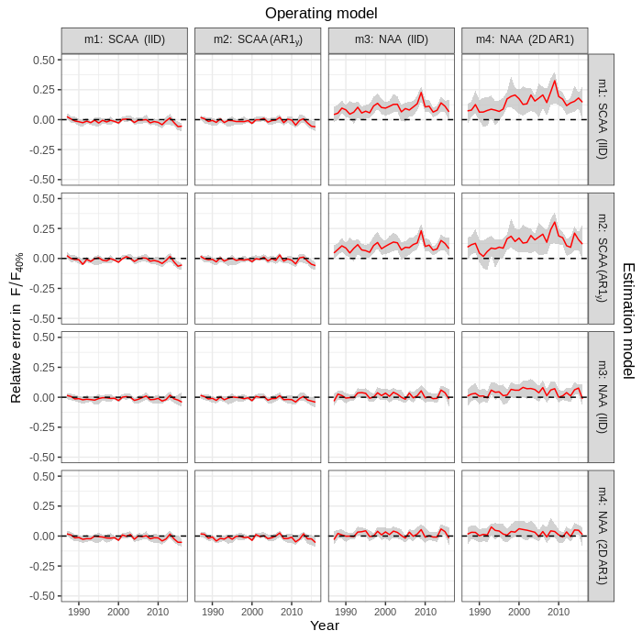
Figure S22. Relative error in F (left) and F / F_{40%} (right) in simulation cross-tests for the four numbers at age (NAA) models fit to Icelandic herring data. Relative error was calculated as , where was the estimate in simulation i for parameter θ, and was the true value (estimate from original dataset). Solid red lines and grey shading show the median relative error with 95% CI, calculated within year and across simulations.

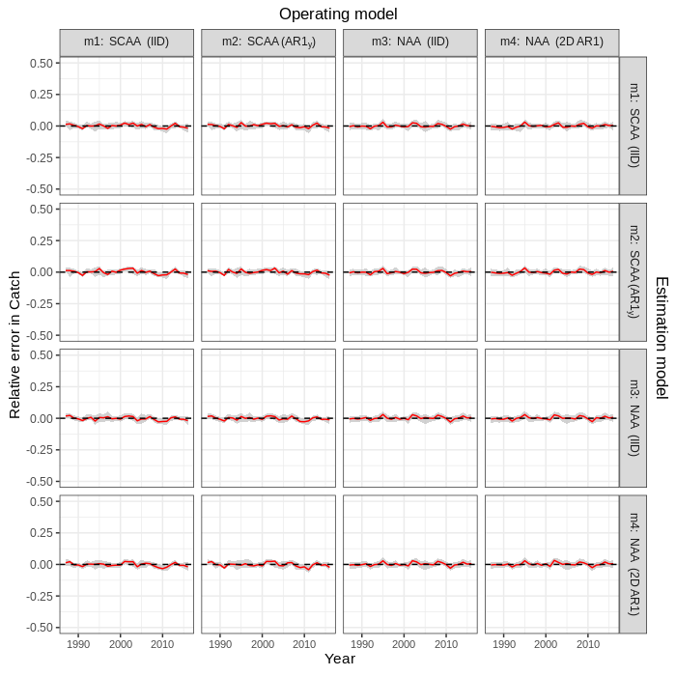
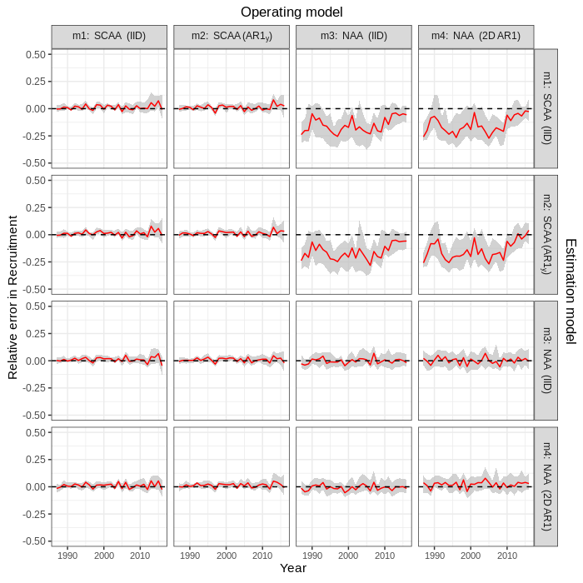
Figure S23. Relative error in recruitment (left) and catch (right) in simulation cross-tests for the four numbers at age (NAA) models fit to Icelandic herring data. Relative error was calculated as , where was the estimate in simulation i for parameter θ, and was the true value (estimate from original dataset). Solid red lines and grey shading show the median relative error with 95% CI, calculated within year and across simulations.
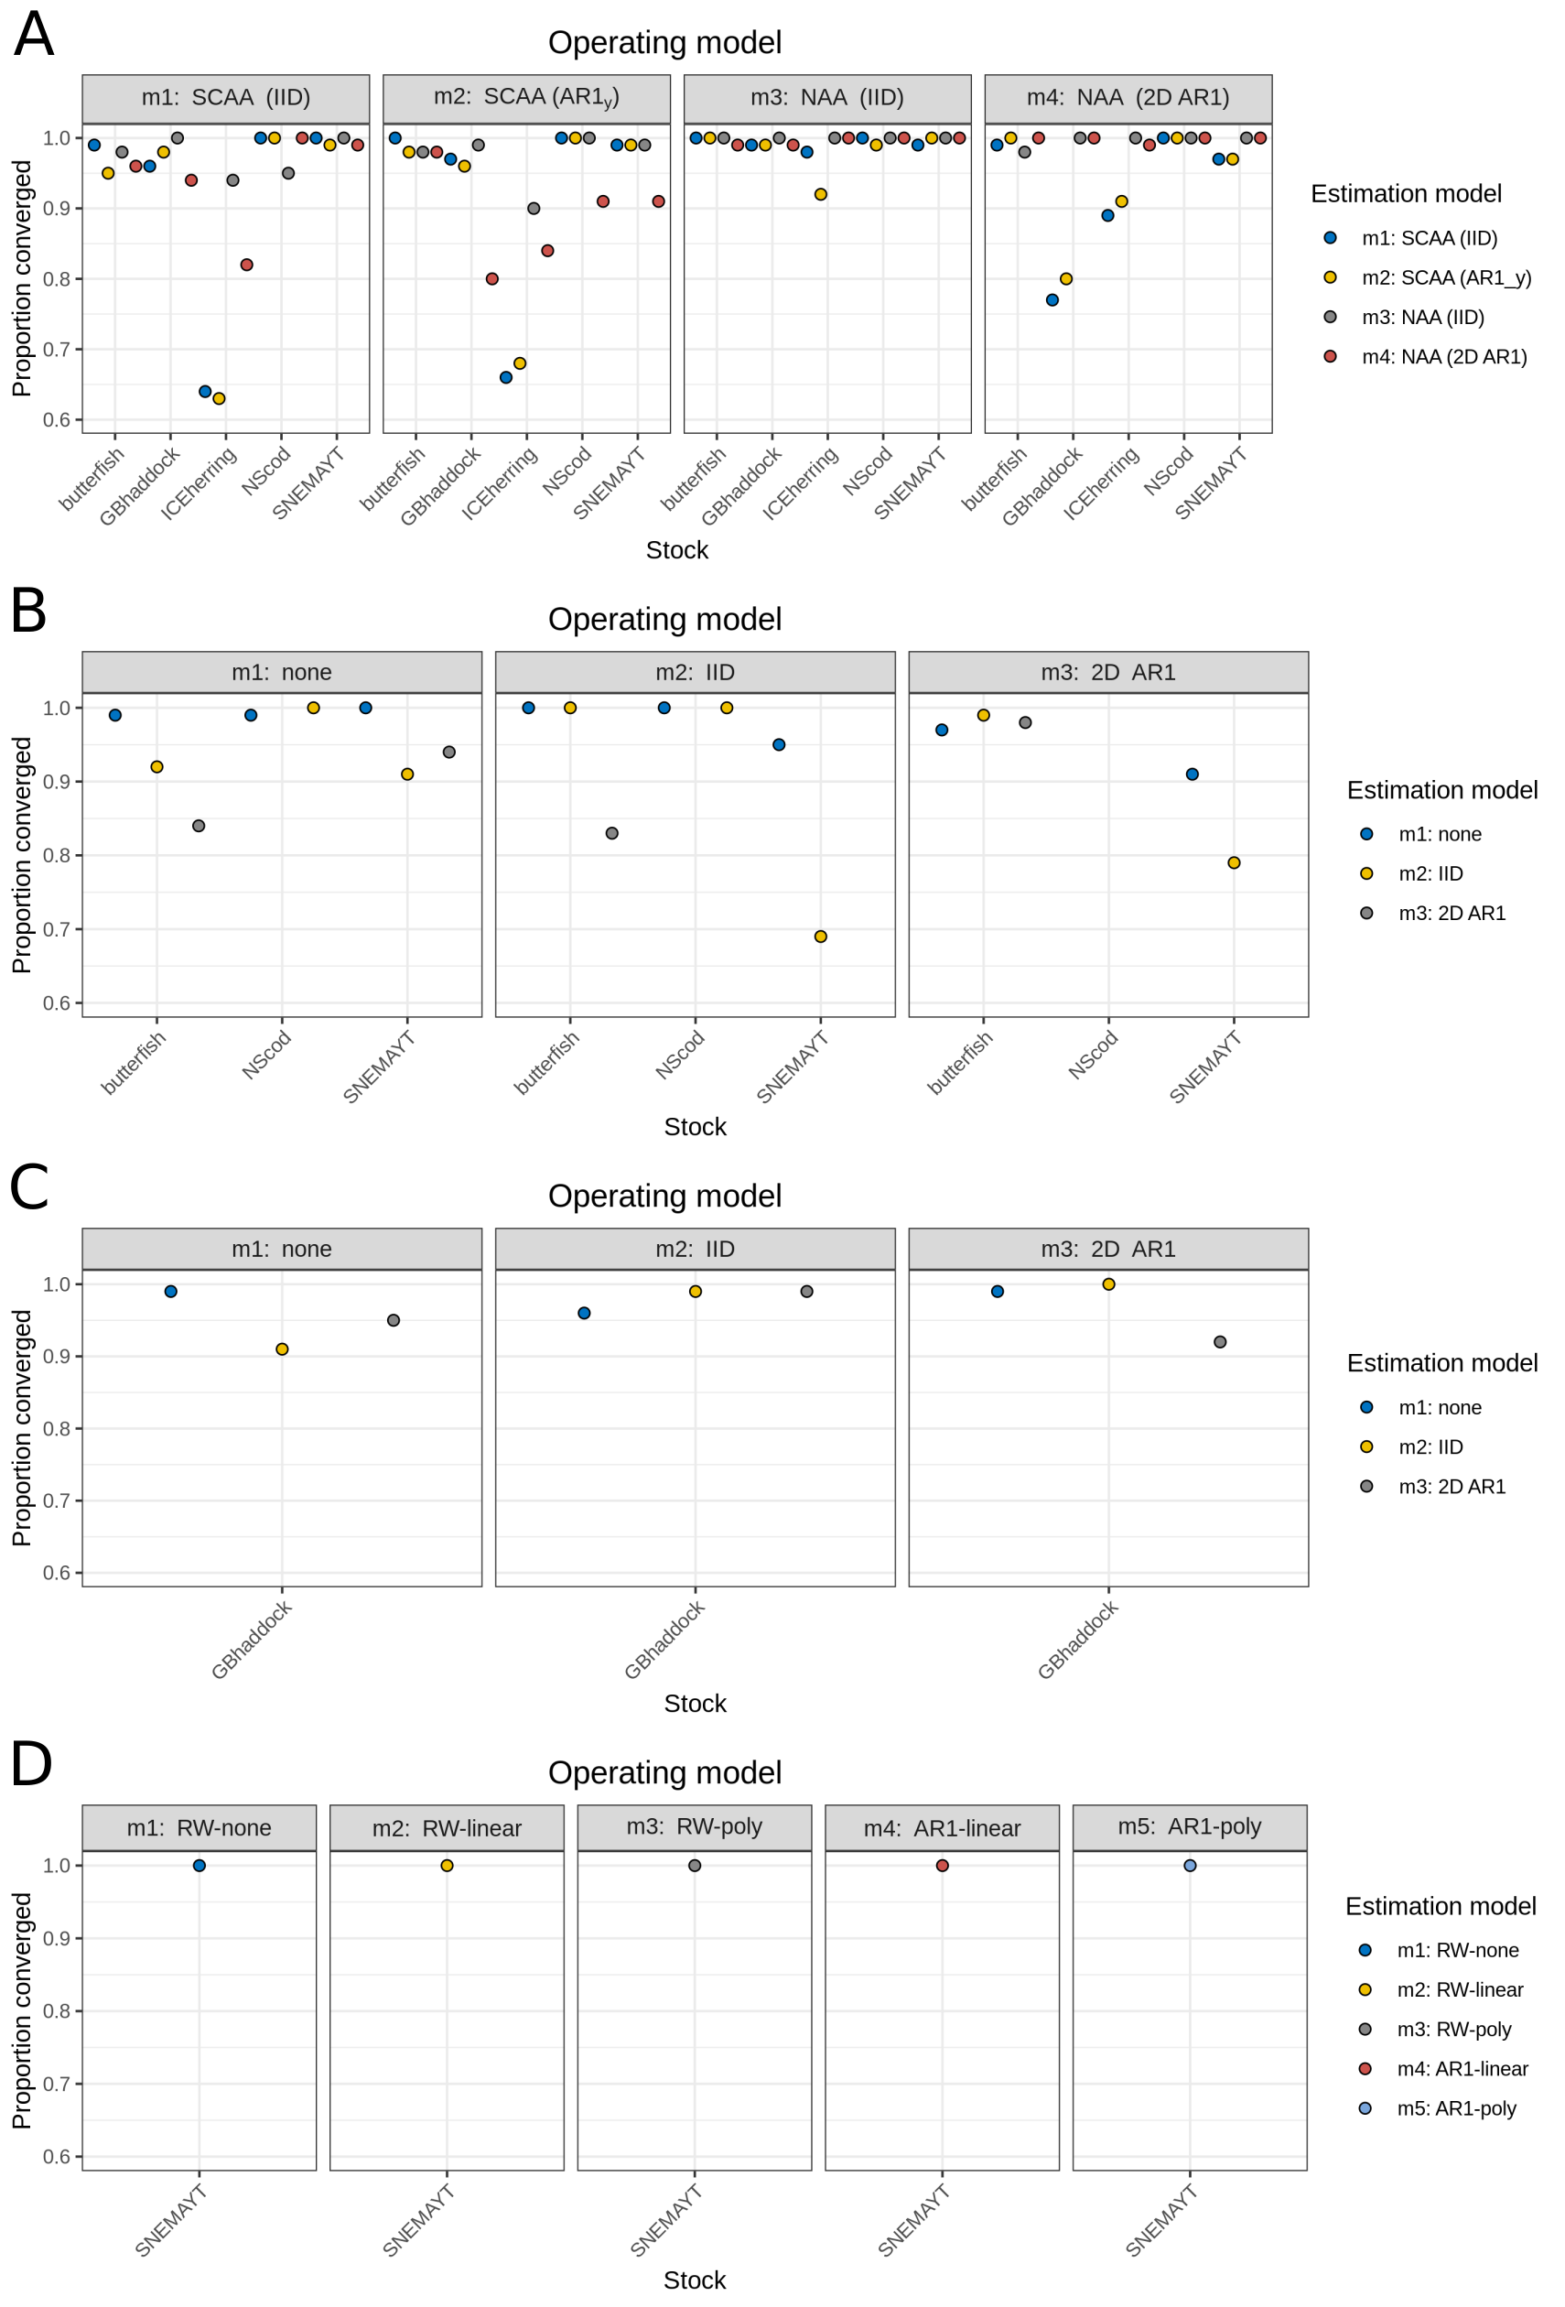

Figure S24. Proportion of cross-test simulations in which models converged for a) NAA, b) M, c) selectivity, and d) Ecov random effects. Models with positive definite Hessian matrix were considered to be converged.

