Supplemental Information

The Woods Hole Assessment Model (WHAM): a general state-space assessment framework that incorporates time- and age-varying processes via random effects and links to environmental covariates

Brian C. Stock* and Timothy J. Miller

*brian.stock@noaa.gov
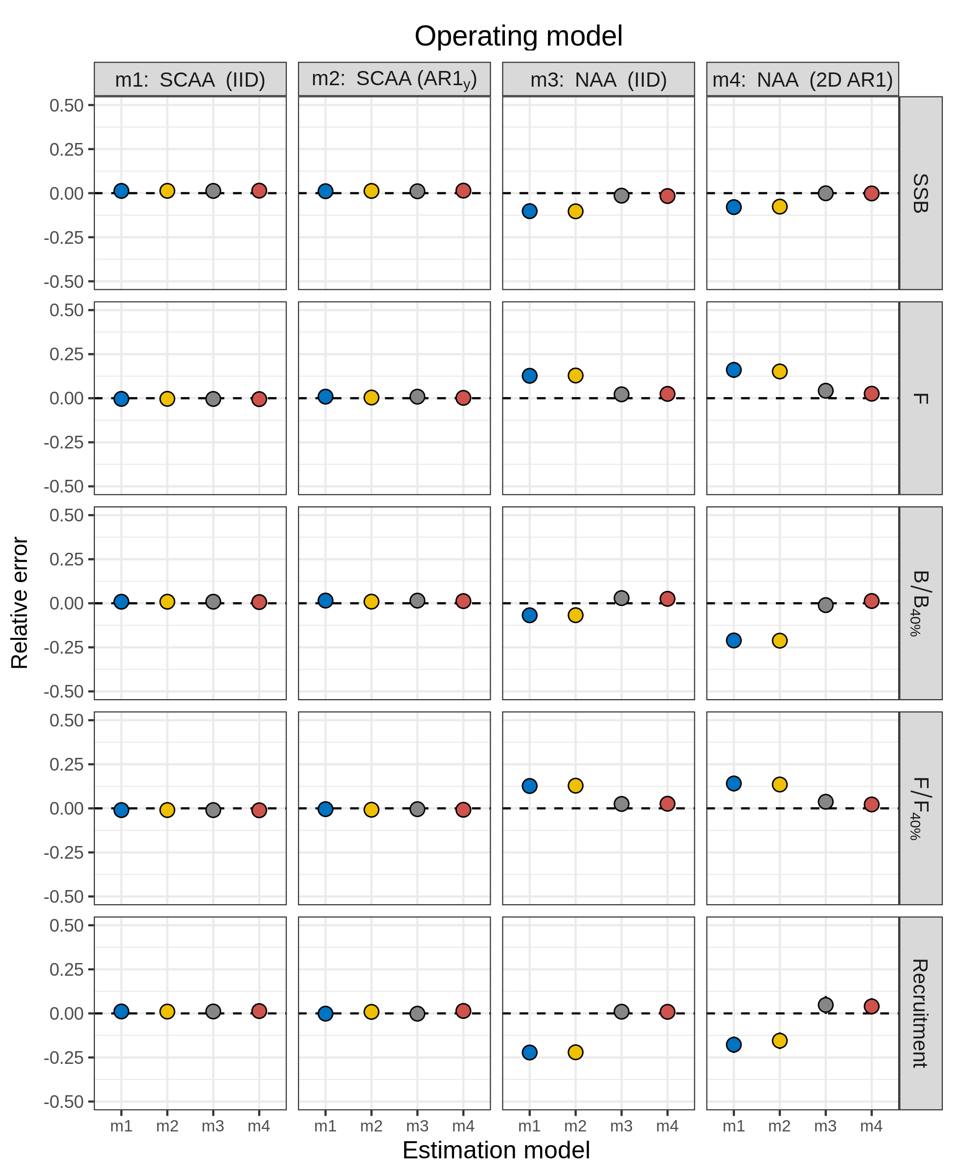
Figure S1. Relative error of key quantities estimated for SNEMA yellowtail flounder using four models of numbers-at-age (NAA) random effects. m1 = only recruitment deviations are random effects (most similar to traditional statistical catch-at-age, SCAA), and deviations are independent and identically distributed (IID). m2 = as m1, but with autocorrelated recruitment deviations (AR1). m3 = all NAA deviations are IID random effects. m4 = as m3, but deviations are correlated by age and year (2D AR1).
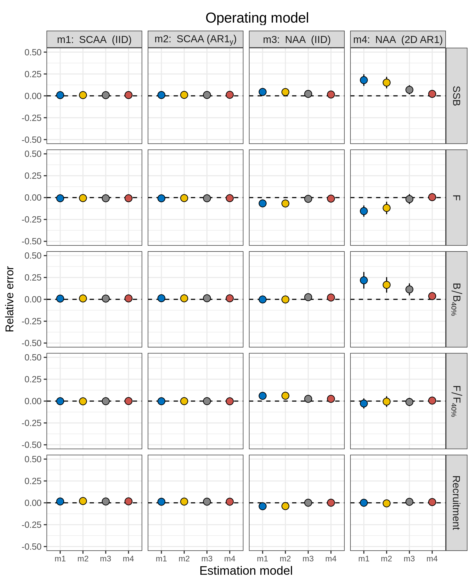
Figure S2. Relative error of key quantities estimated for butterfish using four models of numbers-at-age (NAA) random effects. m1 = only recruitment deviations are random effects (most similar to traditional statistical catch-at-age, SCAA), and deviations are independent and identically distributed (IID). m2 = as m1, but with autocorrelated recruitment deviations (AR1). m3 = all NAA deviations are IID random effects. m4 = as m3, but deviations are correlated by age and year (2D AR1).
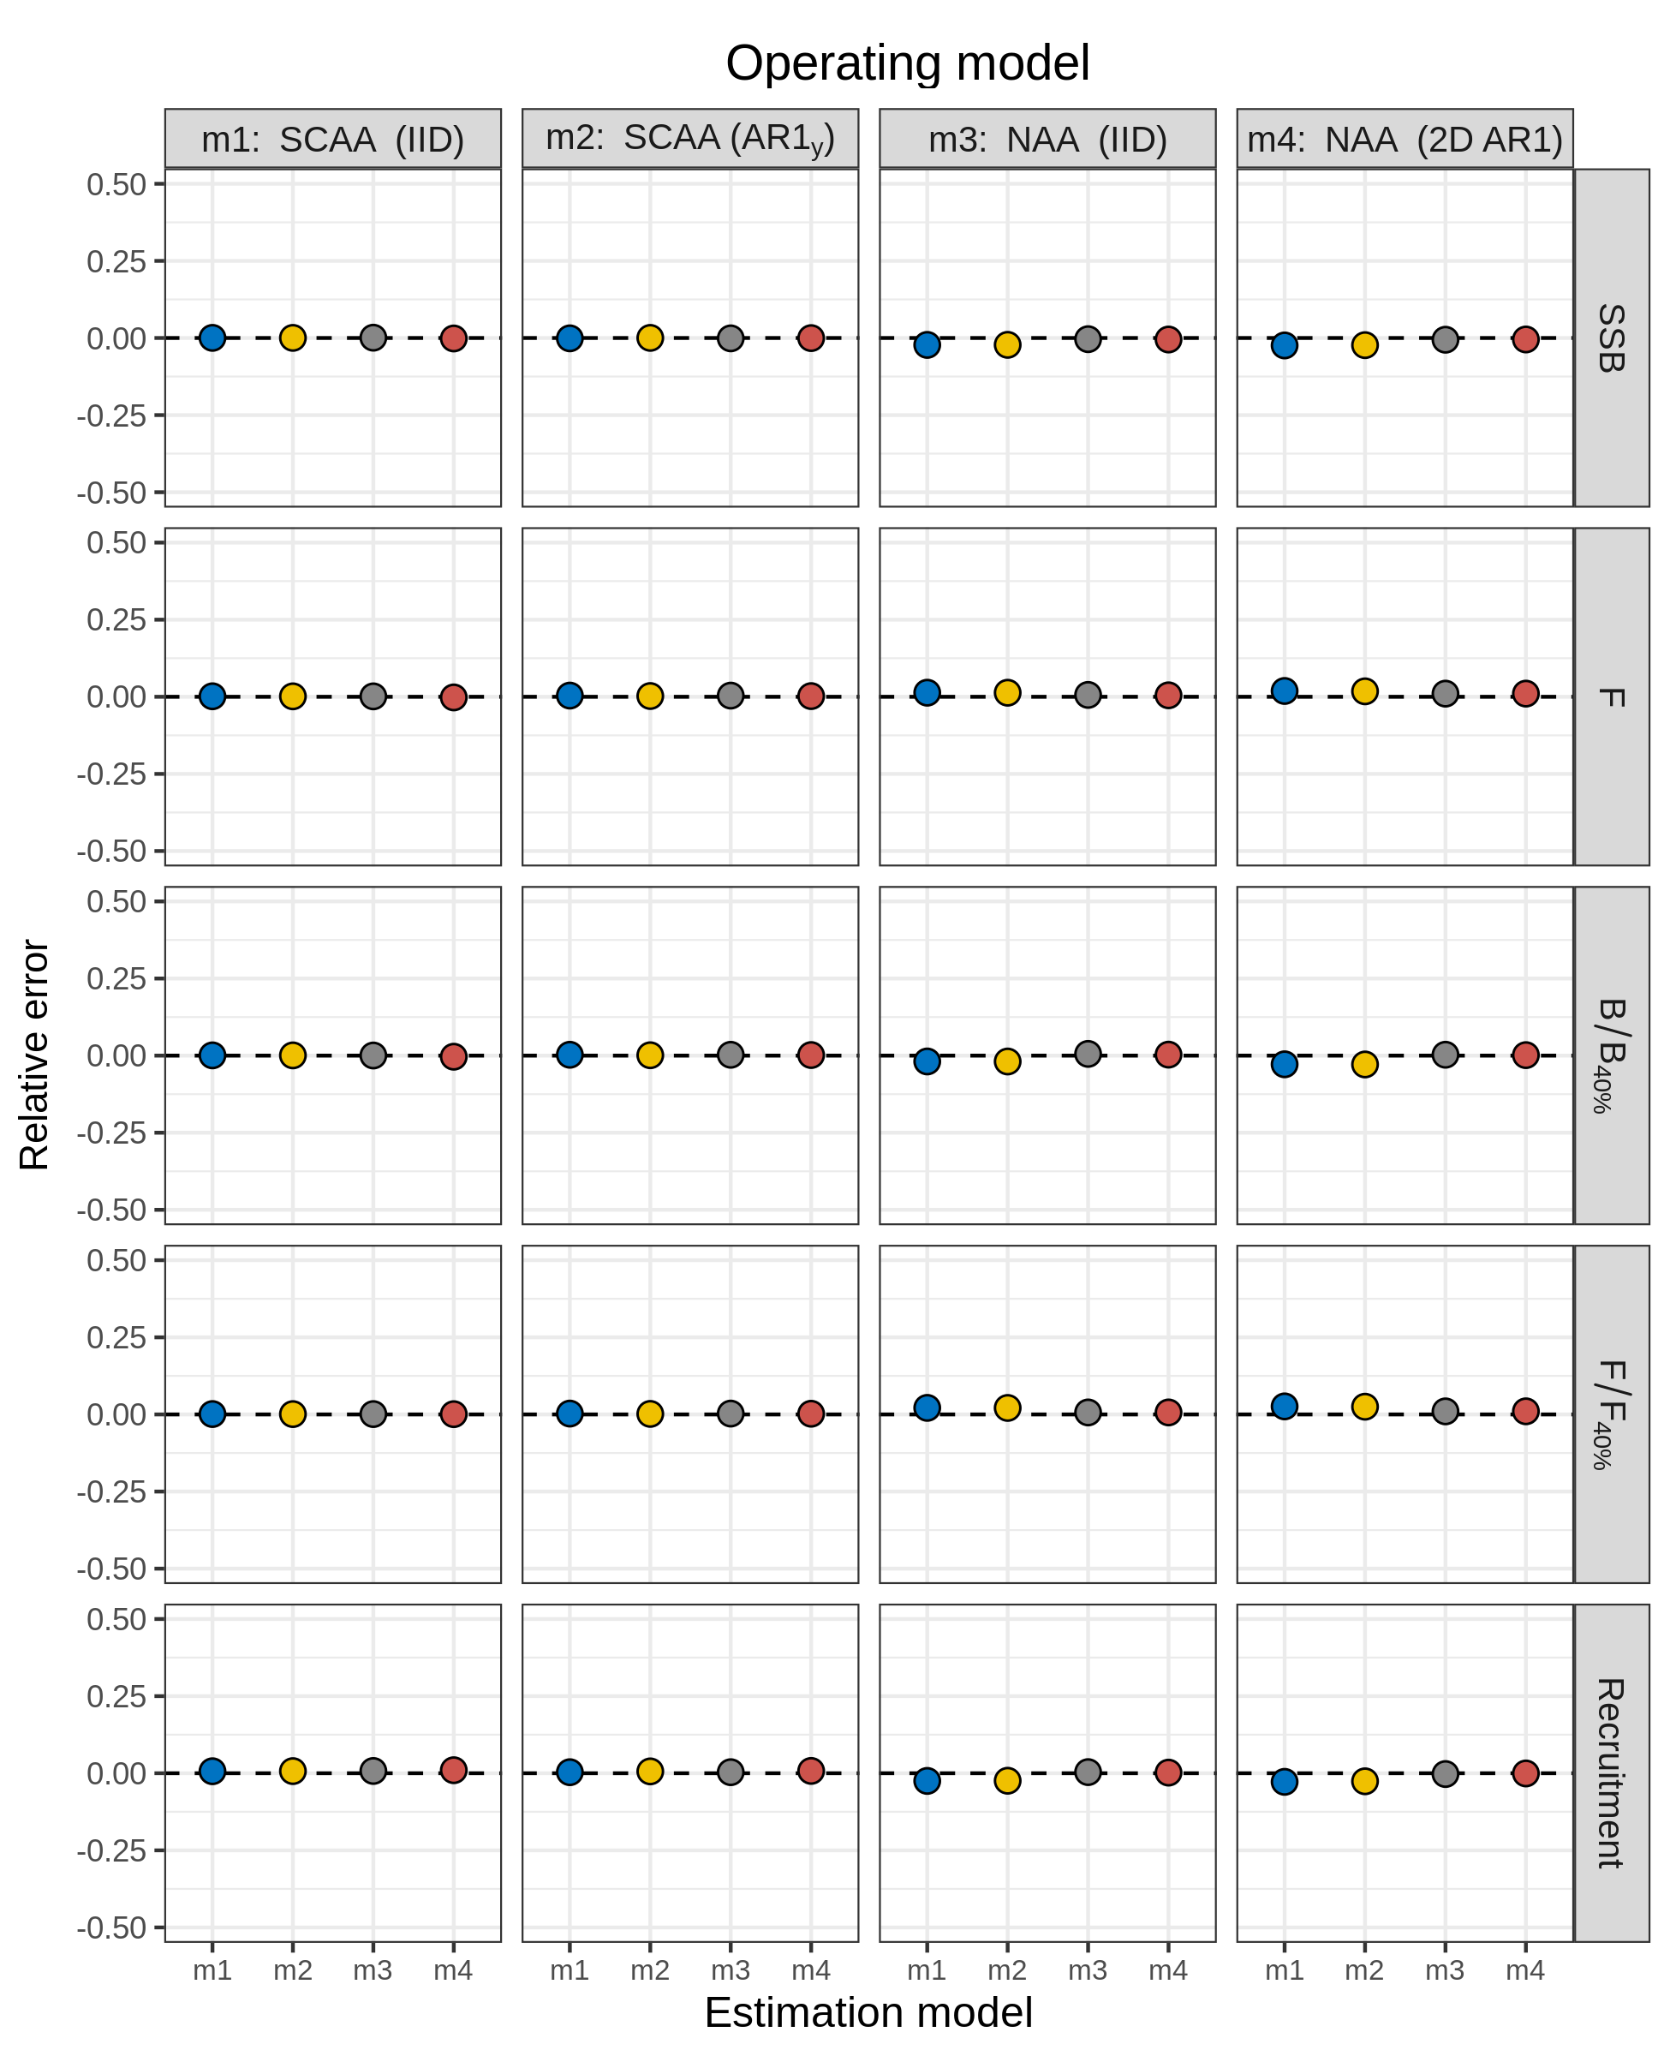
Figure S3. Relative error of key quantities estimated for North Sea cod using four models of numbers-at-age (NAA) random effects. m1 = only recruitment deviations are random effects (most similar to traditional statistical catch-at-age, SCAA), and deviations are independent and identically distributed (IID). m2 = as m1, but with autocorrelated recruitment deviations (AR1). m3 = all NAA deviations are IID random effects. m4 = as m3, but deviations are correlated by age and year (2D AR1).
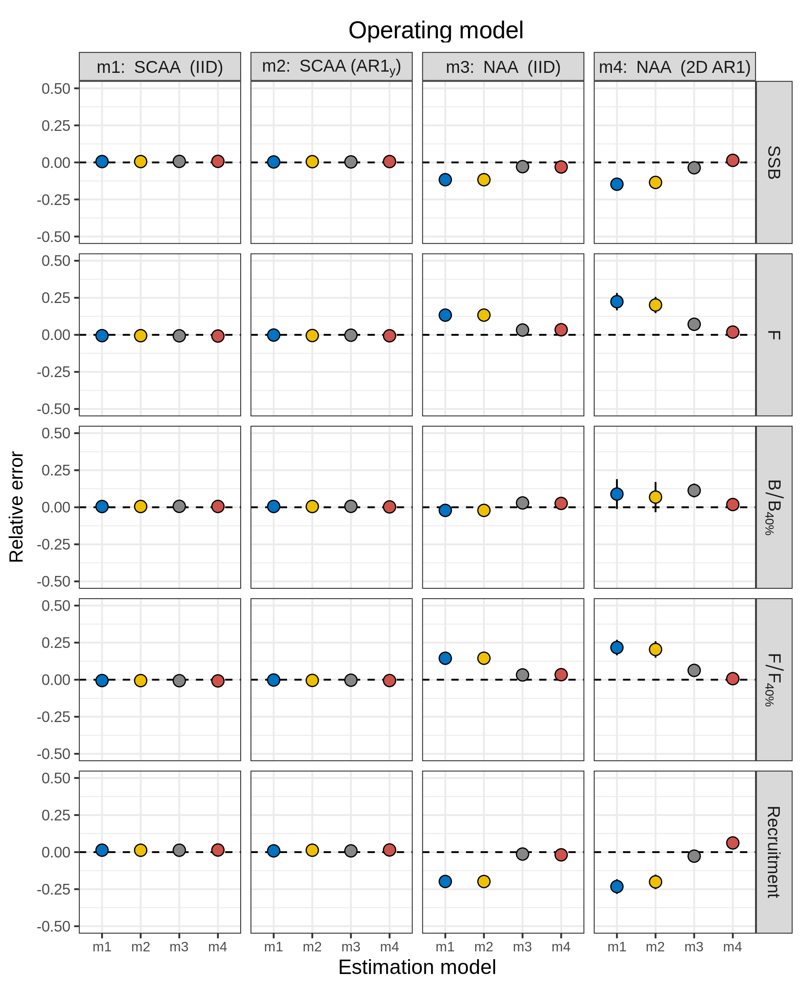
Figure S4. Relative error of key quantities estimated for Georges Bank haddock using four models of numbers-at-age (NAA) random effects. m1 = only recruitment deviations are random effects (most similar to traditional statistical catch-at-age, SCAA), and deviations are independent and identically distributed (IID). m2 = as m1, but with autocorrelated recruitment deviations (AR1). m3 = all NAA deviations are IID random effects. m4 = as m3, but deviations are correlated by age and year (2D AR1).
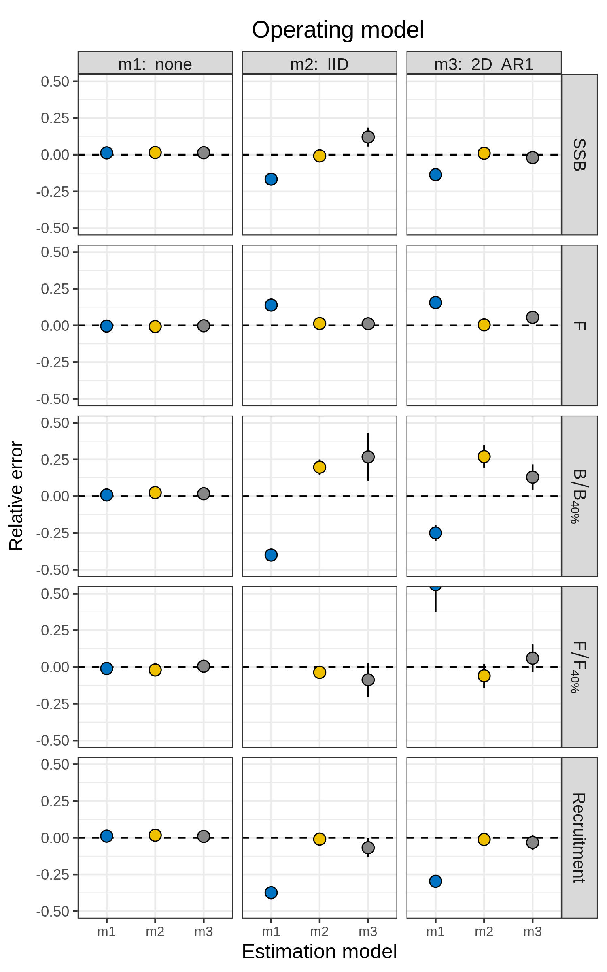
Figure S5. Relative error of key quantities estimated for SNEMA yellowtail flounder using three models of natural mortality (M) random effects. m1 = no random effects on M. m2 = M deviations are independent and identically distributed (IID). m3 = M deviations are correlated by age and year (2D AR1).
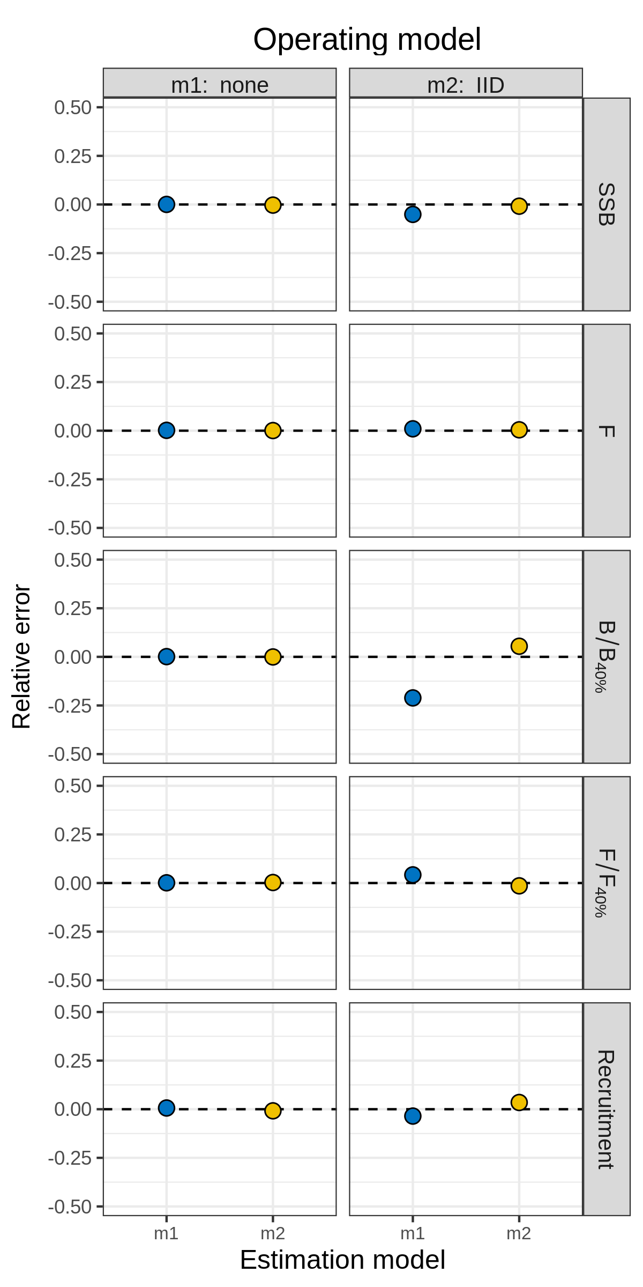
Figure S6. Relative error of key quantities estimated for North Sea cod using two models of natural mortality (M) random effects. m1 = no random effects on M. m2 = M deviations are independent and identically distributed (IID). The model with M deviations correlated by age and year (m3, 2D AR1) did not converge.
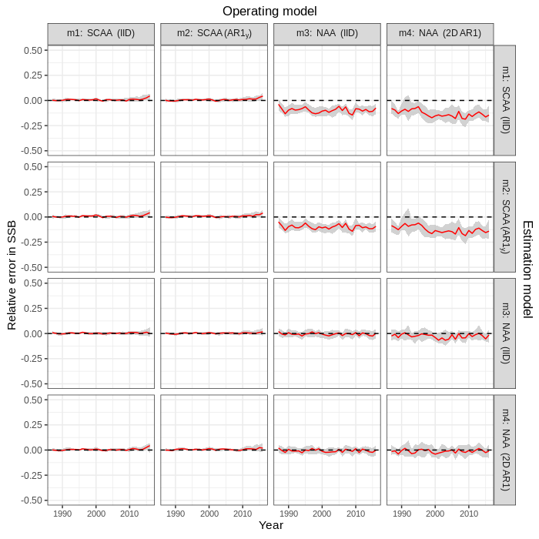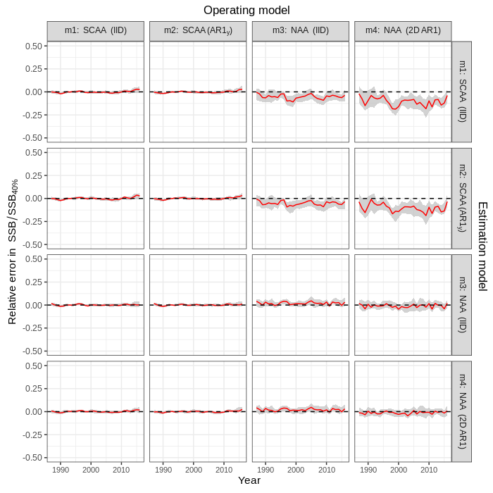
Figure S7. Relative error in SSB (left) and SSB / SSB_{40%} (right) in simulation cross-tests for the four numbers at age (NAA) models fit to Icelandic herring data. Relative error was calculated as , where was the estimate in simulation i for parameter θ, and was the true value (estimate from original dataset). Solid red lines and grey shading show the median relative error with 95% CI, calculated within year and across simulations.
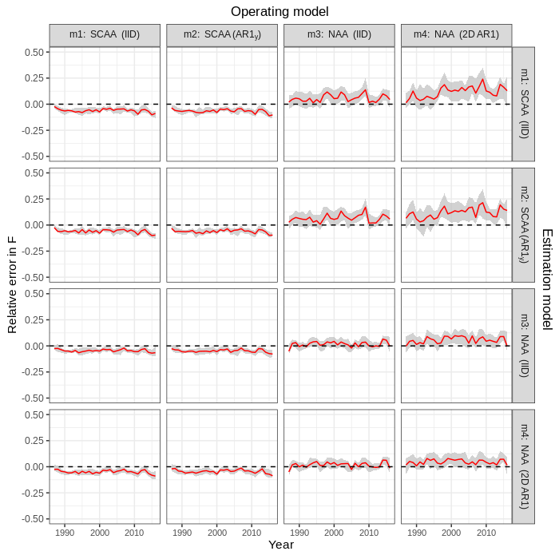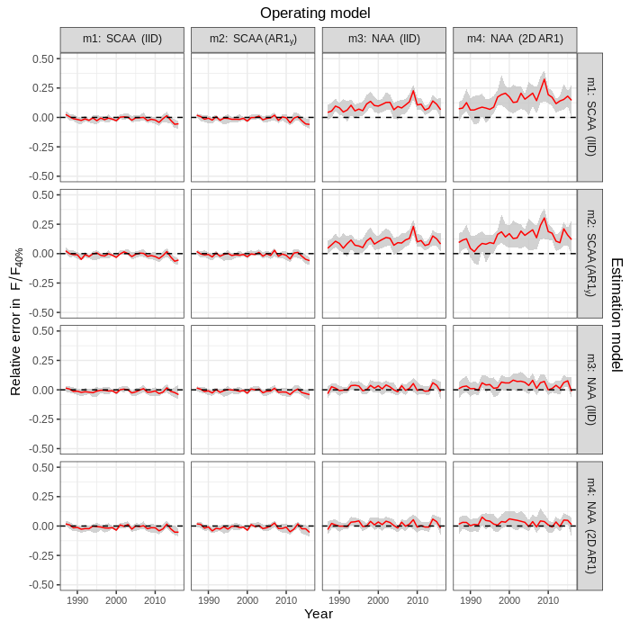
Figure S8. Relative error in F (left) and F / F_{40%} (right) in simulation cross-tests for the four numbers at age (NAA) models fit to Icelandic herring data. Relative error was calculated as , where was the estimate in simulation i for parameter θ, and was the true value (estimate from original dataset). Solid red lines and grey shading show the median relative error with 95% CI, calculated within year and across simulations.
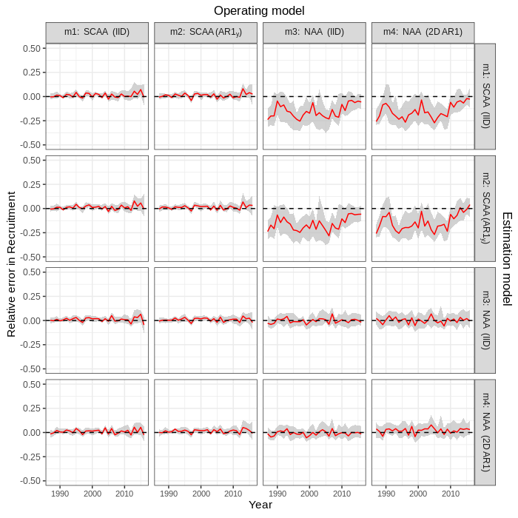
Figure S9. Relative error in recruitment in simulation cross-tests for the four numbers at age (NAA) models fit to Icelandic herring data. Relative error was calculated as , where was the estimate in simulation i for parameter θ, and was the true value (estimate from original dataset). Solid red lines and grey shading show the median relative error with 95% CI, calculated within year and across simulations.
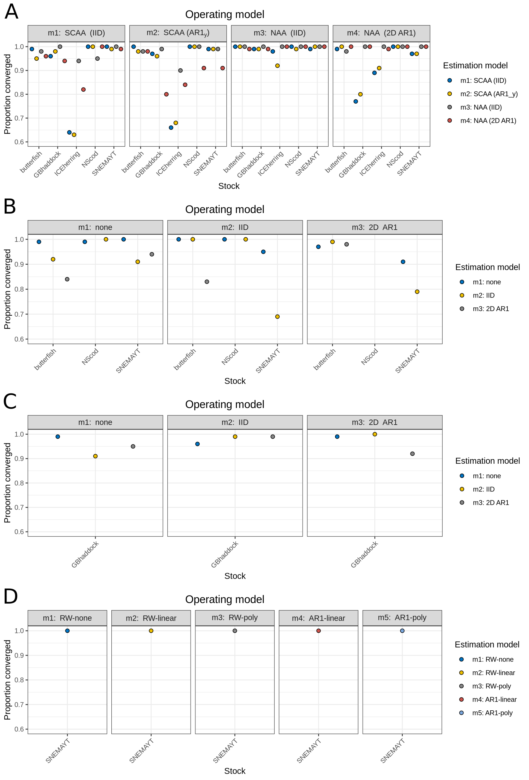

Figure S10. Proportion of cross-test simulations in which models converged for a) NAA, b) M, c) selectivity, and d) Ecov random effects. Models with positive definite Hessian matrix were considered to be converged.

