

**Very Simple Share**

**QUICK START :**

1. **Create a new Canvas if there is no Canvas in your scene.**

To create a new one : 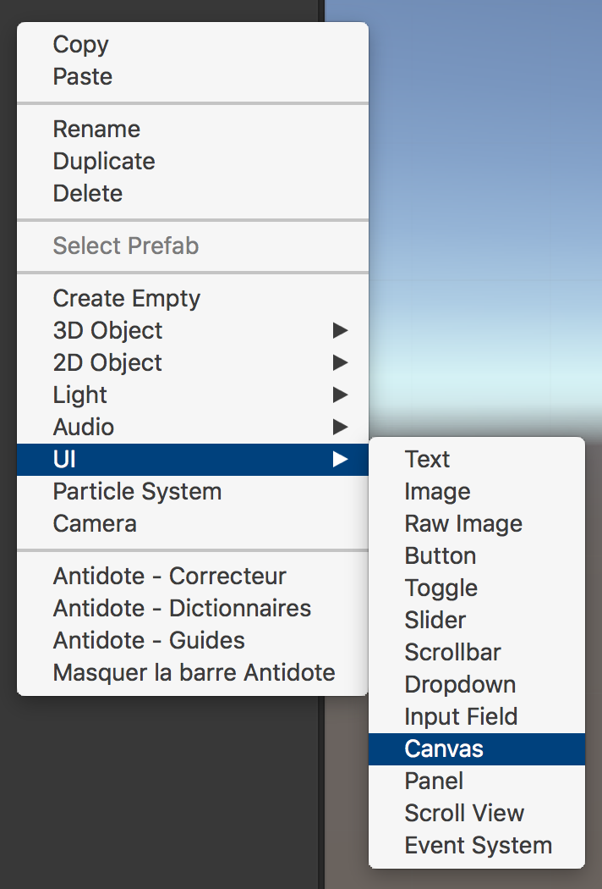

1. **Find the VSSHARE prefab :**

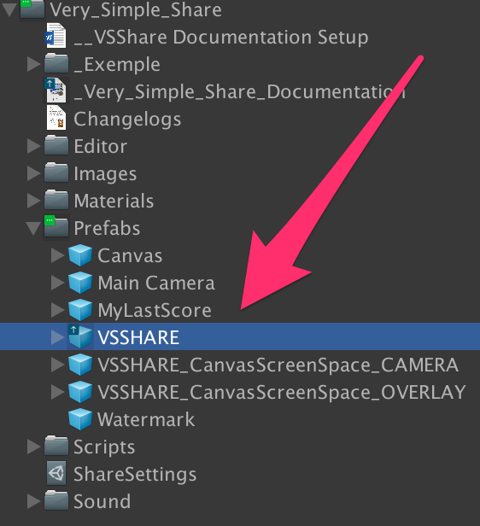

1. **Drag and drop the VSShare prefab in the scene as a child of the Canvas :**

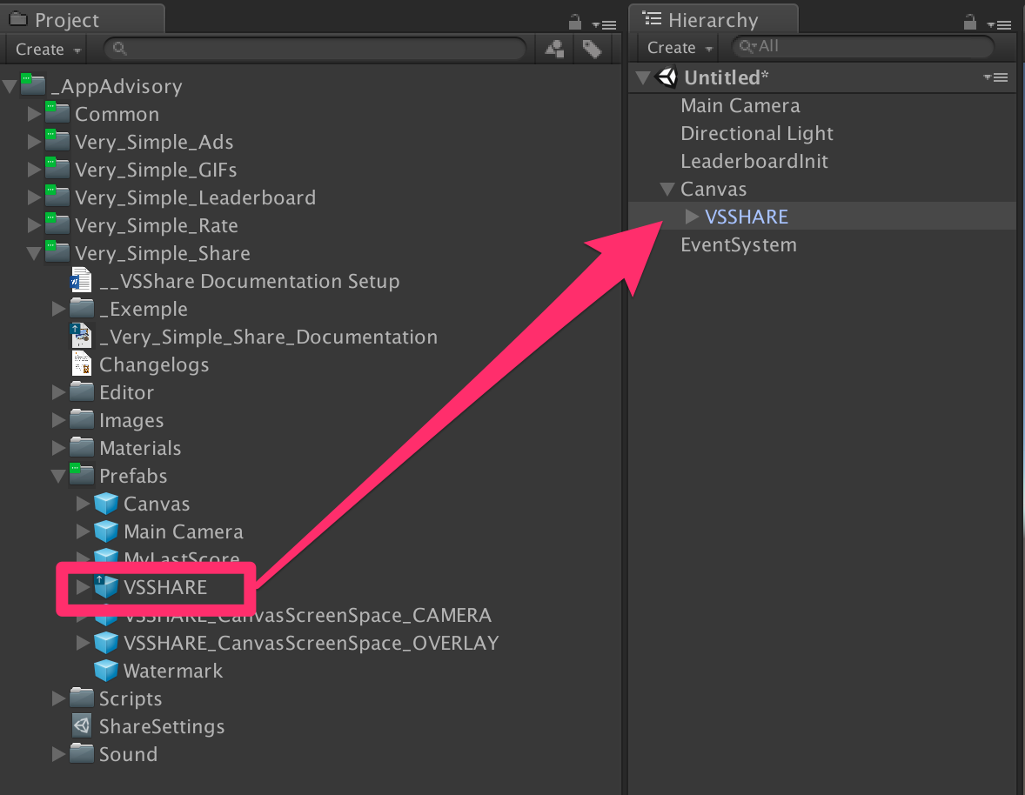

1. **Take the screenshot :**

Always import the sharing system at the top of your script to be able to call the methods :

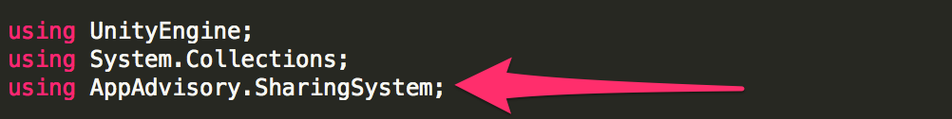

To take a screenshot, you have to call this method :

**./../../../../../../../../var/folders/3d/_68g_**

1. **Show the screenshot :**

You can show the screenshot only after you take one.

To show the screenshot in the VSSHARE UI Game Object, call this method :

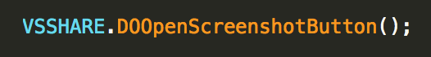

The VSSHARE **button** will appear on the screen.

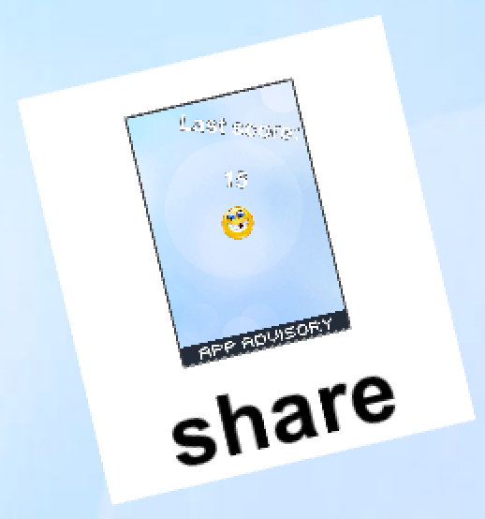

(image from the demo scene)

You can close (= hide) the screenshot button (at this state only) by calling :

./../../../../../../../../var/folders/3d/_68g_

1. **Open the screenshot sharing window:**

Just click/touch the VSSHARE button (view in 5) section).

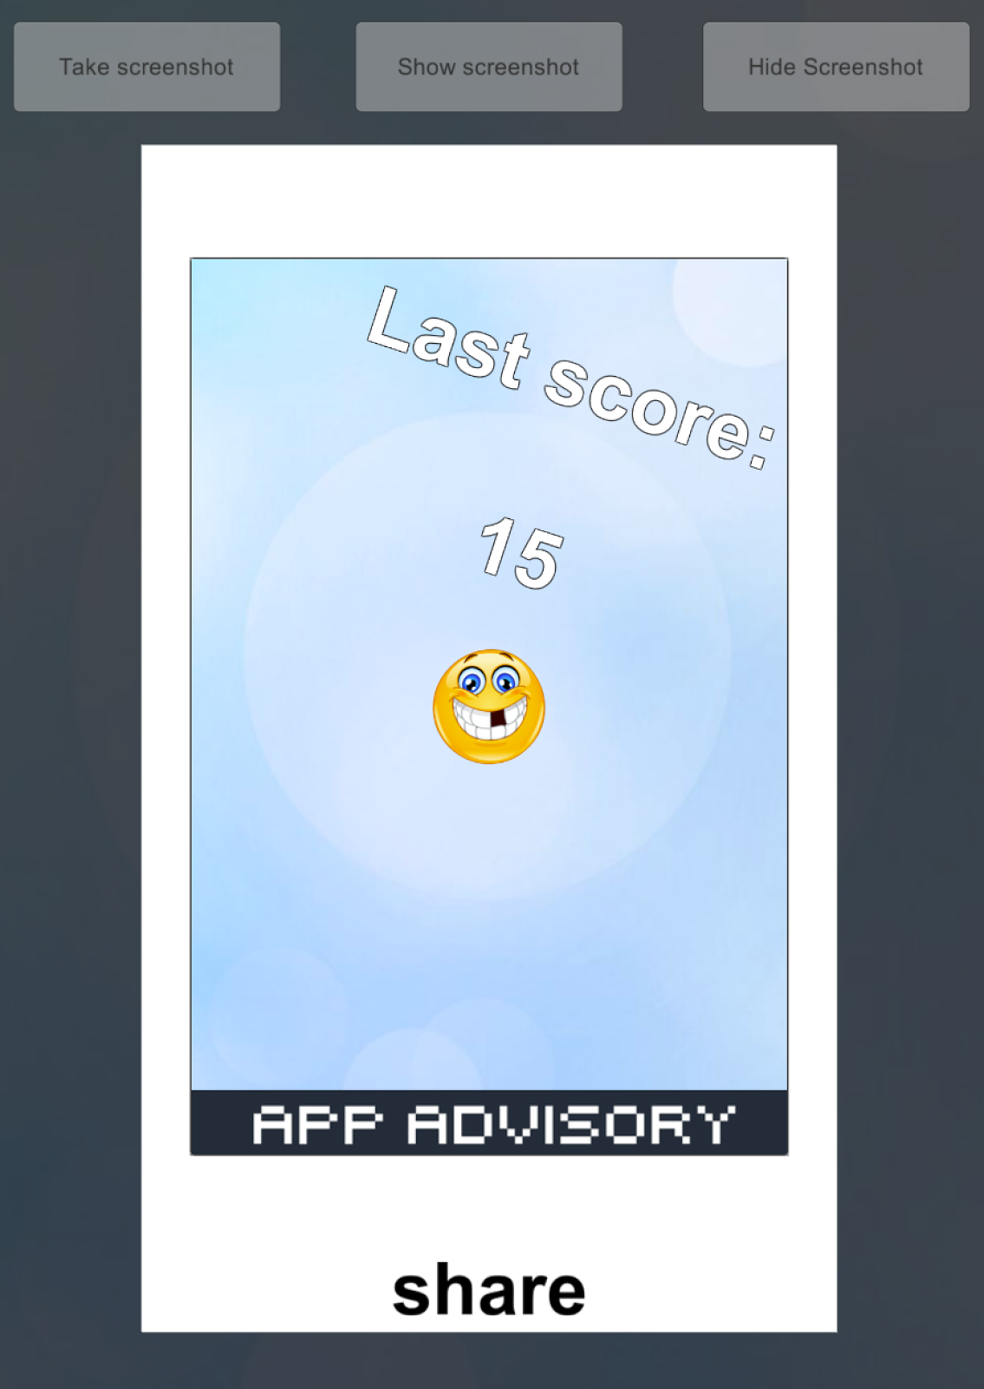

(image from the demo scene)

You can do it from code with this method :

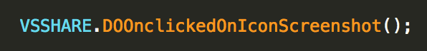

1. **Share or close the screenshot sharing window:**

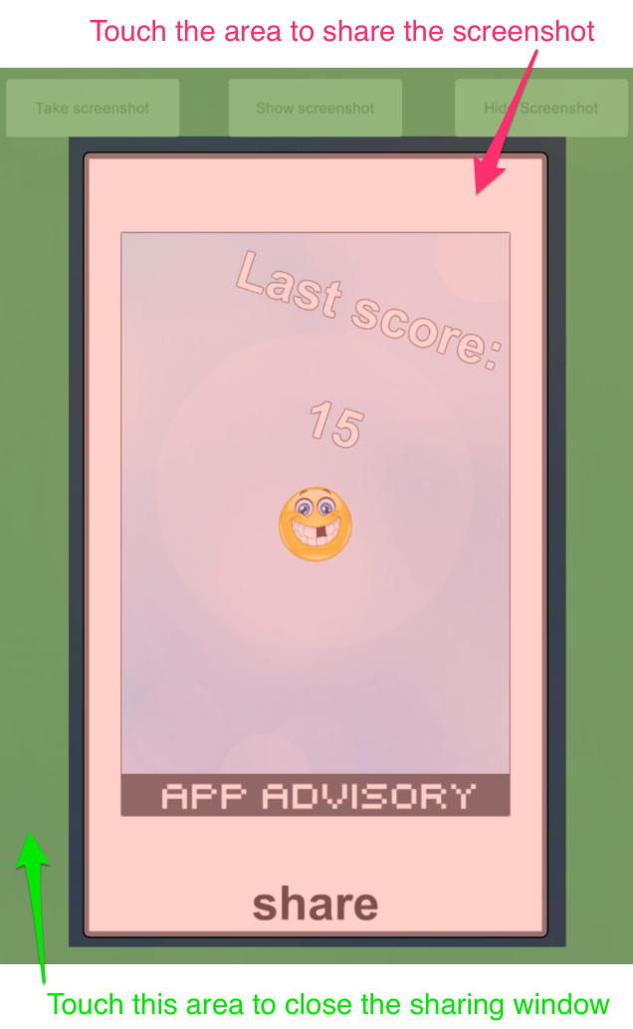

(image from the demo scene)

To close this windows from code:

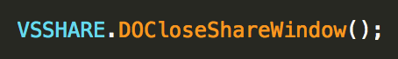

To share the screenshot from code :



**DELEGATES**

You can subscribe to some delegates to have more controls.

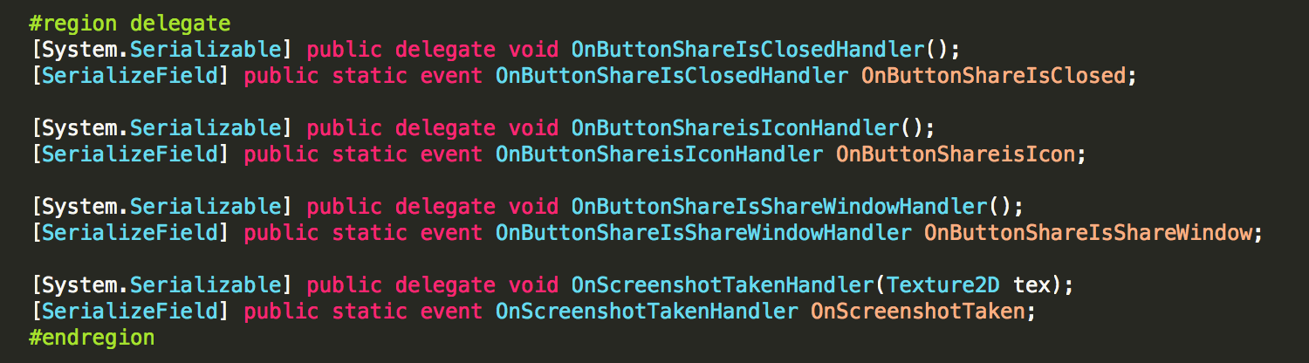

**Delegate which is called when a screenshot is taken :**



Example of use :

BtnTakeScreenshot.cs in the example scene.

Make the subscription :



Receive the event :

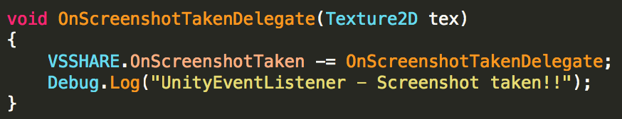

The delegate return the Texture2D (= the screenshot).

**Delegate which is called when the VSSHARE if in the icon state :**



Make the subscription :

./../../../../../../../../var/folders/3d/_68g_

Receive the event :

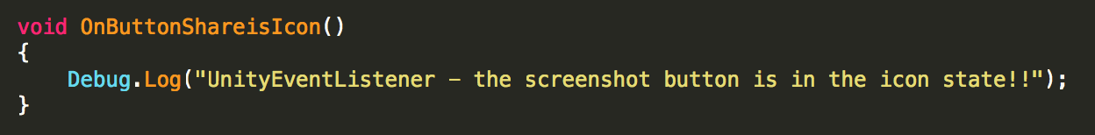

**Delegate which is called when the VSSHARE if in the full screen sharing window state :**

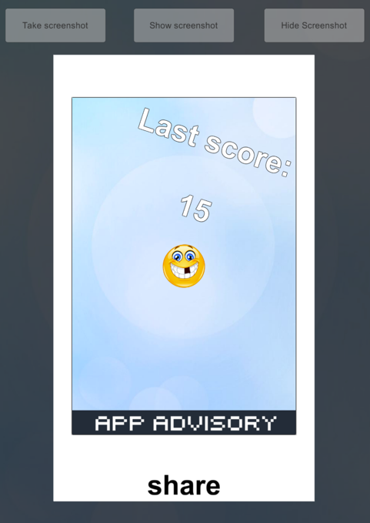



Make the subscription :



Receive the event :

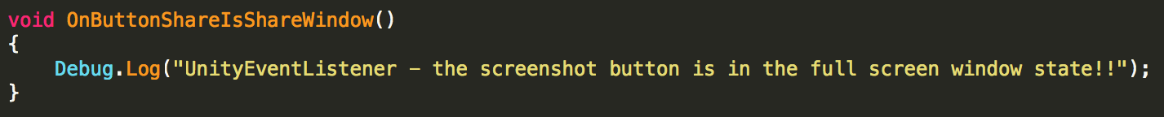

**Delegate who is called when the VSSHARE is closed:**



Make the subscription :

./../../../../../../../../var/folders/3d/_68g_

Receive the event :

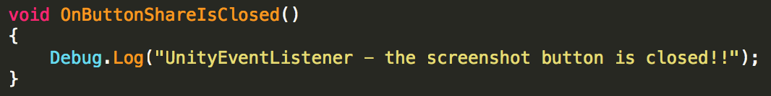

**Customization**

**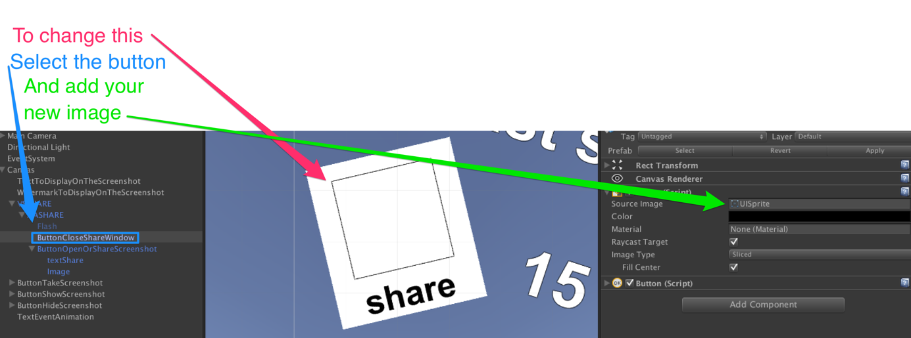**

**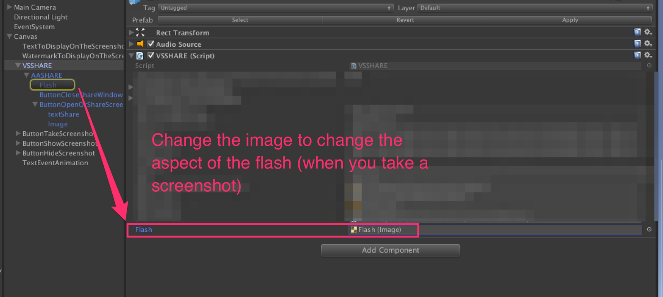**

Open the Settings Window

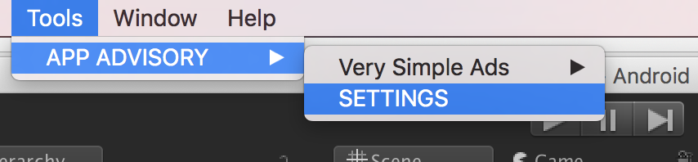

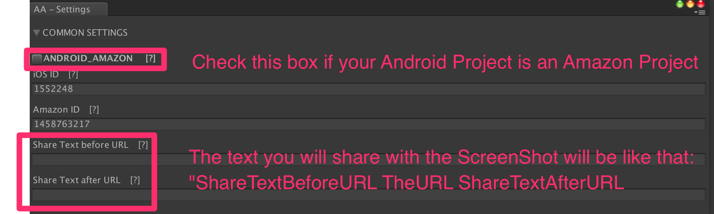

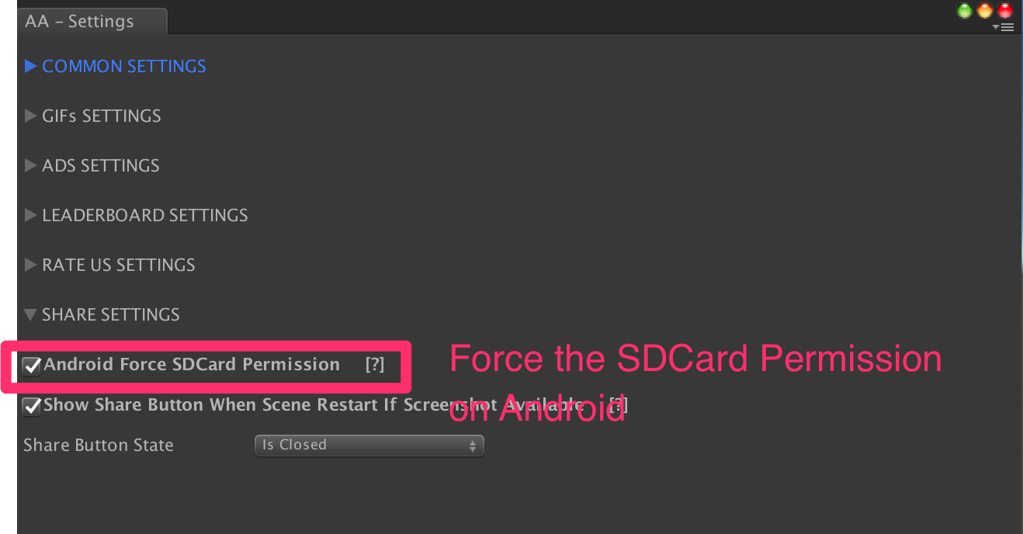

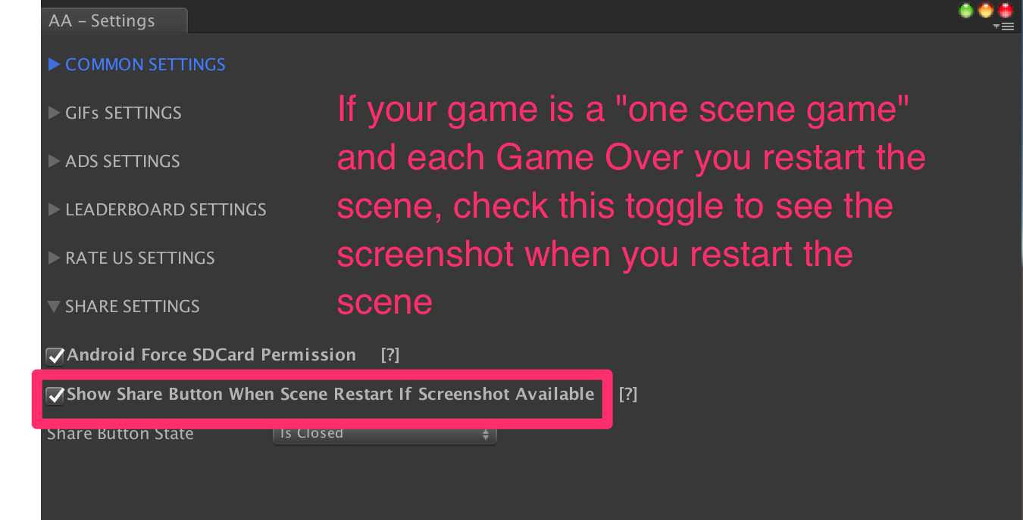

**TIPS :**

* Add text, image (like watermark) etc to the screenshot (and only visible on the screenshot !) :

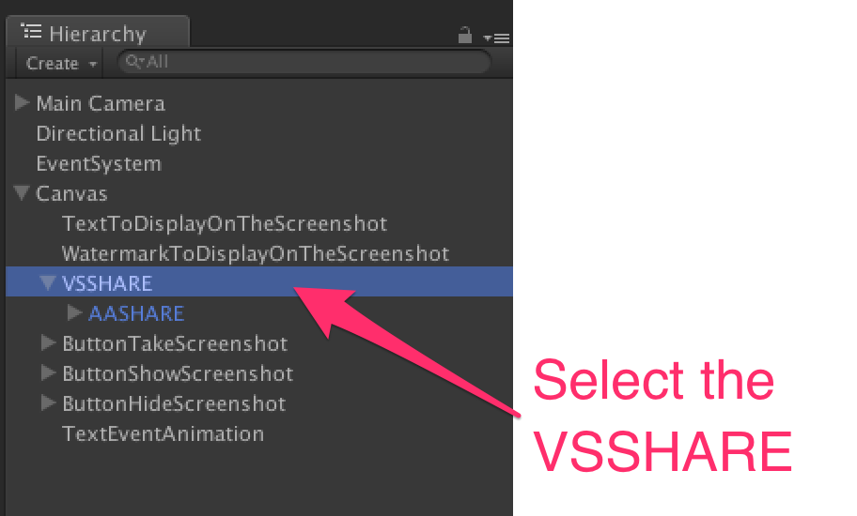

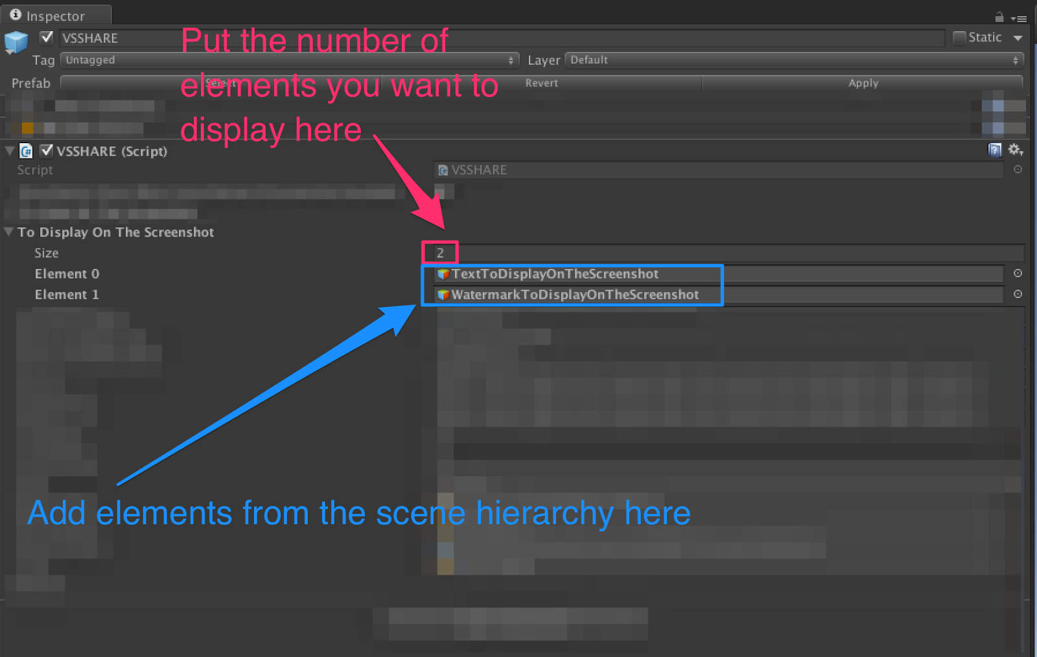

* Hide some scene elements in the screenshot :

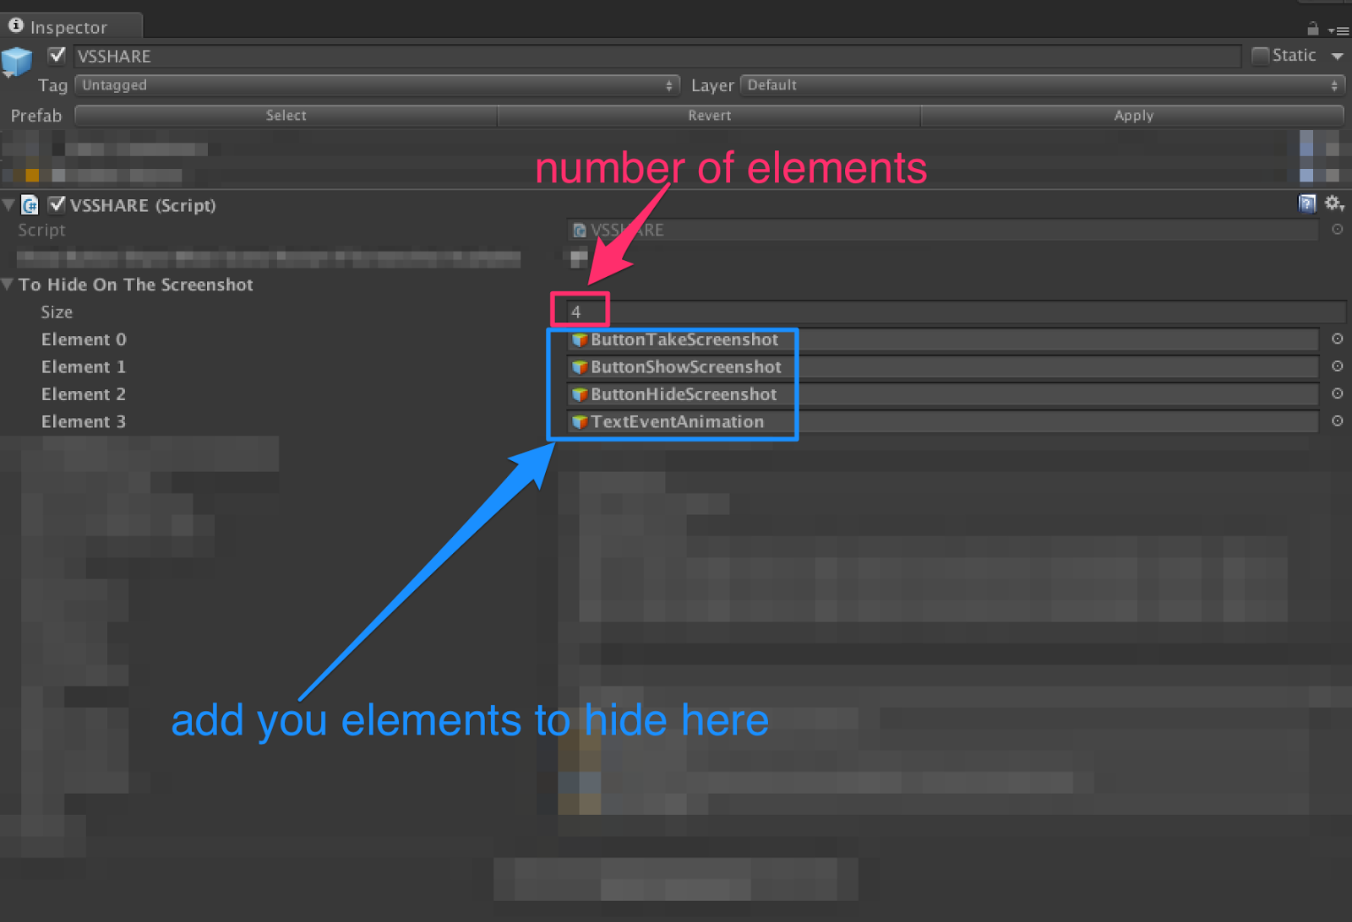

Thanks!

Please rate my file, I’d appreciate it! <http://u3d.as/u3N>

Produced by App Advisory - <http://app-advisory.com>

Facebook: <https://facebook.com/appadvisory>

Contact us: <https://appadvisory.zendesk.com/hc/en-us/requests/new>

App Advisory Unity Asset Store catalog: <http://u3d.as/9cs>

Developed by Gilbert Anthony Barouch - <https://www.linkedin.com/in/ganbarouch>

Inquiries: <https://appadvisory.zendesk.com/>

**Very Simple Ads:**

Everything is done for you: « Very Simple Ad » is already implemented.

Get it here:<http://u3d.as/oWD>

**Very Simple Rate:**

Everything is done for you: « Very Simple Rate » is already implemented.

Get it here: <http://u3d.as/Dt2>

**Very Simple Leaderboard:**

Everything is done for you: « Very Simple Leaderboard » is already implemented.

Get it here:<http://u3d.as/qxf>

**Very Simple GIF:**

Everything is done for you: « Very Simple GIF » is already implemented.

Get it here:<http://u3d.as/ACQ>

