|  |  |  |  |
| --- | --- | --- | --- |
| R(x) |  |  |  |
| W(x) |  |  |  |
|  | R(x) |  |  |
| W(x) |  |  |  |
|  |  | W(x) |  |
|  |  |  | W(x) |

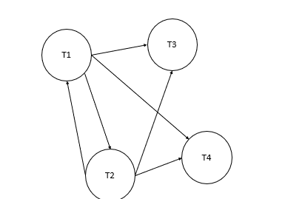

Nicht konflikt-serialisierbar

T2 könnte nur mit T1 parallel laufen

Nicht view-serialisierbar

|  |  |  |
| --- | --- | --- |
|  | R(z) |  |
| R(x) |  |  |
| W(x) |  |  |
|  |  | R(y) |
|  | R(x) |  |
| W(y) |  |  |
| R(x) |  |  |
|  |  | W(z) |
|  | R(y) |  |
|  | R(z) |  |

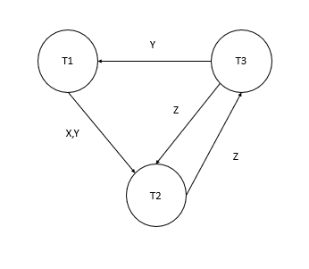

Nicht konflikt-serialisierbar

T3 vor T1

T1 vor T2

T

|  |  |  |  |  |
| --- | --- | --- | --- | --- |
|  | R(x) |  |  |  |
| W(y) |  |  |  |  |
|  |  | W(y) |  |  |
|  |  |  |  | R(z) |
| R(z) |  |  |  |  |
|  |  |  | W(x) |  |
|  | R(z) |  |  |  |
|  |  |  | W(t) |  |
| W(t) |  |  |  |  |
|  |  | R(y) |  |  |

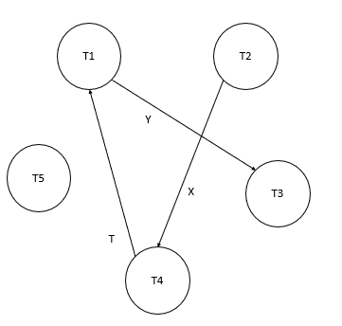

Konflikt-serialisierbar

T1 vor T3

T2 vor T4

T4 vor T1

S = T2, T4, T1, T3, T5

view-serialisierbar

|  |  |  |  |  |
| --- | --- | --- | --- | --- |
|  | W(x) |  |  |  |
| W(t) |  |  |  |  |
|  |  |  | R(t) |  |
| R(x) |  |  |  |  |
|  |  | R(t) |  |  |
| W(y) |  |  |  |  |
|  |  |  |  | R(y) |
|  |  | W(t) |  |  |
|  |  |  |  | W(y) |
|  |  |  |  | R(t) |
| R(z) |  |  |  |  |

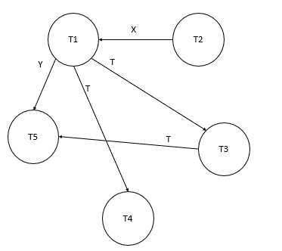

Konflikt-serialisierbar

T1 vor T3, T4, T5

T4 vor T3

T3 vor T5

T2 vor T1

T2, T1, T4, T3, T5

view-serialisierbar

|  |  |  |  |
| --- | --- | --- | --- |
| R(y) |  |  |  |
|  |  | W(x) |  |
|  | R(y) |  |  |
|  |  |  | R(x) |
| W(y) |  |  |  |
|  |  |  | W(z) |
|  |  |  | R(y) |
|  | W(y) |  |  |
|  | W(x) |  |  |

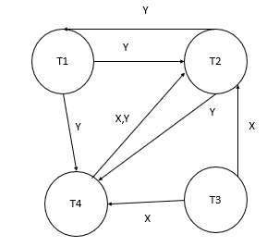

Nicht-konflikt-serialisierbar

T3 vor T4, T2

T4 vor T2

T1 vor T4

Nicht view-serialisierbar da T2 nur parallel zu T1 laufen kann