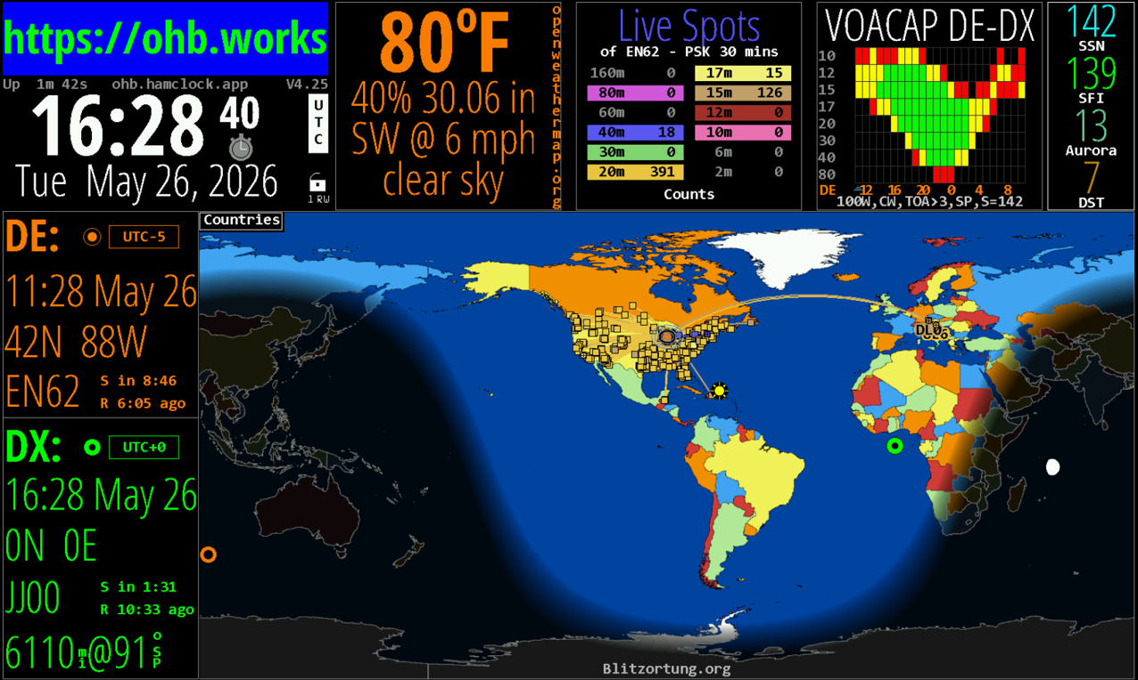

HamClock

User’s Guide

V4.32
September, 2026



Open HamClock Backend Team (OHB)

Table of Contents
Introduction 7
Current Main Features 7
Installation 9
System Description 9
Setup 10
How to remote connect 11
Enter the Setup menus 12
Setup Page 1 13
Setup Page 2 14
Setup Page 3 15
Setup Page 4 17
Setup Page 5 19
Setup Page 6 21
Setup Page 7 22
Setup Page 8 23
Operations 24
Local Info area 25
Lock Menu 27
Upper Data Panes 28
Space WX 29
DX & Contest 33
Weather 39
Sky & Space 43
Other 46
Upper Auxiliar Pane 51
Left Flex Panes 53
The DE pane 53
Data Panes 53
The DX pane 60
Main Map Area 62
Map Overlays 63
Map Projections 64
Mercator Projection 64
Azimuthal Projections 66
Azimuthal Equidistant (Hemisphere View) 67
Robinson Projection 69
Zoom levels 71
Grid overlays 72
Map Styles 73
Countries 73
Terrain 73
Wildfire Overlay 74
ADS-B Overlay 74
DRAP 75
MUF-VCAP 76
MUF-RT 77
Aurora 78
Weather 80
WEFAX 82
Wind 84
Clouds 84
REL (Reliability) 86
TOA (takeoff angle) 87
RSS Banner 88
Night 88
Cities 88
Lightning 88
Pop up panels in maps. 88
Satellite Information 90
Choose satellites/Show DX info here 91
Show pass here 91
Show rise/set table 91
Show freq/modes 92
Show planning tool 93
Show pass progression 93
Show Sky View 94
Show OrbTrack 94
Show SatNogs 95
Show Status 96
Planets 97
Clock Functions 98
Time 98
Stopwatch and Alarms 98
Big Clock 99
Count down 100
Brightness and Light sensor controls 100
On/Off timers 100
Mobile Dashboard 101
Watch Lists 102
External IO Options (Raspberry-Pi only) 104
GPS (Raspberry-Pi only) 106
Android, Fire Tablet and Fire TV Installation and Operational Differences 107
Installation 107
Setup and Configuration 107
Operational Differences 108
Command Line Options 109
RESTful Webserver Command Reference 110
Directional Antenna Maps 112
APRS Symbols — The Full Symbol Chart 113
Version History 114
Version 4.32 September 2026 114
Version 4.31 August 2026 114
Version 4.30 August 2026 114
Version 4.29 August 2026 115
Version 4.28 August 2026 115
Version 4.27 July 2026 115
Version 4.26 June 2026 116
Version 4.25 May 2026 116
Version 4.24: May 2026 116
Version 4.23: April 2026 116
Version 4.22: 2026-01-17 116
Version 4.21: 2025-09-06 117
Version 4.20: 2025-07-06 117
Version 4.19: 2025-06-10 117
Version 4.18: 2025-06-07 117
Credits 118

Introduction
HamClock is an operator‑focused, real‑time information display designed to support amateur radio activity with accurate, at‑a‑glance situational awareness. Whether running on a desktop system, Raspberry Pi, or embedded display, HamClock consolidates essential propagation, timing, and station‑planning data into a single, continuously updated dashboard. Its goal is simple: give operators the information they need without requiring menu diving, web searches, or external tools during on‑air operation.
This manual introduces the core features of HamClock as they exist today and provides guidance for configuring, customizing, and operating the software across supported platforms.
This manual covers the traditional HamClock based on the original application developed by Elwood Downey (WB0OEW) (sk). There are a few new variations on the concept of HamClock which have significant operational differences and are not covered here.

Current Main Features
Real‑Time World Map Display
Shows day/night shading, greyline position, solar terminator movement, and major DX entities for quick propagation assessment.
Solar & Geomagnetic Data Panes
Continuously updated SFI, Kp, A‑index, solar wind, X‑ray flux, and other space‑weather metrics sourced from live data feeds.
Weather Monitoring
Different weather map displays and map overlays. Including external link to windy.com, marine weather warnings and fire weather warnings.
Lightning, Earthquake and Wildfire overlays
Overlays for Lightning, Earthquakes and reported Wildfires.
DX Cluster Integration
Displays recent spots, filtered by band or mode, with optional highlighting for wanted entities or active DXpeditions.
PSK Reporter Integration
Displays recent spots, which can be filtered by band and overlayed on the maps.
Satellite Tracking
Predict passes, footprints, and visibility windows for amateur satellites, including ISS, with real‑time position overlays.
Local & UTC Timekeeping
Multiple clocks with configurable time zones, including sidereal time for astronomy‑aligned operations.
Propagation Prediction Tools
MUF, VOACAP‑style path hints, and band‑opening indicators to help operators choose the most effective band at any moment.
Customizable Layouts & Widgets
Users can tailor the display to their operating style—selecting panes, adjusting colors, and choosing map projections.
Network‑Aware Data Fetching
Automatic retrieval of solar data, DX spots, satellite elements, and other live information through internet sources.
Link to live ADS-B map, displays aircraft movements. Can receive local ADSB receipts information from a Pi ADS-B receiver. Link to live local weather maps from Windy.com
Touchscreen & Remote-Control Support
Designed for both hands‑on interaction and remote operation, making it suitable for shack desktops, wall displays, and field‑deployable setups.
Cross‑Platform Compatibility
Runs on Linux, macOS, Windows (via WSL), Raspberry Pi, Android, Amazon Fire Tablets and a variety of embedded display appliances
This and additional supporting material may be found at https://github.com/openhamclock/hamclock/tree/main/doc

Installation
The installation of HamClock depends on the hardware you are trying to use. There are many platforms supported and each has its unique process.
For Raspberry Pi follow the instructions by Keith - G6NHU (https://qso365.co.uk/2024/05/how-to-set-up-a-hamclock-for-your-shack/#backend)

For Inovato Quadra or N0LSR HK1RBOX you can download ready-made SD card images which then can be used for transferring the whole image to the device. (https://n0lsr.com/downloads )

Android, Fire Tablet and Fire TV users please go to this section for installation and differences in operation. Page 101

If you have problems with the installation, please visit https://ohb.works for links to support sites and for instructions.
For more support join the groups.io group https://groups.io/g/hamclock-support

System Description
HamClock can operate for the most time “headless” that means your device is only connected to power and the internet (wired or Wi-Fi). You will then access HamClock from a different device on the same network in a web browser. However, this only works when the HamClock application is running. If the HamClock application is stopped (shut down), you will lose your remote access through a web browser.
For full access you will need a monitor, keyboard and a mouse. Or you will have to enable remote access software like NoMachine or VNC. However, most of the configurations of HamClock can be done remotely from a Webserver.
Note: If you want to shut down your device, make sure you select “Shutdown Computer” in HamClock and not just switch off the power.

Setup
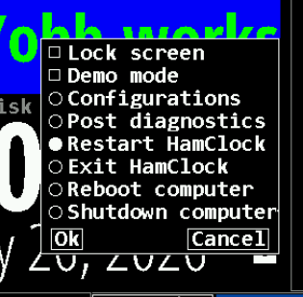
When HamClock starts up you have about 10 seconds to click on the screen to enter the setup menus. If you missed the time or HamClock is already running, you can get back to that point by restarting HamClock from the “Lock” menu. You can do this setup either direct with monitor, keyboard and mouse connected to the device, or you can do it remotely from a web browser.
Note: Android users please go to the Android section for installation and differences in operation. Page 101
Note: Do not select “Exit HamClock” when you are remotely connected to the HamClock device. You will lose your connection.
Setup provides several pages of configuration options. The exact choices available will depend on your platform but all options are shown here for completeness. Orange text denotes passive prompts for the corresponding white entry fields to their right. Cyan text denotes on/off choices or other discrete options. Clicking on a data entry field will place a green cursor where the next character will go. Click Delete to erase the character to the left. Click the Page arrows to move to next or previous. When finish, click Done. If any fields do not pass checks, they are marked with a red Err and you remain on the Setup screen until corrected.
Pages with text fields include a virtual keyboard for use on touch screens or with a mouse. On desktop systems, a normal keyboard may also be used using tab to step to the next prompt; delete to erase a character, space to toggle discrete options; arrow keys to edit; escape to change page and Return for Done.
Many places have popup tool tips activated with either control-click or middle mouse button.
The Setup Pages are available through a remote connection.

How to remote connect
First, you must find out what the IP address is of your HamClock device. If you have a Quadra4k or a HK1RBOX it displays the IP address on the display at the device. For other devices you might have to look at the device table in your router and try to identify the HamClock device. If you can’t find your IP address, you might be able to connect with the host name of the device. To connect use the following entry in your address field from your browser:
<IPAddress>:8081/live.html (replace <IP Address> with the IP address of your device)
e.g.: 192.168.1.124:8081/live.html

If you can’t figure out the IP address, try using the host name instead:
<hostname>:8081/live.html (replace <hostname> with the hostname of your device.
e.g.: Inovato:8081/live.html

To access the dashboard remotely away from home you would have to open the port 8081 or 8082 (recommended) in your firewall and enable port forwarding to your HamClock device.

Note: Remote access with a web browser only works if HamClock is running on your device.

Note: If you try opening links to external sites additional setup might be required, depending on your device and operating system. Many LINUX based devices (e.g., Raspberry PI) have web browser with limited capabilities and might work differently from what you are used to in a Windows or Mac environment.. The easiest way is to access your device remotely from a web browser. The links will then open in a new tab in your web browser.

Enter the Setup menus
When you see this screen:

Click somewhere on the screen to enter the setup menus.
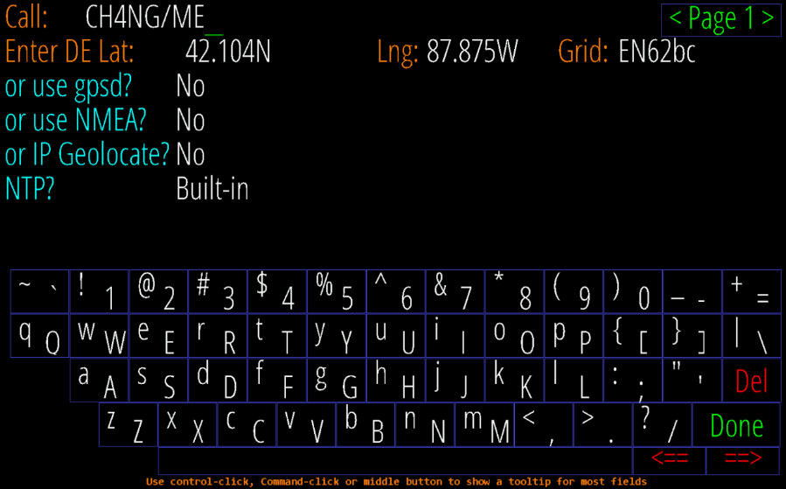
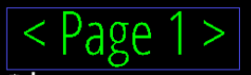
The setup menus are displayed on 8 screens. You navigate between the screens with the <Page> control. The most important options you need to configure are configuration page 1 and configuration page 5. The other pages have optional settings.


Clicking on moves to the next page and clicking on moves you to the previous page.
Most options have help text when you hold the “Ctrl” key and click on the data field or use the middle mouse button.
When you are done with the configuration click on “Done” and HamClock starts.

Setup Page 1
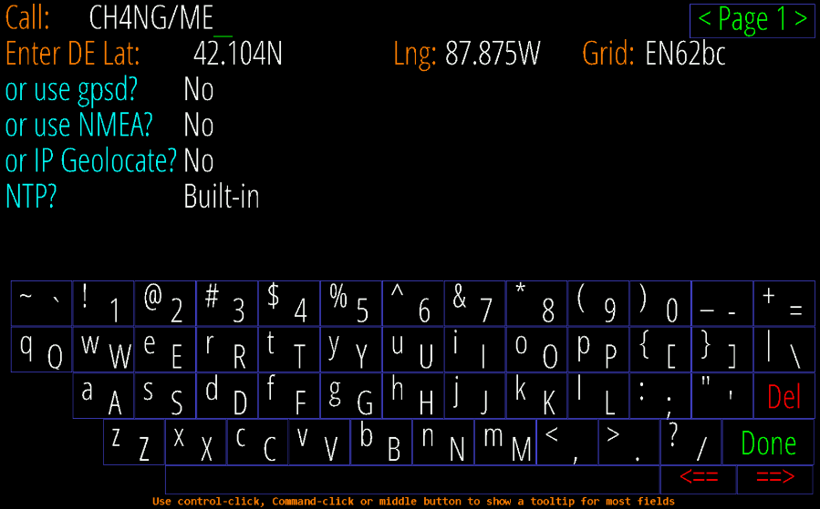
“Call” Enter your callsign. Change this
“Enter DE Lat:/Lng:/Grid” You only need to enter your grid, the rest gets calculated automatically. Change this.
The other entries are optional.
“use gpsd?” Allows connecting to a gpsd daemon on your local network for time. Enter the host name of your gpsd server; the port is fixed to 2947.
“use NMEA?” Allows reading NMEA sentences directly from a GPS device; see page 70
Both gpsd and NMEA normally only set the time but selecting follow will also update the DE location occasionally, handy if HamClock is in an RV for example.
“IP Geolocate?” If Yes, uses your public IP to set DE location once. This may not be accurate.
“NTP? - Built-in” will use the best from among a default set of world-wide NTP servers; host allows entering the IP or host address of any desired NTP server on the network. This is the default for LINUX.
“NTP? – Computer” uses the time from the computer running HamClock (ok, not NTP but here for convenience). This is the setting for Android.

Setup Page 2

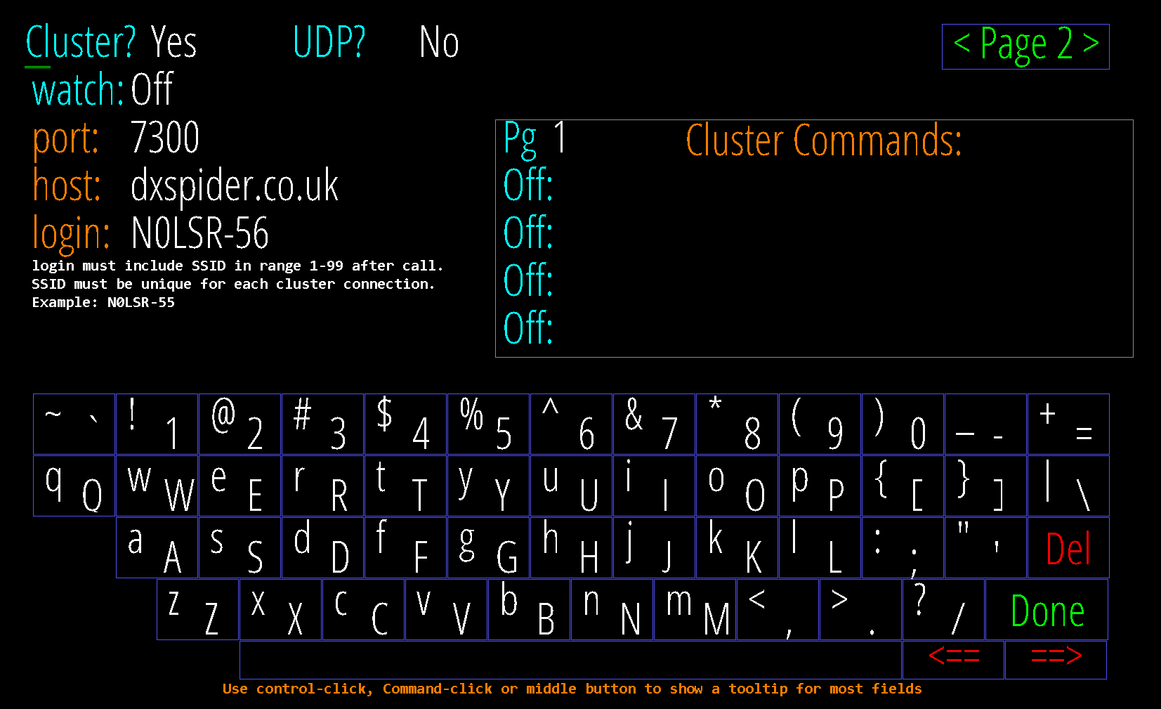
“Cluster?” This section configures listening to an internet DX Cluster or a local program sending spots with UDP packets.
It is by default set to “No”. If you click on it, it will toggle to “YES” and will give you access to other configuration options for DX Cluster operations.
“watch” see page 66 for details.
“port” 7300 for dxspider
“host” dxspider.co.uk
“login” call & SSID in the range of 1-99. Must be unique if you have different devices. Can not exceed a total of 10 characters.
“Cluster Commands” can be entered in the table. Those marked “On” will be sent once to the cluster server right after logging in. These must be in the native cluster syntax, HamClock does not check them. Commands marked “Off” are saved but not sent.

Setup Page 3
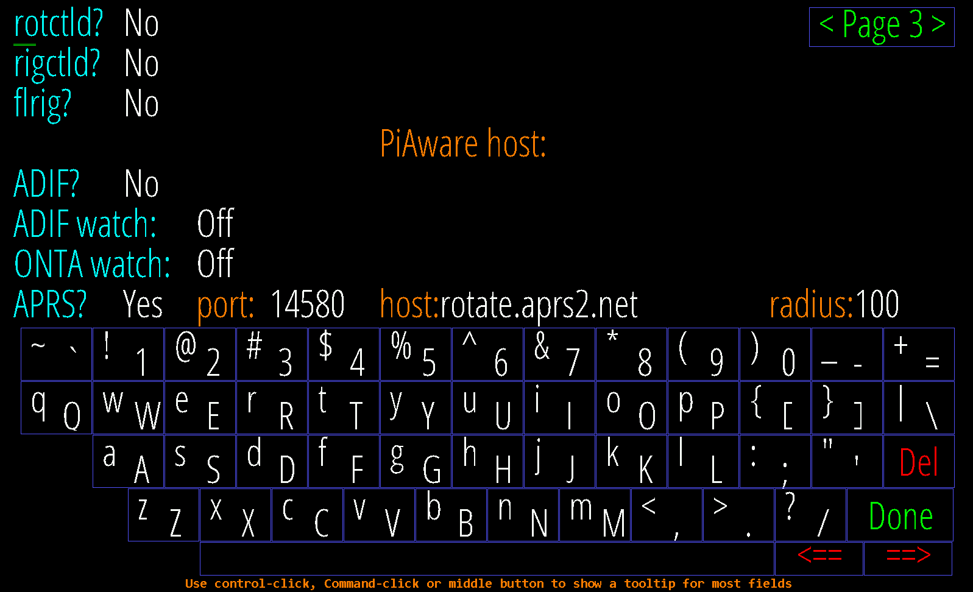
The settings on this page are optional and seldom used.
“rotctld?” and “rigctld?” whether and how to connect to hamlib for rotator and/or radio control. See pages Apendix A.
“flrig?” whether and how to connect to W1HKJ’s flrig for rig control.
“Radio” if using either rig connection, choose whether to set spot frequencies or just monitor PTT.
“ADIF?” set file used by the ADIF pane; may include environment variables and ~.
“ADIF” and “ONTA” watch: see page 22.
Rig control: These settings allow choosing rigctld or flrig for simple rig control. You can also monitor PTT using a hardware connection instead of using software rig control. Also, the RPi can control the frequency of a KX3 via an IO pin, see page 68. Set the host and port fields to the program on your network. When set up correctly, clicking a DX Cluster or On The Air spot will send the frequency to radio VFO A. HamClock also polls PTT to change your call sign to ON THE AIR while transmitting. Three consecutive errors disable PTT polling until the next attempt to send a spot.
“PiAware host” Enter the IP address or DNS host name of a local PiAware ADS-B receiver to use for the ADS-B airplane icon instead of adsb.lol. Leave blank to use adsb.lol.
APRS To enable APRS functionality set this to YES and set your radius to filter APRS signals in a defined radius around your location (default 10). The settings for Port (14580) and Server (rotate.aprs2.net) can stay at the defaults.

Setup Page 4
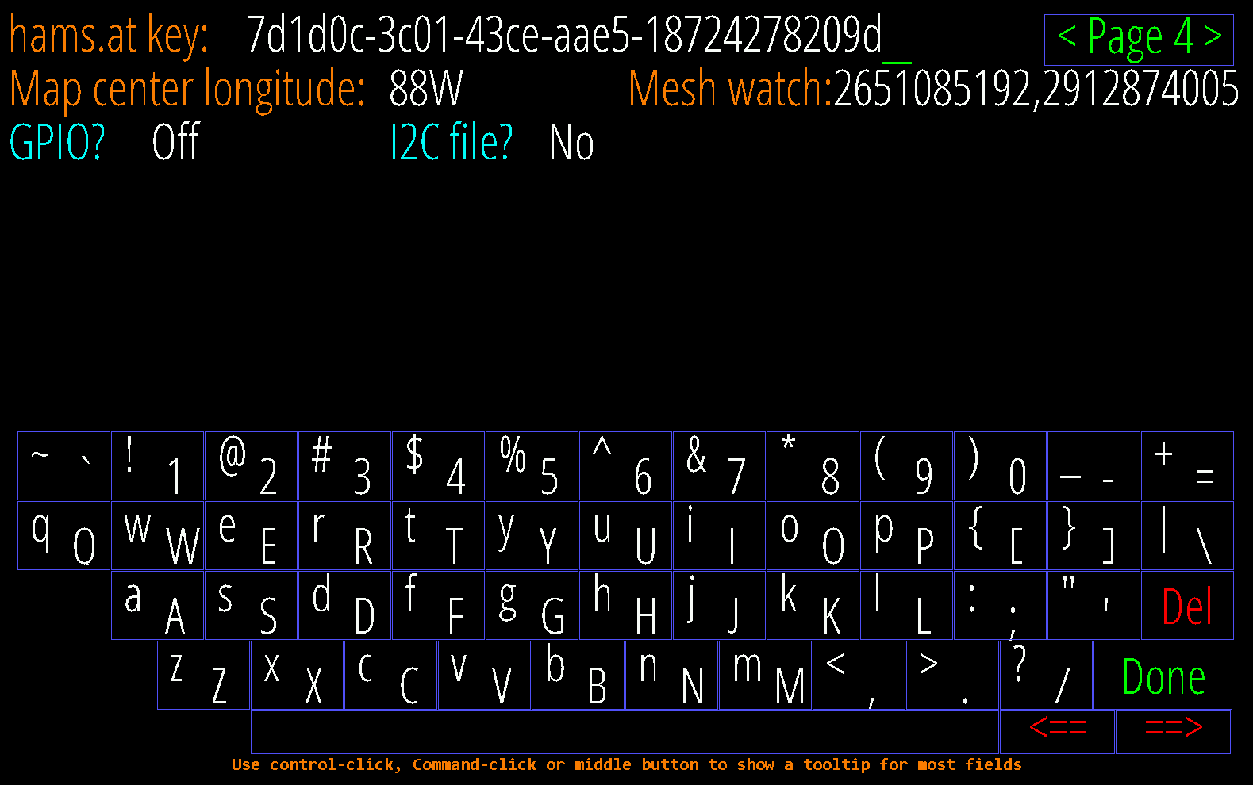
“hams.at key” Enter your hams.at API key for personalized satellite activation match/visibility or leave blank. Register at “hams.at” to obtain an API key.
“Map center longitude” set desired center map longitude for the Mercator and Robinson projections. If you want it to be centered on your location, use the longitude value from setup page 1. Change this to your longitude
“Mesh watch” enter comma-separated Meshtastic node IDs (decimal) to draw neighbor links for on the map and MeshNet pane. Leave blank to show node positions only.
“GPIO?” Controls whether the native RPi GPIO pins will be used by HamClock. See page 68.
“I2C file?” name of the local I2C bus connection, either native or via USB. See page 68.
“dTemp”, “dPres”: temperature and pressure corrections added to each BME280 sensor. See page 68.
“KX3?” Toggle direct KX3 frequency control and set serial baud rate. RPi only; see page 68.
“Brightness Min% and Max%” if supported by your hardware, display brightness range as percent of hardware total.

Setup Page 5
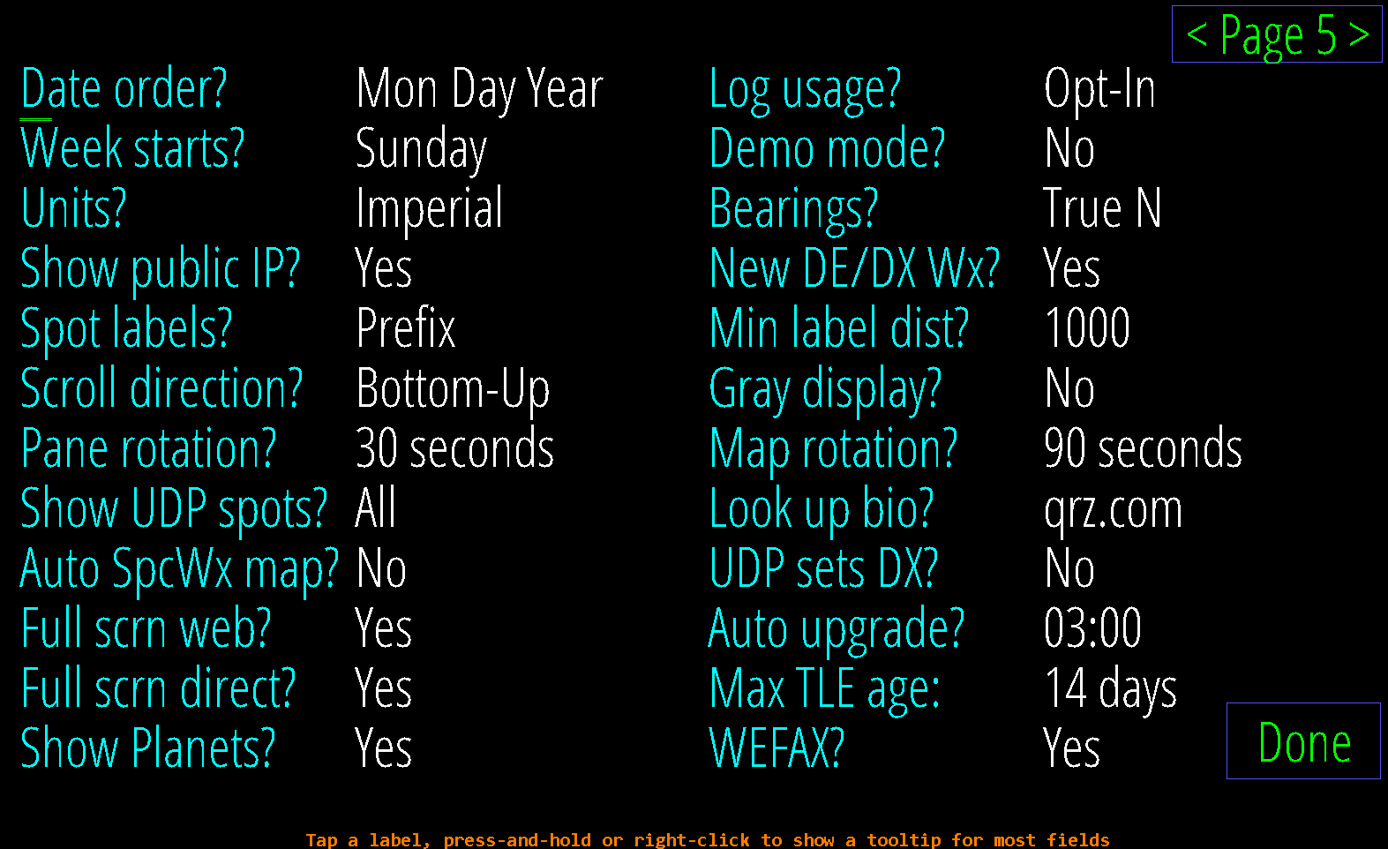
“Date order?” choose one of three formats for all date displays.
“Week starts?” choose whether the first calendar column is Sunday or Monday.
“Units?” choose Metric, Imperial or British units for environment sensor, weather data, speed and distances.
“Show public IP?” whether the main page shows the public network address (local address is always shown)
“Spot labels?” select whether and how to label Live Spots, On The Air and DX Cluster map locations.
“Scroll direction?” whether scrolling panes fill from bottom-up or top-down.
“Pane rotation?” select one of several pane rotation periods.
“Show UDP spots?” select whether to accept all incoming UDP spots or just those by your HamClock call.
“Auto SpcWx map?” turn on Aurora map if > 50% or DRAP if > 25 MHz; off if < 25% or < 15 MHz, with hysteresis.
“Full scrn web?” set to Yes to enable full screen option on remote Live web connections.
“Full scrn direct?” set to Yes to force HamClock to fill all surrounding screen area with black, when applicable.
“Show Planets” weather to show the 7 visible planets on the map at their current position.
“Log usage?” choose whether to send us your HamClock settings anonymously to guide further development.
“Demo mode?” “Yes” causes HamClock to cycle through the different display options automatically.
“Bearings?” choose True or Magnetic North when displaying bearings to DX.
“New DE/DX Wx?” whether to temporarily show weather in left Pane when setting new DX or DE.
“Min label dist?” select minimum distance from DE to label spots; distance in mi or km depending on Units. Set this to 1000 or 2000 to declutter your display.
“Gray display?” whether to render map or entire display in shades of gray
“Map rotation?” select one of several map rotation periods.
“Look up bio?” select which online bio service to use when clicking a spot, if any. Available options are “QRZ.COM”, “HAMCALL.NET”, “CQQRZ.COM” and “HAMQTH.COM”.
“UDP sets DX?” when “Yes” spots from any supported UDP logging program will automatically set the DX object.
“Max TLE age” select maximum allowed satellite Keplerian two-line element age, in days.
“Auto upgrade?” select whether or about when (DE time zone) to automatically upgrade if new version is available. If set to “No” you have the option to manually upgrade. The version number turns red if a new version is available.
“WEFAX?” enables WEFAX charts on the Weather map.

Setup Page 6
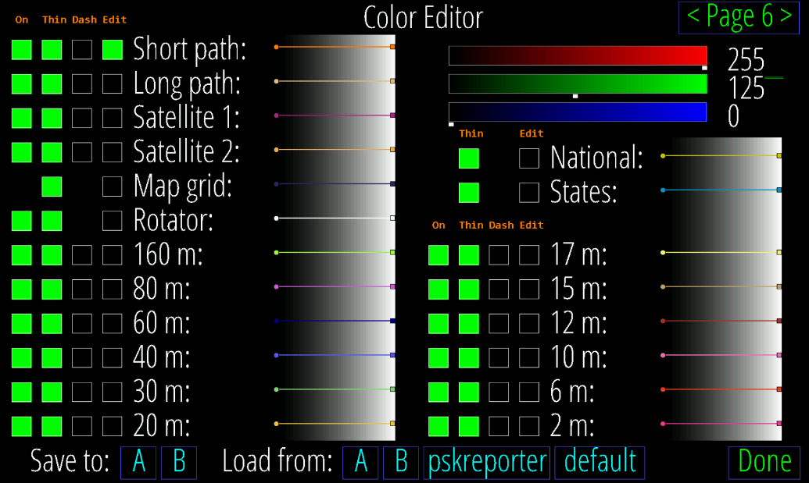
Color Editor: This page displays and controls the colors used for maps, boarders, paths and band indications.
To change a line color, click on “Edit” and move the sliders or change the RGB numbers direct to adjust the color. Some lines can be switched On or Off with the “On” button.
Click “Dash” to toggle whether lines are drawn dashed or solid; “Thin” to set line and symbol size to thin or thick.
A sample of each color shows how the current choices will appear over a full range of background intensities. The current palette and choices may be saved as A or B then later these, or two read-only built-in palettes (default and pskreporter), may be loaded.

Setup Page 7
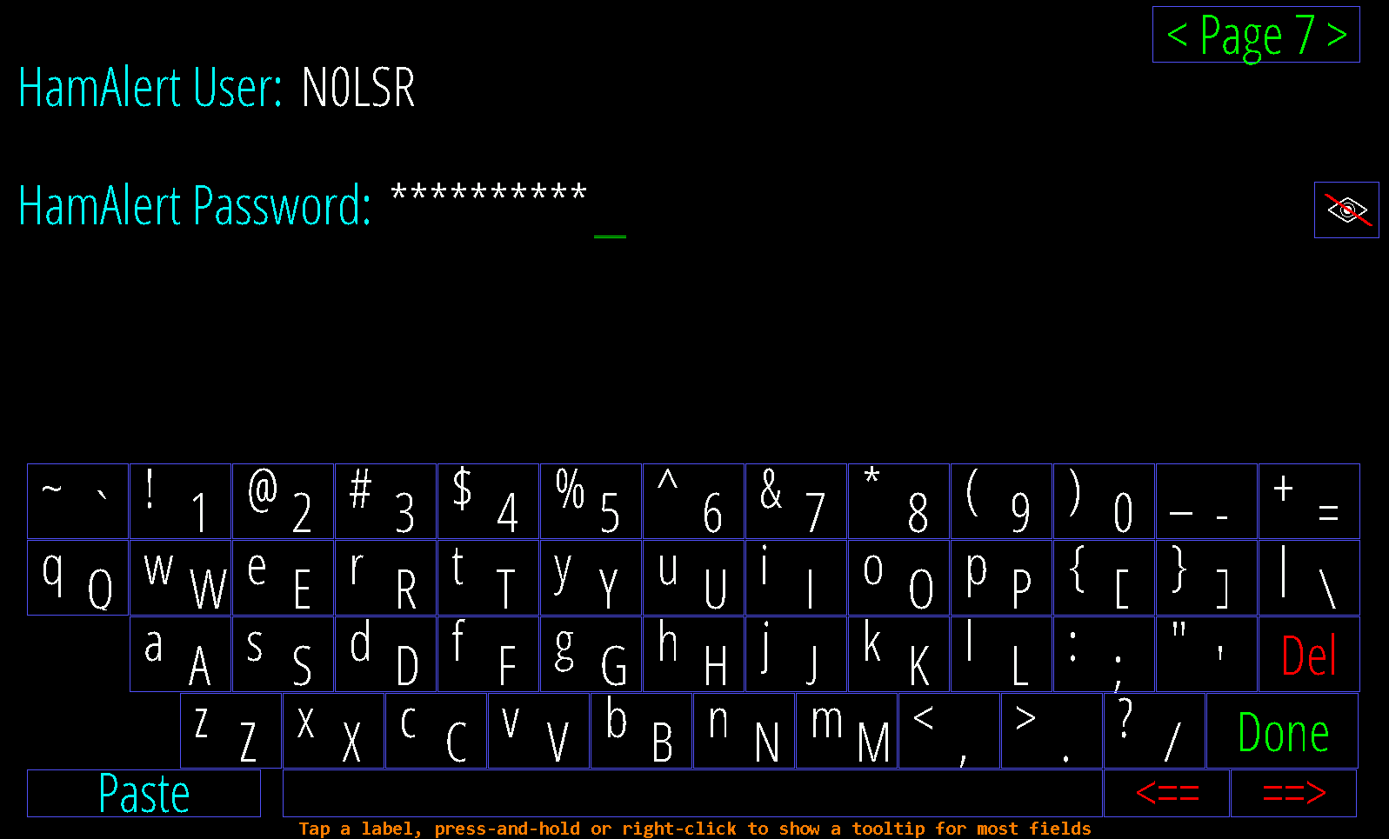
HamAlert: Sign up at HamAlert.org for a free account and enter your HamAlert username and Telnet password. Do not enter your HamAlert account password here.

The “Eye” symbol allows you do display and confirmed the entered password.

Setup Page 8
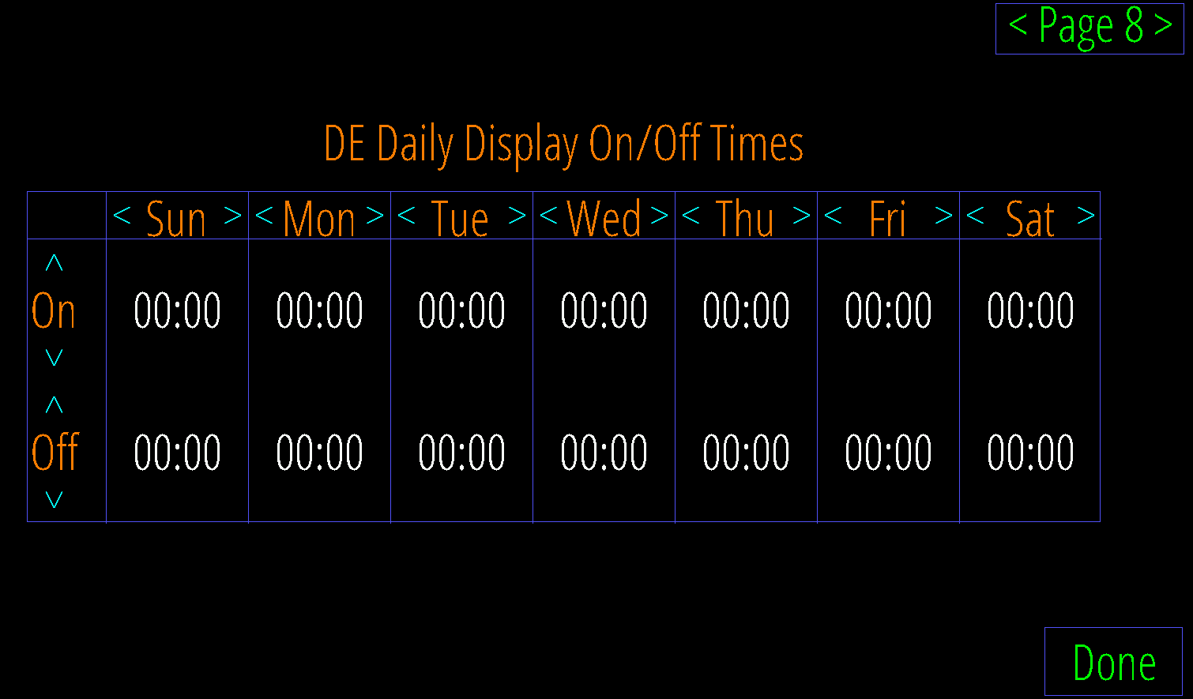
On/Off Times: Use this table to set desired DE on and off (or dim) times for each weekday. Click just above or below each number to increase or decrease. Left and Right arrows copy to the adjacent day. The On/Off pane will also display, and allowed editing, the current day settings (only). The display is never turned off if both times are set equal. It is not supported by all systems.

Operations
The operational screen of HamClock is divided into 5 sections.
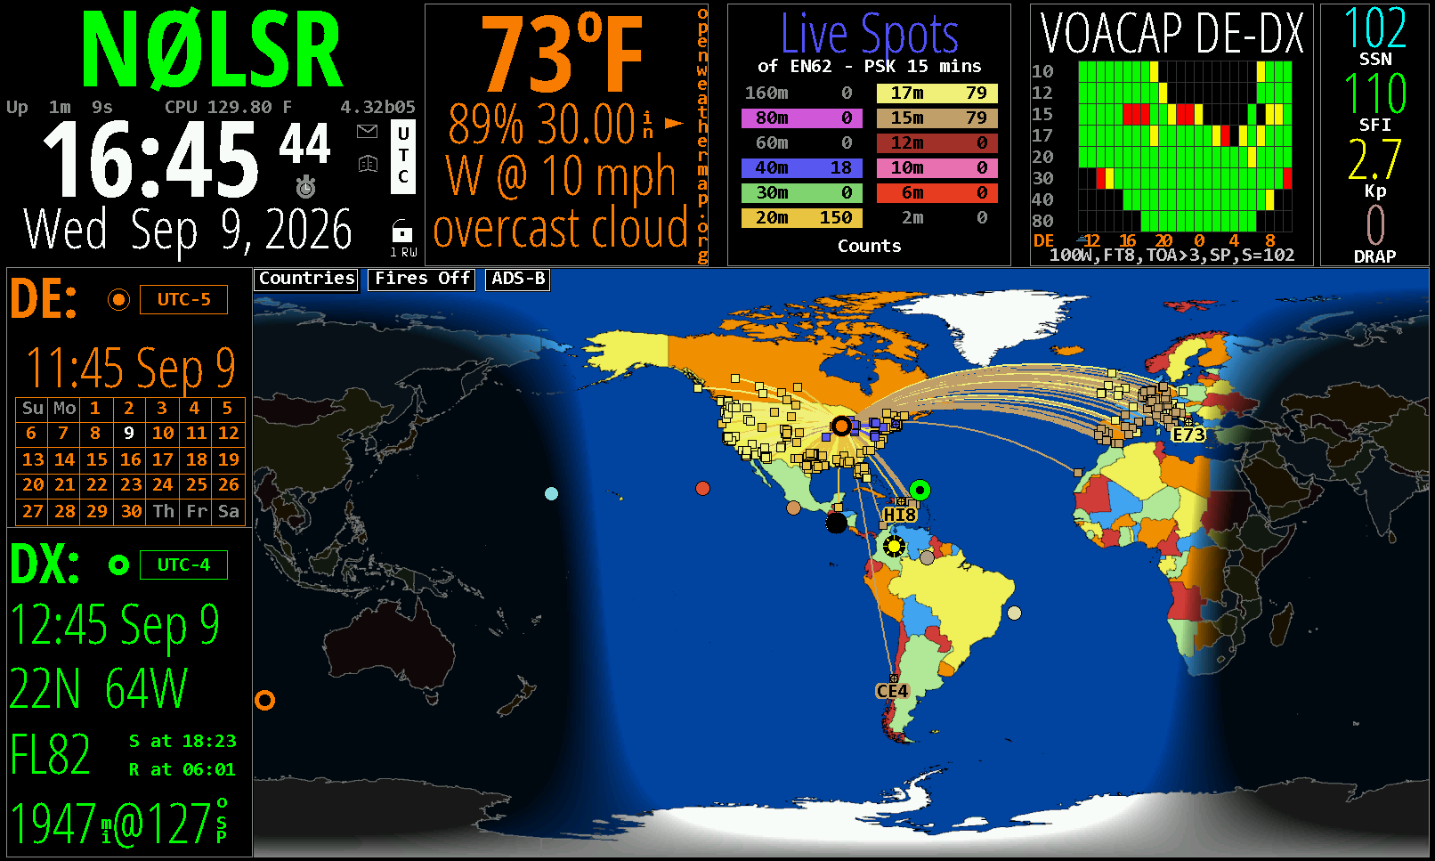
 | Local Info area | This pane has a fixed layout with a few configuration options. It is also the home of the “Lock” menu.
 | Upper Data Panes | These three panes can display selectable information. If multiple options are selected, the pane will display them in sequence.
 | Upper Auxiliar Pane | This smaller pane has only a small set of options which are unique
 | Left Flex Panes | Dedicated for “DE” and “DX” information. The lower pane is also used for satellite functions. They also can be combined for a larger display of selectable information.
 | Main Map Area | The map area will display world maps in selectable projections and diverse overlays.

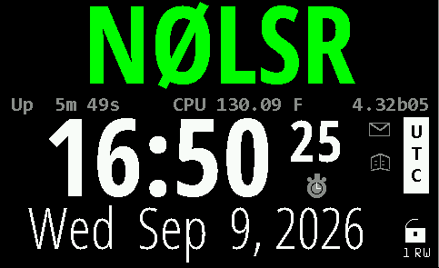
Local Info area
Call/Message
Info banner
Time/Date
Time sync warning
UTC/LCL

Lock menu
Links to the User Guide

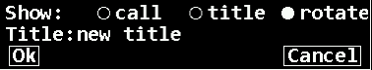
Call/Message Click to the left of the call sign toggle the callsign color. Click to the right of callsign, toggle the background color. Click in the center to select to display a message instead of the call sign. Clicking near the center of the main call sign box brings up the menu shown on the left. Normally the box shows the DE call sign, but it can display any arbitrary text by selecting title and entering the desired text here or rotating between both. In title you can have up to 6 entries separated by a semicolon which will give you a total of 6+1 options to rotate through.
Info banner Displays the uptime of HamClock. Alternates between the following information: Local IP address / Public IP address (if enabled) / Backend server URL / Backend server IP address / CPU temperature / Disk space usage / Wi-Fi signal strength.
Displays the version number to the right. If version number is red, an update is available. To get the update click on the version number. If the version number is clicked without a pending update, it will display the last release notes.

Message Icon A red envelope indicates a system admin message. Click it to display the message in the map area.
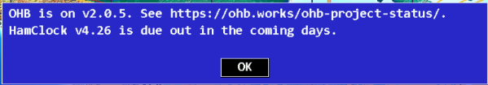
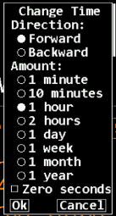
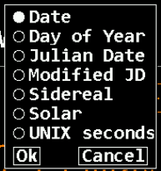
Time/Date Displays time and date. If time is not synchronized a large “?” is displayed to the right. If you click on the time a pop-up menu will allow some time changes. When clicking on the date, you can choose different date formats.
The alarm clock symbol is filled in if an alarm is set. Clicking on it will open the alarm clock menu.
Time sync warning The UTC text will change to a red “OFF” if the UTC time was manipulated and is deviating from UTC.
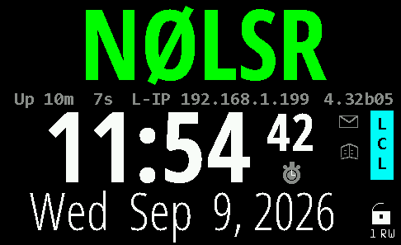
UTC Local Time switch Clicking on the UTC block will change the time display to local time. The UTC block will turn blue and will read “LCL”. Clicking on it again will switch back to UTC time.

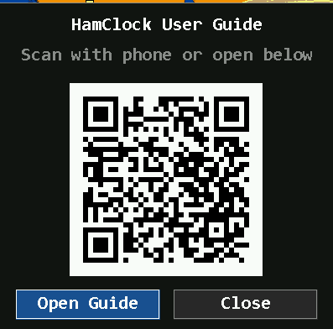
Links to the User Guide A window will pop up with the option to access the latest user guide. You can use the QR code or the “Open Guide” button.

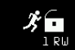
Lock Menu
Provides access to the control menu.
A small “runner” in front of the lock indicates that the demo mode is enabled.
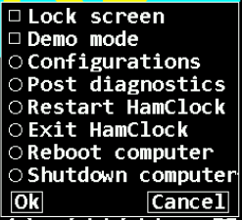
Lock screen Locks the screen from unintentional changes. Hover over a point of interest still works.
Demo mode HamClock will autonomously make a random setting change to itself every 30 seconds, including the plot panes, DX location and map view options. The running man icon indicates demo mode is active. Meanwhile HamClock may still be used normally. Note that whether Demo mode is active is not persistent, so it must be selected again if desired each time HamClock starts.
Configurations enables the (local) saving of setup parameters under specified names and allows to be recalled later.
Post diagnostics This function posts the file to the backend server. Used on request from the development team to help with troubleshooting.
Restart HamClock will restart the HamClock application but not the device HamClock is running on.
Exit HamClock will stop the HamClock application and return to the desktop of the OS. If you select this option from a remote web browser, you will lose the connection.
Reboot computer will restart the device HamClock is running on.
Shutdown computer will shut down the device HamClock is running on.

Note: On the Android, Fire Tablet and Fire TV platforms the “Reboot computer” and “Shutdown Computer” options are not available.

Note: on devices with touchscreen a right click is done with a touch and hold.

Upper Data Panes
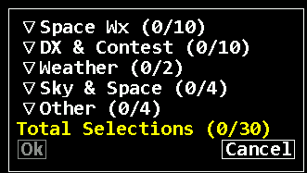
There are three data panes which can display up to 35 different data pane options. Some data pane options are only available on Raspberry PI with specific hardware connected.
The data pane options are grouped into 5 groups and can be selected from collapsible menus. Click the top left of any pane for the menu to show up. You must select a minimum of one option, otherwise the menu will not close or it will fall back to the previous choice.
If more than one option is selected the panes will cycle through them.
Ctrl-click will force rotation. Right click on the upper right corner will select the next pane and right click on the upper left corner will go back to the previous pane.
You can assign an option only to one pane at a time.
Some panes also use sub menus which are described below. The sub menu can be accessed by clicking on the center of a pane.
Some options might not be visible for you if you do not have the necessary hardware installed.
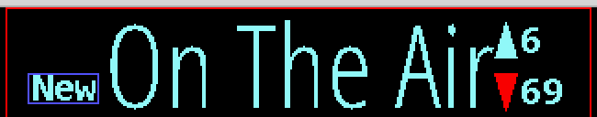
Scroll controls appear automatically when panes have too many lines to display. Up shows how many more lines are above, Down shows the number below. Clicking either shifts the list in the given direction, leaving one line for context. Setup page 5 allows setting whether the list grows top-down or bottom-up. If the scroll entries are DX spots, the arrow is red if there are any spots in that direction matching a Red watch list. If new spots arrive while scrolled away from the front of the list, the list position does not change but a button labeled New appears; clicking it will jump immediately to the front of the list. Also, while scrolled away the border is red, pane rotation is suspended and clicking the title does not offer a menu to assign new choices.

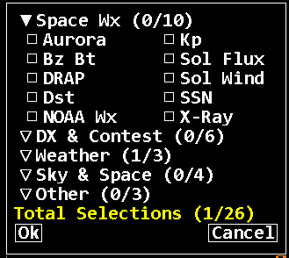
Space WX

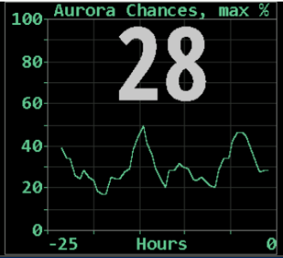
Aurora shows the current and recent maximum percent chances of visible activity anywhere on Earth. To see the current best location, change to the Aurora map style (page 51). Active auroral regions can absorb HF but function as reflecting layers at VHF.
This pane has no additional settings.

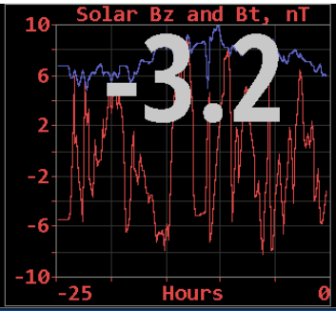
Bz Bt shows the strength of the interplanetary magnetic field near Earth in units of nano Tesla. Bz is the strength of the field pointing north, the same direction as the Earth’s field. Bt is the total vector sum in all directions and thus is always the larger value. When Bz is negative, the fields are in opposite directions, partially cancelling the net shielding effect of the magnetosphere and negatively impacting HF propagation. Values of Bz < -10 can be significant.
This pane has no additional settings.
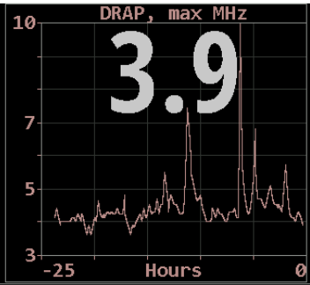
DRAP plot option shows the highest frequency that is attenuated by at least 1 db anywhere on Earth over the past 24 hours. Although the plot does not indicate the location where this occurred, it is usually centered on the Earth daylight side unless there is a Polar Cap Absorption event in progress. Also see the DRAP map option on page 48. The signal paths are for an angle of incidence, a, of 90 degrees (straight up). For shallower angles, multiply the attenuation by 1/sin(a).
This pane has no additional settings.
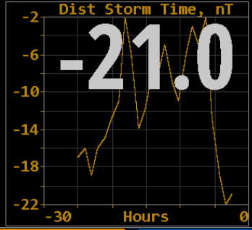
Disturbance refers to the Disturbance Storm Time index which measures the onset and recovery of the magnetosphere ring current, in nano Tesla. Values beyond about ±10 may indicate sufficient energy is stored in the ring to interfere with lower HF propagation, particularly 160 m. Conversely, values near zero may indicate better than average propagation on this band. Data provided by World Data Center for Geomagnetism, Kyoto University, Japan.
This pane has no additional settings.
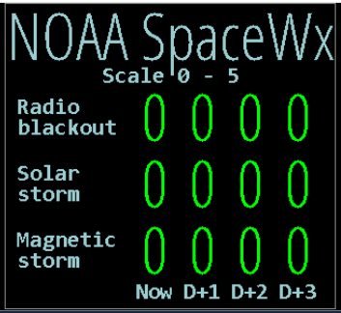
NOAA SpcWx shows the three main NOAA space weather scales. The left column shows the current conditions, and columns to the right are predictions for each of the next three days. All scales use a range of 0 through 5, with larger numbers indicating greater severity and public impact. Radio blackout impacts HF communication and navigation; Solar storm impacts living organisms and exposed electronics; Geomagnetic storm impacts pipeline current, power distribution and disrupts the ionosphere.
This pane has no additional settings.
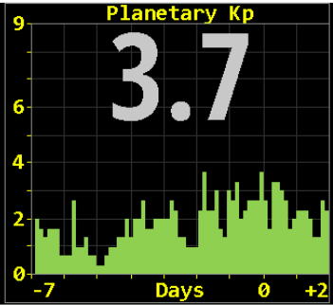
Planetary K shows the Kp index now, with a graph extending from 7 days prior to 2 days forecast. The color scheme matches the NOAA web page.
This pane has no additional settings.

Solar Flux shows the current 10.7 cm measurement from National Research Council Canada, as well as a 30-day history and prediction for the next three days. Click in the lower half to show a longer history.
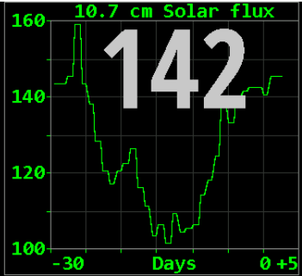
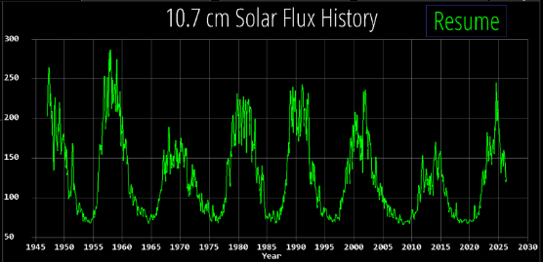

C

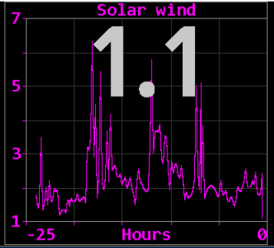
Solar Wind This pane shows 24 hours history of solar wind activity. Solar wind is a good predictor of geomagnetic disturbances such as auroral activity and unusual polar HF propagation. The available real-time metrics are density, in protons cm-3, and speed, in
km s⁻¹. The product of these values gives the flux rate, or number of protons flowing through a unit square per unit time, which is often a better predictor than either value alone. HamClock displays this product in units of 10¹² protons m⁻²-s⁻¹ for which values above five or so suggest better chances for aurora.
This pane has no additional settings.
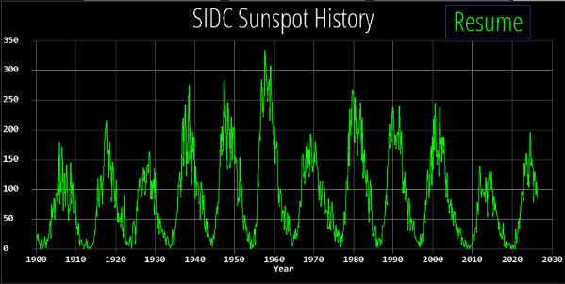
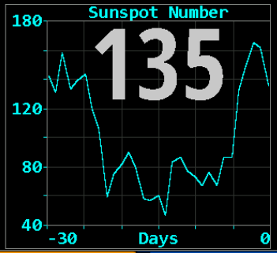
Sunspot N shows the current SIDC sunspot number and 30 days history. Since one solar revolution is approximately this period and solar features typically evolve slowly, the graph provides a crude prediction of solar activity for the next month. Click in the lower half to show a longer history.

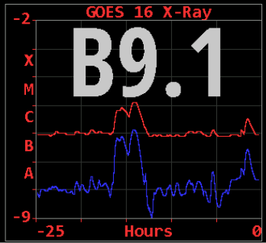
X-Ray shows the current solar X-Ray levels and flare classification as measured by the GOES-16 satellite with a 24-hour history. The levels are the powers of a logarithmic scale computed as log10 (W m⁻²). The blue line is the 0.05 - 0.4 nm band, red is the 0.1 - 0.8 nm band.
This pane has no additional settings.

DX & Contest
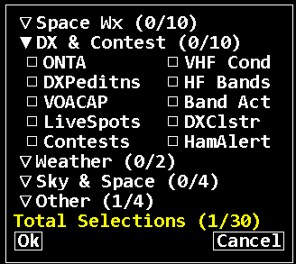
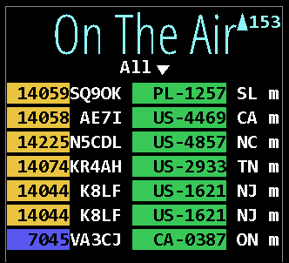
On The Air (ONTA) shows spots from various organizations. Organizations displayed are POTA (green), SOTA (orange), WWFF (teal), IOTA (cyan), GMA (slate grey), LLOTA (indigo), and WWOTA (copper). Parks will be highlighted in the ONTA pane corresponding to POTA, SOTA, WWFF, IOTA.
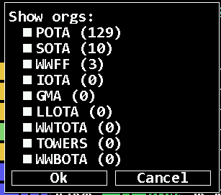
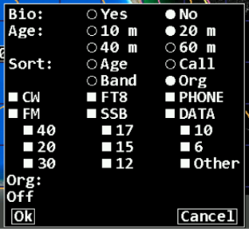
The table columns are kHz, activator call and code, and m if > 10 minutes or h if > 1 hour old. Frequencies are colored by band as per Setup page 6. Click on “All” for a menu to select whether to show bio, max age, desired sort and to edit the Org filter and watch list.
Click on the down arrow to open a menu where you can select or deselect the different organizations. The Org filter may list multiple orgs separated by spaces to rotate; by + to combine without rotation; or an empty filter matches all.
Click a spot row to set DX, radio (if enabled), rotator (if enabled) and bio page if used. Spot locations are plotted but paths are not because the spotter location is not available.
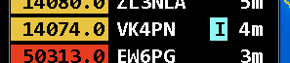
A single character marker will appear that will have a special background color. This marker can be turned off in the DX Cluster menu (Marker -> Hide). The following parks will be scanned in the comment field on a DX Cluster spot: IOTA (cyan), WCA (gold), ARLHS (sky blue), ILLW (sky blue), SOTA (light grey), WAB (coral), and WWBOTA (olive/khaki).
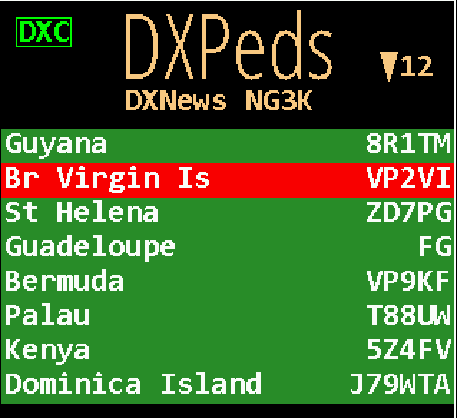
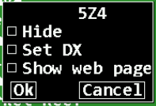
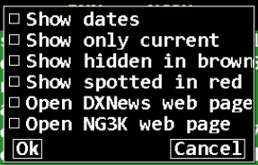
DXPeditions lists current, or upcoming, amateur DX expeditions. Click the credits line for overall menu options. Click a specific contest to hide; set a future alarm; assign to DX; or display the expedition web page, if any. Roaming over a list entry will mark it on the map. Map info table will show spotted frequency and, if ADIF is configured, worked slots to same DXCC. Data is kindly provided by DXNews and G3K.

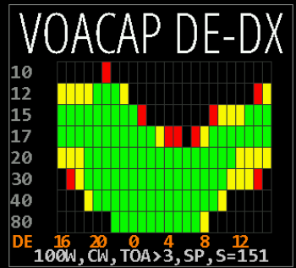
VOACAP This pane choice shows a graph of path percentage reliability predictions from DE to DX spanning 24 hours for each HF ham band starting NOW on the left edge. Graph squares are black if reliability is less than 10%; red if less than 33%; yellow if less than 66% and green if above 66%. Predictions always use VOACAP configured for isotropic 0 dbi antennas on both ends; quiet location noise (-153 db) and the current mean sunspot number.

Variable parameters may be set by clicking the fields across the bottom: transmit power, mode, Take-Off-Angle at DE and SP/LP to select short or long path.

Click band row will show a marker and add a world map of take-off-angle for that band from DE
Click a band row here will show a marker and add a world map of path reliability from DE
The graph time axis always places now at the left edge. Click the timeline to toggle labels in UTC or DE local time.
Clicking the left half of a band row will show a marker and add a world map of path reliability from DE. Click the right half of a row to show map of take-off-angle for that band.
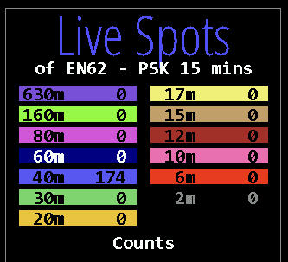
Live Spots shows personalized reports from WSPRnet.org, PSKReporter.info or Reverse Beacon.net. With WSPR and PSK you may choose spots posted by your own DE call or from your grid; or spots which others post of your DE call or grid. Using your grid allows you to explore propagation from your general location without receiving or transmitting. 4- character grid precision is used to find spots near you.
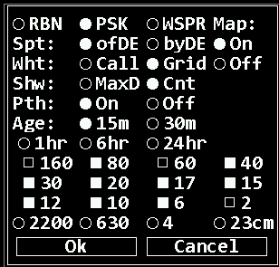
Note: RBN only works with skimmer spots of your call (not by) because grids of the spotted transmitter stations are not available.
Click in the middle of the pane to display a configuration menu.
Here you can select to show the spots on the map (On/Off), set the maximum age; whether to list count or distance to farthest spot; and which bands to map. You can select or deselect bands to be displayed on the maps. Paths show a circle ● at the TX end, a square ■ at the RX end and the farthest path for each band is marked with a target  and labeled as per Setup page 5. Placing the cursor near either end will show the info table in the upper left corner of the map.

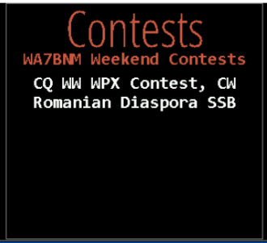
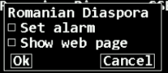
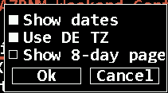
Contests lists amateur radio contests for the upcoming, or current, weekend. Click the credits line to set whether to show dates in UTC or DE time zone. Click a specific contest to set the one-time future alarm to the contest start time or display the WA7BNM web page for the contest. Contests currently in progress are highlighted with a green background. Data are kindly provided with permission by Bruce Horn, WA7BNM.
C
C
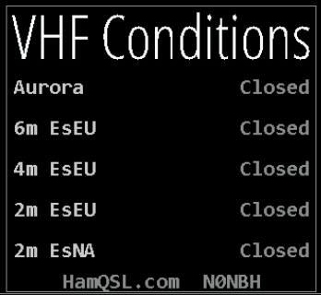
VHF Conditions provides a summary of the current VHF conditions from HamQSL.com.
This pane has no additional settings.

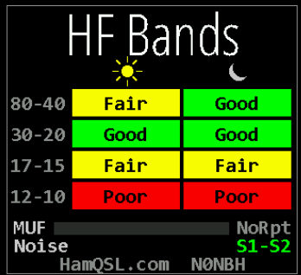
HF Bands provides a summary of the current band conditions from Hamqsl.com
This pane has no additional settings.

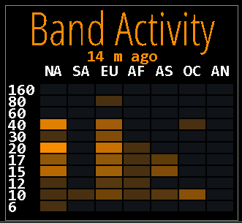
Band Act provides a heatmap style band activity display on a per continent and per band level. Lighter color means more activity. It compliments the Live Spots pane.
It is recommend to run this with the Live Spots+ONTA (in pane #1), HF Bands (pane #2), Band Activity (pane #3) and DX Cluster in the left data pane with time set to LCL for the best experience.
This pane has no additional settings.

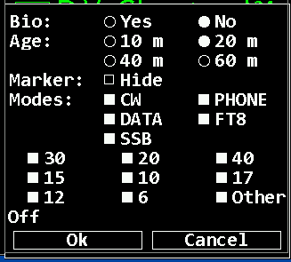
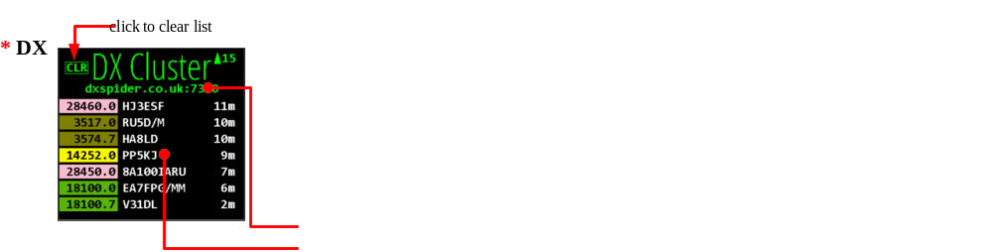
DX Cluster lists and maps spots from the cluster host defined in Setup page 2, subject to age, any filters and watch list. Frequencies are colored by band as per Setup page 6. Only the latest spot of a given call on the same frequency is shown. The columns are kHz, call and age. Click any row to set DX, rotator (if enabled), radio (if enabled) and look up bio if configured.
click to clear

click spot to set DX, radio and bio if enabled; roam over to mark on map

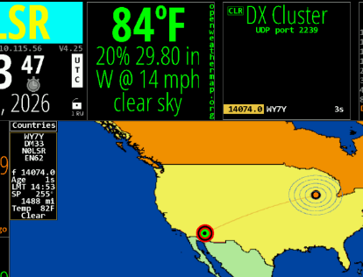

Click the host name to edit the watch list. Roaming over a list entry will mark it on the map. Clear the list by clicking CLR. The list will not move if scrolled away but arrival of a spot will display NEW.

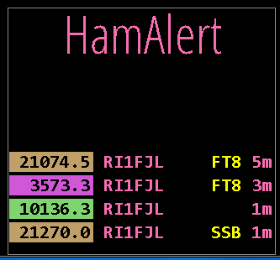
HamAlert shows personalized output from your HamAlert account. To enable this feature, you must first create an account with hamalert.org and enter the information on setup page 7.

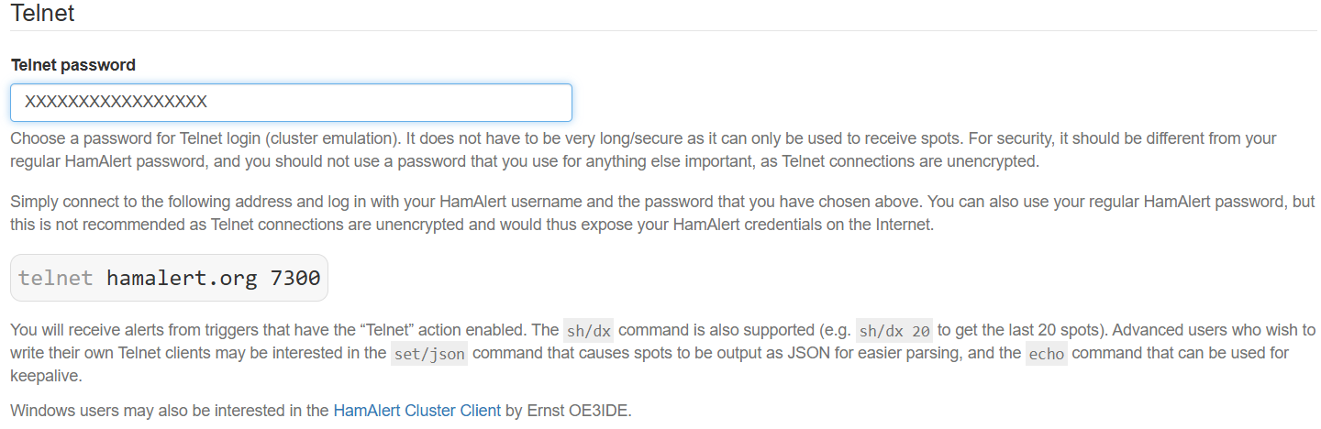
Sign up for a free account with hamalert.org. Then set up Telnet with a Telnet password.
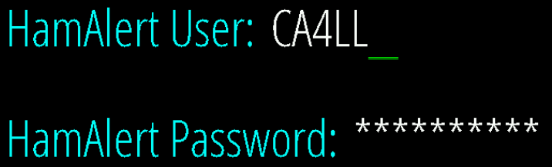
On configurations page 7 enter your HamAlert username and the HamAlert Telnet password (not the account password).

In your HamAlert triggers you must make sure to check the “Telnet” option.
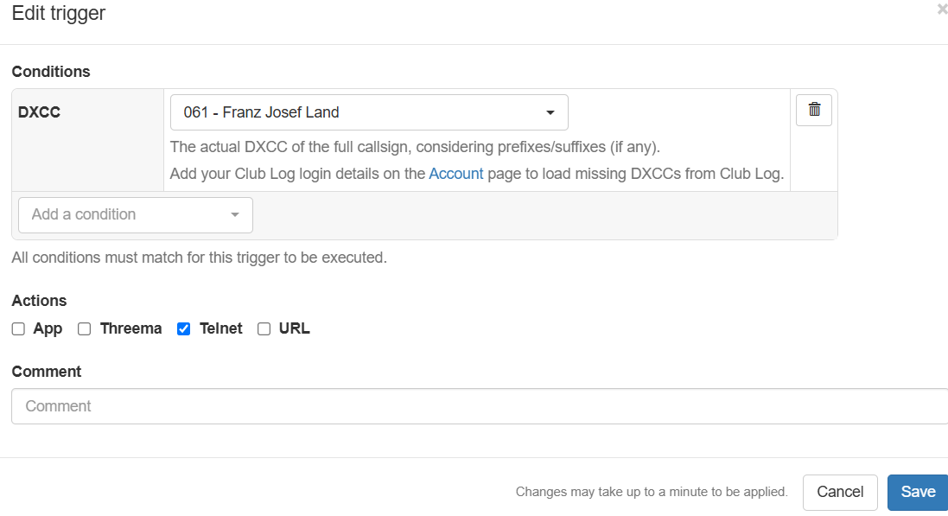

Weather
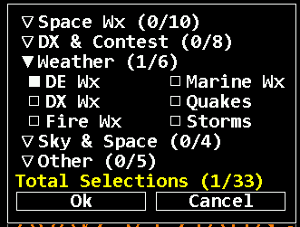
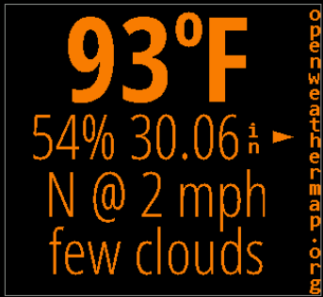
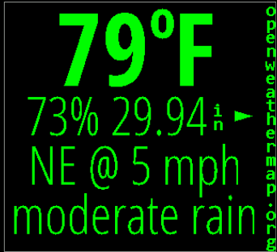
DE Wx and DX Wx show the current weather at DE or DX from OpenWeatherMap.org. If the location is not changed for at least an hour, an up or down arrow may appear to indicate the pressure trend direction. When either DE or DX is changed by any means the left pane will temporarily show its weather, unless already selected on another pane or disabled in Setup page 5
There are no additional settings for
these panes.

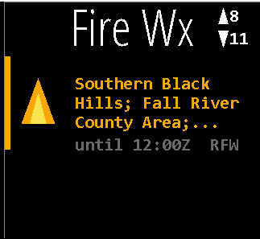
Fire WX Shows fire weather warnings and detailed information about red flag warnings. For details click on the short text and it will change to the detail display.
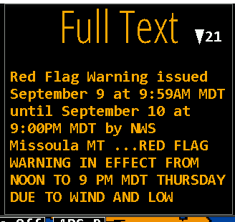

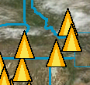
On the maps the location of the fire warnings is displayed as yellow pyramides.

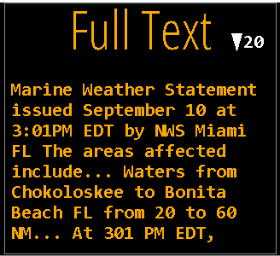
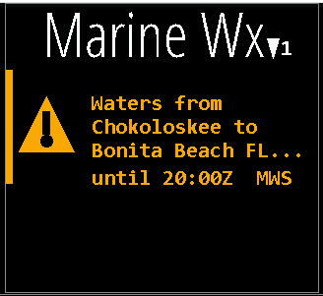
Marine Wx shows marine weather warnings. For more detailed information, click on the text and the detail pane will display.

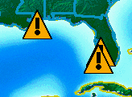

On the maps the location of the marine weather warnings is displayed by a yellow triangle with exclamation mark.
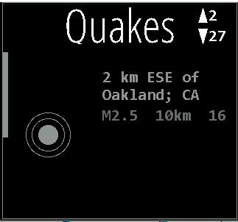
Quakes displays any earthquakes happened in the last 24 hours.
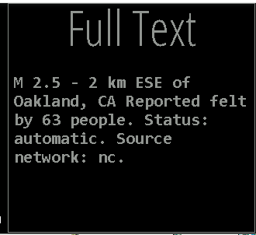
By clicking on the text in the Quake pane more details can be obtained.

In the map area a zoomed picture of the quake area is displayed as a colored circle if the Full Text pane is displayed. Clicking on the Quake symbol will also show a popup with detailed information. The color of the circle is grey for quakes below 3 and orange above 3, and red above 5. The size of the circle gives an indication of the strength in a range.
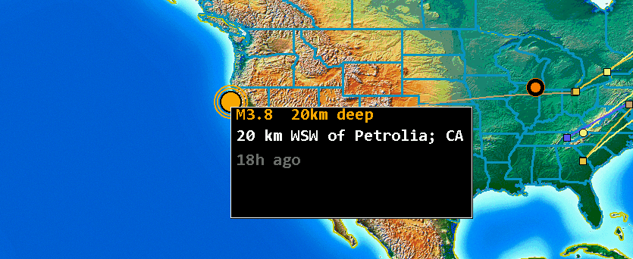
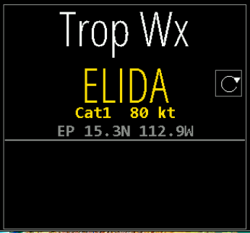
Storms provides a quick visual summary pane of active tropical cyclone activity. It plots active storms on the main map, showing each storm’s current location, intensity, and forecast track. Current positions are emphasized, while forecast points and connecting lines show the expected path over upcoming advisory periods.
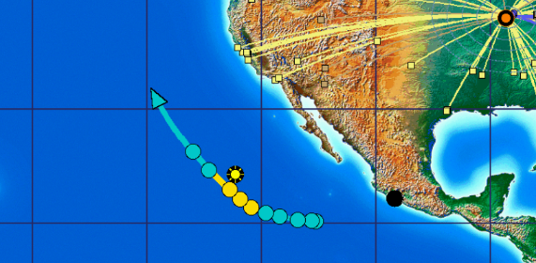
Storm type and intensity are represented using category-aware labeling and colors, making it easier to distinguish tropical depressions, tropical storms, hurricanes, and typhoons at a glance. The pane is intended as a situational-awareness display, not a replacement for official watches, warnings, or local emergency guidance.

Data is supplied by the configured HamClock backend and is normally updated every six hours, consistent with tropical cyclone advisory schedules. When no active storms are available, the pane will indicate that no tropical systems are currently being tracked.

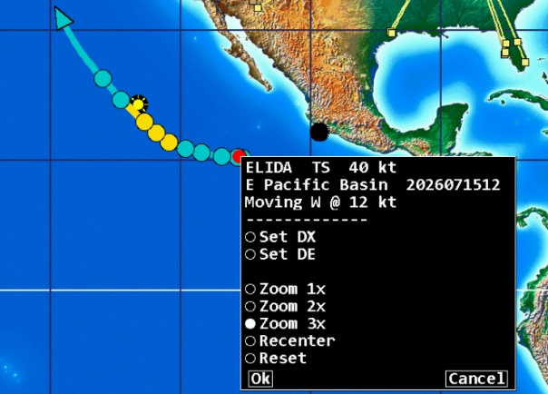
Clicking on the Red dot for the displayed storm will display specific storm information such as speed in knots and general direction. Colors correspond to official Saffir-Simpson Scale colors for storm intensity.

Sky & Space
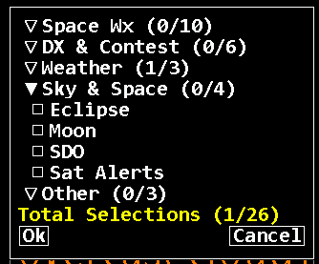
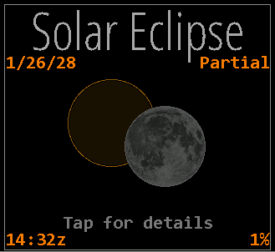
Eclipse displays details about an upcomming Solar Eclipse. Clicking on the pane shows more details.

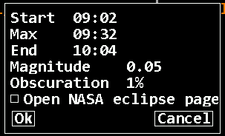

C

For even more information a direct link to the NASA eclipse page is provided.
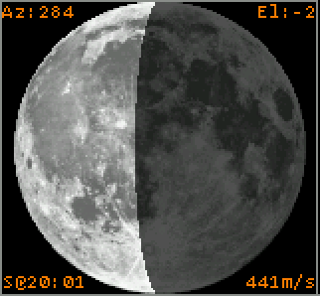
Moon displays a graphic of the lunar surface facing earth with the proper portion shown in shadow. The image is oriented depending on the DE hemisphere. The corners show information with respect to an observer located at DE including the Azimuth, Elevation, time of next Rise or Set, and radial velocity where positive values indicate the motion is away from the observer. Click the lower half for a menu to display a full rotation movie or display the EME planning tool.

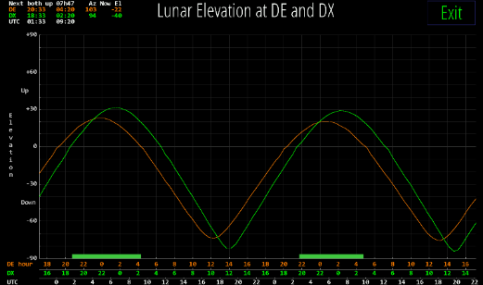
click to show EME planning tool

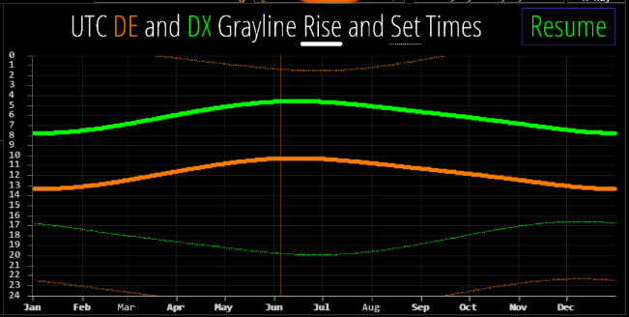
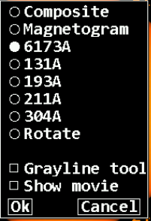
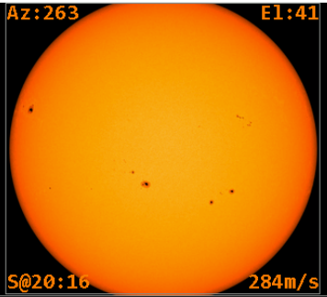
SDO shows current images from the Solar Dynamics Observatory satellite. The corners show current information with respect to an observer located at DE including the Azimuth, Elevation, time of next Rise or Set, and radial velocity where positive values indicate the motion is away from the observer. Click near the center of the image to display a menu allowing any one of several image types to be selected; select Rotate to automatically cycle them all in turn; show a Grayline planning tool where DE and DX share twilight whenever either of their rise/set lines are close together; or display a recent solar Movie in a separate browser window.
C
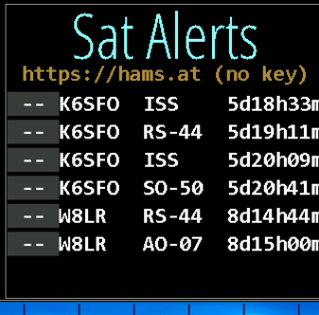
Sat Alerts provides a list of upcomming satellites from “hams.at” and gives you the opurtunity to set alarms or get more information from their website.

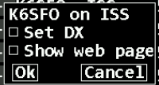

Other
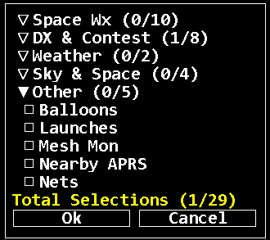

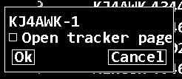
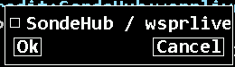
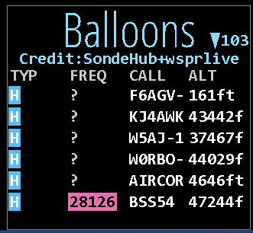
Balloons (HAB – High Altitude Balloons) provides information about flying high altitude balloons and Pico balloons collected from SondeHub and wsprlive. Clicking on the header line above, the listing allows you to open the SondeHub website.
Clicking on a listing provides a link to the high altitude balloon tracker page.
If this pane is selected, the current map will be animated with the listed balloons.

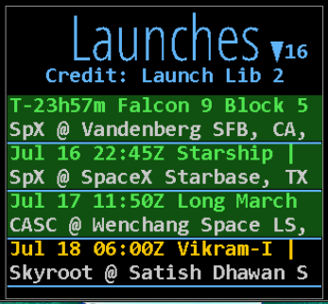
Launches provides information about upcoming satellite launches.
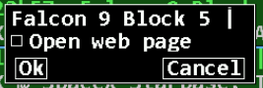
By clicking on a launch, you will be able to open a Google search for more information.

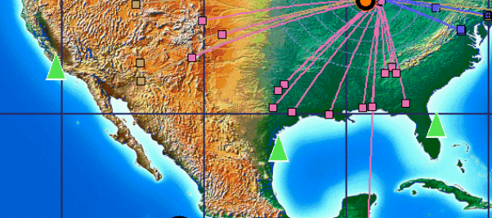
Launch locations are shown on maps with green triangles.

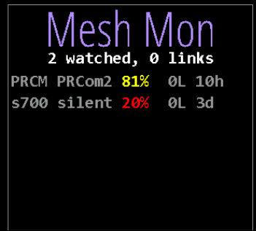
Mesh Mon displays information of watched Mashtastic nodes. The monitored nodes ID are entered on Page 4 of the setup pages.
The nodes are displayed on the map and a link to the node details page is available.

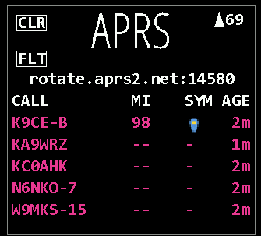
APRS shows nearby active APRS reports. To enable this pane you have to first enable the feature on setup page 3.

There you enable it and set a radios around your DE location. Any APRS reports outside of that radius will be filtered out.
Option in this data pane are to sort by distance, symbol and time. Clicking on an entry provides more information. Details about the displayed symbols can be found on page 105 or on aprs.world.

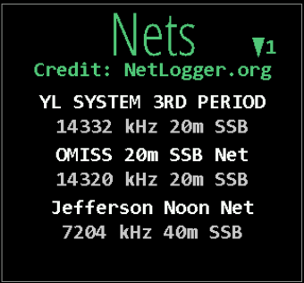
Nets provides a pane shows currently active nets from NetLogger.org.

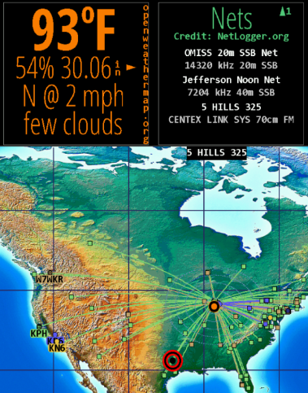
By hovering on the description of the net you will see the location of the control station highlighted on the current map.

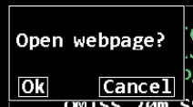
Click the net description will open a Google search for that net.

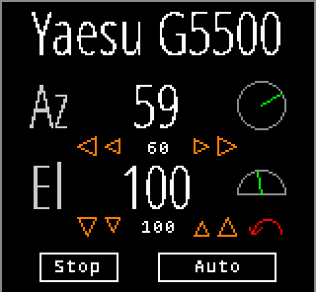
Rotator control If rotctld is set in Setup page 3 (Raspberry-PI only) then a Rotator option is available as a pane choice to control most rotators supported by hamlib. Set the host and port fields to the address of rotctld on your network. You must get rotctld working on your system first, then consider controlling it from HamClock. The Az row shows the rotator azimuth reported by rotctld and an angle graphic. Click the arrows beneath to manually command left and right rotations of 5 and 20 degrees, with the current commanded position shown between in a smaller font. An azimuth beam will also be shown on the main map. If the rotator includes an elevation axis a second row, labeled El, provides similar functions.
Clicking Auto will either track the current satellite, if one is set and there is an elevation axis, or keep azimuth pointing toward the short path of the current DX location. If the elevation axis can rotate beyond vertical to 180 degrees, i.e., upside down, it will be used to avoid an azimuth wrap during tracking and will be indicated with a red arrow arc on the El row. All motion will cease while the Stop button is active or the Rotator pane is not visible. Sat tracking requires HamClock to be set to UTC. Pointing direction honors the long or short path setting (see page 22).
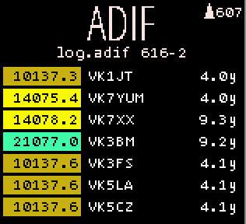
ADIF This pane lists and maps all QSOs in the ADIF file named in Setup page 3. File name is followed by total minus any malformed entries (details are in the diagnostic log). Frequencies are colored by band as per Setup page 6. The file is reread every 2 seconds for automatic monitoring. Click file name for menu to set sort and edit watch list (see page 20) or file name. Click a row to assign the DX object. Each ADIF record must define the fields CALL or CONTACTED_OP; QSO_DATE; TIME_ON; BAND or FREQ; and MODE. GRIDSQUARE or LAT and LON are used if present location is set, looking up CALL in cty list. OPERATOR or STATION_CALLSIGN are used if present else set to DE; MY_GRIDSQUARE, MY_LAT and MY_LON are used if present else set using DE or cty lookup if possible. All other fields are ignored.
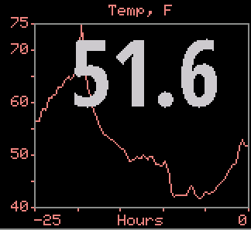
ENV (Raspberry-PI only) If an optional BME280 environmental sensor is installed and working (see page 68), then several pane options are available whose names begin with ENV to display temperature, humidity, dew point or station pressure. The current value is shown along with a 24-hour history. Clicking near the bottom of the pane will cycle immediately to another ENV choice without having to use the normal menu. If two sensors are installed, the pane is split to show graphs from each, labeled with their respective I2C bus addresses.

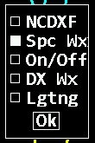
Upper Auxiliar Pane
The upper auxiliar pane, which is located at the upper right corner of the screen, has some unique features which are described here in detail. The available options depend on your hardware, and not all options might be available on your device.
Display Brightness Control (see page 63) | Display On/Off Timer (see page 63.)
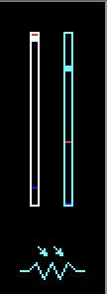  Light sensor reading (if installed)  Display brightnessss  Light sensor presentss | 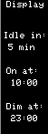  Times are reset from table on Setup page 8 each midnight.  Period until display OFF if no activity; 0 disables  DE on time today  DE off time today  Click just above or below each digit to change
NCDXF Beacons | BME Env stat
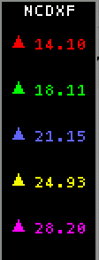  Map color key | 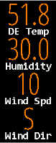  Click value to set Pane.
Space WX stats ranked by impact if Auto | DE/DX Wx stats
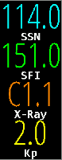
Lightning pane
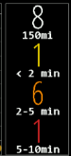
This panel shows an aged list of lightning strikes. Click in the middle of the pane to change radius around your location or select worldwide.

Left Flex Panes
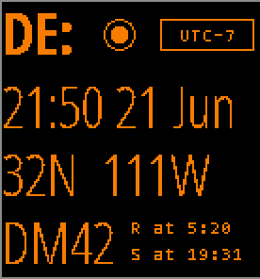
The DE pane shows HamClock’s idea of your location and local time. HamClock uses this location for many purposes from lunar angles to spot bearings. In this default format the panel shows local time and date, latitude and longitude, grid square and sun rise and set events. Click DE: to select other formats or select Data Panes (listed starting on page 22) that can overlay this and the DX panel. Click location to edit lat, long or grid. Click R or S to toggle showing the time at which the next or previous events occur, or the interval in which they will or have occurred. Click the time zone offset to update if necessary; see page 16 for more about how HamClock manages time.

click to manage DE time zone, see page 63
click to set format
click to set DE location, see page 63
click to select at/in
Clicking on DE activates the format menu. There are several clock options to choose from and a monthly calendar.
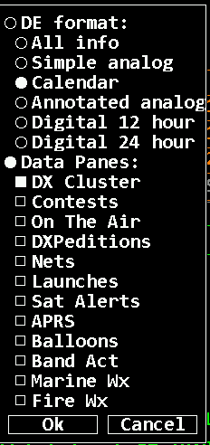
Data Panes - Selecting the Data Panes option will merge the DE and DX pane into a larger pane. There are 10 options of extended data panes which can be displayed here. If they are selected here, they are not available to be selected in the upper data panes and visa-versa.
The configuration options are the same as for the upper data panes (see page 23)

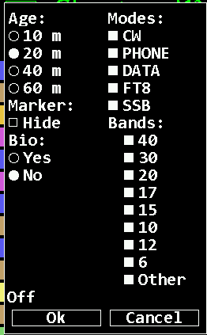
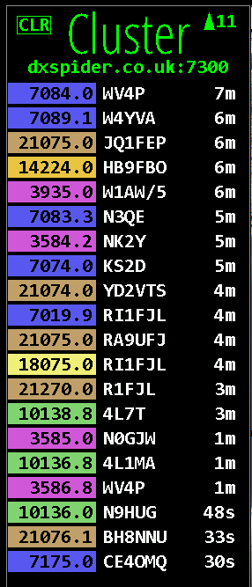
DX Cluster lists and maps spots from the cluster host defined in Setup page 2, subject to age, any filters and watch list. Frequencies are colored by band as per Setup page 6. Only the latest spot of a given call on the same frequency is shown. The columns are kHz, call and age. Click any row to set DX, rotator (if enabled), radio (if enabled) and look up bio if configured.
Clicking on the header line opens the settings window to enable runtime filtering.

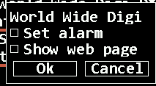
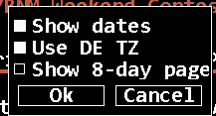
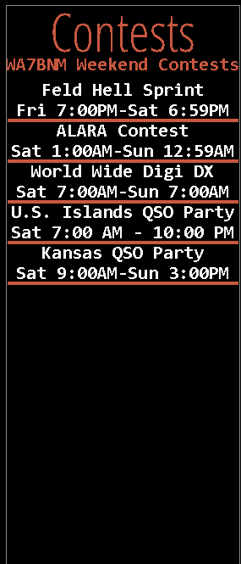
Contests lists amateur radio contests for the upcoming, or current, weekend. Click the credits line to set whether to show dates in UTC or DE time zone. Click a specific contest to set the one-time future alarm to the contest start time or display the WA7BNM web page for the contest. Contests currently in progress are highlighted with a green background. Data are kindly provided with permission by Bruce Horn, WA7BNM.
C
C
Clicking on the header will open a setting window to enable showing dates and setting times to local time. Enabling “Show 8-day page” will open up a 8-day overview page of upcoming contests.
Clicking on a contest line will bring up a settings window to enable an alarm and to open the webpage for the contest.

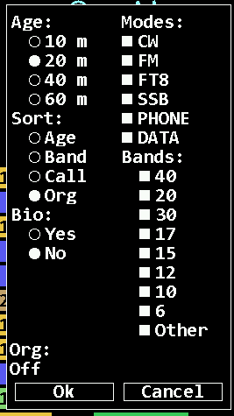
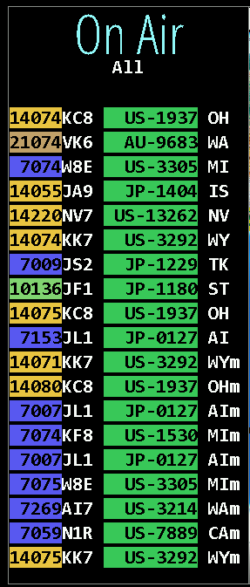
On The Air (ONTA) shows spots from various organizations. Organizations displayed are Current orgs are POTA (green), SOTA (orange), WWFF (teal), IOTA (cyan), GMA (slate grey), LLOTA (indigo), and WWOTA (copper). Parks will be highlighted in the ONTA pane corresponding to POTA, SOTA, WWFF, IOTA.
Click the org name (“All”) for a menu to select whether to show bio, max age, desired sort and to edit the Org filter and watch list. The Org filter may list multiple orgs separated by spaces to rotate; by + to combine without rotation; or an empty filter matches all. Click a spot row to set DX, radio (if enabled), rotator (if enabled) and bio page if used. Spot locations are plotted but paths are not because the spotter location is not available.

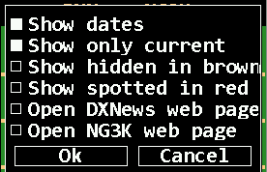
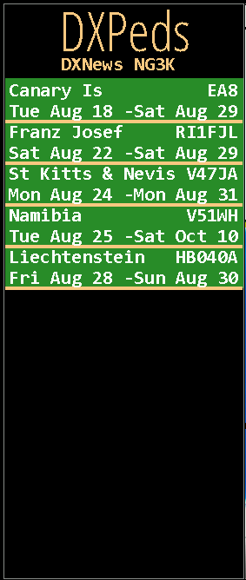
DXPeditions lists current, or upcoming, amateur DX expeditions. Click the credits line for overall menu options. Click a specific contest to hide; set a future alarm; assign to DX; or display the expedition web page, if any. Roaming over a list entry will mark it on the map. Map info table will show spotted frequency and, if ADIF is configured, worked slots to same DXCC. Data are kindly provided by DXNews and G3K

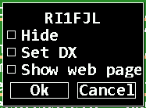

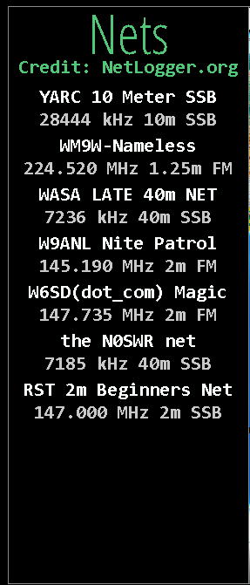
Nets shows currently active nets from NetLogger.org
Clicking on a net entry will provide the option to open the related webpage in a separate window.
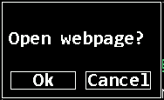

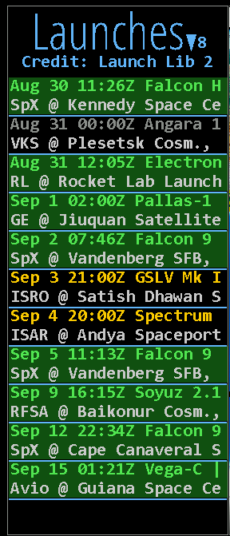
Launches provides information about upcoming satellite launches.
By clicking on a launch, you will be able to open a Google search for more information.
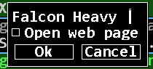

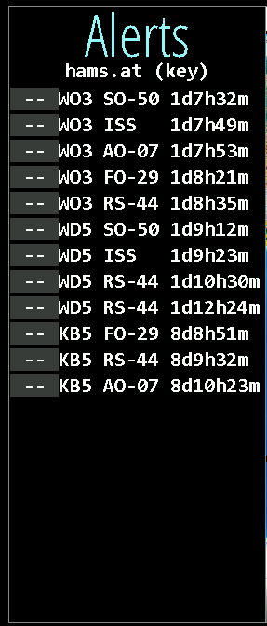
Sat Alerts provides a list of upcomming satellites from “hams.at” and gives you the opurtunity to set alarms or get more information from their website
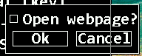
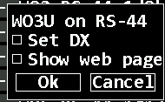

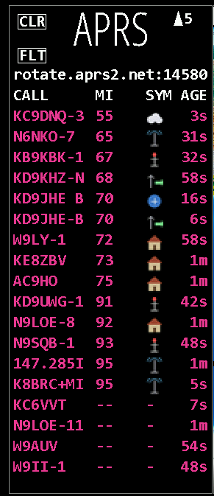
APRS shows nearby active APRS reports. To enable this pane you have to first enable the feature on setup page 3.
There you enable it and set a radios around your DE location. An.y APRS reports outside of that radius will be filtered out.

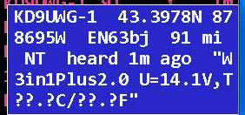

Option in this data pane are to sort by distance, symbol and time. Clicking on an entry provides more information.
Details about the displayed symbols can be found on page105 or on aprs.world.

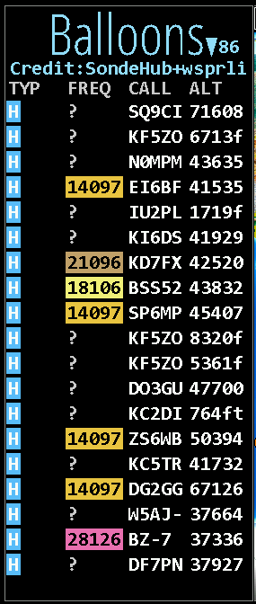
Balloons (HAB – High Altitude Balloons) provides information about flying high altitude balloons and Pico balloons collected from SondeHub and wsprlive. Clicking on the header line above the listing allows you to open the SondeHub website
Clicking on a listing provides a link to the balloons tracker page.
If this pane is selected, the current map will be animated with the listed balloons.
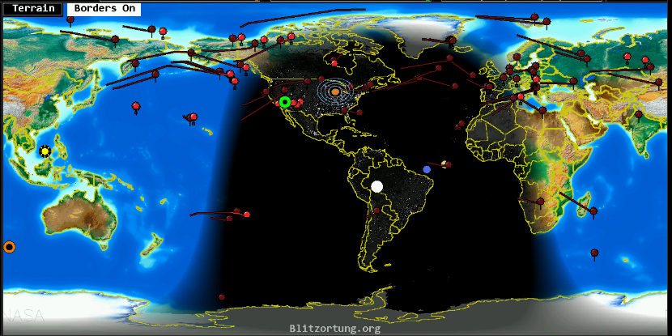

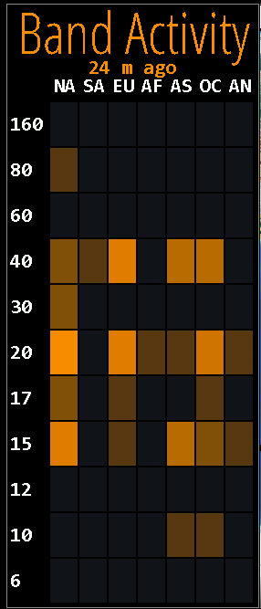
Band Act provides a heatmap style band activity display on a per continent and per band level. Lighter color means more activity. It compliments the Live Spots pane.
This pane has no additional settings.

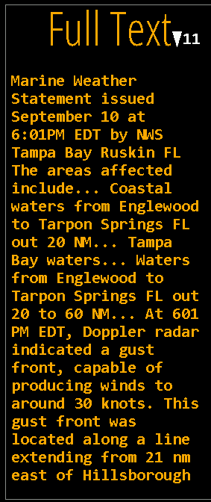
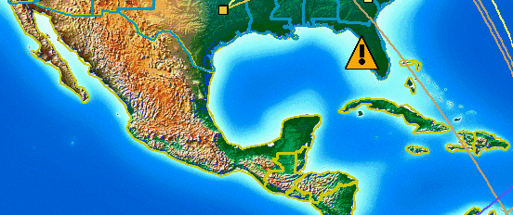
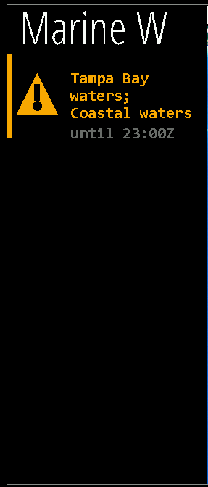
Marine WX - shows marine weather warnings. For more detailed information, click on the text and the Full text pane will display.
On the maps the location of the marine weather warnings is displayed by a yellow triangle with exclamation mark.

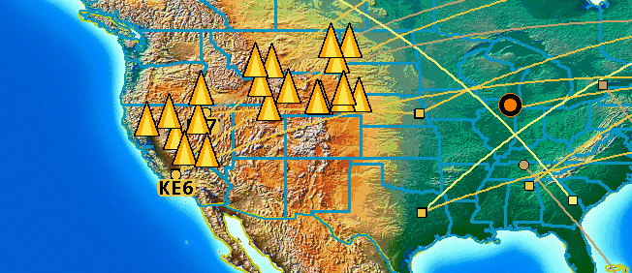
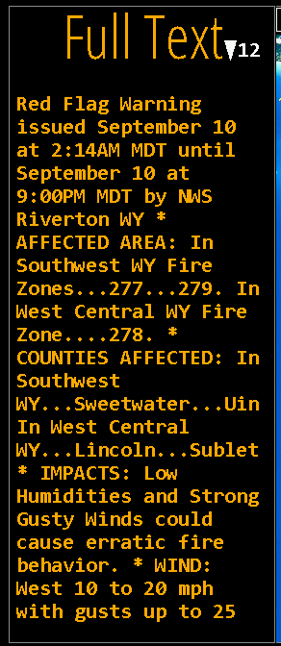
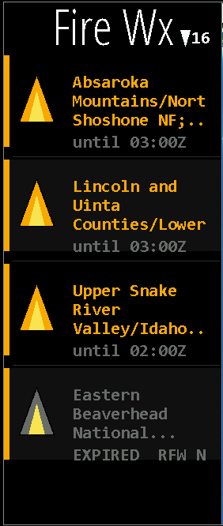
Fire Wx - shows fire weather warnings. For more detailed information, click on the text and the Full text pane will display. Fire weather warnings are displayed as ayellow pyramid on the maps.

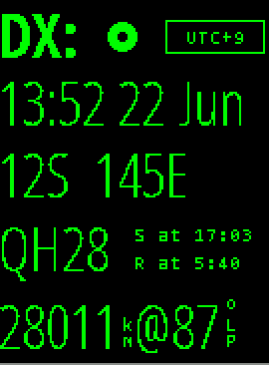
The DX pane shows HamClock’s definition of a second location independent from DE. Controls and layout are like the DE panel except the rise/set table also has an option to show the DX location prefix; clicking DE shows a list of satellites that can be tracked; and clicking LP or SP toggles whether the data shown refers to long path or short path. If a satellite has been selected, this panel changes to display its next pass; see next.

click to select at/in
click to manage DX time zones
click to choose up to two satellites
click to toggle short or long path
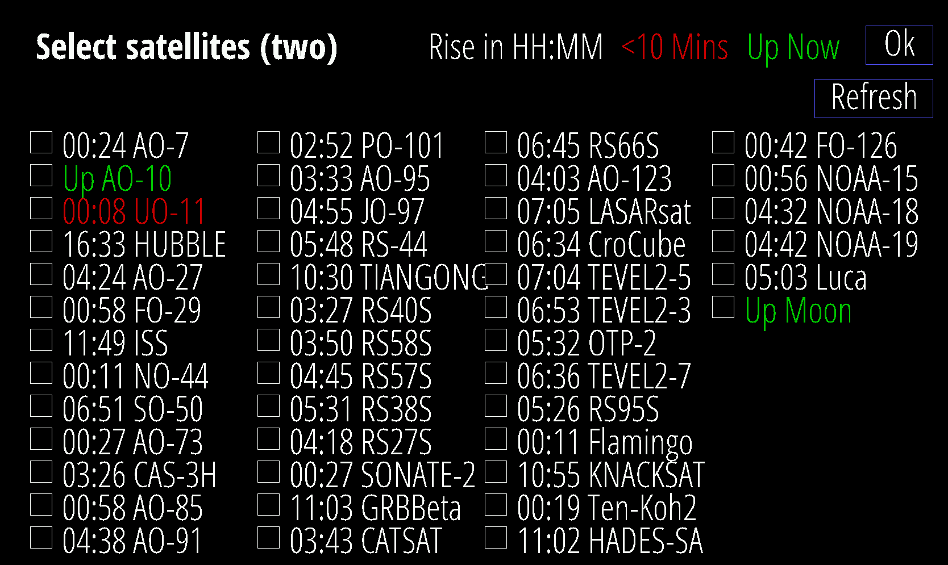
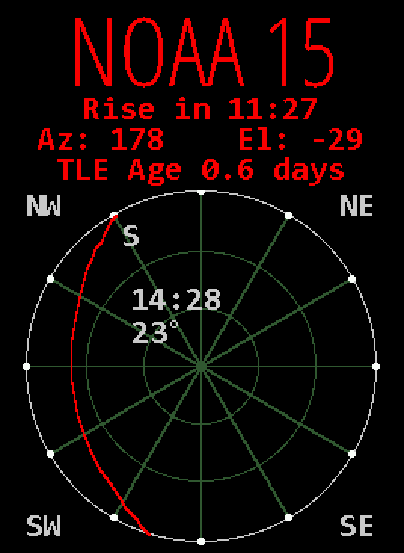
The DX pane can be repurposed to show details of the next satellite pass as viewed from DE. Below the satellite name is the time until the next Rise or Set event, current az and el, and TLE age. Rise and set are based on the satellite passing above or below the ideal geometric horizon without regard to refraction. The time format will be HH:MM if the event is more than an hour away otherwise MM:SS. A schematic representation shows how the pass will appear in the sky above DE oriented as shown by the compass directions in each corner. Faint lines are drawn at 30° and 60° elevation and every 30° in azimuth. The setting end of the pass is marked with an S. Midway along the pass are shown the duration as MM:SS and maximum elevation in degrees. Click anywhere in the circle for a menu of additional options.

click for more options
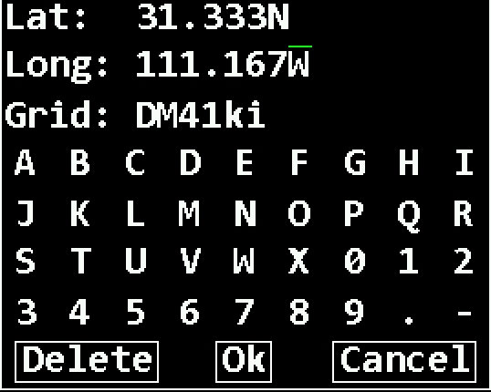
If the DE and DX panels are visible you can set the location directly. Clicking lat, long or grid in the DE: or DX: panes will display a dialog where these values may be directly edited to full precision either by clicking the virtual keyboard or using a real keyboard the same way as Setup.
Corresponding values will be computed automatically, and invalid entries will be flagged when clicking Ok. Grid coordinates are based on the SW corner.
HamClock always uses full precision internally but, due to limited screen space, rounds the display to whole values. This may lead to unexpected results when entering fractional lat or long values.
For example, suppose they are set to 35N and 110.1W so the grid will be DM45ka. The main display will show 35N 110W grid DM45 which, unless one knows the internal values, seems incorrect because 35N 110W exactly is actually in grid DM55. When in doubt, open the dialog to review the values at full precision.

Main Map Area
For the main map area, you can select different projections, styles, and overlays. If you select multiple options, the display will cycle through the options.
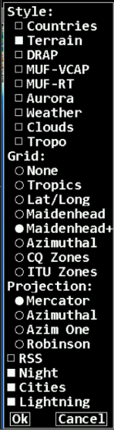
Styles – here you can select the map type.
Grid – for the selection of the grid overlay type.
Projection – You can select between Mercator, Robinson and Azimuthal projection.
RSS – enables the information banner at the bottom of the map.
Night – enables the shading of the night area of the map.
Cities – enables cities as spots to hover over and displaying information about them.
Lightning – enables the lightning display function. If this option is enabled, it will also enable the lightning options for the auxiliar pane.

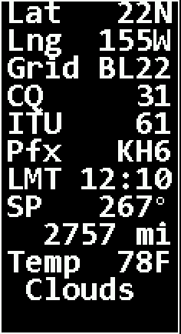
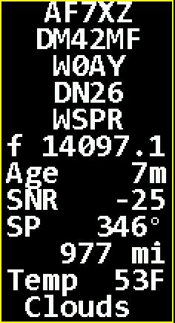
Info table: A box such as those at left will appear automatically in the upper left corner of the map whenever the cursor is over the map, over a spot on the map or listed in a data pane. The contents depend on context but may contain Latitude; Longitude; Grid; Local Mean Time (does not account for savings time); CQ and ITU zone designations; Prefix; TX and RX call and grid; Mode; Frequency; spot Age; Bearing and Distance from DE; and weather conditions. The bearing degree symbol becomes M if referenced to magnetic north (see Setup page 5). When displaying spot information, the border color matches the assigned band color, and a red bullseye shows the corresponding map location.

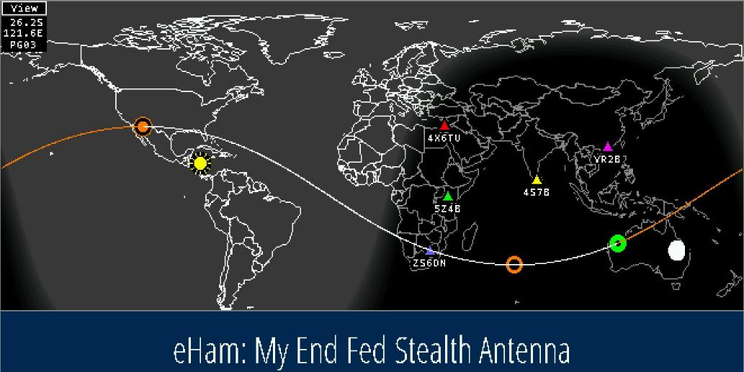
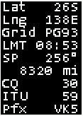
Map Overlays

Map style – see page
Info table, see page 12
Sub-earth Moon location
and phase from surface
Long path
Short path
DE
NCDXF beacon
Sun
Rotating RSS feeds
DX
Most maps have some indicators which are described above. The visibility of these indicators is dependent if certain features are enabled or not (E.g., beacons or satellites).

Map Projections

Mercator Projection
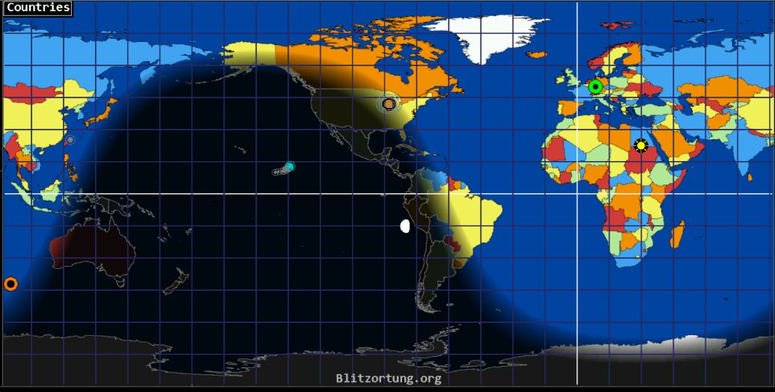
The Mercator projection is a type of world map that displays the Earth on a rectangular grid. HamClock uses it because it keeps shapes and angles accurate, which is extremely useful for radio operators who need to visualize great-circle paths, greyline, and station bearings.
But it comes with tradeoffs.
What the Mercator Projection Preserves
Mercator is a conformal projection, meaning:
- Angles are correct.
- Shapes are preserved locally.
- Compass bearings appear as straight lines.
This is why it’s ideal for:
- Visualizing beam headings
- Tracking DX paths
- Displaying greyline consistently
- Showing weather overlays without distortion of storm shapes
For radio work, this is gold.
What the Mercator Projection Distorts
Mercator greatly exaggerates size as you move toward the poles.
Examples:
- Greenland looks the size of Africa (it’s actually 1/14th)
- Alaska looks huge.
- Antarctica becomes a stretched band.
This happens because the projection stretches the map vertically to keep angles correct.
For HamClock, this means:
- Polar regions look larger than reality.
- Aurora ovals appear stretched.
- High-latitude DX paths look longer than they physically are.
But the direction is still correct, which is what matters for antennas.
Choose HamClock’s Mercator projection to:
- Keep beam headings visually intuitive.
- Makes greyline easy to interpret.
- Displays weather systems in familiar shapes.
- Works well with DX cluster spots.
- Keeps map labels readable.
It’s the most operator-friendly projection for everyday HF/VHF monitoring.

Azimuthal Projections
HamClock includes two distinct Azimuthal Equidistant projections, both centered on your QTH. They look similar at first glance, but they serve different operator needs.

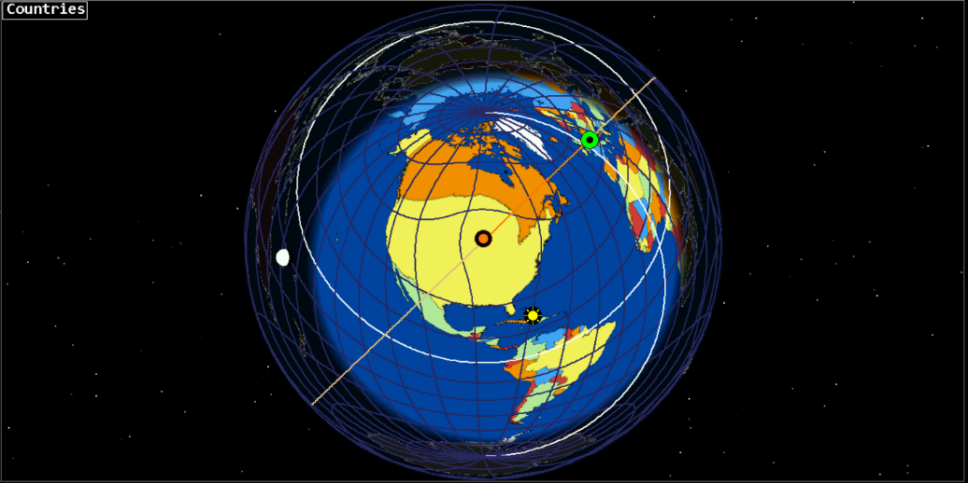
Azimuthal Equidistant (AZIM One - Centered on Your QTH)
Purpose: True great-circle bearings for antenna pointing.
This is the classic ham-radio projection used on wall maps for decades. Every point on the map is plotted so that:
- The direction from your QTH is correct.
- The distance from your QTH is proportional.
- Every straight line = the true great-circle path.
This makes it the best projection for:
- DX antenna headings
- Contesting
- Beam steering
- Path prediction
- Understanding long-path vs short-path
What it looks like:
- Your QTH is at the center.
- The world radiates outward like a compass rose.
- Distortion increases at the edges (normal for this projection).
Why operators love it:
It’s the most accurate map for real-world HF paths. If you point your beam along the straight line on this map, you’re pointing correctly.

Azimuthal Equidistant (Hemisphere View)
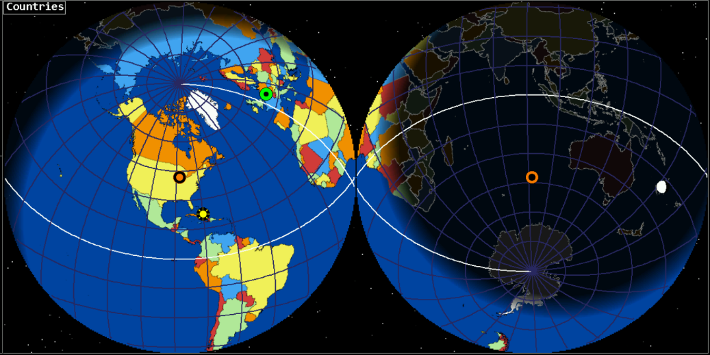
Purpose: A full-Earth view with correct bearings but smoother global context
This version still keeps:
- Correct bearings from your QTH
- Correct distances from your QTH
…but instead of showing the entire Earth on a flat disk, it displays a hemispheric view that:
- Shows your half of the Earth cleanly
- Reduces edge distortion.
- It makes weather, grayline, and DX clusters easier to interpret.
- Keeps the “radio-accurate” geometry without the harsh stretching of the full disk version.
What it looks like:
- Your QTH is still the center.
- The visible half of Earth is shown as a circular hemisphere.
- The far side of Earth is hidden (because it’s behind the globe)
Why operators use it:
- Cleaner, more readable
- Better for global situational awareness
- Still accurate for beam headings
- Ideal for DX cluster overlays, grayline, and weather maps
Which One Should You Use?
Use Azimuthal (Full Disk) when you want:
- Maximum accuracy for antenna headings
- Both short-path and long-path visible at once
- A traditional ham-radio “beam map”
Use Azimuthal (Hemisphere) when you want:
- A cleaner, more readable map
- Better weather and DRAP visualization
- A more intuitive global view
- Accurate bearings without extreme distortion

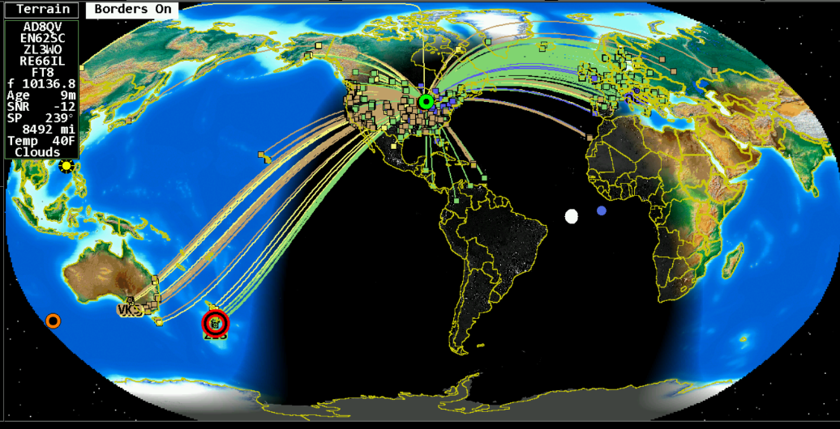
Robinson Projection
In this screenshot the live spots and borders are turned on and one spot is highlighted, displaying the information about this spot in the upper left corner.

The Robinson projection is a world map style designed to look balanced and visually natural, avoiding the extreme distortions of projections like Mercator. It’s often described as a “compromise projection” because it doesn’t preserve any single property perfectly—but it keeps shape, size, and distance errors low enough to produce a map that looks right to the human eye.
For HamClock users, the Robinson projection offers a smooth, aesthetically pleasing global view that’s excellent for monitoring:
- Greyline movement
- Global weather systems
- DX cluster activity
- Satellite footprints
- Worldwide propagation patterns
The Robinson projection is designed for visual realism, not mathematical precision. It provides:
A natural-looking world.
Continents appear proportionate and familiar, without the polar stretching seen in Mercator.
Reduced distortion
- Shapes are more accurate than Mercator at high latitudes.
- Areas are more balanced globally.
- Distances are visually reasonable.
Excellent global context
It’s ideal for dashboards like HamClock where you want to see the whole Earth at once without dramatic distortion.
Because it’s a compromise projection, Robinson does not preserve:
- True angles (so bearings are not accurate)
- True areas (continents are slightly resized)
- True distances (scale varies across the map)
This means it’s not ideal for antenna headings or great-circle path analysis—that’s what the Azimuthal Equidistant projection is for.
Why HamClock Includes the Robinson Projection
HamClock offers Robinson because it provides:
- A beautiful, readable world map
- A balanced view of continents and oceans
- A smooth backdrop for overlays like:
  - Cloud/precipitation maps
  - DRAP absorption
  - MUF-RT and MUF-VCAP
  - Solar terminator (grayline)
  - DX spots
It is the best choice when you want a global situational awareness display rather than precise directional information.

Zoom levels are only available with the Mercator Projection.
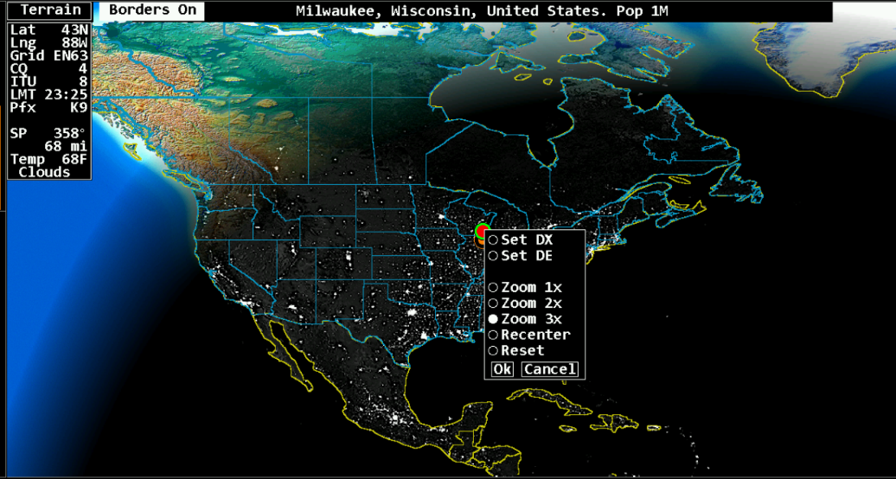
With Terrain or Clouds selected you will be able to switch on “Borders” to display country lines and state lines for US and Canada. Stat and province lines are only visible if you zoom in on the map.
With cities enabled you will be able to get more information about a city when hovering over it.
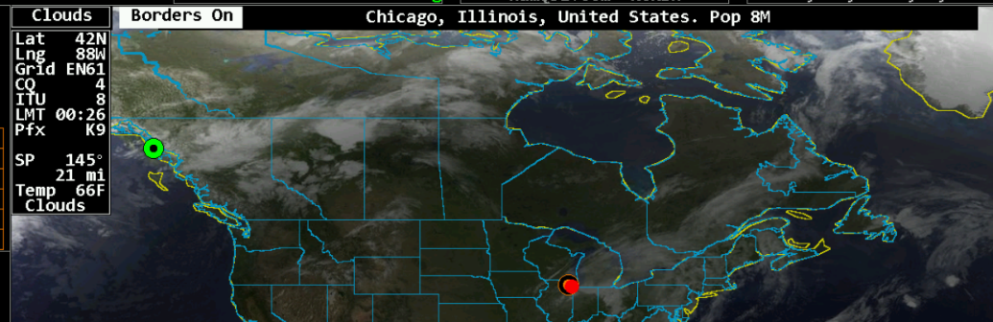

Grids allow you the selection of different grid overlays.

Grid overlays
Lat/Long Grid | Maidenhead Grid
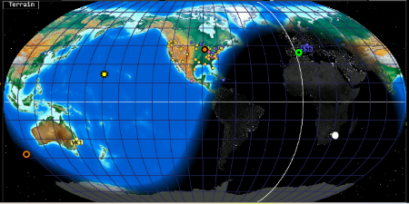 | 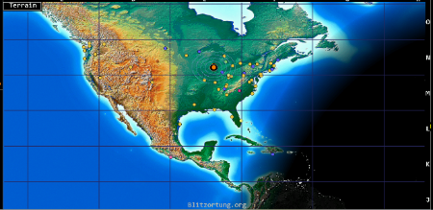
Tropics Lines | Maidenhead Grid+
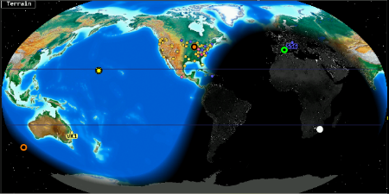 | 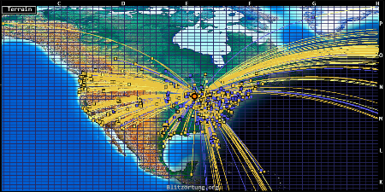
Azimuthal Grid | CQ Zones
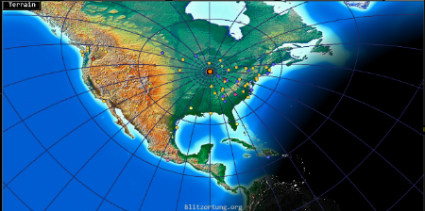 | 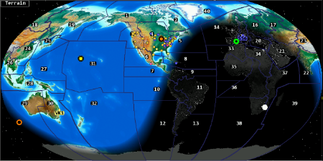

ITU Zones
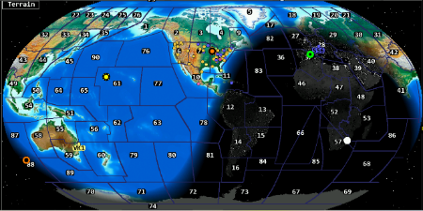

Map Styles

Countries
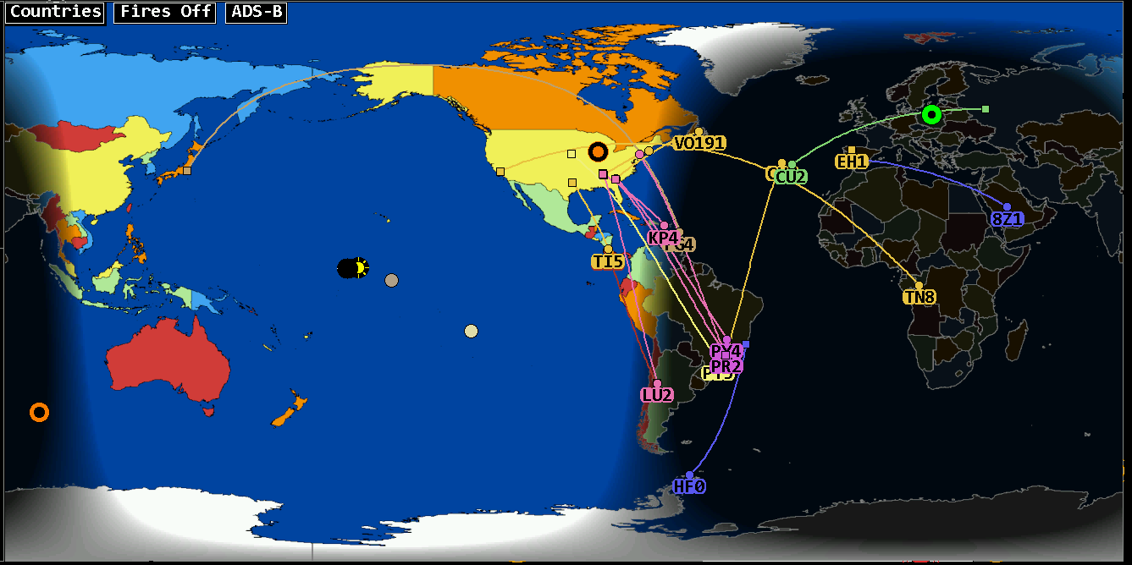
In the “Countries style you see countries marked in different colors.

Terrain
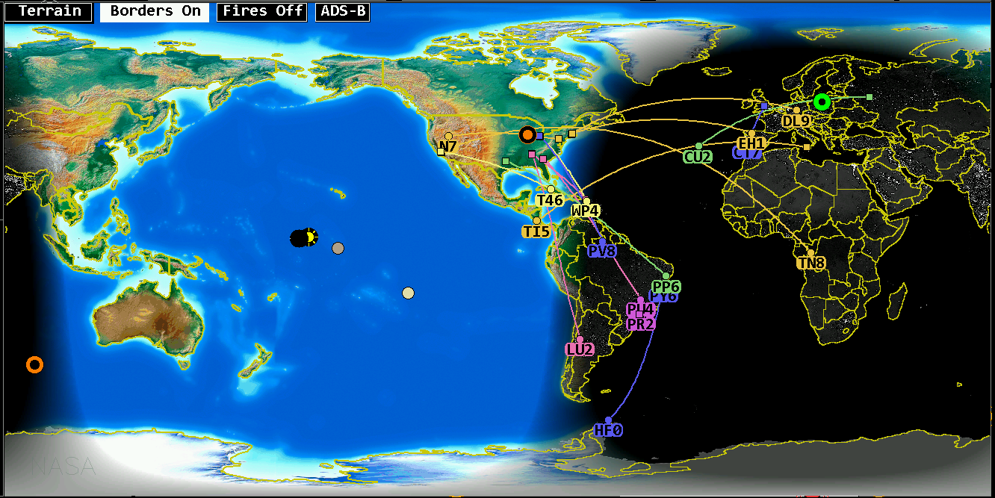
In the terrain style you will be able to switch on country borders with the “Borders” button.

Wildfire Overlay
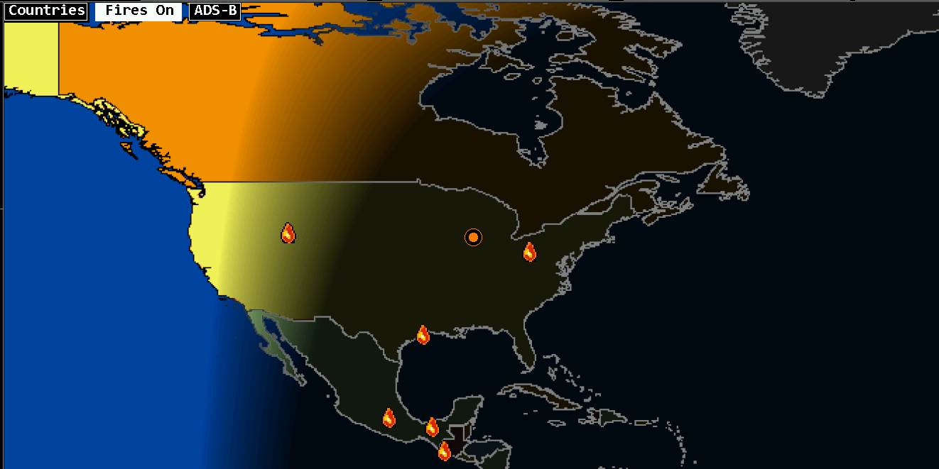
With the “Fires On” button the wildfire overlay can be enabled. Any reported wildfires are displayed with a flame symbol.

ADS-B Overlay
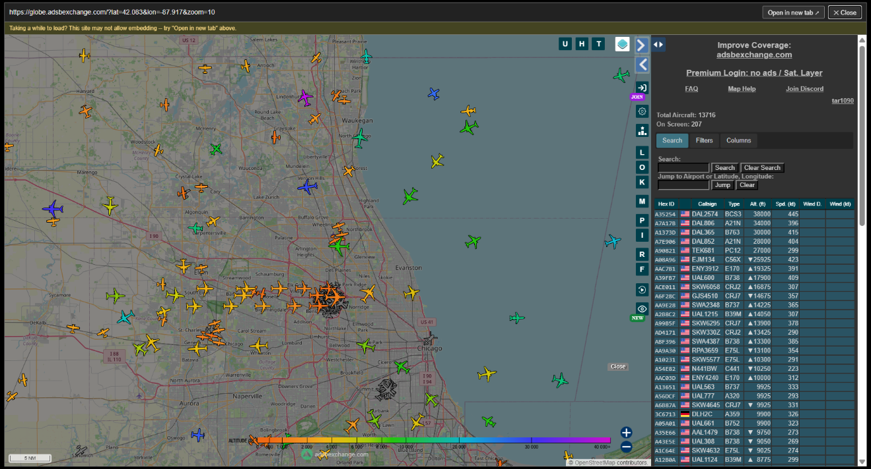
You can close the ADS-B overlay with the “Close” button in the upper right corner.

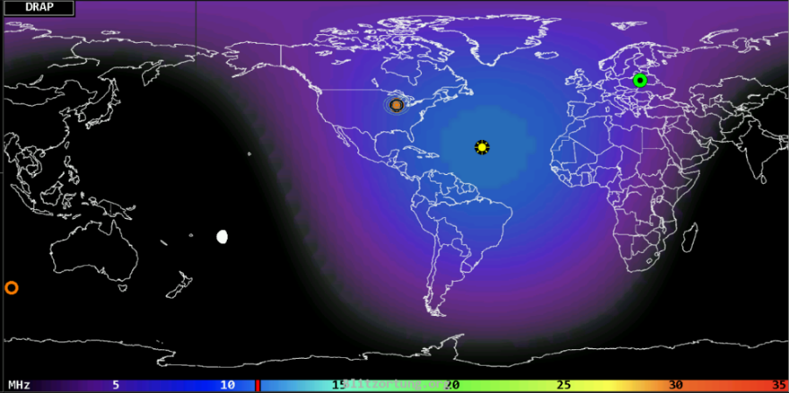
DRAP
This map style shows a near real-time display of the NOAA D Region Absorption Predictions model, or DRAP. The model predicts HF propagation absorption caused by solar X- ray and proton flux events. D layer absorption decreases with increasing frequency, so the map color-codes the highest frequency ray that is attenuated by at least 1 dB while passing through each location. Rays at lower frequencies will experience progressively greater attenuation of 30 dB or more. The color scale is gray for no absorption at any frequency progressing through a spectrum to indicate higher frequencies. See also the DRAP pane (page 23) for a time history.

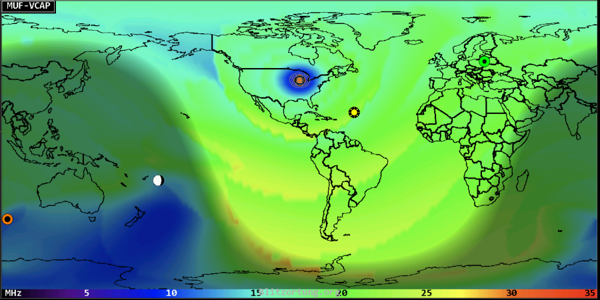
MUF-VCAP
This map style shows the VOACAP model for median Maximum Usable Frequency between DE and other points in the world about half the time each month. This model is useful for long-term planning, such as for a DXpedition; the MUF-RT style is a better indication of current conditions. Note even when a path seems promising, it may still not be unusable due to low signal power, local noise or variable space weather conditions. The map is color coded the same as DRAP.

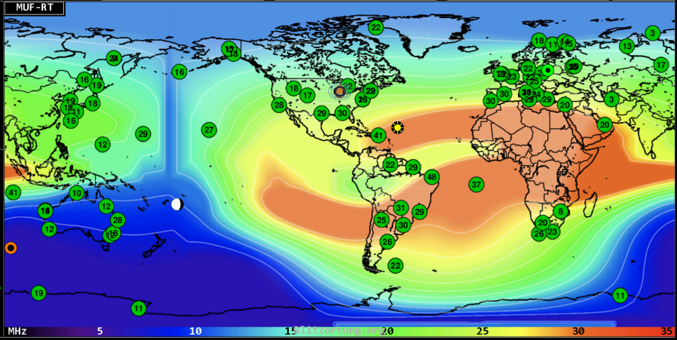
MUF-RT
This style shows a real-time map of Maximum Usable Frequency based on a worldwide consortium of ionosondes, those of which were active within the last hour are labeled with their reporting frequency. The data are updated every fifteen minutes. Note that since the stations are not spaced uniformly, significant license was required to perform global interpolation. At any given location, the MUF value is the highest frequency that will refract back to Earth a wave launched 1500 miles away, thereby supporting a total single hop path of 3000 miles. Waves higher in frequency will generally continue into space and be lost. Using this basic model, one can imagine where the hops will occur along a path from DE to DX and estimate whether they will be supported for a given band. Note even when a path seems promising, it may still not be unusable due to low signal power or local noise. This map is a good indication of current conditions; the MUF-VOACAP style is better suited for long term planning such as for a DXpedition. Both use the same color key. Data for this map are from GIRO collected and used with permission from KC2G.

Aurora
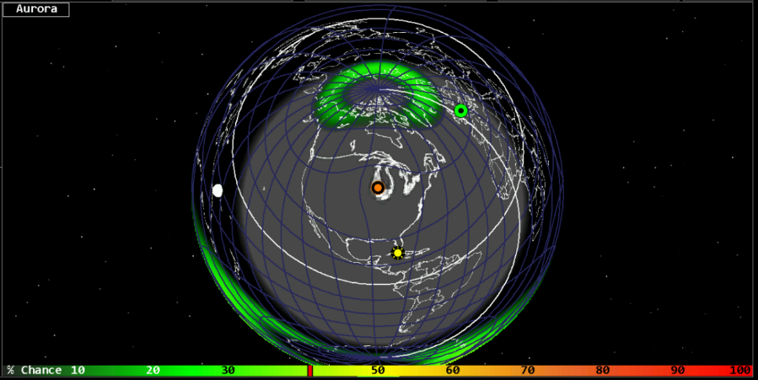
This map style shows the chances for aurora activity based on total ionospheric energy deposition. High activity is often associated with geomagnetic storm conditions. This map is best viewed with the Azimuthal projection.
Aurora for radio propagation refers to the way charged particles from the sun disturb the ionosphere near the polar regions, creating both severe HF degradation and unique VHF propagation modes. Auroras occur when solar-wind particles funnel into the Earth’s magnetic poles and energize atmospheric atoms, producing both the visible aurora and major ionospheric disturbances.
What Causes Aurora
When the solar wind intensifies, especially during geomagnetic storms, the Earth’s magnetic field directs energetic particles into the polar atmosphere. These particles ionize atmospheric gases, creating:
- Visible aurora (green/red curtains)
- Highly disturbed ionospheric regions
- Irregular, turbulent electron densities
These disturbances dramatically alter how radio waves refract or scatter.
HF Effects (3–30 MHz)
Aurora is bad news for HF:
- HF blackouts occur because the ionosphere becomes too disturbed to refract signals normally.
- Severe absorption in the D and E regions kills long-distance propagation.
- Signals become weak, fluttery, or vanish entirely.
- When Kp ≥ 5, expect HF degradation.
- Bands collapse during strong auroral events.
VHF Effects (50–150 MHz)
Aurora creates one of the most unique VHF propagation modes: auroral backscatter.
- Instead of refracting, signals scatter off the auroral curtain.
- The curtain acts like a moving, irregular reflective sheet.
- Operators point antennas north (or toward the auroral oval), not toward the DX station.
- When Kp ≥ 5, expect possible auroral VHF openings.
You will hear:
- Raspy, distorted CW
- Buzz-saw SSB
- Digital modes (e.g., Q65) optimized for aurora are increasingly used.
Auroral propagation is strongest on 6m and 2m but can extend to 10m and 12m during intense events.
Aurora is favorable for:
- VHF DX via auroral scatter
- Short-lived openings at 6m and 2m
- Auroral-E events (Es + aurora) enabling unusual HF/VHF paths.
Unfavorable:
- HF long-distance communication
- Polar paths (e.g., Midwest → Asia via polar route)
- Aviation HF
- Emergency HF nets
- Point beams north for auroral VHF work.
- Use CW or Q65—SSB becomes nearly unreadable.
- Check aurora dashboards (e.g., DXRadar’s aurora tools) for real-time activity.

Weather
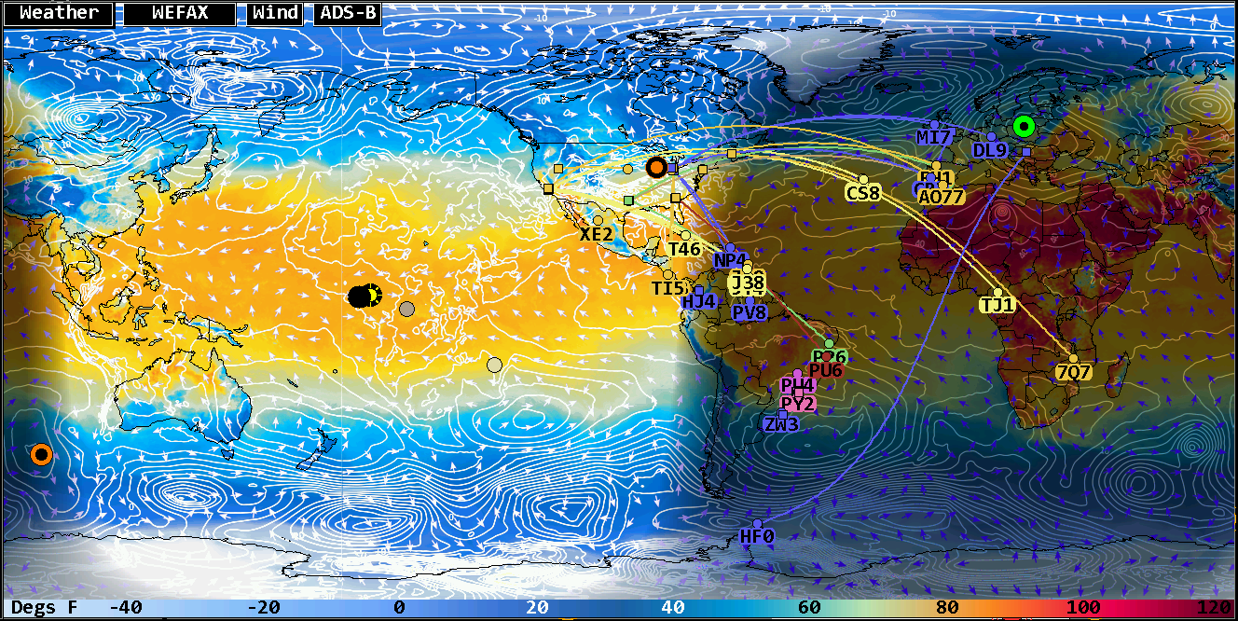
HamClock’s weather map is a real-time (hourly updated) global meteorological layer that includes:
Cloud Cover
- White/gray shading = cloud density
- Helps identify thunderstorm regions, cold fronts, and tropical systems.
- Useful for predicting static crashes (QRN) on HF
Precipitation
- Blue/green/yellow/red shading = rain intensity
- Red/purple = severe storms
- Correlates with lightning activity, which increases HF noise.
Storm Systems
You can visually track:
- Tropical storms / hurricanes
- Mid-latitude cyclones
- Squall lines
- Frontal boundaries
This matters because they change noise levels, absorption, and signal stability.
Weather impact for radio frequencies
Weather doesn’t change the ionosphere directly — but it absolutely affects operating conditions:
HF (3–30 MHz)
- Thunderstorms → QRN spikes
- Lightning → broadband noise across 80m/40m/20m
- Tropical systems → persistent static crashes
- Heavy rain → slight attenuation on higher HF bands
VHF/UHF (50–1200 MHz)
- Temperature inversions → ducting
- High-pressure systems → enhanced tropospheric propagation
- Storm fronts → scatter and fading.
- Humidity gradients → refractive bending
HamClock’s weather map helps you spot these patterns at a glance.
Where HamClock Gets the Weather Data
HamClock pulls from global meteorological satellite composites, typically NOAA and international weather agency feeds. It updates automatically and overlays the data on the world map projection you’ve selected.
HamClock Weather Map Legend
Cloud Cover (Grayscale)
- White / Light Gray — Heavy cloud cover
- Medium Gray — Partial cloud cover
- Dark Gray / Black — Clear skies
Cloud shading helps identify storm systems, fronts, and regions likely to produce HF noise (QRN).
Precipitation (Color Scale)
- Light Blue — Light rain or drizzle
- Green — Moderate Rain
- Yellow — Heavy rain
- Orange — Intense rain / thunderstorms
- Red / Purple — Severe storms, tropical systems, or extreme precipitation
These areas correlate strongly with lightning-generated noise on HF.
Storm Structure Indicators
- Bands of curved precipitation — Mid-latitude cyclones
- Circular or spiral patterns — Tropical storms / hurricanes
- Linear yellow/red streaks — Squall lines or frontal boundaries
These patterns help operators anticipate QRN spikes and VHF scatter conditions.
Geographic & Map Elements
- Coastlines — White or light outlines
- Country borders — Thin gray lines (can be configured on Page
- Latitude/Longitude grid — Optional, depending on your HamClock configuration.
- Day/Night Terminator — Soft shadow showing the grayline (important for HF propagation)

WEFAX
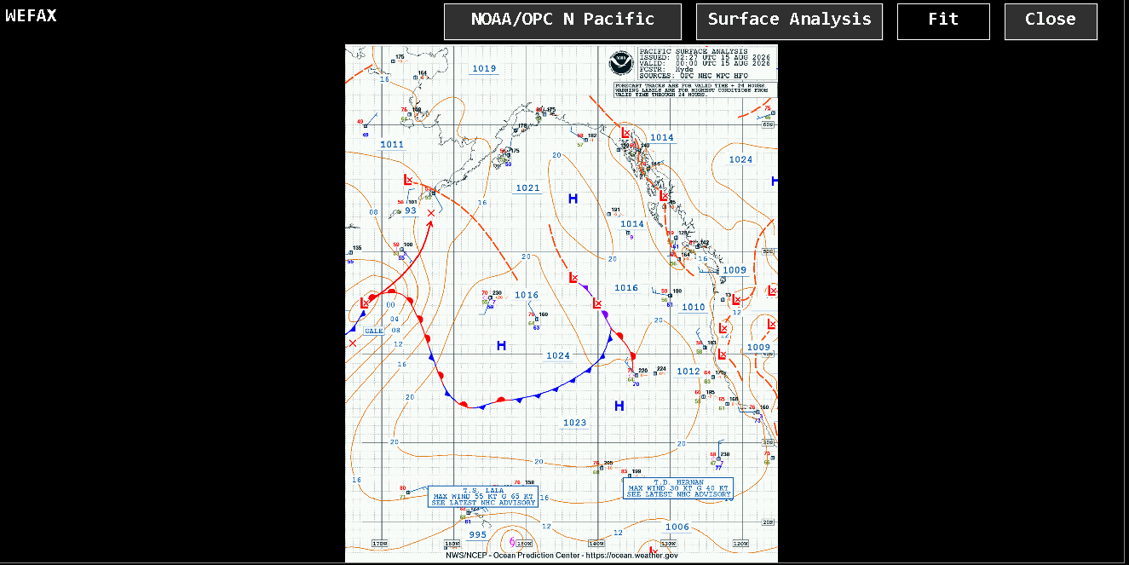
Clicking on WEFAX will display different detailed weather maps.
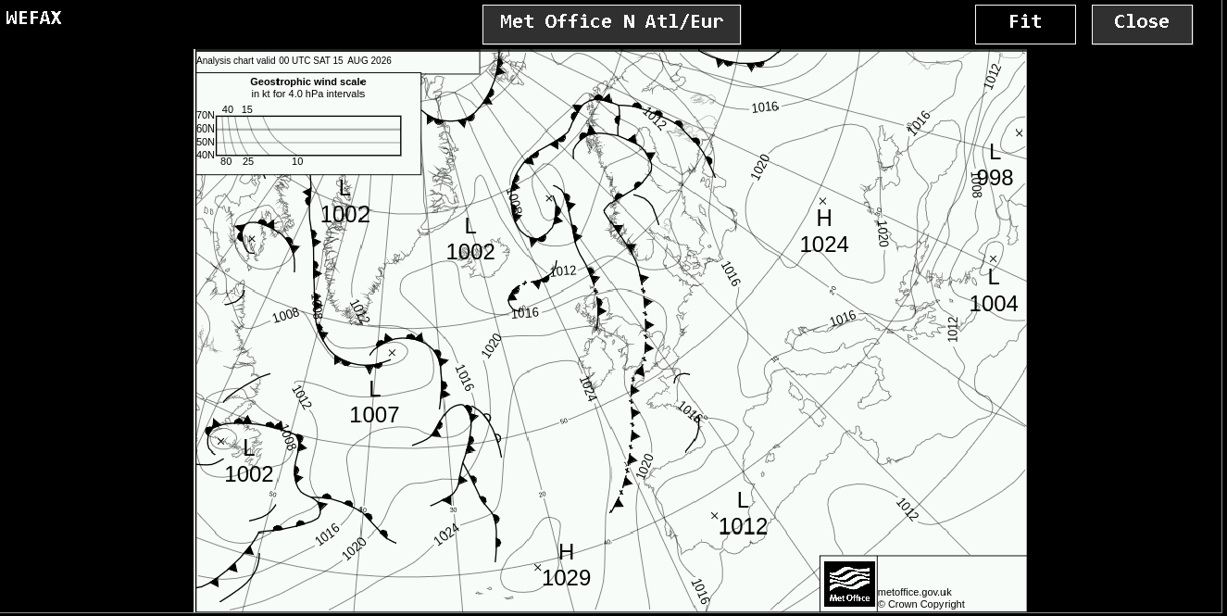
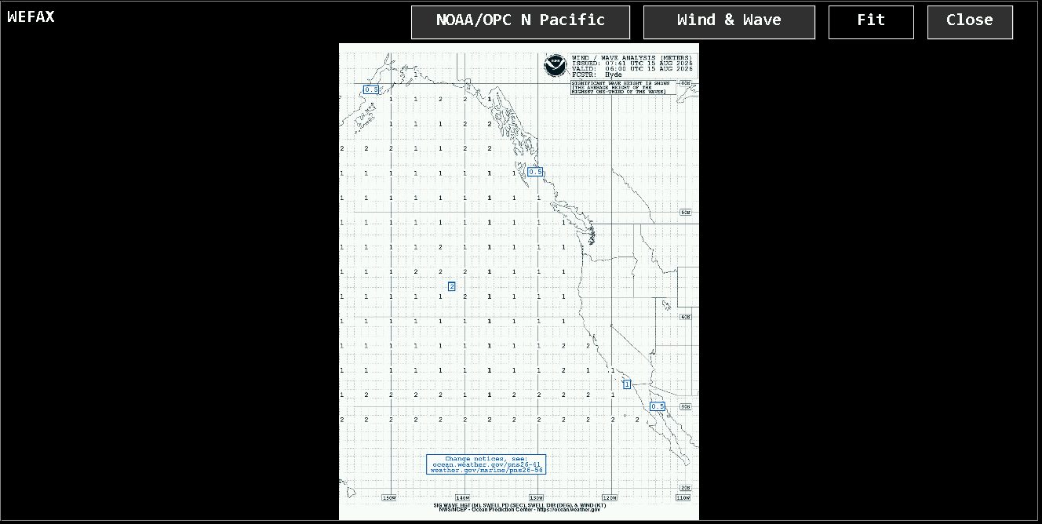

Wind
This button opens an external link to windy.com.
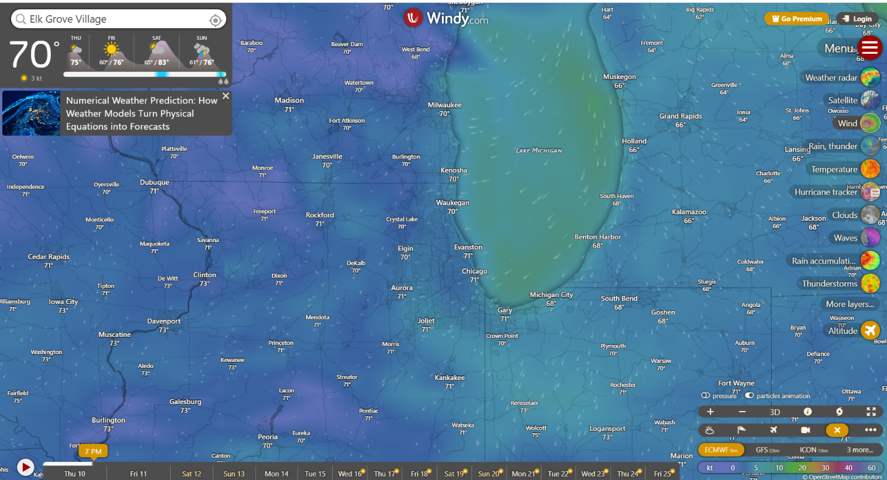

Clouds
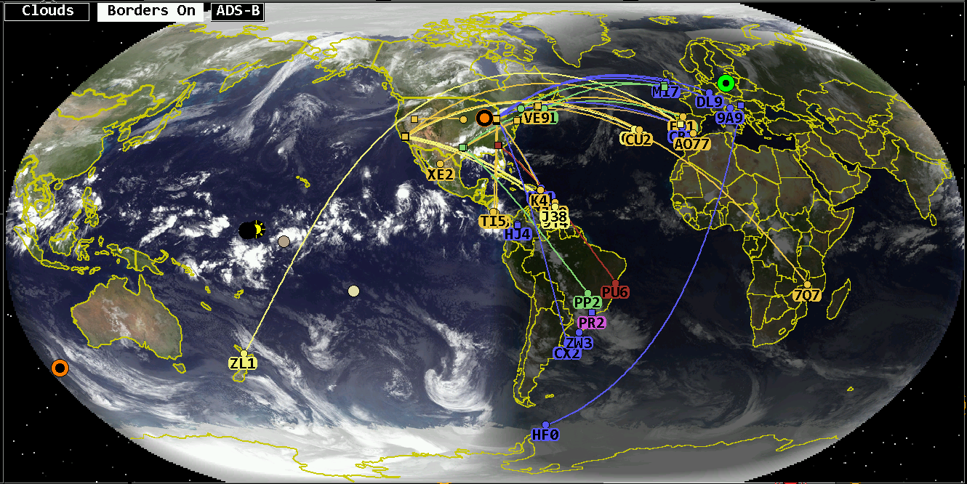
The HamClock Cloud Map is a real-time global weather overlay that displays current (delayed by 1 to 2 hours) cloud cover and precipitation patterns across the Earth. It provides operators with quick situational awareness of weather systems that influence HF noise levels, VHF/UHF propagation, and general operating conditions.
HamClock renders cloud cover in grayscale, where lighter shades indicate denser cloud formations, and darker shades represent clearer skies. Overlaid color regions show precipitation inten sity, from light rain to severe thunderstorms. This allows operators to visually identify storm fronts, tropical systems, and high-pressure zones at a glance.
Because thunderstorms and large weather systems generate significant QRN on HF, the Cloud Map helps predict noisy bands, especially 80m, 60m, and 40m. For VHF/UHF, clear areas under stable high-pressure systems often correspond to enhanced tropospheric propagation, while sharp weather boundaries can indicate scatter or fading.
In short, the HamClock Cloud Map is a radio-relevant weather layer, giving operators a fast, intuitive view of atmospheric conditions that affect real-world operating performance.
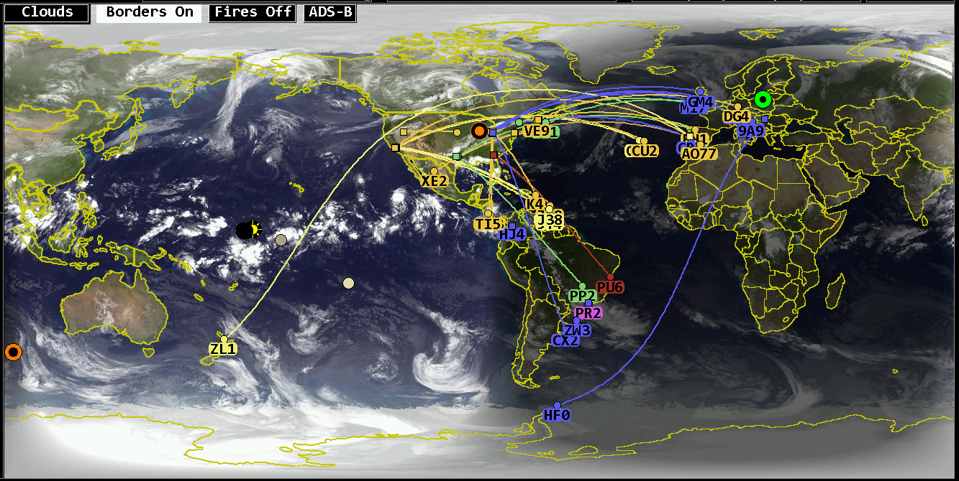
With Mercator projection and Cloud enabled you can display country boarders and when zoomed in, the state lines for the US and province lines for Canada are displayed.

REL (Reliability)
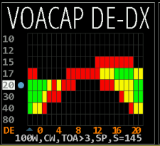
When a specific band is selected in VOACAP band conditions on the left in the VOCAP pane, a reliability map overlay is displayed in the rotation.

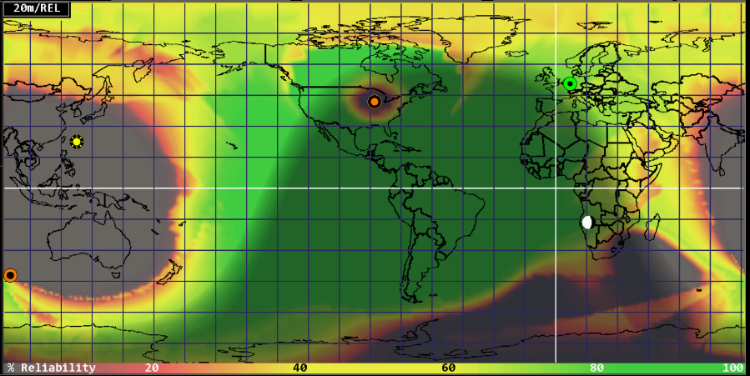

TOA (takeoff angle)
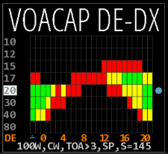
When a specific band is selected in VOACAP band conditions on the right of the VOACAP pane, a takeoff angle map overlay is displayed in the rotation.

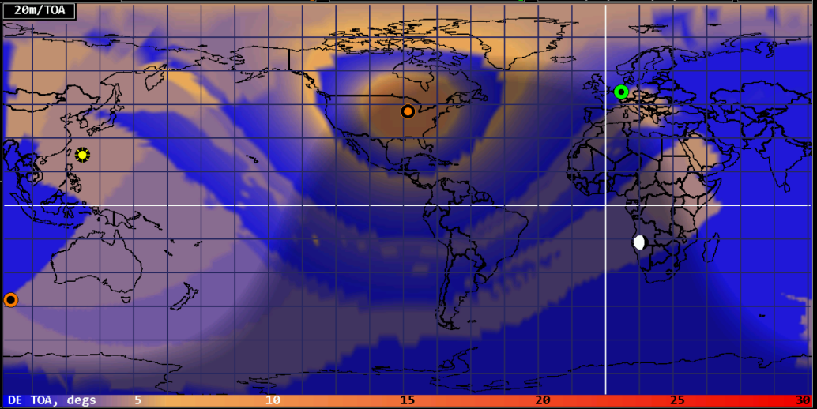

RSS Banner
Overlays the lower map with live RSS feeds, cycling every 15 seconds. Click to show parent web page. Sources are AR Newsline, HamWeekly and NG3K (DXCC).
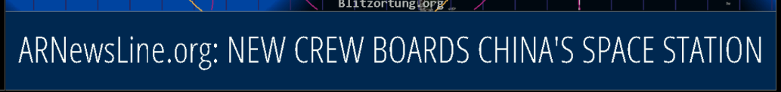

Night
Select to darken the map where it is currently nighttime; good for showing current gray line boundary.

Cities
whether to display name and population of representative cities nearest to cursor, if any.
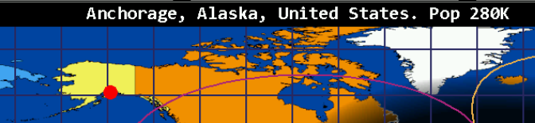

Lightning
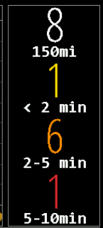
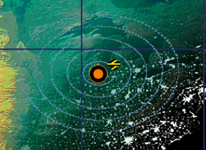
Select to display lightning icons that indicate detected lightning. Range rings for the coverage area are shown. This will also enable the lightning option in the upper right auxiliar pane.

Pop up panels in maps.
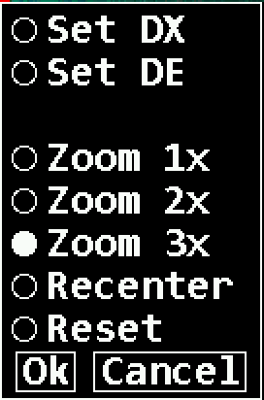
Clicking anywhere on the map brings up a multi-purpose popup menu. It always offers controls to set the HamClock DE or DX object to the clicked location if desired. It may also offer controls to set a specific Zoom factor and/or to Recenter the map at the clicked location, depending on the current map projection. The Mercator projection implements all options although recentering may not extend beyond the poles. Robinson can only shift the center longitude; it cannot zoom. The other projections can neither zoom nor recenter. The menu starts with the current zoom factor preselected. Reset restores the map to full size centered on the longitude specified in Setup page 4. DX can also be set immediately without using the menu by either clicking mouse Button 2 (middle) alone, or Button 1 (left) in combination with the Control or meta key (names vary depending on your keyboard).
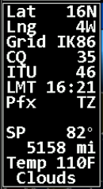
Hovering with your mouse pointer on the map will provide additional information about spots on the earth. Additional to the coordinates it will display the grid locator, CQ zone, ITU zone, the local time and the country prefix. It also will give you the angel for short-path, the distance and the weather conditions if available.

Satellite Information
A very important feature of HamClock is the display of satellites (and some astronomical objects) and their information. The path of a satellite is displayed as an overlay on the maps. You can select up to two satellites to follow.
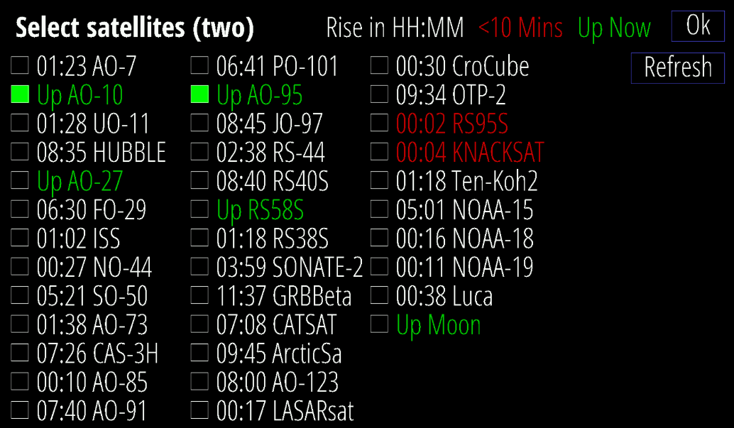
To enable satellites, you click on the top of the DX pane, and the satellite selection page will open.
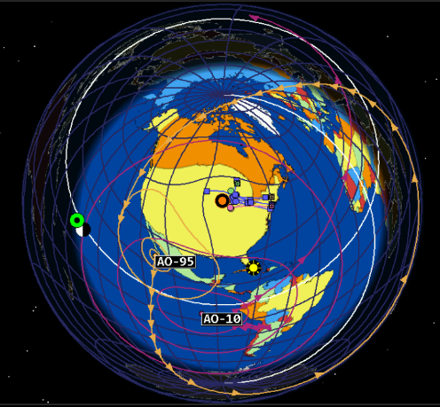
Satellites in red text will be coming up the horizon at the DE location in less than 10 minutes. Satellites in green text are currently above the horizon.

You can select up to two satellites to bring them in focus. After clicking on Ok, they will be displayed on the map.

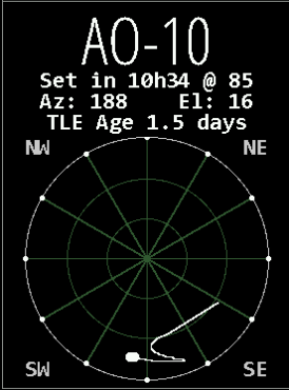
They will be also displayed on the DX pane with the satellite name, current azimuth and current elevation. Negative elevation numbers mean that the satellite is below the horizon and visible at DE. The Age is information about how fresh the data is.

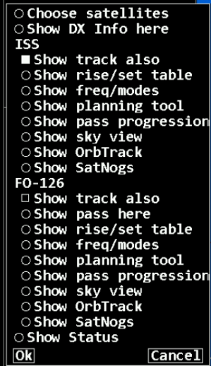
If satellites are enabled, you will have additional options for the DX panel when you click on that panel.
Choose satellites/Show DX info here Here you can select if you want to see the DX information or the satellite information.
Then you get the option to select which satellite path you want to display as overlay on the map (Show track also).
Satellite Specific Information
Show pass here selects which of the satellite information is shown in the DX pane.
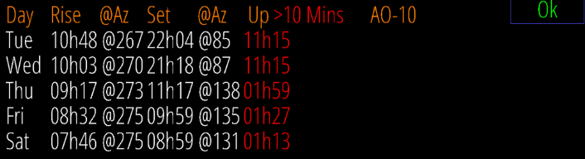
Show rise/set table displays a table with the rise and set time and angular information.

Show freq/modes Shows a table of the active frequencies and modes.
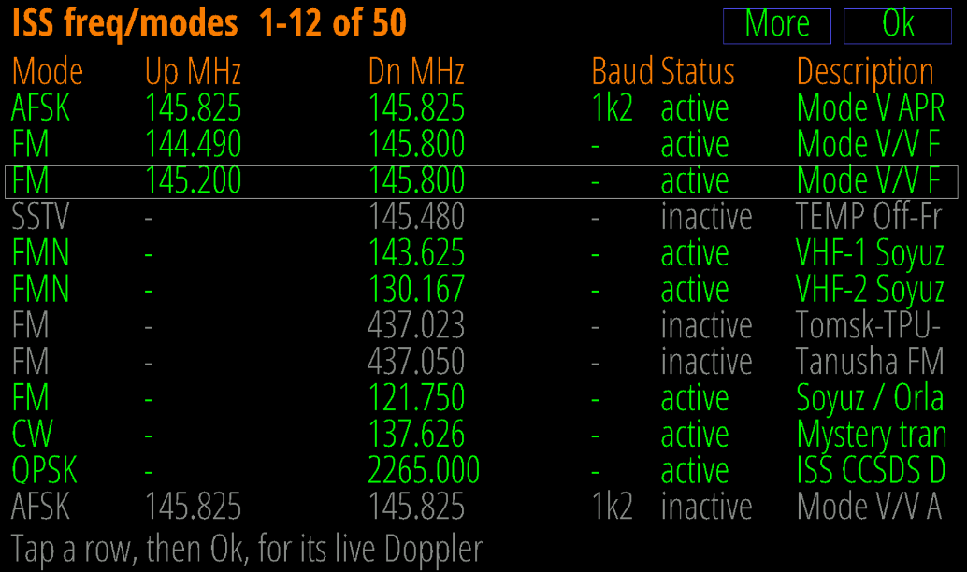
By selecting a line and clicking on “OK” you will see the live Doppler display.
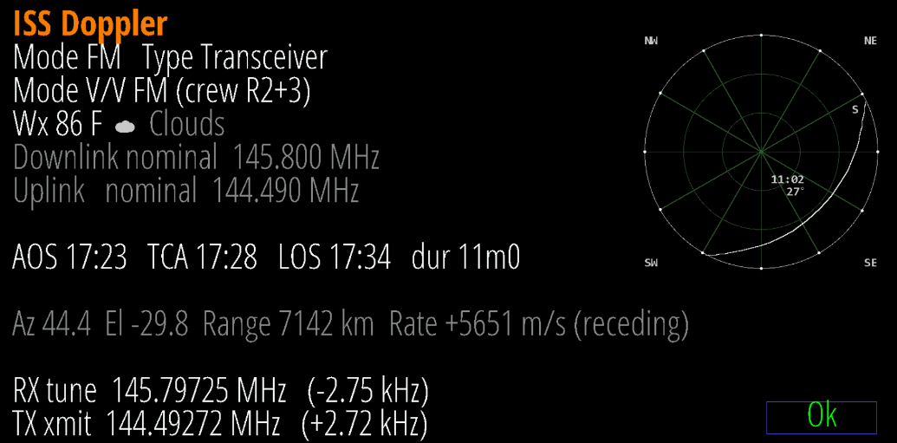

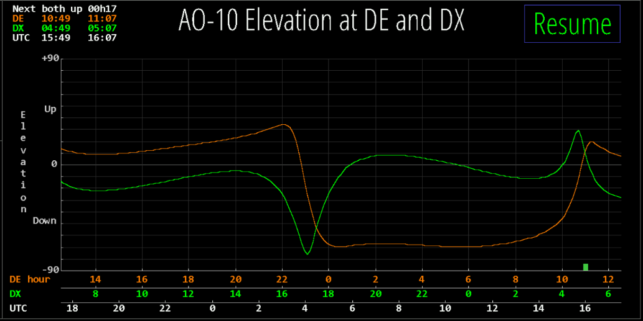
Show planning tool this tool allows you to plan for a satellite connection between DE and DX. The satellite must be above horizon (>0) to make contact possible. There is a green block for the time slot on the DE timeline.
Show pass progression Displays the path progression per day and timeslot.
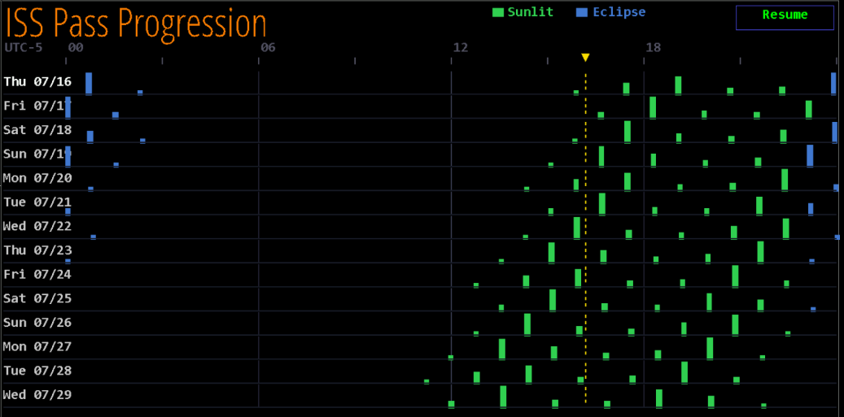

Show Sky View Provides a display of the satellite’s location in the sky.
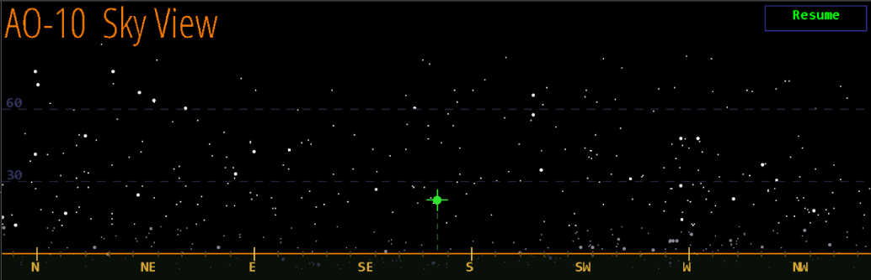
Note: The satellite has to be above the horizon to be shown.

Show OrbTrack Links to the OrbTrack.org website for live satellite tracking.
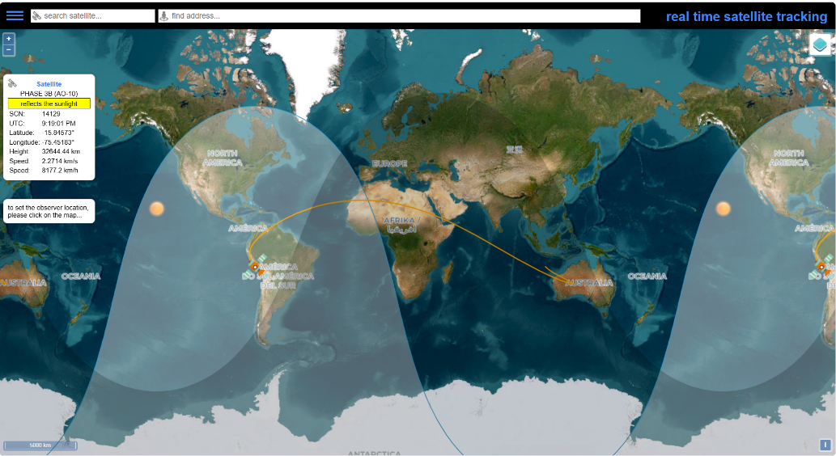

Show SatNogs Links to the SatNogs website for detailed satellite information.
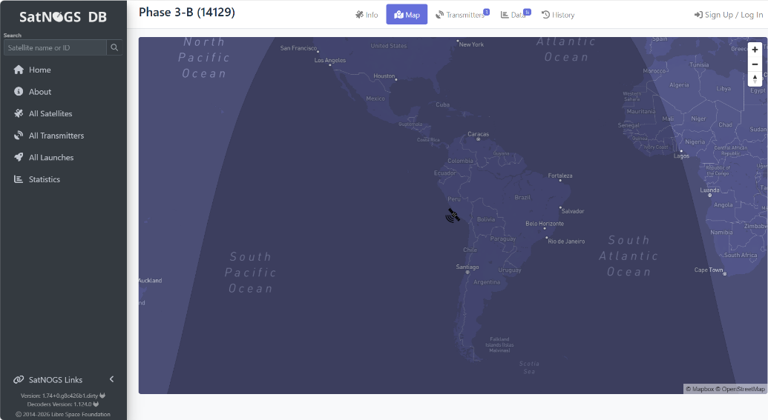
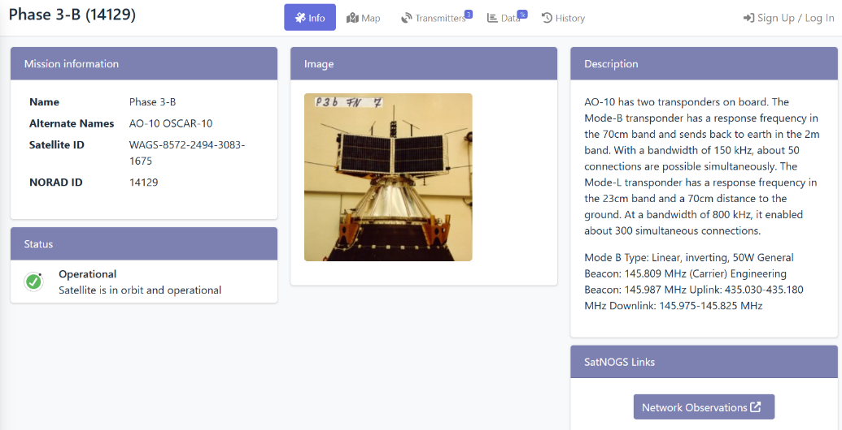

Show Status Links to the AMSAT website for status information of amateur satellites.
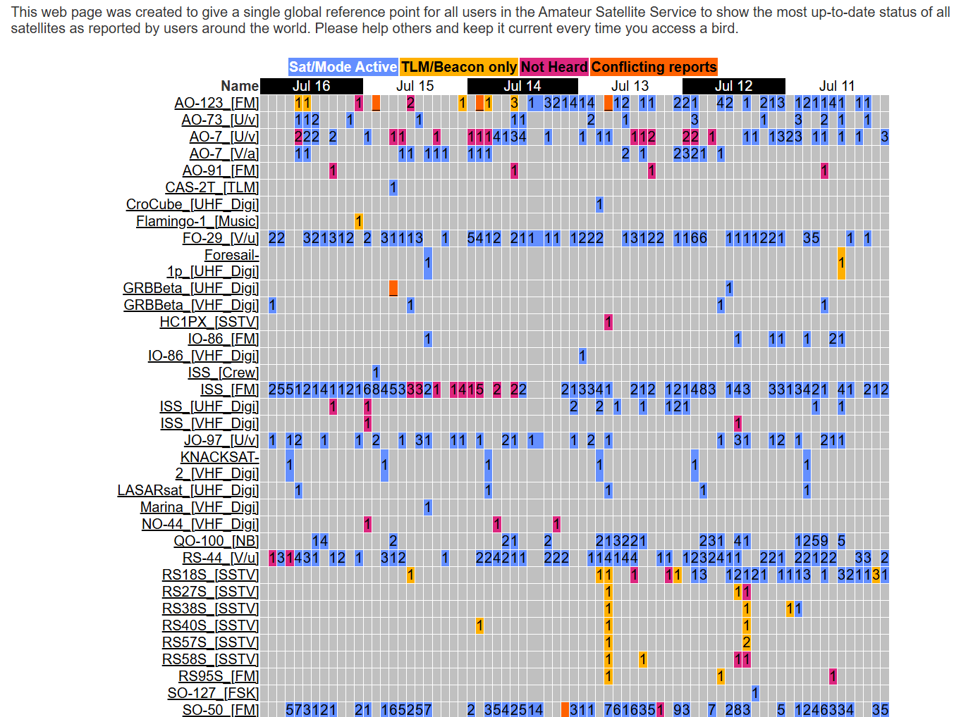

Planets
When enabled on setup page 6, HamClock can dispay the position of the 7 planets visible from earth.
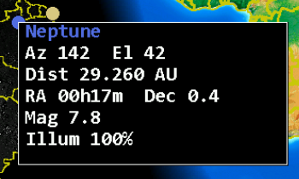
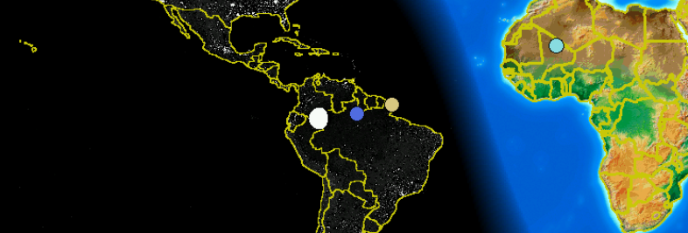

Clicking on a planet provides more information about the selected planet.

Ham Clock will always display the current postion of the Sun and the Moon in the sky.

Clock Functions
It wouldn’t be called HamClock if it wouldn’t have different clock options.

Time
The time shown in large white letters below your call always shows HamClock’s idea of UTC. If your DE time is incorrect, click the time zone offset button. If the UTC button is black-letters-on-white- background, then HamClock is using real UTC. But you may modify the time by clicking on the numbers. This can be useful, for example, to show a satellite location, gray line or VOACAP prediction at some moment in the past or future. Changing away from UTC causes the UTC button to flash red OFF as a stark reminder HamClock is no longer tracking real UTC. Clicking the red button will return abruptly back to real UTC. A large question mark is shown when time is unknown (no NTP server is available due to network issues). Additional time displays are available. Local time in the DE panel (if displayed). Time at the DX location in the DX panel (if displayed).
Clicking on the UTC block will toggle the time to local time. Local time depends on your location which is configured on setup page 1. The UTC button will change to blue and display LCL wen local time is shown. Clicking on that button again will switch back to UTC.

Stopwatch and Alarms
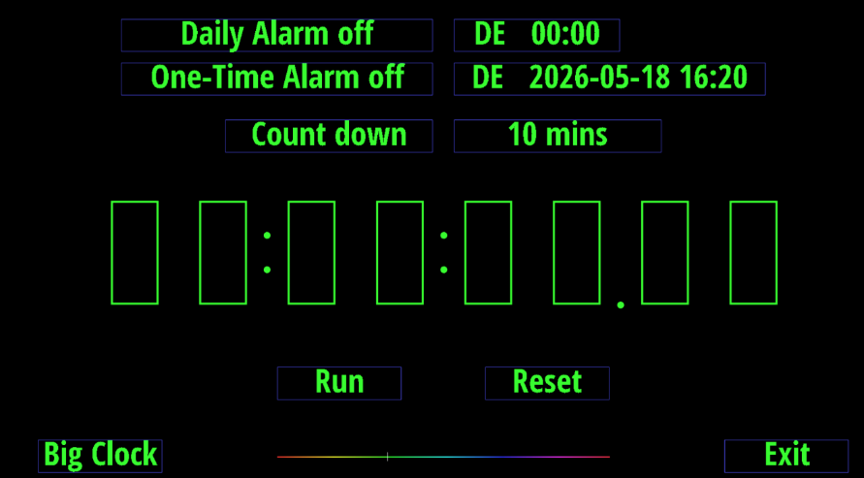
Click the stopwatch icon (beneath UTC seconds) to enter. It will display elapsed time in HH:MM:SS.SS. Clicking Run begins or resumes counting; Stop freezes display and counting; Lap freezes display but continues counting; Reset starts over; click along the spectrum bar to adjust color; Exit returns to main HamClock screen.

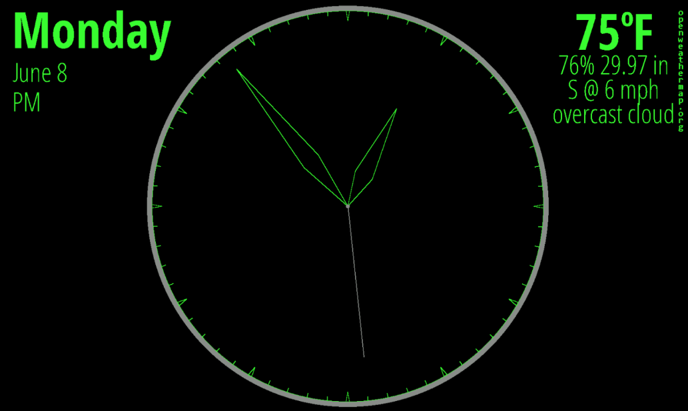
Big Clock selects a full screen digital clock replacing the normal HamClock display.
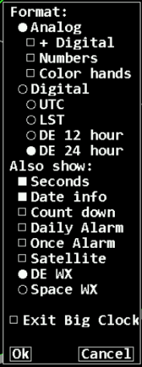
Clicking on the clock area opens up a set of options you can choose from.
You can select between different clock forms (analog/digital), color choices and other options.
Independent 24 hours daily and once-only alarms are available. They may use either DE or UTC time zones. When either is armed, the alarm clock icon on the HamClock main screen will be green (instead of gray) and the alarm time may be shown in Big Clock. When either alarm goes off it will be announced on the main screen in the center pane; on the Stopwatch screen by highlighting its control button; and on Big Clock by highlighting the alarm time. Clicking any of these will cancel the alarm; these alerts automatically time out after 60 seconds. See page 68 for hardware control.
Count down counts backwards from the value set at its right, click just above or below to increase or decrease down to 1 minute. If counting down is active: the main HamClock screen shows the time remaining in lieu of the stopwatch icon; Countdown may be chosen as a Pane option; and the value may be shown in Big Clock. It may be restarted from any of these locations with a click. Hold the main icon for 3 seconds to enter the Stopwatch screen. See page 68 for hardware control.
Brightness and Light sensor controls: If a light sensor is installed (aka “photo resistor” for historical reasons) and the Full scrn direct? option in Setup page 5 is Yes, then the right-most pane may be set to show two vertical scales. The left shows the current display brightness and the right the current light sensor reading. Both include their respective calibration markers. Brightness is scaled from, and limited to, Min% to Max% from Setup page 4. If the display can only be turned on or off, the brightness scale will only show a marker at top or bottom. To calibrate a desired brightness response, start by exposing the light sensor to a bright intensity then click in the upper half of the left scale to set the desired display brightness at that intensity (or just “on”). Then expose the sensor to a dim light and click in the lower half to set the desired brightness at that low intensity (or “off”). Systems without a light sensor but with ability to control display brightness will provide a single slider to control display brightness manually.
On/Off timers: The upper right-most HamClock pane may provide a table of DE clock On and Off times at which the display may be set to Max% or Min%, respectively; set the times equal to disable. Idle sets the number of minutes of no user activity after which the display may change to Min%; set to zero to disable. Changing the On or Off times will also set the On/Off table in Setup page 7 to match the current day. Conversely, the pane values will be reset from this table at each local midnight. If these timers turn the display Off, the light sensor will then not control display brightness again until either a timer commands the display back On or the user clicks anywhere in HamClock to restore brightness.

Mobile Dashboard
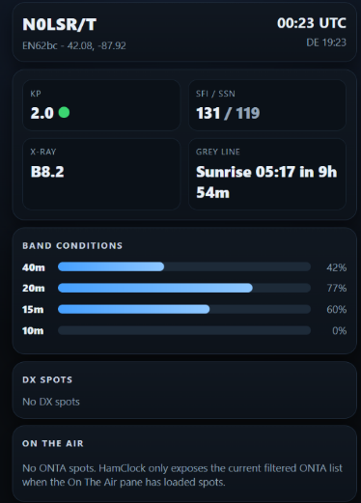
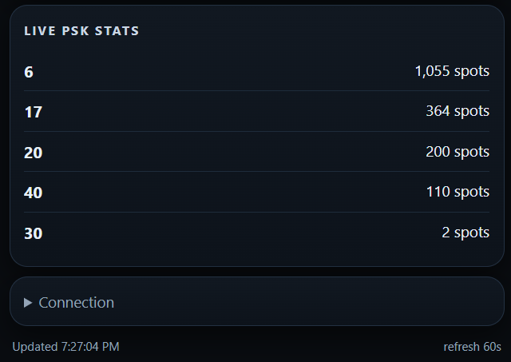
For accessing your HamClock remotely from a phone or tablet on the same network, a mobile dashboard is available. You access it on port 8080 with the following command:
<IPAddress>:8080/dashboard.html
Or using the host name instead:
<hostname>:8080/dashboard.html
The dashboard shows a text representation for the most important information from HamClock.
There are no configuration options at this time.
To access the mobile dashboard remotely away from home you would have to open the port 8080 in your firewall and enable port forwarding to your HamClock device.

Watch Lists
Watch lists are used to filter DX Cluster, On The Air and ADIF spots. They may be edited either in the Setup session or within the popup menus for each pane. Each watch list consists of one or more specifications separated by commas. Each specification may consist of any of the following requirements, all of which are optional:
- Band names in several formats:
  - a single band name followed by M for meters, such as 40M.
  - multiple bands separated by hyphen in either order, such as 20-10M or 10-20M.
  - a sub-band mode may be specified following the band number such as 40CW or 20SSB or 30FT8.
  - multiple sub-band ranges separated with a hyphen, such as 160-10CW or 10-20DATA.
- Exact frequency range:
  - min-max in MHz which may span multiple bands, such as 14-14.02MHZ or 7.0-10.15MHZ
- ADIF keyword: predefined qualities of a spot which must not be found within the current ADIF file:
  - NADXCC: no ADIF entry matches the spot’s DXCC entity.
  - NAPREF: no ADIF entry matches the spot’s prefix.
  - NAGRID: no ADIF entry matches the spot’s grid (first 4 characters only)
  - NABAND: no ADIF entry matches the spot’s band.
  - These may be combined, such as NAGRID NABAND to require no matching grid square or band.
- prefix: anything not fitting the above rules specifies the required leading characters of a call (see more below)
Notes:
- Prefixes only check their number of characters for a match. Ex: prefix AA matches AA0 and AA1 but not A or AB.
- Spot call signs containing a slash (/) are broken into “dx” and “home” portions. The “dx” portion is the shorter side but is ignored if it consists of 1 character or digit, is one of the abbreviations /MM or /AM, or consists of 3 or more characters without any digits such as /QRP. Calls without a slash are always considered to be “home” calls.
- Ex: VK2/WB0OEW and WB0OEW/VK2 both assign “dx” to VK2 and “home” to WB0OEW, but WB0OEW/0 assigns “home” to WB0OEW but has no “dx” portion because /0 is ignored.
- Watch list prefixes that end in a slash, /, apply only to the “dx” portion of a portable call. Prefixes without a slash apply only to the “home” portion of a call. Ex: the prefix VK2 will match WB0/VK2ABC but not VK2/WB0OEW; conversely prefix WB/ will match VK2ABC/WB0 but not WB0OEW/VK2.
- A spot is considered a match if it is selected by all the given requirements within any of the given specifications.
- Think carefully when mixing watch lists with native DX Cluster commands (see Setup page 2).
- The ADIF keywords may not be used in the ADIF watch list.
- The supported sub-band modes are based on those in DX clusters: CW, DATA, FT4, FT8, RTTY, SSB. Modes are implemented as frequency boundaries, not actual transmission content, so may not be correct.

Each watch list can be set to control its display list in one of four ways:
- Off: HamClock will save the watch list, but it has no effect; all spots are displayed normally.
- Red: all spots are displayed but those which match are highlighted in red in the display list.
- Only: like Red but only the matching spots are displayed.
- Not: the opposite of Only, i.e., only spots that do not match all specifications are displayed.

Example Watch List | A spot matches if ...
30M | ... it is any frequency on 30 meters
40-80M | ... it is any frequency on 40 or 80 meters
20-10DATA | ... it is any frequency spiders consider DATA on 20 through 10 meters
20m WA WB K | ... it is on 20 meters with home prefix WA or WB or K
7.0-7.01MHZ | ... it is in the DX CW window of 40 meters
VK/ 20M 30M, ZL/ 30M | ... it is a portable station in VK on 20 or 30, or a portable ZL station on 30
NADXCC | ... its DXCC does not match any spot in the ADIF file on any band.  use this to look for new DXCC entities.
NADXCC NABAND | ... both its DXCC and band do not match any one spot in the ADIF file.  use this to look for new band slots.
40M NAPREF | ... it is on 40 and has a prefix not in the ADIF file.  use this to look for new prefixes on 40m
20-10M NAGRID | ... it is on any band from 20 to 10 and no spots in the ADIF file have the same grid.  use this to look for new grids on these bands.

External IO Options (Raspberry-Pi only)
HamClock supports several optional external devices to enhance the operator experience. These include:
- one or two BME280 environmental sensors for temperature, pressure and humidity.
- LTR329 light sensor for automatic dimming depending on ambient lighting (see page).
- several switches and LEDs to complement the ON THE AIR indicator, timer, alarm clock and satellite status.
- time and location from NMEA sentences from the serial connection of a GPS receiver.
- Elecraft KX3 serial frequency control, available only with RPi header pin 8.
These devices may be connected to HamClock in two different configurations, as shown below. Devices may be connected in any order, and all are optional.
- to the 40-pin header of a Raspberry Pi
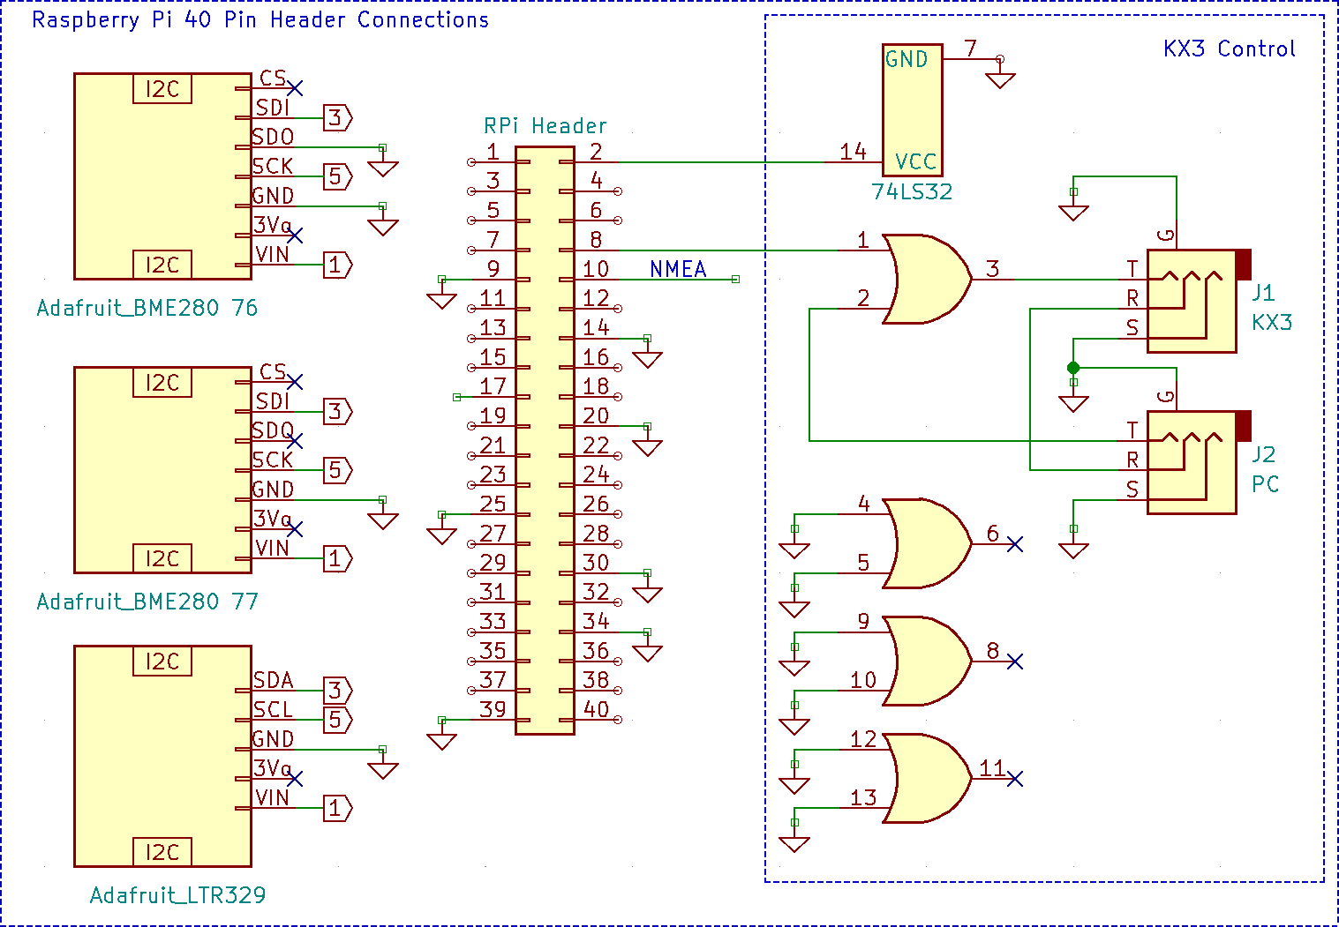
- to any Linux or Mac with a USB port using an I2CMini from i2cdriver.com, including the Pi if preferred.

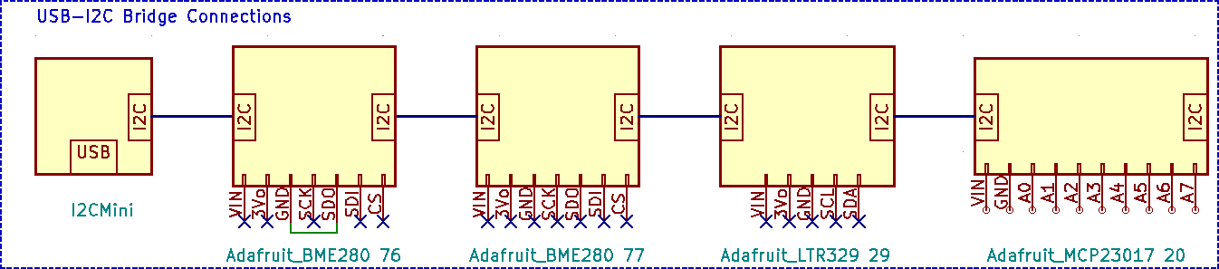
The discrete GPIO options are described in the table below. Each is independent and may be chosen separately as desired. Connect the Terminal connections to either the Pi header or the MCP23017 port expander, depending on the HamClock configuration used. The MCP23017 is not needed if none of these are used.
On Raspberry Pi, Setup page 4 also includes a toggle named GPIO. Setting this Off prevents HamClock from using any of the native pins in order that they may be used for something else. To use the I2C header pins on a RPi the GPIO toggle must be set to Active in addition to setting the proper file name (see next).
GPIO Option | Description | Terminal | Pi Header Pin | MCP23017  Pin
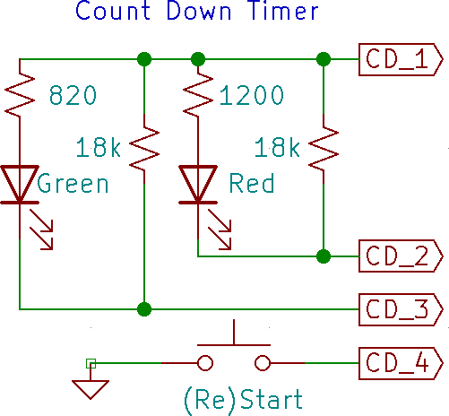 | A falling edge from a SPST switch or PTT line on terminal CD_4 (re)starts the countdown timer. Driving voltage, if any, must not exceed 3.3 V. The LEDs indicate the time remaining: green when counting down; both when 1 minute or less remains; red when timed out. | CD_1 CD_2 CD_3 CD_4 | 17  33  35  37 | VIN A0 A1 A2
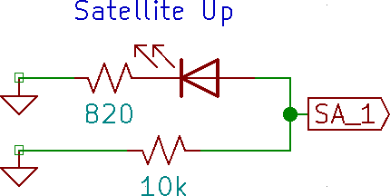 | Output terminal SA_A indicates satellite visibility from DE. Normally low, it cycles high at 1 Hz for 1 minute before rise, stays high during the pass, cycles at 2 Hz during the last minute then stays low again after set. | SA_1 | 38 | A5
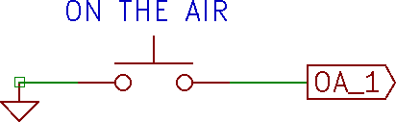 | Grounding input terminal OA_1 with a switch or PTT line will change the call sign text to “ON THE AIR”. Driving voltage, if any, must not exceed 3.3 V. | OA_1 | 40 | A6
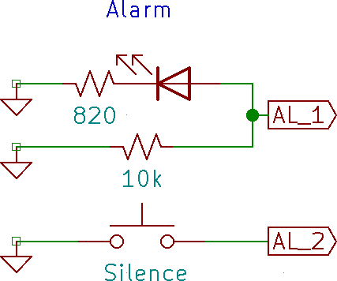 | Output terminal AL_1 will go high while either alarm is “ringing”. The schematic shows an LED, but a piezo buzzer works also. Briefly grounding input terminal AL_2 will silence either alarm. | AL_1 AL_2 | 31  29 | A3 A4
This flexibility does come at a price. You must determine and enter the name assigned by the host to the native or bridged I2C bus in the I2C file field of Setup page 4. The table below shows a sample of systems and typical names. One way to discover the exact name on Linux is to start a terminal session and run the command ls/dev. Look for something similar or, in the case of a USB-I2C bridge, remove and plug the device back in and see what changes. If you find both tty and cu names that are otherwise the same, always use the cu name.

Configuration | Typical I2C File name
Raspberry Pi 40 pin header | Debian /dev/i2c-1 FreeBSD /dev/iic0
USB-I2C bridge | Debian /dev/ttyUSB0 FreeBSD /dev/cuaU0  macOS /dev/cu.usbserial-DK0C3XGZ

GPS (Raspberry-Pi only)
The serial output from a GPS module that sends the RMC NMEA sentence may be connected directly to HamClock. The TX line from the module can be connected to Raspberry Pi header pin 10 or via any serial-USB converter cable supported by your computer operating system.
To use the RPi header, perform the following steps:
- Connect the TX line from the module to header pin 10. If needed, +5V can be taken from pin 2 and ground from pin 14.
- run sudo raspi-config, go to Interfaces and select Serial. Turn Off console and On hardware support; finish and reboot.
- Got to HamClock Setup page 1, turn on NMEA, set the baud rate of the GPS module and enter file.
- /dev/serial0 on RPi 4 or earlier, or /dev/ttyAMA0 on RPi 5.
- To use a USB converter cable on any computer running HamClock:
  - connect cable +5V, ground and RX to the GPS module and plug the USB end into the computer.
  - run ls /dev before and after plugging in the USB to find the new entry. On RPi it might be /dev/ttyUSB0; macOS something like /dev/cu.usbserial-AL00FP5D; FreeBSD it might be /dev/cuaU0.
  - Go to HamClock Setup page 1, turn on NMEA, set the module baud rate and the file name found above.
- Bonus! Use UNIX fifo:
  - Use mkfifo to create a fifo file anywhere.
  - Enter the fifo path as the HamClock NMEA file. Baud rate does not matter.
  - Now any NMEA sentences piped into the fifo will be read and processed by HamClock.

Android, Fire Tablet and Fire TV Installation and Operational Differences
HamClock on these platforms operates for the most part like on the other traditional platforms. Any major differences are described here.

Installation
The Android HamClock app wil be installed from the Google Play Store.
The Fire Tablet application can be found in the Amazon App Store. Search for “HamClock”.
For the Amazon Fire Stick or TV the application can be found under Applications. From there go to the Applications Store for Fire TV.

Setup and Configuration
After initial installation, you will be presented with the Setup Page 1 to enter your call. The grid location is preconfigured from the devices GPS. Make sure to allow access for the HamClock app to the devices GPS (when application is running). All the Setup pages are the same like for the Linux version. A few fields on Setup Page 5 are not available on the Android and Fire platform.
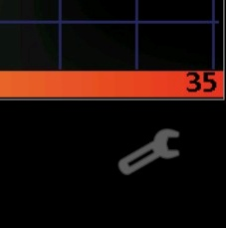
To go back to the Setup Pages and for other configuration settings use the “wrench” icon in the lower right corner.

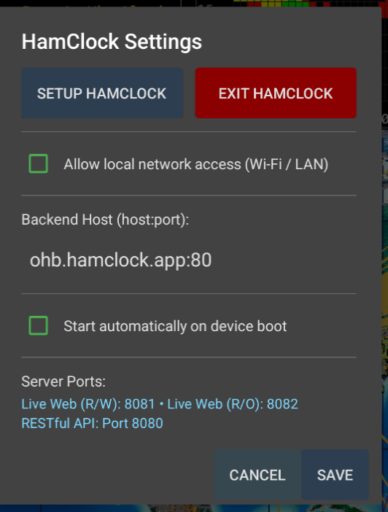
SETUP HAMCLOCK - will get you back to the Setup Pares.
Allow local network access - if enabled, it will allow remote access of the HamClock screen from another device. The access is the same as for the LINUX version with “<IP-Address>:8081/live html”.
Start automatically on device boot – if enabled, will start the HamClock app on device startup.

Operational Differences
Basic HamClock functionality is the same on the Android and Fire platforms.
Hardware dependent features are not available on these platforms (e.g., Rig control and Radio control).

Command Line Options
The HamClock program accepts the following optional arguments. For example: to skip the initial setup screens (assuming all fields are valid) to immediately begin normal operation, change the read/write web interface to port 20000, and throttle the CPU load to 20%, run HamClock as:

hamclock -k -w 20000 -t 20

-0 : restore all original default Setup values
-a x : set debug name=level, bogus name gives list
-b h : set backend host:port to h; default is ohb.hamclock.app:80
-d d : set working directory to d; default is ~/.hamclock/
-e p : set RESTful web server port to p or -1 to disable; default is 8080
-f o : force display full screen initially to "on" or "off"
-g : init DE using geolocation with current public IP; requires -k
-h : print this help summary then exit
-i i : init DE using geolocation with IP i; requires -k
-k : start in normal mode, ie, don't offer Setup or wait for Skips
-l l : set Mercator or Robinson center longitude to l degrees, +E; requires -k
-m : enable demo mode
-n t : set live web idle timeout to t minutes; default forever
-o : write diagnostic log to stdout instead of in ~/.hamclock/
-p f : require passwords in file f formatted as lines of "category password"
changeUTC configurations exit newde newdx reboot restart setup shutdown unlock upgrade
-q : ignore saved startup screen location and size
-r p : set read-only live web server port to p or -1 to disable; default 8082
-s d : start time as if UTC now is d formatted as YYYY-MM-DDTHH:MM:SS
-S s ; set Software server host for OTA download; default is ohb.hamclock.app
Must come after -b if used
-t p : throttle max cpu to p percent; default is 80
-T t ; set max timeout for responses from backend; default is 10
-v : show version info then exit
-w p : set read-write live web server port to p or -1 to disable; default 8081
-x n : set n max live web connections; max 100; default 10
-y : activate keyboard cursor control arrows/hjkl/Return -- beware stuck keys!

RESTful Webserver Command Reference
In addition to the HamClock’s main web interface HamClock provides a REST interface that allows external control by the user via a browser or programmatically by an external program. The general web interface is, by default, on port 8081 (See options -w and -r on page 25), HamClock’s REST interface is, by default, on port 8080 (See option -e on page 25).
The REST (Representational State Transfer) interface takes a command in the form of a web address with an argument that returns result information in ascii text form. Please note that some web browsers may not access these rest web addresses consistently, so command line access is recommended using command curl which is available on Windows and Linux. An exception is antennas.html which is a widget designed to work in a browser.
Commands that take arguments have the argument start with ? and any additional arguments separated by &. Here is an example of setting the grid to EM13 and the callsign to KR8X:
curl "http://172.18.51.41:8105/set_newde?grid=EM13&call=kr8x"

Entering an invalid command or no REST command after the RESTful port will list all of the available RESTful webserver commands (for example): curl "http://192.168.1.42:8080/"
antennas.html antennas widget to administer antenna information
get_antennas.txt Get antenna information from hamclock and backend
get_capture.bmp get live screen shot in bmp format
get_config.txt get current display settings
get_contests.txt get current list of contests
get_de.txt get DE info
get_dx.txt get DX info
get_dxpeds.txt get current list of DXpeditions
get_dxspots.txt get DX spots
get_gpio? pin=MCP&latched=[true,false]
get_livespots.txt get live spots list
get_livestats.txt get live spots statistics
get_ontheair.txt get POTA/SOTA activators
get_satellite.txt get current sat info
get_satellites.txt get list of all sats
get_sensors.txt get sensor data
get_spacewx.txt get space weather info
get_sys.txt get system stats
get_time.txt get current time
get_voacap.txt get current band conditions matrix
list_antennas.txt list antenna indexes and description
set_adif? pane=[0123] (POST)
set_alarm? state=off|armed&time=HR:MN&utc=yes|no
set_antennas? antdeindex=n&antdxindex=n&antdedxcontrol=n&antdeaz=n.n&antdxaz=n.n
set_auxtime? format=[one_from_menu]
set_bmp? pane=[1,2,3,map]&fit=[resize,crop,fill][&off] (POST)
set_cluster? host=xxx&port=yyy
set_debug? name=xxx&level=n
set_defmt? fmt=[one_from_menu]&atin=RSAtAt|RSInAgo
set_displayOnOff? on|off
set_displayTimes? on=HR:MN&off=HR:MN&day=[Sun..Sat]&idle=mins
set_gpio? pin=MCP&level=[hi,lo]&blink=hz
set_livespots? (see error message)
set_mapcenter? lng=X
set_mapcolor? setup=name&color=R,G,B
set_mapview? Style=S&Grid=G&Projection=P&RSS=on|off&Night=on|off
set_newde? grid=AB12&lat=X&lng=Y&call=AA0XYZ
set_newdx? grid=AB12&lat=X&lng=Y
set_once_alarm? state=off|armed&time=YYYY-MM-DDTHR:MN&tz=DE|UTC
set_pane? Pane[0123]=X,Y,Z... any from:
VOACAP_DEDX DE_Wx DX_Wx Solar_Flux Planetary_K Moon NOAA_SpcWx Sunspot_N
X-Ray SDO Solar_Wind DRAP Contests Live_Spots Bz_Bt On_The_Air Aurora
DXPeditions Disturbance
set_panzoom? pan_x=X&pan_y=Y&pan_dx=dX&pan_dy=dY&zoom=Z
set_rotator? state=[un]stop|[un]auto&az=X&el=X
set_rss? reset|add=X|network|interval=secs|on|off|file (POST)
set_satname? abc|none
set_sattle? name=abc&t1=line1&t2=line2
set_screenlock? lock=on|off
set_senscorr? sensor=76|77&dTemp=X&dPres=Y
set_stopwatch? reset|run|stop|lap|countdown=mins
set_time? change=delta_seconds
set_time? ISO=YYYY-MM-DDTHH:MM:SS
set_time? Now
set_time? unix=secs_since_1970
set_title? call|title|onair=[text]&fg=R,G,B&bg=R,G,B|rainbow
set_touch? x=X&y=Y
set_voacap? band=X&power=W&tz=DE|UTC&mode=X&map=X&TOA=X
exit exit HamClock
postDiags post diagnostic logs and configuration settings
restart restart HamClock
updateVersion update to latest version

Directional Antenna Maps
Band conditions, Reliability Maps, Take Off Angle Maps and VOAcap Maps default to a generic omnidirectional isotropic antenna for the DE location and DX location. RESTful commands are available to administer the types of antennas and how they are used (see page 26). Directional antenna support requires support of the backend server.
Restful command antennas.html brings up the Antenna manager widget for user control of this function.
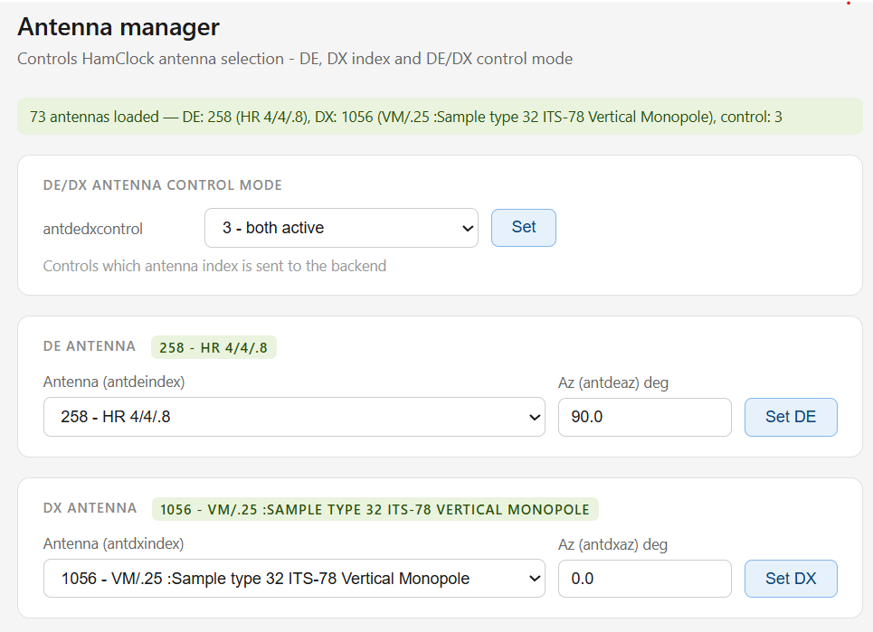

APRS Symbols — The Full Symbol Chart
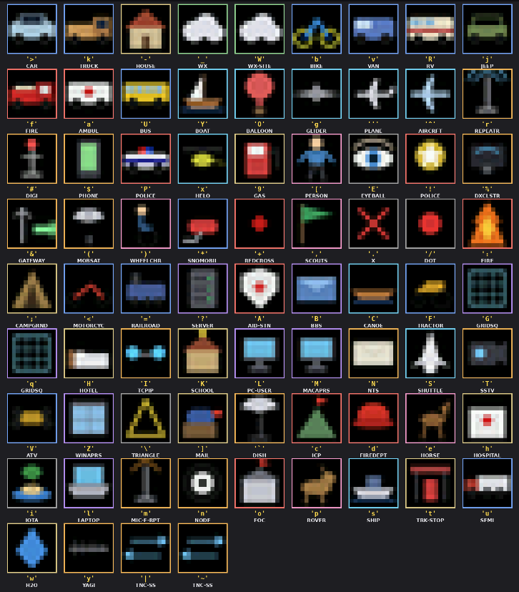
Every APRS station picks an icon with a two-byte symbol code: a table identifier (/ for the primary table, \ for the alternate table) plus a single printable character. Below is the full set, rendered with the same canonical APRS glyphs aprs.world draws on the live map — the standard icons hams recognise across the ham radio ecosystem. Each card shows the icon, what it means, and the exact symbol pair to type into your radio or client.
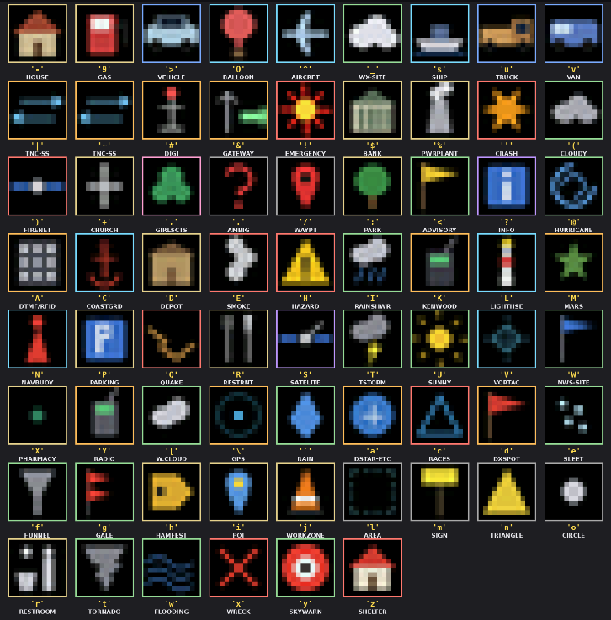

Version History

Version 4.32 September 2026
- new Android support
- new Amazon Fire Tablet support
- new Fire WX monitoring
- new display of wildfires on maps
- new marine weather warning and monitoring
- new earthquake monitoring
- ADS-B and windy access changes
- support spots for 4m,630m and 2200m in live spots
- support HamQTH lookups
- ONTA improvements
- Open user guide with QR code
- Touchscreen improvements
- Password visibility toggle
- Right click panels forward/back
- Fix to allow special characters in passwords
- Fix cancel button on de/dx overwrite

Version 4.31 August 2026
- new APRS monitoring
- new HAB (high altitude balloon) monitoring
- new HamAlert monitoring
- new band activity pane
- added feature for multiple strings for tital
- more OTNAs and highlights
- add 630m spots
- update X-ray sat to GEOS-18
- touchscreen fixes for ok/cancel
- touchscreen fixes for tool tips

Version 4.30 August 2026
- new WEFAX on WX maps
- new future eclipses pane
- new pane options with collapsible menus
- add IOTA to OnTtheAir (OTA)
- add IOTA to DXcluster
- toggle UTC to local time
- expanded lightning limit to 9999
- storm trajectory on all projections
- support of HTTP 304 message to use local cache if no changes
- fix vertical position of callsign
- fix disappearing icons

Version 4.29 August 2026
- clean stray pixel in status
- snappier refresh of sat tracks
- country lines on maps
- US state lines on maps
- Canadian province lines on maps
- fix magnetic bearing display issues
- fix various cyclone display issues

Version 4.28 August 2026
- add Sat Alerts via Hams.at
- add plane icon to launch to ADSB
- add wave icon to launch to Windy.com
- add Planets Display in Setup
- add POTA support for ONTA
- add Meshtastic watch support
- improve display refresh performance
- improve visibility of icons

Version 4.27 July 2026
- improving the lightning strike icon for the lowest resolution display
- add cyclones to maps
- fixed mbox icon disappears sometimes
- fixed tropics for map zoom
- update tropics more frequently
- voacap timeout increased to 15s
- fix init/saved pos'n on some X windows
- fix some compiler warning and do some housekeeping/cleanup
- new pane for nets
- new pane for HF Bands
- new pane for VHF Conditions
- new pane for launches
- new flex panel for nets
- new flex panel for launches
- new satellite freq/modes display
- new satellite pass progression display
- new satellite Sky View display
- new satellite information link to OrbTrack
- new satellite information link to SatNog
- new satellite information status link to AMSAT website

Version 4.26 June 2026
- mobile dashboard on 8080:/dashboard.html
- update dxcluster connection retry
- center clicked on zoom map
- lightning uses config units
- fix DE format's OK button broken
- fix web-3200x1920 in alpine docker
- support sys admin messages
- ensure sat tracks on top
- support 4-char grid squares
- prelim support for tropo maps

Version 4.25 May 2026
- improve lightning icons
- fix UA missing in lightning
- tropical cyclone feature
- support saving configuration
- allow unselect all
- better missing satellite

Version 4.24: May 2026
- fix: maidenhead conversions in REST api
- add: show lightning strikes on maps
- add: directional antennas in voacap
- add: highlight "now" as ^ in VOACAP DE-DX

Version 4.23: April 2026
- fix: 1-sat crash in Show planner
- change: better diag file posting
- change: show backend host/IP in status
- fix: prevent OTA crash on long pre/suffix
- fix: gpio pin for alarm
- add: add -T for HTTP timeout
- add: add T= build argument for HTTP timeout
- add: add -S for alt software server
- add: add S= build argument for software server
- add: add B= build argument for backend server:port

Version 4.22: 2026-01-17
- change: clicking wifi strength now shows a history plot
- fix: don't offer Moon track in satellite
- menufix: make satellite track option persistent
- fix: satellite name could overlay RSS
- fix: remove unused watchdog funtion calls
- fix hopefully: TZ updates could repeat continuously if net fails

Version 4.21: 2025-09-06
- new: support up to two simultaneous satellites
- new: add Live Spots menu item to choose whether to show paths
- change: add next rise and set azimuth to Sat pane
- change: tweak satellite path arrowheads
- fix: TZ updates could repeat continuously if net fails even briefly

Version 4.20: 2025-07-06
- fix: NOAA SpaceWx day label color was not consistent
- fix: add arrows to dashed satellite
- pathfix: Big Clock refresh could leave extra bits
- fix: avoid versions of gpiod that are too old

Version 4.19: 2025-06-10
- change: add timeline labels beneath NOAA SpaceWx
- columns fix: next sat pass was not updated after set

Version 4.18: 2025-06-07
- new: support user file of sat TLEs in ~/.hamclock/user-esats.txt new: add Setup option to configure desired max sat TLE age new: add Setup option to set minimum spot label distance
- new: ctrl-click data pane title, map style or NCDXF to force rotation change: EME tool is now full size and remains up until dismissed change: separate Demo and padlock icons
- change: + in On-The-Air Org shows all selections without rotation
- change: NOAA SpaceWx pane now spells out scale and category meanings
- change: show expedition mode if spotted
- change: add satellite TLE age above passfix: map info table lookup is now faster to handle larger data sets
- fix: add Makefile args FB_DEPTH=16/32 and WIFI_NEVER=0/1
- fix: posting diagnostics worked but menu was broken

Credits
HamClock would not be possible without the following resources:

Space Weather Prediction Center for several data sets: Sunspot number
Solar flux monthly and current Aurora
Scales DRAP X-Ray Solar wind
K index and K and SFI forecast Bz and Bt
Jari Perkimki, Gregory Hand and Jim Watson for generous VOACAP support. DX cluster operators and spotters the world over.
SOTA, POTA and WWFF users and their respective database maintainers. Bruce Horn, WA7BNM, for the 8 day context calendar.
Celestrak for timely satellite elements. NASA for SDO and STEREO images.
National Research Council Canada for 70 years of continuous 10.7 cm solar flux data. Open Weather Map for near-real-time world-wide weather data.
Philip Gladstone, N1DQ, for assistance and live data from his web site PSKReport.info . Pete Smith, N4ZR, and Felipe Ceglia, PY1NB, for the Reverse Beacon Network.
Arne for assistance and live data from his site wspr.live.
NOAA for the World Magnetic Model and their Science on a Sphere real-time cloud maps. Davidson Francis for his Websocket server.
Andrew D. Rodland, KC2G, for his ionosonde data via GIRO. Sean Barrett for a compact and easy-to-use image format writer. Jim Reisert, AD1C, for maintaining the cty country file.
ITU and CQ zones based on data from zone-check.eu.
Mario, DL4MFM, for his support and assistance with data from WWFF. DX expedition data from NG3K and DXNews
World Data Center for Geomagnetism, Kyoto University, for DST data

And special shoutouts to Adafruit and Raspberry Pi Foundation for great products and support.

If you spot any errors or you think a section needs clarification please send an e-mail to udo@n0lsr.com .

